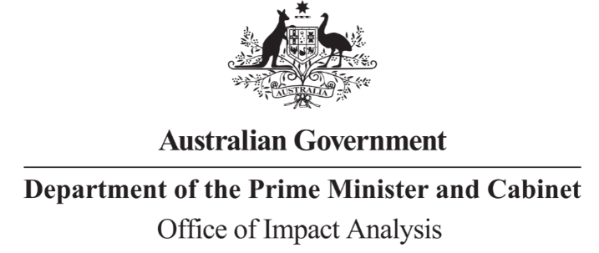

Reference: OBPR22-02412  
Telephone: 6271 6270  
e-mail: [helpdesk-oia@pmc.gov.au](mailto:helpdesk-obpr@pmc.gov.au)

Martin Hehir

Deputy Secretary  
Workplace Relations Group  
Department of Employment and Workplace Relations  
  
  
Dear Mr Hehir

**Certification of Impact Analysis Equivalent: Standing Up For Casual Workers**

Thank you for your letter certifying the following reviews undertook a process and analysis equivalent to an Impact Analysis (IA):

* + Senate Select Committee on Job Security Inquiry
  + Statutory review of the *Fair Work Amendment (Supporting Australia's Jobs and Economic Recovery) Act 2021.*

The Office of Impact Analysis (OIA) acknowledges the certification as an Impact Analysis Equivalent (IAE). Under the *Australian Government Guide to Policy Impact Analysis*, the OIA does not assess the adequacy of the analysis contained in an IAE but does assess whether the options analysed in the certified documents are relevant to the policy proposal. The OIA also assesses the IAE for the coverage of the seven IA questions conducted and whether the IAE or certification letter identifies regulatory costs.  
  
In this case, the OIA’s assessment is that the options analysed in the IAE are sufficiently relevant to the policy proposal. The IAE contains additional analysis prepared by the Department to address IA question seven.

We would appreciate you advising us when a final decision has been announced and forwarding a copy of the IAE in a form meeting the Government’s accessibility requirements. The OIA will publish the IAE, along with your certification, on the OIA’s website at oia.pmc.gov.au.

Further, where a regulation is tabled in Parliament, your IAE needs to be included in the Explanatory Memorandum or Statement, as stipulated in the *User Guide to the Australian Government Guide to Policy Impact Analysis*.

Yours sincerely  
  
  
  
Jason Lange  
Executive Director  
Office of Impact Analysis

24 August 2023

|  |  |  |  |
| --- | --- | --- | --- |
| |  | | --- | |  | | |  | | --- | | 1 National Circuit, Barton ACT 2600 • Telephone 02 6271 6270 • Internet oia.pmc.gov.au | |