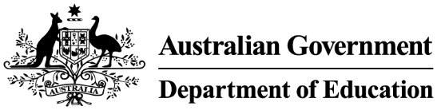

Meg Brighton Deputy Secretary

Jason Lange Executive Director

Office of Impact Analysis

Department of the Prime Minister and Cabinet

Sent via email: [Helpdesk-OIA@pmc.gov.au](mailto:Helpdesk-OIA@pmc.gov.au)

Dear Mr Lange

**Sunsetting of the Australian Education Regulation 2013**

I am writing to the Office of Impact Analysis (OIA) regarding the *Australian Education Regulation 2013* (the 2013 Regulation). As per subsection 50(1) of the *Legislation Act 2003,* the 2013 Regulation is scheduled to sunset on 1 October 2023.

The current 2013 Regulation underpins the *Australian Education Act 2013,* which is the main legislation for the provision of Commonwealth funding to government and non-government schools. The 2013 Regulation specifies elements of the Schooling Resource Standard to calculate annual funding entitlements for schools, capital and other funding provisions and requirements for compliance and conditions of receiving funding. To ensure the continued provision of school education in Australia, the instrument has been remade, without significant amendment, as the *Australian Education Regulations 2023*.

The Department of Education certifies that the current 2013 Regulation is operating effectively, and that an Impact Analysis is not required for this instrument to be remade.

The department’s assessment was informed by consultation with state and territory Education officials and Education Ministers. Feedback from stakeholders noted that the current 2013 Regulation continues to support current funding policy and that there will be future opportunities for revision once the next National School Reform Agreement (NSRA) is in place. The Australian Government has established an expert panel to inform the next NSRA, with a final report to Education Ministers by 31 October 2023.

The department has considered the regulatory burden to businesses, community organisations or individuals, using the *Australian Government’s Regulatory Burden Measurement Framework.* As there

are no changes to how the current 2013 Regulation and the remade Regulations will operate, there is no net saving or benefit. Therefore, there is no change in regulatory costs from business as usual.

I acknowledge that OIA will publish this letter for transparency purposes. Yours sincerely

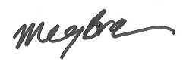

Meg Brighton Deputy Secretary Schools Group

Department of Education 3 August 2023