Heavy Vehicle National Law high-level regulatory framework
May 2023
Decision regulation
impact statement

Report outline
Title | Heavy Vehicle National Law high-level regulatory framework
Type of report | Decision regulation impact statement
Purpose | For approval by the Infrastructure and Transport Ministers’ Meeting June 2023
Abstract | This decision regulation impact statement (RIS) assesses the impact of legislative reforms intended to significantly improve the Heavy Vehicle National Law. Recommended reforms have been identified through the Heavy Vehicle National Law (HVNL) Review and subsequent consultation processes.  The key reforms being assessed in this RIS would see obligations in the HVNL restructured to support industry in developing safer, more efficient business practices and to have those practices recognised as an alternative to compliance with prescriptive obligations. This will enable the HVNL to better support a diverse road freight industry and encourage ongoing industry practice improvements.  In total, this RIS assesses 14 complementary policy reforms that are intended to deliver a more efficient, collaborative, and risk-based regulatory regime that will benefit the road freight sector and have flow-on effects for the economy and the broader community.
Attribution | This work should be attributed as follows, Source: National Transport Commission, Heavy Vehicle National Law, Decision Regulation Impact Statement.  If you have adapted, modified or transformed this work in anyway, please use the following, Source: based on National Transport Commission, Heavy Vehicle National Law, Decision Regulation Impact Statement.
Key words | heavy vehicle national law, national heavy vehicle regulator, national heavy vehicle accreditation scheme, heavy vehicle safety
Contact | National Transport Commission  Level 3/600 Bourke Street  Melbourne VIC 3000  Ph: (03) 9236 5000  Email: enquiries@ntc.gov.au  www.ntc.gov.au

Foreword
Australia’s heavy vehicle sector is a key economic enabler driving the movement of freight and people across the nation. Encompassing a wide range of businesses, from small single truck or bus operators through to large fleets, heavy vehicles are essential in transporting goods, people and livestock, and vital to our mining and construction industries. Transport is also a major employer in Australia, generating over 1 million jobs, many of which are in the heavy vehicles sector.
It is therefore vital that Australia’s heavy vehicle sector is able to innovate and respond to changing technology and business practices. This requires a regulatory environment that encourages industry growth and innovation, fosters productivity, enables the regulator to respond to new and emerging risks and above all supports a safe operating environment.
The National Transport Commission (NTC) has developed this Decision Regulatory Impact Statement (D-RIS) to support Australia’s transport ministers in making decisions on the future Heavy Vehicle National Law (HVNL). It contains 14 recommendations that will form the foundation of a future law that will deliver more effective, flexible regulation, be more responsive to a dynamic contemporary environment, support improvements to safety and productivity, reduce red tape and streamline governance and administration.
To implement these recommendations, the first step will be to establish the right foundations, by changing the design and structure of the HVNL regulatory framework so that it serves as a gateway – not a barrier – to a more flexible regulatory regime.
With the future HVNL regulatory structure locked in place, NTC can complete consultation and regulatory impact assessments for key reforms including vehicle mass and dimension changes and fatigue rules. These reforms are critical to the safety, productivity and sustainability of Australia’s heavy vehicle sector.
The changes outlined in the DRIS, will complement other reforms to systems and processes that do not require changes to the law. This includes important improvements to Australia’s heavy vehicle access systems. Together they will provide a more supportive environment for safety and productivity in Australia’s heavy vehicle sector.
The NTC will continue to engage with industry and jurisdictions as we finalise the HVNL reforms and deliver a better law.
Dr Gillian Miles
Chief Executive Officer and Commissoner
Aaron de Rozario
Executive Leader, Regulatory Reform
Contents
Report outline 2
Foreword 3
Executive summary 7
1 Context 9
1.1 Introduction 9
1.1.1 Approach to Heavy Vehicle National Law Review policy analysis 11
1.2 Background 12
1.2.1 National transport reforms including a law to regulate heavy vehicles 12
1.2.2 Heavy Vehicle National Law Review 13
1.3 Approach and consultation 13
1.3.1 Consultation informing this regulation impact statement 13
1.3.2 HVNL Review issues papers 14
1.3.3 Consultation regulation impact statement 15
1.3.4 HVNL Safety and Productivity Program, Kanofski Report and decision regulation impact statement development 15
2 Scope 18
2.1 What is in scope for this decision regulation impact statement 18
2.2 What is out of scope for this decision regulation impact statement 19
2.2.1 Issues supported through the Kanofski Report and consultation RIS which are being progressed through subsequent RIS processes 19
2.2.2 HVNL Review consultation RIS proposals that are not being progressed 21
2.2.3 Derogations and national participation 21
2.2.4 Issues raised by stakeholders through consultation that are primarily non-legislative operational matters 21
3 Statement of the problem 23
3.1 Problems with the Heavy Vehicle National Law 23
3.1.1 A better balance between prescriptive and more flexible obligations 24
3.1.2 The HVNL is unresponsive to changes in the operating environment 24
3.1.3 Alternative compliance options are too heavily constrained by legislation 24
3.1.4 No clear pathway for recognising new technologies 25
3.1.5 Outdated, inflexible or unnecessarily constrained regulatory tools and powers 26
3.1.6 Existing delegations of authority limit the National Heavy Vehicle Regulator as a modern, risk-based regulator 27
3.2 An evolving regulatory task – key trends 28
3.2.1 Diversity in operational scale and tasks 28
3.2.2 The road freight and road passenger environment is dynamic and evolving 28
3.2.3 Heavy vehicles and road safety 29
3.2.4 Heavy vehicles contribute to the Australian economy and productivity has stalled 30
3.3 Need for government action 32
3.3.1 Justification for regulation remains unchanged 32
4 Assessment and analysis process 34
4.1 A package of reforms for the future HVNL regulatory framework 34
4.2 Recommendation assessment methodology 35
4.3 Impact assessment methodology 35
4.3.1 Choosing an assessment approach 36
4.3.2 Impact categories and assessment criteria 36
4.3.3 Assessing the options 41
5 Assessment of reform options for the future HVNL regulatory framework 43
5.1 Summary 43
5.1.1 Overall impact assessment summary 44
5.2 Regulatory framework 52
5.2.1 Overview 52
5.2.2 Policy deliberations 53
5.2.3 Future work 56
5.2.4 Assessment of policy recommendations 57
Recommendation 1 – Tiered safety assurance environment 59
Recommendation 1a – Baseline compliance tier 1 65
Recommendation 1b – Alternative compliance tier 2 74
Recommendation 2 – Ministerial approvals 85
Recommendation 3 – Ministerial directions 94
Recommendation 4 – Codes of practice 99
Recommendation 5 – Improvement notices 106
5.2.5 Summary impact analysis 109
5.3 Assurance and accreditation 117
5.3.1 Overview 117
5.3.2 Policy deliberations 117
5.3.3 Future work 118
5.3.4 Assessment of policy recommendations 119
Recommendation 6a 121
Recommendation 6b 121
Recommendation 7 131
Recommendation 8 147
5.3.5 Summary impact analysis 151
5.4 Technology and data 157
5.4.1 Overview 157
5.4.2 Policy deliberations 157
5.4.3 Future work 158
5.4.4 Assessment of policy recommendations 159
Recommendation 9 159
Recommendation 10 163
Recommendation 11 165
Recommendation 12 168
Recommendation 13 170
5.4.5 Summary impact analysis 171
5.5 Primary duties and responsibility 176
5.5.1 Overview 176
5.5.2 Policy deliberations 176
5.5.3 Assessment of policy recommendations 178
Recommendation 14 178
5.5.4 Summary impact analysis 180
6 Proposed implementation pathway 182
6.1 Preferred implementation pathway – a single legislative package 182
6.2 Alternative option – multiple legislative amendments 183
7 Monitoring and evaluation 184
8 Conclusion 185
8.1 Analysis of options 185
Appendix A Ken Kanofski Reform Propositions – August 2023 187
Appendix B Recommendations list matched against ITMM reform package 214
Appendix C Consideration of consultation RIS issues not being progressed through high-level regulatory framework decision RIS 218
Appendix D Indicative list of indispensable duties and obligations, for adaptation into the future HVNL 226
Appendix E Relevant sections of current HVNL 233
Appendix F Overview of tiered safety assurance environment 237
Appendix G Links between primary duty, safety management systems, accreditation and the national audit standard 238

Executive summary
The review of the Heavy Vehicle National Law (HVNL) led by the National Transport Commission (NTC) and subsequent consultation processes have identified a series of foundational changes to the HVNL. These changes are critical for the law to accommodate the current and future needs of Australia’s heavy vehicle industry.
This decision regulation impact statement (RIS) assesses the impact of supported policies that will underpin a significantly improved HVNL. If approved for implementation as a package, the policies assessed by this RIS will increase the responsiveness and adaptiveness of the HVNL. The changes will lay a foundation for supporting future innovations in delivering heavy vehicle safety and productivity. They will allow the regulatory environment to more easily adapt to changing industry trends and enable the National Heavy Vehicle Regulator (NHVR) to administer ongoing improvements to the regulatory framework.
Chapter 5 analyses stakeholder-endorsed policy recommendations against a base case (the current HVNL). The consideration of these issues is broken down into themes and aligns with the HNVL Review consultation RIS. Where there are no policy recommendations relevant to the scope of this RIS, chapters instead contain an analysis of deliberations and highlight future work.
Context
The HVNL applies to heavy vehicles over 4.5 tonnes of gross vehicle mass. The HVNL consists of the Heavy Vehicle National Law and five sets of regulations. A first principles review of the HVNL was commenced in 2019, and a consultation regulation impact statement was released for stakeholder comment in 2020.
Following the release of the consultation RIS, an extensive policy refinement process has been undertaken in collaboration with regulators, industry representatives and government stakeholders. As a result of this process, a package of policies that have broad consensus support was approved by ministers at the Infrastructure and Transport Ministers’ Meeting (ITMM) in August 2022 (the ITMM reform package).
Conclusions and recommendations
This RIS assesses policies recommended for inclusion in the future HVNL with consensus support. On balance, the policy recommendations as a package will deliver benefits to stakeholders. Individually, the recommendations are neutral or deliver small or moderate net benefits. The recommendations establish enabling mechanisms and will facilitate the realisation of more significant benefits as they are further developed and implemented. Importantly, recommendations have a consistent impact on all HVNL-participating jurisdictions.
If approved, these policies will form the foundations of the future HVNL.
While the reforms recommended by this RIS propose significant changes to the structure and mechanics of the HVNL, they do not represent the full suite of operational and legislative improvements identified by stakeholders through the HVNL review process. If endorsed, the recommendations in this RIS will set the right foundations for enabling further changes to HVNL duties, obligations and outcomes. This work will proceed through developing regulations and subordinate instruments under the policy work program being overseen and monitored by then HVNL Steering Committee.
The key reforms being assessed in this RIS would see obligations in the HVNL restructured to support industry in developing safer, more efficient business practices and to have those practices recognised as an alternative to compliance with prescriptive obligations. Outcomes will enable the HVNL to better support a diverse road freight industry and encourage ongoing improvements in industry practice.
To complement changes to prescriptive obligations, this RIS considers enhancements to the National Heavy Vehicle Accreditation Scheme (NHVAS) based upon a safety management system approach. While it is proposed that NHVAS will continue to be a voluntary scheme managed by the NHVR, the proposed structural improvements will increase the flexibility of the scheme and empower the NHVR to establish mutual alignment arrangements and accelerated pathways for accreditation of operators already certified under non-HVNL schemes. Critically, the enhanced NHVAS will enable the NHVR to offer industry access to a broader range of accreditation options that will, in turn, allow access to alternative compliance options that may include regulatory concessions.
In recognising the role of technology in ensuring safety and increasing productivity, this RIS also assesses the impact of establishing a new technology and data framework within the HVNL. This will improve the responsiveness of the HVNL by formalising a process for certifying technologies and having them recognised within the regulatory framework.
This RIS assesses 14 complementary policy reforms intended to deliver a more efficient, collaborative, and risk-based regulatory regime that will benefit the road freight sector and have flow-on effects for the economy and broader community.
The NTC would like to acknowledge the assistance of industry and government stakeholders who have collaborated in developing these policies.
Next steps
If approved, the foundational changes to the HVNL can be prepared. This will then allow for the development of the supporting regulations and other subsidiary instruments, such as heavy vehicle obligations and the outer limits of and constraints on the enhanced NHVAS to be developed. The regulations and other subordinate instruments, including further policy recommendations in the ITMM reform package, will be subject to further consultation with industry and other stakeholders to include regulatory impact assessments where required.

Context
Key points
- The Heavy Vehicle National Law (HVNL) commenced in 2014. Numerous amendment packages have been required since in response to changes to the regulatory environment, to address inconsistencies, and to improve safety and productivity.
- The HVNL Review demonstrated that the HVNL is not fit for purpose and that a reform of the law could have significant benefits.
- Extensive consultation with stakeholders across industry, governments, regulators and enforcement agencies has been conducted to seek input and agreement on policy proposals to address the issues with the HVNL. This included a consultation regulation impact statement (RIS) in 2020, and more recently a process led by Mr Ken Kanofski, at the request of ministers at the Infrastructure and Transport Ministers’ Meeting (ITMM).
- In September 2022, ITMM announced a reform package consistent with Mr Kanofski’s recommendations and directed the NTC to develop a decision RIS that assesses the impact of legislative reform of the HVNL (the ITMM reform package).

Introduction
In September 2022 ITMM directed the NTC to develop a decision RIS addressing a set of legislative policy changes recommended to ITMM by Mr Ken Kanofski. The work of Mr Kanofski built upon the outcomes of the HVNL Review, the HVNL Safety and Productivity Program and the NTC’s consultation RIS, which was released in June 2020.
Mr Kanofski’s recommendations were delivered through a report (Kanofski Report) in which he assessed the HVNL Review processes and considered:
- Policy settings for the future HVNL demonstrating how safety and productivity improvements can be achieved.
- Areas where policy positions are unresolved and ways forward.
- The forward work required to deliver the future HVNL, including timeframes, process, and cost-benefit analysis.
- Any systemic barriers to national heavy vehicle reform.
The Kanofski Report presented a series of policy recommendations, noting the need to undertake assessments of the costs and benefits of policies prior to implementation.
In September 2022 Ministers announced through an ITMM Communique:
Ministers have taken a significant step forward in delivering reforms to the Heavy Vehicle National Law, with agreement to implement the reforms recommended by Mr Ken Kanofski.
This decision RIS has been prepared to inform infrastructure and transport ministers of the costs and benefits of foundational reforms to the HVNL that will deliver key policies that ministers have agreed to progress. If implemented, these reforms will provide a more agile HVNL that can more easily deliver supporting policies recommended through the Kanofski Report and the HVNL Review.
Through consultation during the HVNL Review, overarching problems with the structure and design of the HVNL were identified that, if resolved, will provide for a more responsive and adaptable law. At a foundational level, analysis found that:
- A better balance between prescriptive and performance-based obligations is required to support a highly diverse heavy vehicle industry that seeks both flexibility and certainty in complying with the intent and word of the law.
- The HVNL is currently unresponsive to changes in the operating environment.
- The HVNL alternative compliance options offered under the National Heavy Vehicle Accreditation Scheme are constrained by legislation.
- The HVNL is not technology neutral, does not provide a clear pathway for recognising modern technologies and does not provide adequate provisions for data sharing.
- The regulatory tools and powers for the National Heavy Vehicle Regulator (NHVR) are in some instances outdated, inflexible or unnecessarily constrained.
- Existing delegations of authority are, in some cases inefficient. These limit the ability of the NHVR to be a modern, risk-based regulator and to manage risks.
These issues are examined in greater detail in chapter 3.
The limitations of the current HVNL present a barrier to an effective, flexible regulatory regime and an impediment to improved safety and productivity. The heavy vehicle regulatory environment:
- Does not adequately facilitate a risk-based approach to regulation.
- Fails to keep pace with rapidly changing external environments and dynamic contexts to manage changes to risks for safe operations in the industry.
- Does not reflect and support the diversity of the heavy vehicle industry.
- Could more actively encourage parties to improve safety management and invest in more advanced safety technologies by recognising new technologies and systems within the compliance framework.
- Does not adequately support changing technologies, data systems and business practices.
- Does not adequately support the NHVR in its role as a modern regulator.
To assess whether the policy options being considered deliver on the aims of the HVNL Review, this decision RIS considers options against the original direction of ministers that the HVNL Review delivers a modern, outcome-focused law regulating the use of heavy vehicles that will:
- Simplify the HVNL, its administration and enforcement.
- Support the use of modern technologies and methods of operation.
- Provide flexible, outcome-focused compliance options.
- More closely align the HNVL with best practice regulatory approaches in other work health and safety regulations.
- Improve safety for all road users.
- Support increased economic productivity and innovation.

Approach to Heavy Vehicle National Law Review policy analysis
In his 2022 report to infrastructure and transport ministers, Mr Kanofski advised that the legislative package outlined in his report has broad support, even though individual aspects may not be stakeholders’ first preference. Substantial compromise and reconciliation of views were reached through the consultation process between historically entrenched and often competing views of stakeholders. Mr Kanofski recommended to ministers that his recommendations be considered as a package - an approach consistent with the HVNL Review and mirrored through this RIS process.
This decision RIS does not assess all approved policy components expected to comprise the future HVNL. The focus of this decision RIS is on foundational policy changes required to change the structure and design of the law to create a modern platform for future reforms to HVNL policy. It is expected that following consideration of this foundational decision RIS, additional RIS processes will allow ministers to consider further changes to HVNL policy, including through the development of subordinate instruments and further consider key policy areas, such as heavy vehicle access and fatigue management.
The policy proposals being assessed intends to improve the ability of the HVNL and the NHVR to respond to the diverse and dynamic needs of the heavy vehicle industry. It is anticipated that the policy options assessed as part of this foundational decision RIS will predominantly result in changes to the primary law, with subsequent processes more focussed upon regulations.
The NTC acknowledges that policies being assessed are intended to enable ongoing improvements to the heavy vehicle regulatory environment however, in some cases, they will have no direct regulatory impact. As a result, the approach of this RIS is to undertake a qualitative analysis of impacts. For the purpose of analysing impacts, this RIS assumes that, in general, current policy settings will be maintained via exemptions or other mechanisms, as required.
Future RIS processes will consider additional changes to policy arising from the HVNL Review and will deliver on the remaining elements of the ITMM reform package. Policies considered as part of subsequent RIS processes will directly impact industry and regulators, requiring a new consultative approach to inform a detailed quantitative analysis. It is expected that future RIS processes will be supported by a quantitative analysis approach, analysing the impacts of substantive reform options. If supported through a subsequent RIS process, policy options presented will result in more immediate and tangible changes to the heavy vehicle regulatory environment when implementing the restructured HVNL. Fatigue management and vehicle mass and dimension limits (for as-of-right access) are viewed by the NTC asain areas for further work.
The NTC expects that Queensland Parliament will not consider the future HVNL until both the primary law and supporting instruments have been completed and approved by infrastructure and transport ministers. This will require the completion of all necessary RIS processes and legislative drafting. More detail on the process for implementation can be found at chapter 6.

Background

National transport reforms including a law to regulate heavy vehicles
In July 2009, the then Council of Australian Governments agreed to establish the NHVR and a national body of law governing the regulation of all vehicles weighing more than 4.5 tonnes. The intent of this new arrangement was to improve safety, reduce costs and regulatory burden for Australian transport operations, and reduce the costs of exports and trade.
The HVNL regulates the operation of heavy vehicles, such as the mass and dimensions of heavy vehicles, vehicle safety standards, work and rest rules for heavy vehicle drivers, heavy vehicle accreditation and use of intelligent transport systems. The HVNL also places obligations on identified off-road parties involved in the transport and logistics chain (chain of responsibility parties) and includes enforcement powers and administrative provisions.
The HVNL was proclaimed in 2012, and the NHVR commenced regulatory operations in January 2013.
Following a collaborative development process led by the NTC, the HVNL consolidated safety-focused heavy vehicle laws in six of Australia’s eight states and territories, providing more consistent regulatory outcomes and harmonising processes across borders.
The objective of the reform was to implement a seamless, national, uniform and coordinated system of heavy vehicle regulation in a way that:
- promoted public safety
- managed the impact of heavy vehicles on the environment, road infrastructure and public amenity
- promoted industry productivity and efficiency in the road transport of goods and passengers by heavy vehicles
- encouraged and promoted productive, efficient, innovative and safe business practices.
The HVNL and its regulations commenced in 2014 in the Australian Capital Territory, New South Wales, Queensland, South Australia, Tasmania and Victoria. Although Western Australia and the Northern Territory have not adopted the HVNL, the HVNL applies equally to vehicles from those jurisdictions when they cross into one of the HVNL-participating states or territories.
Amendments to the HVNL require the approval of infrastructure and transport ministers through ITMM. As host jurisdiction for the HVNL, the Queensland Parliament must consider and pass amendments to the national law before participating jurisdictions can apply them through application legislation.
In 2020, the Productivity Commission released a report on National Transport Regulatory Reform (Productivity Commission Report). The report found that the move to national laws and regulators has ‘fundamentally changed how transport safety is regulated’. However, the Productivity Commission’s detailed considerations of heavy vehicle road safety and the HVNL concluded that there is difficulty in finding direct causal links between the introduction of the national law and regulatory reforms to improvements in heavy vehicle road safety performance.

Heavy Vehicle National Law Review
In many respects, the current HVNL represents a consolidation of dated model laws and policy compromise between the views of jurisdictions, industry and other key stakeholders. The result has been inefficiency and inconsistency. The law has not been adopted by two jurisdictions (Western Australia and Northern Territory). Participating jurisdictions also derogate (that is, depart) from the HVNL in certain areas through their local HVNL application laws.
Infrastructure and transport ministers agreed in May 2018 that the NTC should bring forward the planned review of the HVNL and supporting regulation by two years, to commence in January 2019. In November 2018, ITMM agreed terms of reference for the HVNL Review.
As directed by ministers under the HVNL Review Terms of Reference, the NTC has undertaken a first-principles review of the HVNL and regulations.
Without limiting its scope, ministers stated that the HVNL Review would address the following priorities:
- safe and efficient heavy vehicle access, including simpler, quicker and more amenable access decision-making processes
- a risk-based approach to regulating fatigue, based on evidence, to reduce complexity and administrative burdens
- an improved accreditation framework, designed to inspire and embed more innovative, more efficient and safer compliance
- the increasing use of technology and data for regulatory purposes
- any other priorities identified during the review.

Approach and consultation

Consultation informing this regulation impact statement
Preparation of this decision RIS has been informed by a comprehensive legislative review and policy analysis process, which was undertaken in close consultation with industry and government stakeholders.
Throughout this reform process, the NTC consulted with:
- the trucking industry and trucking industry associations
- the National Heavy Vehicle Regulator
- the Australian Government
- state and territory governments, including non-participating jurisdictions
- local governments
- police and enforcement agencies
- other regulated parties and their representatives
- Austroads and Transport Certification Australia
- the Australian community.
The approach taken, involving research, analysis and extensive stakeholder consultation, is summarised below.

HVNL Review issues papers
During the first stage of the HVNL Review, the NTC undertook a detailed analysis of the HVNL and researched examples of best-practice regulation from Australia and overseas. The research focused on heavy vehicle regulation but included other types of transport regulation for comparison.
The NTC produced a series of seven issues papers for public consultation covering the key HVNL policy areas (released between March 2019 to October 2019). These are listed in Table 1.
- HVNL Review issues papers – summary
Title | Content
A risk-based approach to regulating heavy vehicles | Investigated the way heavy vehicles are covered under the current HVNL. It explored how taking a risk-based approach to regulation might improve the law.
Effective fatigue management | Examined the problems with the way fatigue management is covered by the HVNL and how the law is applied. It presented a comparison with other fatigue management laws and set out high-level principles that a revised law should cover.
Easy access to suitable routes | Analysed issues with the current access arrangements under the HVNL. It included a comparison with other ways heavy vehicle access is regulated.
Safe people and practices | Set out how the current HVNL manages safety and examined what the HVNL doesn’t regulate. It looked at what is and isn’t working and included a comparison with management of safe people and practices in heavy vehicle transport with other transport modes in Australia.
Vehicle standards and safety | Summarised current vehicle standards and safety provisions in the HVNL and how the law is applied. It explored options for a risk-based approach to managing safety.
Assurance models | Described assurance frameworks and their role, and summarised the way certification is regulated through the HVNL and related instruments. It set out assurance model options for a future HVNL.
Effective enforcement | Looked at how data and technology relate to enforcement and compliance. It explored options for better use of information, technology and data.

In response to the issues papers, the NTC received over 250 formal and 300 informal submissions from governments, regulators, heavy vehicle drivers, operators large and small, peak industry bodies, technology providers, and many others.
Reform options identified through the issues papers were further tested at a high level with stakeholders of varied perspectives in a series of workshops held in late 2019.
In January 2020, the NTC released a summary of consultation outcomes that outlined industry feedback and other feedback and helped inform the development of the consultation RIS.

Consultation regulation impact statement
In 2020 the NTC released the HNVL Review consultation RIS. It analysed in greater detail an extensive suite of reform options which had been identified by the review to that point. It sought further feedback and comment from stakeholders on the problems identified, the options considered and a preliminary assessment of options for the future HVNL.
A suite of incremental improvements and reform options relating to key provisions of the HVNL were considered separately in the consultation RIS. It was envisaged at the time that further thought would be given to packaging reform options in developing the decision RIS.
The consultation RIS considered a full range of HVNL policy options, including many issues that have subsequently been determined to be unviable or best addressed through operational reform.
The consultation RIS divided issues into the following chapters:
- Primary duties and responsibility
- Regulatory tools
- Technology and data
- Assurance and accreditation
- Fatigue
- Access
- Safer vehicle design
- Roadworthiness.
The consultation RIS provided an opportunity for all stakeholders to comment on multiple policy options and the impact of these options. The NTC received 68 online submissions and over 300 ‘shoutbox’ (an online consultation tool) comments on consultation RIS issues.
In May 2021, ITMM was presented with consultation RIS outcomes and an analysis of stakeholder sentiment towards various policy options.

HVNL Safety and Productivity Program, Kanofski Report and decision regulation impact statement development
In May 2021, ministers agreed that the HVNL Review should transition to a programmatic approach, known as the Safety and Productivity Program.
The Safety and Productivity Program comprised the following six projects designed to deliver detailed policy recommendations for ITMM’s consideration:
- Project A: Operator Assurance Scheme
- Project B: Technology and Data
- Project C: Duties and Driver Health Project
- Project D: Fatigue Management Project
- Project E: Vehicles and Access Project
- Project F: Legislative Approach.
The Safety and Productivity Program was supported by new consultation and governance arrangements that were intended to enable the NTC to work with policy experts to more quickly develop implementation-ready policy proposals based upon the extensive industry feedback provided through the issues papers and consultation RIS processes.
Following industry requests for additional engagement, in February 2022 Mr Ken Kanofski was appointed by ITMM to lead further stakeholder consultation on the HVNL, supported by the NTC, and to present reform options to ministers that consider the interest of all stakeholders.
Mr Kanofski consulted with approximately 80 people representing industry organisations and jurisdictions over a series of forums, which included:
- 11 multi-lateral meetings
- all-day workshops
- 37 individual unilateral meetings.
Following this consultation process, Mr Kanofski presented a report to ITMM in August 2022 that included a range of policy proposals that were recommended to be progressed. Mr Kanofski observed that the problems with heavy vehicle regulatory settings could be addressed by legislative (that is, HVNL) and non-legislative reforms.
In September 2022, ministers agreed to progress a package of legislative reforms that the Kanofski Report advised has ‘strong consensus.’ The reforms are:
- Improve both flexibility for industry and safety through a two-tiered fatigue management system, with a mandatory safety management system a key feature of the second tier, where the NHVR will be able to provide greater flexibility to operators who show greater systemic focus on safety.
- Ensure that safety obligations for drivers, operators and third parties in the chain of responsibility are more clearly articulated, and encourage all parties to manage risks so far as is reasonably practical, by prescribing specific obligations on off-road parties and developing specific penalties in the future HVNL.
- Improve safety by examining mandatory risk-based medical screening of drivers via the Assessing Fitness to Drive Guidelines (note: ministers had already asked the NTC to examine this).
- Re-focus roadside enforcement to be more safety risk based on deliberate and systemic failures rather than administrative processes.
- Overhaul the Performance Based Standards approval process to maximise the opportunities for use of these safer and more productive vehicles.
- Consider how to end the multiple and duplicative assurance audits that operators are currently required to undertake.
- Make modest improvements to general access mass and dimension (subject to a cost-benefit analysis and regulatory impact assessment).
- Take an outcome-based approach to regulation that encourages and enables innovative practices, while also allowing for prescriptive measures for heavy vehicle businesses that prefer to follow the rules-based system.
- Provide a more flexible legislative framework that moves many rules down from primary legislation to regulation and other subordinate instruments, such as codes of practice. This will allow the regulator to deliver real-time safety and productivity improvements and easily adapt to future industry developments.
- Optimise the use of technology and data for both regulatory and road manager purposes by enabling the development of technology and data standards, protections for privacy and security, and a certification system, via a new technology and data framework.
This decision RIS contains analysis of options to deliver the first tranche of these recommendations, which form the ITMM reform package.

Scope
Key points
- This decision regulation impact statement (RIS) considers the regulatory impact of legislative changes contained in the Infrastructure and Transport Ministers’ Meeting (ITMM) reform package (refer ITMM Communique, September 2022), as well as complementary policies that have been identified through the HVNL Review process.
- The scope of this RIS does not include all aspects of the ITMM reform package. Some are non-legislative and have been allocated to other organisations to progress, and some legislative aspects of the ITMM reform package will be addressed through subsequent related RIS processes.
- Some of the issues and options raised in the consultation RIS process will be addressed in subsequent related RIS processes.
- The enforcement regime, offences and penalties, while important, are not subject to an impact assessment, similarly for non-legislative reform proposals and operational matters raised through consultation.
- Derogations from the HVNL and national participation are outside the scope of this reform process.

What is in scope for this decision regulation impact statement
This decision RIS focuses on policies that will form the foundations of an improved regulatory framework and underpin future reforms. Critically, the reforms that are in scope for this decision RIS are intended to provide an improved regulatory framework regardless of whether remaining policies that are part of the ITMM reform package are supported for implementation following detailed impact analysis.
Broadly, the policies being considered by this RIS cover:
- The HVNL regulatory framework.
- Changes to the National Heavy Vehicle Accreditation Scheme to make it more agile and to embed a broader safety management system requirement as well as a more comprehensive auditing regime that is able to be adopted within other accreditation schemes.
- Establishing a new national framework for managing technology and data under the HVNL.
- New and modified ministerial and regulatory powers to support the future HVNL.
- Clarifying amendments to duties to make it clear that drivers must be fit to undertake the driving task.
It is intended that, if approved for implementation, these policies will provide certainty to the NTC and other stakeholders when developing supplementary policies and undertaking quantitative analysis required for the subordinate instrument RIS processes.
It is expected that additional RIS processes will be required to develop supporting policies and draft regulations for the future HVNL. These processes will include consultation and may include both a consultation and decision RIS.

What is out of scope for this decision regulation impact statement

Issues supported through the Kanofski Report and consultation RIS which are being progressed through subsequent RIS processes
The Kanofski Report built upon the HVNL Review consultation RIS and refined several policy proposals which ministers have agreed should be progressed for inclusion in the future HVNL. A full list of Kanofski Report recommendations is contained at Appendix A. This package of recommendations is referred to as the ‘ITMM reform package’ throughout this Decision RIS.
This RIS is focused on foundational reforms to the HVNL and does not assess all recommendations and policies that are expected to be included in the future HVNL. Several key policies from the ITMM reform package will require focused analysis, while others are operational issues that will be included in the operational work program being overseen by the HVNL Steering Committee.
Critical HVNL topic areas that will be analysed through subsequent RIS processes are discussed below. The NTC notes that additional policies and issues that require impact analysis are likely to be raised by stakeholders. Consequential amendments to the HVNL may also arise from the operational work program and these may need to be incorporated into the subsequent RIS processes.
Fatigue
Fatigue management has been consistently identified as a key concern for the heavy vehicle industry. During the HVNL Review, the consultation RIS and the subsequent HVNL Safety and Productivity Program, a range of fatigue proposals have been considered, however none of them received sufficient support from industry and jurisdictional stakeholders for a consensus to be achieved.
As a result, fatigue management was a key discussion point during the additional stakeholder engagement sessions chaired by Mr Kanofski. During this process a range of propositions were tested, and a package of reforms was agreed and subsequently approved by ministers in August 2022 for additional work.
As a result of these discussions, the options put forward in the consultation RIS will not proceed. This is because some of the options are different from those envisaged in the consultation RIS and require further consultation, but also because the recommendations in the package were conceived as a package and should be considered together. Therefore, in place of the consultation RIS options, a new set of options consistent with the ITMM reform package will be tested through the subsequent RIS processes. The subsequent processes will include stakeholder engagement on the future management of fatigue as a holistic package of fatigue reforms under the future HVNL.
The affected consultation RIS options (that is, options that will not proceed) are summarised below:
- 8.1 Making standard hours less complex
- 8.1a Making counting time simpler
- 8.1b Reclassifying time using a “rest reference”
- 8.2 Revision to tier 2 and 3 of fatigue management framework
- 8.3 Widen the scope of fatigue requirements
- 8.3a Target the scope at high-risk category drivers
- 8.3b Widen the scope of fatigue regulated heavy vehicles
- 8.3c A combination of drivers and vehicles
- 8.4 Reforms to make record keeping simpler and risk-based
- 8.5 Mandate electronic records.
It should be noted that some of the recommendations in the ITMM reform package canvas similar matters to the options being closed out from the consultation RIS.
Access
Consultation RIS feedback highlighted industry concerns about inefficiencies in current arrangements for managing heavy vehicle access. However, the Kanofski Report concluded that many of industry’s concerns with how heavy vehicle access is regulated are largely a matter of operational and system deficiencies as opposed to problems inherent in the law. Participating stakeholders supported this conclusion.
Following consultation with road managers, which raised concerns about consultation RIS proposals to increase general access limits, the following access-focused consultation RIS recommendations will not be progressed as proposed:
- 9.1 Changes to increase general access via mass and dimension limits
- 9.2 Improvements to the permit access decision process by recognising precedent, allowing for delegations, providing for geospatial maps to have standing in the law and simplifying vehicle classifications
- 9.3 Improving access permit decision-making processes by changing statutory timeframes and formalising the decision framework with deemed refusals, and allowing for third-party review of access decisions
- 9.4 Moving the access decision-making framework and processes into regulations and standards
- 9.5 A national approach to pilots and escorts through a national operational accreditation scheme.
Ministers have instead endorsed progressing access initiatives through further cost-benefit and safety-risk analysis as well as a comprehensive operational package.
In progressing subsequent RIS processes, the NTC will consult with road managers and industry stakeholders to assess the impact of increasing general mass and dimension limits and whether these should be included in the future HVNL (Kanofski Report recommendation 2.6).
This additional analysis will complement a significant operational work program being monitored by the HVNL Steering Committee (see section 2.2.4 below for more detail). HVNL Reform Implementation agenda items 2.1 to 2.10 are focused on improving access arrangements.
Where further analysis of impacts is required or provisions in the law are needed to enable operational reforms or both, this work will be progressed through the subsequent RIS processes.
Safer vehicle design and vehicle classification
The Kanofski Report recommended a number of potential improvements to the Performance Based Standards (PBS) Scheme. These are being progressed by the NHVR through the operational PBS 2.0 project, which aims to identify options to incentivise industry uptake, accelerate growth in the PBS scheme, and enable continued fleet innovation. The NTC expects that consequential changes to the HVNL may arise from this operational work and these may require assessment through the subsequent RIS process.
Ministers have also asked the NTC to assess the benefits of moving vehicle classes and classifications from primary legislation to regulations (or other statutory instruments) to better enable future vehicle types to be recognised in the law.
The enforcement regime, offences and penalties
During consultation, stakeholders consistently raised issues about the fairness and effectiveness of the enforcement regime and HVNL offences and penalties.
Under Office of Impact Analysis (formerly the Office of Best Practice Regulation) guidelines, these matters are not considered in the regulatory impact assessment process. However, the NTC intends to address these issues through the HVNL reform process in consultation with industry and enforcement stakeholders.

HVNL Review consultation RIS proposals that are not being progressed
The HVNL Review consultation RIS contained a number of policy proposals that are not being progressed through this stage of the legislative reform process. Many of the policy proposals flagged in the consultation RIS have been modified as a result of consultation during the Kanofski Report process and will now progress under the ITMM reform package.
A table showing consultation RIS issues that are not specifically considered through this decision RIS, and the actions being taken, is included at Appendix C.

Derogations and national participation
The 2020 Productivity Commission inquiry report into national transport regulatory reform highlighted that ‘substantial’ and ‘unnecessary’ derogations from the HVNL remained in place in jurisdictions and that these should be removed. It also highlighted that the non-participation of Western Australia and the Northern Territory remains as unfinished business from the national reform process.
While it is expected that a collaborative process to develop an improved HVNL will reduce the need for derogations, ultimately whether derogations will remain (or are made) under an applied law regime is a matter for state and territory parliaments.

Issues raised by stakeholders through consultation that are primarily non-legislative operational matters
Through consultation on the HVNL, some industry stakeholders raised concerns about operational issues that are not a matter for legislative reform. These issues can be progressed without the need for legislative change and so do not require impact assessment under this process.
Non-legislative reforms, which will be progressed by nominated state or territory governments and lead transport agencies, include a new national system to automate approvals for heavy vehicle access.
The Australian Government has established a HVNL Steering Committee to oversee progression of these reforms. A copy of its expected work plan for non-legislative projects can be found on the Department of Infrastructure, Transport, Regional Development, Communications and the Arts website.

Statement of the problem
Key points
- The foundations of the HVNL are dated, which impacts the ability of the National Heavy Vehicle Regulator (NHVR) to implement a modern, risk-based regulatory regime that can respond to opportunities brought about by new technologies and ways of working.
- In the context of a growing road freight and passenger task, overall road safety performance has improved under the HVNL, while productivity has plateaued.
- Operation of heavy vehicles remains an inherently dangerous task and there is still significant scope to improve public safety outcomes.
- Industry, regulators and governments are concerned that the current heavy vehicle regulatory environment is no longer fit for purpose.

Problems with the Heavy Vehicle National Law
This section outlines problems identified through the HVNL Review that the policy recommendations considered in chapter 5 aim to address. It considers how these problems manifest in an inefficient regulatory framework and how they impact stakeholders.
The foundational legislatives issues identified during consultation that the policy proposals in this regulation impact statement (RIS) seek to address are:
- Problem 1: A better balance between prescriptive and more flexible obligations is required to support a highly diverse heavy vehicle industry that seeks both flexibility and certainty in complying with both the intent and word of the law.
- Problem 2: The HVNL is unresponsive to changes in the operating environment.
- Problem 3: The alternative compliance options (ACOs) available under the National Heavy Vehicle Accreditation Scheme (NHVAS) are too heavily constrained by legislation.
- Problem 4: The HVNL does not provide a clear pathway for recognising modern technologies and does not provide adequate provisions for data sharing.
- Problem 5: The regulatory tools and powers in the HVNL are in some instances outdated, inflexible or unnecessarily constrained.
- Problem 6: Existing delegations of authority are in some cases inefficient. These limit the ability of the NHVR to be a modern, risk-based regulator and to manage risks.
Together these flaws limit the effectiveness of the HVNL in meeting its stated objectives to:
- promote public safety
- manage the impact of heavy vehicles on the environment, road infrastructure and public amenity
- promote industry productivity and efficiency in the road transport of goods and passengers by heavy vehicles
- encourage and promote productive, efficient, innovative and safe business practices.

A better balance between prescriptive and more flexible obligations
The current HVNL is a mixture of risk, performance and prescriptive legislative requirements. Almost two-thirds of the HVNL are prescriptive. Analysis undertaken as part of the consultation RIS indicated that the HVNL has 10 prescriptive rules for each performance-based requirement, while the Rail Safety National Law and model Work Health and Safety Act are closely balanced between prescriptive and performance-based requirements.
Like other safety laws, such as for work health and safety, overarching general safety duties for those in the chain of responsibility have been introduced into the HVNL in recent years to promote a systematic approach to the management of risk. However, the current HVNL retains many highly prescriptive and strict liability requirements that have been inherited from old model laws.
This prescriptive approach has the benefit of providing certainty for industry and simplifying compliance and enforcement. For these reasons stakeholder feedback during the HVNL Review was that some operators would prefer to follow a prescriptive regulatory regime but the future HVNL should offer compliance options that focus on safety outcomes as well as guidance on how to comply through specific actions.
Excessive focus on prescriptive requirements can act as an impediment to the industry and regulator adopting more contemporary means of managing safety. Such an approach also limits the ability of the regulator to develop performance and risk-based regulatory approaches that more actively manage safety risks.
As a result of the overly prescriptive approach in the current HVNL, industry participants may focus more upon following prescriptive rules than considering, assessing and addressing the safety risks inherent in their business operations. As noted by the Productivity Commission (2020), ‘Prescription can … create a sense that businesses are primarily responsible for complying with regulation, rather than for managing safety risks to the best of their ability’ (p 5).

The HVNL is unresponsive to changes in the operating environment
Unlike other safety-focussed regulatory frameworks, in which compliance requirements and ‘how to’ guidance is in subordinate regulatory instruments such as regulations and codes of practice, the current HVNL has significant detail contained in the primary law.
Due to the level of prescriptive detail in the primary law, changes to the primary legislation (and regulation in some cases) are required to respond to innovations, new safety risks and other changes in heavy vehicle operations. Where changes to prescriptive requirements are appropriate and required, the current legislative structure means changes take a long time to implement. Even relatively straightforward amendments typically take more than a year.
The structural issues with the law, along with policy settings favouring prescriptive compliance, combine to produce an overly rigid regulatory environment. As a result, it is difficult to tailor and adapt heavy vehicle regulation as new opportunities to manage risk arise, our understanding of the severity of potential risks improves, or as new technologies emerge.

Alternative compliance options are too heavily constrained by legislation
Under the current HVNL there is limited flexibility for operators who do not wish to follow prescriptive rules to manage safety risks. These operators may apply to be accredited under the NHVAS and access certain alternate compliance options (ACOs), for example Advanced Fatigue Management.
The ACOs allowed under the NHVAS are predominantly hardwired into the law and regulations. For example, both the Mass Management and Basic Fatigue Management modules of the NHVAS allow operators to access alternative mass and fatigue limits respectively in return for implementing management systems to manage risks, but these are specified in the law or regulations.
The prescriptive nature of the NHVAS constrains the ability of the NHVR to enable more diverse ACOs, even where improved business practices or new technologies can demonstrate that relevant safety or other risks could be managed to at least an equivalent standard as the prescriptive requirements. For example, the NHVR does not currently have the power to develop a simpler, less permissive fatigue accreditation than the prescribed Basic Fatigue Management, limiting the ability of transport operators to access minor concessions. Similarly, the NHVR is currently unable to develop modules addressing the business needs of specific industries.
The limitations of the existing NHVAS further compound issues with the overly prescriptive and inflexible requirements in other parts of the law. For example, heavy vehicle operators who invest in new technologies or develop innovative business practices to manage safety risks are still required to comply with prescriptive requirements in most cases.
The flaws with the current NHVAS manifest in the following problems for stakeholders:
- Limited ability for the NHVR to provide ACOs, even where safety management practices demonstrate no increased risk.
- Constrains productivity by failing to accommodate and reward innovative business practices of systems.
- Operators who invest in new safety equipment, develop innovative practices and undertake research and development do not necessarily gain efficiency or commercial benefit.
- Limited ability for the NHVR to offer tailored accreditation options to meet the needs of a diverse heavy vehicle industry.

No clear pathway for recognising new technologies
The prescriptive requirements in the current HVNL means that a change to the law is required to recognise new technologies to support safety and productivity.
The HVNL does not recognise technologies capable of improving the safety and productivity of heavy vehicles, except for the Intelligent Access Program and Electronic Work Diaries (and in-vehicle safety systems). The current law does not include provisions for the use of technology and sharing of data for a range of regulatory and non-regulatory purposes.
Where new technology presents an opportunity to improve the safety or productivity of heavy vehicle operations, there is no overarching framework or clear, general process to enable new technology to be used to aid compliance (for example, on-board mass devices or fatigue and driver distraction monitoring devices). While the current HVNL does enable the NHVR to make technologies a condition of a Mass, Dimension and Loading or fatigue exemption, there is no common process for identifying, certifying or integrating new technologies into these processes.
The lack of an agreed process for recognising new technologies and integrating them into the regulatory framework without amending the primary law results in the following problems:
- Limited ability for the NHVR and industry to take advantage of opportunities to leverage new technologies and business practices to improve safety and productivity.
- Recognition and integration of new technologies can require slow and sometimes complex legislative changes.
- Encourages jurisdictions to unilaterally develop arrangements for the uptake of new technologies, resulting in inconsistent application and requirements across jurisdictions.
The HVNL is also lacking in the areas of data standards, controls for data sharing and privacy and protection. There are no provisions in the current HVNL related to the privacy and protection of heavy vehicle data collected as part of the operation of heavy vehicles, except under very specific circumstances.
With the growing reliance on data across the broader transport sector, there is a need for a focused and consistent approach to the collection, management and protection of data which can increase productivity and improve the safety of heavy vehicle operations.
The iMOVE Cooperative Research Centre’s comprehensive analysis of freight data released in 2019 found a highly fragmented environment in which a significant amount of data is collected, but inconsistency and dispersed storage reduces the utility of the data. With appropriate protections in place, data collected by new technologies can increase the efficiency of supply chains and inform prioritisation of infrastructure needed by the heavy vehicle industry.
From a broader freight perspective, the National Freight and Supply Chain Strategy National Action Plan points out that there is a lack of available information and data to measure, monitor and evaluate supply chain performance. Insufficient information or visibility across the supply chain is exacerbated by data inconsistency across jurisdictions and an absence of appropriate data sharing frameworks. Controls related to data sharing in the heavy vehicle industry to ensure privacy and commercial confidentiality are lacking.

Outdated, inflexible or unnecessarily constrained regulatory tools and powers
The HVNL Review identified a number of issues with the current HVNL that could be remedied as part of broader structural changes. HVNL-defined processes for use of regulatory tools and powers are, in some cases, inefficient or out of line with best-practice regulation. Stakeholders expect these processes to be reviewed and, if necessary, improved to ensure that the regulatory framework is operating as intended.
The issues identified could be seen as individual projects or progressed as maintenance changes, however a major review of the HVNL provides an opportunity to improve these tools and powers through a single package.
In addition to remedying existing issues, consequential changes to HVNL powers and delegations will be needed to ensure an appropriate balance between regulatory flexibility and ministerial oversight following proposed changes to make the HVNL more responsive.
These issues include:
- As a result of proposed changes to accreditation, existing approval powers for accreditation business rules and standards will be inappropriate in the context of the new regulatory environment. Changes are required to support the development of alternate compliance options and the creation of modules and standards.
- Reforms to the ministerial guideline process have been requested to ensure that guidelines are being developed as was intended as part of the HVNL exemption power framework. Under the current law, very few guidelines have been developed.
- A new power is required to enable ministers to approve a national audit standard.
- The existing process through which ministers are required to approve standards for sleeper berths is inefficient. The NTC has been directed to progress changes to enable the development of standards to apply to sleeper berths as part of the overall vehicle standards framework.
- As the proposed future HVNL will provide a more flexible safety assurance environment, amendments to arrangements for responsible ministers to provide direction to the NHVR will be required. These new arrangements will need to set an appropriate balance between regulator autonomy and ministerial oversight.
- To support establishing a more consistent risk-based Heavy Vehicle Inspection Scheme to be operated by the NHVR, the future HVNL will require a head of power for ministerial approval of vehicle inspection schemes.

Existing delegations of authority limit the National Heavy Vehicle Regulator as a modern, risk-based regulator
During consultation, industry expressed a strong view about ‘letting the regulator regulate’. While regulatory discretion is available to enforcement agencies, the Productivity Commission (2020) noted that the current HVNL constrains the regulator’s ability to take flexible and risk-based approaches to regulation (p 120).
Under the current HVNL, regulatory heads of power only contemplate current and known risks to safety. This limits the ability of the HVNL and the regulator to impose appropriate requirements in relation to new technologies or business practices.
Risks, harms and risk management approaches evolve over time. To be effective, regulation needs to be responsive and adapt to any improved understanding of risks and how to manage them. The law needs to encourage operators to take on the burden of risk (where they are better placed to do this) and provide operators with the flexibility to choose the most suitable compliance approach.
Under the current HVNL Codes of Practice (CoPs) are initiated by industry, rather than the NHVR. CoPs are intended to support specific parties to manage specific risks and are a feature of many duties-based regulatory regimes where primary legislation prescribes the risks to be managed, and CoPs set out non-mandatory risk management methods. Industry has only been able to develop a limited number of CoPs applying to operators. As a result, drivers and other chain of responsibility parties do not have access to CoPs that set out risk management methods appropriate to specific operating risks.
Regulatory action, when taken, should be proportionate, targeted and based upon an assessment of the nature and magnitude of the risks and the likelihood that regulatory action will be successful in achieving its aims. During consultation, there was consistent feedback from regulated parties that their compliance and enforcement experience under the HVNL did not appear to be consistent with best-practice risk-based safety regulation.

An evolving regulatory task – key trends
The HVNL regulatory task is rapidly evolving. This section discusses the key trends that will require a more flexible and responsive regulatory framework.

Diversity in operational scale and tasks
Regulated road transport parties are diverse in scale of operations and the freight and passenger tasks they fulfil:
- The road freight industry has an estimated 40,332 operators, ranging from single-vehicle operators to large corporations (IBISWorld, 2018).
- An Australian Transport Economic Account report from 2018 estimated there were 1.027 million people employed in Transport Activities – 803,000 full time and 224,000 part time.
- The NTC used Australian Bureau of Statistics (ABS) data to estimate that around 58 per cent of truck drivers are in the ‘transport, postal and warehouse’ category and can be considered performing a ‘hire and reward’ task. Around 43 per cent of truck drivers may be considered to be performing an ancillary role within their primary industry of employment (for example, wholesale trade, manufacturing or construction).
- Given that around 70 per cent of all road freight operators only have one truck in their fleet and about 24 per cent have two to four trucks, many operators are likely to be small- or medium-sized businesses. Less than 0.5 per cent of all operators have fleets with 100 or more trucks.
- The road freight task is also diverse, comprising long-haul interstate tasks (accounts for around 18-19 per cent of total road freight movements), road freight movements in capital cities (around 20 per cent) and road freight movement in urban areas outside capital cities (comprising a further 10 per cent), and around 50 per cent comprises freight transported between capital cities and regional areas and other interstate and intrastate freight.
- There are also an estimated 3,000 bus companies operating across Australia in cities, towns and regional centres, as well as tour and charter bus companies, and most are small- to medium-sized businesses.

The road freight and road passenger environment is dynamic and evolving
The environment within which the road freight and road passenger industry exists is dynamic and evolving. Some of the key opportunities and challenges, to which governments, regulators and the heavy vehicle industry may need to respond, are:
- Growth and changes in demand: Road freight grew by over 75 per cent between 2000-01 and 2015-16. This growth trend is forecast to continue through to 2040 and likely beyond. Urban freight is forecast to increase by nearly 60 per cent over 17 years to 2040 in conjunction with growing population density pressures, with changes in consumer preferences leading to changes in the freight task.
- New technologies: Advances in technology and digitisation of the supply chain will deliver opportunities and challenges for the heavy vehicle industry, regulators and road managers. As technologies provides increased capacity for automation and other new methods of freight transportation, new safety risks will emerge that may require regulatory intervention.
- Road charging reform: While the nature of future changes to heavy vehicle charging models is unknown, changes are inevitable, with the Australian Government-led Heavy Vehicle Road Reform program aiming to turn the provision of heavy vehicle road infrastructure into an economic service where feasible. The electrification of heavy vehicles will also impact revenue collected from fuel excise. While the HVNL will not be the mechanism though which charging reform is implemented, the HVNL needs to be able to adapt to any change in industry behaviour or regulatory implications (such as access or data management) that may result from these reforms.
- Gig economy and skills shortages: The growth of the gig economy is expected to affect employer-employee relations. This may lead to changing work habits (such as less constancy in driver scheduling), may increase cost pressures on operators and change how interactions work along the chain of responsibility. The Australian freight sector is having difficulties in attracting and keeping skilled and experienced drivers. The stresses associated with complex and burdensome regulatory settings contributes to issues attracting and retaining workers. At the same time, automation and other technological changes are shifting workforce needs.
- Security and cyber threats: as data systems and use grows, there is significant interest and concern in the community and industry around the security and uses of data.
- External disruptions: Recent and ongoing external disruptions, including climate change, the COVID-19 pandemic and international conflict affecting resources (particularly fuel costs), have shown the importance of flexibility in regulation and highlighted Australia’s reliance on the heavy vehicle industry.
- Environmental policies and emissions targets: Australian Government targets for zero emissions by 2050 and alternative energy usage, for example, hydrogen-fuelled and electric vehicles, will have a significant impact on the business operations of the heavy vehicle industry.
As the nature of the freight task and the make-up of the freight industry continues to evolve, a more dynamic and responsive regulatory framework is needed to support it.

Heavy vehicles and road safety
The size and weight of heavy vehicles means that crashes involving heavy vehicles are often very serious. In Australia, heavy vehicles are involved in around 18 per cent of all road fatalities while making up around 3 to 4 per cent of the vehicle fleet. Heavy vehicles account for 7 per cent of vehicle kilometres travelled on Australian roads yet they are involved in 16 per cent of road crash fatalities.
The causes of crashes involving heavy vehicles are numerous and complex, with limited data or detailed heavy vehicle crash investigations to provide comprehensive causal factors. Importantly, interactions with other road users play a key role, and it has been estimated that in 2021 the driver of the heavy vehicle was not at fault in 70 percent of crashes.
Figure 1 from the Bureau of Infrastructure and Transport Research Economics (BITRE) shows fatalities in crashes that involved heavy vehicles, with an overall downward trend over time.
- Annual counts of fatalities in crashes involving heavy vehicles, 2012-2021
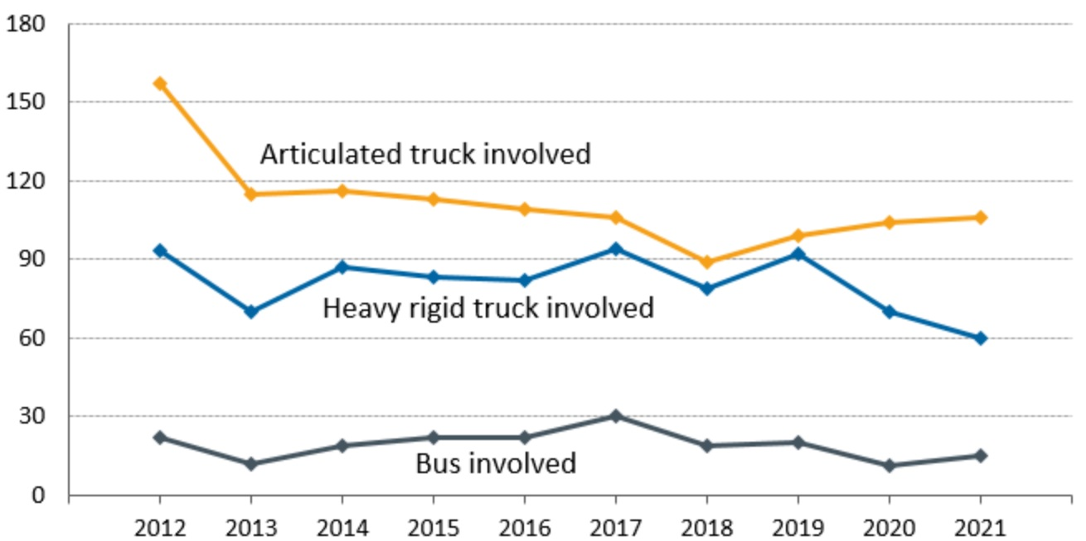
The overall social cost to the Australian economy of road crashes is estimated to be $30 billion annually, and heavy vehicles contribute around $1.5 billion of this cost. This cost is broadly borne by the community, business and government.
The regulatory settings for heavy vehicle operations need to support ongoing improvements in public safety outcomes.

Heavy vehicles contribute to the Australian economy and productivity has stalled
The heavy vehicle industry significantly contributes to the national economy. According to the Productivity Commission (2020, p 178) transport, postal and warehousing represented 4.5 per cent of GDP and 5.1 per cent of total employment in 2018-19, and this contribution is higher when in-house transport activity by businesses outside the transport industry (for example, agriculture and construction) is included. Road transport (including heavy vehicles) represents half of the transport sector’s output.
Expected growth in heavy vehicle productivity will impact the number of vehicles and drivers required to meet the future freight task, and ultimately affect the cost of goods transported by road freight. The National Freight and Supply Chain Strategy reports that a 1 per cent improvement in supply chain productivity (including all modes) could generate $8-20 billion in savings to the Australian economy over 20 years.
As reported by BITRE (2011), over the period from 1971 to 2007 the average productivity of rigid and articulated trucks was an almost six-fold increase. It concluded that the principal factors that contributed to increased heavy vehicle productivity over this period include:
- The introduction of, and expanded network access for, larger heavy vehicle combinations, particularly B-double articulated trucks (which gained more widespread access to the network in the 1990s).
- Progressive increases in regulated heavy vehicle mass and dimension limits.
- Strong growth in long-distance freight.
- Cumulative long-term investment in major road infrastructure, particularly the realignment and duplication of parts of the inter-capital national highway network.
However, freight productivity and costs have plateaued overall in more recent years for the freight sector. Real interstate freight rates for road fell by 31 per cent from 1978 to 1998, and marginally increased by 5 per cent in the period from 1998 to 2018.
For the passenger task, the contribution of buses has been significant since the early 1980s. In 2013-14, the national domestic passenger transport task totalled 427 billion passenger kilometres, of which road accounted for almost 80 per cent and rail just under 4 per cent. Passenger growth for buses in urban areas has been steady, though the sector has been substantially impacted by COVID-19. In urban areas, buses support the urban passenger task and therefore contribute to reducing road congestion. Avoidable road congestion in Australia’s cities cost an estimated $24 billion in 2018-19, and unless countered, is expected to grow an estimated 45 per cent by 2029-30. The bus industry reports that the coach sector, which comprises long distance, rural, tour, charter and express bus operators, moves more than 1.5 million domestic travellers and contributes over $5 billion dollars to the Australian economy.
The Productivity Commission pointed out that a key driver of productivity relates to decisions of operators in the industry and the regulatory environment:
“The regulatory environment influences the productivity outlook, affecting the cost structure of operators, how markets operate, and the degree of innovation by operators. The design of regulation and practices by regulators can affect productivity…[I]f operators can meet regulatory safety outcomes in a flexible rather than prescriptive way, this can provide avenues for innovation and productivity while maintaining or improving safety. The costs of operators complying with regulation and administrative costs of operators also affect productivity…” (p 178)
Many factors will affect productivity in the transport sector over time, including technological change, innovation, competition, design of regulation and behaviour of regulators.

Need for government action

Justification for regulation remains unchanged
The consultation RIS explored the rationale for the law, which is that governments have a responsibility to attempt to protect road users in the community. By virtue of their size, heavy vehicles are disproportionately involved in casualty crashes and these crashes tend to be more severe, as outlined in the previous section. Regardless of improvements in safety outcomes over recent years, there remains significant scope to reduce the number of deaths and serious injuries associated with heavy vehicle operations.
As pointed out in the Productivity Commission’s review into national transport regulatory reform (2020):
Transport activities involve inherent risks to safety. Governments have a role in encouraging and informing safe practices as well as ensuring that safety standards are not compromised by commercial pressures. At the same time, regulation should achieve safety objectives while minimising compliance costs and barriers to innovation, the latter being key to productivity growth and improved living standards. P.3
Self-regulation of heavy vehicle activities is not considered to be an acceptable alternative to government regulation. In most cases the use of heavy vehicles is commercially motivated. Industry competition is significant in the road freight sector in particular. Together these factors provide an incentive for some operators to ‘cheat’ by sacrificing safety standards or compliance with regulations for a competitive edge. Government regulation establishes a base level of safety and through this a ‘level playing field’ for industry.
The business practices and decisions of heavy vehicle operators, drivers and others within the industry affect the safety of heavy vehicle operations on Australian roads. The behaviour and practices of these parties affects the risk of crashes and breakdowns involving heavy vehicles, which can be costly not only for those directly affected but also wider society.
Heavy vehicle crashes create externalities. An externality is a cost (or benefit) that affects a third party who was not involved in the action or activity. In the case of heavy vehicle crashes, operators, drivers and others within the industry do not bear the full social costs of crashes that result from any action or lack of action on their part. Examples of costs related to crashes include:
- cost on drivers, other road users and their families associated with death, rehabilitation or loss of income
- cost on operators associated with any losses of capital stock, lost working hours or lost productivity
- indirect cost on operators associated with any lost customer confidence in the reliability of heavy vehicles and hence reduced volume and revenues
- cost on customers associated with any resulting delays and lost freight
- costs for other road users from resulting delays to their journey
- cost for society more broadly from environmental and infrastructure damage and clean-up, death and injury of members of the public, and costs to the health system.
These externalities mean that some individual heavy vehicle operators and drivers may not sufficiently invest in mitigating road safety risks if they only consider direct costs. This creates a risk that without government involvement, the industry may not deliver public safety outcomes that would be beneficial to society.
This is the prima facie case for regulatory intervention in the form of the HVNL. As a result, the HVNL exists as a national scheme for facilitating and regulating the use of heavy vehicles on roads in a way that, among other things, focuses on ensuring that heavy vehicles and their drivers are safe, and that they are operating on suitable routes to minimise public risks.

Assessment and analysis process
Key points
- This regulation impact statement (RIS) uses a multi-criteria analysis to assess the cost and benefits of each policy recommendation intended to form a cohesive package of reforms proposed for the future HVNL regulatory framework.
- The multi-criteria analysis is primarily qualitative because there is a lack of relevant quantitative information, and the proposals are mostly enabling reforms that do not have a direct regulatory impact.
- The multi-criteria analysis uses six impact categories that drive impacts (costs and benefits) of the policy recommendations compared with the current HVNL (base case):
- public safety
- improvements to operational efficiency or productivity
- regulatory burden for industry
- regulatory costs for government
- asset management
- flexibility and responsiveness.
- If the package of policy reforms in this RIS is endorsed, it is intended that future work will focus on detailed policy design and changes to regulations and other subordinate instruments. It is expected that further consultation and regulatory impact assessments will be required.
This chapter details the approach taken in presenting policy recommendations and the methodology for assessing their impacts.

A package of reforms for the future HVNL regulatory framework
In August 2022 the Kanofski Report provided infrastructure and transport ministers with a package of reforms that has been tested extensively with government and industry stakeholders through the HNVL Review and Mr Kanofski and that has broad support. Ministers agreed ‘to progress a package of propositions recommended by Mr Kanofski that will improve safety and productivity in the heavy vehicle sector’.
The Kanofski Report emphasises the need for these reforms to be considered as a cohesive package ‘to allow the reform to move forward maximising the goodwill and momentum that has been built through consultation.’
In keeping with the recommendations presented to ministers, this RIS does not consider a range of alternative options as would normally be the case in a RIS. This RIS instead looks to assess the impact of implementing the enabling policies identified, which have the broad support of stakeholders. It is considered that this process is the most likely to succeed and will set the foundations for further reform while reducing the likelihood of jurisdictions derogating from the future HVNL.
Chapter 5 of this RIS contains analysis of the proposed path forward for the HVNL through 24 policy proposals. Similar to the consultation RIS, these proposals are categorised into themes and detail specific changes to the law along with impact analyses.
Each recommendation within the proposed reform package has been subjected to regulatory impact analysis using the assessment methodology detailed below. If endorsed by ministers following consideration of this RIS, these policies will form the foundations of the future HVNL.

Recommendation assessment methodology
Each policy recommendation has been subjected to regulatory impact analysis using a standardised template. The template prompts the following considerations for each policy proposal:
- What is proposed?
Explains the nature of the recommendation.
- What are the objectives?
Outlines how the recommendation will improve the HVNL and resolve issues identified in the problem statement detailed in chapter 3.
- How will the law change?
Comparison of the base case (that is, current law) and what is proposed for the future law.
- What are the impacts?
Consideration of the impacts of the recommendation using the impact assessment methodology which is described in more detail in section 4.3.
- Implementation, transition and evaluation arrangements
Lists any specific implementation or transition arrangements being proposed to accompany the recommendation. Outlines how and when the success of the proposal will be measured and what metrics need to be captured to gauge success.

Impact assessment methodology
The steps involved in developing the impact assessment approach were:
- Choosing an assessment approach (multi-criteria analysis).
- Identifying key impact categories and assessment criteria.
- Identifying individuals or groups who are likely to be affected by the reform options.
- Assessing options.

Choosing an assessment approach
A cost-benefit analysis is the preferred impact analysis framework of the Office of Impact Analysis (OIA). Where possible, it requires the impacts (benefits and costs) to be expressed in monetary terms.
The consultation RIS provided a preliminary assessment of the costs and benefits of individual policy reform options under key topic areas using a qualitative cost-benefit analysis (see Appendix A of the consultation RIS for details on the approach). As noted in the consultation RIS, many impacts cannot be quantified, for example:
- Safety, infrastructure, and overall crash risk reduction benefits are challenging to value. There is data available on the costs of road crashes and estimates of the costs of road crashes involving heavy vehicles (see problem statement, chapter 3). However, there is limited understanding and certainty around the extent to which different risk management approaches might contribute to the likelihood of a crash, and the extent to which different regulatory options may reduce this risk.
- Impacts on innovation or operational efficiency are also difficult to measure. It is challenging to assess the benefits forgone if a regulatory policy delays or reduces innovation.
- The Productivity Commission review investigated the impact of national regulation reforms on safety outcomes in the transport sector, including heavy vehicles, and concluded:
it has not been possible to separate the effect of the national laws from other factors such as the introduction of safer technology or improvements in infrastructure. Some policy changes are expected to contribute to longer term improvements in risk management, their benefits might not yet be apparent but could emerge over time. (2020:p 9).
The main challenge with a cost-benefit analysis approach for this RIS is that most policy proposals being assessed in this RIS are enabling reforms that will not have a direct regulatory impact. These reforms do enable future changes in the regulatory environment that would be assessable using a cost-benefit analysis. The future changes would need to be tested via a separate regulatory impact process.
For this RIS, the NTC has therefore used a multi-criteria impact analysis approach to assess proposed changes to the HVNL. This approach is commonly used where full monetisation of costs and benefits is not appropriate or possible, consistent with OIA’s cost-benefit analysis guidelines.

Impact categories and assessment criteria
This RIS uses key impact categories and associated assessment criteria (outlined in Table 2) to identify and compare the costs and benefits of each of the recommended reform options against a base case. This allows for a qualitative comparison of the relative effectiveness of the policy proposal option (modifying the HVNL) and the ‘maintain status quo’ option (the current HVNL). The analysis is incremental in that it tries to identify additional costs and benefits against the base case.
The NTC selected six impact categories for multi-criteria analysis, modelled on the consultation RIS, with modifications to ensure all necessary impacts are appropriately considered. These six impact categories were selected for the following reasons:
- Public safety – having safe heavy vehicles on Australian roads is a fundamental accepted standard under existing regulation and will continue to be under any new heavy vehicle regulatory regime.
- Productivity and efficiency – the performance of the freight supply chain operating on Australian roads and the movement of people in buses and coaches is critical to Australia’s future economic success and competitiveness.
- Regulatory burden to industry – a new regulatory framework has the potential to create additional administrative burden on the heavy vehicle industry. If the costs are too high, there may be detrimental effects to the sustainability of heavy vehicle businesses.
- Regulatory costs to government – a new regulatory framework will have some upfront and ongoing costs to government; these costs need to be proportionate to the benefits.
- Asset management – road infrastructure has large investment and maintenance costs, and road networks support safe and efficient movement of people and goods.
- Flexibility and responsiveness – the heavy vehicle industry is operating in a dynamic environment with rapid advances in technology and business practices. Any modern regulatory framework needs to be sufficiently flexible to adapt to realise opportunities.
The assessment is carried out at a national level. The costs and benefits will be broadly similar across different states and territories. The specific costs and benefits in each state or territory will depend in part on the nature of the heavy vehicle fleet and its use in each state or territory.

- Impact categories and assessment criteria
Decision RIS impact category | Assessment criteria
1. Public safety | - Ensures responsibility sits with the party best able to manage the risk.  - Addresses emergent safety risks that may not have been specifically identified or considered.  - Enables the introduction of targeted compliance and enforcement options, including sanctions and penalties for non-compliance.  - Provides community assurance that heavy vehicle safety risks have been comprehensively addressed.  - Supports industry to develop and invest in safer technology and safer management practices.
2. Improvements to operational efficiency or productivity | - Supports uptake of newer and more efficient heavy vehicles in the fleet.  - Supports efficient heavy vehicle access decision-making.  - Enables more efficient scheduling and other business practices.  - Enables industry to develop and deploy innovative technology and practices to lower costs.
3. Regulatory burden for industry | - Results in low upfront and ongoing compliance, administrative and delay costs.  - Provides clear and consistent regulatory expectations to industry about its responsibilities and what is required to comply.  - Supports an approach that is consistent across all jurisdictions.
4. Regulatory costs for government | - Minimises upfront structural, organisational and regulatory change to implement the model, including a minimal impact on existing processes and minimal regulatory layers.  - Supports efficient ongoing administrative and operational processes.  - Clearly defines the roles and responsibilities of states, territories, local governments and the Australian government for regulating heavy vehicles.
5. Asset management | - Ensures the impact on road infrastructure – including bridges, other structures and pavements – is sustainable and services the needs of all road users, including all general access and restricted access heavy vehicles.  - Minimises the impact on community amenity.
6. Flexibility and responsiveness | - Allows flexibility for industry by focusing on safety outcomes, minimising prescriptive requirements.  - Legislation should be technology-neutral and able to recognise innovative solutions.  - Allows flexibility for government in addressing emerging safety risks.  - Reflects and supports the diversity of the heavy vehicle industry across different freight tasks, geographical areas, and scale and type of operations.  - Legislative structure can keep pace with advances in technology and other changes in context, business operating models and risk management methodologies.

Individuals and groups likely to be affected
To assess the costs and benefits of the reform options it is important to identify the individuals and groups affected by the reform. Table 3 outlines the key groups and individuals that are most likely to be affected by the reform options.
- Groups likely to be affected
Decision RIS impact category | Group Impacted
Public safety | - Heavy vehicle drivers and other road users (who may be killed or injured), including vulnerable road users such as cyclists, motorcyclists and pedestrians  - Chain of responsibility parties  - General public (through wider costs of crashes)  - Public and private providers of transport, emergency response, health, infrastructure and insurance services (secondary beneficiaries)  - Enforcement agencies, including police and the National Heavy Vehicle Regulator (NHVR)
Improvements to operational efficiency and productivity | - Heavy vehicle drivers, operators and businesses  - Off-road chain of responsibility parties (reduced costs of moving goods)  - General public (through reduced costs of moving goods)
Regulatory burden to industry | - Heavy vehicle drivers, operators, and businesses  - Off-road chain of responsibility parties
Regulatory costs to government | - Australian government  - State and territory governments  - Local government  - Enforcement agencies, including police and the NHVR
Asset management | - State and territory governments  - Local governments and other road managers  - Heavy vehicle operators, drivers and businesses  - the Australian community
Flexibility and responsiveness | - Heavy vehicle drivers, operators, businesses  - Off-road chain of responsibility parties  - Vehicle suppliers  - Vehicle safety (and other) technology suppliers  - State and territory governments  - NHVR

Assessing the options
A comparative analysis scale to assign each policy recommendation against each impact category has been developed. Table 4 shows the scale used to indicate the option’s comparative advantage or disadvantage compared with the baseline (current HVNL).
Where recommendations are ‘enabling’ without a direct regulatory impact, for the purpose of analysis this RIS assumes that existing base case policy settings will be maintained.
The assessment of the policy recommendations is set out in chapter 5.
A broad overview of the individual and the combined impacts of the policy recommendations is also discussed in chapter 5.

- Impact categorisations
Significant negative impact | Negative impact | Neutral | Improvement | Large improvement
The option would most likely result in a large decline compared with the baseline option | The option would most likely result in some (limited or moderate) decline compared with the baseline option | The option would most likely have a negligible impact compared with the baseline option | The option would most likely result in some (limited or moderate) improvement compared with the baseline option | The option would most likely result in a large improvement compared with the baseline option

Assessment of reform options for the future HVNL regulatory framework
Key points
- The regulatory impact assessments contained in this chapter detail the foundational changes to the HVNL that are being proposed by the NTC and provide the evidence to support their implementation.
- This chapter also details deliberations in each policy area and alternatives which were considered through the consultation regulation impact statement (RIS) and subsequent consultation processes.
- Recommendations assessed in this chapter are designed to deliver:
- a modern regulatory framework
- an improved National Heavy Vehicle Accreditation Scheme (NHVAS) as part of a tiered assurance environment
- a technology and data framework
- an expanded driver duty.
- If endorsed, the recommendations in this chapter will set in place the right foundations for an improved HVNL.

Summary
The HVNL Review and subsequent consultation processes identified changes to the foundations of the HVNL that the Infrastructure and Transport Ministers’ Meeting (ITMM) has agreed to progress. This chapter assesses supported policies that are intended to underpin a significantly improved HVNL to ensure that there will be no significant adverse impacts and that the expected benefits can be delivered. The policies being assessed have been identified for their potential to improve the HVNL and enable the National Heavy Vehicle Regulator (NHVR) to administer ongoing improvements to the regulatory framework.
While the policies assessed in this chapter propose significant changes to the structure and mechanics of the HVNL, the enabling nature of many of these proposals means that the direct impacts are expected to be minimal. If endorsed for inclusion in the future HVNL, the recommendations in this chapter will set in place the right foundations for an improved HVNL that can accommodate future changes to regulatory framework.
Section 5.2, Regulatory framework, assesses the impacts of restructuring obligations in the HVNL to support industry in developing safer, more efficient business practices and to have those practices recognised as an alternative to compliance with prescriptive requirements. This will enable the HVNL to better support a diverse road freight industry and encourage ongoing improvements in industry practice.
The policy changes being considered in section 5.2 focus on addressing problem 1 (‘a better balance between prescriptive and more flexible obligations is required to support a highly diverse heavy vehicle industry that seeks both flexibility and certainty in complying with both the intent and word of the law’) and problem 2 (‘the HVNL is unresponsive to changes in the operating environment’).
To complement changes to the structure of HVNL obligations, section 5.3, Assurance and accreditation, assesses changes to enhance the NHVAS and embed a safety management system (SMS) approach. Under the proposed changes, NHVAS will continue to be a voluntary scheme managed by the NHVR, however the proposed structural changes will increase the flexibility of the scheme and make it simpler for the NHVR to offer a broader range of accreditation options that will, in turn, enable access to more flexible alternative compliance options (ACOs).
The policy changes being assessed in section 5.3 are focused on resolving HVNL problem 3 (‘the alternative compliance options (ACOs) available under the NHVAS are too heavily constrained by legislation).
In recognising the role of technology in ensuring safety and increasing productivity, section 5.4, Technology and data, assesses the impact of establishing a new technology and data framework within the HVNL. The recommendations being assessed aim to improve the responsiveness of the HVNL by formalising a process for certifying technologies and data-sharing schemes and having them recognised within the regulatory framework.
The policy changes being assessed in section 5.4 are focused on resolving HVNL problem 4 (‘the HVNL does not provide a clear pathway for recognising modern technologies and does not provide adequate provisions for data sharing’).
In response to stakeholder feedback that the clarity of duties within the HVNL could be improved, section 5.5, Primary duties and responsibility, considers the impact of a modest amendment to the driver duty to make it clear that drivers should not drive if unfit for the task. The policy change being assessed in section 5.5 is focused on resolving HVNL problem 5 (‘regulatory tools and powers in the HVNL are in some instances outdated, inflexible or unnecessarily constrained’).
In total, this chapter assesses 17 complementary policy recommendations which are intended to deliver a more efficient, collaborative, and risk-based regulatory regime.

Overall impact assessment summary
Table 5 contains summary assessments of the overall impact of each recommendation undertaken using in the methodology outlined in chapter 4. Each recommendation is considered in greater detail and analysed against each of the chapter 4 impact criteria within the subsequent sections of chapter 5.
The summary shows that all recommendations considered in the RIS will result in overall improvements to the regulatory framework.

- Overall impact assessment summary
RECOMMENDATION | OVERALL IMPACT
Regulatory framework
1 – Tiered safety assurance environment  That the future HVNL establish a tiered safety assurance environment comprising a baseline tier and an alternate compliance tier, designed to reflect industry diversity and deliver regulatory flexibility.  1a – Baseline compliance tier 1  That as part of the tiered safety assurance environment, the future HVNL establish a baseline tier comprised of simplified, predominantly prescriptive requirements, given effect by a broad head of power for the prescribing of heavy vehicle obligations.  1b – Alternative compliance tier 2  That, as part of the tiered safety assurance environment, the future HVNL establish an alternative compliance tier for accredited operators, underpinned by a new power allowing the regulator to issue alternative compliance options, within prescribed outer limits and other specified constraints. | Improvement  The tiered assurance environment will create greater flexibility for industry and will provide improvements to safety and productivity to benefit the community.  The regulatory regime will be better able to keep pace with advances in technologies and practices, which benefits the heavy vehicle industry, vehicle and safety technology suppliers, and the regulator and governments.  For tier 1, there are negligible impacts for industry and government as changes are structural.  For tier 2, operators will have greater choice on how to manage compliance obligations to realise productivity and gains. There will be start-up costs for accredited operators who don’t have a NHVAS-compliant SMS, and for the NHVR to administer a more complex, bespoke scheme (see recommendation 7).  Note: Based on the assumption that the NHVR uses the new regulatory framework to deliver more diverse ACOs, otherwise the impacts will be negligible.
2 – Ministerial approvals  That, as part of establishing an appropriate balance of regulatory discretion and ministerial oversight, the future law establish new arrangements for ministerial approvals, such that:  2a In recognition of restructured arrangements for alternative compliance and accreditation, ministers will no longer be required to approve accreditation business rules.  2b As part of enhancements to accreditation, ministers will be empowered to approve a national audit standard to be applied as part of the National Heavy Vehicle Accreditation Scheme, as well as other schemes and third parties. A national audit standard audit certificate will be automatically admissible evidence in primary duty proceedings.  2c The law clarify that consultation requirements apply to the development of ministerially approved guidelines.  2d Ministers will no longer be required to approve a sleeper berth standard, noting this may be prescribed as a heavy vehicle obligation in the future. | Improvement  Enabling mechanisms to support risk-based regulation and the new assurance environment by improving regulator autonomy and discretion and more targeted ministerial oversight and direction.  Note: Does not set out any substantive proposals and may be characterised as having no direct regulatory impact, but benefits may occur over time.
3 – Ministerial directions  To enable ministers to appropriately direct the regulator, and without impinging on regulatory autonomy, the future law establish new ministerial direction arrangements, such that:  3a Ministers (collectively) will be empowered to give written directions about the issuing of alternative compliance options.  3b Ministers (individually or collectively) may direct the regulator to exercise a certain function or power in the case of a serious public risk, and when in the public interest to do so.  3c Ministers (individually or collectively) may direct the regulator to investigate or provide advice or information about a matter relating to a public risk.  3d Ministers (collectively) may direct the regulator to cancel a code of practice.  3e Ministers will retain the existing power (collectively) to direct the regulator about policies to be applied. | Neutral  The expanded Ministerial direction powers will serve to provide assurances to Ministers and the community that the regulator will exercise its functions within the parameters of Ministers’ risk appetite.  Does not set out any substantive proposals and may be characterised as having no direct regulatory impact.
4 – Codes of practice  That the future law establish new arrangements for codes of practice, replacing the existing industry code of practice mechanism and allowing the regulator to initiate, develop and approve codes of practice. | Improvement  Guidance to drivers and chain of responsibility parties through CoPs can be provided more efficiently and effectively. This is expected to lead to improved compliance and safer behaviour, helping to reduce crashes.  Note: Analysis assumes that the regulator implements effective CoPs, otherwise impact may be negligible.
5 – Improvement notices  That the future law revise arrangements for improvement notices to allow improvement notice and prosecution processes to run concurrently. | Improvement  More proportionate regulatory interventions lead to improved safety and productivity outcomes.
Assurance and accreditation
6a That as part of the new alternative compliance tier (recommendation 1b), the future law restructure the National Heavy Vehicle Accreditation Scheme so that accredited operators can apply for an expandable range of alternative compliance options – either on a bespoke basis or as part of accreditation modules developed by the regulator, within the ministerially approved limits.  6b That the law ensures a three-year transition period for current NHVAS operators to provide operators adequate time for them to develop the necessary safety management system to qualify for the enhanced scheme. | Improvement  The expanded range of ACOs is expected to improve flexibility and responsiveness and contribute to safety and operational efficiency outcomes.  A three-year transition period is proposed to assist existing NHVAS operators and the regulator by allowing time to cover potential costs, particularly for operators to set up an SMS, auditors and external assistance, and for regulator resourcing.
7 That, as a fundamental enhancement to the scheme, the law establishes a scalable safety management system as a core accreditation requirement. | Improvement  Safety benefits across the industry from greater focus on SMS and safety culture are difficult to quantify but are expected to have a positive impact over time that will outweigh the initial upfront costs.  Based on survey data, at least 65% of all operators have a basic SMS. Average estimated SMS start-up costs to accredited operators (around 8,400 in the current scheme, or 3.16% of the total heavy vehicle industry) per operator:  - Small operators $5,000 to $10,000  - Medium operators $6,200 to $15,000  - Large operators $6,400 to $25,000.  The average NHVAS participant setup cost is $5,800.  Note: There are challenges in determining a cost-benefit analysis for an SMS as an SMS creates immediate, direct and ongoing costs, while benefits are mostly intangible, difficult to quantify and emerge over time (for example, improved safety culture, effective regulatory compliance, public confidence).
8 That, to support mutual alignment pathways and scheme robustness, a national audit standard be developed by the regulator and approved by ministers. | Improvement  More robust auditing standards may improve community confidence in heavy vehicle regulation, leading to safety improvements.  Industry may gain productivity benefits from the potential to drive down requirements for multiple audits from customers and across schemes.  These benefits are expected to outweigh the costs to the regulator to establish the new audit standard.
Technology and data framework
9. That the future HVNL enables technologies to be recognised under the HVNL by establishing a technology and data framework that includes powers, functions, duties and obligations for specified roles in the framework, and appropriate rules in relation to technologies recognised under the HVNL for data protection, stewardship and assurance, and access and use. | Improvement  The framework will create greater flexibility for industry and the regulator and will provide improvements to safety and productivity to benefit the community.  The regulatory regime set up by the law will be able to accommodate and respond to advances in technologies and practices, which benefits the heavy vehicle industry, vehicle and safety technology suppliers, the regulator and governments.  Note: Assumes that the framework is enlivened and implemented as per the policy intent. Direct impacts are difficult to quantify and are dependent on the efficacy of the framework in practice.
10 That the technology and data framework will include the role, powers and functions of a framework administrator and include provisions for ministers to appoint one or more framework administrators. | Neutral  Governance arrangements are essential for reforms but will not in themselves have a direct impact.
11 That the future HVNL enables the creation of data and technology applications by a framework administrator to outline the technical, data sharing, assurance and governance requirements for technologies recognised by the HVNL in line with ministerial requirements. | Neutral  Enabling mechanism. The benefits of data and technology applications will be specific to the forms of technology they enable.
12 That the future HVNL prohibits the access and use of data produced by recognised technologies under the HVNL (other than by its owner), except as allowed by the HVNL and regulations, other applicable Acts, and as specified in the relevant data and technology application. | Neutral  Reinforces data restrictions and protections.
13 That the future HVNL ensures that a person can present to a court data from a non-certified application as evidence of complying with the HVNL and it will be up to the court to decide what weight to place on that evidence. | Neutral  Reinforces existing arrangements.
Primary duties and responsibility
14 That the future law expands the driver duty not to drive while fatigued to also include not driving if unfit for other reasons. | Improvement  Benefits due to increased public safety.

Regulatory framework

Overview
This section of the RIS sets out policy recommendations designed to deliver a modern regulatory framework that will make the law more:
- responsive to new and emerging risks
- adaptive to a diverse and rapidly evolving heavy vehicle transport sector.
The policy recommendations in this chapter have also been designed to achieve a simpler and more coherent regulatory framework that is easier for parties to understand. This should, in turn, improve rates of compliance and reduce risks to safety. As discussed in chapter 3, the HVNL is a long and prescriptive law, with detailed obligations for regulated parties specified in the primary legislation. This leads to a ‘one-size-fits-all’ approach to regulation that fails to recognise the diverse purposes of heavy vehicle transport, the risks associated with different geographical areas, and types of operating risk.
While the law offers a limited range of alternative compliance options for operators accredited under the NHVAS, the regulatory environment underpinning this scheme is such that most ACOs are hardwired into the law or regulation.
This environment constrains the ability of the NHVR to encourage operators to invest and find new, better and more efficient ways of addressing safety risks.
This environment also fails to realise the benefits of encouraging operators to become accredited. It fails to set in place mechanisms that incentivise innovation and investment in advanced safety technology.
Other factors also constrain the regulator’s ability to tailor and adapt its approach to reflect a rapidly evolving environment. Unlike other regulatory settings that employ a more performance-based approach, the regulator is unable to support compliance with regulatory tools such as codes of practice. Existing arrangements around the use of business rules and improvement notices also impede the regulator’s ability to respond to instances and trends of noncompliance in a way that is tailored to severity and certain behavioural drivers.
Throughout the HVNL Review and subsequent processes, several changes to the regulatory framework were considered to deliver a law that:
- Reflects a diverse and modernising heavy vehicle sector (for example, through establishing a multi-tiered safety assurance environment with a greater range of ACOs).
- Sets an appropriate balance of regulatory discretion and ministerial oversight
- Supplies tools and powers for a modern and mature regulator to deliver an adaptive and risk-based approach to regulation.
The HVNL Review identified that to achieve these improvements, changes to the structure and mechanics of the HVNL are required. These changes involve new regulatory powers, tools and instruments that will fundamentally redesign the HVNL to better align with other performance-based frameworks. These changes do not involve substantive proposals to change duties and obligations on parties. Rather, the policy recommendations in this chapter will create an enabling environment whereby changes to duties and obligations will be facilitated more responsively in the future.

Policy deliberations
During the HVNL Review, the NTC undertook detailed analysis of the current HVNL regulatory framework to identify deficiencies and consult on potential solutions. As discussed in section 1.3.2, the NTC produced a series of issues papers framed around risk-based regulation. The first tranche of issues papers covered what should be regulated by the HVNL. The second tranche of issues papers covered how the HVNL should regulate and increase compliance, covering assurance models and effective enforcement.
In relation to potential regulatory frameworks for the future HVNL, the Assurance models issues paper canvassed and sought feedback of a range of options, including:
- a vertically integrated model that is similar to the current NHVAS
- a market for regulatory certification
- a market for accreditation
- a performance rules model whereby accreditation and certification are removed from the law.
In relation to the use of regulatory tools under the future HVNL, the Effective enforcement issues paper highlighted the importance of ensuring the future law is both easy to understand and straightforward to comply with. It also discussed the importance of the use of sanctions and enforcement tools in a way that is proportionate to the severity of risk.
Following the issues paper phase, the NTC convened a number of combined industry and government stakeholder workshops focused on specific policy options for the future HVNL regulatory framework and regulatory tools. These included:
- a two-tier model with strictly prescriptive or performance-based options
- a three-level regulatory structure, including a co-regulatory tier for more sophisticated operators
- compulsory safety management system (SMS) requirements
- a work health and safety-style code of practice mechanism
- empowering the regulator to develop regulatory standards.
Following this process, and based upon stakeholder feedback, the NTC developed a set of options to be formally tabled in a consultation RIS. Jurisdictions were also closely involved in identifying options suitable for inclusion in the consultation RIS.
Chapter 5 of the consultation RIS tabled four options for improving regulatory tools under the HVNL:
- Option 5.1: Establish a CoP mechanism in the HVNL. This option centred on a change to the HVNL that would allow CoPs to be developed by the NHVR and approved by ministers. This option was designed to replace existing industry-led CoP arrangements under the current HVNL and replicate the way CoPs are developed and approved under model WHS laws and also the Rail Safety National Law. Under this proposal CoPs would serve as part of a more streamlined regulatory environment to provide clarity to parties on how to comply with duties under the HVNL. This option proposed that CoPs would not be mandatory, noting that non-mandatory CoPs nonetheless set minimum expectations of practice and are relevant to an assessment of how duties are met under the law.
The option of replacing the existing industry CoP mechanism with a revised CoP arrangement was broadly supported. Further consultation led by Ken Kanofski resulted in further changes to the detail of this proposal, particularly in relation to oversight and approval arrangements (discussed in greater detail at recommendation 4).
- Option 5.1: Establish a safety standards mechanism in the HVNL. This option proposed that the HVNL establish a power to develop, vary and revoke safety standards which would prescribe rules for how to comply with duties under the primary law. This proposal was modelled on similar powers held by other transport safety regulators, such as the Civil Aviation Services Authority.
This option was generally not supported, particularly by industry parties citing concerns around potential proliferation of red tape and increasingly prescriptive regulation.
- Option 5.3: Establishing a geographic ‘remote zone’: This option proposed establishing a remote zone, most likely through a geospatial instrument, to enable a more targeted risk-based approach to regulation to be developed for vehicles operating in these unique areas.
This option was generally not supported as it is considered that it would add significant complexity to the regulatory framework, particularly for vehicles operating between remote and non-remote zones.
- Option 5.4: Enable sharing of data with the NHVR. This option considered expanding the purpose for which information can be shared between the NHVR and agencies to any purpose associated with the regulation of heavy vehicles. While jurisdictions already share information with the NHVR for purposes wider than the NHVR administering the HVNL, this currently requires an information sharing or service agreement. This option will remove the need for such an agreement.
This option was not supported due to variations in privacy and data sharing legislation in in each jurisdiction and the complexity involved with applying a consistent approach through the HVNL.
Following the consultation RIS, further deliberation with industry parties, jurisdictions and the regulator highlighted the importance of ensuring the future HVNL is more flexible and adaptable. Much of this feedback related to issues originally canvassed in the first HVNL Review issues paper, A risk-based approach to regulating heavy vehicles. Stakeholders expressed a desire to see tangible options for ensuring the structure of the future HVNL will be responsive and able to support continuous improvement in safety in the rapidly changing and advancing industry.
To this end, the Kanofski Report, which contained a number of recommendations, was considered by infrastructure and transport ministers and became the ITMM reform package. Table 6 outlines the recommendations in that package that are relevant to developing the regulatory framework for the future law.
- Recommendations agreed to be progressed as part of the future HVNL regulatory framework
ITMM reference | ITMM reform package recommendation
1.5 | To the maximum extent possible, the new law should be outcome based while also allowing for a prescriptive approach.
1.6 | To the maximum extent possible, the new law should place detail into regulations and subordinate instruments as set out in several better regulation guidance documents
3.3 | Introduce a two-tiered fatigue management regime
5.2b | Recognising operator diversity, increase the flexibility for operators to meet compliance obligations to run their business now and into the future
5.2c | Reduce compliance costs for operators to achieve and demonstrate compliance, including reducing the need for multiple audits requested by customers to meet their chain of responsibility obligations
5.3b | More flexible and diverse alternative compliance. The regulatory framework supporting the improved NHVAS will also enable a greater range of ACOs, underpinned by Ministerial Directions. The framework should be scalable to support different levels of sophistication of operators. Operators with less sophisticated business operations who enter the scheme would be eligible for relatively small concessions and operators with more sophisticated operations would be eligible for highly flexible alternative compliance options.
5.3e | Reduce the reliance on audits by customers to meet their chain of responsibility obligations.
5.3f | National audit standard. A National Auditing Standard will be recognised in law as part of the scheme. The standard will be outcomes based, designed so that it can be adopted by other assurance schemes. The National Auditing Standard could also be used for non-certification audits intended to establish adherence/compliance with the primary duty. The law will also specify that a Court may consider an audit conducted under the Standard as part of determining whether the primary duty has been met.
7.1 | The future law should introduce a regulatory head of power for Heavy Vehicle Safety Obligations, which would be made as regulations and subject to parliamentary disallowance in Queensland Parliament. The law will describe the risks a HVSO may regulate and the parties to which a HVSO may apply. HVSOs would be developed by the NTC subject to Regulatory impact analysis process for Ministerial councils and national standard setting bodies.
7.2 | The law will set out a non-exhaustive list of risk areas to which an HVSO may apply. The non-exhaustive list will align with the agreed risks to be managed under the primary duty:  - Fatigue  - Fitness to drive  - Vehicle Standards and Roadworthiness  - Mass and Dimension  - Loading  - Speed  - Competence, and  - Any other risk to public safety.
7.3 | Existing prescriptive requirements in relation to fatigue, mass management and vehicle maintenance will be recast and simplified (where appropriate) as a HVSO.
7.4 | The new law will allow for the establishment of prescriptive requirements, for off-road parties (HVSOs). Any off-road party to whom a HVSO applied will need to be defined (in primary law or regulations). The law should enable Ministers to prescribe parties from time to time in regulation, subject to regulatory impact assessments. It is proposed to retain the current list of specific parties in the law, and to conduct regulatory impact assessments for new proposed parties.
7.5 | The law should have provisions to enable introducing specific offences for off-road chain of responsibility parties. More work needs to be done to develop specific offences.
9.3 | Detailed proposals on ITMM/non-ITMM decision making, covering codes of practice, business rules, application forms, ministerial guidelines, ministerial directions, and consultation requirements etc.

Future work
As discussed in chapter 3, the intent of the policy recommendations being assessed is to improve the HVNL to enable a more effective and flexible regulatory regime that can respond to the diverse and dynamic needs of the heavy vehicle industry. This section of the RIS canvasses policy options that can be regarded as foundational to the overall regulatory framework of the HVNL. These changes relate to enabling features and mechanisms of the law that may be described as having no direct regulatory impact. Once implemented, these enabling features of the law will create the pathway required for substantive regulatory change, particularly in the areas of fatigue and access. To be clear:
- Recommendations 1, 1a and 1b set out the legislative mechanics of the new tiered safety assurance environment. Recommendations 6, 7 and 8 also provide detail on key enhancements to the NHVAS, which is a fundamental pillar of the alternative compliance tier of the new tiered environment. This RIS does not, however, deal with specific obligations for baseline compliance operators, or ACOs for accredited operators. Some of these ACOs will represent a translation of existing requirements to the new framework (that is, no policy change), while any new or substantially modified ACOs will be developed further and assessed through subsequent RIS processes.
- Recommendation 2 sets out revised arrangements for ministerial approvals under the future law, including revised arrangements for accreditation business rules and standards, guidelines, and a new mechanism to enable approval of a national audit standard. This RIS does not consider the detail of accreditation standards or business rules or what guidelines should be developed. While recommendation 8 also provides further detail of the role of the NAS in the context of the NHVAS, this RIS does not assess a fully-developed NAS. These items will be considered for development during the subsequent RIS processes.
- Recommendation 3 sets out revised arrangements for ministerial directions. This includes an option to allow ministers to issue written directions about ACOs, and it is envisaged that a suite of ministerial directions may be developed for this purpose, ready for commencement of the future law. Nonetheless, this RIS does not consider any specific ministerial direction.
- Recommendation 4 sets out the legislative mechanics of revised arrangements for codes of practice. This RIS does not assess any specific CoP or propose what CoPs should be developed for commencement of the future HVNL. The development of specific CoPs will be the task of the regulator.
Noting the new regulatory framework involves many subsidiary instruments designed to support operation of the law, developing and finalising a suite of ministerial directions, ministerial guidelines, as well as the NAS, will be critical for implementation of the future HVNL.

Assessment of policy recommendations
Figure 2 provides a summary of the policy recommendations in this section of the RIS, and how they relate to specific outcomes, that in turn will address problems identified. Each policy recommendation is assessed individually, but together these recommendations are designed to establish a modern, outcomes-focused regulatory framework.
- Overview of regulatory framework recommendations for the future HVNL
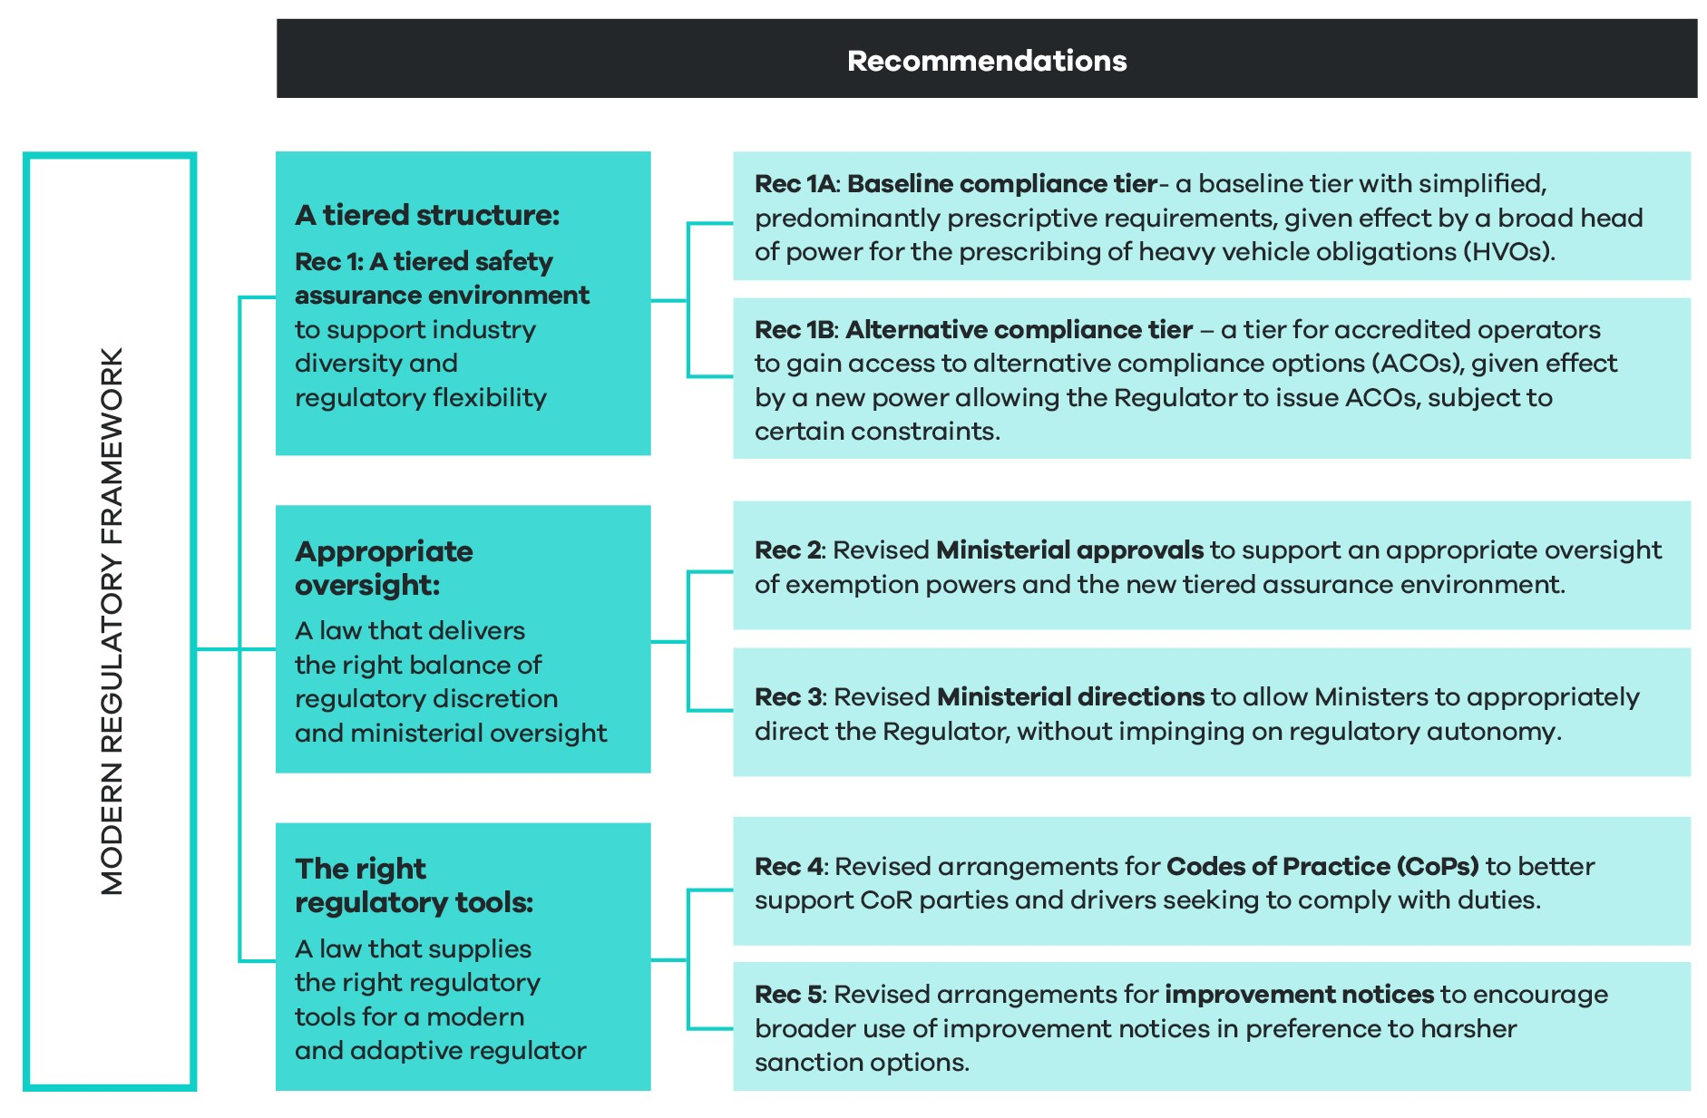
Links to other decision RIS recommendations
The recommendations in this chapter link together to provide an overarching regulatory framework for a modern and responsive law. All other sections of the RIS should be read against this framework, noting the following key links:
- Accreditation (section 5.3, recommendations 6 to 8): examines the detail of how an enhanced accreditation scheme will work under the future HVNL. This forms one critical feature of the tiered assurance environment covered under recommendations 1, 1a and 1b. These recommendations also cover the detail of how a new national audit standard will improve the robustness of the new accreditation scheme. This topic is also covered under recommendation 2, which explains the legislative mechanics of the NAS, including its legal impact and applicability beyond HVNL accreditation.
- Technology and data (section 5.4, recommendations 9 to 13): sets out arrangements for establishing a data and technology framework to enable technologies to be recognised under the HVNL. The framework interacts with the overarching regulatory framework by enabling recognition of new technologies in the context of baseline, prescriptive regulations, or as conditions or requirements for accreditation and alternative compliance.
- Duties (section 5.5, recommendation 14): proposes that the current duty on drivers to avoid driving while fatigued, be expanded to include fitness for work. In the context of the proposed regulatory framework, this duty constitutes an indispensable duty. It cannot be exempted or subject to an alternative compliance option, in any circumstances.
Recommendation 1 – Tiered safety assurance environment
That the future HVNL establish a tiered safety assurance environment comprising a baseline tier and an alternate compliance tier, designed to reflect industry diversity and deliver regulatory flexibility.
What is proposed?
- Overview of recommendation 1
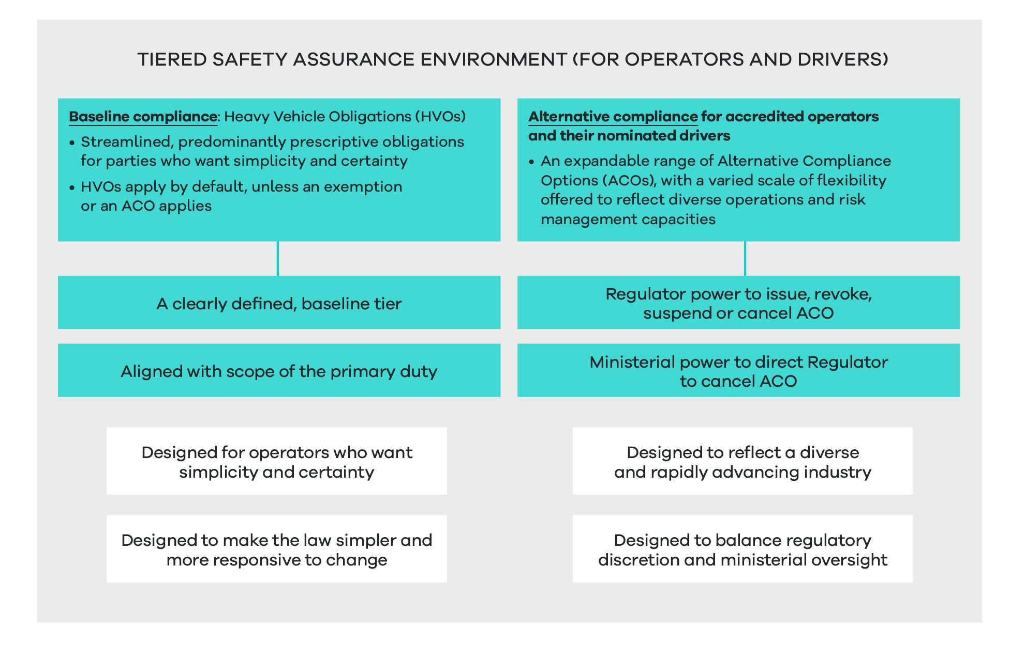
This recommendation has been designed to progress propositions 1.5, 1.6, 3.3, 5.2b, 5.3b, and 7.1 to 7.5 of the ITMM reform package (see Appendix A). Fundamentally, these propositions recommended a restructure of the law to enable a tiered safety assurance environment comprising:
- A baseline compliance tier (tier 1): a default tier with simplified, predominantly prescriptive requirements, mechanised by a broad head of power for the prescribing of heavy vehicle obligations (HVOs).
- An alternative compliance tier (tier 2): a tier for accredited operators to gain access to a diverse range of ACOs, mechanised by a new power allowing the regulator to issue ACOs, subject to certain constraints.
While the law already contains elements of a tiered approach to regulation, the future law will enable a more expansive alternative compliance environment to support a more diverse range of ACOs, with degrees of flexibility.
This section analyses impacts of the new tiered safety assurance environment holistically. Recommendations 1a) and 1b) then examine the detail of each tier and their impacts separately.
What are the objectives?
As discussed in chapter 3, the HVNL fails to:
- Provide a clear and coherent compliance regime for operators who prefer the simplicity and certainty of prescriptive regulation.
- Reflect and support industry diversity.
- Keep pace with changing technology and business practices, and emerging risks.
- Encourage parties to improve safety management and invest in more advanced safety management technology.
With these problems in mind, the proposed tiered safety assurance environment has been designed to:
- Establish a simple, clear and coherent baseline tier of predominantly prescriptive obligations for operators who prefer simplicity and certainty.
- More responsively enable the prescribing of requirements and obligations, as new risks to safety emerge.
- Support and recognise industry diversity, including the diverse range of:
- freight tasks
- geographical variances
- risk management capacities.
- Establish a more flexible accreditation scheme that:
- the regulator can adapt and expand in line with emerging risks, advancing technology and increasing sophistication of operators
- can encourage operators to take on increased risk management responsibility
- offers a diverse range of ACOs.
In recognising the new tiered environment will increase the discretion of the NHVR to develop and offer pathways for alternative compliance, the environment will also build in additional ministerial direction powers. The goal of these arrangements is to ensure that ministers are able to set a clear risk appetite for alternate compliance by specifying clear parameters for the regulator. Striking an appropriate balance of regulatory discretion and ministerial oversight is therefore a key objective of the proposal.
How will the law change?
Current law (the base case)
The law already contains some aspects of a tiered safety assurance environment in that it:
- Sets out a range of prescriptive, baseline requirements relating to:
- fatigue (standard work and rest hours, and record keeping requirements)
- mass and dimension (general mass limits and dimension requirements)
- vehicle standards.
- Establishes the NHVAS, which gives accredited operators some flexibility to operate out of prescribed regulations within the context of accreditation modules, as follows:
- NHVAS Mass Management: accredited operators are able to operate at above general mass limits.
- NHVAS Basic Fatigue Management (BFM) and Advanced Fatigue Management (AFM): accredited operators receive access to longer working hours and flexibility in scheduling.
- NHVAS Maintenance Management: accredited operators receive exemptions from annual inspection requirements, which can be resource intensive.
- Establishes the Performance Based Standards (PBS) Scheme, which provides exemptions from many prescriptive vehicle standard requirements.
To a large extent, ACOs are hardwired into the law and regulation. This is particularly the case for Mass Management and BFM which offer alternative schedules of prescriptive requirements.
Advanced Fatigue Management represents a more flexible approach, whereby the regulator is able to approve bespoke work and rest hour schedules. The process for gaining AFM accreditation is, however, cumbersome and resource intensive, and generally not available to smaller, simpler operators who may still be able to manage safety with the benefit of small adjustments to the general schedule.
The HVNL otherwise does not enable the regulator to expand and adapt ACOs for accredited operators, for example with fatigue regimes that would provide more varied levels of flexibility, either sitting between standard hours and BFM, or BFM and AFM.
Future law
The future law will be more explicit about establishing a tiered safety assurance environment.
In terms of establishing the baseline tier:
- Where possible, the law will be redrafted to ensure that prescriptive obligations are simpler and clearer for regulated parties to understand.
- To the maximum extent possible, obligations and requirements will be prescribed in regulation, not the primary law, to make the law more responsive.
- To the maximum extent possible, the law will be able to prescribe new obligations and requirements relating to new and emerging risks.
In terms of establishing the alternative compliance tier:
- ACOs will no longer be hardwired into the law.
- A regulatory head of power (or equivalent mechanism) will allow the setting of outer limits and other relevant aspects of ACOs.
- The regulator will receive new powers to be able to create modules, apply conditions and issue ACOs.
- Ministerial direction powers will be expanded to reflect the new regulatory environment.
A step-by-step example of how this tiered environment will work in the context of fatigue is included later in this section.
What are the impacts?
An enabling environment
As already discussed, this recommendation is an ‘enabling reform’ that relates to the overall structure of the HVNL.
For example, while a new heavy vehicle obligation mechanism is proposed, this RIS does not propose any substantive changes to prescriptive obligations, or any new obligations. Rather, it proposes an environment that will enable more responsive changes to prescriptive requirements in the future.
Similarly, the proposal in this section outlines the legislative mechanisms for enabling a new diverse alternative compliance environment. Specific alternative compliance options are not considered in this RIS.
Potential impacts
In terms of assessing the impacts of the new tiered environment holistically, improvements can be projected across all assessment criteria when compared to the baseline option, particularly in the areas of safety, operational efficiency or productivity, and flexibility and responsiveness.
As highlighted below, some negative impacts may be projected in the categories of regulatory burden for industry and costs for government.
To a large extent, and owing to the enabling characteristics of this proposal, the new tiered assurance environment may deliver a neutral or negligible impact if the regulator does not utilise the new regulatory framework to deliver more diverse ACOs.
Potential improvements
Considering the new tiered safety assurance environment as a whole, a fundamental aim is to cater to a more diverse range of operators, ranging from simpler operators who want simplicity and certainty, through to highly sophisticated operators who can manage safety effectively with highly flexible options in place.
The terminology of a ‘tiered’ regulatory environment is used because it is familiar to industry and government agencies. However, this proposal may also be described as a sliding spectrum of options that reflects the highly varied landscape of operating models, transport tasks and levels of sophistication across the sector.
As discussed at recommendation 7 in section 5.3, the safety management system requirement for entry into the alternative compliance tier will be scalable so as to create an appropriate standard for entry and to allow smaller or less complex operators into the scheme. This will enable the regulator to offer modest ACOs to simpler operators who may still prefer predominantly prescriptive rules over more flexible performance-based options.
This new environment has potential to deliver productivity benefits to industry in a variety of ways:
- For smaller or less complex operations, the new regulatory environment will enable creating alternative compliance options for operators that would not receive access to ACOs under the base case. Although these operators will need to make an initial investment in a basic safety management system, these costs are able to be offset by the offer of modest ACOs that are nonetheless able to be implemented.
- For mid-tier operations, the new regulatory environment will enable a greater range of ACOs not previously catered for under the HVNL. For example, fatigue-related ACOs are limited to BFM and AFM. Many operators do not require the flexibility of a bespoke AFM schedule and therefore refrain from investing in AFM accreditation. BFM, however, is based upon a prescriptive work and rest hour schedule which, while more flexible than standard hours, may not be suitable for a range of mid-tier operators. The new environment will allow the regulator to develop a range of ‘mid-level’ ACOs that properly reflect the risk management capacities of mid-tier operators and the diversity of operations at this level of the sector.
- For sophisticated operators, the new regulatory environment will enable more flexible ACOs, subject to outer limits. While AFM currently enables the approval of bespoke work and rest hour schedules, this process can be administratively cumbersome and costly, partly because operators must invest in developing a safety case. Under the new regulatory environment, the regulator will be able to convert common AFM schedules into ACOs available to highly sophisticated operators. Here, the safety case can be embedded into the requirements of the ACO.
In summary, this more nuanced safety assurance environment should reduce the misalignment of risk-management methods to specific operating models, allowing operators to adopt the most effective safety management strategy for their business (assessment criteria 1e). If implemented effectively, this more flexible environment has the potential to increase the overall value of accreditation for operators, better incentivising uptake of accreditation by operators, thereby also increasing regulatory visibility of heavy vehicle operators and fleet. This can support the regulator’s risk profiling system and better enable the introduction of targeted compliance and enforcement options (assessment criteria 1c).
Potential negative impacts
A more diverse alternative compliance environment is also likely to make enforcement more complex, although it should be noted that there are existing problems around the interaction of enforcement officers and accredited operators. Currently, accredited operators report that some police officers, in particular, have a limited understanding of ACOs for fatigue available under the NHVAS. Complexities around the enforcement of bespoke AFM schedules are likely to continue under the new environment. Nonetheless, the new environment will also enable the regulator to streamline AFM schedules, in turn reducing enforcement complexity (assessment criteria 4b). The negative impacts of complexity of enforcement may also be counterbalanced by enhancements to operator risk profiling systems.
The new tiered environment is also likely to be more complex for the regulator and other parties to administer. Costs associated with recruiting, educating and training staff and developing new systems are likely to increase at inception of the new alternative compliance system. Ongoing costs associated with maintaining and administering the system are also likely to increase (assessment criteria 4b). Similarly, road manager consent processes may be more complex, particularly if and when new mass-related ACOs are developed (assessment criteria 4b).
Unknown impacts, or areas of neutral or negligible impact
Greater flexibility for the prescribing of obligations on off-road parties will allow for better allocation of responsibility with supply chain parties best able to manage risk (assessment criteria 1a). This will also increase the responsiveness of the law in terms of addressing emergent safety risks (assessment criteria 1b).
The assessment considers impacts at a national level. The costs and benefits will be broadly similar across different states and territories. The specific costs and benefits in each state or territory will depend in part on the nature of the heavy vehicle fleet and its use in each state or territory.
Implementation, transition and evaluation arrangements
As already discussed, this RIS examines the legislative mechanics of establishing a tiered safety assurance environment. Subsequent RIS and consultation processes will delve into the detail of substantive obligations, outer limits and ACOs for each tier.

Recommendation 1a – Baseline compliance tier 1
That as part of the tiered safety assurance environment, the future HVNL establish a baseline tier comprised of simplified, predominantly prescriptive requirements, given effect by a broad head of power for the prescribing of heavy vehicle obligations.
What is proposed?
- Overview of recommendation 1a
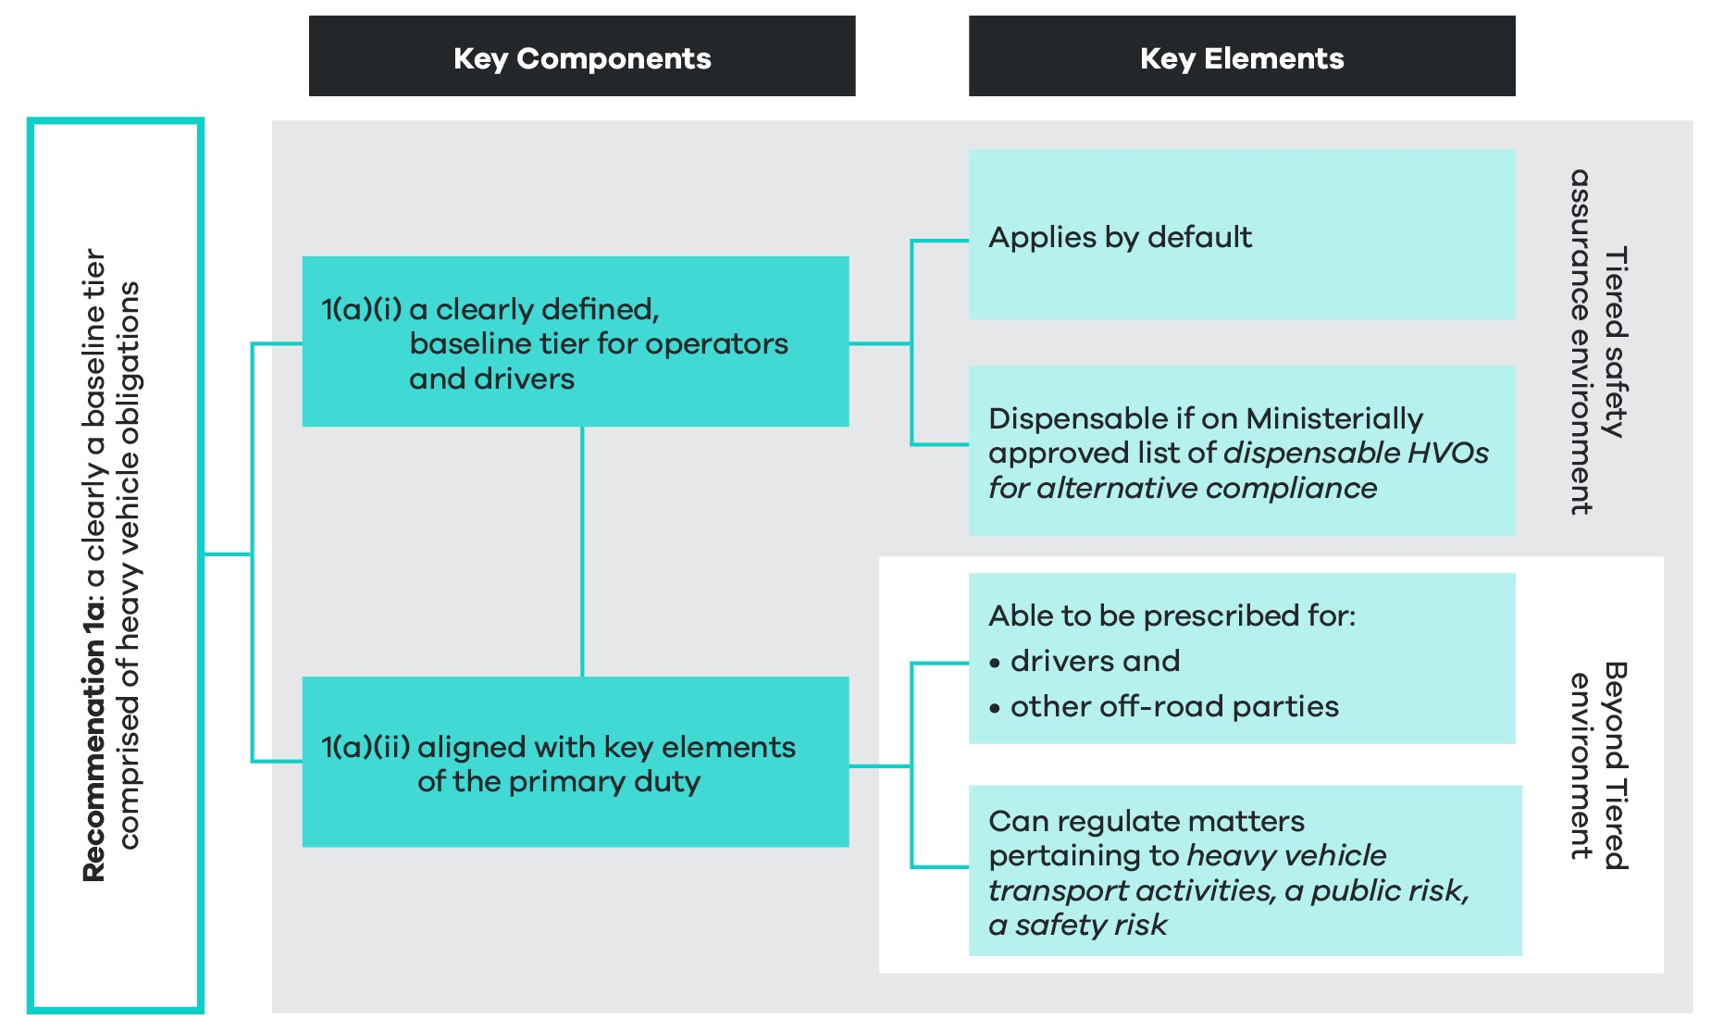
This recommendation has been designed to implement propositions 1.5, 1.6 and 7.1 to 7.5 of the ITMM reform package (see Appendix A). Fundamentally, those propositions proposed the introduction of a regulatory head of power for Heavy Vehicle Safety Obligations (HVSOs), which would be made as regulations and subject to parliamentary disallowance in Queensland Parliament. While remaining consistent with the ITMM reform package, this recommendation has reframed the HVSO construct, instead using the terminology of heavy vehicle obligation (HVO). This is because the object of the HVNL is broader than safety, and the HVSO recommendation is primarily intended to enable the prescribing of obligations, in regulation, to support the object of the law.
Primarily this RIS examines the HVO construct within the context of the new tiered safety assurance environment. Currently the tiered safety assurance environment is only relevant to operators who are able to gain access to ACOs as part of their accreditation, and the drivers who are employed or contracted by these operators.
HVOs will, however, have a broader application than just operators and drivers. For example, the law currently sets out a range of prescriptive obligations for off-road parties such as employers, consigners, packers and vehicle owners (to name a few). These obligations are not part of the tiered safety assurance environment because the law does not envisage ACOs for these parties. The HVO construct will, however, be sufficiently broad to enable the prescribing of obligations for off-road parties, including parties in the chain of responsibility (as defined in section 5 of the HVNL), and other parties not currently identified in law.
To this end, the ITMM reform package also envisaged that this head of power would be used as a mechanism to facilitate a redistribution of obligations down from the Primary Law and into regulations, to create a more responsive regulatory regime.
In terms of how HVOs will be constructed as part of the tiered safety assurance environment, HVOs will be established as a clearly defined baseline tier for operators and drivers. This baseline tier will apply by default unless it is dispensed with as part of an exemption or exception, or an ACO. If an HVO is to be dispensed with as part of an ACO, the HVO will need to be on the ministerially approved list of dispensable HVOs for alternative compliance. An overriding policy principle of this reform is to construct the HVO power as broadly as possible, to enable the prescribing of obligations for off-road parties and for new and emerging risks. Here, the scope of HVOs will be designed to align with the non-exhaustive scope of risks to be managed as part of the primary duty. This is based on the definition of ‘transport activities’ (section 5 of the HVNL) and the definitions of ‘public risk’ and ‘safety risk’ (section 5 of the HVNL). Noting this policy objective, the precise construction of the regulatory head of power or powers will be subject to the requirements of Parliamentary Counsel’s Committee and fundamental legislative principles.
1a(i) A clearly defined baseline tier for operators and drivers
As part of the tiered safety assurance environment, the future law will establish a baseline tier comprised of predominantly prescriptive requirements, described as heavy vehicle obligations. This element of the recommendation is most relevant to operators, who are able to apply for ACOs once they become accredited, but also drivers who may be employed or contracted by accredited operators.
A HVO will apply to an operator or a driver unless the HVO is dispensed with, either:
- through the issue of an ACO to an accredited operator, in relation to the specified HVO
- by way of an exemption or an exception.
Distinguishing heavy vehicle obligations from indispensable duties and obligations
As part of the construct for defining the HVO baseline tier, the law will effectively demarcate some duties and obligations under the law which are ‘indispensable’, distinguishing them from HVOs, which will be dispensable in certain circumstances.
From a policy perspective,, indispensable safety duties and obligations are those duties and obligations that are fundamental to the object of the law and which cannot be dispensed with under any circumstances.
Some examples of indispensable duties and obligations are obvious, including the primary duty (section 26C of the HVNL) and the duty to avoid driving while fatigued (section 228 of the HVNL). The ability to dispense with some other duties and obligations may be subject to further policy analysis and debate. For example, there are differing views around whether an overarching record-keeping requirement should be dispensable under the future law.
The subsequent regulatory impact analysis processes will involve close examination of each offence provision under the law to determine whether they should be categorised as indispensable or as an HVO. For illustrative purposes only, Appendix D provides a list of examples of duties and obligations that are likely to be indispensable under the future HVNL. The assessment of whether a duty or obligation should be deemed indispensable will involve thorough policy analysis that will consider a range of factors. Further policy analysis will involve consideration of factors, summarised below, to determine how a duty or obligation should be categorised.

General policy considerations relevant to determining whether a duty or obligation should be indispensable
These considerations will be used to guide further policy analysis of every obligation and duty under the HVNL to determine whether a duty or obligation should be categorised as indispensable.
1. Object of the law: Does the duty or obligation establish an absolute, non-derogable requirement that is fundamental to achieving the object of the law?
2. Overarching obligations vs prescriptive requirements: Does the duty or obligation establish an overarching requirement to manage risk, or alternatively does it prescribe a method for managing a risk, that is linked to other obligations under the law?
3. Fundamental legislative principles: Does the duty or obligation raise issues relating to rights and liabilities of individuals, and the institution of parliament?
Appendix D elaborates on these considerations.
Circumstances under which a heavy vehicle obligation may be dispensed with for alternative compliance
It is envisaged that most indispensable duties or obligations will be established in primary law. HVOs will be prescribed in regulation. In the context of the tiered safety assurance environment, a HVO will be dispensable and able to be replaced with an ACO in particular circumstances.
In order for a HVO to be dispensed with by issuing an ACO, the HVO must be on a ministerially approved list of dispensable HVOs for alternative compliance. The law will specifically empower ministers to approve a list of dispensable HVOs for alternative compliance and a first list will be required to be approved by ministers for commencement of the future law.
While the HVO mechanism will form a key feature of the tiered safety assurance environment, the mechanism will also allow the prescribing of obligations for off-road parties, including other parties in the chain of responsibility (s 5), and potentially other parties defined in law. These parties are not subject to the tiered safety assurance environment and considerations around dispensability of the obligation are not relevant.
It is also relevant to note that HVOs may be dispensed with by way of a regulator exemption power. Exemption power arrangements fall outside the tiered safety assurance environment and are unlikely to change under the future law.
Three categories for duties and obligations under the future HVNL
The effect of this construct will be to create three broad categories of duties and obligations under the future law, as outlined in Figure 5.
- High-level categories of duties and obligations under future regulatory framework
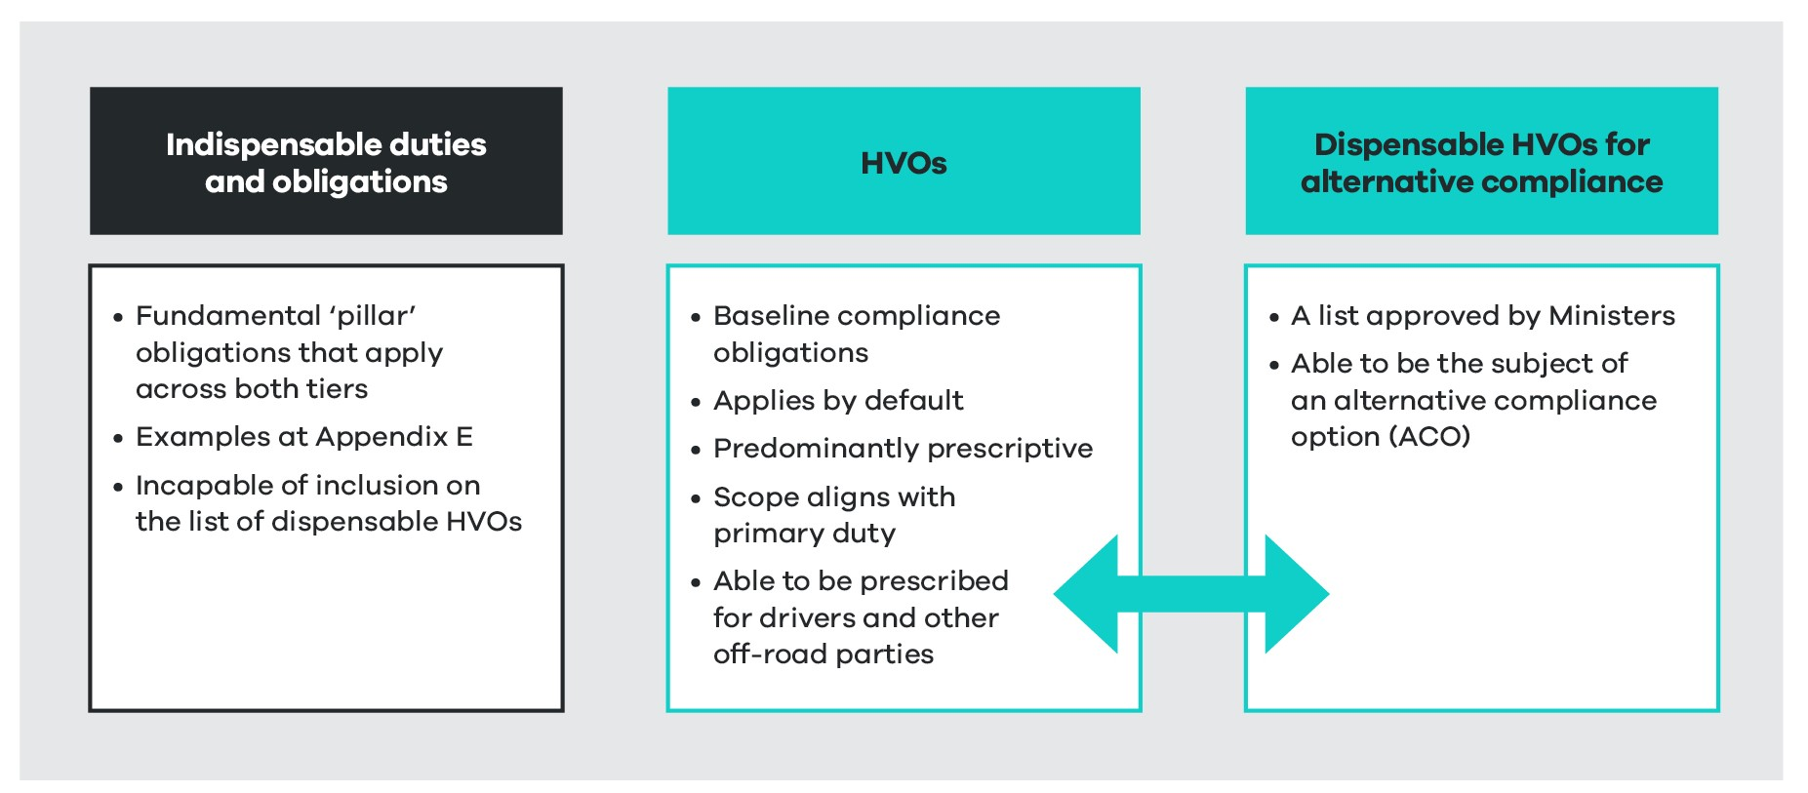
To be clear, when an HVO is classified as a dispensable HVO, it is not automatically dispensed with. Rather, a dispensable HVO may enliven the regulator’s power to issue an ACO (subject to other constraints discussed in recommendation 1b.
1a(ii) A broadly constructed head of power, the scope of which will align with risks to be managed under the primary duty
As part of delivering a more responsive law, to the maximum extent possible, HVOs will be prescribed regulation.
HVOs will cover a broader range of matters than the scope of risk-management areas currently covered by existing heads of power in the HVNL. To enable this, the primary law may establish a single head of power or several heads of power.
While the precise construction of regulatory heads of power is a matter for Parliamentary Counsel’s Committee, the overriding policy principle is that the future law should enable the prescribing of HVOs pertaining to the broadest range of matters possible, limited by the scope of risks required to be managed under the primary duty.
By design, the scope of risks required to be managed under the primary duty is broad. This has the benefit of ensuring parties are accountable for managing all risks relevant to the conduct of the heavy vehicle transport task, including new risks as they emerge. The scope of the primary duty is based upon:
- the definition of ‘transport activities’ (section 5 of the HVNL) (see Appendix E)
- the definition of ‘public risk’, which refers to a definition of safety risk (section 5 of the HVNL) (see Appendix E).
If necessary, the law will put beyond doubt that ‘transport activities’ and ‘public risk’ is intended to capture a non-exhaustive list of risks arising from the use of heavy vehicles on roads. This proposal is designed to ensure the law comprehends future risks around the advents of automation, electrification, digitisation, climate change and any other future advent with potential to impact on public safety.
While the scope of matters able to be regulated by HVOs will align with the primary duty, HVOs will also be able to be prescribed for drivers and parties other than those captured by the chain of responsibility under the primary duty. Table 7 provides a summary of the scope of HVOs.
- Scope of heavy vehicle obligation construct
Scope components | Heavy vehicle obligations
What may be prescribed | - Any matter captured by the definition of ‘heavy vehicle transport activities’ (section 5 in the HVNL) (see Appendix E). This definition refers broadly to ‘activities, including business practices and making decisions, associated with the use of a heavy vehicle on a road’.  - Any matter captured by the definition of ‘public risk’ (section 5 of the HVNL) (see Appendix E). This definition refers to the risk of damage to road infrastructure. It also refers to a ‘safety risk’, which is defined in section 5 of the HVNL as including a risk to public safety or harm to the environment.
Who can be regulated? | - Any party in the chain of responsibility, as defined exhaustively in section 5 of the HVNL to include employers of drivers, prime contractors, operators, schedulers, consignors, consignees, packers, loading managers, loaders, and unloaders (see Appendix E).  - Drivers of heavy vehicles.  - Other off-road parties, noting these additional off-road parties would need to be defined in regulation. This may include auditors, heavy vehicle repairers, parties preparing livestock for transportation, and so on.

What are the objectives?
As discussed in chapter 3, the HVNL fails to:
- Provide a clear and coherent compliance regime for operators who prefer the simplicity and certainty of prescriptive regulation.
- Keep pace with changing technology, business practices and emerging risks.
Throughout the HVNL Review and subsequent consultation, industry parties, particularly operators, expressed there was a need to ensure the future law can prescribe additional obligations for off-road parties, for example, heavy vehicle repairers.
With these problems in mind, this reform has been designed to:
- Increase the responsiveness of the law – to the maximum extent appropriate, obligations should be placed in regulation and subsidiary instruments to allow the law to respond quickly to changes in context, technologies, knowledge and practices.
- Increase adaptability of the law, including the ability to responsively prescribe obligations on parties.
How will the law change?
Current law (the base case)
The current HVNL contains regulatory heads of power for a range of safety matters including (but not limited to):
- heavy vehicle standards (section 59)
- vehicle modification (section 88)
- mass requirements (section 95)
- dimension requirements (section 101)
- loading requirements (section 110)
- standard hours (section 249)
- work diary requirements (section 295).
The law does not definitively enable the prescribing of additional requirements for off-road parties.
The HVNL also does not expressly enable the prescribing of requirements relating to other known risks to heavy vehicle safety – for example, fitness for duty, driver distraction or competency.
The HVNL also appears to be limited in terms of what may be prescribed for risks to heavy vehicle safety that may arise in the future – for example, risks relating specifically to electric and automated vehicles.
Future law
The HVO mechanism will be designed to encompass the current suite of regulatory heads of power that enable the prescribing of requirements or obligations. But the list of matters to which a HVO will apply will be constructed as broadly as possible.
In effect, this will broaden the scope of safety matters to which a safety obligation may be prescribed. This will make the law more adaptive and ensure the law can move rapidly to regulate new risks to safety, while still ensuring that obligations relate directly to heavy vehicle activities.
The law will also incorporate a mechanism to allow ministers to approve a list of ‘dispensable’ HVOs. This list will reflect the range of HVOs to which ministers are comfortable that an exemption or an ACO may be applied. It is envisaged that this list be reviewed periodically to reflect the evolving heavy vehicle transport landscape and the potential for new ACOs in the future.
If appropriate (as determined by Parliamentary Counsel’s Committee), the law will specifically define a class of indispensable duties and obligations.
Appendix D provides a potential list of indispensable duties and obligations for the future law. This potential list is for illustrative purposes only and does not represent a concrete set of recommendations. A definitive list will be considered during a subsequent RIS process.
Appendix D provides a potential list of HVOs for the future law and a brief discussion around policy considerations for deciding on a list of dispensable HVOs to be approved by ministers.
What are the impacts?
An enabling environment
This proposed reform is an enabling provision that will change the structure of the law and the scope of matters that are able to be regulated by the law. This proposal does not consider any substantive proposals to prescribe additional obligations on parties, or any changes to existing obligations.
It should be noted that this recommendation describes one feature of an overarching framework and should be considered in that context. Therefore, while in isolation this recommendation may be described as having no direct regulatory impacts, as a fundamental feature of the tiered safety assurance environment there are whole of system impacts to flow from a restructuring of the law.
Potential impacts
Noting the enabling characteristics of this proposal, longer term improvements are projected across assessment criteria categories, particularly in the areas of road safety, operational efficiency, reduced regulatory burden and flexibility and responsiveness.
Impacts are expected to be neutral or uncertain in terms of regulatory costs for government, and asset and environmental protection.
Again, noting the mechanical nature of this proposal and the fact that it does not involve any substantive change to obligations under the law, no significant negative impacts have been identified.
Potential improvements
The fundamental objectives of this proposal are to simplify the HVNL and enable the prescribing of obligations in response to current, new and emerging risks.
A simpler law will:
- Make the law easier for parties to understand and apply, in the long-term increasing compliance and a reduction in overall public risk.
- In the long term, reduce compliance costs – for example, training costs for drivers and the risk of incurring fines due to noncompliance (assessment criteria 3a).
A more responsive law will:
- Deliver greater flexibility for the prescribing of obligations on off-road parties that will allow for better allocation of responsibility with supply chain parties best able to manage risk (assessment criteria 1a). This will also increase the responsiveness of the law in terms of addressing emergent safety risks (assessment criteria 1b and 6c).
- Ensure the law can keep pace with advances in technology and changes in context, technologies, knowledge and practices (assessment criteria 6c and 6e).
Unknown impacts, or areas of neutral or negligible impact
The HVO construct and its relationship to alternative compliance may be perceived as adding an additional layer of unnecessary bureaucracy to decisions around how HVOs can become dispensable (assessment criteria 4b). Establishing a process that requires ministers to approve a list of dispensable HVOs for alternative compliance may give rise to some administrative costs, particularly in the first instance where the NTC will run a consultation process to develop a list of dispensable HVOs, ready for commencement of the future HVNL.
From thereon, any review process for the list of HVOs can be embedded into the NTC’s existing legislative function of ‘monitoring and maintaining uniform or nationally consistent regulatory and operational reforms’ (section 3 of the National Transport Commission Act 2003 CTH).
Stakeholders have raised that a list of dispensable HVOs should instead be specified in regulation. The administrative costs associated with this option are likely to be the same, or slightly more, than creating a ministerially approved list, as a ministerially approved list would not require drafting resources or parliamentary scrutiny processes associated with specifying such a list in regulation.
Noting any administrative costs are likely to be absorbed into existing maintenance processes run by the NTC, when compared to the base case these are also likely to be offset by the benefits of lifting the alternative compliance system out of regulation and into a more flexible environment (assessment criteria 6c).
The assessment considers impacts at a national level. The costs and benefits will be broadly similar across different states and territories. The specific costs and benefits in each state or territory will depend in part on the nature of the heavy vehicle fleet and its use in each state or territory.
Implementation, transition and evaluation arrangements
An enabling environment
As discussed above, this reform element is an enabling feature of the proposed HVNL option. Noting the three categories of obligations discussed above, following this foundational RIS further policy work will be carried out to determine:
- which duties and obligations will be indispensable
- which obligations should be classed as HVOs
- which obligations should be placed on the list of dispensable HVOs.

Recommendation 1b – Alternative compliance tier 2
That, as part of the tiered safety assurance environment, the future HVNL establish an alternative compliance tier for accredited operators, underpinned by a new power allowing the regulator to issue alternative compliance options, within prescribed outer limits and other specified constraints.
What is proposed?
- Overview of recommendation 1b
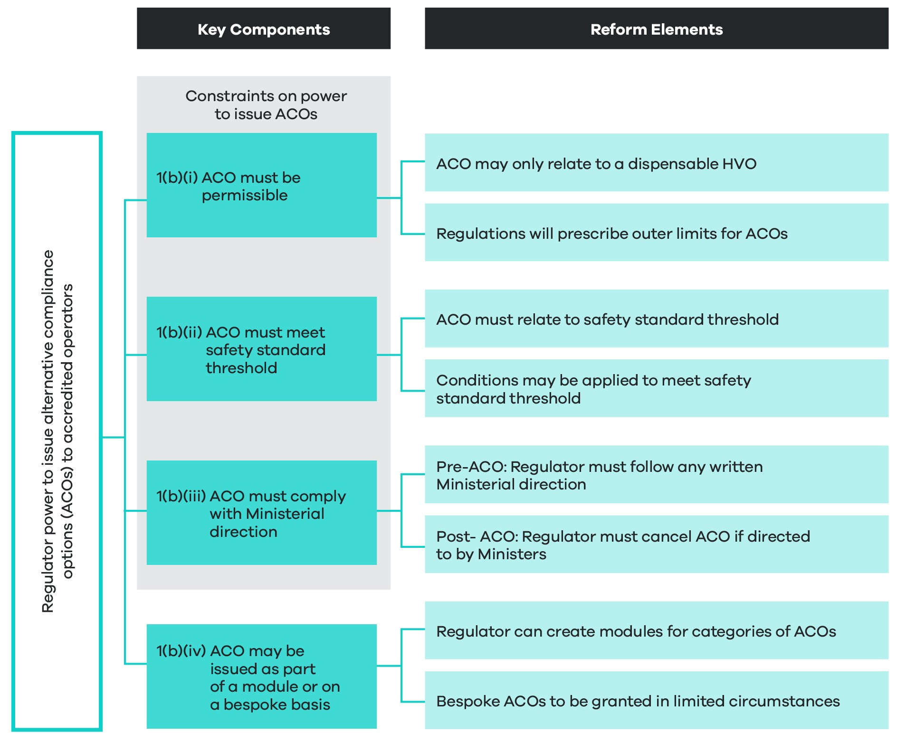
This recommendation has been designed to implement proposition 5.3b of the ITMM reform package (see Appendix A), which relates to establishing an environment for more flexible and diverse ACOs, underpinned by ministerial directions.
Instead of hardwiring ACOs into law and regulation, the future law will empower the NHVR to issue ACOs to accredited operators either:
- as part of an accreditation module
- on an individual, bespoke basis where a safety case and unique business need can be demonstrated.
This new power will allow the regulator to expand and adapt the new accreditation scheme in line with advances in technology, changing business models and new and emerging risks to heavy vehicle safety. While this change represents an increase in regulatory discretion, the power to issue ACOs will not be a broad-based power, but a constrained power, as detailed under the key components listed in Figure 6 above and summarised below.

Summary of constraints on regulator power to issue alternative compliance options
Before the NHVR can exercise this power it will need to assess a proposed ACO in light of three key constraints:
- It must be permissible under the law. Permissibility arrangements will include:
- A new head of power to enable the prescribing of limits on ACOs, in regulation.
- A new mechanism allowing development and approval of a list or schedule of ‘dispensable HVOs’, such that the regulator will only be empowered to offer ACOs in relation to the HVOs on this list.
- The ACO must meet a safety standard threshold, meaning:
- The ACO must result in a standard of safety that is at least equivalent to tier 1.
- Conditions may be applied to the operator to ensure the standard can be met.
- The ACO must follow any relevant ministerial direction which may be either:
- provided prior to the issuing of an ACO
- provided in relation to an ACO that has already been issued, but only in limited circumstances where the ACO gives rise to a serious risk to public safety.
These constraints on the regulator’s power will be the same irrespective of whether the power is used to issue an ACO on an individual or modular basis. Operationally, the process for issuing an ACO will differ between each group (discussed further later in this section).

Key definitions for understanding new arrangements for alternative compliance
Alternative compliance option: an ACO, once issued to an accredited operator, will result in dispensation of a relevant baseline HVO and a requirement to comply with a new set of requirements and conditions contained in the ACO.
Risk area standards: standards to be established in regulation that relate to particular risk areas, for example, fatigue, mass and maintenance. In line with risk-area standards, the regulator may establish accreditation modules.
ACO accreditation modules: developed by the regulator, accreditation modules will set out criteria and standards to be met and assessed as part of obtaining and maintaining accreditation and gaining access to an ACO. These modules will be based around risk area standards, laid out in regulation.
Non-ACO accreditation modules: as part of the new environment, the regulator may develop accreditation modules that do not give rise to ACOs. This will be up to the discretion of the regulator, but could involve modules relating to driver competency, health and fitness, sustainability, and so on.

Linking policy recommendations around accreditation and alternative compliance
The policy recommendations in this section fundamentally link with policy recommendations on the new accreditation scheme in section 5.3.
While the regulator will have increased discretion to issue ACOs, this will be matched by measures geared towards increasing trust in the robustness of the scheme, and the level of safety assurance of accredited operators. These measures include:
- a core safety management system (SMS) requirement
- a national audit standard (NAS).
The detail of this scheme is discussed in section 5.3.
Section 5.3.4 provides a holistic picture of how new arrangements for alternative compliance will operate together with other aspects of the enhanced accreditation scheme and the NAS.
Section 5.3.4 also provides a step-by-step process of how an operator may gain access to an ACO as part of the accreditation process (see table 9).

1b(i) Constraint on power: the alternative compliance option must be legally permissible
In order to issue an ACO the regulator will first need to consider whether the ACO is permissible under the HVNL.
- Overview of permissibility arrangements for alternative compliance options under the HVNL
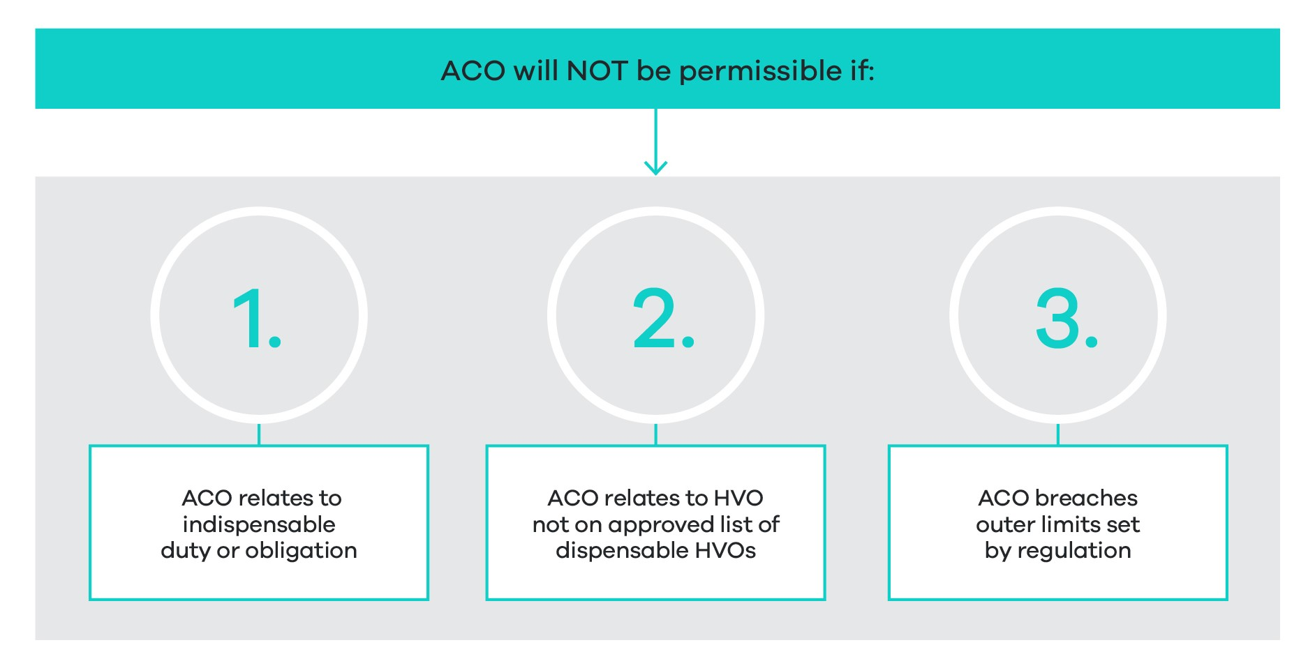
The ACO will not be permissible if:
- The ACO relates to an indispensable duty or obligation, for example the primary duty (section 26C of the HVNL) or the duty not to drive fatigued (section 228 of the HVNL). Appendix D provides a list of potential indispensable duties and obligations.
- The ACO relates to a HVO that is not on the ministerially approved list of dispensable HVOs.
- The ACO breaches an outer limit set by regulation. Here, the law will (most likely through regulation) prescribe outer limits for ACOs in particular risk areas. While the precise formulation of outer limits will be determined during the subsequent regulatory impact analysis process, existing work and rest hour limits for AFM operators will be translated into the future law for the fatigue risk area.
1b(ii) Constraint on power: the alternative compliance option must meet safety standard threshold
In order to issue an ACO, the regulator will be required to assess and demonstrate that the ACO meets the ‘safety standard threshold’. This threshold will be established clearly in law to reflect the overriding policy objective that an ACO must not result in an increased risk to safety.
Noting the proposed ACO power operates in a similar manner to an exemption power, the proposed constraint has been modelled on Regulation 685 of the Work and Safety Regulations, which sets out a range of matters to be considered in granting an exemption, namely that:
whether…the exemption will result in a standard of health and safety…that is at least equivalent to the standard that would be achieved by compliance with the relevant provision or provisions.
This legal threshold will be constructed as a strict constraint on the regulator’s ACO power. That is, the regulator will not be able to grant an ACO unless it is satisfied that the granting of the ACO will not result in a lower standard of safety than established by complying with the HVO.
As part of assessing the proposed ACO against the safety standard threshold, the regulator will be empowered to apply conditions to an operator and should also consider whether the application of additional conditions will result in the safety standard threshold being met.
In addition to assessing the ACO against the safety standard threshold, the regulator will be required to demonstrate that this assessment has been carried out, including a summary of findings of the assessment, as part of issuing the ACO.
1b(iii) Constraint on power: alternative compliance option must follow a ministerial direction
As a final ‘failsafe’ to ensure the regulator does not step outside expectations of ministers, the HVNL will also empower ministers to give directions to the regulator about the issuing of ACOs. As part of issuing an ACO, the regulator will be required to follow any such direction.
In this context, ministerial directions may operate in a similar way to how ministerial guidelines work with respect to exemption powers under the current HVNL. However, the law will be clear that the regulator must follow a direction in issuing an ACO. This is a stricter obligation than simply being required to have regard to a guideline.
This proposed power relates to the issuing of ACOs. It will not apply in relation to an ACO that has already been issued. If, however, it emerges that an ACO is posing a serious risk to public safety, ministers will be able to lean on a separate ministerial direction power to direct the regulator to suspend or cancel the ACO. This power will only be available to use in circumstances of a serious public risk, and when in the public interest to do so. More information about the legal machinations of both ministerial direction powers is provided in the discussion on recommendation 3, further below.
1b(iv) Alternative compliance options may be issued as part of a module, or on a bespoke basis for operators demonstrating a unique business case
- Overview of arrangements for module-based and bespoke ACOs
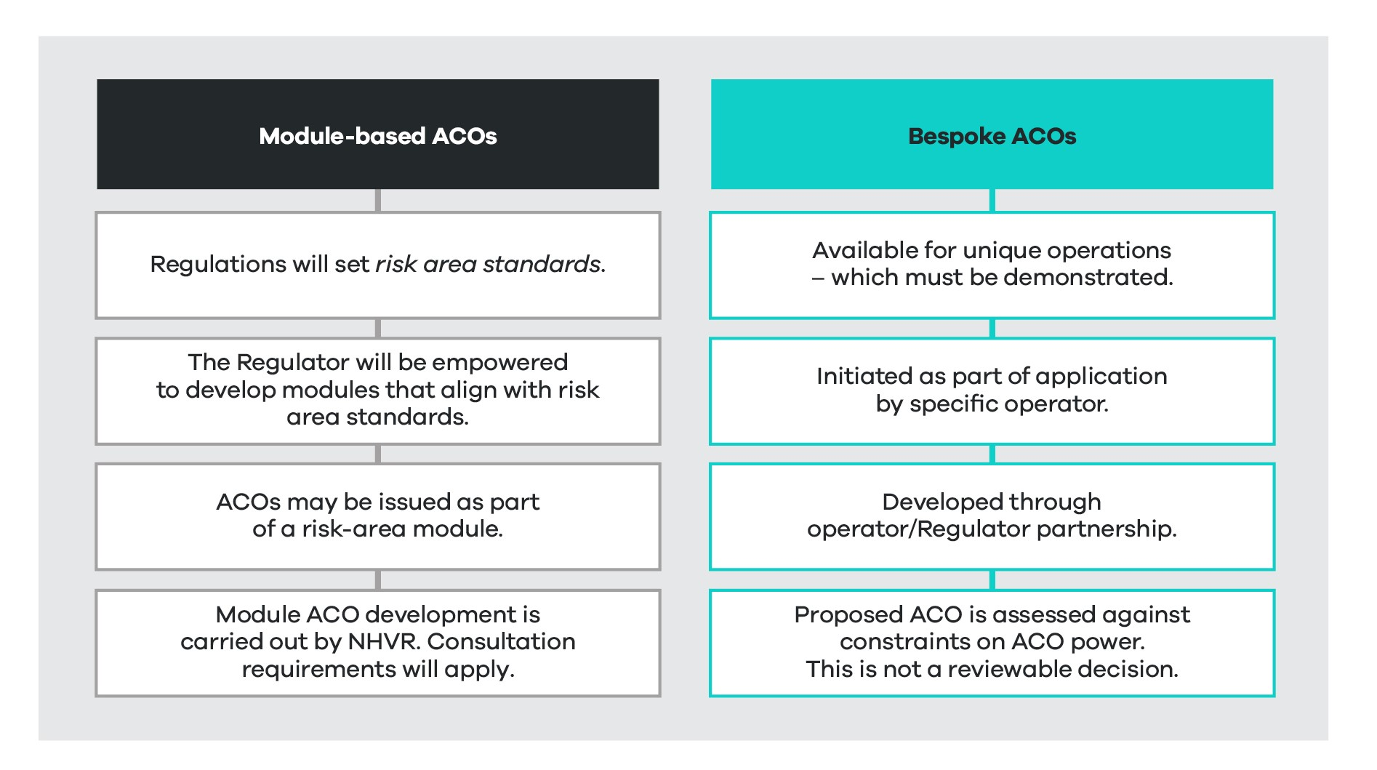
Module-based alternative compliance options
Instead of hardwiring accreditation modules into law and regulation, the new regulatory environment will allow the regulator to establish new accreditation modules. These modules will be established as an integrated feature of the new power to issue an ACO, but the regulator will also have the ability to establish modules that do not directly give rise to an ACO (as discussed in the breakout box below).
If a module is developed as part of or in association with an ACO, the module must align with risk area standards set in regulation. For example, the regulations may set out risk area standards for fatigue. The regulator will then be able to develop a library of fatigue-related modules with associated ACOs, in line with these fatigue standards.
- Arrangements supported by law for accreditation modules and associated alternative compliance options
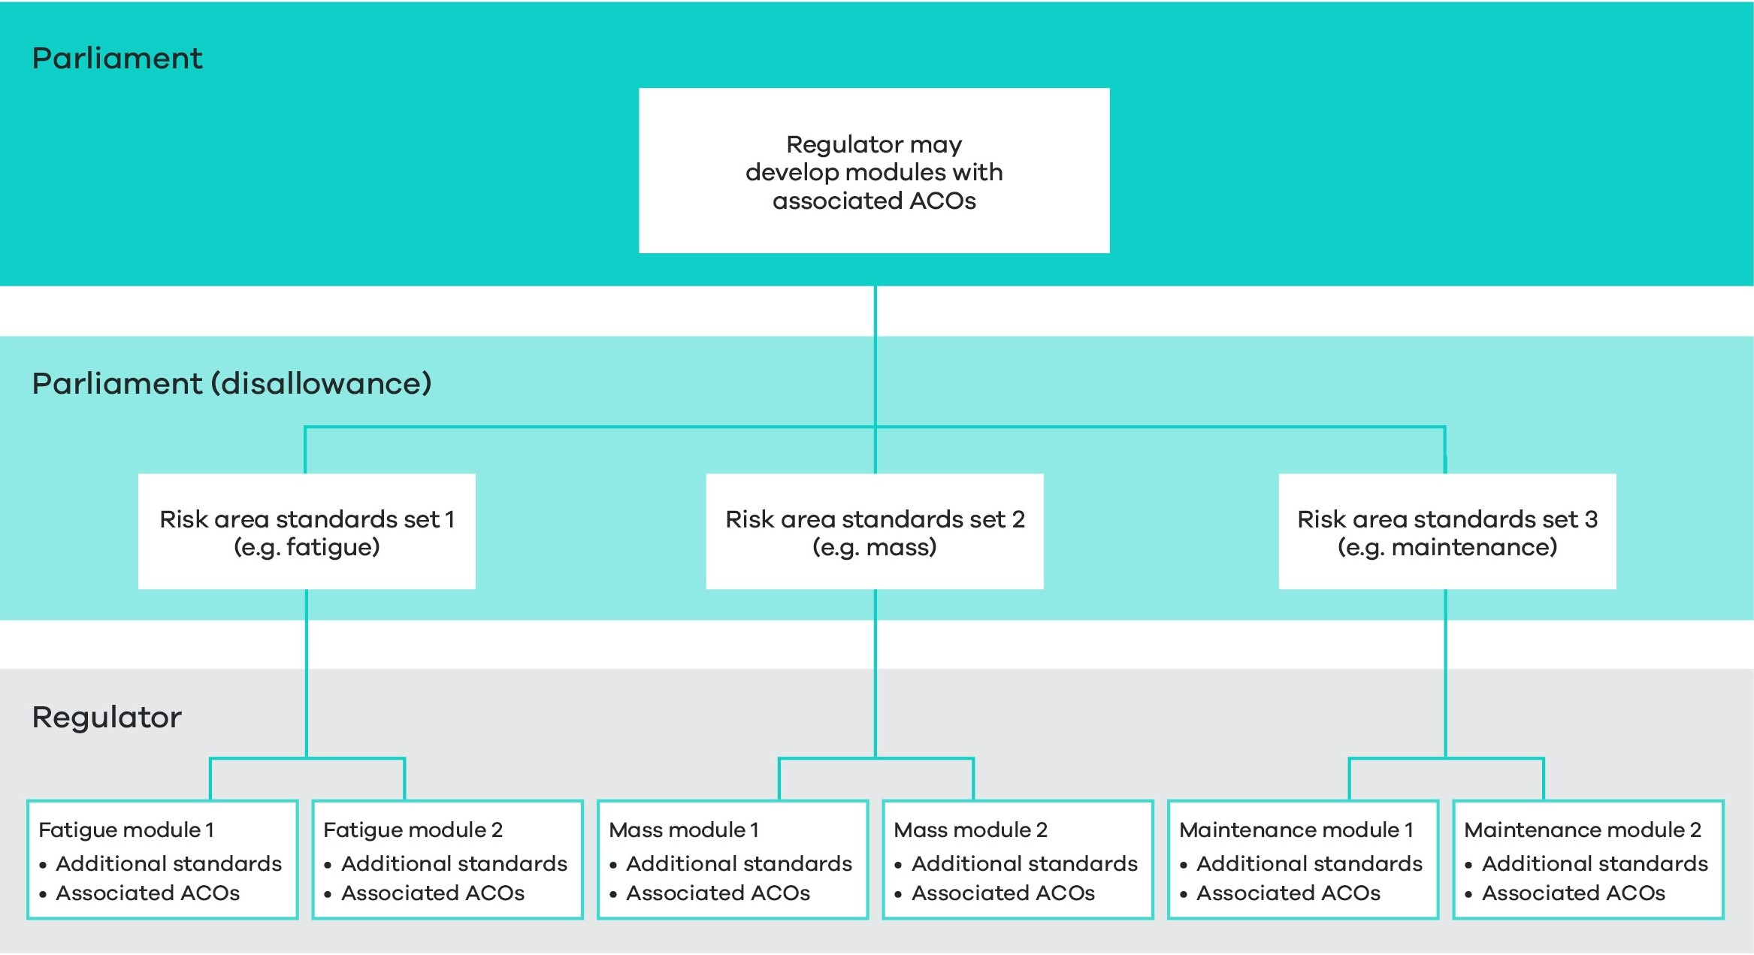
Figure 11 provides a basic outline of the legislative mechanics for the way modules and associated ACOs are created under the law. Recommendation 6 expands on this explanation in the context of the NHVAS scheme architecture more broadly.
In terms of the administrative process around developing module-based ACOs, Table 8 outlines high level steps for the regulator to follow.
Non-alternative compliance option modules
Under the new regulatory environment, the regulator may also choose to develop modules that do not lead to ACOs. For example, modules around driver competency, driver health and fitness, environment and sustainability may be developed at the regulator’s discretion. The development of these modules would not be constrained by risk area standards or by outer limits set in regulation, because they would not give rise to an ACO.
There is potential for the regulator to use this mechanism to establish ‘highest standard’ risk management practices in certain areas. Operators may see value in becoming certified in a non-ACO module, particularly if customers specify as part of procurement arrangements that an operator should be accredited in such a module.
Accreditation in a non-ACO module would also serve to provide assurances (though not a complete guarantee) that an operator is complying with that particular component of the primary duty. A non-ACO module will be auditable under the national audit standard, discussed under recommendations 2b and 8. As laid out under recommendation 2b, an audit relating to a non-ACO module will also be admissible as evidence of compliance with the primary duty.
- Administrative process supported by law for developing modules and alternative compliance options
Initiation | Development | Publish
The regulator may identify an opportunity to develop a module and associated ACO.  Ministers may request the regulator to develop a module and related ACO.  An industry party may request the regulator to develop an ACO. | The regulator will develop the module and related ACOs, considering the three constraints.  As part of assessing the safety standard threshold, the regulator will need to carry out and document a safety assessment.  The regulator will be required to consult on the proposed module and ACO and consider any comments. | The regulator will be required to publish the ACO and the safety assessment accompanying the ACO, on its website.  An operator will receive access to the ACO once they are accredited in the relevant module.
Bespoke alternative compliance options
The future law will allow individual operators to propose bespoke ACOs to the regulator. As part of this proposal, the operator will need to demonstrate:
- a safety case setting out how the safety standard threshold is met
- a unique business need
- that both the baseline HVOs and available ACOs are impractical and inappropriate for meeting the unique business need.
The regulator may develop policy and guidance material setting out key considerations for satisfying the above criteria. For example, as part of demonstrating whether a relevant HVO or available ACO is impractical or inappropriate, guidance material may set out that an operator should provide evidence of matters such as:
- undue economic hardship
- potential welfare concerns (for example, animal welfare)
- how the HVO or relevant ACO makes the freight task prohibitively difficult to deliver.
Administratively, a proposal for a bespoke ACO will run as a separate process to applying for access to the ACO. Operationally, these processes will likely coincide, but the proposal for an ACO will be assessed against the three constraints. This is ultimately a decision on the legality of the ACO itself and whether the regulator is able to exercise the ACO power. This assessment goes to the validity of the application and it will not be reviewable.
Once the proposed ACO is determined to be valid, the regulator is then able to assess whether the operator meets standards required for the ACO to be safe.
Table 9 outlines the administrative process for issuing an individual or bespoke ACO supported by the law.
- Process steps supported by law for issuing an individual or bespoke alternative compliance option
Proposal for bespoke ACO | Assessment of ACO | Assessment of accreditation application | Publish
An operator may propose a bespoke ACO – either:  - As part of an application for accreditation.  - As an add on to an existing accreditation. | The regulator will assess the proposed ACO in light of the three constraints.  The regulator will also assess whether the applicant has established a unique business need that can’t be addressed through the relevant HVO or any available ACO.  The assessment of the ACO is not a reviewable decision. | The regulator may grant, refuse or elect to reconsider the application for accreditation.  This process differs from assessing the legality of the ACO, and instead focuses on assessing whether the operator meets requisite standards.  A refusal decision will be a reviewable decision under the HVNL, and therefore subject to internal review, and further judicial review. | The bespoke ACO and accompanying safety assessment will also be published on the NHVR website.
What are the objectives?
As agreed by ministers, the framework will be scalable to support different levels of sophistication of operators. Operators with less sophisticated business operations who enter the scheme should be able to access relatively small concessions, and operators with more sophisticated operations should be able to receive access to highly flexible ACOs.
This includes supporting the diverse range of freight tasks, risks associated with geographical areas, and types of operators. It also includes recognising the varied capacities of heavy vehicle operators, noting that:
- Some operators prefer the simplicity and certainty of prescriptive compliance options and have no interest in alternative compliance.
- Some operators may still be able to manage safety effectively with only minor ACOs in place.
- Some operators have a highly sophisticated risk management capability and are able to manage safety effectively with highly flexible ACOs in place.
While the law should be able to support ACOs for unique business operations, this must also be balanced against the need for regulatory efficiency. To avoid the risk of overwhelming the regulator with bespoke ACO applications, the process for applying for an ACO has been designed to encourage operators to make use of module-based ACOs.
How will the law change?
Current law (the base case)
The HVNL establishes the NHVAS, which gives accredited operators some flexibility to operate out of prescribed regulations, within the context of accreditation modules, as follows:
- NHVAS Mass Management: accredited operators are able to operate at above general mass limits.
- NHVAS Basic Fatigue Management (BFM) and Advanced Fatigue Management (AFM): accredited operators receive access to longer working hours and flexibility in scheduling.
- NHVAS Maintenance Management: accredited operators in New South Wales and Queensland receive exemptions from annual inspection requirements, which can be resource intensive.
To a large extent, ACOs are hardwired into the law and regulation. This is particularly the case for Mass Management and BFM, which offer alternative schedules of prescriptive requirements.
AFM represents a more flexible approach, whereby the regulator is able to approve bespoke work and rest hour schedules within prescribed limits. The process for gaining AFM accreditation is, however, cumbersome and resource intensive, and generally not available to smaller or simpler operators who may still be able to manage safety with the benefit of small adjustments to the general schedule.
The HVNL otherwise does not enable the regulator to expand and adapt ACOs for accredited operators.
Future law
The future law will change from the current HVNL by:
- Establishing a power allowing the NHVR to issue ACOs. As part of this, the NHVR will also be able to develop accreditation modules. Consultation requirements will apply.
- Establishing a head of power that enables the prescribing of limits on ACOs.
- Allowing ministers to approve a list of dispensable HVOs.
- Establishing a new ministerial direction power regarding the granting of ACOs.
The regulator’s functions may be amended to reflect increased regulatory discretion as part of the new regulatory environment proposed.
What are the impacts?
An enabling environment
As discussed previously, the tiered safety assurance environment proposal involves a series of structural reforms to the HVNL that have no direct regulatory impact.
The proposal in this section outlines the legislative mechanisms for enabling a new diverse alternative compliance environment. Specific ACOs are not considered in this RIS.
In addition, ACOs are by nature ‘opt-in’, and as such, this reform can be described as having no direct regulatory impact.
Potential impacts
While noting the enabling characteristics of this proposal, some longer-term improvements can be projected across assessment criteria categories, particularly in the areas of road safety, operational efficiency, and flexibility and responsiveness.
Impacts in the area of asset and environmental protection are projected as neutral or uncertain.
There is potential for some negative impacts in the areas of regulatory burden and costs for both industry and government. These may, however, be offset by overall improvements to operational efficiency, road safety, and regulatory visibility of the heavy vehicle fleet.
Potential improvements
The proposed changes are projected to deliver benefits including:
- A law that better reflects the diversity of heavy vehicle operators, in turn:
- Allowing operators to realise productivity gains when more flexible or appropriate ACOs are offered to suit their business (assessment criteria 2c and 2d).
- Enabling a reduction in overall safety risk, risk to infrastructure, and overall crash risk by allowing operators to adopt the most appropriate risk management approach for their business (assessment criteria 1d, 1e and 5a).
- A law that can keep pace with rapid advances in technology and changes across the heavy vehicle transport sector and support innovation, in turn:
- Increasing operational efficiency and productivity gains where operators adopt the most cutting-edge safety management technology (assessment criteria 2d and 6b).
- Supporting an overall reduction in risk to safety and infrastructure, and overall crash risk by ensuring operators are not locked into old and ineffective risk management approaches (assessment criteria 1e).
- A law that will enable the NHVR to expand and adapt the accreditation scheme to encourage operators to take increased responsibility for managing risk (assessment criteria 1c, 6c).
- The offer of more attractive and appropriate ACOs should also result in an increased uptake of accreditation. This in turn should support:
- Improvements in overall safety of the heavy vehicle fleet and reduction in adverse safety incidents and overall crash risk, noting that accredited operators will be required to demonstrate they have a safety management system (SMS) (assessment criteria 1e).
- Increased regulatory visibility of the heavy vehicle fleet, with associated benefits relating to risk profiling and more efficient concentration of regulatory effort on higher risk operators.
Potential negative impacts
The process of applying for an individual or bespoke ACO is likely to be administratively cumbersome for both operators and the regulator (assessment criteria 3a and 4a), although not necessarily more so than the current process for applying for AFM accreditation. While the regulator will be able to charge an application fee to recoup costs, the value of this reform for operators is dependent upon the degree of flexibility and associated improvement that can be gained from receiving the bespoke ACO.
The process of establishing an ACO assessment process will also involve administrative and resourcing costs for the regulator. This is particularly the case for bespoke ACO applications, which will also require establishing an internal review process.
A more diverse alternative compliance environment is also likely to make enforcement more complex, although it should be noted that there are perceptions of existing problems around the interaction of enforcement officers (particularly police) and accredited operators (assessment criteria 3b). As discussed previously, currently accredited operators report that some police officers, in particular, have a limited understanding of ACOs for fatigue available under the NHVAS. Complexities around the enforcement of bespoke AFM schedules are likely to continue under the new environment. Nonetheless, the new environment will also enable the regulator to streamline AFM schedules, in turn reducing enforcement complexity (assessment criteria 4b). The negative impacts of complexity of enforcement may be counterbalanced by enhancements to operator risk profiling systems.
Implementation, transition and evaluation arrangements
To ensure continuity for existing accredited operators, the regulator will adapt existing ACOs such that they can be applied as part of the new regulatory environment.
To deliver on the overall objectives of the new legislative environment, the regulator will also be expected to develop a limited suite of other ACOs, ready for commencement of the new law. Evaluation and consultation on new proposed ACOs will be carried out by the NHVR as part of the next RIS process.

Recommendation 2 – Ministerial approvals
That, as part of establishing an appropriate balance of regulatory discretion and ministerial oversight, the future law establish new arrangements for ministerial approvals, such that:
2a In recognition of restructured arrangements for alternative compliance and accreditation, ministers will no longer be required to approve accreditation business rules.
2b As part of enhancements to accreditation, ministers will be empowered to approve a national audit standard to be applied as part of the National Heavy Vehicle Accreditation Scheme, as well as other schemes and third parties. A national audit standard audit certificate will be automatically admissible as evidence in primary duty proceedings.
2c The law clarify that consultation requirements apply to the development of ministerially approved guidelines.
2d Ministers will no longer be required to approve a sleeper berth standard, noting this may be prescribed as a heavy vehicle obligation in the future.
What is proposed?
Recognising that the proposed regulatory framework includes a more flexible safety assurance environment, the future law will also include revised approval arrangements for responsible ministers to ensure that increased regulatory discretion is balanced with appropriate ministerial oversight.
Revised arrangements for ministerial approvals powers are comprised of four main elements (see Figure 12).
- Overview of recommendation 2
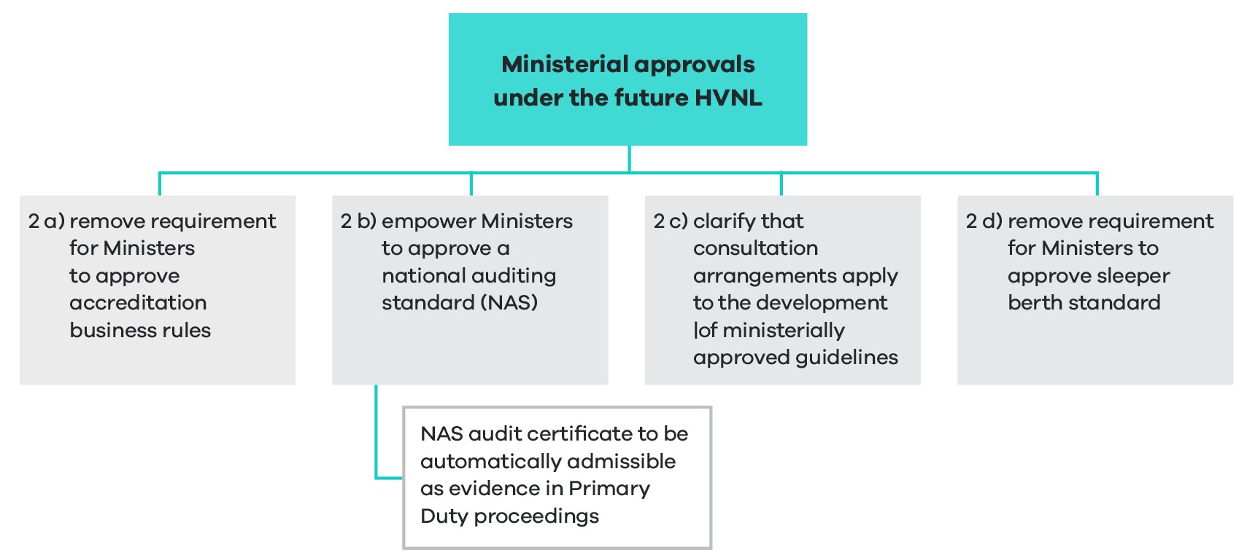

2a Remove ministerial approval power for accreditation business rules and standards
In September 2022, ITMM agreed to progress arrangements for accreditation business rules to be revised to allow the regulator to develop and approve accreditation business rules.
In their current form the NHVAS business rules serve a number of different purposes. They set out:
- operational detail of applying for and maintaining accreditation
- conditions that apply to all NHVAS operators
- module-specific conditions
- module-based standards and audit framework to be satisfied in order to become accredited
- information on NHVAS sanctions
- review arrangements
- auditor compliance rules.
In the context of how ACOs will be developed and issued under the new scheme, it is no longer necessary for the HVNL to include a mechanism for approving accreditation business rules and standards.
This reform speaks to the machinations of the new accreditation scheme, and in particular how the safety management system standards, ACOs and accreditation modules will link together (detailed under recommendations 6, 7 and 8). In effect, matters currently covered by accreditation business rules will be redistributed into a more efficient regulatory environment. Table 10 provides an overview of how accreditation business rules will be adapted into the new regulatory environment.
- Adaptation of business rules into new regulatory environment
Current NHVAS business rules | Future regulatory environment
Operational detail | Guidance material, developed and maintained by the regulator
Conditions common to all NHVAS operators | Likely set out in regulation
Module-specific conditions | Likely applied by the regulator as part of an ACO power
Module-based standards | Likely set out in regulation, with added regulator power to set additional standards
Audit framework | Provided under the national audit standard, to be approved by ministers
Information on sanctions | Guidance material, designed to support understanding of sanctions under law
Review arrangements | Guidance material, designed to support understanding of review arrangements under law
Auditor compliance rules | National audit standard
To implement the above, the law needs to:
- allow regulations to establish risk area standards for modules and conditions
- allow the regulator to establish module standards and apply additional conditions
- allow ministers to approve a NAS (discussed below under section 5.3 recommendation 8)
2b Empower ministers to approve a national audit standard
The future law will allow ministers to approve a NAS developed by the regulator in consultation with jurisdictions, industry and interested parties. This will replace the existing approval power which relates to a class of auditors (section 654(1)(c) of the HVNL).
This power will be constructed broadly and will not prescribe detailed requirements as to what the NAS will contain. That said, the purpose of this approval mechanism and the standard is to:
- Support a more robust auditing system for the new NHVAS.
- Set standards for the conduct of audits for non-HVNL accreditation schemes that wish to enter into mutual alignment arrangements with the NHVR.
- Set standards of conduct for the conduct of audits for ‘non-certification’, third-party audits intended to help establish compliance with the primary duty .
- Provide assurance (although not a 100 per cent guarantee) to governments and the community that accredited operators have implemented an effective SMS.
To achieve this, the NAS will be designed around the key elements of a safety management system.
Developing the standard
The regulator will develop the national audit standard, in collaboration and consultation with jurisdictions and industry. The regulator will be required to consult with:
- governments and government bodies
- industry representatives
- other interested people, bodies and organisations.
Content of the standard
The law will not prescribe the content of the audit standard. The regulator will, however, be required to develop the standard in line with the overall objectives of ensuring the standard is sufficiently robust; can be applied to non-accreditation audits; and provide a pathway for mutual alignment with non-HVNL schemes.
While the regulator will develop the standard to support a robust auditing system for the new NHVAS, the standard will be drafted agnostically, such that it can be applied by both non-HVNL accreditation schemes, and third parties seeking to carry out non-accreditation audits relating to the primary duty.
It is anticipated that the regulator will develop additional, NHVAS-specific audit guidance for the NHVAS auditing regime. This material will not be subject to ministerial approval.
National audit standard audit certificate to be automatically admissible as evidence relevant to considering breach of primary duty
The law will establish a complementary measure to send a signal to accreditation providers and third parties that a recent NAS audit carried out is an indicator (although not a guarantee) of compliance with the primary duty (section 26C of the HVNL).
The law will state that an audit certificate issued following a NAS audit is admissible as evidence, and relevant to an assessment of whether an operator has done what is reasonably practicable to manage the safety of heavy vehicle transport activities under the primary duty. This provision will be similar to section 632A of the current HVNL, which relates to the use of codes of practice in proceedings.
This proposal is not intended to limit or prevent other evidence from being adduced during proceedings for prosecution of the primary duty.
This proposal is also not intended to impose an obligation on the court as to what it must consider in assessing a potential breach of the primary duty, or the weight it must give to this evidence.
The law will not impose any requirement about the currency of the audit certificate. However, it stands to reason that an old audit certificate would not carry weight with respect to an assessment of whether an operator is currently managing primary duty obligations. If appropriate the law or explanatory memoranda may confirm that as part of assessing the weight to be given to an audit certificate, the court may take into account the currency of the certificate.
It is worth noting that if such a provision were not included in the HVNL, evidence of such an audit would not be prevented from being admitted. The intention of including such a provision is to send a signal that an audit carried out under the national audit standard should be regarded as credible evidence (although not holistic evidence) that a party has taken steps to do what is reasonably practicable to manage safety.
This does not mean that a NAS audit will amount to deemed compliance with the primary duty. In fact, the primary duty requires proactive and preventative safety risk management. An audit alone is unlikely to meet the standard of so far as is reasonably practicable. It is, however, one factor to be considered as part of an overall assessment of whether the primary duty has been met.

Relationship between the primary duty, safety management systems, accreditation, and the national audit standard
Appendix G provides a diagrammatic representation of the relationship between the the primary duty, an SMS, accreditation and the NAS. This relationship is critical for understanding the role of the NAS in the context of the overarching regulatory framework. The underpinning logic of this relationship is as follows:
1. The primary duty requires operators, as chain of responsibility parties, to manage the safety of heavy vehicle transport activities, so far as is reasonably practicable. It also requires chain of responsibility parties to eliminate or at least minimise public risks.
2. ‘Transport activities’ is defined under the law to capture a non-exhaustive range of risks. ‘Public risk’ is defined under the law to mean a safety risk or a risk of damage to road infrastructure. ‘Safety risk’ is also defined to mean a risk to public safety or of harm to the environment.
3. An SMS may be defined as ‘a systematic approach to managing safety, including the necessary organisational structures, accountabilities, policies and procedures, which is integrated throughout a business wherever possible.’ By definition, an SMS should contemplate and respond to the broad range of risks captured by the HVNL definitions of transport activities, public risk and safety risk.
4. While the primary duty does not specifically require an SMS, if an operator can demonstrate implementation of an effective SMS, this provides a strong indicator that they are meeting their primary duty obligations – so far as is reasonably practicable.
5. The NAS will be designed to audit an operator’s SMS in the context of accreditation, both under the enhanced NHVAS, and other SMS-based schemes. Here, the NAS should deliver increased trust that accredited operators are also meeting their primary duty obligations.
6. The NAS will also be designed to be applied by non-accredited operators and third parties. Here also, the NAS should deliver increased trust that the operator is complying with the primary duty.
7. As detailed above, the law will send a signal around the reliability of a NAS audit by allowing a NAS audit certificate to be automatically admitted as evidence of partial compliance with the primary duty.

2c Revise arrangements for ministerially approved guidelines
The future law will clarify that before ministers can approve a guideline for the purposes of section 653 of the HVNL, it must first be consulted on. To support this change, the law will specify that the regulator, jurisdictional agencies, police, industry and any other interested party must be consulted.
2d Remove ministerial power to approve sleeper berth standard
Section 654(a) of the current HVNL allows responsible ministers to approve a standard for sleeper berths.
In September 2022, ministers approved that work progress on removing this approval power from the HVNL, and that, should any future standards regarding sleeper berths be developed, these be developed as vehicle standards and prescribed in regulation.
This RIS does not consider any substantive proposal for the development of sleeper berth regulations. However, this element of proposed regulatory framework will restructure the law to facilitate future work in this area. Currently there is no specific proposal to develop sleeper birth regulations, however the NTC will request input from stakeholders on whether any such proposal should be considered during a subsequent RIS process.
What are the objectives?
Reforms to ministerial approval arrangements have been designed to ensure the new safety assurance environment is overlayed with appropriate ministerial oversight:
- Sleeper berth proposal: the objective here is to enable the development of standards to apply to sleeper berths as part of the overall vehicle standards framework, noting that these are prescribed in regulation. This RIS does not consider any substantive proposal to develop sleeper berth standards but sets in motion a pathway for this to be considered as part of a subsequent RIS process.
- Business rules proposal: this reflects other broader reforms relating to the issuing of ACOs and the creation of modules and module standards in instruments which grant an ACO.
- Guidelines proposal: reforms in this area respond to stakeholder concerns that under the current law many guidelines have not been developed, notwithstanding the fact that exemption powers require the regulator to have regard to them.
- National audit standard proposal: The proposal to allow ministers to approve a national audit standard has been developed in line with overarching objectives to:
- support more robust auditing under the NHVAS
- support a pathway towards mutual alignment of HVNL and non-HVNL accreditation schemes
- set a standard for auditing operators to assess whether they are meeting primary duty obligations.
How will the law change?
Current law (the base case)
Sections 653 and 654 of the HVNL allow responsible ministers to approve guidelines about a select group of matters (see appendix E, as well as a standard for sleeper berths, accreditation standards and business rules, and a class of auditors for the purpose of chapter 8 of the HVNL.
These approvals must be gazetted, and the regulator is required to publish these approvals on its website.
The law also allows the NHVR Board to approve minor and insubstantial amendments to existing ministerial approvals.
In terms of regulator guidelines, currently the HVNL sets out 19 provisions that require the regulator to have regard to an approved guideline in exercising its powers:
- PBS approvals (sections 22 and 23)
- vehicle standards exemptions (sections 62 and 70)
- mass and dimension exemptions (sections 118 and 124)
- Class 2 authorisations (sections 139 and 145)
- road manager consent (sections 156A, 174 and 178)
- work and rest hour exemptions (sections 267 and 275)
- electronic recording system approvals (section 343)
- record keeper exemptions (sections 378 and 384)
- grant of accreditation (section 461).
Future law
The future HVNL will:
- Remove the requirement for ministers to approve a sleeper berth standard.
- Remove the requirement for ministers to approve accreditation standards and business rules.
- Retain the guideline mechanism, including the matters about which a guideline may be made, but also clarify arrangements around how a guideline must be developed.
- Allow ministers to approve a national audit standard, replacing the power to approve a class of auditors.
- Provide that a national audit standard audit may be considered by a court as part of an assessment of whether the primary duty has been met.
What are the impacts?
An enabling environment
This proposed reform sets out enabling provisions for what responsible ministers will be able to approve under the future law. This section does not set out any substantive proposals around guidelines or standards to be developed, and therefore may be characterised as having no direct regulatory impact.
Potential impacts
Reforms to proposed arrangements around ministerial approvals can be expected to deliver longer term improvements across assessment criteria areas relating to road safety, operational efficiency and productivity, and flexibility and responsiveness.
Noting the enabling characteristics of this set of policy recommendations, this analysis has not identified negative impacts.
Potential impacts in the area of regulatory burden for industry, costs for government, and asset and environmental protection impacts, have been assessed as neutral or uncertain.
Potential improvements
Potential improvements around removing the ministerial approval requirement for accreditation business rules have been discussed earlier in this section.
By establishing a mechanism for a national audit standard, the law will enable the regulator to:
- Implement a more robust auditing system for the NHVAS, leading to safety improvements for accredited operators (assessment criteria 1d).
- Develop mutual alignment arrangements for non-HVNL operators, reducing the administrative burden and overall cost for operators participating in multiple accreditation schemes (assessment criteria 3a and 3c).
An auditing standard that is able to be relied upon by third parties as part of meeting primary duty obligations also has the potential to drive down instances of duplicative auditing by consignors and consignees. This in turn will result in improvements in operational efficiency for operators, and other participants in the supply chain (assessment criteria 2d and 3a).
Clarified arrangements for development of ministerially approved guidelines are likely to create a stronger mandate for the development of guidelines which inform the exercise of exemption powers. While these clarified arrangements do not guarantee that guidelines will be developed, if they are developed this will likely provide greater assurance that HVNL exemption powers are exercised appropriately and in line community expectations (assessment criteria 1d).
The assessment considers impacts at a national level. The costs and benefits will be broadly similar across different states and territories. The specific costs and benefits in each state or territory will depend in part on the nature of the heavy vehicle fleet and its use in each state or territory.
Implementation, transition and evaluation arrangements
Existing ministerially approved guidelines will continue to be used under the future HVNL.
Existing NHVAS business rules will be adapted to the future HVNL, ready for commencement of the new accreditation scheme.
The regulator will develop the new national audit standard, ready for commencement of the future HVNL.

Recommendation 3 – Ministerial directions
To enable ministers to appropriately direct the regulator, and without impinging on regulatory autonomy, the future law will establish new ministerial direction arrangements, such that:
3a Ministers (collectively) will be empowered to give written directions about the issuing of alternative compliance options.
3b Ministers (individually or collectively) may direct the regulator to exercise a certain function or power in the case of a serious public risk, and when in the public interest to do so.
3c Ministers (individually or collectively) may direct the regulator to investigate or provide advice or information about a matter relating to a public risk.
3d Ministers (collectively) may direct the regulator to cancel a code of practice.
3e Ministers will retain the existing power (collectively) to direct the regulator about policies to be applied.
What is proposed?
Overview
Recognising that the new regulatory framework proposes a more flexible safety assurance environment, the future law will also include revised arrangements for responsible ministers to ensure that increased regulatory discretion is balanced with appropriate ministerial oversight.
Revised arrangements for ministerial direction powers are comprised of five main elements (see Figure 14).
- Overview of recommendation 3
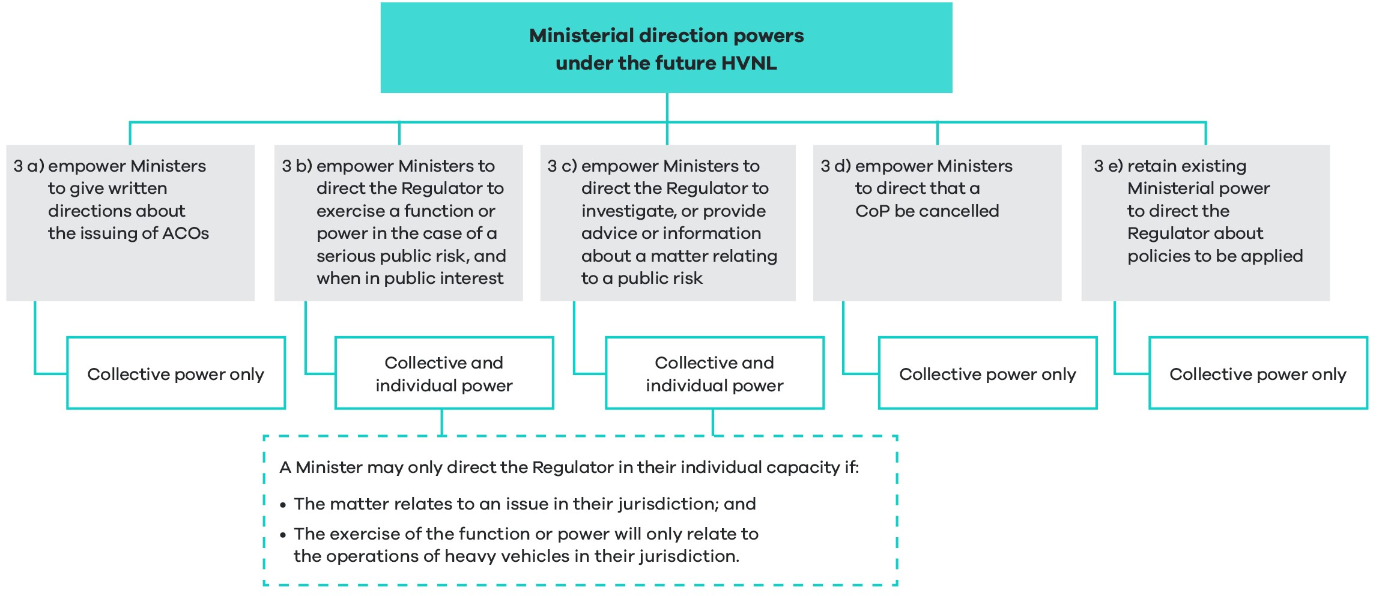

3a Allow minsters to give directions relating to the issuing or granting of alternative compliance options for accredited operators
The future HVNL will empower ministers to issue written directions about granting ACOs. This provision is intended to give ministers an additional mechanism for setting limits around the use of the ACO power, noting this power will also be constrained by legislative parameters (in regulation), and a safety standard threshold (as discussed under recommendation 1b.
The law will be clear that the regulator must follow a ministerial direction with respect to the granting of an ACO. This is a stricter obligation than simply being required to have regard to a guideline, as is currently the case in relation to exemption powers under the HVNL.
ACO ministerial directions may work in a similar way to ministerially approved guidelines and exemption powers. The power will be constructed broadly to allow for directions about a number of matters, but could cover matters such as:
- The matters the regulator must consider when assessing the safety standard threshold of an ACO.
- That an ACO not be issued in breach of certain limits (for example, work and rest hours, mass and dimension).
- That a certain data and technology application be specified as a condition of an ACO (for example, ministers may specify that a greater-than-12-hour driving limit must not be granted unless an operator implements electronic work diaries).
Written ministerial directions for ACOs will be designed to constrain the way the regulator exercises its ACO power and therefore apply before an ACO is granted.
Once an ACO is granted, ministers will still be empowered to direct that the ACO be suspended or revoked, but only if it emerges that the ACO poses a serious public risk and that it is in the public interest to do so (using the power proposed at 3b below).
3b Ministers’ power to direct the regulator to take action in circumstances of a serious public risk and when it is in the public interest
The future law will empower responsible ministers to give directions in particular circumstances, namely:
- where there is a serious ‘public risk’ (as defined in section 5 of the HVNL)
- where ministers consider it is in the public interest to give such a direction.
The power will enable ministers to direct the regulator to do any of the following:
- perform a particular function or exercise a particular power
- perform a function or exercise a power in a manner that is subject to conditions that ministers consider appropriate
- not perform a function or exercise a particular power.
This power will include three limitations, including that the direction should not concern any one of the following:
- a particular person
- a particular heavy vehicle; or
- a particular application or proceeding.
The power will, however, specify one exception to the three limitations, relating to the cancellation of an ACO for a particular operator, or their accreditation. In effect, this will allow ministers to respond swiftly following serious safety incidents involving particular accredited operators.
This power will also allow ministers to direct that a module-based ACO be revoked. This power could be used if ministers were not satisfied that an adequate safety case assessment was carried out before issuing an ACO.
This power will be given to ministers to exercise collectively, or in their individual capacity. However, the ability of a minister to exercise this power individually will be constrained as follows:
- An individual minister will not be able to direct the regulator to perform functions or exercise powers in other jurisdictions.
- An individual minister will may only direct the regulator to perform a function or exercise a power in relation to the operations of heavy vehicles in their jurisdiction.
The regulator will be required to publish a copy of the ministerial direction in its annual report with an explanation of how it complied with the direction.
3c Ministers (individually or collectively) may direct the regulator to investigate, provide advice or information about a matter relating to a public risk
The future law will empower ministers to direct the NHVR to investigate, or provide advice or information about, a matter relating to a public risk. This provision will be similar in form and serve a similar purpose to section 41 of the Rail Safety National Law. Under that provision, ministers are not empowered to:
- Direct the regulator as to how to conduct an investigation.
- Direct the regulator as to which persons the regulator may request, direct, or provide assistance to in investigating a rail safety matter.
- Direct about any outcome of any such investigation
- Direct the regulator to stop any such investigation.
The power proposed is slightly broader than section 41 of the Rail Safety National Law in that the direction may relate to a ‘public risk’ as opposed to ‘a safety matter’. Public risk is defined under the HVNL to cover ‘a safety risk’, or a ‘risk of damage to road infrastructure’ (section 5 of the HVNL).
This power will be given to ministers to exercise collectively, or in their individual capacity. However, a minister will only be empowered to give a direction in their individual capacity if the ‘particular safety matter’ relates to a public risk in their own jurisdiction. The direction must also not result in inconsistent compliance arrangements for a group of operators (that is, more than one operator).
The regulator will be required to publish a copy of the direction in its annual report with an explanation around how it complied with the direction.
3d Empower ministers to direct the regulator to amend or cancel a code of practice, in certain circumstances
The future law will empower ministers to direct the regulator to amend or cancel a CoP, in circumstances where either:
- the CoP creates standards of practice that are unreasonable or impracticable
- the CoP is otherwise not supporting the object of the law.
The future law will also empower ministers to direct the regulator to amend a CoP, in the same above circumstances. However, the regulator will need to consult on any amendments that are not minor or insubstantial.
As discussed under recommendation 4, CoPs will not be mandatory under the future law. Parties will be free to implement equivalent or better risk management practices than those laid out in a CoP. Codes of practice do however have the effect of setting minimum standards of practice, because the law states that a court may have regard to a CoP as evidence of what is ‘reasonably practicable’ to comply with a duty. Therefore, for a CoP to create ‘standards of practice that are unreasonable and impracticable’, it would need to be shown that the CoP ‘sets the bar too high’ and that no alternative means of risk management can be regarded as equal to of equivalent to the CoP.
3e Retain ministers’ current power to give directions about policies, and require the regulator to report back on this as part of their annual report
Section 651 of the HVNL will be preserved under the future law, meaning that ministers will be able to give directions about the application of policies. The same exclusions provided under section 651(2) of the HVNL will apply, meaning the power will not extend to directions about a particular person, a particular heavy vehicle, or a particular application or proceeding.
In addition to the existing requirement for the regulator to publish a copy of a section 651 direction in the annual report, the regulator will also be required to supplement this with an explanation of how it has complied with the direction.
What are the objectives?
Ensure the new safety assurance environment is overlayed with appropriate ministerial oversight
Revised arrangements for ministerial direction powers have been designed to reflect and complement the new safety assurance environment which gives the regulator increased discretion to grant ACOs.
In this context it is necessary that ministers have avenues to set clear parameters for the granting of ACOs, noting that the regulator’s power is already constrained by other factors, including legal permissibility arrangements and the safety standard threshold.
Ensure that ministers can respond adequately in the event of significant or systemic risks to safety
During the Services Transition Assurance Review, jurisdiction representatives expressed concern that the transition of services from state-based authorities to the regulator has removed the ability of individual responsible ministers to direct regulatory action, in particular when major incidents or suspicion of system risks occur.
Noting that ministers are generally responsible for their road network and road safety, these ministers need assurance that the regulator will respond adequately to significant events or systemic risks. However, this should be balanced against the principle of regulatory autonomy and reserved for the most serious of circumstances.
How will the law change?
Current law (the base case)
Section 651 of the HVNL allows responsible ministers to give directions to the regulator about the application of policies in exercising its functions under the HVNL. The law does not specially empower ministers to give directions about performing certain functions or investigating certain events. This is distinct from other transport regulatory environments which allow ministers to give directions about the performance of functions and exercise of powers:
- ‘in relation to the performance of functions and exercise of powers’ (section 14 of the Australian Communications and Media Authority Act 2005 (CTH))
- ‘to investigate, or provide advice or information about, a safety matter relating to the particular jurisdiction’ (section 41 of the Rail Safety National Law)
- ‘perform a particular function or exercise a power’ (section 22 of the Road Management Act 2004 (VIC)).
Future law
The future law will establish a new ministerial direction power, or potentially several powers to enable ministers to:
- make directions about policies to be applied
- make directions to investigate or provide advice or information about a safety matter
- make directions about the performance of functions and exercise of powers, but only in the advent of a serious safety risk
- make directions about the issuing of ACOs.
What are the impacts?
The expanded ministerial direction powers will serve to provide assurances to ministers and the community that the regulator will exercise its functions within the parameters of ministers’ risk appetite.
The assessment considers impacts at a national level. The costs and benefits will be broadly similar across different states and territories. The specific costs and benefits in each state or territory will depend in part on the nature of the heavy vehicle fleet and its use in each state or territory.
Implementation and transition and evaluations arrangements
New ministerial direction powers will be available to ministers upon commencement of the law.
Recommendation 4 – Codes of practice
That the future law establish new arrangements for codes of practice, replacing the existing industry code of practice mechanism and allowing the regulator to initiate, develop and approve codes of practice.
What is proposed?
- Overview of recommendation 4
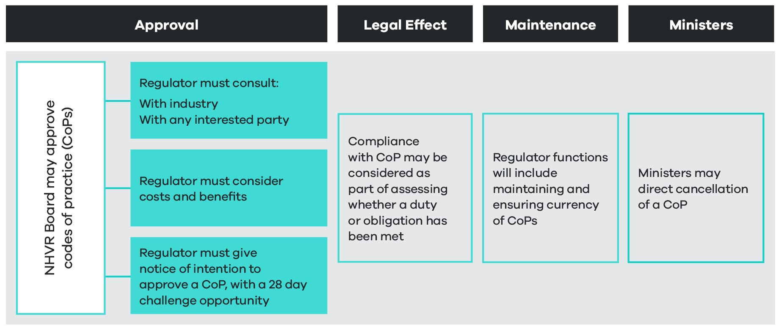
This recommendation has been designed to implement propositions 9.3a and 9.3g of the ITMM reform package. It also builds on recommendations previously agreed to by ministers in December 2021.
A code of practice may be generally defined as a document providing practical guidance on how to comply with legal obligations, often setting out best practice methods for managing safety in a particular industry or area of work.
CoPs are utilised in a variety of regulatory settings, particularly where primary legislation requires compliance with broad-based duties but does not specify particular requirements for managing these duties.
CoPs will play a more prominent role in the future HVNL. As agreed by ministers, this will bring the HVNL into closer alignment with the model WHS laws, where CoPs form one feature of a performance-based regulatory environment geared towards supporting compliance with broad-base duties.
A new CoP mechanism will replace the existing industry CoP mechanism, however the law will require the regulator to consult with industry as part of developing any CoP, and also provide industry with opportunity to challenge a CoP.
The law will empower the NHVR Board to approve CoPs, but only when:
- satisfied that the specified consultation process has been followed
- satisfied that the regulator has adequately assessed the costs and benefits of the CoP
- a notice of intention to approve a CoP has been issued, with a 28-day challenge opportunity.
Initiating a code of practice
The future law will allow for the development of a code of practice to be initiated in three main circumstances – see Table 11.
- Circumstances supported by law for initiating a code of practice
1. Regulator identifies need | 2. Industry proposes development of CoP | 3. Ministers request regulator to develop CoP
The regulator will be able to initiate development of a CoP of its own volition. The regulator may do this to:  - support compliance  - elevate the importance of a particular area of risk management to establish minimum expectations around achieving compliance  - provide general information and managing particular hazards, risks and control measures. | The law will allow an industry party to propose the development of a CoP. The regulator will need to consider the proposal and act on it in good faith, by either:  - Developing the CoP in a timely fashion.  - Providing reasons why the proposed CoP is not necessary or beneficial, including any alternative course of action to help solve industry concerns. | The law will allow ministers to request the regulator to commence the process of developing a CoP.  The regulator will be required to report back to ministers on the progress of the development of the CoP, including any consultation feedback that may prevent the regulator finalising a CoP.
The law may not need to specifically empower ministers to request the regulator to develop a CoP, and the ability of ministers to do this will not be constructed as a ‘direction’ power. While ministers may make this request, a CoP may not be able to proceed due to consultation feedback or cost-benefit analysis findings.
Development, consultation, minor amendments
The law will specifically charge the regulator with responsibility for developing CoPs.
The law will specify that CoPs can only be approved, revoked or varied if a process of consultation is followed. Participating jurisdictions, industry representatives, and all interested people, bodies and organisations (including other government agencies, relevant road managers and police) will need to be consulted as part of this process, and the regulator will also be required to consider any comments provided as part of consultation.
The law will specify a minimum 28-day timeframe be provided for comment on the proposed CoP.
The law will provide that amendments can be made without consultation if, and only if, the amendment is minor, editorial and does not alter the meaning of the CoP.
Approval, revocation and challenge
The future law will:
- Empower the NHVR Board to approve codes of practice, but only:
- once satisfied that the specified consultation process has been followed
- once satisfied that an adequate cost-benefit analysis has been carried out
- when a notice of intention to approve a CoP has been issued, with a 28-day challenge opportunity.
The law will state that a party may challenge the implementation of a CoP if they are not satisfied that a proper consultation process has been followed. The NHVR Board will then be required to consider the challenge as part of determining whether it is satisfied that the consultation process has been followed.
The law will also empower the NHVR Board to revoke a CoP. The board’s power to do this will be dependent upon the same process of consultation, notice of intention to revoke and opportunity to challenge.
Legal effect and evidentiary value
Codes of practice will not be mandatory under the future HVNL. CoPs do, however, have the effect of establishing minimum expectations of practice and therefore can have a regulatory impact.
The current HVNL states that a registered industry CoP is admissible as evidence of whether or not a duty or obligation under the HVNL has been complied with (section 632A(2) of the HVNL), and that the court may have regard to the CoP as evidence of what is known about a hazard or risk, risk assessment or risk control. It may also rely on the CoP to determine what is reasonably practicable, which is relevant to an assessment of whether the Primary Duty has been breached. This model is also used in the model WHS laws (section 275) and the Rail Safety National Law (section 250). It is intended to retain these principles in the new CoP mechanism.
To be clear, CoPs under the future HVNL will not be used as a deemed-to-comply mechanism, although in most instances compliance with a CoP will amount to strong evidence of that a duty has been met.
Maintaining codes of practice
The law will state that as part of the regulator’s function to develop CoPs comes an added obligation to maintain CoPs. This should encourage the regulator to be proactive about proposing to revoke CoPs when they no longer serve their intended purpose or where they impose an unnecessary regulatory burden on regulated parties.
Ministers’ ability to direct that a code of practice be cancelled
As set out under proposition 3d, the ITMM reform package recommended that ministers should have the ability to cancel a CoP. Noting that CoPs can have a regulatory impact, it is proposed that this should only happen in particular circumstances, for example where either:
- the CoP creates standards of practice that are unreasonable or impracticable
- the CoP is otherwise not supporting the object of the law.
What are the objectives?
During the HVNL Review stakeholders raised that the current industry CoP process under the HVNL is complex and inefficient.
As at end-April 2023, only three CoPs are registered:
- The Master Register Code of Practice (Master Code) was developed by the Australian Trucking Association and the Australian Logistics Council and was registered on 23 November 2018.
- The Tasmanian Agricultural and Horticultural Registered Industry Code of Practice was developed by the Tasmanian Farmers & Graziers Association on 30 June 2022.
- The Managing Effluent in the Livestock Supply Chain Registered Industry Code of Practice was developed by the Australian Livestock and Rural Transporters Association on 23 December 2022.
In relation to the Master Code, smaller operators raised that it was developed with input from large operators, with limited opportunity or consideration of simpler operations.
The HVNL is also deficient in that it does not allow the regulator to initiate the development of a CoP when it identifies opportunities to:
- Develop a CoP to support parties to comply with the primary duty, which is drafted broadly to capture new and emerging risks.
- Elevate the importance of a particular risk by highlighting best practice methods for managing certain risks.
- Provide sector- or party-specific guidance, for example to drivers.
As discussed in chapter 3, the HVNL also fails to provide a clear and coherent compliance regime that is easy for parties to understand.
Codes of practice can be used to offer sector-specific tailored guidance on how to manage risk. They can support drivers and chain of responsibility parties to comply with the HVNL by setting out risk management methods appropriate to specific operating tasks.
With this in mind, the new CoP mechanism has been designed to:
- Support the regulator in delivering a risk-based approach to managing compliance for a diverse range of operators and parties.
- Ensure the regulator is able to develop CoPs responsively and adaptively.
- Ensure that industry still has a role in the CoP process.
How will the law change?
Current law (the base case)
Part 13.2 of the HVNL allows industry parties to develop codes of practice in line with guidelines developed by the NHVR. The NHVR may then register an industry CoP for the purposes of the law.
Section 632A of the HVNL provides that a CoP is admissible as evidence of whether or not a duty or obligation has been complied with. Section 632A(3) sets out that a court may have regard to a CoP as part of assessing what would have been reasonably practicable as part of complying with a duty.
The law does not empower the NHVR or any other party to develop a CoP of its own volition. This differs from other transport and safety regulatory environments, for example, rail and work health and safety, which allow regulators and others to develop CoPs which are then approved by ministers.
Future law
The future law will specifically empower the NHVR Board to approve codes of practice.
If necessary, the law may also clarify that it is part of the NHVR’s role to develop CoPs.
The law will specify that a CoP may not be approved unless:
- The required consultation process has been followed.
- An adequate cost-benefit analysis has been carried out.
- A notice of intention to approve a CoP has been issued, with a 28-day challenge opportunity.
The law will replicate section 632A of the current HVNL, in effect applying the same legal and evidentiary standard.
What are the impacts?
An enabling environment
While the proposed reform will enable the NHVR to develop codes of practice in the future, this RIS does not consider the regulatory impact of any specific CoP. As such, this reform element may be described as having no direct regulatory impact.
Potential impacts
While noting this proposal does not involve developing a specific CoP, some longer-term improvements of the new CoP can be projected across assessment criteria categories, particularly in the areas of road safety, operational efficiency, and flexibility and responsiveness, when compared to the base case.
Potential improvements
A key area of difference from the base case relates to the regulator’s ability to initiate the development of CoPs in response to emerging safety risks, or where it identifies an area where industry would benefit from specific guidance on how to manage obligations.
Codes of practice have potential to support a more coherent and clear compliance environment, where parties receive sector-specific and potentially party-specific guidance on how to manage obligations under the law. For example, the regulator may develop:
- A CoP providing guidance to drivers on how to manage fatigue as part of their general duty to avoid driving while fatigued (section 228 of the HVNL).
- A CoP directing particular attention to the issue of managing driver competency.
- A CoP providing specific risk management advice to specific sectors such as waste management, mining or food industry transport.
Both of these changes may indirectly make obligations clearer and easier to understand and drive an increased rate of compliance (assessment criteria 3b).
When compared to the base case, the new approach to developing CoPs is likely to reduce operational and administrative costs for both industry and government (assessment criteria 3a, 4a, and 4b). It is widely agreed that the industry CoP process has been cumbersome, time consuming and ineffective. While the regulator will be required to consult on any new proposed CoP, this is likely to be a more seamless process than the base case which relies on an industry-led consultation process and a regulator registration procedure.
Potential negative impacts
It is plausible that the regulator may have some minimal increased administrative costs associated with maintaining and updating CoPs. The scale of this impact will depend on the extent to which the regulator utilises this power, but costs associated with this are unlikely to exceed existing costs around issuing and maintaining regulatory advice, and are also likely to be offset by benefits around reduced administration for industry CoPs (assessment criteria 4b).
Implementation, transition and evaluation arrangements
Existing Industry codes of practice will be reviewed by the regulator and transitioned to the new environment. Any changes will be subject to consultation and challenge, following the process laid out above.
The assessment considers impacts at a national level. The costs and benefits will be broadly similar across different states and territories. The specific costs and benefits in each state or territory will depend in part on the nature of the heavy vehicle fleet and its use in each state or territory.

Recommendation 5 – Improvement notices
That the future law revise arrangements for improvement notices to allow improvement notice and prosecution processes to run concurrently.
What is proposed?
The future law will retain existing improvement notice provisions but remove section 573(3). This will allow improvement notice and prosecution processes to run concurrently. The Regulator will be able to:
- commence proceedings against a party, even where an improvement notice has been issued for the same offence; and
- issue an improvement notice, even while prosecution proceedings are underway for the same offence
Consistent with the WHS Model Law, the future HVNL will also clarify that as part of an improvement notice a party may be required to implement a code of practice.
What are the objectives?
During the HVNL Review the regulator raised that section 573(3) of the HVNL creates perverse policy outcomes for both industry parties and government.
Improvement notices and prosecution are used as complementary regulatory tools in a variety of regulatory contexts. Unlike section 573(3) of the HVNL, section 191 of the model WHS laws does not prevent offence proceedings while an improvement notice is on foot. Section 178 of the Commercial Passenger Vehicles Act 2017 (VIC) goes further and specifically states that the issue of an improvement notice does not prevent offence proceedings. These arrangements enable an ongoing contravention to be immediately remedied while an investigation occurs and, if appropriate, a prosecution is finalised.
Part of the policy rationale for section 573(3) of the HVNL was to ensure that parties are afforded an opportunity to comply with an improvement notice and rectify a breach before being proceeded against. In practice, the regulator has raised that if a prosecution is on foot but a safety risk needs to be remedied for the same contravention, the regulator is forced to employ tools further up the enforcement pyramid, including:
- issuing a prohibition notice
- an enforceable undertaking may be entered into
- the court may need to issue a supervisory intervention order.
These mechanisms are cumbersome and costly for all parties involved. Prohibition notices can effectively shut an operation down. Enforceable undertakings and supervisory intervention orders often contain similar terms to improvement notices but are less responsive and more expensive for both the regulator and the prosecuted party.
In contrast, the Rail Safety National Law, like the model WHS laws and Commercial Passenger Vehicles Act 2017 (VIC) , recognises that duties proceedings (and associated investigations) can take time and that improvement notices can be utilised during this period to remedy certain risks to safety. This is particularly relevant in the context of primary duty proceedings whereby several safety risks may be identified and easily remedied, notwithstanding the need to continue primary duty proceedings to address systemic issues of non-compliance.
On this basis, the objectives of this reform are to:
- Bring improvement notice provisions into closer alignment with other regulatory environments, including WHS, commercial passenger vehicles, and rail.
- Support the regulator and police with the right tools to implement a risk-based approach to managing compliance.
- Ensure the regulator and police can respond to existent safety risks with proportionate measures.
How will the law change?
Current law (the base case)
Section 573(3) of the HVNL states that a person who is given an improvement notice cannot be proceeded against for an offence constituted by the contravention unless the improvement notice is not complied with or the improvement notice is revoked.
This provision of the HVNL differs from improvement notice provisions in other regulatory contexts:
- Model WHS laws (sections 191-194): allows inspectors to issue improvement notices requiring a person to remedy or prevent a likely contravention of the law. This provision is not constrained by the advent of a prosecution.
- Commercial Passenger Vehicles Act 2017 (VIC) (section 178): explicitly states that the service of an improvement notice does not have any effect on a proceeding for an offence against the Act or regulations.
- Rail Safety National Law (section 175): sets out a similar improvement notice mechanism to the model WHS laws. If the regulator is of the opinion that the action is likely to result in significant costs or expenses, section 175(3) requires a cost-benefit analysis of the improvement notice action. This mechanism is not otherwise constrained by the advent of a prosecution.
Future law
Improvement notice provisions are likely to remain substantially the same under the future law. Section 573(3) of the HVNL will simply be removed.
What are the impacts?
Potential impacts
The regulator utilises improvement notices to secure compliance as part of its incident-triggered enforcement approach. While this element of the regulator’s intervention strategy is directed towards parties whose risk profiles indicate a history of noncompliance, improvement notices are less punitive than other enforcement measures, such as enforceable undertakings and prohibition orders.
This recommendation is intended to remove a barrier for the issuing of improvement notices to parties in order to secure compliance and remedy an immediate safety risk.
The potential expansion of the use of improvement notices to secure compliance is projected to have positive impacts in road safety, regulatory burden for industry and costs to government.
Some parties may perceive that the proposal to allow the regulator to run a prosecution process may undermine the overall rationale of improvement notices, which in theory should allow a party the opportunity to remedy a safety risk.
The impact of this proposal in the areas of operational efficiency and productivity, asset and environmental protection, and flexibility and responsiveness, are likely to be neutral.
Potential improvements
Improvement notices are often the most appropriate regulatory intervention for securing timely compliance and mitigation of an ongoing safety risk. Prosecution processes are often long and drawn out, during which time a party may continue to pose a risk to road infrastructure and the community.
Allowing the regulator and police to run improvement notice and prosecution processes concurrently will likely improve road safety through direct remediation of ongoing and identified risks to safety (assessment criteria 1c). This will be of particular utility for parties whose profile indicates a history of lower-level noncompliance that nonetheless pose a safety risk to the community and warrant prosecution, but where a prohibition notice or enforceable undertaking may not be a disproportionate response (assessment criteria 1d).
Allowing the regulator and police to exercise more proportionate regulatory interventions will also result in productivity improvements and reduce the regulatory burden for industry. This reform will potentially reduce the likelihood of the regulator or police issuing a prohibition notice to a party. The regulator reports that prohibition notices can effectively shut a company down or come at a high cost.
Similarly, this reform may also reduce the likelihood of being issued an enforceable undertaking or a court-issued supervisory intervention order in response to a safety breach. Both of these interventions involve a time-intensive and costly exchange between the regulator or police, regulated parties and the court (assessment criteria 3a and 4a).
Potential negative impacts
Some parties may perceive that the ability to commence a prosecution after an improvement notice is issued removes an incentive to comply with an improvement notice, in effect undermining the rationale of this provision.
In effect, compliance with an improvement notice can sometimes be a mitigating factor in sentencing. This potentially creates a stronger incentive to comply with an improvement notice. Furthermore, a prosecution for a contravention of the HVNL would not dissolve the ability of the regulator to further prosecute an offence for failing to comply with the terms of an improvement notice, so this incentive to comply with the improvement notice remains.
The assessment considers impacts at a national level. The costs and benefits will be broadly similar across different states and territories. The specific costs and benefits in each state or territory will depend in part on the nature of the heavy vehicle fleet and its use in each state or territory.
Implementation, transition and evaluation arrangements
The NTC will proceed with developing drafting instructions to remove section 573(3) of the law.
The regulator will be able to rely on new improvement notice arrangements on commencement of the future law.
If necessary, transition provisions will make it clear that the new improvement notice arrangements are able to be relied on in relation to proceedings commenced prior to commencement of the future law.

Summary impact analysis
Table 12 summarises the impact analysis for the regulatory framework recommendations.

- Regulatory framework recommendations – summary impact analysis, including impact category
RECOMMENDATION | Overall impact | Public safety | Improvements to operational efficiency or productivity | Regulatory burden for industry | Regulatory costs for government | Asset Manage-ment | Flexibility and responsiveness
1 – Tiered safety assurance environment  That the future HVNL establish a tiered safety assurance environment comprising a baseline tier and an alternate compliance tier, designed to reflect industry diversity and deliver regulatory flexibility.  1a – Baseline compliance tier 1  That as part of the tiered safety assurance environment, the future HVNL establish a baseline tier comprised of simplified, predominantly prescriptive requirements, given effect by a broad head of power for the prescribing of heavy vehicle obligations.  1b – Alternative compliance tier 2  That, as part of the tiered safety assurance environment, the future HVNL establish an alternative compliance tier for accredited operators, underpinned by a new power allowing the regulator to issue alternative compliance options, within prescribed outer limits and other specified constraints. | Improvement  The tiered assurance environment will create greater flexibility for industry and will provide improvements to safety and productivity.  For tier 1, there are negligible impacts for industry and government, as changes are structural.  For tier 2, there will be start-up costs for accredited operators who don’t have a NHVAS-compliant safety management system, and for the regulator to administer a more complex, bespoke scheme (see recommendation 7).  Note: Based on the assumption that the regulator uses the new regulatory framework to deliver more diverse ACOs, otherwise the impacts will be negligible. | Large improvement  Improvement for the community by making the law easier for parties to understand and apply, leading to increased compliance and a lower number of crashes.  Improvement for industry, the regulator, and community by increasing responsiveness of the law to address emergent risks.  Improvement for industry as operators can adopt more effective safety management strategies for their business. Improved safety systems are linked to reduced number of crashes and deliver safety benefits for the community.  Greater flexibility for prescribing obligations for off-road parties best able to manage risk, supporting changes in behaviour to lower number of crashes.  Supports risk-based regulation and better enables targeted compliance and enforcement options to deter unsafe practices and encourage safer behaviours and result in a lower number of crashes. | Large improvement  Improvement for industry as tier 2 allows operators more choice on how to manage compliance obligations to realise productivity gains. Reduced cost of moving goods provides benefits to off-road chain of responsibility parties, customers, and the public.  May increase the number of operators that will be able to gain access to alternative compliance options, across all sizes of operations (small, medium, and large), enabling broader productivity gain across the industry. | Improvement  Industry, particularly those participating only in the baseline compliance tier 1, may experience negligible impact of changes to the structure of the law. Over time, industry is expected to have reduced compliance costs as the law is simpler and easier to understand.  Industry operators in the accreditation scheme will incur upfront costs to establish an SMS, (see recommendation 7). Over time, industry may achieve savings depending on the flexibility of ACOs made available under the scheme. SMS costs should also be offset by benefits accrued through increased scheme robustness and reduction in duplicative auditing (see recommendation 2b). | Improvement  For tier 1, there may be administrative costs to government to develop a list of dispensable heavy vehicle obligations. However, these costs will largely be absorbed by existing NTC HVNL maintenance processes.  The flexibility of tier 2 will be more complex for the regulator to administer, incurring upfront costs to set up staff, processes and systems, and ongoing costs to maintain a more complex scheme.  Increased complexity of tier 2 may increase the complexity and costs of on-road enforcement, particularly in the short term. Over time, better targeted, risk-based enforcement will result in a more efficient compliance effort. | Neutral | Large improvement  Better caters to a more diverse range of operators, from those who want simplicity and certainty to businesses with complex operations to manage safety effectively with highly flexible options in place.  The proposed structure of the law and flexibility of Tier 2 will ensure that the law keeps pace with advances in context, technologies, knowledge and practices which benefits the heavy vehicle industry, vehicle and safety technology suppliers, and the regulator and governments.  Enables the regulator to expand and adapt the accreditation scheme to encourage operators to take increased responsibility for managing risk.
2 – Ministerial approvals  That, as part of establishing an appropriate balance of regulatory discretion and ministerial oversight, the future law establish new arrangements for ministerial approvals, such that:  2a In recognition of restructured arrangements for alternative compliance and accreditation, ministers will no longer be required to approve accreditation business rules.  2b As part of enhancements to accreditation, ministers will be empowered to approve a national audit standard to be applied as part of the National Heavy Vehicle Accreditation Scheme, as well as other schemes and third parties. A national audit standard audit certificate will be automatically admissible evidence in primary duty proceedings.  2c The law clarify that consultation requirements apply to the development of ministerially approved guidelines.  2d Ministers will no longer be required to approve a sleeper berth standard, noting this may be prescribed as a heavy vehicle obligation in the future. | Improvement  Enabling mechanisms to support risk-based regulation and the new assurance environment by improving regulator autonomy and discretion and more targeted ministerial oversight and direction.  Note: Does not set out any substantive proposals and may be characterised as having no direct regulatory impact, but benefits may occur over time. | Large improvement  Enables accredited operators to develop and invest in safer management practices under a more robust auditing system which encourages ongoing safety management improvements (assessment criteria 4b).  Assures the community that heavy vehicle safety risks have been addressed with more targeted oversight of the regulator’s activities such as exemption powers (assessment criteria 1d). | Large improvement  Industry will benefit from the opportunity for more efficient business processes based on an expectation that instances of duplicative auditing decline (assessment criteria 3a). | Large improvement  Industry benefits for operators in multiple schemes by reduced administrative burden and overall costs as over time the NAS is intended to support mutual recognition with other schemes (assessment criteria 3a).  Potential benefits in driving down instances of duplicative auditing by allowing schemes and third parties to rely on NAS audits as part of demonstrating compliance with primary duty obligations.  Industry may experience some added costs associated with participation in consultation processes for guidelines, although these processes are voluntary. | Neutral | Neutral | Neutral
3 – Ministerial directions  To enable ministers to appropriately direct the regulator, and without impinging on regulatory autonomy, the future law establish new ministerial direction arrangements, such that:  3a Ministers (collectively) will be empowered to give written directions about the issuing of alternative compliance options.  3b Ministers (individually or collectively) may direct the regulator to exercise a certain function or power in the case of a serious public risk, and when in the public interest to do so.  3c Ministers (individually or collectively) may direct the regulator to investigate or provide advice or information about a matter relating to a public risk.  3d Ministers (collectively) may direct the regulator to cancel a code of practice.  3e Ministers will retain the existing power (collectively) to direct the regulator about policies to be applied. | Neutral  The expanded ministerial direction powers will serve to provide assurances to ministers and the community that the regulator will exercise its functions within the parameters of ministers’ risk appetite.  Does not set out any substantive proposals and may be characterised as having no direct regulatory impact. | Neutral | Neutral | Neutral | Neutral | Neutral | Neutral
4 – Codes of practice  That the future law establish new arrangements for codes of practice, replacing the existing industry code of practice mechanism and allowing the regulator to initiate, develop and approve codes of practice. | Improvement  Guidance to drivers and chain of responsibility parties through CoPs can be provided more efficiently and effectively. This is expected to lead to improved compliance and safer behaviour, helping to reduce crashes.  Note: Analysis assumes that the regulator implements effective CoPs, otherwise impact may be negligible. | Improvement  Public safety benefits as a CoP can be initiated by the regulator in response to emerging safety risks, or where industry would benefit from specific guidance on how to manage safety obligations.  If safety obligations are clearer and easier to understand, this may increase compliance rates, improving behaviour and reducing crashes. | Improvement  Industry may benefit from more efficient process for developing CoPs through reduced operational costs and receiving more effective guidance. | Improvement  Potential benefit to industry by supporting a more coherent and clear compliance environment. | Neutral  Potential for administrative costs to the regulator to update and maintain CoPs, although these are unlikely to be greater than existing costs associated with the regulator issuing and maintaining advice. | Neutral | Improvement  Industry and the regulator benefit from greater flexibility as a CoP can be updated and initiated more efficiently and responsively.
5 – Improvement notices  That the future law revise arrangements for improvement notices to allow improvement notice and prosecution processes to run concurrently. | Improvement  More proportionate regulatory interventions lead to improved safety and productivity outcomes. | Improvement  Likely to improve road safety through direct remediation of ongoing and identified risks to safety. | Improvement  More proportionate regulatory interventions will improve overall productivity. | Improvement  More proportionate regulatory interventions will reduce regulatory burden for industry. | Improvement  More proportionate regulatory interventions will reduce time and cost in the courts. | Neutral | Neutral

Assurance and accreditation

Overview
The previous section provided an overarching regulatory framework for the future HVNL. In particular, recommendation 1 explained the legislative mechanics of a new, tiered safety assurance environment. This proposal included fundamental changes to how alternative compliance options will be developed and issued to accredited operators. This section provides more information about the practical application of the regulatory framework in the context of accreditation. It explains new operator assurance and accreditation arrangements under an enhanced NHVAS and includes a detailed analysis of the scheme's proposed structure, policy arrangements and cost impacts on industry, governments and the community.
Throughout the HVNL Review, stakeholders consistently raised problems with the current assurance and accreditation approach, including:
- Lack of comprehensiveness: the current NHVAS does not encourage a comprehensive approach to managing safety as it does not explicitly require an operator to have a safety management system (SMS). Several incidents, including a fatal crash in Mona Vale, Sydney, in 2013, have revealed that some NHVAS operators do not meet community expectations concerning comprehensive safety management. Furthermore, the NHVAS does not support operators in meeting the full range of obligations under the primary duty.
- Lack of confidence: peak bodies and operators have expressed that because the scheme is not comprehensive, third parties can't be confident they are engaging with a safety-assured operator, partly explaining the rise of duplicative auditing practices, mainly by customers seeking to cover their primary duty obligations.
- Lack of flexibility and utility: modules within the NHVAS are overly prescriptive and do not actively encourage operators to manage the risks associated with their operations. Moreover, NHVAS-accredited operators are currently only provided with limited ACOs, limiting the potential benefits for participating operators.
- Lack of regulatory flexibility: the hardwiring of concessions to accreditation modules limits the ability of the regulator to maximise accreditation as a tool to encourage operators to improve compliance and safety management practices.
The HVNL Review and the Safety and Productivity Program identified limitations in the current NHVAS structure, with several possibilities for improvements to be delivered in the future law.

Policy deliberations
The consultation RIS considered several policy options for an improved accreditation approach. These were:
- Operator enrolment or licensing (consultation RIS Option 7.1). Proposed that operators should be required to enrol with the NHVR or become licensed as operators. This option canvassed four sub-options intended to enhance the NHVR's visibility of the industry:
- Voluntary enrolment (consultation RIS option 7.1a).
- Mandatory enrolment (consultation RIS option 7.1b).
- Operator licensing (all operators) (consultation RIS option 7.1c).
- Operator licensing (higher risk operators only) (consultation RIS option 7.1d).
There was low support for enrolment in schemes and less support for operator licensing due to concerns about cost and regulatory burden to industry with limited safety benefits and a view that the NHVR should have access to data via existing systems for enhanced visibility of regulated parties.
- Remove the regulatory assurance framework and rely on performance standards (consultation RIS option 7.2). Under this option, the NHVAS would be discontinued. Instead, performance standards, which define acceptable outcomes relating to mass, vehicle maintenance and fatigue, would replace prescriptive requirements within the HVNL.
This option was not supported overall by stakeholders. Removing the assurance scheme was seen as a backwards step in recognising industry's efforts and investments in safety management.
- Enhanced opt-in single regulatory certification scheme (consultation RIS option 7.3). Here, the framework of the current NHVAS assurance model would remain.
The NHVR would continue administering the NHVAS, setting the standards and certifying operators that meet those standards using an audit framework. The NHVR will continue to have powers to impose sanctions on certified operators for non-compliance, including suspension from the scheme.
This option received the most support and is considered in greater detail below.
- Enable multiple regulatory certification schemes (consultation RIS option 7.4). This option focuses on changing the assurance framework to recognise assurance schemes other than the NHVAS that meet the necessary standards.
This option was not supported, with concerns including the ability of non-regulatory agencies to enact regulatory concessions and added complexity if drivers and operators had to enrol in many schemes to meet contractual requirements.
The Kanofski Report reinforced the policy option supported in the consultation RIS, specifically, 'a single voluntary certification scheme to give operators the flexibility to meet compliance obligations, administered by the NHVR'. The ITMM reform package included:
- The new certification scheme will be an improvement on the current NHVAS as it will:
- Create a base level that includes a safety management system requirement.
- Allow the development of a more diverse range of alternative compliance options to better support operator diversity.
- Introduce a better compliance regime, including a national audit standard, to help to reduce the need for multiple audits requested by customers to meet their chain of responsibility obligations.

Future work
This RIS establishes a framework for an improved NHVAS as part of the tiered assurance environment. It analyses the impacts of restructuring the scheme around a core safety management system requirement and a new national audit standard.
Further work will be carried out on developing policy detail around SMS requirements for HVNL regulations. Other subordinate instruments, such as guidelines for detailed SMS criteria, will need to be developed.
The new regulatory framework will allow the regulator to develop and issue alternative compliance options. It is anticipated that existing ACOs will be adapted into the new regulatory framework, ready for the commencement of the future law. It is also envisaged that the regulator will develop a limited set of additional, more flexible ACOs for the commencement of the new law.
To facilitate this, future regulatory impact analysis processes will focus on establishing outer limits for ACOs (to be specified in regulations) and risk-area standards, which will also set the foundations for developing modules and associated ACOs.
Further work is needed to develop the NAS to be approved by ministers. The regulator will develop the NAS in consultation with industry and jurisdictions to guide audits of varying scope and scale, including those conducted by large audit teams. The NAS will be underpinned by an SMS approach and adopt the international standard ISO 19011 Guidelines for auditing management systems.

Assessment of policy recommendations
This section of the RIS provides information and analysis of recommendations to increase confidence, trust and robustness in the current NHVAS.
The enhanced NHVAS is a foundational feature of the Alternative Compliance Tier within the tiered safety assurance environment outlined in recommendation 1b. To gain access to ACOs, an operator must be accredited under the new NHVAS.
Figure 16 provides an overview of recommendations, emphasising the most fundamental enhancements to the NHVAS and the transition process for current NHVAS operators.
- Overview of recommendations for assurance and accreditation
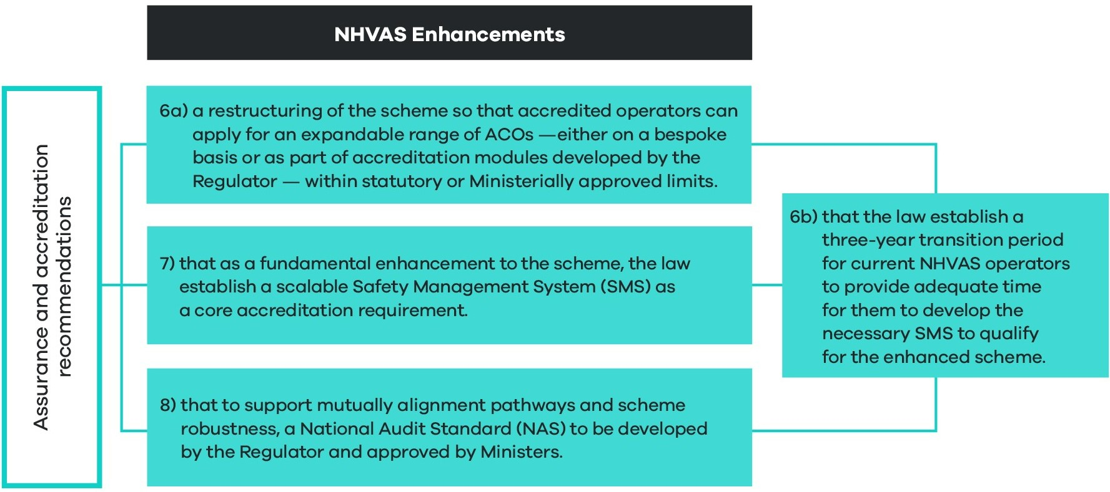
Like the current NHVAS, the future scheme will be a single opt-in scheme administered by the NHVR. It will retain the strengths of the current scheme.
The long-term objectives of the NHVAS are linked to the object of the HVNL (section 3). They include:
- Improving public safety.
- Increasing the productivity of the transport industry through the adoption of sound risk management practices by participants.
- Improving efficiency for participants.
- Managing the impact of heavy vehicles on the environment, road infrastructure and public amenity.
Recommendations 6a, 7 and 8 set out key enhancements to the scheme, including:
- Recommendation 6a: a new alternative compliance environment.
The future law will create a more flexible alternative compliance environment, enabling development of a diverse range of ACOs.
This environment will enable development of modest ACOs for less complex operators to enter the scheme. It will also enable development of more flexible ACOs for more sophisticated operators.
- Recommendation 7: a safety management system core requirement.
The future law will require an operator to demonstrate implementation of an effective SMS as a gateway requirement for accreditation under the NHVAS. A risk-based and scalable SMS approach to operator assurance that offers flexibility for industry.
- Recommendation 8: a national audit standard.
The future law will allow ministers to approve a NAS, designed to improve audit outcomes.
The NAS will be designed to be applied by non-HVNL schemes and also third parties as part of meeting primary duty obligations. This in turn should help drive down instances of duplicate auditing.
Implementation, transition, and evaluation arrangements
Future regulatory impact assessment processes will focus on:
- Developing outer limits for ACOs, to be specified in regulations.
- Developing risk area standards for accreditation modules, also to be specified in regulations.
- Revising existing ACOs and, where appropriate, adapting them to the new regulatory environment.
During this phase the regulator will also develop and consult on the NAS, to be approved by ministers. It is also envisaged that an initial suite of additional ACOs (offering increased flexibility) will also be developed, ready for commencement of the future law.
Recommendation 6a outlines that a three-year transition period will apply to current NHVAS participants to provide adequate time for operators to qualify for the enhanced NHVAS. This will allow NHVAS operators to develop and implement an SMS that complies with the SMS gateway requirement.

Recommendation 6a
That as part of the new alternative compliance tier (recommendation 1b), the future law restructure the National Heavy Vehicle Accreditation Scheme so that accredited operators can apply for an expandable range of alternative compliance options – either on a bespoke basis or as part of accreditation modules developed by the regulator, within the ministerially approved limits.
Recommendation 6b
That the law ensures a three-year transition period for current NHVAS operators to provide operators adequate time for them to develop the necessary safety management system to qualify for the enhanced scheme.
What is proposed?
Recommendation 1b of this decision RIS provided information about and analysed the impacts of new legislative mechanisms for alternative compliance under the future law. Fundamentally, this will involve transitioning from the approach of hardwiring ACOs into regulation to allowing the regulator to issue ACOs within set limits determined by ministers and parliament.
Recommendation 6a expands on recommendation 1b and provides information about how a new and enhanced NHVAS will work in practice. Figure 17 provides an overview of the key elements of this recommendation.
Under recommendation 6b, transitional arrangements for NHVAS participants will allow existing NHVAS operators to have their accreditation and associated regulatory concessions recognised until the operator's first scheduled audit, three years from the commencement of the new accreditation scheme.
The regulatory framework will enable the continuation of current ACOs and introduce several new and more flexible options.
- Key elements of restructured NHVAS
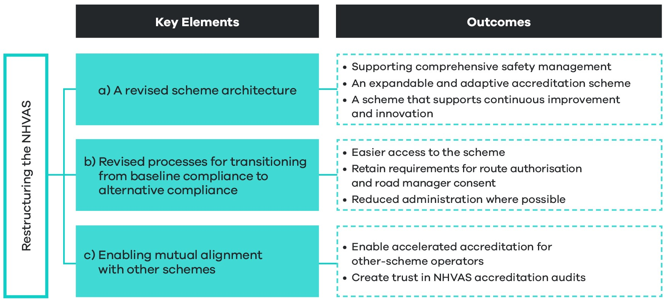
The role of the NHVAS in the tiered safety assurance environment
As outlined, instead of hardwiring ACOs into law and regulation, the future law will empower the NHVR to issue ACOs to accredited operators either:
- in relation to an accreditation module
- on an individual, bespoke basis where a safety case and unique business need can be demonstrated.
To become accredited an operator will first need to demonstrate that they have implemented an effective SMS in line with certain requirements (detailed under recommendation 7). This new SMS requirement forms a fundamental pillar of the scheme, designed to improve safety performance indicators for accredited operators and fundamentally generate trust in the scheme for governments, industry and the community.
It is against this backdrop of increased safety performance and scheme robustness that the new tiered safety assurance environment will offer increased discretion to the regulator to develop and issue ACOs. Over time, this new environment will allow the regulator to gradually expand available ACOs, in line with changing business practices, advancing technology, and increasing sophistication of heavy vehicle operations. Similarly, this new regulatory environment will also allow the retirement of certain ACOs if they become obsolete or if they cease to deliver value to industry, governments and the community.
6a A revised scheme architecture
New arrangements for alternative compliance, coupled with SMS and auditing enhancements, will result in a fundamental restructuring of the scheme that will change the architecture of risk-based modules and tools available to the regulator to use accreditation as a tool for encouraging continuous improvement. An overview of fundamental roles and responsibilities for parties interacting with the scheme is summarised below.

Roles and responsibilities for parties interacting with alternative compliance options under the enhanced NHVAS
Regulatory framework: will establish mechanisms to ensure that ACOs do not result in a lower standard of safety, or breach particular outer limits. The framework will also set out high level standards that must be met as part of issuing an ACO (risk area standards).
Ministers: Will be able to provide additional directions about the issuing of ACOs, or the cancellation of ACOs.
The regulator: Will be able to develop modules that align with high level risk area standards specified in regulation and issue ACOs within the parameters specified in primary law, regulations, and any ministerial direction. These modules may specify more detailed standards, and conditions that need to be satisfied in order to be issued an ACO as part of the module. The regulator will also continue to administer an NHVAS audit program that applies the NAS. It will also continue to provide operational guidance to scheme participants.
Road managers: Will still provide route authorisation and consent in relation to any relevant mass ACO.
Operators: Will need to demonstrate implementation of an effective SMS as part of their application for accreditation. As part of this application, they may also apply for ACOs. Confirmation that a NAS audit has been carried out will be required to demonstrate they have been audited against the SMS requirements and any specific module requirements for ACOs.
Third parties: Will be able to draw on the NAS as an indicator that an operator has an effective SMS and gain assurance that the operator has effective systems in place to meet requirements under the primary duty.
Non-HVNL accreditation schemes: Will be able to align scheme requirements with NHVAS SMS and module requirements, in turn allowing the regulator to develop accelerated accreditation pathways for these operators, including access to ACOs.
How modules will work as part of the new National Heavy Vehicle Accreditation Scheme
The SMS gateway requirement and new arrangements for ACOs will fundamentally change how modules work under the scheme.
As outlined, instead of hardwiring ACOs and their associated modules into law and regulation, the future law will empower the NHVR to issue ACOs to accredited operators in relation to accreditation module.
As part of this power, the regulator will be able to create modules. These modules must align with sets of risk area standards set out in regulation. The law will not restrict the regulator regarding the architecture of modules. Feasibly, the regulator may establish a library of modules related to risk area standards. Figure 19 provides a worked example of how fatigue-based modules and associated ACOs may be developed by the regulator as part of the future law.
- Arrangements for developing accreditation modules, supported by law (fatigue example)
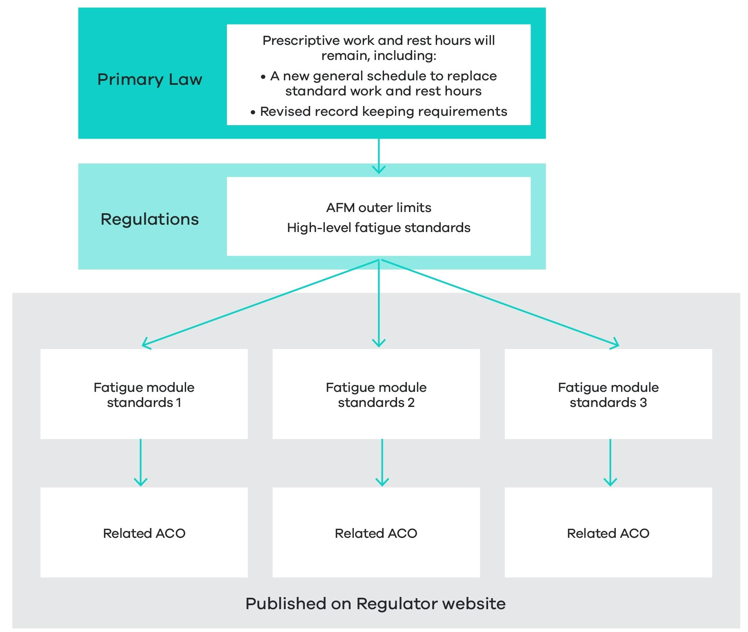

As flagged under recommendation 1b, the new regulatory environment will also allow the regulator to develop modules that do not lead to ACOs. For example, modules around driver competency, driver health and fitness, environment and sustainability may be developed at the regulator’s discretion. The development of these modules would not be constrained by risk area standards or by outer limits set in regulation, because they would not give rise to an ACO.
There is potential for the regulator to use this mechanism to establish ‘highest standard’ risk management practices in certain areas. Operators may see value in becoming certified in a non-ACO module, particularly if customers specify that an operator should be accredited under such a module as part of procurement arrangements.
The relationship between the safety management system gateway requirement and risk-based modules
As discussed under recommendation 7, an SMS (by definition) represents a comprehensive and systematic approach to managing safety. An effective SMS should address all risks relevant to a particular heavy vehicle operation. As such, if an operator applies to access certain ACOs as part of a risk area module, the module standards and relevant conditions will need to be embedded into an operator’s overall SMS.
Recommendation 7 explains that the SMS gateway requirement will be constructed around five SMS standards and a non-exhaustive list of risks to be managed that align with what is required to be managed under the primary duty. The SMS requirement will be designed so that it is scalable to suit a range of operators of varying size and complexity. By contrast, risk area modules will set out standards and conditions required to access certain ACOs.
Critically, an operator will not need to be assessed twice in relation to the SMS and module-specific requirements. Rather, the regulator will assess the SMS holistically, embedding the module-specific requirements into the overall assessment.
Accreditation as a tool to support innovation and continuous improvement
The new regulatory environment will be designed to allow the regulator to deploy accreditation as a tool to support innovation and continuous improvement.
Accreditation modules and associated ACOs will be expandable and contractable over time. With technological advances and associated reforms to better recognise certified technology under the HVNL, the regulator can develop ACOs with associated conditions that specify and therefore incentivise the use of particular technologies.
The legal mechanics of the new regulatory environment will also allow the regulator to suspend or cancel certain ACOs for particular operators without also cancelling their accreditation. This is a change from the current HVNL which, as a result of hardwiring modules and ACOs into the law, requires the regulator to cancel an operator’s accreditation in order to remove that operator’s access to the ‘alternative compliance arrangement’ or the regulatory concession associated with an accreditation module (or both). This can result in perverse compliance or safety outcomes, as accreditation allows the regulator to maintain visibility of an operator and partner with them to improve safety management outcomes.
6b Revised processes for transitioning from baseline compliance to alternative compliance
While this RIS provides information about and analyses the impact of legislative mechanisms to enable the development of ACOs in the future, further regulatory impact processes will consider specific ACOs in mass and fatigue. Noting ministers’ commitment to progressing a more flexible suite of ACOs to reflect increasing sophistication and advancement of the sector, it is intended that an initial set of ACOs will be ready for the commencement of the future law.
In addition to setting outer limits, developing an initial set of ACOs will also depend upon policy changes to existing baseline requirements under standard work and rest hours (to be recast as the general schedule) and general mass limits (GML). However, in order to develop these ACOs it will be necessary to assess the degree of flexibility provided against the baseline compliance option.
Notwithstanding the above, it is worth noting the differences in processes to be applied when operators transition from baseline compliance to alternative compliance under fatigue and mass modules, respectively (see Figure 20).
- Transitioning from baseline mass requirements to alternative compliance mass requirements
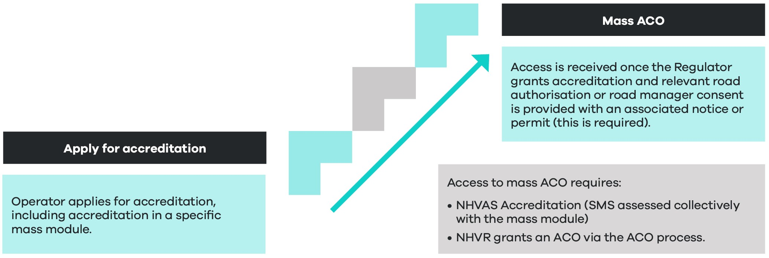
Details around the process of transitioning from baseline mass requirements to alternative mass requirements will be dependent upon further work on existing categories of general mass limits (GML), concessional mass limits (CML), and higher mass limits (HML), as well as work on a new vehicle classification system for restricted access vehicles (RAVs). Currently under the HVNL, mass-accredited operators may access CML. Operating at HML involves additional conditions, such as road-friendly suspension, and compliance with approved routes. Route access for RAVs is dependent on a permit or notice, with relevant road manager consent, being in effect.
While further policy work may result in changes to or realignment of mass-related vehicle categories, principles around the requirement for route authorisation or road manager consent will be preserved under the future law.
- Transitioning from baseline fatigue requirements to alternative fatigue requirements
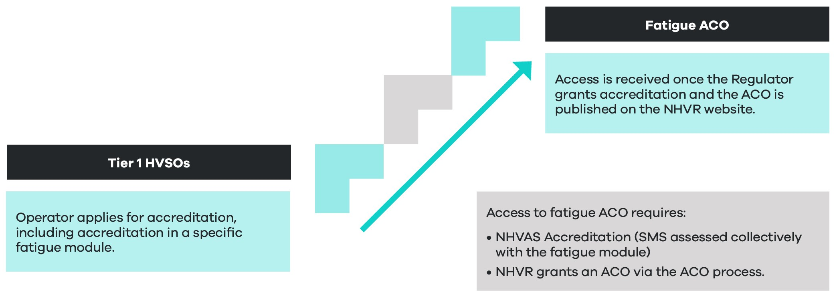
Details around the process for transitioning from baseline fatigue requirements to alternative fatigue requirements, will be dependent upon further work to adjust standard work and rest hours and create a new general schedule (see Figure 21). New work will ensure mass and ACO limits are preserved.
Enabling mutual alignment with other schemes
The regulatory environment for the enhanced scheme is designed to enable mutual alignment with non-HVNL schemes and accelerated pathways for NHVAS accreditation and issuing of ACOs to these operators.
To a large extent, opportunities for mutual alignment will depend upon the extent to which non-HVNL schemes adopt an SMS approach. The Western Australian Heavy Vehicle Accreditation (WAHVA) scheme currently integrates SMS principles, and further work is underway under partnership arrangements between the NHVR and the Western Australian Department of Main Roads to increase areas of alignment.
The NAS will be a fundamental feature of the regulatory environment enabling mutual alignment with non-HVNL schemes. The NAS will be designed agnostically so that it can applied by any SMS-based heavy vehicle accreditation scheme.
Noting the future HVNL will not specifically provide an option for mutual recognition, Figure 22 provides an overview of factors that will drive an increase in mutual alignment of NHVAS and non-HVNL schemes.
- Factors influencing mutual alignment of NHVAS and non-HVNL schemes
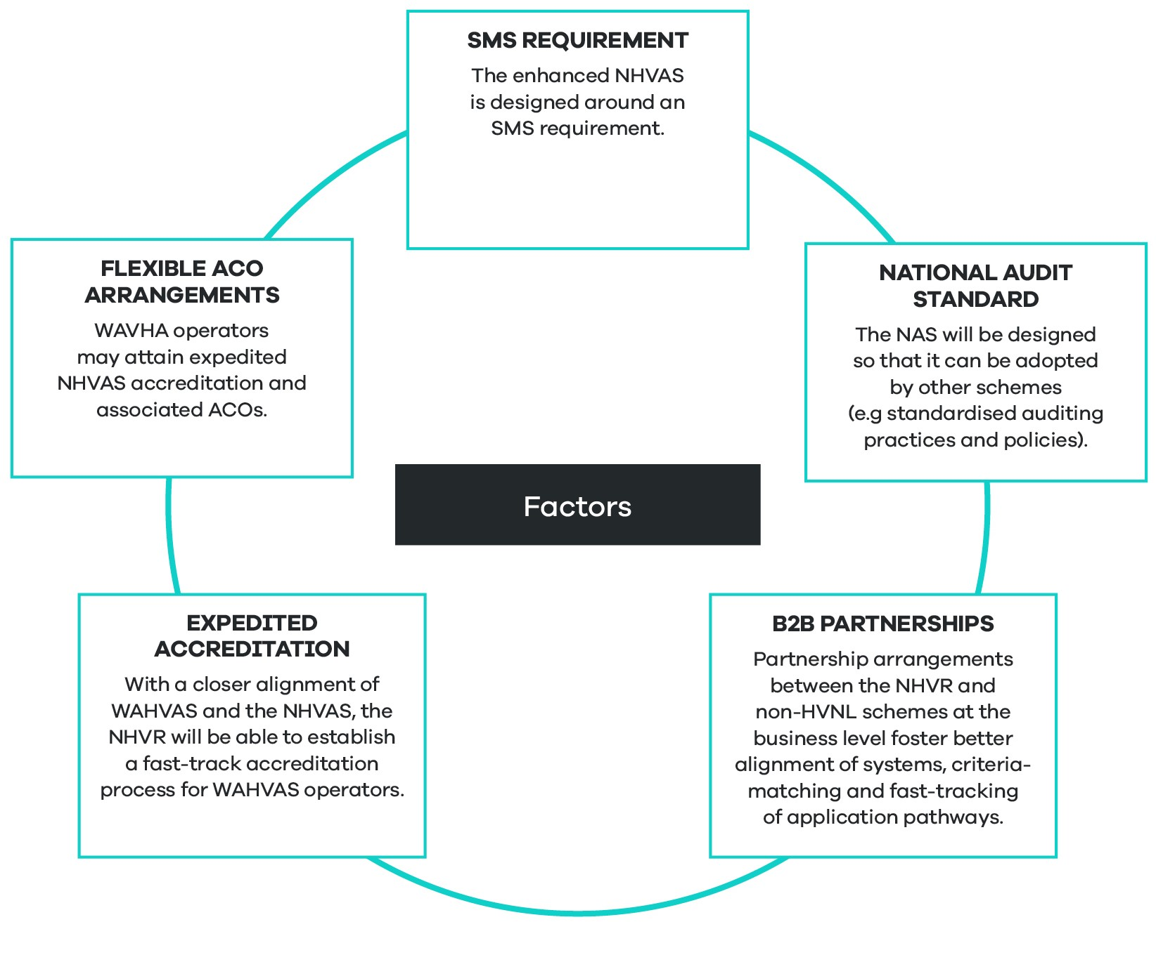
What are the objectives?
The fundamental objective of developing an enhanced NHVAS is to increase the value of the scheme for industry, governments, regulators and the community. For this to occur, the NHVAS should deliver improved safety performance outcomes from the heavy vehicle sector and increased flexibility to operators who can manage safety effectively with alternative systems in place. Recommendations 7 and 8 discuss key objectives around improving safety performance and robustness of the scheme. This recommendation centres on enhancing the value of the scheme for operators, with key objectives including:
- Creating an alternative compliance environment that truly supports industry diversity, with a greater range of ACOs to match varied levels of sophistication and types of operation.
- Creating a more adaptive alternative compliance environment that can keep pace with the increasing sophistication of industry and technology advances.
- Enabling the development of ACOs that deliver the flexibility required to incentivise operators to become accredited and advance through higher levels of accreditation as safety management practices improve.
- Allowing the regulator to use accreditation to support and encourage continuous improvement.
- Creating pathways for mutual alignment of non-HVNL schemes, including accelerated accreditation and access to ACOs.
How will the law change?
Current law (the base case)
The HVNL establishes the NHVAS, which gives accredited operators some flexibility to operate outside of certain prescribed regulations within the context of accreditation modules, as follows:
- NHVAS Mass Management: accredited operators can operate above general mass limits, specifically CML and HML.
- NHVAS Basic Fatigue Management (BFM) and Advanced Fatigue Management (AFM): accredited operators receive access to longer working hours and more flexibility in scheduling.
- NHVAS Maintenance Management: accredited operators receive exemptions from annual inspection requirements.
To a large extent, ACOs are hardwired into the law and regulation. This is particularly true for CML, HML, and BFM, which offer alternative schedules of prescriptive requirements.
AFM represents a more flexible approach, whereby the regulator can approve bespoke work and rest hour schedules. However, the process for gaining AFM accreditation is cumbersome and resource intensive and generally not available to smaller or less complex operations, which may still be able to manage safety with the benefit of minor adjustments to the general schedule.
Accreditation and ACOs are also ‘tethered’ together under the current HVNL. For the regulator to take enforcement action to remove an ACO, it must cancel an operator’s accreditation.
The HVNL also does not enable the regulator to expand and adapt ACOs for accredited operators.
Future law
The future law will change from the current HVNL by:
- Allowing operators to apply for an expandable range of ACOs as part of their accreditation.
- Allowing the regulator to develop an expandable range of modules with associated ACOs.
- Decoupling the accreditation process from alternative compliance, such that the regulator can suspend an ACO, without suspending an operator’s accreditation.
What are the impacts?
An enabling environment
As already highlighted, the proposal to restructure the NHVAS involves a series of structural reforms to the HVNL which have no direct regulatory impact.
The proposal in this section outlines how the new regulatory environment will affect the overall architecture of the NHVAS, how modules are developed, how operators may transition between tiers, and how mutual alignment pathways may be created. Specific ACOs are not considered in this RIS.
In addition, ACOs are by nature ‘opt-in’, and, as such, this recommendation can be described as having no direct regulatory impact.
Many of the impacts cited in this section are similar to the impacts highlighted under recommendation 1b.
Potential impacts
While noting the enabling characteristics of this proposal, some longer-term improvements can be projected across assessment criteria categories, particularly in road safety, operational efficiency, and flexibility and responsiveness.
Potential improvements
The proposed changes are projected to deliver benefits including:
- A law that better reflects the diversity of heavy vehicle operators, in turn:
- Allowing operators to realise productivity gains when more flexible or appropriate ACOs are offered to suit their business (assessment criteria 2d).
- Enabling a reduction in risk to overall safety, risk to infrastructure, and overall crash risk by allowing operators to adopt the most appropriate risk management approach for their business (assessment criteria 1e).
- A law that can keep pace with rapid advances in technology and changes across the heavy vehicle transport sector and support innovation, in turn:
- Increasing operational efficiency and productivity gains where operators adopt the most cutting-edge safety management technology (assessment criteria 2d and 6b).
- Supporting an overall reduction in risk to safety and infrastructure, and overall crash risk by ensuring operators are not locked into old and ineffective risk management approaches (assessment criteria 1e).
- A law that will enable the NHVR to expand and adapt the accreditation scheme to encourage operators to take increased responsibility for managing risk (assessment criteria 6b).
- The offer of more attractive and appropriate ACOs should also result in an increased uptake of accreditation. This in turn, should support:
- Improvements in the overall safety of the heavy vehicle fleet and reduction in risk to safety and infrastructure, and overall crash risk, noting that accredited operators will be required to demonstrate they have a safety management system (assessment criteria 1e).
- Increased regulatory visibility of the heavy vehicle fleet, with associated benefits relating to risk profiling and more efficient concentration of regulatory effort on higher risk operators.
- Approved ACOs will enable industry to develop and deploy innovative technology and practices that lower costs. Further enhancement can be realised by introducing the proposed technology and data framework (as outlined in section 5.4).
- ACOs will enable the management of new risks in emergent areas, such as environmental protection. The NHVR will have flexibility under the enhanced scheme to support new environmentally friendly technology and other environmental initiatives.
- A restructured NHVAS improves flexibility and responsiveness for the NHVR to issue ACOs with conditions allowing elasticity for industry by focusing on safety outcomes and minimising prescriptive requirements. Additionally, it provides responsiveness for government to address emerging safety risks, as ACOs offer flexibility against the current rigid module framework.
Potential negative impacts
- While the new regulatory environment gives the regulator more discretion to develop and administer ACOs, this inevitably will involve increased administrative costs and a realignment of regulator resources (assessment criteria 3a and 4a).These costs may be passed onto industry in the form of increased regulatory charges (assessment criteria 3a).
- A more diverse alternative compliance environment is also likely to make enforcement more complex, although it should be noted that there are existing problems around the interaction of authorised officers (including police) and accredited operators (assessment criteria 3b). As discussed previously, accredited operators report that, in some cases, enforcement officers have a limited understanding of ACOs for fatigue available under the NHVAS. Complexities around the enforcement of bespoke AFM schedules will likely continue under the new environment. Nonetheless, the new environment will also enable the regulator to streamline AFM schedules, reducing enforcement complexity (assessment criteria 4b). Enhancements to operator risk profiling systems may counterbalance the negative impacts of complexity of enforcement.
The assessment considers impacts at a national level. The costs and benefits will be broadly similar across different states and territories. The specific costs and benefits in each state or territory will depend in part on the nature of the heavy vehicle fleet and its use in each state or territory.
Implementation, transition, and evaluation arrangements
To ensure continuity for accredited operators, the regulator will adapt existing ACOs to be applied as part of the new regulatory environment.
To deliver on the overall objectives of the new legislative environment, the regulator will also be expected to develop a limited suite of other ACOs, ready for commencement of the new law. The NHVR will evaluate and consult on proposed new ACOs as part of the subsequent RIS process.

Recommendation 7
That, as a fundamental enhancement to the scheme, the law establishes a scalable safety management system as a core accreditation requirement.

What is proposed?
The future HVNL will restructure the new NHVAS around a core SMS requirement. This fundamentally enhances and increases trust in the scheme by ensuring accredited operators implement a comprehensive approach to managing safety.
Research has shown that a well-implemented SMS, predominantly where the organisation invests effort, is associated with enhanced safety performance and improved safety culture and awareness (ATSB, 2011, p 27).
Figure 23 provides an overview of key elements of the SMS core requirement.
- Key elements and outcomes for the SMS core requirement
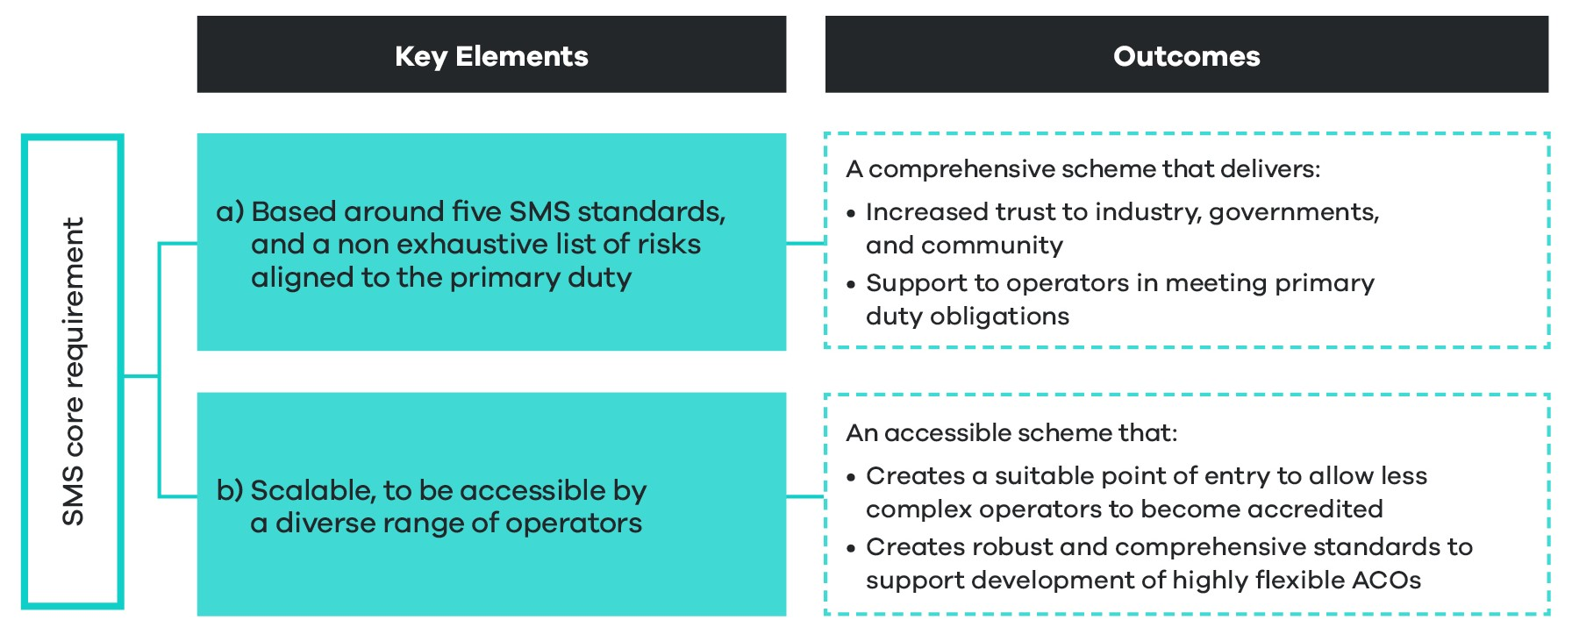

Consistent with international literature, the law will broadly define a ‘safety management system’ as encompassing a systematic approach to managing safety, including the necessary organisational structures, accountabilities, policies and procedures. This is consistent with the NHVR’s current guidance to operators, outlined in Figure 24.
- Safety management system (NHVR, 2021)
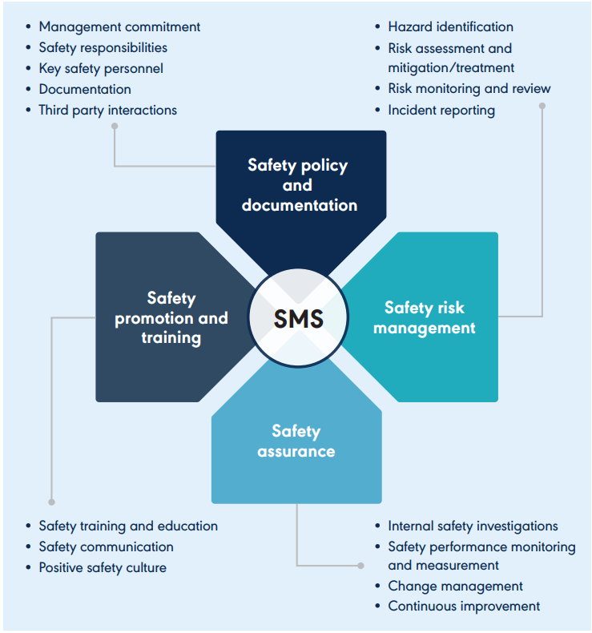

Key foundations: Are based on five safety management system standards, and a non-exhaustive list of risks aligned to the primary duty
The SMS core requirement will be constructed around five SMS standards (SMS core elements) and a list of non-exhaustive risks to be managed in line with each SMS standard. The SMS risk areas will be designed to achieve alignment with the primary duty. At a minimum, these will include:
- fatigue
- mass
- maintenance
- health
- loading
- speed
- competency
- distraction
- any other relevant risk.
Under the enhanced scheme, the regulator cannot grant accreditation to an operator unless it is satisfied that the operator meets the SMS accreditation standards, is managing prescribed risk areas and complies with any other requirements, as set out in regulations, guidelines or the NHVAS business rules.
The law will define an SMS based on five core elements in Figure 25. Core elements were initially proposed by the Medlock Review (2020) and further refined by the NTC and stakeholders via consultation in 2022.
SMS core elements include leadership commitment, risk management, people, safety systems and assurance. These elements will be further tested with industry.
The SMS accreditation elements and a non-exhaustive list of risks to be managed per SMS accreditation standards will be established in regulation and are subject to expansion or change over time.
High-level SMS scheme architecture will include a scalable core SMS requirement where the NHVR assesses an operator’s SMS to determine whether all identified risks are managed comprehensively, commensurate to the operation’s size complexity and nature of the freight task.
It is important to note that while the SMS aligns with the risks identified under the primary duty, NHVAS accreditation does not equate to compliance with the primary duty. Primary duty compliance and upkeep of a well-functioning and non-deteriorating SMS is the ongoing responsibility of the operator and driver.
- Proposed five safety management system core elements as recommended by the Medlock Review – example only
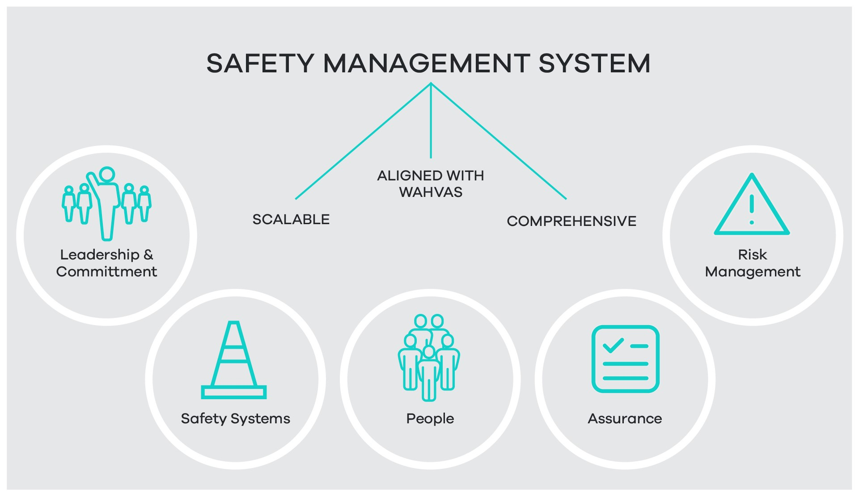

- Leadership and commitment. Demonstrated commitment to the highest safety outcomes based on strong leadership and clear safety responsibilities.
- Risk management. A proactive, outcomes-focused approach to managing the risks associated with transport activities. The adequacy of risk management should be continuously reviewed and revised to ensure that the risks of transport activities are effectively identified and controlled.
- People. Appropriate resourcing is available, and people at all levels of the organisation are fit for duty and have the knowledge, competence and attitude to operate safely and efficiently.
- Safety systems. Appropriate systems are implemented effectively to ensure safe and efficient operations.
- Assurance. Demonstrated competency and capacity of operators to meet their safety duties.
Key element: scalable, to be accessible by a diverse range of operators
The law will ensure that the SMS core requirement is scalable so that operators can develop their SMS relative to their operation’s size, complexity and specific business needs. To achieve this, the SMS standards and specified risks will be drafted with the brevity required to contemplate a diverse range of operators.
As discussed under recommendation 6, the SMS core requirement will be designed so that risk area modules can be embedded into an overall assessment of an operator’s SMS. Figure 26 provides an overview of how the SMS core requirement will interact with risk area modules under the new regulatory environment.
- Overview of scalable safety management system and interaction with modules
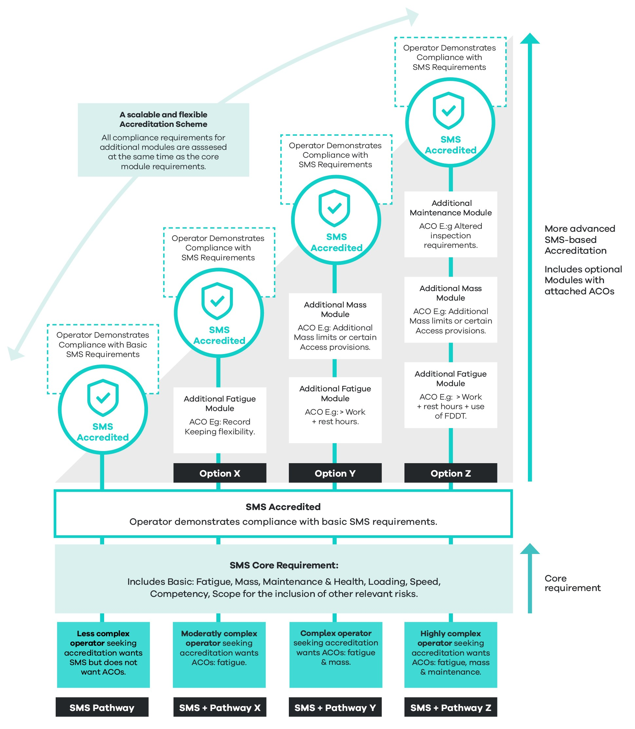
Note – ACOs listed in the above chart are an example only.
What are the objectives?
The SMS core requirement will be designed to achieve:
- A comprehensive scheme that supports operators in meeting their primary duty obligations.
- Increased safety assurance to operators, regulators, governments and the community. Under an enhanced SMS-based scheme, compliant operators will be accredited as having an effective, documented SMS. An NHVAS SMS will provide some assurance that accredited operators are effectively managing their safety risks.
- Scalability, such that a diverse range of operators, from less complex to highly sophisticated, can access the scheme. A risk-based SMS approach to operator assurance offers a clear and coherent compliance regime for operators who prefer the simplicity and certainty of prescriptive regulation. This approach also provides more complex operations with the flexibility to develop a highly sophisticated or bespoke SMS commensurate with the operation’s scale and specific to the freight task.
- Achieving an improved safety culture and improved safety outcomes for industry participants and the community.
How will the law change?
Current law (the base case)
The NHVAS is based on separate risk-based fatigue, mass and maintenance management modules. While NHVAS business rules draw on and integrate several SMS principles, the scheme does not require operators to demonstrate an effective SMS.
A key criticism of the NHVAS is that accredited operators cannot draw on their accreditation management practices to manage their obligations under the primary duty. While the primary duty does not explicitly require the implementation of an effective SMS, it nonetheless requires operators to manage the safety of transport activities so far as is reasonably practicable. In this context, an SMS can be used to indicate that an operator adequately manages primary duty obligations.
The long-term objective of the NHVAS is to improve compliance and road safety. The NHVAS is a formal process for recognising operators with robust safety and other management systems and is also increasingly used to show compliance with general duty requirements under the HVNL.
In addition to requiring certain SMS elements under the NHVAS, the NHVR has developed a suite of guidance tools to assist operators in developing their SMS. These include the following instruments:
- Nine-step SMS roadmap (NHVR, 2022)
- SMS checklist (NHVR, 2018).
- SMS factsheet (NHVR, 2021)
- Introduction to SMS in the heavy vehicle industry guide (NHVR, 2021).
Future law
The law will enshrine the core requirement for an NHVAS-accredited operator to have in place an effective SMS. Consistent with international literature and regulatory approaches in Australian rail, maritime, bus and aviation industries, the law will broadly define SMS as a systematic approach to managing safety, including the necessary organisational structures, accountabilities, policies and procedures. The SMS core module may otherwise be described as a gateway requirement for all other modules in the scheme. Subordinate instruments will detail the industry's requirements and guidance concerning NHVAS SMS compliance.
What are the impacts?
The following section outlines aggregate summary statistics about the existing NHVAS customer profile and broader industry cohorts.

- Current NHVAS customer profile count as of March 2023
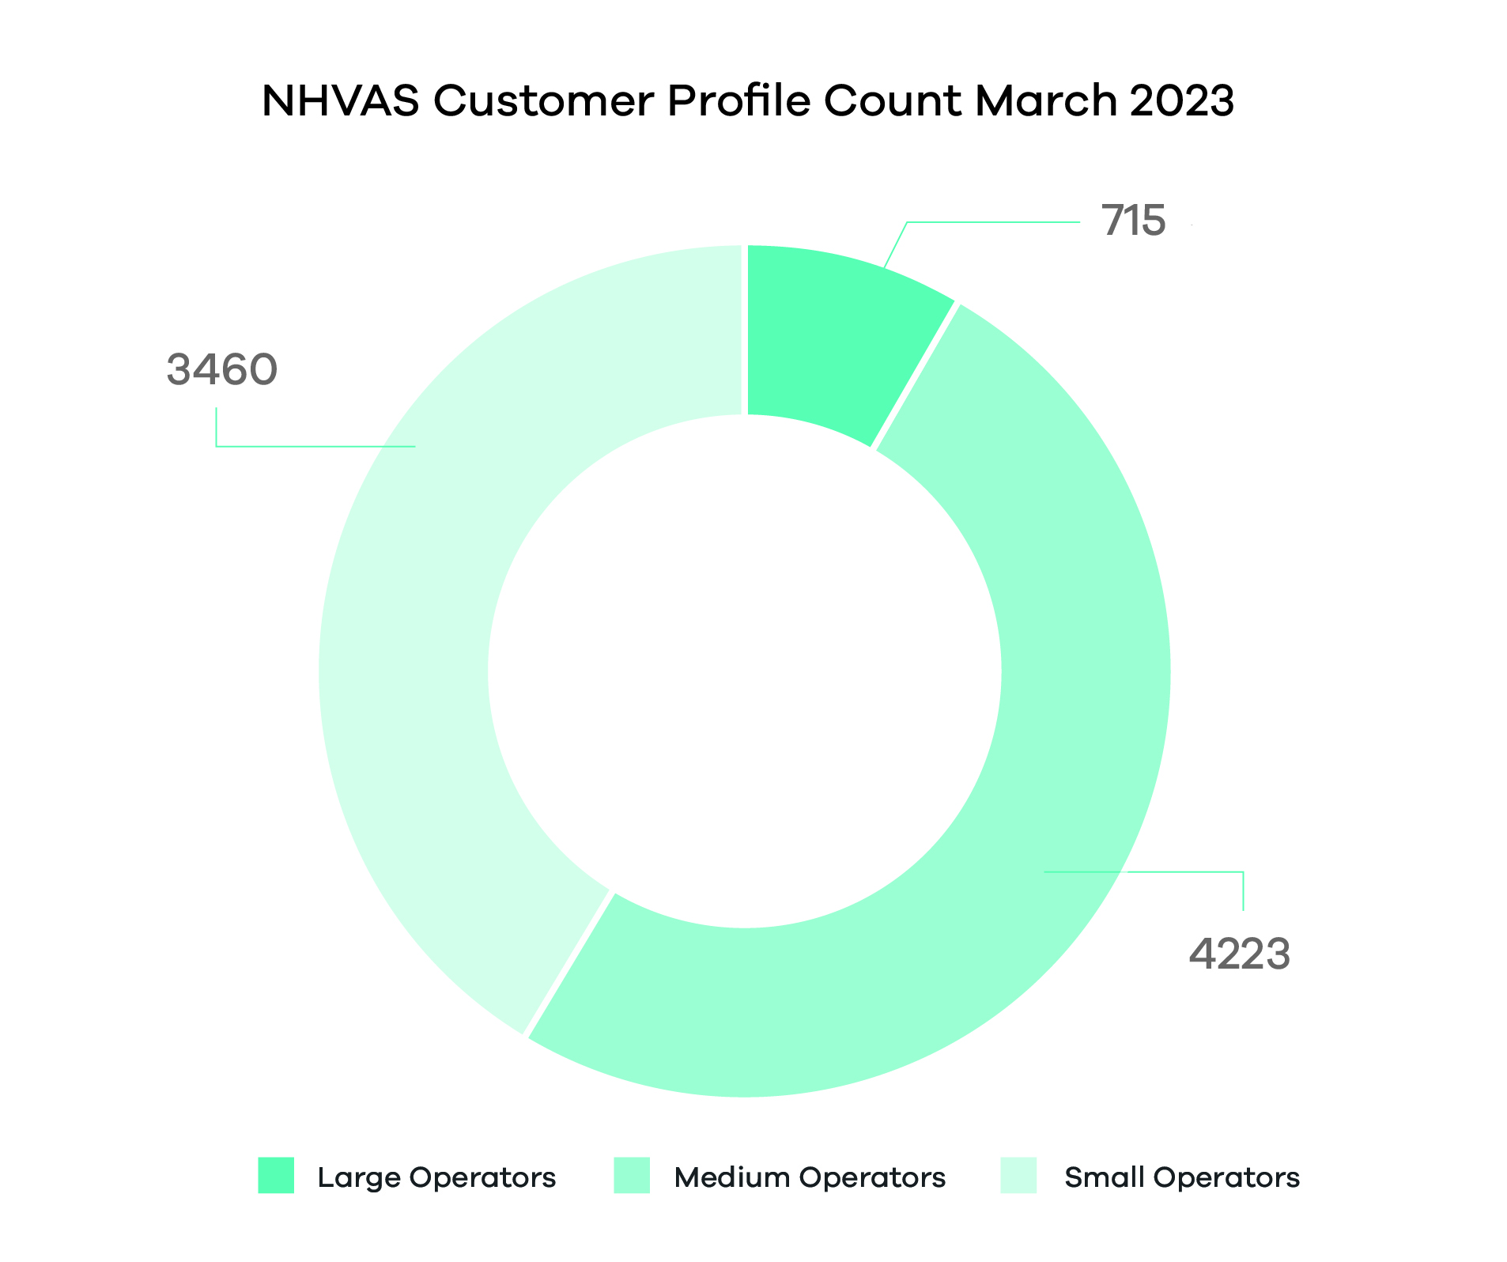

- Existing NHVAS customers as of March 2023 totalled 8,399. Customers are segmented into three groups. As of January 2023, there were approximately 266,000 operators in Australia’s heavy vehicle road transport industry. The 8,399 NHVAS-accredited operators currently represent 3.16 per cent of this profile (approximately). As of March 2023, NHVAS was experiencing an annualised customer growth rate of 3.86 per cent (NHVR, 2023).
- NHVAS customer module packages by customer count as of March 2023
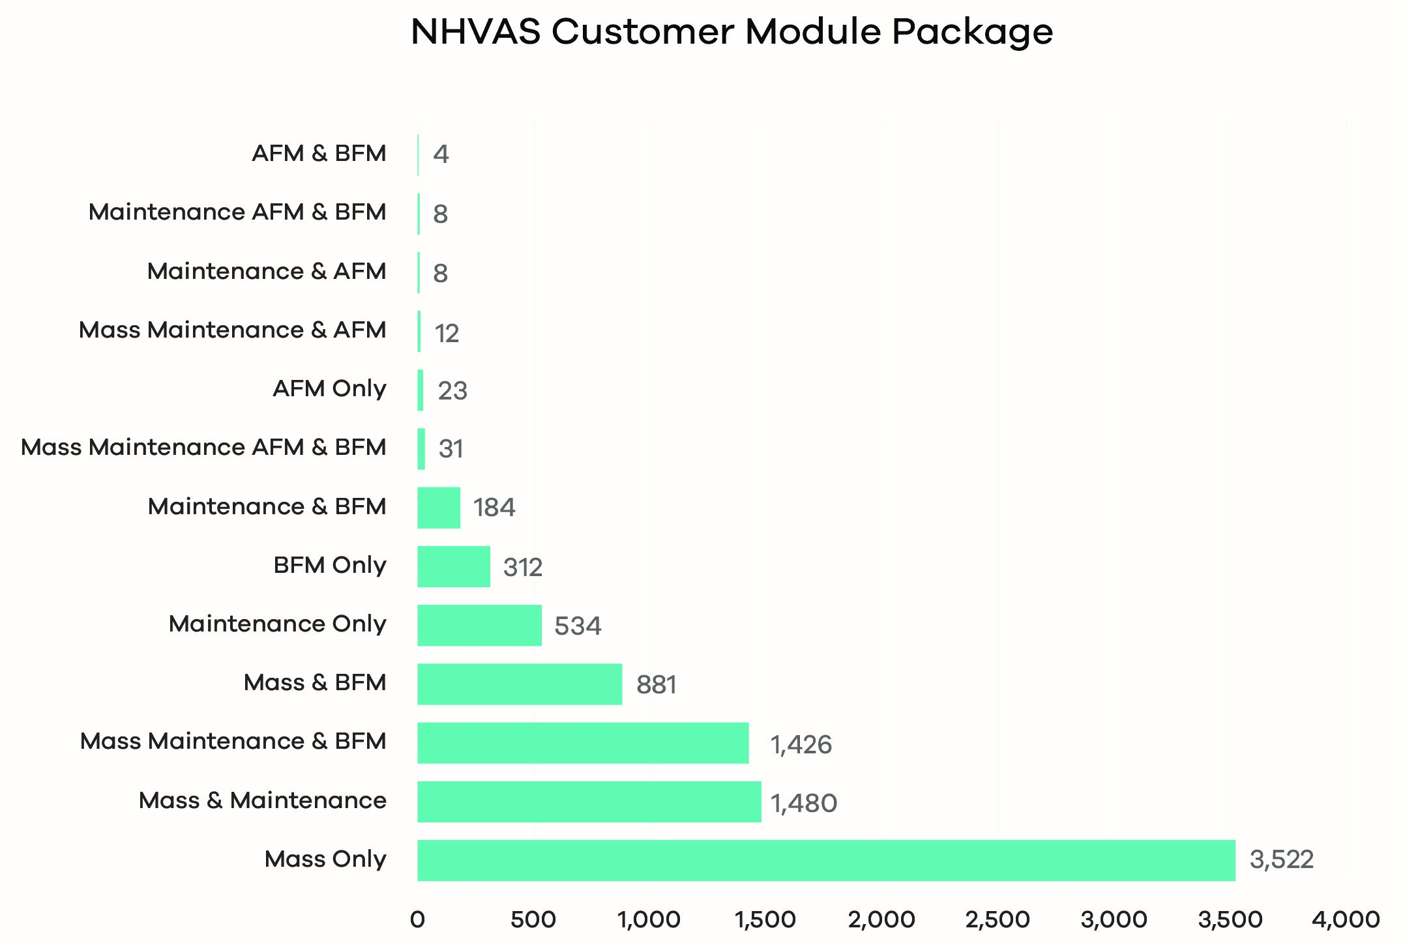
- Mass only and mass and maintenance modules comprise 3,522 (41.81 per cent) and 1,480 (17.57 per cent) of all NHVAS customers respectively.
- Mass, maintenance and BFM represent the third highest package preference with 1,426 (16.93 per cent) of all NHVAS customers.
- Conversely, four out of 8,399 NHVAS-accredited customers hold AFM and BFM modules. This indicates that, overwhelmingly, customer preference is to have AFM or BFM singularly.

- Number of NHVAS-accredited operators by state as of February 2023
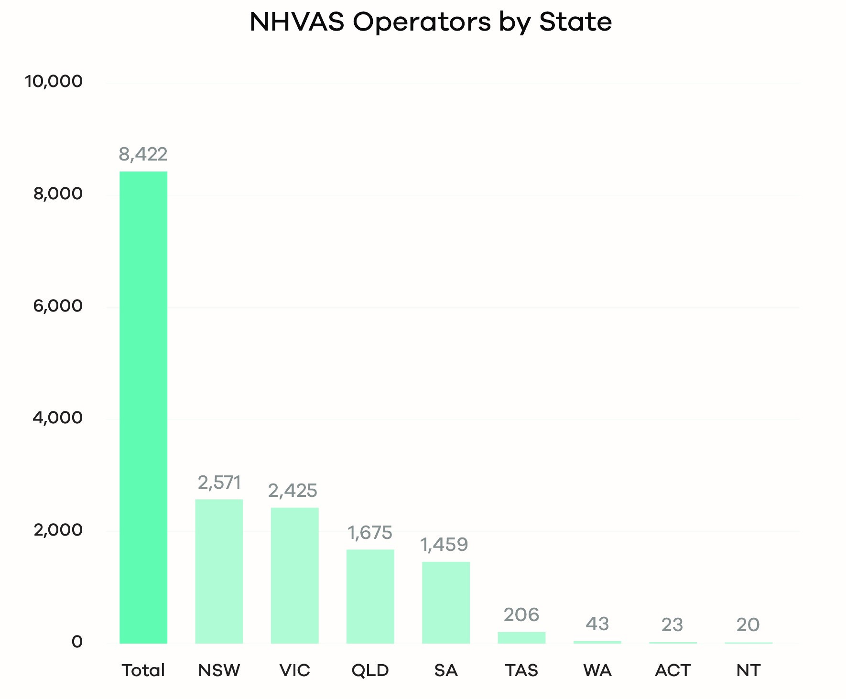

- Number of NHVAS-accredited operators by state and module as of February 2023
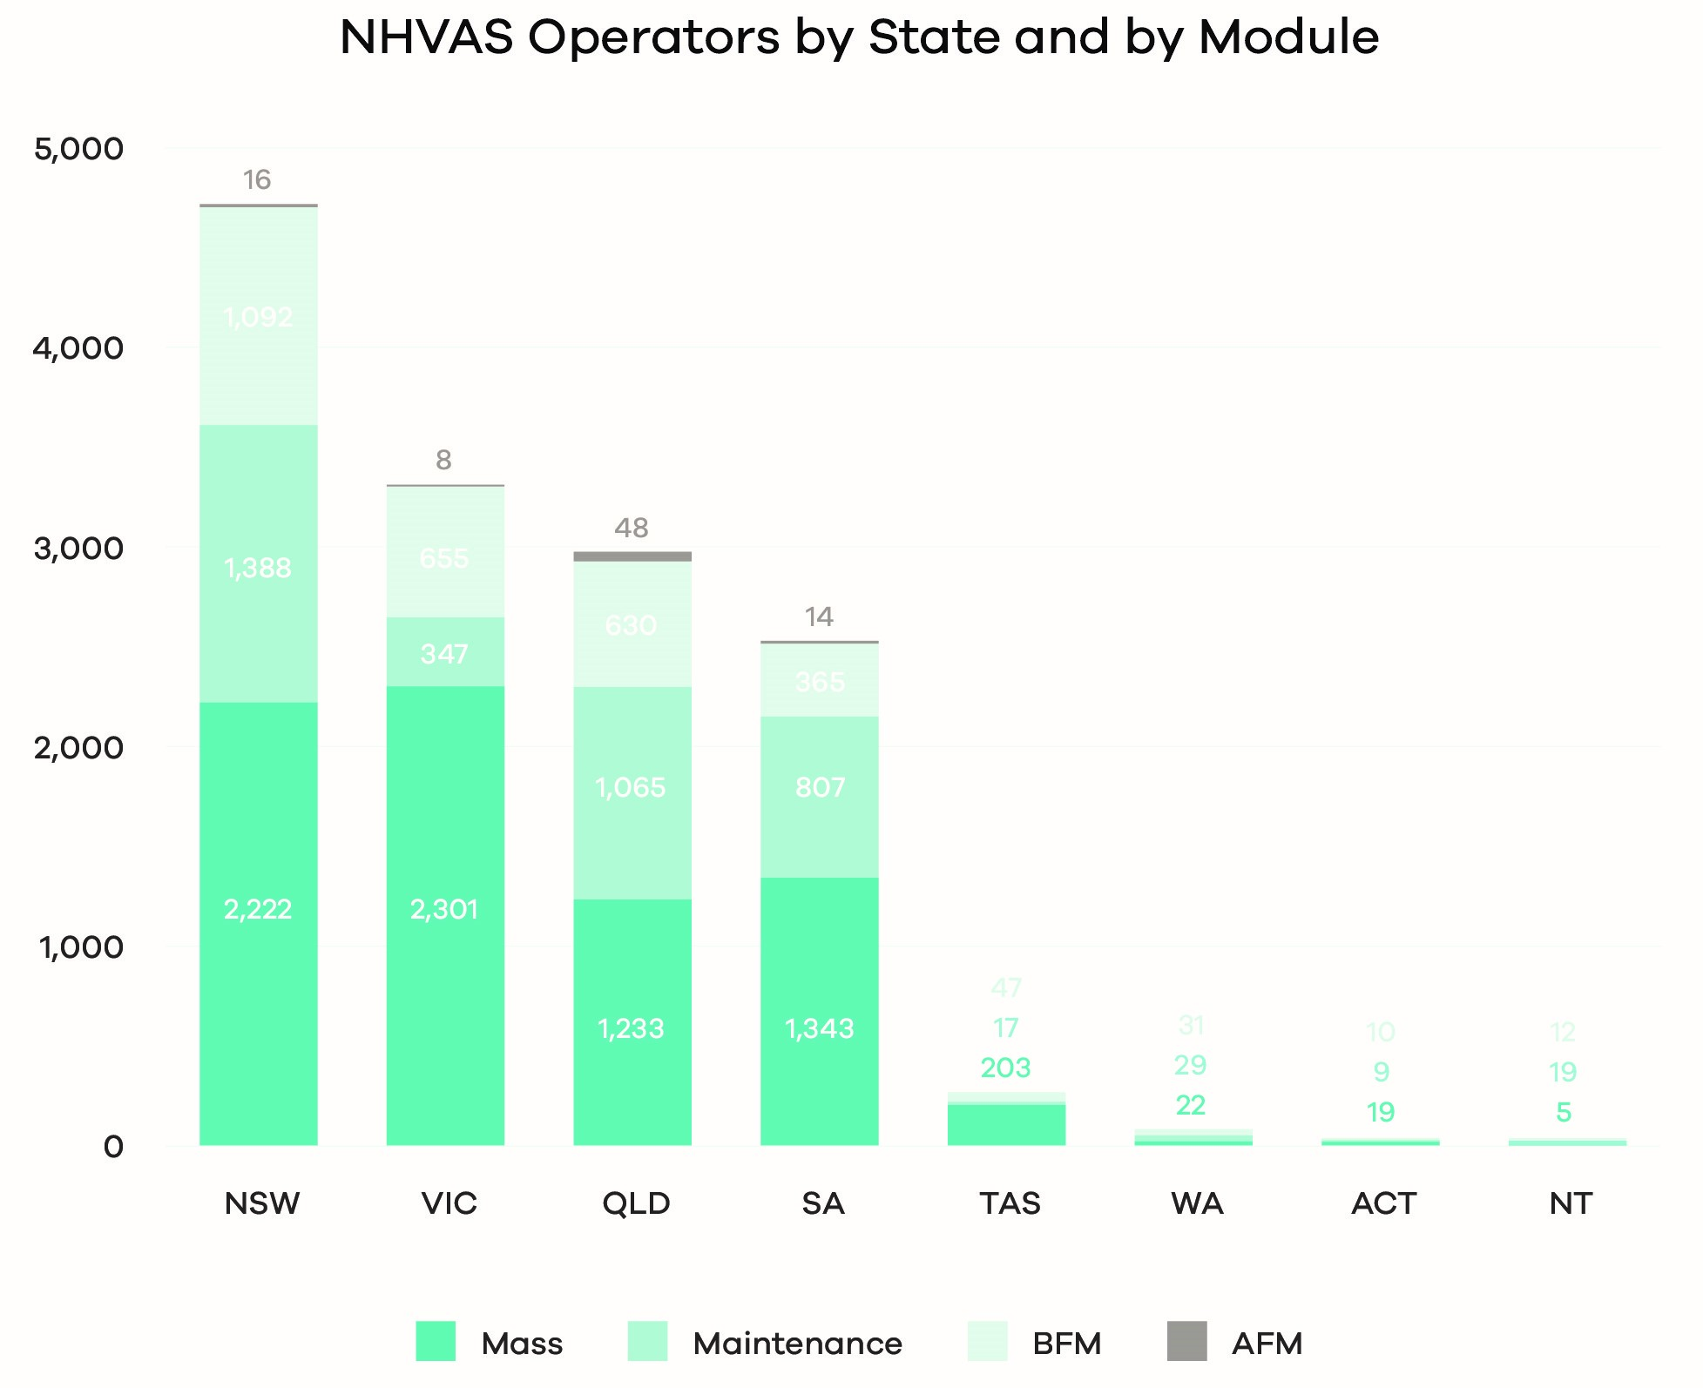
- Number of NHVAS-nominated vehicles by accreditation by state and module as of February 2023
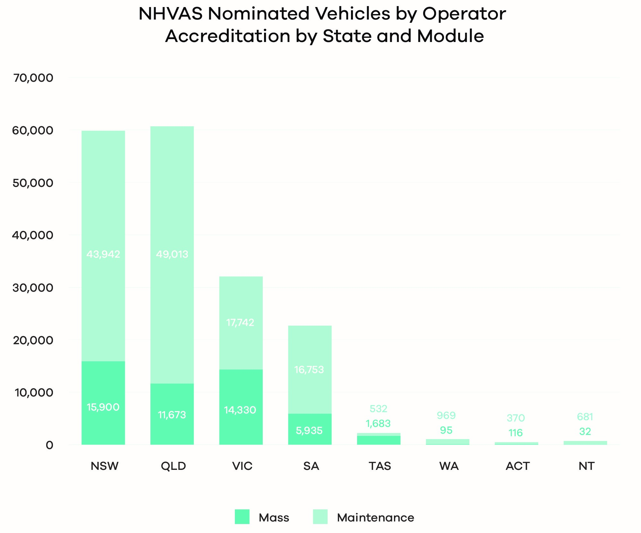
- Fatigue is not represented in the above chart, as vehicles are only accredited for mass and maintenance.
- Total number of NHVAS-registered vehicles as of February 2023
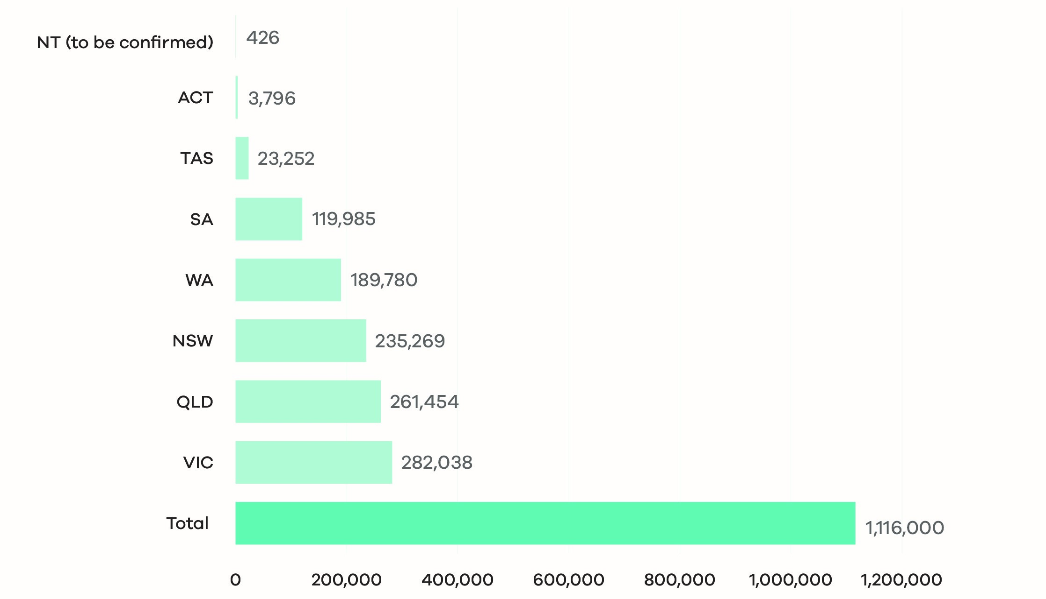
- Figures are based on the number of registered heavy vehicles rather than the number of operators (noting the operator is not always the registered owner).
Conducting a cost-benefit analysis for an SMS core requirement presents certain challenges. While the up-front costs of implementing an SMS are quantifiable, many SMS benefits are intangible. Benefits associated with improved safety culture, effective regulatory compliance, and increased public confidence are difficult to quantify and may take time to manifest (Safety Management International Collaboration Group, 2016). An effective SMS may incorporate many elements of an organisation's complex business operations and processes, making it difficult to isolate the effects of individual components of an SMS for cost-benefit analysis.
Measuring the impact of safety management systems is complex. However, research indicates a strong relationship between having an SMS and an effective safety culture and safety awareness in an organisation, which creates a more positive, safe working environment for employees, resulting in better productivity and morale (Thornwaite and O’Neill, 2016, p31). Research literature that attempts to quantify the effects of safety management systems and effective safety culture is limited, though existing work supports a positive impact on safety outcomes as indicated by insurance claims and safety, infrastructure and overall crash risks (Mooren, 2017).
Impacts of introducing an enhanced National Heavy Vehicle Accreditation Scheme with a safety management system as a core accreditation requirement
Improved safety, productivity and recognition of industry diversity:
- Improves safety and productivity outcomes for the NHVAS by aligning NHVAS accreditation and SMS requirements with the primary safety duty in the law.
- Supports uptake of the number of heavy vehicle operators with accreditation and an effective SMS in place. Evidence from a range of published reports suggests accredited operators are safer.
- Reflects and supports industry diversity through a scalable approach that supports operators to develop an SMS suitable to meet their level of complexity (of freight tasks and operations), unique organisational risk profile and individual business needs.
- Provides a scalable solution in supporting the diversity of the heavy vehicle industry by allowing the NHVR to offer a range of specific ACOs to address specific safety risks for different freight tasks and operations.
Promoting new technologies, improved audit outcomes and better alignment with WAHVA:
- Incentivises investment in new technologies and safety management practices for better safety and productivity outcomes through enhanced accreditation standards (and corresponding ACOs).
- The NHVR will be able to operationalise mutual alignment arrangements through a more seamless accreditation process for WAHVA operators and potentially other SMS-based schemes in the future.
Effective risk management:
- Operators can manage risks associated with their operations.
- Operators and the regulator will be better equipped to address emergent safety risks that may not have been previously identified or considered.
- SMS accreditation allows operators to demonstrate to customers, suppliers and the community that they have robust safety systems and processes checked by the regulator and confirmed to meet a defined standard.
Greater flexibility and improved options for operators:
- An SMS core requirement provides a pathway for operators to access alternative compliance under the updated scheme.
- A decoupling of accreditation and alternative compliance, such that an operator may be accredited without applying for or being granted an ACO.
Reduced compliance costs:
- Reduced costs for industry by eliminating paper carrying requirements.
- Reduced compliance costs are expected for operators by establishing a NAS and NHVAS audit regime to minimise multiple third-party audit requests where possible.
- A moderate cost burden exists for operators concerning upfront costs to transition to the enhanced NHVAS. Changes to standards, module design, and NHVAS business rules will impact operators' initial costs relative to their size, complexity and specific business needs.
- The proposal may involve minimal regulatory costs for the NHVR to establish the changes to the NHVAS systems.
Improved capacity to regulate higher-risk operators:
- The NHVR will be able to allocate better distribution of regulatory efforts as an increasing level of confidence in accredited operators through improved safety outcomes will unlock additional resource capacity for regulating higher-risk operators.
Business benefits of an SMS may include:
- A reduction in indirect costs, for example, lower insurance premiums and reduced legal fees.
- Some operating costs are reduced by exposing inefficiencies in existing processes and systems.
- A positive work environment and staff engagement and retention.
- A more holistic view of the organisation, safety decision-making and long-term planning.
- Contribution to a competitive advantage, better business reputation and increase in public (and shareholder) confidence in the organisation's ability to manage risks.
- Increased confidence by the regulator in an organisation's safety management capabilities, decreased regulatory involvement and reduced direct and indirect oversight costs.
Safety management system costs
It is recognised that there may be additional costs for existing and new NHVAS operators without a basic SMS. Costs may be relative to the scale and complexity of an operation. Estimates of costs to industry to establish an SMS as a new requirement for the enhanced NHVAS are considered in this RIS, noting that a more detailed analysis will be possible as the precise SMS requirements are further tested, approved and developed. The diversity of the heavy vehicle industry in terms of complexity and size of business operations and individual needs means that the cost to establish an SMS will vary between individual operators.
A recent NHVR Industry Safety Survey of approximately 6,000 participants indicated that most heavy vehicle operators have at least a basic SMS in place:
- Sixty-five per cent of industry respondents indicated they have at least a basic SMS in their business (NHVR, 2022).
- Organisations of all sizes are consistent in SMS implementation. Businesses with 11 to 20 staff have the highest implementation rate at 70 per cent.
- Sixty-nine per cent of those in an accreditation scheme indicated they had at least a basic SMS in their business. Some respondents were unsure.
Costs are directly related to the scale of operations and other factors, including whether existing non-SMS modules have been achieved, the degree to which an SMS has already been implemented, and individual operator transition capacity and capability. Accreditation in existing NHVAS modules (for example, mass, maintenance and fatigue) could reduce SMS start-up costs by 20 to 60 per cent. For instance, over half of NHVAS customers are accredited in mass only or combined mass and maintenance modules. It is, therefore, reasonable to expect that an operator with mass accreditation would, in most cases, meet basic SMS mass requirements with minimal or no mass-related system changes required.
Conversely, with an accredited SMS, meeting safety-related compliance requirements specific to additional modules or ACOs will be easier for new entrants and could result in significant downstream cost savings.
Considering the above, indicative costs for NHVAS module development were developed based on the following input fields:
- accreditation establishment fee
- estimated 40 hours of establishment work
- two corrective action requests (CARS) for rectification, average 32 hours
- audit costs
- consultancy fees.
- Total safety management system set-up costs across the NHVAS. Total NHVAS aggregate industry costs are $48.8 million
- The average SMS set-up costs for all NHVAS operators are $5,800.
Small operators
As of March 2023, there were 3,460 small-sized operators in the NHVAS, representing 41.08 per cent of all NHVAS customers. Small-sized operators are classified as businesses with 10 or less vehicles.
NHVR-estimated SMS start-up costs were based on the following cost inputs:
- a $95 Accreditation establishment fee
- development cost (average $1,500)
- estimated 20 hours of establishment work at $55 per hour
- Two CARS for rectification at 32 hours at $55 per hour
- audit cost (average $1,000)
- establishment fee 15 per cent operational on-cost.
Total SMS start-up costs:
- Total SMS costs for small NHVAS operators is $17.73 million comprising 36 per cent of total NHVAS customer costs.
Average range of SMS cost for a single operator:
- The NHVR estimates an average SMS start-up cost of $5,800 per operator (NHVR,2023).
- Deloitte Access Economics estimates an average SMS start-up cost of $10,000 per operator (Deloitte Access Economics, 2020, p19), a report commissioned by the Australian Trucking Association and NatRoad.
Medium operators
As of March 2023, there were 4,223 medium-sized operators in NHVAS, representing 50.14 per cent of all NHVAS customers. Medium-sized operators are classified as businesses with more than 10 but less than 100 vehicles.
NHVR-estimated SMS start-up costs were based on the following cost inputs:
- a $95 accreditation establishment fee
- development cost (average $2,500)
- estimated 20 hours of establishment work at $55 per hour
- Two CARS for rectification at 32 hours at $55 per hour
- audit cost (average $1,000)
- establishment fee 15 per cent operational on-cost.
Total SMS start-up costs:
- Total SMS costs for medium NHVAS operators is $26.5 million comprising 54 per cent of total NHVAS customer costs.
Average range of SMS cost for single operator:
- The NHVR estimates an average SMS start-up cost of $6,273.
- Deloitte Access Economics estimates an average SMS start-up cost of $15,000 per operator.
Large operators
- As of March 2023, there were 715 large-sized operators in NHVAS, representing 8.5 per cent of all NHVAS customers.
- Large-sized operators are classified as businesses with over 100 vehicles.
NHVR-estimated SMS start-up costs were based on the following cost inputs:
- a $95 accreditation establishment fee
- development cost (average $1,500)
- estimated 40 hours of establishment work at $55 per hour
- Two CARS for rectification at 32 hours at $55 per hour
- audit cost (average $1,500)
- establishment fee 15 per cent operational on-cost.
Total SMS start-up costs:
- Total SMS costs for large NHVAS operators is $4.57 million, comprising 9 per cent of total NHVAS customer costs.
Average range of SMS cost for a single operator:
- The NHVR estimates an average SMS start-up cost of $6,400.
- Deloitte Access Economics estimates an average SMS start-up cost of $25,000 per operator.
NHVAS cost support structures
The NHVAS will provide direct support, consultation, education, tools, templates and other resources to support all NHVAS operators in minimising their initial and ongoing SMS costs.
This impact analysis indicates that the proposal to have an assurance framework that is underpinned by an SMS is expected to deliver moderate improvement to road safety (impact category 1). Some efficiency improvements are likely due to changes resulting from a more holistic focus on business operations (impact category 2).
Given the analysis of benefits and costs, the proposal is expected to have moderate impacts on the regulatory burden faced by heavy vehicle industry operators currently in the scheme (impact category 3), as there is a high level of existing SMS uptake and moderate to low transition costs.
There are potential impacts on the regulatory costs for the government (impact category 4), such as costs to the NHVR (as scheme administrator) to establish the SMS compliance requirements.
This proposal to provide for an SMS under the NHVAS also is expected to contribute a moderate improvement to flexibility and responsiveness (impact category 6). It allows flexibility for industry to focus on safety outcomes under the SMS performance-based requirements. It allows flexibility for government to address emerging safety risks (assessment criteria 6c), and the scalability of SMS requirements reflects and supports industry diversity (assessment criteria 6d).
Implementation, transition and evaluation arrangements
Transition arrangements
From a design perspective, understanding the transition arrangements of the existing NHVR SMS module to the enhanced scheme's SMS core module is a priority.
Ongoing consultation with the NHVR is critical to understanding the practical transition arrangements and overall suitability of modules for adaption or part adaption into the new SMS core module. The NTC is working closely with the NHVR to ensure a smooth transition.
The NTC will initially work with the NHVR, which will lead the transfer and updating of existing modules by streamlining existing safety elements across other modules into the SMS core module and developing new criteria where relevant.
The NHVR will support NHVAS operators in transitioning to the enhanced scheme. While operators will have up to three years to transition to the new scheme, the NHVR will encourage operators to transition earlier.

Recommendation 8
That, to support mutual alignment pathways and scheme robustness, a national audit standard be developed by the regulator and approved by ministers.
What is proposed?
A national audit standard for the enhanced NHVAS
A NAS will be developed by the regulator and approved by ministers, to be applied as part of the regulator’s existing function to implement and manage an audit program for the NHVAS. The standard will be outcomes based, and designed so that other assurance schemes can adopt it. The NAS will also be designed to be used for non-accreditation audits intended to establish adherence to or compliance with the primary duty. As discussed under recommendation 2, the law will also specify that a court may consider an audit conducted under the standard as part of determining whether the primary duty has been met.
The NAS will follow the principles of ISO 19011 Guidelines for Auditing Management Systems (as amended occasionally).
The NAS will be applied to guide audits of varying scopes and scales, including those conducted by large audit teams. It is intended to apply to various potential users, including auditors and organisations implementing management systems or organisations conducting management system audits for contractual or regulatory reasons. The NAS will be flexible enough for users to apply the guidance in developing their own audit-related requirements or regimes.
The NAS will address how audits are undertaken for accreditation within a regulatory framework. It will include guidance on the purpose of audits, how they should be undertaken and who should conduct them. Additionally, it will outline specific requirements relating to oversight of the audit standard.
The standard will not include detailed instructions or workflows regarding which elements of an accredited operator's system should be assessed, such as:
- the sharing of audit information between the auditor, accredited operator and oversight body
- auditor training requirements
- operator requirements
- fee-paying arrangements
- any potential regulator reporting requirements.
The regulator will develop detailed instructions and workflows above under the NHVAS auditing regime. Instructions and workflows will include guidance material to complement the NAS.
- National audit standard and audit regime overview
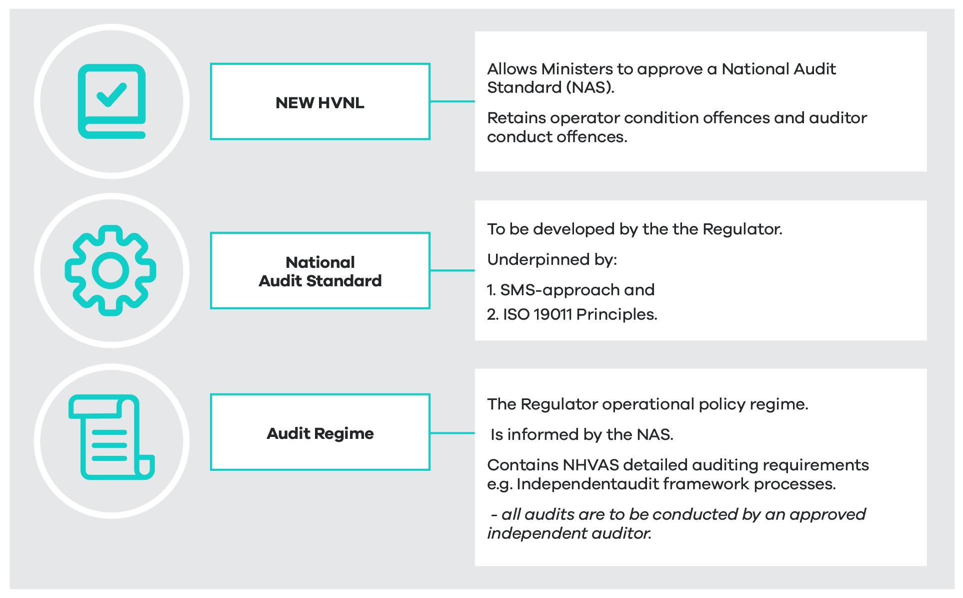
The new law will allow ministers to approve a NAS to build a more robust auditing regime for the new NHVAS (see recommendation 2).
The NAS will establish the requirements for developing an auditing regime to support heavy vehicle accreditation under a risk-based SMS approach established in law.
The regulator’s audit regime will adopt the NAS approach as outlined under ISO19011 – Guidelines for Auditing Management Systems, which includes:
- An audit program consisting of the arrangements to complete all the individual audits needed to achieve a specific purpose.
- Proactive risk management and a 360-degree wrap-around model that provides continuous improvement for operators at all levels. This approach differs from the current compliance-based approach to auditing, which focuses only on assessing an operator's capacity to meet minimum compliance standards.
Audits will include measures to assess the operator's system's effectiveness in achieving the accreditation scheme's desired outcomes.
Appendix G provides an overview of the relationship between the primary duty, SMS, accreditation requirements, and the application of the NAS in this regulatory environment.
What are the objectives?
In late 2017, ITMM commissioned the NHVR to review heavy vehicle accreditation schemes throughout Australia, where it identified issues around the quality and robustness of audits and a lack of trust in the current process. The review noted that a NAS could improve industry safety, efficiency and productivity outcomes by implementing an outcome-based approach to auditing. In 2021, ministers agreed that a revised accreditation scheme would establish a NAS and a new auditing regime under a future law.
A NAS will be used to confirm that accredited operators or operators applying for accreditation have an appropriate SMS that meets the SMS module requirements and standards. Moreover, it will ensure that audits of accredited operators are undertaken to determine the effectiveness of their SMS in achieving the outcomes sought in the SMS core module. The NAS will be the instrument against which NHVAS module standards will be assessed.
The NAS will:
- Utilise measures to assess the effectiveness of the operator's system in achieving NHVAS accreditation standards.
- Ensure audits align with the relevant principles and processes.
This approach focuses on proactive risk management and continuous improvement of an operator's management systems over time, as opposed to the current process, which essentially assesses audits based on an operator meeting the minimum compliance standards.
The NAS may also reduce the reliance on separate audits by customers to meet their chain of responsibility obligations by offering a standardised approach to audits, establishing a basis for consistency.
The NHVR will be responsible for administering the auditing regime with a focus on delivering increased confidence in the robustness of NHVAS to governments, third parties and the community. The regime under the enhanced NHVAS will emphasise the competence of auditors, regularly assessing vehicle roadworthiness, driver competence and fitness for duty. Incident reporting and investigation will also be essential in the regime's ability to identify potential safety systems and performance weaknesses.
How will the law change?
Current law (the base case)
Regarding existing auditing requirements, an approved auditor is of a class approved by the responsible ministers under section 654 of the HVNL. The law requires that a statement from an approved auditor must accompany applications for heavy vehicle accreditation. The regulator may decide on an application for heavy vehicle accreditation based on the results of any audits carried out on the applicant's relevant management system (and anything else it deems appropriate). The regulator may consider it appropriate to require additional records to be kept and audits to be performed to ensure practices applying under the accreditation (for example, driver fatigue management practices) are followed consistently and effectively. Offences relating to auditors include maximum penalties of $10,000 for false representation of auditors and audits.
Future law
The future law will change from the current HVNL by enabling ministers to approve a NAS recognised in law as part of the scheme. The NAS will specify outcomes-based auditing requirements that align with the SMS risk-based principles and relevant national or international standards (for example, ISO19011 is a standard that sets out guidelines for auditing management systems and contains guidance on managing an audit program, principles of auditing and evaluating individuals responsible for managing the audit programs).
A NAS provides a framework for consistent and standardised auditing practices that other SMS-based assurance schemes can adapt. The standard could also be used for non-accreditation audits to establish adherence to or compliance with the primary duty. In this context, the law will specify that a court may consider an audit conducted under the standard as part of determining whether the primary duty has been met.
The future law will also ensure that:
- An operator of a heavy vehicle may apply to the regulator for heavy vehicle accreditation under the HVNL in the approved form and accompanied by a statement that the applicant is compliant.
- A statement from an approved auditor that the auditor has considered the applicant's relevant SMS may be required to ensure compliance with the applicable standards and business rules.
- In deciding on an application for heavy vehicle accreditation, the regulator may have regard to anything it considers relevant, including the results of any audits or audit certificates.
- Offences relating to auditors include false representation or misrepresentation, and associated penalties will remain.
The regulatory environment will:
- Outline the detail of the NAS that can be utilised by non-HVNL parties, including other SMS-based assurance schemes, and as part of audits carried out by upstream chain of responsibility parties (particularly customers).
- Set forth outcomes-based performance standards for the SMS and associated modules. For the SMS module, the performance-based standards will cover the five SMS elements – leadership commitment, risk management, people, safety systems and assurance – that safety management systems will be audited against under the NAS approach.
- Include explanatory memoranda that will clarify that chain of responsibility parties must adopt a practical approach to managing risks under the primary duty and that an audit process will not (on its own) demonstrate that obligations have been met.
- Set out procedural matters and common conditions, for example, critical incident reporting, auditing process requirements and requirements to ensure the electronic documentation system is current.
What are the impacts?
Potential impacts
The proposal for outcomes-based auditing standards and practices is expected to provide a moderate improvement in public safety (impact catagory 1). The NAS will form an effective and reliable tool supporting management policies and controls, providing information on how an organisation can improve its safety performance. The proposal supports targeted, risk-based enforcement options for the NHVR (assessment criteria 1c). The NAS will be designed to confirm that accredited operators or operators applying for accreditation have an appropriate SMS that meets the SMS core requirements and ensures audits of accredited operators are undertaken to determine the effectiveness of their SMS in achieving safety outcomes.
Potential improvements
The proposal uses a risk-based outcomes approach to auditing to assess the effectiveness of the operator's system in achieving NHVAS standards. The risk-based approach should substantively influence the planning, conducting and reporting of audits to ensure that audits are focused on matters that are significant for the audit client and for achieving the audit programme objectives. This proposal is aimed at community assurance that heavy vehicle safety risks have been comprehensively addressed (assessment criteria 1d) and is expected to deliver a moderate improvement in operational efficiency or productivity (impact catagory 2).
The proposal has the potential to increase customer and supplier confidence which may lead to reduced duplicative (non-NHVAS) audits conducted by third parties, or more efficient business practices (assessment criteria 2c). The regulator will aim to use the NAS as guidance to streamline its audit regime processes and administration arrangements to resolve persisting fee structure, payment and audit cost issues.
Potential negative impacts
Limited regulatory costs for government (assessment criteria 4a) may result from this proposal as a new audit regime requires reviewing existing systems, processes, and people. For industry, it is estimated that costs will be primarily associated with increased SMS entry requirements (for example, shifting from managing the risks associated with accreditation to managing all risks to support primary duty compliance).
The assessment considers impacts at a national level. The costs and benefits will be broadly similar across different states and territories. The specific costs and benefits in each state or territory will depend in part on the nature of the heavy vehicle fleet and its use in each state or territory.
Implementation and transition arrangements
Under the NHVAS Business Rules and Standards and independent audit framework, all audits will continue to be conducted by an approved independent auditor. These auditors must be registered or recognised by the NHVR as NHVAS-approved auditors. The NAS is likely to require a staffing increase for the regulator. The implementation of the NHVAS audit programme will be monitored and measured continuously to ensure its objectives have been achieved.

Summary impact analysis
Table 13 summarises the impact analysis for the assurance and accreditation recommendations.

- Assurance and accreditation recommendations – summary impact analysis, including impact category
RECOMMENDATION | Overall impact | Public safety | Improvements to operational efficiency or productivity | Regulatory burden for industry | Regulatory costs for government | Asset Management | Flexibility and responsiveness
6a That as part of the new alternative compliance tier (recommendation 1b), the future law restructure the National Heavy Vehicle Accreditation Scheme so that accredited operators can apply for an expandable range of alternative compliance options – either on a bespoke basis or as part of accreditation modules developed by the regulator, within the ministerially approved limits.  6b That the law ensures a three-year transition period for current NHVAS operators to provide operators adequate time for them to develop the necessary safety management system to qualify for the enhanced scheme. | Improvement  The expanded range of ACOs is expected to improve flexibility and responsiveness and contribute to safety and operational efficiency outcomes.  A three-year transition period is proposed to assist operators and the regulator by allowing time to cover potential costs, particularly for operators to set up an SMS, auditors and external assistance, and regulator resourcing. | See recommendation 1 | See recommendation 1 | Neutral  Operators will incur initial and additional ongoing costs. However, over time, long-run safety benefits can offset costs. | Neutral  The environment will be more complex to administer. However, overtime costs can be offset by more targeted, risk-based enforcement. | See recommendation 1 | See recommendation 1
7 That, as a fundamental enhancement to the scheme, the law establishes a scalable safety management system as a core accreditation requirement. | Improvement  Safety benefits across the industry from greater focus on SMS and safety culture are difficult to quantify but are expected to have a positive impact over time which will outweigh the initial upfront costs.  Note: There are challenges in determining a cost-benefit analysis for an SMS as an SMS creates immediate, direct and ongoing costs, while benefits are mostly intangible, difficult to quantify and emerge over time (for example, improved safety culture, effective regulatory compliance, public confidence). | Large improvement  For accredited operators an SMS is expected to lead to a reduction in crashes, and associated indirect costs, for example, lower insurance premiums.  Improves operators' ability to continuously identify hazards and manage safety risks. | Large improvement  Contribution to competitive advantage, better business reputation, and a more holistic focus on business operations.  Operators will benefit from improved health and safety performance.  Operators have greater assurance that accreditation is supporting them to comply with the primary duty. | Neutral  Costs for some parts of industry to develop an SMS where there is not currently one (or where it does not meet the new standard). Note that the requirements will be scalable, businesses are already required to have an SMS under work health and safety laws. A NHVR survey of around 6,000 operators found uptake is high: around 65% of all operators report having at least a basic existing SMS, (around 69% for accredited operators.)  As of March 2023 there were 8,399 operators in the scheme, an estimated 3.16% of the total heavy vehicle industry.  Total estimated SMS start-up costs for current NHVAS operators at the aggregate industry level is $48.78m. For each segment of industry:  Small $17.71m  Medium $ 26.5m  Large $4.57m  Average estimated costs per operator:  Small operators $5,000 to $10,000  Medium operators $,6,200 to $15,000  Large operators $6,400 to $25,000.  Initial set-up requirements may impose a moderate burden, expected to be offset by longer term safety benefits. | Improvement  Costs to the regulator to establish the SMS compliance requirements and to carry out consultation, direct support, education, training and staff resources.  Increased confidence in an organisation's safety management capabilities may help the regulator to better target resources to areas of greater safety risk. | Neutral | Large improvement  Allows flexibility for industry to focus on safety outcomes under the SMS performance-based requirements.  Allows flexibility for government to address emerging safety risks.  Scalability of the SMS requirement reflects and supports industry diversity.
8 That, to support mutual alignment pathways and scheme robustness, a national audit standard be developed by the regulator and approved by ministers. | Improvement  More robust auditing standards may improve community confidence in heavy vehicle regulation, leading to safety improvements.  Industry may gain productivity benefits from the potential to drive down requirements for multiple audits from customers and across schemes.  These benefits are expected to outweigh the costs to the regulator to establish the new audit standard. | Large improvement  Improved auditing environment for industry as they have access to an effective and reliable tool supporting management policies and controls, providing information on how they can improve safety performance.  An improvement for the regulator by supporting targeted, risk-based enforcement options.  Provides community assurance that heavy vehicle safety risks are managed through a robust assurance standard. | Large improvement  Industry may benefit as the NAS has the potential to increase customer and supplier confidence, which may lead to reduced duplicative (non-NHVAS) audits conducted by third parties which negatively impact day-to-day operations. | Neutral  Industry impacts may be limited as accredited operators are already subject to the existing scheme audit regime.  Industry benefits for operators in multiple schemes by more streamlined application processes, reducing administrative burden and overall costs as the NAS may lead to mutual recognition with other schemes over time. | Improvement  Some regulatory costs for the regulator to establish the new approach and review systems, processes, and people. | Neutral | Neutral

Technology and data

Overview
Experience with fatigue and distraction detection technology and consultation during the HVNL Review has identified numerous opportunities where technologies, including systems and data services, could be used to achieve improved safety, productivity and compliance outcomes. With the increasing reliance on data across the broader transport sector, there is also a growing need for heavy vehicle technology that can interface with other transport modes and agencies to support the progression and development of safety- and productivity-related initiatives, including transport infrastructure planning and management. However, the current HVNL has no overarching process to readily recognise and enable such technologies and as a result these opportunities are either being missed or not optimised.
Specific limitations with the HVNL include:
- The HVNL only recognises two technology and data sharing schemes that support heavy vehicle safety and productivity – the Intelligent Access Program (IAP) and electronic work diaries (EWDs). These are both hardwired into the HVNL.
- To recognise a new technology, the HVNL primary law must be amended, which can be time consuming and complex.
- To change how data from an existing technology (that is, IAP or EWD) is used or shared, the relevant provisions in the HVNL require amendment.
As a result, industry, the regulator and road managers cannot readily leverage new technologies to provide safer and more efficient heavy vehicle services or to support infrastructure planning and network management, and the ability of the transport industry to innovate or expand its use of technology is constrained.

Policy deliberations
Consultation RIS
The consultation RIS considered the following two options for improving technology and data provisions in the HVNL:
- Establish an overarching technology and data certifier under the HVNL (consultation RIS Option 6.1). Under this option, the future HVNL would recognise technology and data assurers. This will provide a clear and consistent approach to managing technology and data under the law and enable technology to be used and recognised for risk management and assurance under the HVNL in a way it cannot presently. This option has been supported and is considered further below (see recommendation 10).
- Ability to carry and produce electronic documentation (consultation RIS Option 6.2a). This option involved the HVNL permitting all documents to be carried and produced electronically. There would also be the option to access documents via a reference to the NHVR system. As such, this option would provide flexibility to stakeholders in how they carry and produce any required documentation. The law would require the electronic document to be accessible by relevant parties (for example, drivers, operators, the NHVR and enforcement at the roadside).
Allowing regulated parties to carry and produce electronic documentation has been supported in principle. Work to allow documents to be carried electronically will be progressed in consultation with industry and enforcement stakeholders before implementing the future HVNL.
A sub-option ‘Documentation must be produced in a specified period’ (consultation RIS Option 6.2b) was also considered, under which certain documentation would not be required to be accessible immediately when requested. Instead, operators and drivers would be required to produce it to the NHVR or police within a specified period.
This option was not supported as it was considered administratively burdensome and would also unnecessarily increase the complexity of the HVNL.
ITMM reform package
In May 2021, ITMM agreed a set of policy goals for a future technology and data framework as part of the HVNL Safety and Productivity Program. These goals were:
- A technology, data and information assurance and data sharing framework, including the roles of relevant parties.
- Legislative amendments to establish the framework and its operation.
Following further consultation, the ITMM reform package included two recommendations relating to technology and data:
6.1. The new law must enable provisions to provide for the following:
a. developing technology standards or adopting international standards
b. the protection of on-board data
c. ensuring that privacy is protected
d. a process for certifying technologies as being compliant, including recognition of technologies approved internationally
e. new specific provisions to clarify the legal status of data generated by certified technologies
f. a specific provision to clarify that a person can present to court evidence of complying with the HVNL based on a non-certified technology system. It would be up to the court to decide what weight to place on that evidence
6.2. The law should enable but not require that Ministers can, by regulation, establish a Technology and Data Framework/s and a Technology and Data Framework Administrator/s (one or more appointed by ITMM from time to time or for specific regulatory purposes).

Future work
The ITMM reform package recommended creating the enabling mechanisms for a technology and data framework but did not recommend activating the framework or making recommendations concerning what entity or entities should be appointed as framework administrator(s).
To enable the framework, work needs to be undertaken to:
- Confirm the requirements for key elements of the framework, including the functions and responsibilities of a framework administrator and the content of data and technology applications (DTAs).
- Define other key roles and activities that may be required for the framework to be operationalised (for example, definitions for data steward and data aggregator roles).
- Develop appropriate offences for misconduct under the framework, noting that these are likely to be based upon offence provisions currently specified in the HVNL for the IAP under Chapter 7 and for EWD in Part 6.4, Requirements about record keeping.
- Confirm whether existing technologies, such as the IAP and EWD, are to be transitioned to the framework.
- Confirm the high-level requirements for data sharing under the framework.

Assessment of policy recommendations
Recommendation 9
That the future HVNL enables technologies to be recognised under the HVNL by establishing a technology and data framework that includes powers, functions, duties and obligations for specified roles in the framework, and appropriate rules in relation to technologies recognised under the HVNL for data protection, stewardship and assurance, and access and use.
What is proposed?
The HVNL will include a framework to enable technology and data sharing schemes to be recognised for regulatory and non-regulatory purposes.
A regulatory purpose could include a requirement for a heavy vehicle to use a particular technology and share certain data as a result of one or more of the following:
- prescribed under a heavy vehicle obligation
- imposed as a condition of an alternative compliance option
- required as part of an access permit or gazette notice
- another purpose prescribed by regulation that does not fit into the above categories.
Any new requirement for a DTA to be used for a regulatory purpose under the framework would typically require a regulatory impact assessment.
A non-regulatory purpose could have a broader range of purposes, including:
- A mandatory requirement for a heavy vehicle to have a system that generates data for a non-regulatory purpose. For example, a vehicle must provide data, and that data is used for infrastructure monitoring, not compliance with the law (this kind of requirement may require a regulatory impact assessment).
- A voluntary data sharing scheme, whereby operators may elect to share identified, or de-identified data with jurisdictions (or other parties).
The framework will not prevent voluntary data sharing schemes from being made outside the auspices of the HVNL. However, data sharing outside the framework would not enjoy the data assurance and data protections afforded by the provisions of the framework.
Technology and data sharing schemes governed by the framework would be subject to rules relating to system approval requirements, data access, data formats and data use. This would include high-level rules about the kind of data that a person can be compelled to share or provide under the HVNL, and to whom (for example, the regulator, police and other government agencies).
The framework will comprise the core functions, controls components and rules required for creating technology and data sharing standards. These integrated assurance and approval mechanisms safeguard the framework’s integrity to ensure industry has confidence that investments in new technology meet relevant standards.
The framework will aim to facilitate data sharing and to complement (not replace) existing programs or schemes that currently provide data sharing services or outcomes within or about the heavy vehicle industry.
What are the objectives?
Establishing the framework will support the following objectives proposed in the ITMM reform package:
- Simplify the HVNL by allowing new technologies to be incorporated into regulatory functions without changing primary legislation.
- Provide opportunities for more flexible compliance options by enabling technology to be used as part of an alternative compliance option.
- Support innovation by enabling new technologies to be part of operators' productivity and safety approaches.
- Provide clear and consistent approval requirements and processes for technologies.
- Provide common standards in data formats across the HVNL to encourage standardisation and interoperability (for example, easier collation and analysis of data from multiple systems and better enabling a single technology product to provide data for various purposes).
- Facilitate appropriate and controlled sharing of data from operators to other parties.
- Standardise protocols for de-identifying data where required.
- Standardise requirements for advising parties about data collection.
- Standardise requirements for providing parties information about what data is being held about them.
How will the law change?
Current law (the base case)
The current HVNL explicitly recognises two types of technology that can be used for regulatory purposes. Chapter 6 of the HVNL provides for electronic work diaries and contains usage and record-keeping requirements and obligations. Division 7 of Chapter 6 also includes provisions for approving electronic recording systems and explicitly provides for the NHVR to approve EWD systems and suppliers.
Chapter 7 of the HVNL outlines the Intelligent Access Program and contains roles, responsibilities and data protection provisions, as well as provisions for the collecting, keeping and handling of IAP information. Transport Certification Australia has legislated functions and powers under Part 7.5 of the HVNL that include:
- Certifying and cancelling the certification of IAP service providers.
- Auditing IAP service providers.
- Approving and cancelling the approval of intelligent transport systems for use by IAP service providers to monitor the relevant monitoring matters for an IAP vehicle.
- Engaging individuals, consultants and contractors to assist Transport Certification Australia in its auditing activities.
The current HVNL is limited because it provides for a fixed range of recognised technologies that are hardwired into the law and regulation. Moreover, the party or entity assessing and approving systems for those technologies is also hardwired.
Should there be a need or desire for the HVNL to recognise a new technology or change the data sharing requirements of an existing technology, the law must be amended; a complex and often slow process. This limits the ability for emerging technology to be used to support safety, productivity and meet regulatory obligations, and is inconsistent with an agile regulatory approach.
Future law
The future HVNL will incorporate the enabling mechanisms for a technology and data framework so that new technology and data sharing opportunities, with appropriate protections in place, can be implemented more quickly.
Key components of the framework will include:
- Establishing the roles, functions and obligations of a framework administrator, including the provisions for appointing a framework administrator (see recommendation 10).
- Establishing data and technology applications, an administrative instrument that describes technical, functional, process and approval requirements for technologies, and the rights to access and use data, recognised under the HVNL (see recommendation 11).
- Provide appropriate powers for ministers to prescribe requirements for DTAs, including high-level requirements and restrictions on data sharing.
- Definitions of key activities and roles relevant to the framework so that they can be appropriately referenced in a DTA and be used to impose responsibilities. These key activities and roles will be primarily functional in nature, for example, data storers, data transmitter, data receiver.
- Provide appropriate powers for ministers to make high-level technology and data sharing rules under the HVNL. This would include rules in relation to consultation, publication, sharing of data, and so on.
Typically, the framework will be used where it is desirable for a technology, and the data that the technology produces, to be used to meet a heavy vehicle obligation, enable an alternative compliance option, or as a condition of an access permit or gazette notice.
What are the impacts?
Potential impacts
Establishing the technology and data framework is an enabling mechanism that will not have any direct practical impact on industry. This proposal does not consider any substantive proposals to enact the framework.
The framework will impact industry when it is called upon and used to enable certain technologies and data sharing arrangements. This impact will vary depending upon:
- the type of technology being used
- who is required to utilise that technology (for example, all operators or a specific subset of operators)
- how that technology and data is intended to be used
- the benefits the technology provides the user
- the costs of implementing and using that technology.
The selected framework administrator's business model will also influence the framework's impact, and the impacted parties, once operationalised.
In the event the framework is used to replicate the existing requirements of IAP and EWD on a no-policy change basis, there would be no impact on operators or other stakeholders.
Potential improvements
Industry, governments and road managers may benefit from the framework over time as additional technologies and data sharing arrangements are developed and operationalised. For example, industry may benefit from more flexible alternative compliance options under the enhanced NHVAS see section 5.2.4), while governments or road managers may be able to use data shared under the framework to improve understanding of infrastructure utilisation. Data generated under the framework may also provide the regulator with better data for undertaking risk-based compliance and understanding industry trends and behaviours.
The framework will also provide transparent processes for developing, implementing and approving technologies intended to be recognised under the HVNL. Framework administrators (see recommendation 10) will support the adoption of standards and consistency in technology and data formats.
Overall, it is expected that the framework will positively impact both government and industry. It is difficult to quantify such impacts, as the technologies to be recognised under a framework are unknown, as are the extent of the utilisation and types of benefits such technologies might afford.
The assessment considers impacts at a national level. The costs and benefits will be broadly similar across different states and territories. The specific costs and benefits in each state or territory will depend in part on the nature of the heavy vehicle fleet and its use in each state or territory.
Implementation, transition and evaluation arrangements
The ITMM reform package recommended creating the enabling mechanisms for a technology and data framework but did not recommend activating the framework or making recommendations concerning what entity or entities should be appointed as framework administrator(s).
To implement the framework, ministers will need to confirm that intent. Following that decision, additional work and consultation will be required to establish key elements of the framework, and one or more framework administrators will need to be appointed. Ministers may also wish to determine whether IAP and EWD should be transitioned to the framework.
In addition, it may be appropriate to incorporate two other heavy vehicle-focussed telematics applications, which are currently in use, into the framework. These are the Road Infrastructure Management and the Telematics Monitoring Application , which road managers are currently using as a condition for heavy vehicle access in some jurisdictions.
If the framework is implemented, it is expected that the range of technologies recognised by the HVNL should expand well beyond the existing IAP and EWD (for example, fatigue and distraction detection technology).

Recommendation 10
That the technology and data framework will include the role, powers and functions of a framework administrator and include provisions for ministers to appoint one or more framework administrators.
What is proposed?
A framework administrator will be responsible for developing data and technology applications (see below), approving or otherwise validating that technology products developed for the framework meet required standards (that is, comply with the relevant DTA) and supporting the framework's general operation. A framework administrator will also work to promote consistency and commonality in data and data formats where possible so that the value and benefits from using data are maximised across heavy vehicle-related initiatives and reforms.
The key functions of a framework administrator will be to:
- create, consult on and approve DTAs, based upon the policy intent of ministers
- approve or validate that systems, service providers and data services comply with a DTA to the relevant level of assurance
- create, publish and maintain a registry of DTAs within its responsibility, along with approved systems and key entities that may be involved in performing functions under that DTA.
Ministers will be able to appoint one or more framework administrators. The instrument of appointment will indicate the start and end dates for the appointment, along with any specific limitations imposed on the administrator in the exercise of its functions. Examples of such limitations could include limiting a framework administrator to a specific DTA or set of DTAs, particularly if more than one administrator is appointed.
Ministers would also be given the power to cancel or amend a framework administrator appointment.
What are the objectives?
The appointment of a framework administrator is necessary to operationalise the technology and data framework and achieve the following objectives:
- realise the policy intent of ministers through the development and maintenance of one or more DTAs
- provide a mechanism to approve or validate that technology products and the data produced by those products are compliant with relevant DTAs to the relevant level of assurance
- ensure consistency in technology and data requirements across technologies used under the HVNL
- ensure approved DTAs, along with approved providers of technology and key functions in a DTA, are published.
How will the law change?
Current law (the base case)
The current HVNL explicitly recognises two types of technology that can be used for regulatory purposes, IAP and EWD. Transport Certification Australia performs the equivalent role of framework administrator for IAP. For EWD, the NHVR performs the equivalent function of framework administrator. If ministers wished to incorporate either of these technologies under the framework provisions, or change the framework administrator, the HVNL would need to be amended.
Future law
In the future HVNL, ministers could appoint one or more framework administrators and assign them responsibility for specific technologies and data sharing schemes. Ministers could change administrators or select other administrators according to the changing requirements of new technologies and the capability of framework administrators.
Ministers would also be able to collectively prescribe requirements and obligations to framework administrators to ensure that administrator functions are carried out as consistently and transparently as possible.
Nothing in the law will prevent administrators from working with third parties to perform their functions (for example, contracting a third party to test or evaluate systems) or relying on approvals or certification issues by other entities when performing its functions (for example, using international standards and certifying bodies).
It should be noted that ministers may choose a single framework administrator and assign that administrator responsibility for all DTAs created under the framework.
What are the impacts?
Potential impacts
The framework administrator function is an enabling mechanism that will not directly impact industry.
Positive improvements
By specifying the functions of a framework administrator in law, and the requirement for administrators to publish a register of DTAs containing relevant information about approved systems, the heavy vehicle operators and technology suppliers will have greater transparency concerning technology recognised under the HVNL.
Potential negative impacts
Framework administrators will impact industry when they are called upon to develop and administer DTAs. The selected funding or cost recovery model will influence the costs and cost distribution associated with HVNL-recognised technology. These factors will need to be considered by ministers when appointing administrators.
The assessment considers impacts at a national level. The costs and benefits will be broadly similar across different states and territories. The specific costs and benefits in each state or territory will depend in part on the nature of the heavy vehicle fleet and its use in each state or territory.
Implementation, transition, and evaluation arrangements
Implementing this recommendation requires ministers to enact the framework and consider if and when existing HVNL technologies (IAP and EWD) will be transitioned.
Framework administrator effectiveness should be monitored continuously, with their performance expectations being set by ministers as part of the appointment process. Administrator evaluation should be informed by factors such as the responsiveness of administrators to requests for developing or amending DTAs; responsiveness concerning approving technologies; quality of consultation; the degree to which DTAs meet the requirements of users and other key stakeholders; along with the economic efficiency of the administrator in performing its functions.

Recommendation 11
That the future HVNL enables the creation of data and technology applications by a framework administrator to outline the technical, data sharing, assurance and governance requirements for technologies recognised by the HVNL in line with ministerial requirements.
What is proposed?
Framework administrators will be able to develop data and technology applications outlining the technical and approval requirements for technologies to be recognised under the HVNL. DTAs will describe a specific technology and the data produced by that technology, along with technical standards that a technology must meet (which can reference national or international standards), as well as testing and evaluation requirements for system approval, which can include references to approval or certification by other bodies.
DTAs will be able to describe the technical requirements for technologies to be used for multiple purposes. For example, a particular DTA might set out multiple levels of assurance and provide various data sharing formats for compliance purposes (for example, demonstrate compliance as part of an alternative compliance option) and non-compliance purposes (for example, de-identified data being used for infrastructure monitoring).
Information contained in a DTA will include:
- A unique identifier.
- Description of the DTA purpose.
- Description of the data that a system must be able to produce, store or transmit, and rights to access and use data. This can include multiple descriptions of different data formats where the DTA will be used for multiple purposes.
- Technical requirements for the systems generating the data (described in a manner that is results focused).
- Descriptions of roles and functions required for the DTA to function effectively. For example, a DTA might require that all data is provided to a single entity that transforms that data into specific data feeds for different end users.
- Requirements for system approval and assurance.
The future HVNL will provide mechanisms for ministers to specify requirements common to all DTAs and standard requirements for framework administrators to adhere to when developing DTAs. This will include conditions for administrators to consult with the NHVR, police, industry and jurisdictions before a DTA is approved to ensure it is fit for purpose.
A DTA will be required to comply with state, territory and Commonwealth law in relation to privacy, and also be consistent with relevant jurisdictional privacy principles and data protection arrangements.
A DTA has no practical effect until it is enlivened under the law. This will most commonly occur where a DTA is called up by a heavy vehicle obligation, an alternative compliance option or an access notice or permit.
What are the objectives?
That the HVNL provides a clear and transparent means for:
- developing, approving and publishing technical requirements for technology and data sharing schemes recognised under the law
- setting out requirements for technology systems to be approved or assured to the required standard for recognition under the HVNL
- technical and data requirements that are updated as technologies and technology use cases evolve.
How will the law change?
Current law (the base case)
The current law only provides for technical and approval requirements for two technologies – the Intelligent Access Program and electronic work diaries.
Future law
The future HVNL will allow for creating, amending and approving an administrative instrument called a data and technology application to outline the technical and approval requirements for technology and data sharing schemes to be used under the HVNL. The law will include provisions for:
- Specifying the core requirements of a DTA and permitting ministers to adjust these requirements over time.
- Defining parties and functions that can be called up or referenced in a DTA so that the DTA can adequately describe the functioning of a DTA.
- Specifying consultation requirements that a framework administrator must follow when developing a DTA. This would include requirements to consult with the NHVR, industry and other relevant parties when making or amending a DTA.
- At a high level, define the levels of assurance that can be incorporated into a DTA and make it clear the level of assurance required for DTAs that are relevant to compliance and enforcement with the law; and activities that require lower levels of assurance.
What are the impacts?
Potential impacts
The DTA is one of the mechanisms that will be used to enable the technology and data framework in the HVNL. As an enabling mechanism, it does not directly impact industry or other stakeholders, and this proposal does not consider any substantive suggestions for DTAs to be created and called up in the future HVNL.
Potential negative impacts
Individual DTAs will impact industry participants when operationalised. Costs incurred by technology providers when developing DTA complaint systems and obtaining system approval are likely to be passed on to industry participants purchasing or leasing those products or services. Other costs may be associated with using DTA-compliant systems, such as data storage costs, service fees or internet connectivity.
In a circumstance where it is proposed that a DTA is to be mandatory for the heavy vehicle industry, or a defined subset of the heavy vehicle industry (for example, by prescribing a new heavy vehicle obligation), the costs associated with operationalising DTA-compliant systems would need to be tested via regulatory impact assessments.
Other DTAs may be voluntary for industry, and in those circumstances, operators will be able to make business decisions as to whether the benefits of the DTA outweigh the associated costs.
The assessment considers impacts at a national level. The costs and benefits will be broadly similar across different states and territories. The specific costs and benefits in each state or territory will depend in part on the nature of the heavy vehicle fleet and its use in each state or territory.
Implementation, transition, and evaluation arrangements
Implementing this recommendation requires a decision by ministers to enact the technology and data framework and considerations about what technologies should be recognised under it. Consideration should be given to whether the following applications should be remade under the framework using a DTA:
- Intelligent Access Program
- electronic work diaries
- Road Infrastructure Management
- Telematics Monitoring Application
- existing onboard mass applications.

Recommendation 12
That the future HVNL prohibits the access and use of data produced by recognised technologies under the HVNL (other than by its owner), except as allowed by the HVNL and regulations, other applicable Acts, and as specified in the relevant data and technology application.
What is proposed?
Technologies that monitor drivers, vehicle movements and operational characteristics of vehicles, and that share collected data, have the potential to significantly improve compliance with the requirements of the HVNL and improve road safety and productivity. However, such monitoring technologies can be intrusive, and data sharing can have privacy and commercial confidentiality considerations. It is, therefore, essential that data sharing provisions in the HVNL are accompanied by appropriate controls limiting data access and use and ensuring that individuals are aware of data being collected about them and their activities.
Addressing the access and use of data, and ensuring only those parties who require data can access and use it, will facilitate the adoption of technologies and reduce the likelihood of tampering with data. De-identifying data, where attributable data is not required, will address privacy and confidentiality concerns of parties being monitored.
There are a variety of state and national acts and regulations providing legal structures for data access, protection and privacy, including acts that enable access to sensitive data for law enforcement and national security issues. Data protection and privacy principles in the HVNL are not intended to replace or affect the operation of these legal structures but rather focus on specific protections relating to the collection and use of data under the HVNL.
What are the objectives?
Establishing restrictions on the access and use of data for HVNL purposes by prohibiting its use except as allowed under a DTA, and ensuring an assurance regime is implemented, will achieve the following objectives:
- Ensure that parties identified in a DTA have legal access to use, share or receive data in accordance with the DTA.
- The access, use and sharing of data is conducted in accordance with the requirements and constraints specified in the relevant DTA.
- Approved technology operates as required under the relevant DTA, and data access, use and sharing meets the standards required in the relevant DTA.
- Specified data privacy and confidentiality requirements are met, in accordance with the DTA and any relevant legislation.
- Persons about whom data is being collected are appropriately informed about the data collecting activities and systems.
How will the law change?
Current law (the base case)
The current law has provisions related to application-specific data protection and privacy requirements for the IAP and EWD. Whilst other provisions exist, they generally concern powers for authorised officers and allowable actions. Unless captured by the IAP or EWD definition, any new technology would not benefit from data protection under the HVNL unless specific provisions were made in the law.
The current HVNL also provides for the Information Privacy Act 2009 of Queensland to apply for the purpose of the HVNL, enabling privacy matters arising from the HVNL to fall under the jurisdiction of the Office of the Information Commissioner Queensland.
Future law
The future law will have overarching provisions that enable a data and technology application to specify data that will be collected, how that data will be collected, what roles within the DTA have access to data, and in what form. The technology and data framework provisions would ensure that all relevant parties have clear roles and responsibilities, including around access and sharing of data, privacy and data protection.
Provisions will also be included to clarify that data access and usage are restricted unless otherwise enabled by an approved DTA as part of implementing an approved application.
The scope of data sharing enabled by a DTA will be constrained by the law that will specify the allowable data sharing arrangements that can be facilitated by a DTA and the purpose of that data sharing. As such, a framework administrator cannot authorise jurisdictions access to data via a DTA, unless there are appropriate authorising provisions.
It is not intended for these HVNL provisions to prevent a person (for example, an operator) sharing their own data with third parties for non-HVNL purposes. These types of voluntary or commercial data sharing arrangements would be governed by relevant state, territory or Commonwealth legislation.
Rules relating to the treatment of personal information and personal privacy will be modelled on existing provisions in Part 7.4 of the current HVNL.
It is not intended for the current application of the Information Privacy Act 2009 of Queensland to change.
What are the impacts?
The inclusion of provisions relating to privacy and limitations on the use and sharing of data is not expected to have a practical impact on stakeholders. The law already contains these kinds of protections and the effect of these provisions to enable them to apply generally across HVNL recognised technologies.
Potential improvements
Including general data and privacy protections into the law will ensure that all HVNL-recognised technologies and data sharing schemes are operating consistently, reducing the need for parties collecting, sharing or using data under the HVNL to have different rules for each data type. Clear legal protections for data use and sharing may provide operators with additional confidence that they can invest in HVNL-recognised technologies and know how data generated by those systems will be used.
Potential negative impacts
Data sharing and privacy rules may lead to circumstances where the potential benefits of data are not realised.
The assessment considers impacts at a national level. The costs and benefits will be broadly similar across different states and territories. The specific costs and benefits in each state or territory will depend in part on the nature of the heavy vehicle fleet and its use in each state or territory.
Implementation, transition and evaluation arrangements
Overarching provisions for data protection, privacy, access and usage will take effect when the technology and data framework is enlivened and data and technology applications are created. In the event ministers decide that the Intelligent Access Program and electronic work diaries should transition to the framework, the specific data protection provisions for these technologies will be replaced by the overarching protections in the HVNL.

Recommendation 13
That the future HVNL ensures that a person can present to a court data from a non-certified application as evidence of complying with the HVNL and it will be up to the court to decide what weight to place on that evidence.
What is proposed?
During consultation on the technology and data framework, concerns were raised that operators would be unable to present evidence from non-certified systems (that is, systems not approved under the framework) as evidence of complying with the HVNL, or otherwise as part of a defence against a charge under the HVNL. An agreement was reached that the future HVNL should expressly permit the admissibility of evidence from non-certified systems and that it would fall on a court decision to determine what weight to give to that evidence.
What are the objectives?
That data from non-certified applications is not disallowed explicitly or implicitly under the HVNL from being presented as evidence in a court.
How will the law change?
Current law (the base case)
The current law does not explicitly permit or disallow data from ‘non-certifying applications’.
Future law
The future law will contain an explicit provision confirming that the HVNL does not prevent a person from tendering data from a non-certified application as evidence and that it will be up to the court to determine what weight to place on evidence.
What are the impacts?
This recommendation reinforces existing arrangements and therefore has no regulatory impact.
Implementation, transition and evaluation arrangements
There are no transition or implementation arrangements required for this recommendation.

Summary impact analysis
Table 14 summarises the impact analysis for the technology and data recommendations.

- Technology and data recommendations – summary impact analysis, including impact category
RECOMMENDATION | Overall impact | Public safety | Improvements to operational efficiency or productivity | Regulatory burden for industry | Regulatory costs for government | Asset Management | Flexibility and responsiveness
9 That the future HVNL enables technologies to be recognised under the HVNL by establishing a technology and data framework that includes powers, functions, duties and obligations for specified roles in the framework, and appropriate rules in relation to technologies recognised under the HVNL for data protection, stewardship and assurance, and access and use. | Improvement  The framework will create greater flexibility for industry and the regulator and will provide improvements to safety and productivity to benefit the community.  The law will be better able to keep pace with advances in technologies and practices, which benefits the heavy vehicle industry, vehicle and safety technology suppliers, the regulator and governments.  Note: Assumes that the framework is enlivened and implemented as per the policy intent. Direct impacts are difficult to quantify and are dependent on the efficacy of the framework in practice. | Improvement  Improvement in road safety from advancing safety technologies to address emergent risks. Improved safety technology may support reducing the number and severity of crashes and deliver safety benefits for the community.  Improvement for industry as operators can adopt more effective safety technologies to support safety management strategies for their business. | Improvement  The framework is expected to provide more flexible compliance options for industry by enabling new technologies to be used as part of an alternative compliance option under the enhanced NHVAS.  Gives operators more choice on how to manage compliance obligations to achieve productivity gains. Reduced cost of moving goods provides benefits to off-road chain of responsibility parties, customers, and the public.  Supports innovation for industry by enabling new technologies to be part of productivity and safety approaches. | Improvement  Industry may benefit from clear and consistent approval requirements for technologies.  Industry may experience some savings depending on the flexibility and diversity of alternative compliance options and enabled technologies. | Negative Impact  Potential costs to government to establish the framework.  Data generated under the framework may provide the regulator with better data for undertaking risk-based compliance and understanding industry trends and behaviours. | Improvement  Road managers and the regulator may be able to use data generated under the framework to provide new insights into infrastructure use, improving asset management. | Improvement  Greater flexibility to recognise new technology and provide for data sharing and use in the HVNL without changing primary legislation.
10 That the technology and data framework will include the role, powers and functions of a framework administrator and include provisions for ministers to appoint one or more framework administrators. | Neutral  Governance arrangements are essential for reforms but will not in themselves have a direct impact. | Neutral | Improvement  Standardised requirements for technology and data systems required for regulatory purposes expected to result in increased productivity. | Neutral | Negative Impact  Potential costs to government will depend upon the funding or cost recovery model that is adopted. | Neutral | Neutral
11 That the future HVNL enables the creation of data and technology applications by a framework administrator to outline the technical, data sharing, assurance and governance requirements for technologies recognised by the HVNL in line with ministerial requirements. | Neutral  Enabling mechanism. The benefits of DTA will be specific to the forms of technology they enable. | Neutral | Neutral | Improvement  Improved clarity and certainty for industry in the required level(s) of assurance for DTAs that are relevant to compliance and enforcement.  Individual DTAs may incur varying costs and benefits to technology providers and operators. The creation of DTAs may potentially add time and cost to operators seeking to use new technology. | Negative impact  Potential costs to government and the framework administrator to create DTAs. | Neutral | Improvement  Greater flexibility via creating a standardised process to enable new data and technology applications, rather than hardwired specifications in law.
12 That the future HVNL prohibits the access and use of data produced by recognised technologies under the HVNL (other than by its owner), except as allowed by the HVNL and regulations, other applicable Acts, and as specified in the relevant data and technology application. | Neutral  Reinforces data restrictions and protections. | Neutral | Neutral | Neutral | Neutral | Neutral | Neutral
13 That the future HVNL ensures that a person can present to a court data from a non-certified application as evidence of complying with the HVNL and it will be up to the court to decide what weight to place on that evidence. | Neutral  Reinforces existing arrangements. | Neutral | Neutral | Neutral | Neutral | Neutral | Neutral

Primary duties and responsibility

Overview
The current HVNL imposes a primary duty on a defined list of parties in the chain of responsibility to ensure, so far as is reasonably practicable, the safety of transport activities relating to a heavy vehicle.
The current primary duty requires specified parties to take steps to ensure that drivers behave safely and that vehicles used on the road network are safe for drivers and other road users. Instead of prescribing what parties must not do, it sets a standard that parties should work to achieve, requiring them to apply a proactive and preventative approach to managing safety.
The NTC has considered judicial interpretations of the current law and the effectiveness of similar regulatory instruments (including WHS and rail safety laws) in considering changes to the HVNL duties. As the current approach is largely consistent with similar regulatory frameworks and is being applied as intended by courts, reform options considered as part of the HNVL Review focused on refining and clarifying the primary duty approach rather than making holistic changes to the structure of the duties regime.

Policy deliberations
Primary duties
The key problem identified in the consultation RIS was some parties not having defined duties and responsibilities under the HVNL, limiting the extent to which they can be subject to enforcement action, and therefore the extent to which they are incentivised to manage risks within their control. Additionally, some stakeholders suggested that the current primary duty in the HVNL was very general and could be ambiguous, making it difficult for chain of responsibility parties to understand the precise nature of their obligations.
The consultation RIS examined two options as potential improvements the application and clarity of the HVNL primary duty, these were:
- Expand application of the primary duty to parties who influence the safety of transport activities (consultation RIS Option 4.1). This option would amend the HVNL to expand the application of the primary duty to parties who influence the safety of heavy vehicle transport activities. The current list of chain of responsibility parties (as defined in section 5 of the HVNL) would remain to ensure that the primary duty includes these parties.
- A sub-option was also considered (consultation RIS Option 4.1b), through which the future HVNL would add specific parties to the definition of party in the chain of responsibility (section 5 of the HVNL), making them subject to the primary duty under section 26C of the HVNL.
Options 4.1 and 4.1b are not supported at this time. A range of potential parties were examined and suggested, however insufficient evidence was found to justify the inclusion of additional parties at this time.
- Amend primary duty to clarify requirements relating to driver competency and driver fitness to work (Option 4.4). This option was not intended to alter or change to whom the primary duty applies or what the primary duty requires chain of responsibility parties to do. Instead, this option would amend the HVNL to clarify that the primary duty covers driver competency and driver fitness for work.
This option was not supported as case law has established that courts already consider that the existing duty covers driver competency and fitness for work. Instead, a new code of practice power (see section 5.2.4) will improve the ability of the NHVR to provide guidance and clarity for industry.
Driver duties and health
Specifically concerning drivers, the key problem identified in the consultation RIS was that the regulation of duties and responsibilities for drivers is fragmented, with the HVNL acting in combination with WHS law, state and territory licensing legislation, road rules and industry codes. As a result, drivers have poorly defined duties and responsibilities under the HVNL, particularly in relation to their fitness to drive.
The consultation RIS also examined several options relating to driver duties and a driver’s health and fitness for duty, including:
- Establish a separate driver duty that substantially replicates the duty of workers under section 18 of the model Work Health and Safety Law (consultation RIS Option 4.2). This option would amend the HVNL to establish a duty on drivers to take reasonable care of their own safety and reasonable care that their acts or omissions do not adversely affect the health and safety of other persons. Drivers already have this duty under sections 28(a) and (b) of the model WHS laws, but authorised officers under the HVNL do not have the power to enforce it. While the work health and safety duty applies broadly to all behaviour in the workplace, this duty would be confined to the context of transport activities relating to the heavy vehicle.
Consultation RIS Option 4.2 is not supported as the consensus agreement of stakeholders was that duplicating existing obligations from work health and safety legislation is not efficient regulatory practice. However, section 5.5.3 includes a recommendation that the duty to not drive while fatigued be expanded to include a duty not to drive while not fit to do so. This will clarify the driver duty without the need to replicate work health and safety legislation as considered in consultation RIS Option 4.2.
- Applying the primary duty (section 26C of the HVNL) to drivers (consultation RIS Option 4.3). This option would amend the HVNL to apply the primary duty to drivers. This would mean drivers would have a duty to ensure, so far as is reasonably practicable, the safety of transport activities relating to the heavy vehicle they are driving. They would be subject to the same offence categories and penalty framework as chain of responsibility parties who breach the primary duty.
Consultation RIS Option 4.3 was not supported as stakeholders broadly agreed that the intent of the primary duty is to assist drivers in complying with extensive prescriptive requirements through shared accountability along the chain of responsibility.
- National health assessment standard (consultation RIS Option 8.6). This option would establish a heavy vehicle driver national standard and includes a requirement for all heavy vehicle drivers to undertake periodic and triggered health assessments against the standard.
- Right to stop if deemed not fit for duty (consultation RIS Option 8.7). This option would establish a right for drivers to stop driving at the soonest safe opportunity if they are deemed not fit for duty and would link with primary duty obligations on the chain of responsibility parties not to prevent a driver from stopping if they are deemed not fit for duty.
- Driver self-assessment and declaration of fitness to work (consultation RIS Option 8.8). This option would establish a requirement for drivers to self-assess and declare their fitness to work at the start of a shift, with an obligation to ensure they do not continue driving if their fitness deteriorates to an unacceptable level during the course of a shift.
There was support for options to manage driver health and fitness, but some stakeholders (government and industry) questioned the value of a driver self-assessment option (consultation RIS Option 8.8).
During the consultation by Mr Kanofski, there was extensive discussion about the most appropriate regulatory mechanism to support risk-based screening tests for health and fitness conditions associated with road safety risks, and issues with mandating regular medicals. Stakeholders supported applying national driver medical standards as a mechanism rather than creating a separate standard:
The commercial standards in Assessing Fitness to Drive (AFTD) Guidelines should be upgraded to include risk-based screening tests for diabetes, sleep apnoea and cardiovascular issues.
The Kanofski Report also proposed that, ‘All heavy vehicle drivers should be required to have regular medicals against the standards as part of the driver licensing process'.

Assessment of policy recommendations
Recommendation 14
That the future law expands the driver duty not to drive while fatigued to also include not driving if unfit for other reasons.
What is proposed?
While the specific consultation RIS options for driver duties and health were not supported, the importance of a driver’s fitness for duty on the safety of transport activities was widely recognised. To this end, there is broad support for encouraging drivers to take responsibility for managing this risk by including a positive mechanism in the new law for drivers to take a proactive approach to managing their fitness to drive.
The future law should place obligations on drivers to take a proactive and preventative approach to managing their health and fitness because they have a shared responsibility to ensure they are fit to drive.
To this end, the future law will expand the current duty to not drive if impaired by fatigue to also include not driving a heavy vehicle if they are not fit to safely do so for other reasons.
What are the objectives?
Heavy vehicle drivers are at higher risk of poor physical and mental health, which may affect driving performance and increase risk to safety and infrastructure and overall crash risk.
A driver’s fitness to drive is an essential part of ensuring the safety of transport activities. Drivers have a shared responsibility to ensure they are fit to drive a heavy vehicle which is not reflected in the current HVNL.
The future law should place obligations on drivers to take a proactive and preventative approach to managing their health and fitness and to not drive a heavy vehicle if they are not fit to do so safely.
This policy position is consistent with Kanofski Report recommendation 3.7(c) and is included in the ITMM reform package.
How will the law change?
Current law (the base case)
Under current arrangements the regulation of the duties and responsibilities for drivers is fragmented, with the HVNL acting in combination with WHS laws, state and territory licensing legislation, road rules and industry codes. There is no positive mechanism in the HVNL to encourage drivers to apply a proactive approach to managing their health and fitness.
While drivers do have a duty under WHS legislation to take reasonable care of their own safety and the safety of others, the NHVR has no power to enforce this duty. Crossovers in regulatory responsibilities like this create a risk that some hazards will not be managed at all. By way of example, police and the NHVR have limited ability to penalise or prosecute a driver who is not fit to drive for reasons other than fatigue. In the absence of consequences or penalties, there is a risk drivers may not adequately manage their health and fitness.
The duty on drivers in the current HVNL (section 228) is to not drive a heavy vehicle if impaired by fatigue. It does not cover driving a heavy vehicle if not fit to safely do so for other reasons.
There is also no obligation on the driver to be fit. The obligation to be fit is only applied to authorised drivers moving a heavy vehicle (section 518 of the HVNL) and to AFM and BFM drivers through the fatigue management system obligations for accredited operators (section 457 of the HVNL).
Future law
The future HVNL will extend the existing driver duty not to drive if they are impaired by fatigue (section 228 of the HVNL) to also cover not driving a heavy vehicle if they are not fit to safely do so for other reasons.
Expanding the driver’s duty under the HVNL not to drive if they are not fit to safely do so for other reasons will also give legal protection to drivers to stop driving if needed, as chain of responsibility parties must ensure their conduct does not directly or indirectly cause or encourage the driver to contravene the HVNL.
As outlined in detail at section 5.2.4, the new law will empower the NHVR to develop codes of practice, allowing the NHVR to develop a code of practice that provides more detailed information to drivers about how to manage their obligation under this duty.
Any law changes should ensure that the provision in the law is practical, enforceable and does not overlap with jurisdictional driver licensing and drink and drug driving laws. To this end, the definition of ‘fit’ will be revised to ensure it delivers the intended policy outcome.
What are the impacts?
There are no impacts expected for drivers because they already have a duty under work health and safety legislation to take reasonable care of their own safety and the safety of others.
There are potential benefits in the regulator having active oversight of this safety risk and providing guidance to drivers, operators and other parties in the chain to clarify their responsibilities in relation to a driver’s fitness to drive. This is expected to result in a moderate improvement to public safety.
By including the expanded driver duty in the HNVL, the policy proposal ensures responsibility sits with the party best able to manage the risk. It also provides community assurance that heavy vehicle risks have been comprehensively addressed.
The assessment considers impacts at a national level. The costs and benefits will be broadly similar across different states and territories. The specific costs and benefits in each state or territory will depend in part on the nature of the heavy vehicle fleet and its use in each state or territory.
Implementation, transition and evaluation arrangements
The changes to the HVNL will need to be supported by guidance material and clear standards for operators and drivers to understand how to meet their obligations.

Summary impact analysis
Table 15 summarises the impact analysis for the primary duties and responsibility recommendations.

- Primary duties and responsibility recommendations – summary impact analysis, including impact category
RECOMMENDATION | Overall impact | Public safety | Improvements to operational efficiency or productivity | Regulatory burden for industry | Regulatory costs for government | Asset Management | Flexibility and responsiveness
14 That the future law expands the driver duty not to drive while fatigued to also include not driving if unfit for other reasons. | Improvement  Benefits due to increased public safety. | Improvement  Ensures responsibility sits with the party best able to manage the risk. It also provides community assurance that heavy vehicle risks are being appropriately managed. | Neutral  Drivers already have an obligation to take reasonable care of their own safety and the safety of others under WHS. | Neutral  Operators already have a duty to manage drivers’ fitness to driver under the primary duty. | Neutral  There may be minor costs associated with developing guidance materials to clarify what is expected of drivers, operators and other chain of responsibility parties.  There would also be costs for the regulator to enforce this extended duty as it is a serious offence and must be dealt with by the court. | Neutral | Neutral

Proposed implementation pathway
Key points
- All policies recommended by this RIS should be implemented through a single reform package which also includes new HVNL regulations. This will require completion of subsequent RIS processes and associated consultation but will enable consideration of a single package by the Queensland Parliament and simplify reform implementation and communication of the reform scope to industry and governments.

Preferred implementation pathway – a single legislative package
There is a consensus view among consulted stakeholders that recommended policies in this decision RIS should be implemented simultaneously through one legislative package rather than though an incremental approach.
Implementing these reforms as a single legislative package will require the supporting regulations and other subordinate instruments to be developed and completed so they can be considered by ministers.
The benefits of implementing all recommendations as part of a single legislative package are:
- Allows implementation of structural changes that are dependent and complementary. This is particularly important for the foundational reforms being assessed in this RIS. For example, accreditation changes recommended at section 5.3 are dependent upon the implementation of structural reforms to the regulatory framework that are considered in section 5.2.
- A single, legislative package provides certainty for industry that changes will not be ongoing or piecemeal and that any modifications to business practice required to comply with the new law will be once off.
- Enables consideration of the legislation once by the Queensland Parliament.
- Will simplify communication to industry and other stakeholders in relation to the reform scope and action required by impacted parties.
- Allows a coordinated evaluation approach which will enable a better understanding of the success of the reforms as a package.
While all legislation would be implemented as a single reform package, this approach would still allow for flexibility in application of any new industry requirements. For example, the proposed three-year transition arrangements for those with existing NHVAS accreditation.
Some industry stakeholders have requested that HVNL policies outside the scope of this decision RIS be implemented as a matter of urgency through a HVNL maintenance package. While this may be possible, it is outside the scope of this RIS.

Alternative option – multiple legislative amendments
The alternative to implementation of this reform as a single package would be to implement the approved policy changes through a number of ‘maintenance-style’ amendment packages.
Prior to the establishment of the HVNL Review, a series of amendments to the HVNL were progressed on an as-needs basis. The development of these amendment packages was managed by the NTC and progressed through a cross-jurisdiction NTC Maintenance Advisory Group.
While this process was successful in remedying drafting errors and implementing some improvements to the HVNL, changes were incremental and the Maintenance Advisory Group process was unable to address structural issues in the current HVNL. In addition, industry stakeholders at the time advised that the ongoing modifications to the law were hard to keep track of and led to constantly shifting compliance requirements.
To provide clarity for impacted stakeholders and to minimise uncertainty and disruption in implementation, it is recommended that all approved policies be implemented concurrently through a single legislative package.

Monitoring and evaluation
Key points
- A detailed HVNL reform evaluation plan for the monitoring and evaluation of policies considered by this RIS should be developed in the context of the full package of changes to the HVNL. This will enable success metrics to be targeted and prevent unnecessary duplication.
The purpose of monitoring and evaluation is to determine whether the reform objectives are being achieved and whether the problems with the current HVNL have been successfully addressed.
Under the preferred implementation approach, the timing for implementation of recommendations from this RIS will be contingent upon the completion of future HVNL regulations and other subordinate instruments. For this reason, the NTC recommends that a detailed HVNL reform evaluation plan be developed and enacted in the context of the full package of legislative changes.
The benefits of detailing an evaluation approach in the context of broader reforms include:
- Ensures that timelines for evaluation are set appropriately in the context of the implementation timeline.
- Ensures that responsibility for collecting data needed to evaluate success sits with the most appropriate parties.
- Ensures that the collection of evidence that could be used to evaluate multiple policies is undertaken efficiently and without unnecessary duplication.
The NTC will develop a HVNL reform evaluation plan for consideration by ministers as part of a subsequent RIS process prior to implementation of HVNL reforms. This plan will include evaluation of changes to the HVNL against the stated objectives of the HVNL, as well as analysis against the impact categories and assessment criteria detailed in section 4.3.2.
It will also include detailed stakeholder consultation processes to ensure that changes are working as intended for industry and the NHVR and for other stakeholders.
The reform implementation plan will require full visibility of the regulatory and other changes tested in the subsequent RIS and consultation processes before being finalised.

Conclusion
Key points
- Impact analysis indicates that all recommended policies will have an overall positive benefit as intended.
- The NTC considers that all policy recommendations should be agreed for adoption in the future HVNL. It is recommended that they be implemented as a package to deliver a modern foundation for ongoing improvements to the regulatory framework.
- If the recommendations of this RIS are supported, the NTC will commence drafting instructions for an amended HVNL concurrent with policy work to develop subordinate instruments.

Analysis of options
Analysis of the policy options in chapter 5 shows that, on balance, all proposed reforms will result in improvements and that they will complement the objectives of the HVNL. This can be partially attributed to the key recommendations being enabling reforms that provide for potential future benefits.
While the direct impact of implementing the reform recommendations will be minimal, structural changes to the HVNL will create a more efficient, flexible and responsive regulatory framework that will have long-term benefits for an evolving heavy vehicle industry.
Where additional costs will be borne by industry or regulators, these costs will not be excessive and are expected to be offset by safety improvements.
Reforms to the structure of duties and obligations will increase the capability of the National Heavy Vehicle Regulator to take a common sense approach to regulation, making it easier for risks to be managed outside of prescriptive requirements with appropriate oversight by ministers.
Changes to the regulatory framework will be supported by an enhanced National Heavy Vehicle Accreditation Scheme that enables the regulator to issue a broader range of accreditation options to operators who can demonstrate that their business practices are mitigating safety risks.
If implemented, new arrangements for technology and data will ensure that the HNVL is future focused and can be receptive to new and emerging technologies that will make the heavy vehicle industry safer and more efficient.
The assessments in this RIS have been carried out at a national level. The costs and benefits will be broadly similar across different states and territories. The specific costs and benefits in each state or territory will depend in part on the nature of the heavy vehicle fleet and its use in each state or territory.
Crucially, the recommended changes to the HVNL will support implementing changes to the subordinate components of the law that will be considered in detail through subsequent RIS and consultation processes. This will include changes to fatigue and mass, dimension and loading arrangements included in the Infrastructure and Transport Ministers’ Meeting (ITMM) reform package.
Surveys undertaken during the consultation by Mr Ken Kanofski suggest that the recommended policies will have a high level of support from government and industry stakeholders.

- Ken Kanofski Reform Propositions – August 2023
Table 1 Overall Reform Propositions
Proposition | NTC Leg Reforms | Cost Benefit Analysis | Additional Work Streams
- Retain current objects of the law.  Comment: The suitability of productivity improvement as an object of the law has been tested with RAC+ and while some stakeholders would like to see the objective removed with the law becoming a safety focused law like the National Maritime and Rail laws and others would like to see the objective strengthened, the pragmatic position is to leave it as it is. | No Policy Change | - | -
1.2. Participating jurisdictions should be required to report every three years on improvements made to heavy vehicle productivity, including infrastructure and regulatory settings, based on metrics and templates set by Ministers. Participating jurisdictions should also produce a three-year forward program for future access improvements; and these plans are to include information for local government bodies within their jurisdiction.  Comment: The 2020 Productivity Commission report acknowledged that road managers hold the most government levers in terms of heavy vehicle productivity. If Road Managers have the levers to improve road access, then they should also be accountable and subject to reporting obligations, including details and evidence of improvements to access. The Productivity Commission report acknowledges that road managers have the most government levers in terms of heavy vehicle productivity. | - | -
1.3. The law and/or other relevant supporting documents should make clear the roles of the respective government parties with respect to heavy vehicle productivity.  Comment: A description of the roles of the various parties will be developed (other than NHVR which is described in 1.4 below). | - | -
1.4. The NHVR’s role in productivity is specific to:  - Facilitating productivity improvements without compromising safety  - Creating and maintaining a national integrated access decision making process and system, including the production of statistics  - Support and encourage the uptake of safer and higher productivity vehicles  - Collaborating with road managers and industry to proactively drive national harmonisation of vehicle access and operating conditions to enable safe and seamless movement of goods and passengers by heavy vehicles across state and territory borders. | No Policy Change | -
1.5. To the maximum extent possible the new law be outcome based while also allowing for a prescriptive approach. |  | - | -
1.6. To the maximum extent possible, the new law should place detail into regulations and subordinate instruments as set out in several better regulation guidance documents |  | - | -

Table 2 Access
Proposition | NTC Leg Reforms | Cost Benefit Analysis | Additional Work Streams
Key points
- The message for improving heavy vehicle network access is clear – we need a positive game changer to improve the efficiency and transparency of the decision-making system and improve network access.
- To progress, parties need to treat roads as an economic asset, recognising that road mangers are the asset owner and ultimately responsible for access decision-making and performance of the road asset.
- A step change to improve productivity and safety can be achieved by investing in a new system to automate access decision-making (to the maximum extent possible) akin to the Tasmanian model, which appears to be well regarded by all parties.
- It is acknowledged that this is an ambitious national reform that will require strong partnership with and significant support for local councils.
- The key proposals include:
  - Establishing a Steering Committee of road managers, Australian Local Government Association and the Regulator to advance the new system:
    - Advise on what system can be implemented and how it should be delivered for a successful national rollout
    - Assess the benefits, costs and risks of the new IT system
    - Detailed Implementation plan developed within 6 months for consideration by Ministers
  - Set a target that a new automated access system will be in place within 3 years and the number of access permits required is reduced by 50% within 3 years and 90% within 5 years for all classes of heavy vehicles.
  - Conduct a cost benefit and safety risk analysis (as part of the HVNL impact assessment) of expanding general access from GML to CML and vehicle length from 19m to 20m.
- It is recommended that a proposal put forward by the ATA to open up as-of-right-access along specific routes on a National Road Transport Network (connecting major cities) be subject to a rapid economic assessment.
- A major barrier to the growth of new safer and more efficient PBS vehicles in the fleet is the lack of certainty on access, which could be addressed with the automated access system.

2.1. Re-affirm that road managers are the ultimate access decision makers in their role as road asset owners and managers but need to make those decisions in an efficient, transparent, and accountable way. | No Policy Change | - | -
2.2. Retain the existing decision-making criteria for access, however, update ministerial guidelines on access decisions to consider the productivity benefits of the application and require decision makers when considering rejecting an access application to consider the impact of alternative means of moving the freight which is the subject of the application. | - | -
2.3. That a target be set for all jurisdictions to implement upgraded access arrangements within 3-5 years including:  - Automated real time decision making within 3 years  - Implementation of automated access assessment supported by access under notice such that the number of access permits required is reduced by 50% within 3 years and 90% within 5 years for all classes of heavy vehicles (including PBS).  Comment: While the specific numbers may be debated (e.g. at RAC+ industry suggested 95% within 5 years target), setting targets will help to focus efforts to achieve reform. | - | -
2.4. That within the next 6 months a national implementation plan for upgraded access arrangements be prepared for ITMM endorsement by independent consultants and overseen by a small independently chaired jurisdictional/regulator Steering committee which should include all jurisdictions and must include Local Government representation (e.g. ALGA). The implementation plan includes:  - The most effective operating model and systems arrangements to address access requirements and jurisdictional asset data requirements. Options may include one national system incorporating all relevant assessment tools and data or a federated system with a seamless front end.  - Ensuring that whatever systems architecture is chosen it is accessible via the NHVR portal.  - Appropriate mechanisms for incorporating risk appetite for road managers (consistent with asset management plans into the system.  - The costs, benefits, and risks of the full implementation.  - Methodology for data gathering and asset assessments in a time and cost and time efficient manner.  - Leveraging existing investments in initiatives, platforms, databases and data collection processes.  - Any required legislative or regulatory change to support the implementation  Comment: A small oversight group, supported by independent experts, is needed to drive this reform agenda. The implementation plan will enable clarity on what system can be implemented and how, and the costs, benefits, and risks. The outcome will be to expedite a proposed detailed implementation plan to Ministers on the reform needed to achieve a step change in access. | -
2.5. The National Heavy Vehicle Access Policy Framework (being led by NSW), be expedited, and be brought to the next ITMM for approval. The Framework should:  - Include the proposal approved by ministers in 2020 that comprises strategic policy principles to improve access and deliver national harmonised arrangements  - Include identifiable and tangible policies and principles as solutions  - Include a working group comprised of industry and jurisdictions to oversee implementation of the policies. | - | -
2.6. As part of the final RIS economic analysis for the HVNL (and/or supporting regulations) that a cost benefit analysis and safety risk analysis be prepared on the merits of making any or all the following changes to mass and dimension:  - GML increase to CML  - Overall Length increase from 19 to 20 metres (note: thus, removing many approvals required)  - Overall height to increase from 4.3m to 4.6m.  - Ensure general access width automatically reflects relevant changes in Australian Design Rules  Comment: CML is available to all operators now if they are part of the mass module of NHVAS, there is no logic that says being in the accreditation scheme means the truck does less damage to the road. Vehicles up to 20 metres are commonplace now on the network, what is proposed here is that they should not need a special permit (i.e. this is red tape reduction). | - |  | -
2.7. That a rapid economic appraisal be conducted on the costs and benefits of an ambitious reform agenda of opening up as-of-right access to specific routes along the National Road Transport Network and that subsequent business cases be prepared where benefits outweigh costs. The routes proposed for appraisal are the Hume Highway productivity upgrade (NSW, VIC & ACT), Queensland Inland Freight Route, Port Wakefield-Adelaide Duplication (SA), Great Northern Highway upgrade (WA), Northern Tasmanian Road Freight upgrade, Stuart Highway Flood Immunity. | -
2.8. That Performance Based Standards (PBS) approvals be better linked with access to networks:  - Provide certainty of access for PBS Design Approvals.  - Provide transparent and certain access for PBS vehicles (real and/or design concepts) by providing a similar approach to the Tasmanian HVAMS approach which has been successfully applied to SPV’s and OSOM.  - Recognise common and proven PBS combinations under gazette or in regulations and provide certainty of access through designated networks (i.e., take them out of the PBS process).  - Improve effectiveness and efficiency of the PBS design review process by requiring applicants to submit PBS approvals in digital form (not PDF) to the Regulator (to share with road managers). | -
2.9. Provide corresponding access networks for PBS vehicles to a standard vehicle, general access (up to 50.5t GCM) for PBS Level 1 vehicles, and B-double access for PBS Level 2 vehicles.  Comment: An original intention of the PBS scheme was for certain types of PBS vehicles to have corresponding access to a standard vehicle. In practice, the way access has evolved, the B-double network is different to the PBS Level 2 network. This issue would be addressed under an automated access system. | - | -
2.10. Proposed improvements to the PBS Scheme:  - Enable manufacturers of PBS vehicles to self-certify that the build is as per the design. Comment: Technically, there are different interpretations involved in certifying that the design is the same as the build (e.g. actual masses) which create challenges for access approvals. Acceptance of\agreed tolerances should be considered.  - Type approval of component vehicles for the PBS Scheme.  Comment: The purpose of this proposition is to enable approval of individual PBS vehicle units and encourage fleet interchangeability in some circumstances.  - Update PBS standards to reflect learnings over the last 20 years and recognise technologies where appropriate (NHVR has started this work – it should accelerate if possible).  - Streamline governance of PBS scheme (Nearer term) and continue to gazette networks for PBS vehicles, until online notices are developed  - Allow transfer of approvals with sale of a PBS combination.  Comment: Approval is associated with access to a network which is a potential constraint as the new owner may have different access needs. NHVR is examining certification of individual units and fleet interchangeability. | - | -
2.11. Enable businesses to rely on official network maps and automated approvals, instead of needing to refer to gazette notices for legal certainty. |  | - | -
2.12. Empower the Regulator to amend gazette notices to reflect changes to the ADRs or vehicle standards HVSOs/Regulations, without needing the consent of road managers. |  |  | -
2.13. Regulatory instruments and decisions on access issues e.g., mass, dimension and PBS requirements should always be tested for the impact on buses.  Comment: The specialised characteristics and requirements of buses would be addressed under an automated access system. | - |  | -

Table 3 Fatigue Management
Proposition | NTC Leg Reforms | Cost Benefit Analysis | Additional Work Streams
Key points
- All vehicles over 4.5 tonne are by default considered fatigue regulated heavy vehicles, however, regulations would allow for categories/classes/types of vehicles to be excluded from certain provisions (e.g., record-keeping). This proposal should be tested by a consultation regulatory impact assessment. The default exclusions should mirror the present exclusion, with any changes to be validated through the regulatory impact assessment process.
- There is recognition that until technology allows for roadside detection of fatigue, work and rest rules will need to be applied as a proxy for managing fatigue. Continue to pursue technology as a mechanism for managing fatigue and distraction.
- While there is industry support to move to EWDs (digital record keeping), the views on mandating EWDs currently are mixed. Industry is of the view that the current fatigue regulatory framework is a barrier to voluntary uptake of digital record keeping, which can be overcome by removing prescriptive rest breaks and administrative work diary offences and penalties.
- A two-tiered regulatory regime for fatigue is proposed:
  - General schedule of prescriptive rules is maintained with the option of some flexibility on rest breaks for all operators and some further flexibility for those with EWDs.
  - A second tier Fatigue Certification Scheme with greater flexibility, alternative compliance options and regulatory concessions for certified operators, starting with SMS as a minimum, will be further developed by the NHVR.
- Fatigue enforcement and compliance should focus on patterns of behaviour, risk profiles, systemic issues, and serious deliberate breaches.
- That the number and type of penalty offences and the level of penalty that attaches to them be streamlined and reviewed to ensure that they are risk based and proportionate. Administrative offences should be minimised in the design of the law and a formal warning system be developed and adopted for administrative offences.
The new fatigue regime should be tested through pilots in real world conditions.
3.1. That fatigue detection and distraction technology should be pursued as a mechanism for actively managing fatigue. | - | -
3.2. Enable the scope of Fatigue-regulated heavy vehicle (FRHV) to be expanded in the law, such that all vehicles over 4.5 tonne are by default considered fatigue-related heavy vehicles. Conduct a Regulatory Impact Assessment which would include testing exemption options for classes of vehicles or areas of operation from being covered by fatigue regulations (e.g., removing the exemption for vehicles between 4.5 and 12 tonnes and/or removing the 100km exclusion).  Comment: This proposition would make a law change so that administratively the expanded scope of FRHV could be implemented.  This proposal is likely to impact on new industry sectors and other impacts e.g., enforcement, so detailed consideration through a consultation regulatory impact assessment process is required. This includes developing and testing exclusions to FRHV to be placed in regulation e.g., present 100-kilometre exclusion; recreational vehicles; vehicles below 12 tonne GVM. The benefit of placing exclusions in regulation, rather than incorporated into the FRHV definition in primary law, is that they can be changed more easily over time, with those changes being subject to consultation requirements.  Issues with implementation will require detailed consideration of the process of consultation and a transition pathway to support industry. Exemptions would need to be prescribed by regulation, so they would require Ministerial endorsement. |  |  | -
3.3. Introduce a two-tiered Fatigue management regime consisting of:  - Tier 1 Fatigue General Schedule.  - Outer driver hour limits per 24 hours, per week and per fortnight will remain as per the existing General Schedule.  - Work and rest rules for fatigue management for drivers, which are an improvement to the current General Schedule with a simpler set of rules.  - More flexible rest break requirements. Drivers should take a one-hour break (may consist of multiple short rest breaks) over a 12-hour period and should not work for more than 5 ¼ hours without a break.  - The 15 minute “blocks” of rest time be replaced by minute-by-minute counting rest time for those using EWDs, with no 15-minute minimum.  - The issue of overlapping 24-hour periods is addressed by initial testing and, if suitable, progressing the permitting the 24-hour period to reset after 10 hours of continuous break.  - Tier 2 Fatigue Certification Scheme.  - That additional flexibility be provided to drivers working through operators who can demonstrate active safety management in their business (have a certified SMS) and, where appropriate, to use EWDs to record driver work and rest hours digitally. [It is noted that document management for business operations may vary (e.g., paper-based systems, a mix of digital/paper-based systems) and there are no requirements for these systems to be electronic.]  - The NHVR will work with operators to set up flexible scalable certification options/levels within the scheme and corresponding business rules. Operators will present the tools and technology solutions to manage fatigue based on risk.  - Outer legislated limits should be prescribed, aligned with the current AFM outer limits.  Comment: Most of the flexibility required by operators (e.g., an additional one hours’ work in exceptional circumstances, split shifts etc) will be able to be accommodated in the graduated second tier that will ensure that flexibility is achieved in a safe way. Long transition arrangements will be made available to current BFM and AFM certified operators. |  |  | -
3.4. Record Keeping  - Adequate records are needed to ensure the HVNL is enforceable and provides safety and fairness for the heavy vehicle industry. However, record keeping requirements should not exceed what is necessary to ensure the law is enforceable.  - The new HVNL should allow for (but not require) record keeping requirements to be prescribed by regulation. This would allow for the form and format of fatigue records to be changed over time, or for the regulations to prescribe different record keeping formats to suit different operations.  - The regulatory system should where possible incentivise the uptake of electronic fatigue records e.g., Electronic Work Diaries (EWDs). |  |  | -
3.5. Fatigue Enforcement  A review of offences and fines should be undertaken in consultation with jurisdictions, the NHVR, Police and industry. The review should consider the following:  - Roadside enforcement and issuing of infringement notices for fatigue should focus on the immediacy of fatigue risks, rather than historical breaches; historical breaches should be considered through the lens of other regulatory tools (e.g., improvement notices).  - The time frame for issuing infringements for fatigue breaches should be amended to 14 days (except where the timeframe for the fatigue measure exceeds 14 days).  - Infringements for work/rest breaches should shift from focusing on specific incidents to focussing on overall breach risk profiles. A fatigue breach risk profile would consider both the number and severity of individual work/rest breaches.  - The fines for administrative offences should be proportionate with the risk.  - Administrative offences should focus on deceptive conduct e.g., providing false, misleading, or omitting information where that omission is misleading. It should not be an offence to omit information if it does not result in ambiguity.  The rectification of administrative oversight at the roadside should be the primary mechanism for addressing administrative errors. If a driver does not rectify administrative errors at the roadside this should lead to issuing a penalty infringement notice. |  | - | -
3.6. The new Fatigue Regime proposed in 3.2, 3.3., 3.4, and 3.5 should be tested against existing industry operations and piloted under real world conditions, and subject to expert safety advice as required, to ensure it delivers reduced complexity without affecting safety. |  | - | -
3.7. Duties and Driver Health.  - The commercial standards in Australian Fitness to Drive (AFTD) Guidelines should be upgraded to include risk-based screening tests for diabetes, sleep apnoea and cardiovascular issues.  Comment: Note that this project should be pursued outside the HVNL process as part of the new AFTD. Expect that a benefit cost analysis will be conducted on the impacts of mandatory health screening prior to implementation. There are some concerns about waiting times for access to health services for rural and remote operators that would need to be considered. It should be noted that this proposition is presently being actioned by the NTC at the request of ITMM.  - All heavy vehicle drivers should be required to have regular medicals against the standards as part of the driver licensing process,  Comment: Expect that a benefit cost analysis will be conducted on the impacts of mandatory medicals if the requirement will apply to all drivers (assume a similar approach to current commercial passenger vehicle licensing/accreditation requirements).  - Extend the duty to avoid driving while fatigued (s 228) to include a duty not to drive a HV if not fit to do so for other reasons. Amend the primary duty to clarify requirements relating to driver competency and fitness to work. | (For c.) | (For a. & b.) | (For a. & b.)

Table 4 Enforcement, Penalties and Offences
Proposition | NTC Leg Reforms | Cost Benefit Analysis | Additional Work Streams
4.1. That the shift to risk-based safety-focused law (while maintaining some prescription), needs to be supported by requisite skills and resourcing for effective and appropriate enforcement and compliance. On road enforcement action requires training and resources. NHVR risk-based profiling and chain of responsibility investigations and prosecutions should also be supported as appropriate. | - | -
4.2. That Road Managers in participating jurisdictions need assurance that there is adequate enforcement and compliance for restricted access vehicles across the national network. As part of the Implementation Plan for the new access arrangements outlined in recommendation 2.3 and 2.4, a review of compliance and the enforcement of access permission should be conducted. | - | -
4.3. That record keeping systems be overhauled so that the number and type of penalties being issued by each enforcement body can be readily ascertained and collated at a national level. | - | -
4.4. A national regulatory forum be convened once per year by the NHVR to for all enforcement agencies to discuss with industry strategies for ensuring enforcement is more consistent. | - | -

Table 5 Accreditation
Proposition | NTC Leg Reforms | Cost Benefit Analysis | Additional Work Streams
Key Points:
- A single voluntary certification scheme will give operators flexibility to meet compliance obligations, administered by the NHVR.
- The new certification scheme will be an improvement on the current NHVAS:
  - create a base level which includes a Safety Management System (SMS) requirement
  - allow development of a more diverse range of alternative compliance options to better support operator diversity
  - introduce a better compliance regime including a National Auditing Standard to help to reduce the need for multiple audits requested by customers to meet their chain of responsibility obligations.
5.1. That improvements are made to the existing NHVAS for a single, modular, opt-in (voluntary) certification scheme, administered by the NHVR. |  | - | -
5.2. The overall aim of this reform is to improve safety and productivity outcomes for the NHVAS:  - Align NHVAS accreditation with the primary safety duty in the law.  - Recognising operator diversity, increase the flexibility for operators to meet compliance obligations to run their businesses now and into the future.  - Reduce compliance costs for operators to achieve and demonstrate compliance, including reducing the need for multiple audits requested by customers to meet their chain of responsibility obligations.  Suggest leave out these propositions as key focus is on the proposed scheme |  |  | -
5.3. Key elements of the improved voluntary NHVAS are:  - Safety Management System (SMS) Core Module. The compulsory module will be scalable and specifically designed to support compliance with the primary duty.  - More flexible and diverse alternative compliance. The regulatory framework supporting the improved NHVAS will also enable a greater range of alternative compliance options, underpinned by Ministerial Directions. The framework should be scalable to support different levels of sophistication of operations. Operators with less sophisticated business operations who enter the scheme would be eligible for relatively small concessions and operators with more sophisticated operations would be eligible for highly flexible alternative compliance options.  - Electronic documentation will replace NHVAS paper-based requirements, with operators retaining the option to carry paper copies of documents.  - Less administratively burdensome.  - Reduce the reliance on audits by customers to meet their chain of responsibility obligations.  - National Audit Standard. A National Auditing Standard will be recognised in law as part of the scheme. The standard will be outcomes-based, designed so that it can be adopted by other assurance schemes. The National Auditing Standard could also be used for non-certification audits intended to establish adherence/compliance with the primary duty. The law will also specify that a Court may consider an audit conducted under the Standard as part of determining whether the Primary Duty has been met. |  |  | -
5.4. Transitional arrangements for NHVAS participants will allow operators accredited under the current NHVAS to have their accreditation and associated regulatory concessions recognised until the operator’s first scheduled audit three years from commencement of the new certification scheme. |  | - | -

Table 6 Technology and Data
Proposition | NTC Leg Reforms | Cost Benefit Analysis | Additional Work Streams
Key Points:
- Technology and data provisions are currently hard-wired into the law.
- Heavy vehicle operators who invest in data-generating technology are not able to use those systems as a way of demonstrating compliance with prescriptive obligations.
- Current compliance and enforcement provisions enable authorized officers to access heavy vehicle generated data (from operators or third parties) for enforcement purposes (e.g., data mining for offences). This is acting as an impediment to industry investing in technology to improve safety and productivity.
- The new law could facilitate a flexible and responsive legal mechanism for adopting technology and data sharing.
6.1. The new law to have enabling provisions to provide for:  - developing technology standards or adopting international standards  - the protection of on-board data  - ensuring that privacy is protected  - a process for certifying technologies as being compliant, including recognition of technologies approved internationally  - new specific provisions to clarify the legal status of data generated by certified technologies  - a specific provision to make it clear that a person can present to court with evidence of complying with the HVNL based on a non-certified technology system. It would be up to the court to decide what weight to place on that evidence. |  | - | -
6.2. The law should enable but not require that Ministers can by regulation establish a Technology and Data Framework/s and a Technology and Data Framework Administrator/s (one or more appointed by ITMM from time to time or for specific regulatory purposes).  Comment: A legal mechanism that enables data sharing schemes does not in and of itself create a regulatory or cost burden for industry. The regulatory or cost burden is created by the individual data sharing schemes (e.g., technology acquisition and data transmission costs).  Data sharing schemes that are mandatory for some or all heavy vehicles (i.e., where costs will be incurred by industry) will be subject to a regulatory impact statement process so that a cost benefit analysis (CBA) for any proposed scheme is undertaken.  Data sharing schemes that are voluntary in nature (e.g., a scheme being sought by an industry participant for more cost effective compliance with law) will not be subject to a RIS process or CBA. The decision to invest in a voluntary data sharing scheme are a business investment decision. |  | - | -

Table 7 Safety Obligations and chain of responsibility
Proposition | NTC Leg Reforms | Cost Benefit Analysis | Additional Work Streams
Key Points:
- There are limited examples of cases where parties further up the chain have been investigated and prosecuted. It is still easier to go after the driver or operator. The future law will seek to address current accountability gaps for off-road parties that influence the safety of heavy vehicle transport activities by creating discrete offences for off-road parties.
The future law will set out a non-exhaustive list of risk areas to which safety obligations will apply under the primary duty.
7.1. The future law should introduce a regulatory head of power for Heavy Vehicle Safety Obligations, which would be made as regulations and subject to parliamentary disallowance. The law will describe the risks a HVSO may regulate and the parties to which a HVSO may apply. HVSOs would be developed by the NTC subject to the Regulatory impact analysis process for ministerial councils and national standard setting bodies.  Comment: this will have the effect of placing prescriptive obligations into regulations. |  |  | -
7.2. The law will set out a non-exhaustive list of risk areas to which an HVSO may apply. The non-exhaustive list will align with the agreed risks to be managed under the primary duty:  - Fatigue  - Fitness to drive  - Vehicle Standards and Roadworthiness  - Mass and Dimension  - Loading  - Speed  - Competence, and  - Any other risk to public safety.  Comment: Note that for “fitness to drive”, the law will focus on being unfit to drive, whether due to a short-term issue or a long-term medical assessment managed through state-based driver licensing system (included through the AFTD). Any mandated training or other requirements, e.g., if competency-based training was mandated, then it is a given that such an initiative would be subject to regulatory impact assessment. |  | - | -
7.3. Existing prescriptive requirements in relation to fatigue, mass management and vehicle maintenance will be recast and simplified (where appropriate) as a HVSO. |  |  | -
7.4. The new law will allow for the establishment of prescriptive requirements, for off-road parties (HVSOs). Any off-road party to whom a HVSO applied will need to be defined (in primary law or regulations). The law should enable Ministers to prescribe parties from time to time in regulation, subject to regulatory impact assessments. It is proposed to retain the current list of specific parties in the law, and to conduct regulatory impact assessments for new proposed parties. |  |  | -
7.5. The law should have provisions to enable introducing specific offences for off-road chain of responsibility parties. More work needs to be done to develop specific offences.  Comment: Creating discrete offences for specific off-road parties will assist in ensuring that parties turn their mind to the safety implications of their business model and activity. To assist off-road parties with voluntary compliance, the Regulator should be able to produce party-specific CoPs. Off-road parties breaching a HVSO would also be subject to other regulatory actions (e.g., an infringement notice) in addition to an infringement.  The maximum penalty for a regulatory offence under the HVNL is $4,000 for an individual and $20,000 for a corporation, as indexed (s 730(3)(b)). These maximums are considered appropriate for consideration. Offences serious enough to warrant a higher penalty should be prosecuted under Chapter 1A. |  | - | -

Table 8 Heavy Vehicle Registration
Proposition | NTC Leg Reforms | Cost Benefit Analysis | Additional Work Streams
Comment: Some consideration has been given to investigating a National HV Registration Scheme. Essentially, there is very little prospect that an economic appraisal would show net economic benefits, therefore this proposal has been dropped.  8.1. Those jurisdictions that don’t currently allow businesses the option of paying heavy vehicle registration monthly by direct debit should consider implementing this customer service improvement | - | -

Table 9 Delegation of authority in the Heavy Vehicle National Law
Proposition | NTC Leg Reforms | Cost Benefit Analysis | Additional Work Streams
9.1. Reform the delegation of authority in the HVNL so the NHVR Board has the power to sufficiently regulate and be held accountable for doing so. At present, many operational and technical matters are reserved to ITMM. |  | -
9.2. The new law is likely to give the NHVR Board greater discretion and flexibility. It seems appropriate to review the composition and skills mix of the Board and its governance (noting that the Board should remain skills-based). The review findings should be incorporated into the new regulatory framework. | - | -
9.3. Detailed Proposals on ITMM/Non-ITMM Decision-making  - Codes of Practice should be developed, approved, amended, and cancelled by the Regulator, subject to statutory consultation requirements. The Regulator can develop a Code of Practice at the request of industry, or at the direction of Ministers.  - Business Rules for certification should be developed and approved by the Regulator.  - Application forms should be developed and approved by the Regulator (without being subject to any statutory consultation requirements)  - Ministerial guidelines should be reviewed, and consideration given to adopting an approach that focuses on Ministerial Directions.  - The specific ministerial power in s 654(1)(a) to approve a standard for sleeper births should be removed. Any sleeper berth standard under the law should be made as part of the vehicle standards HVSO.  - The Regulator should be subject to statutory consultation requirements with industry, participating jurisdictions and affected parties (minimum consultation timelines etc). Minor amendments and non- substantive changes can be excluded from these requirements.  - Ministers should have the power to cancel a Code of Practice, or a Business Rule approved by the Regulator.  - Mechanisms should exist for the decision to approve a Code of Practice to be challenged (and therefore overturned) for circumstances where a party believes a Code of Practice was not developed in line with statutory consultation requirements (process review not merit-based review). |  | -

Table 10 Current law
Mechanism | Oversight
Industry codes of practice (s 706) | Industry develops  NHVR registers
Guidelines (s 653) | NHVR develops  Ministers approve

Table 11 Future Law
Mechanism | Oversight
Codes of practice | NHVR will develop in partnership with industry and in line with statutory consultation requirements.  Industry will be able to propose a CoP  NHVR Board to approve.  CoP can be challenged on certain grounds
Guidelines | Developed by party nominated by Ministers eg. NTC  Ministers approve, delegation for minor amendments

Table 12 Vehicle Classifications
Proposition | NTC Leg Reforms | Cost Benefit Analysis | Additional Work Streams
10.1. That vehicle classes and classifications will be moved from primary legislation to regulations (or other statutory instruments) to better enable future vehicle types to be recognised in the law. |  | - | -

Fatigue Management General Schedule and Proposed
Table 13 Current General Schedule (1 UP)
Total Period | Max Work Time | Min Rest Time
5.5 hrs | 5.25 hrs | 15 continuous minutes rest time
8 hrs | 7.5 hrs | 30 minutes rest time, in blocks of at least 15 continuous minutes
11 hrs | 10 hrs work time | 60 minutes rest time, in blocks of at least 15 continuous minutes
24 hrs | 12 hours work time | 7 continuous hours stationary rest time
7 days (168 hrs) | 72 hours | 24 hours continuous rest time
14 days | 144 hours work time | 2 night rest breaks; and 2 night rest breaks taken on consecutive days

Table 14 PROPOSED GENERAL SCHEDULE using WWD
Total Period | Max Work Time | Min Rest Time
5.5 hrs | 5.25 hrs | 15 continuous minutes rest time
12 hrs | 11 hrs | 60 minutes rest time in blocks of at least 15 continuous minutes.
24 hrs | 12 hrs work time | 7 continuous hours stationary rest time.
7 days (168 hours) | 72 hours | 24 hours continuous rest time
14 days | 144 hours work time | 2 night rest breaks; and 2 night rest breaks taken on consecutive days

Table 15 Proposed Schedule using EWD
Total Period | Max Work Time | Min Rest Time
5.5 hrs | 5.25 hrs | 15 minutes total short rest time **
12 hrs | 11 hrs | 60 minutes total short rest time
24 hrs | 12 hrs work time | 7 continuous hours stationary rest time.
7 days (168 hours) | 72 hours | 24 hours continuous rest time
14 days | 144 hours work time | 2 night rest breaks; and 2 night rest breaks taken on consecutive days
** no prescribed minimum duration for a short rest break

- Recommendations list matched against ITMM reform package
Recommendation | Reference in ITMM endorsed package (see Appendix A)
Regulatory framework
1 – Tiered safety assurance environment  That the future HVNL establish a tiered safety assurance environment comprising a baseline tier and an alternate compliance tier, designed to reflect industry diversity and deliver regulatory flexibility.  1a – Baseline compliance tier 1  That as part of the tiered safety assurance environment, the future HVNL establish a baseline tier comprised of simplified, predominantly prescriptive requirements, given effect by a broad head of power for the prescribing of heavy vehicle obligations.  1b – Alternative compliance tier 2  That, as part of the tiered safety assurance environment, the future HVNL establish an alternative compliance tier for accredited operators, underpinned by a new power allowing the regulator to issue alternative compliance options, within prescribed outer limits and other specified constraints.. | 1.5  1.6  3.3  5.1  5.2  7.1  7.2  7.5
2 – Ministerial approvals  That, as part of establishing an appropriate balance of regulatory discretion and ministerial oversight, the future law establish new arrangements for ministerial approvals, such that:  2a In recognition of restructured arrangements for alternative compliance and accreditation, ministers will no longer be required to approve accreditation business rules.  2b As part of enhancements to accreditation, ministers will be empowered to approve a national audit standard to be applied as part of the National Heavy Vehicle Accreditation Scheme, as well as other schemes and third parties. A national audit standard audit certificate will be automatically admissible evidence in primary duty proceedings.  2c The law clarify that consultation requirements apply to the development of ministerially approved guidelines.  2d Ministers will no longer be required to approve a sleeper berth standard, noting this may be prescribed as a heavy vehicle obligation in the future. | 9.3
3 – Ministerial directions  To enable ministers to appropriately direct the regulator, and without impinging on regulatory autonomy, the future law establish new ministerial direction arrangements, such that:  3a Ministers (collectively) will be empowered to give written directions about the issuing of alternative compliance options.  3b Ministers (individually or collectively) may direct the regulator to exercise a certain function or power in the case of a serious public risk, and when in the public interest to do so.  3c Ministers (individually or collectively) may direct the regulator to investigate or provide advice or information about a matter relating to a public risk.  3d Ministers (collectively) may direct the regulator to cancel a code of practice.  3e Ministers will retain the existing power (collectively) to direct the regulator about policies to be applied. | 9.3d
4 – Codes of practice  That the future law establish new arrangements for codes of practice, replacing the existing industry code of practice mechanism and allowing the regulator to initiate, develop and approve codes of practice. | 9.3a  9.3g
5 – Improvement notices  That the future law revise arrangements for improvement notices to allow improvement notice and prosecution processes to run concurrently. | Process improvement
Assurance and accreditation
6a That as part of the new alternative compliance tier (recommendation 1b), the future law restructure the National Heavy Vehicle Accreditation Scheme so that accredited operators can apply for an expandable range of alternative compliance options – either on a bespoke basis or as part of accreditation modules developed by the regulator, within the ministerially approved limits.  6b That the law ensures a three-year transition period for current NHVAS operators to provide operators adequate time for them to develop the necessary safety management system to qualify for the enhanced scheme. | 5.1  5.2  5.4
7 That, as a fundamental enhancement to the scheme, the law establishes a scalable safety management system as a core accreditation requirement. | 5.3
8 That, to support mutual alignment pathways and scheme robustness, a national audit standard be developed by the regulator and approved by ministers. | 5.3
Technology and data
9 That the future HVNL enables technologies to be recognised under the HVNL by establishing a technology and data framework that includes powers, functions, duties and obligations for specified roles in the framework, and appropriate rules in relation to technologies recognised under the HVNL for data protection, stewardship and assurance, and access and use. | 6.1
10 That the technology and data framework will include the role, powers and functions of a framework administrator and include provisions for ministers to appoint one or more framework administrators. | 6.2
11 That the future HVNL enables the creation of data and technology applications by a framework administrator to outline the technical, data sharing, assurance and governance requirements for technologies recognised by the HVNL in line with ministerial requirements. | 6.1
12 That the future HVNL prohibits the access and use of data produced by recognised technologies under the HVNL (other than by its owner), except as allowed by the HVNL and regulations, other applicable Acts, and as specified in the relevant data and technology application. | 6.1
13 That the future HVNL ensures that a person can present to a court data from a non-certified application as evidence of complying with the HVNL and it will be up to the court to decide what weight to place on that evidence. | 6.1f
Primary duties and responsibility
14 That the future law expands the driver duty not to drive while fatigued to also include not driving if unfit for other reasons. | 3.7c

- Consideration of consultation RIS issues not being progressed through high-level regulatory framework decision RIS
Heavy Vehicle National Law Consultation RIS – Deliberation of policy issues not progressed through HVNL high-level regulatory framework Decision RIS
The proposals listed below were included in the Consultation RIS but are not addressed directly through a corresponding chapter of the DRIS.
More detail on proposals can be found in the CRIS: https://www.ntc.gov.au/sites/default/files/assets/files/HVNLR-consultation-RIS.pdf
Consultation RIS Chapter | Proposed HVNL reform | Deliberation/ action
8. Fatigue | Fundamental changes to the framework for managing fatigue (consultation CRIS Options 8.1 and 8.2).  Amend the standard hours outlined in the HVNL (consultation RIS Option 8.1): This option considered broad changes to the prescriptive standard rules for prescribed work and rest hours, with two sub-options to simplify prescriptive rules (Tier 1).  The wider framework associated with assurance (that is, fatigue modules under the NHVAS) (consultation RIS Option 8.2): This option proposed to establish a ‘performance-based’ Tier 2 with more flexibility, and for highly sophisticated operators with data-driven systems, a ‘safety assurance’ Tier 3. | Fatigue issues will be progressed through a subsequent RIS process in line with the recommendations of the Kanofski Review.  In responding to the CRIS, stakeholders supported the options to enable a flexible, performance-based approach but not as complex as two additional tiers.  Some stakeholders preferred and strongly advocated for the WA model of fatigue management. This was not supported in post CRIS consultation as WA fatigue management is part of the work health and safety regulatory framework and it was considered that trying to incorporate those concepts into the structure of the HVNL would make it too complex.
 | Widening the scope of fatigue requirements to cover a greater number of heavy vehicles (consultation RIS Option 8.3).  A sub-option, Option 8.3 (b) was considered to widen the scope of fatigue-regulated heavy vehicles to apply specific fatigue-related requirements to all vehicles with a gross vehicle mass (GVM) greater than 4.5 tonnes (that is, all vehicles under the HVNL definition); or all vehicles with a GVM greater than 8 tonnes, in line with licensing categories (medium or heavy rigid or above). | This option was supported, subject to tests. Stakeholder feedback emphasised that any changes to scope (for example, changes to requirements for ‘local work’ within 100km radius of base) need a clear policy evidence base and cost benefit analysis. For this reason this work will be progressed through a subsequent RIS and supported by in-depth analysis.  Kanofski recommendation 3.2 states that the future HVNL should: ‘Enable the scope of Fatigue-regulated heavy vehicle (FRHV) to be expanded in the law, such that all vehicles over 4.5 tonne are by default considered fatigue-related heavy vehicles. Conduct a Regulatory Impact Assessment which would include testing exemption options for classes of vehicles or areas of operation from being covered by fatigue regulations (e.g., removing the exemption for vehicles between 4.5 and 12 tonnes and/or removing the 100km exclusion).’
 | Targeted fatigue requirements for high-risk category drivers (consultation RIS Option 8.3.(a)) and a sub-option which would consider combinations of specific drivers and specific vehicles (consultation RIS Option 8.3.(b)). | These sub-options were not supported in post CRIS consultation due to the potential for added complexity and concerns about practical application.
 | Principle-based Record Keeping (consultation RIS Option 8.4). Under this option, the HVNL would include an obligation to demonstrate compliance with the prescribed work and rest requirements for operators working under prescriptive rules and keep a record of the driver’s work and rest time, but prescriptive work diaries that set out how the information should be kept would no longer be required. This option also would remove the distinction between local work and work greater than 100km. | Stakeholder feedback was generally supportive of simplification of record keeping, subject to management of safety risks, and operators being provided with more flexibility. Not prescribing work diary requirements and moving to bespoke recordkeeping received some support, though there were concerns about clarity of information requirements and supporting roadside enforcement.  To ensure that an appropriate balance is between simplify and veracity of records and to allow for record keeping requirements to be determinised in the context of an agreed understanding of the foundations of the HVNL, work to streamline record keeping requirements will be progressed through a subsequent RIS.  Kanofski recommendation 3.4 relates to record keeping and states ‘record keeping requirements should not exceed what is necessary to ensure the law is enforceable’.
 | Mandatory Electronic Records (CRS Option 8.5). This option proposed that all fatigue-regulated operators or drivers operating under prescriptive rules would be required to use an electronic work diary (EWD) to record information to demonstrate compliance with work and rest rules. Operators in other tiers may choose an EWD as their primary method of demonstrating compliance with any work and rest rules, and they would also be able to choose other compliance methods, such as fatigue monitoring technology. The EWD would need to be approved as fit for purpose. | Stakeholder feedback was that EWDs (digital record keeping) and other technologies for record keeping systems are strongly supported. However, there were mixed views on mandating EWDs, especially under the prescriptive tier. Some were concerned about a potential regulatory burden. Inflexible rules and administrative work diary offences and penalties are seen as a barrier to uptake of digital record keeping.  Mandating electronic records was not a recommendation put to Ministers through the Kanofski Review.
 | Roadside Enforcement and Offences for fatigue recordkeeping. Options 8.4 and 8.5 included the possibility of no longer using roadside enforcement for record-keeping offences, rather the NHVR risk-based audit compliance approach would be used. | This was not supported, due to stakeholder concerns about increased safety risk if roadside enforcement of record keeping was removed especially for significant risk breaches.  Stakeholder feedback was also that the effectiveness of current record keeping offences was questioned and arguments put forward that enforcement should apply to high-risk fatigue operators with repeated failures to correctly record work and rest information and not for simple administrative breaches.  During the Kanofski consultation, there was further firming of policy positions on record keeping for fatigue to simplify record keeping requirements and encourage EWDs.
9. Access | Changes to increase general access via mass and dimension limits (Consultation RIS Option 9.1). | This option was not supported outright due to jurisdictional concerns about limitations on infrastructure on the current general access network. A cost benefit analysis will be undertaken as part of a subsequent RIS.  Kanofski recommendation 2.6 states:  As part of the final RIS economic analysis for the HVNL (and/or supporting regulations) that a cost benefit analysis and safety risk analysis be prepared on the merits of making any or all the following changes to mass and dimension:  a. GML increase to CML  b. Overall Length increase from 19 to 20 metres (note: thus, removing many approvals required)  c. Overall height to increase from 4.3m to 4.6m.  d. Ensure general access width automatically reflects relevant changes in Australian Design Rules
 | Improvements to the permit access decision process by recognising precedent, allowing for delegations, providing for geospatial maps to have standing in the law and simplifying vehicle classifications (Consultation RIS Option 9.2). | This option is partially supported and will be considered in greater detail as part of a subsequent RIS.
 | Improving permit access division decision processes by changing statutory deadlines timeframes and formalising the decision framework with deemed referrals , and allowing for third-party review of access decisions . (Consultation RIS Option 9.3). | CRIS feedback highlighted industry concerns about inefficiencies in current arrangements for managing heavy vehicle access. However, the Kanofski Report concluded that many of industry’s concerns with how heavy vehicle access is regulated are largely a matter of operational and system deficiencies. For this reason these amendments are not progressing as proposed in the CRIS.  To address these issues the HVNL Steering Committee has committed to oversee an operational project to set targets to implement upgraded access arrangements within 3-5 years:  a) Automated real time decision making within 3 years.  b) Implementation of automated access assessment, such that the number of access permits required is reduced by 50% within 3 years and 90% within 5 years for all classes of heavy vehicles (including those under the Performance Based Standards (PBS) scheme).
 | Moving access decision-making framework and processes into regulations/ standards (Consultation RIS Option 9.4). | This change is supported in principle, however the structure of legislation is ultimately a drafting decision.
 | National approach to pilots and escorts through a national operational accreditation scheme (Consultation RIS Option 9.5). This work is not being progressed through the legislative component of the HVNL review and is instead being managed as an operational project. | This work is not being progressed through the legislative component of the HVNL review and is instead being managed as an operational project.
10. Safer Vehicle Design | Streamline the PBS approval process (Option 10.1)  This option considered five distinct elements with the intent of streamlining the PBS approval process:  - NHVR is given the authority to assess and approve applications  - Linking access permissions to design  - Manufacturers self-certify that the build is as per the design  - Type approval of component vehicles  - Allow transfer of approvals with sale of a PBS vehicle | As noted by the Kanofski report, the most efficient way to improve PBS does not include amendment to legislation. For this reason operational reforms to PBS are being progressed through the NHVR project ‘Performance Based Standards 2.0’, which focuses on opportunities to reduce regulatory, administrative and cost barriers for industry and promote innovative approaches to heavy vehicle safety and productivity.  A full list of PBS focused initiatives can be found on the Heavy Vehicle National Law Reform non-legislative projects list on the Department of Infrastructure, Transport, Regional Development, Communications and the Arts website.  While legislative reforms considered in the CIRS are not being progressed at this time, any changes arising from PBS 2.0 can be integrated into the new HVNL and considered in subsequent RIS processes if necessary.
PBS technology standard (Option 10.2)
The creation of a PBS technology standard will allow for recognition of technology as an alternative means of complying with PBS scheme standards (both infrastructure and safety-related).

Increased vehicle width (Option 10.3)
The option focussed on aligning permitted heavy vehicle width in Australia with international standards. It would create a short-form PBS approval process for heavy vehicles whose only departure from the ADRs is that they exceed the permitted widths (i.e. 2.5m).
11. Roadworthiness | Standardised maintenance / roadworthiness assessment (Option 11.1)  This option had three key features:  - Recognising the NHVIM expressly in the HVNL in order to increase consistency in the roadside inspection of vehicles. Currently the NHVIM is only used for annual inspections or  - Amending the HVNL to require the use of self-clearing defects for non-safety cases.  - Where a defect does relate to safety then an inspection for defect clearance would only be required to check whether the identified defect has been rectified, rather than a full inspection. | In post CRIS consultation stakeholders supported the recognition of the NHVIM as the national standard for vehicle inspections. This change is expected to be progressed in alignment with Option 11.2 though a subsequent RIS process (if further analysis is required).
 | Risk-based inspection scheme (Option 11.2)  This option considered the NHVR including powers for the NHVR to develop a national regime of risk-based inspections of heavy vehicles (as set out in the National Heavy Vehicle Inspection Manual). Under this option the NHVR would develop risk criteria for identifying which vehicles have a higher risk of being unroadworthy, drawing on jurisdictional understanding of risk to roadworthiness. | Stakeholder feedback following the CRIS indicated that most stakeholders support the NHVR being granted a power to establish risk-based inspection schemes. This work will be progressed through stakeholder consultation and may be investigated further through subsequent RIS processes.

- Indicative list of indispensable duties and obligations, for adaptation into the future HVNL
Key points
- This appendix provides an indicative, but not final, list of safety duties and obligations that, when adapted into the future HVNL, will likely be categorised as indispensable.
- If a duty or obligation is categorised as being indispensable, it will not be:
  - Exemptible or;
  - Able to be subject to an alternative compliance option.
- Some duties and obligations under the current HVNL will self-evidently be categorised as indispensable. Others may be the subject of further analysis and policy debate.
- The process of developing a final list of indispensable duties and obligations will be carried out during the subsequent regulatory impact analysis phase.

General considerations for determining whether a duty or obligation will be indispensable
Part of the rationale for developing a clear category of indispensable duties and obligations is to allow clear expression of parliamentary intent around which duties and obligations should form fundamental pillars of the law. While the law will not establish definitive criteria for determining whether a duty or obligation should be indispensable, the NTC has developed the following general policy considerations:

- Object of the law: Does the duty or obligation establish an absolute, non-derogable requirement that is fundamental to achieving the object of the law?

The concept of “non-derogability” is traditionally used in human rights law contexts to explain the principle that certain fundamental rights or obligations are non-negotiable and cannot be waived or overridden by exemptions or alternative arrangements. Here, the key consideration is whether an exemption or alternative compliance option would have any negative impact on achieving the object of the law.

- Overarching obligations vs prescriptive requirements: Does the duty or obligation establish an overarching requirement to manage risk, or alternatively does it prescribe a method for managing a risk, that is linked to other obligations under the law?

A key example here relates to the duty to avoid driving while fatigued, under s 228 of the HVNL. This offence essentially provides an overarching obligation to manage the risk of fatigue. In contrast, work and rest hour schedules, and record-keeping requirements, prescribe methods for managing the overarching fatigue risk.

- Fundamental legislative principles: To what extent does the obligation or duty raise fundamental legislative principles, in particular having regard to:
  - The rights and liabilities of individuals; and
  - The institution of parliament

Safety duties
S 5 of the HVNL defines safety duties as including a set of offence provisions, including:
Section | Duty
26C | The Primary Duty on CoR parties
26E | Prohibited requests and contracts
89(1) | Safety requirement requiring a person not to use or permit use of an unsafe heavy vehicle
93(1), (2) or (3) | Speed limiter tampering offences
129(1), (2) or (3); | Contravening condition of mass or dimension exemption generally
137 | Using a class 2 heavy vehicle
150(1) | Contravening condition of class 2 heavy vehicle
153A | Using restricted access vehicle
186(2), (3), (4) or (5) | False or misleading transport documentation for goods
187(2) or (3) | False or misleading information in container weight declaration
335(1) | Must not tamper with approved electronic recording system
336 | Using approved electronic recording system must not permit tampering with it
337 | IAP program reporting entity must not permit tampering with approved electronic recording system
454(1) or (2) | Offence to tamper with approved intelligent transport system
467 | Compliance with conditions of BFM and AFM accreditation
470(2), (3) or (4); | General requirements applying to operator with heavy vehicle accreditation
604 | Contravention of supervisory intervention order
610 | Contravention of prohibition order
In addition to the s 5 definition of safety duty, the law sets out other offences commonly referred to as safety duties, including:
Section | Duty
26D | Duty of executive legal entity
228 | The duty to avoid driving fatigued
264 | Duty of employer, prime contractor, operator and scheduler to ensure driver compliance with fatigue requirements
Most safety duties will be retained under the future law, although many will be adapted to suit the new regulatory environment and changes to accreditation, vehicle classification, and technology and data arrangements.

Complying with management of specific safety risks
These are general requirements to manage specific safety risk areas identified in the law. Compliance with the applicable requirements for these specific safety risks cannot be exempted. Drivers/operators must comply with the requirements that are applicable to their operations, noting that the requirements may differ depending on the vehicle/type of operation.
Under the current HVNL they include the following sections:
Section | Title
96 | Compliance with applicable mass requirements
102 | Compliance with applicable dimension requirements
111 | Compliance with loading requirements
250 - 260 | Compliance with applicable work and rest requirements
296, 297, 298, 299, 303, 319A, 322, 323 | Compliance with driver record keeping (work diary) requirements
319, 321, 324 | Compliance with (operator) record keeper requirements
The future HVNL will retain but adapt overarching offences for specific safety risk areas. Overarching offences for applicable mass, dimension and loading requirements will be retained and categorised as indispensable obligations. The precise manner of adaptation will align with the new heavy vehicle classification framework, the detail of which will be landed during the subsequent regulatory impact assessment process.
An overarching offence for complying with applicable work and rest requirements will also be retained and adapted into the new accreditation environment.
There are differing views on how driver record keeping provisions should be provided for under the future law. This will be considered during the subsequent regulatory impact process.

Complying with operating requirements for exemptions, authorisations/approvals and accreditation
These are requirements that apply to drivers/operators of vehicles that are operating under exemptions (permit or notice) from prescribed requirements (such as a mass or dimension exemption or a standard work and rest hour exemption), under a mass/dimension authorisation (permit or notice), under a PBS approval or under accreditation.
They include requirements relating to documentation, operating conditions etc. These requirements cannot be exempted or subject to alternative compliance options. Under the current HVNL they include the following sections:
Section | Title
25A | Keeping copy of PBS vehicle approval while driving
79 | Return of permit (HV standards)
80 | Replacement of defaced etc permit (HV standards)
Div 4 | Operating under vehicle standards exemption
Div 4 | Operating under mass or dimension exemption
Div 5 | Operating under class 2 HV authorisation
137 | Using class 2 HV in accordance with authorisation
153A | Using RAV on approved roads
181 | Return of permit (M&D)
182 | Replacement of defaced etc permit (M&D)
284 | Return of permit (W&R Exemption)
285 | Replacement of defaced etc permit (W&R Exemption)
Part 6.3 Div 8 Subdiv 4 | Offences relating to operating under work & rest hours exemption
373 | Return of permit (work diary exemption)
374 | Replacement of defaced etc permit (work diary exemption)
375 | Contravening condition of a work diary exemption
376 | Keeping relevant document while operating under work diary exemption (notice)
392 | Return of permit (record keeping exemption)
393 | Replacement of defaced etc permit (record keeping exemption)
395 | Contravening condition of record keeping exemption
466 | Accreditation labels for maintenance & mass accreditation
Part 8.3 | Operating under HV accreditation
476 | Return of accreditation certificate
477 | Replacement of defaced etc accreditation certificate

Approval and use of technology and data
These are requirements that relate to the approval of technology, how it is to be used, tampering offences and protection of data. These cannot be exempted or subject to alternative compliance options. Under the current HVNL they include the following sections:

Section | Title
314 | How EWD must be used
Part 6.4 Div 7 | Approval of Electronic Recording Systems
Part 6.4 Div 5 | Interfering with work records (EWDs)
Part 7.2 | Duties and obligations of operators of IAP
Part 7.3 | Obligations of drivers of IAP vehicles
Part 7.4 | Powers, duties and obligations of IAP service providers
Part 7.5 | Functions, powers, duties and obligations of TCA
Part 7.6 | Powers, duties and obligations of IAP auditors
Part 13.4 | Duties relating to protected information
These offences will be adapted as part of implementation of the Technology and Data framework.

General safety and enforcement requirements
Most offences relating to general safety and enforcement requirements are expected to remain under the future law, and most will be categorised as indispensable duties and obligations. Each will be assessed in light of the general considerations above during the subsequent regulatory impact analysis phase.
Section | Title
85 | Modifying heavy vehicle requires approval
87A | Person must not tamper with plate or label
89 | Safety requirement
90 | Requirement about properly operating emission control system
91 | Person must not tamper with emission control system
92 | Display of warning signs required by HV standards
93 | Person must not tamper with speed limiter fitted to HV
108 | Dangerous projections
109 | Warning signals
134 | Displaying warning signs if not required by dimension exemption
184 | Towing restriction
185 | Requirements about coupling trailers
186 | False or misleading transport documentation for goods
187 | False or misleading transport documentation for container weight declarations
Div 4 | Other offences about container weight declarations
193 | Weight of freight container exceeds stated weight
305 | Driver must make supplementary records in particular circumstances
306-307 | Driver must notify Regulator if WWD filled up etc
308 | What driver must do if lost or stolen WWD found
315 | Extended liability for driver record keeping requirements
Part 6.4 Div 4 | Provisions about false representations relating to work records
Part 6.4 Div 5 | Interfering with work records
341 | Period for which, and way in which, records must be kept
396 | Owner must maintain odometer
397 | Driver must report malfunctioning odometer
398 | What owner must do if odometer malfunctioning
399 | What employer or operator must do if odometer malfunctioning
454 | Offence to tamper with approved ITS
478 | Offences relating to auditors
517 | Complying with direction to move HV if causing harm
522 | Produce a HV for inspection
524 | Complying with direction to leave HV
526 | Driver must give defect notice to operator
528 | Must not remove or deface defective vehicle label
529 | Must not use contrary to defect notice
531 | Give amendment or withdrawal notice to operator
533 | Comply with direction (minor risk breach MDL)
534 | Comply with direction (substantial risk breach MDL)
535 | Comply with direction (severe risk breach MDL)
542 | Non-compliance with notice given by authorised officer
553 | Non-compliance with seizure requirements of authorised officer
558-559 | Non-compliance with embargo notice or requirements
567 | Requirement to give name, address and date of birth
568 | Requirement to produce document etc required to be in driver’s possession
569 | Requirement to produce documents etc generally
570 | Requirement to provide information etc about heavy vehicles
570A | Requirement to give information (coercive powers)
573 | Contravention of improvement notice
576C | Compliance with prohibition notice
577 | Requirement to provide reasonable help
584-585 | Obstruct or impersonate authorised officer
590B | Offence to not comply with enforceable undertaking
604 | Contravention of supervisory intervention order
610 | Contravention of prohibition order
636-638 | Liability of executive officer of corporation, unincorporated partnerships and unincorporated bodies
Part13.1 Div 1 | Offence about discrimination or victimisation
Part 13.1 Div 2 | Offences about false or misleading information

- Relevant sections of current HVNL
Definition of transport activities (S 5)
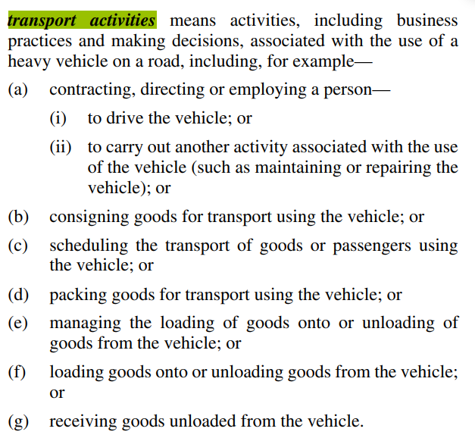

Definition of public risk (S 5)
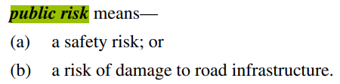

Definition of safety risk (S 5)
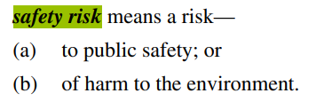
Definition of party in the chain of responsibility (S 5)
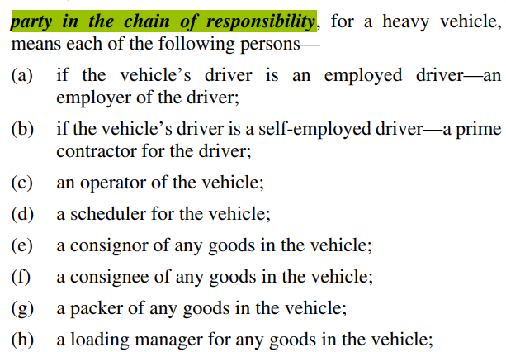
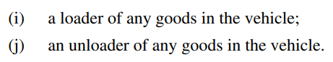

Ministerial approvals (s 653 and 654)
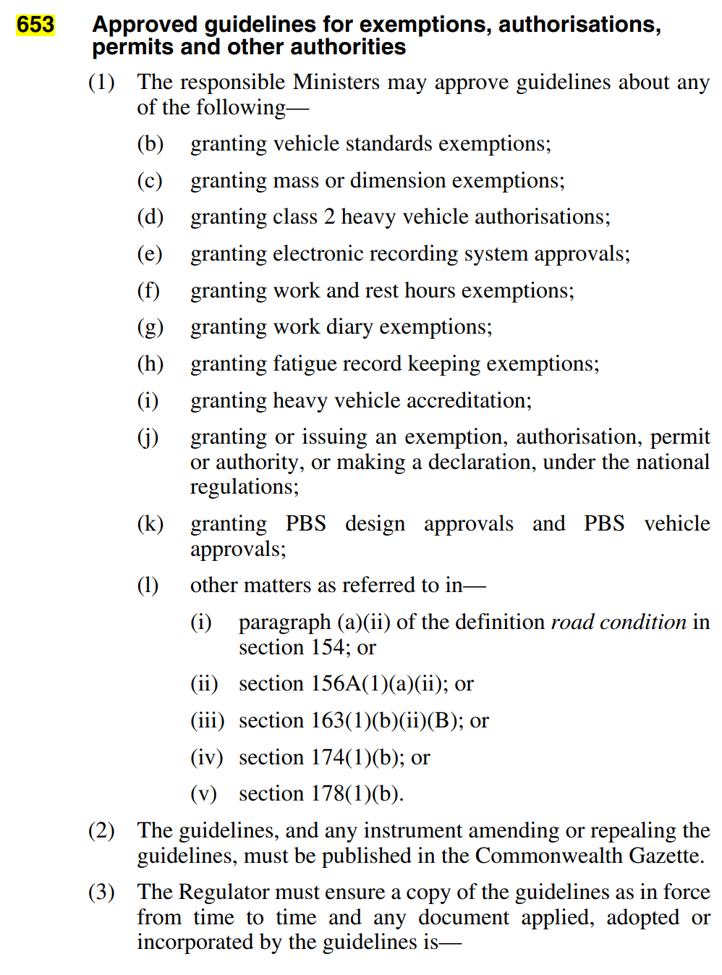
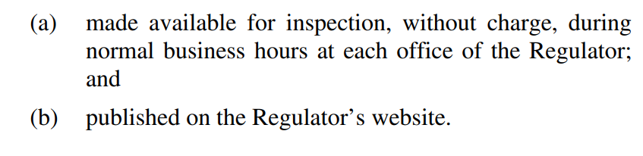
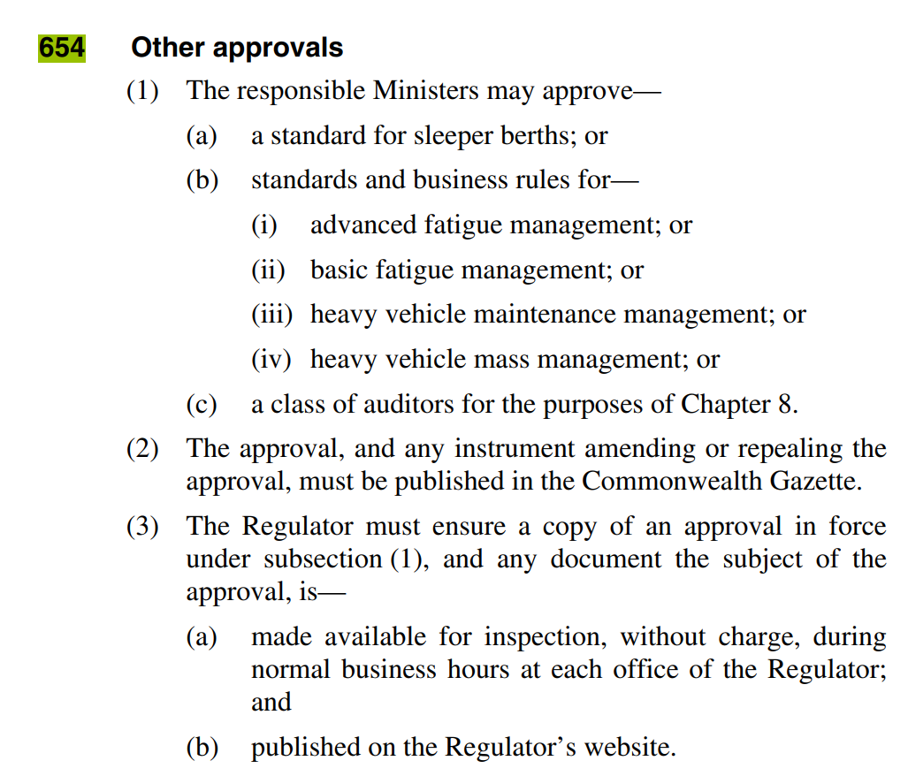

- Overview of tiered safety assurance environment
 | Baseline compliance: HVOs | Alternative compliance
Description | - The baseline tier that applies by ‘default’ to all operators, unless either:  - an exemption applies  - an alternative compliance option, relating to the specific HVO, elevates the operator to tier 2.  - Constructed new regulatory heads of power that enable the prescribing of ‘heavy vehicle obligations’ (HVOs). | - A diverse range of alternative compliance options (ACOs) that may be either:  - issued to categories of operators  - granted to individual operators.  - For accredited operators only.  - Mechanised through a new power allowing the regulator to grant ACOs. Constraints on this power include:  - Legal permissibility  - A safety standard threshold  - Ministerial directions.
What is the key change? | - The HVNL already contains heads of power that enable the prescribing of obligations in regulations.  - The HVO heads of power will be constructed as broadly as possible to make the law more adaptive and able to respond to new technologies, business practices and risks to safety. | - Instead of hardwiring ACOs into legislation, the future law will empower the regulator to grant or issue ACOs.
What are the benefits? | - Increased adaptiveness.  - Increased responsiveness. | - Supporting operator diversity through enabling a broader range of bespoke and nuanced ACOs.  - Better tools to incentivise increased investment in safety.  - Creates a pathway for mutual alignment of HVNL and non-HVNL accreditation schemes.

- Links between primary duty, safety management systems, accreditation and the national audit standard
- Transport activities is defined broadly under the HVNL to capture ‘activities, including business practices and making decisions, associated with the use of a heavy vehicle on a road’. This definition is supported by a non-exhaustive list of examples covering contracting, directing, employment, consignment, scheduling, packing goods, loading and receiving goods.
- Currently the definition of transport activities is called up in the Primary Duty under s 26C of the HVNL, which requires CoR parties to manage the safety of transport activities, so far as is reasonably practicable. The Primary Duty will be categorised as an indispensable requirement under the future law.
- The new HVO construct will also lean on the definition of transport activities. This effectively means that the scope of risks required to be managed under the primary duty, and the scope of matters potentially regulated by an HVO – will be the same.
- To this end, HVOs may be described as prescriptive obligations setting out requirements for managing specific elements of the Primary Duty.
- HVOs will not, however, amount to deemed compliance with the 26C. HVOs will also be prescribed for drivers, who are not subject to the Primary Duty.
- In the future, HVOs may also be prescribed for other off-road parties not listed in the CoR (who are also not subject to the Primary Duty).
- Appendix F elaborates on this relationship by providing a more comprehensive explanation of the relationship between “transport activities”, the Primary Duty, HVOs, the Safety Management System (SMS) requirement for accredited operators, and ACOs.

- Key HVNL definitions for risk-management under the HVNL (S 5)

National Transport Commission
Level 3/600 Bourke Street
Melbourne VIC 3000
Ph: (03) 9236 5000
Email: enquiries@ntc.gov.au
www.ntc.gov.au

iMove Freight Data Requirements Study - February 2019
IBISWorld, 2018, Road Freight Transport June 2018.
The Australian Transport Economic Account (ATEA) https://www.abs.gov.au/statistics/economy/national-accounts/australian-transport-economic-account-experimental-transport-satellite-account/latest-release
NTC, 2016, Who Moves What Where August 2016 (2016) NTC commissioned analysis of ABS 2011 Census Data for estimates, See page 32-33.
National Transport Insurance, 2016, p. 6
NTC, 2016, Who Moves What Where August 2016 p. 75ff
NTC, 2016, Who Moves What Where August 2016
Department of Infrastructure, Transport, Cities and Regional Development, 2019, National Freight and Supply Chain Strategy August 2019
https://www.infrastructure.gov.au/infrastructure-transport-vehicles/transport-strategy-policy/heavy-vehicle-road-reform
https://www.bitre.gov.au/publications/ongoing/road-trauma-involving-heavy-vehicles
Department of Infrastructure and Regional Development, 2016, Heavy truck safety: crash analysis and trends.
National Transport Insurance, 2022, Major Crash Investigation Report 2022 p 16
BITRE 2023, Road Trauma Involving Heavy Vehicles – Annual Summaries
National Road Safety Strategy 2021-2030.
Department of Infrastructure, Transport, Regional Development and Communications. Reducing Heavy Vehicle Lane Departure Crashes. Consultation Regulatory Impact Statement, April 2022.
Bureau of Infrastructure, Transport and Regional Economics 2011, Truck productivity: sources, trends and future prospects, Report 123, Canberra, ACT.
Department of Infrastructure, Transport, Cities and Regional Development, 2019, National Freight and Supply Chain Strategy August 2019 p 7
NTC, 2016, Who Moves What Where August 2016
ABS https://www.abs.gov.au/media-centre/media-releases/covid-19-natural-disasters-disrupt-201920-vehicle-use
ABS https://www.abs.gov.au/media-centre/media-releases/covid-19-natural-disasters-disrupt-201920-vehicle-use
NTC, 2016, Who Moves What Where August 2016
Productivity Commission 2020, National Transport Regulatory Reform, April 2020 pg. 11
For example, Work Health Safety and Rail.
These papers covered effective fatigue management, easy access to suitable routes, vehicle standards and safety, and safe people and practices.
Although the NAS has a broader application than the NHVAS.
This exemption is mechanised operationally and is only available to operators in New South Wales and Queensland.
Please note that the impacts of the baseline tier and alternative compliance tier proposals have been assessed separately under recommendations 1a and 1b below.
A regulation disallowed in Queensland Parliament would then not be applied in any participating jurisdiction.
To be clear, ACOs are not proposed for these obligations either.
As discussed, this aspect of recommendation 1a is limited to operators and drivers, because the HVNL does not establish any kind of “Tiered” environment for off-road parties.
The law may or may not specifically define a class of ‘indispensable’ duties and obligations. This will be a drafting decision left to Parliamentary Counsel’s Committee.
The law may not need to explicitly establish three main categories of obligations. This will ultimately depend on drafting decisions for Parliamentary Counsel’s Committee.
The NTC has traditionally run an annual legislative maintenance process involving jurisdictions, the regulator and industry stakeholders.
This was agreed by ITMM in August 2023 (see Kanofski Report recommendation 3.3)
This is different to the WHS exemption power, which only requires the regulator to ‘consider’ whether a lower standard of safety might arise.
Currently under the HVNL, most exemption powers require the regulator to ‘have regard to’ a relevant ministerially approved guideline.
To be clear, these are examples of criteria the regulator could refer to as part of its assessment. They are not intended as legislative criteria.
This benefit is not available to operators based in other jurisdictions.
Currently set out under Part 12.1 of the law.
Refer to 9.3b of the package of propositions recommended by Ken Kanofski.
It should be noted that the primary duty requires a practical, proactive and preventative approach to managing safety. An audit in isolation cannot be used to establish compliance with the primary duty, however it may feature as part of a suite of measures used by a chain of responsibility party to manage their primary duty obligations.
This will depend on advice from Parliamentary Counsel’s Committee.
Or the equivalent provision for the future law.
See 9.3e of the Overall Reform Propositions recommended by Ken Kanofski, agreed to by ITMM as the ITMM reform package.
Currently set out under Part 12.1 of the law.
Regulations will also specify outer limits for ACOs, but this ministerial direction option provides an additional mechanism for the specifying of outer limits.
A similar power is provided to Ministers under section 22 of the Road Management Act 2004 (VIC).
This will not prevent the regulator from undertaking further investigations in the event that a safety matter identified in one jurisdiction, becomes a multi-jurisdictional matter.
This unlikely to occur, noting that the power is about investigating and providing information about particular safety matters, not changing compliance arrangements.
Noting that Parliamentary Counsel’s Committee may choose to redraft this provision.
Parliamentary Counsel’s Committee will determine the most appropriate construction of powers.
There is a risk that the regulator will be overwhelmed with industry proposals for CoPs, noting the law will also impose an obligation on the regulator to consider any proposal and respond. To avoid this the regulator may be able to develop an approved form requiring a clear business and safety case for the CoP.
A decision not to develop a CoP proposed by Industry will not constitute a reviewable decision under the HVNL.
This may be reflected in the functions of the regulator.
This is consistent with times frames proposed in other similar regulatory contexts, for example the Aviation Regulations require the Civil Aviation Services Authority to provide at least 28 days for comment on a proposed standard.
This means that a code of practice may be the subject of a regulatory impact assessment process, following rules and guidelines set out by the Office of Impact Analysis.
It should be noted that in this context a CoP would not have the same evidential value as a CoP that is considered as part of assessing what is “reasonable and practicable” in the context of the primary duty.
NHVR, Our Regulatory Intervention Strategy – a roadmap for compliance monitoring and enforcement : p 3, https://www.nhvr.gov.au/files/media/document/81/202209-1324-regulatory-intervention-strategy.pdf#:~:text=The%20NHVR%27s%20Regulatory%20Intervention%20Strategy%20applies%20risk%20profiles%20to%20locate,are%20complying%20with%20the%20HVNL, accessed 27 April 2023.
This exemption is mechanised operationally and is only available to operators in New South Wales and Queensland.
All SMS costings are derived at 10 per cent confidence (NHVR, 2023).
Currently specified under section 659H of the HVNL.
National Heavy Vehicle Regulator, Regulatory Advice – Fitness to drive: Physical Health
https://www.infrastructure.gov.au/infrastructure-transport-vehicles/transport-strategy-policy/infrastructure-and-transport-ministers-meetings
Additional Work Streams are initiatives that are outside the NTC Review program of work.
Additional Work Streams are initiatives that are outside the NTC Review program of work.
Additional Work Streams are initiatives that are outside the NTC Review program of work.
Additional Work Streams are initiatives that are outside the NTC Review program of work.
Additional Work Streams are initiatives that are outside the NTC Review program of work.
As such, the scheme most closely resembles 7.3.3 Enhanced opt-in regulatory certification scheme, canvassed in the Consultation Regulation Impact Statement (C-RIS).
Currently ministerial guidelines can be made. Ministerial Directions will be used as there is no ambiguity about the requirement to adhere to them. In general terms ministerial directions will be preferred wherever they relate to matters that ministers have authority to control.
Additional Work Streams are initiatives that are outside the NTC Review program of work.
Additional Work Streams are initiatives that are outside the NTC Review program of work.
Additional Work Streams are initiatives that are outside the NTC Review program of work.
Additional Work Streams are initiatives that are outside the NTC Review program of work.
Additional Work Streams are initiatives that are outside the NTC Review program of work.

