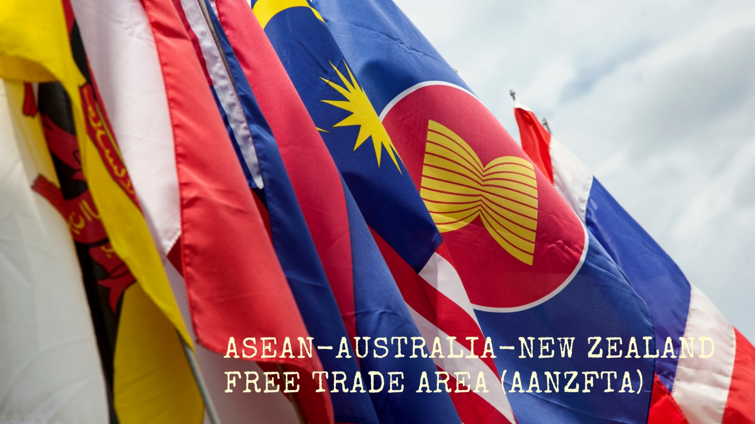

Signing of the Second Protocol to Amend the Agreement Establishing the ASEAN-Australia-New Zealand Free Trade Area

Impact Analysis

Department of Foreign Affairs and Trade

Contents

1. What is the problem you are trying to solve? 3

1.1 DFAT assessed that the original AANZFTA no longer meets Australian consumer and business requirements 3

1.2 AANZFTA Parties agreed that the original AANZFTA required upgrading 4

1.3 DFAT assessed that the original AANZFTA is no longer consistent with Australia’s trade diversification agenda 8

2. Why is Government action needed? 8

2.1 Objectives of government action 8

2.2 Why government action is required 10

2.3 Potential Implications of failure to take government action 12

2.4 Alternatives to government action 12

2.5 Barriers to government action 12

3. What policy options are you considering? 12

3.1 Option 1 – Sign the upgraded AANZFTA 12

3.1.1 Key AANZFTA Upgrade Outcomes 12

3.2 Option 2 – No action 18

4. What is the likely net benefit of each option? 18

4.1 Option 1 – Sign the upgraded AANZFTA 18

Impacts of key changes to AANZFTA through the upgrade process 19

4.2 Option 2 – No action 24

Trade Impact Assessment 24

5. Who did you consult and how did you incorporate their feedback? 25

5.1 Submissions Received 25

5.2 Stakeholder Engagement 27

5.3 States and Territories 27

5.4 Whole of Australian Government Engagement 27

6. What is the best option from those you have considered? 27

6.1 Option 1 – Sign the upgraded AANZFTA 28

7. How will you implement and evaluate your chosen option? 29

7.1 Implementation 29

7.2 Evaluation 29

**Introduction**

Signing the Second Protocol to Amend the Agreement Establishing the ASEAN-Australia-New Zealand Free Trade Area

In accordance with the Australian Government Guide to Policy Impact Analysis, the Department of Foreign Affairs and Trade (DFAT) has completed this Impact Analysis (IA) to analyse the impact of the decision to sign *the Second Protocol to Amend the Agreement Establishing the ASEAN-Australia-New Zealand Free Trade Area (AANZFTA Amendment).*

The Agreement Establishing the ASEAN-Australia-New Zealand Free Trade Area (AANZFTA) entered into force in January 2010 for Australia. It is a regional free trade agreement (FTA), with the ten ASEAN Member States (Brunei Darussalam, Cambodia, Indonesia, Laos, Malaysia, Myanmar, the Philippines, Singapore, Thailand, Vietnam), Australia and New Zealand. The Agreement has provisions for regular reviews to improve its implementation and ensure it remains a high quality, ambitious, and contemporary FTA.

In 2016, the Parties commenced a General Review of AANZFTA, in line with Article 9 of Chapter 18 of the Agreement, with the aim of removing impediments to trade and to further increase trade and investment between the Parties.

In 2018, AANZFTA Ministers endorsed recommendations from the General Review, agreeing to start upgrade negotiations. These negotiations were formally launched in late 2020, with negotiation rounds starting from 2021. Ministers involved in the negotiations substantially concluded negotiations to the upgraded AANZFTA on November 13, 2022, at the 40th and 41st ASEAN Summit in Phnom Penh, Cambodia.

Negotiations on the AANZFTA Amendment were finalised in June 2023. The 2023 ASEAN Chair, Indonesia, alongside other ASEAN member states, intends the AANZFTA Amendment to be signed in the margins of the ASEAN Economic Ministers’ Meetings in Semarang, Indonesia, between 20-22 August 2023. This is a Priority Economic Deliverable for Indonesia as 2023 ASEAN Chair, highlighting Indonesia’s commitment to these timeframes.

Australia has a strong relationship with ASEAN states. Australia is ASEAN’s first dialogue partner and in 2024, Australia will celebrate 50 years of dialogue partnership, including with a proposed Special Commemorative Summit. In 2021, our relationship was elevated to a Comprehensive Strategic Partnership (CSP). The CSP highlighted regional priorities, including the development of high-quality digital trade standards and the Regional Trade for Development (RT4D) initiative, in which Australia will contribute AUD46 million to support the implementation of both RCEP and AANZFTA through economic cooperation programs to maximise the benefits of these agreements. Ensuring that AANZFTA is a high-quality, contemporary agreement is essential to enable delivery of these key priorities.

Prime Minister Anthony Albanese has commented directly on the value of AANZFTA Amendment, by saying: ‘Strengthening trade agreements with ASEAN and New Zealand will mean better outcomes for Australian business and Australian families.’ The Minister for Trade and Tourism, Senator Don Farrell, said: ‘By upgrading AANZFTA, we hope to create new commercial opportunities for Australians, our exporters and investors to work hand-in-hand with ASEAN. This would cement Australia as a partner of choice in an open and inclusive region.’

#### Impact Assessment Timeline

Below is a summary of the timeline of updates to the Impact Assessment.

# 1. What is the problem you are trying to solve?

## 1.1 DFAT assessed that the original AANZFTA no longer met Australian consumer and business requirements

The original AANZFTA has not kept pace with new opportunities in the ASEAN region, such as in education, services, investment, mobility, and digital trade. Since AANZFTA entered into force in 2010, best practice for FTAs has changed as a result of technological developments in the digital economy and uptake of e-commerce, in order to facilitate greater e-commerce in the region and enhance consumer confidence, data transfers, promote privacy and combat fraud. The original AANZFTA also lacks modern FTA outcomes on areas such as environmental protection, competition, government procurement, labour rights and gender equality.

The upgrade to AANZFTA solves the problem of the current version of AANZFTA no longer meeting the consumer and business requirements for a high-quality, contemporary FTA.

ASEAN’s trade is important for the Australian economy and it is therefore important to ensure that Australia remains a trading partner of choice for ASEAN. In 2021, Australia's trade with ASEAN countries was $127.1 billion, which is greater than our two-way trade with Japan and the United States. Our two-way investment with ASEAN in 2021 was $248.7 billion. A strong AANZFTA is also important as it reinforces a rules-based and ASEAN-centred regional economic architecture.

#### Australian Stakeholders assessed that AANZFTA required upgrading

Submissions received from key Australian stakeholders, including peak industry bodies, on balance indicated that the Australian business community saw a requirement for the AANZFTA upgrade. In particular, stakeholders saw a need for streamlined rules of origin processes and updated services and investment outcomes to increase certainty for Australian businesses and investors. Stakeholders also sought trade facilitation measures and for progressive trade outcomes, such as on competition and sustainable development, to be included in the upgrade.

***What problems does the AANZFTA upgrade solve?***

## 1.2 AANZFTA Parties agreed that the original AANZFTA required upgrading

The AANZFTA Parties envisaged that the Agreement would be a ‘living’ document and need periodic review and updating to ensure it remained a high quality and ambitious agreement. The First Protocol to Amend AANZFTA was signed by Ministers on 26 August 2014. This responded to practical business concerns in resolving implementation problems associated with Certificates of Origin and Rules of Origin.

In 2018, following the delivery of a 2017 comprehensive review of the Agreement (the AANZFTA General Review Stage One Report), AANZFTA trade and economic ministers agreed that AANZFTA required further modernisation to address technological advancements and to bring it in line with contemporary FTAs such as the Comprehensive and Progressive Agreement for Trans-Pacific Partnership (CPTPP).

The General Review Stage One Report found that the implementation period had been positive, with an ongoing implementation agenda, supported by review mechanisms, work programs and institutional arrangements established under the Agreement. Trade, investment and AANZFTA business utilisation had continued to increase. However, questions remained over business awareness and use of AANZFTA.

One challenge that reaffirmed the need to change international trade structures was the COVID-19 pandemic. This demonstrated a need for expedited trade during humanitarian crises, epidemics and pandemics - reinforcing the need to upgrade the Agreement to promote supply chain resiliency and economic integration.

#### 1.1.3 Key areas where the original AANZFTA required upgrading

Industry inputs to the General Review highlighted a number of key issues for further work under AANZFTA, which are illustrated in Box 3.1, which was included in the Stage One Report.

The report highlighted that the broader regional architecture had evolved, with many AANZFTA Parties having signed more comprehensive bilateral and multilateral FTAs that provided more access to certain investment, services , digital opportunities, and closer economic cooperation commitments. AANZFTA Parties were also involved in the RCEP negotiations, which aimed to go further on goods, services, and investment commitments. In this broader context, it became imperative for AANZFTA to progress its built-in agenda and issues of interest to business, as well as to engage with other stakeholders. In particular, there was considerable potential for more work in the areas of customs procedures, sanitary and phytosanitary measures (SPS) and standards, technical regulations and conformity assessment procedures (STRACAP). Priority was accorded to progressing the services and investment built-in agendas, in particular on improving legal certainty and predictability of services regulations and investment regimes, as well as further developing rules in areas where policy frameworks are still developing, such as e-commerce. AANZFTA also provides a strategic focus for Australia, to promote ASEAN centrality and support the international rules-based order. The upgrade will further instil the importance of ASEAN in our region to promote economic integration, security, and supply chain resilience.

To address these limitations, the Ministers agreed to initiate AANZFTA upgrade negotiations on the following

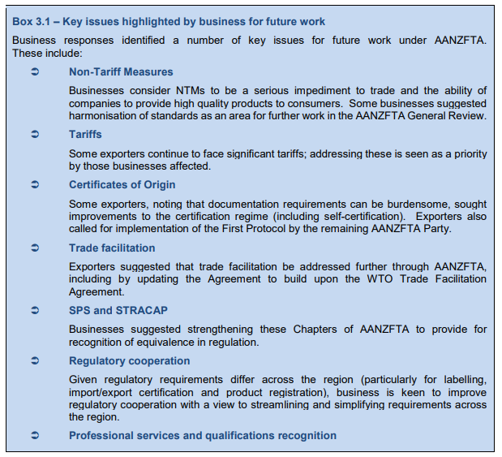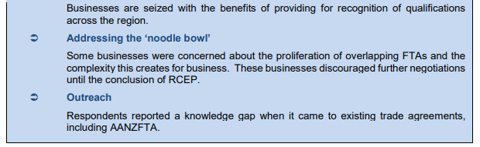

* **Rules of origin:** to take better account of modern trade practices, address implementation issues encountered by Australian exporters and make rules of origin easier to use and less costly for traders.
* **Customs procedures:** enhance and modernise AANZFTA’s provisions on customs procedures to promote trade facilitation, including a new provision that promotes expedited trade during humanitarian crises, epidemics and pandemics.
* **Services and investment**: incorporate best practice rules and legal architecture, as reflected in modern FTAs, such as the CPTPP and RCEP, to support market openness and enhance trade facilitative practices and regulatory certainty.
* **Movement of natural persons:** to better facilitate the movement of natural persons engaged in the conduct of trade and investment between the Parties and improve transparency of procedures of visa applications.
* **E-Commerce:** modernise AANZFTA to support the growth of the digital economy in Australia and reflect the substantial developments in the digital economy since AANZFTA was originally negotiated.
* **Competition (including consumer protection):** build on RCEP standards to include new provisions on consumer protection, including regional cooperation on the development and implementation of matters covered by the revised chapter.
* **Government procurement:** facilitate enhanced cooperation on labour rights, women’s economic empowerment and environmental protection.
* **Micro, small, and medium enterprises (MSMEs):** new provisions for MSMEs as well as a framework for sharing information on best practice programs and activities aimed to enhance the capability of MSMEs to participate in and benefit from the economic opportunities created by the upgraded agreement.

AANZFTA’s services and investment outcomes are modest compared to other agreements. Only 2.8 per cent of Australian investment goes to ASEAN and services exports are also underutilised, with Singapore accounting for one third of all Australian services exports to ASEAN. Australian companies are deterred from entering the underutilised ASEAN markets as they are concerned that the domestic laws and policies will change with no or little notice.

In their 13 November 2022 joint statement on the upgrade’s substantial conclusion, the AANZFTA ministers emphasized the importance of the upgrade to strengthening the resilience of supply chains. The joint statement said that the upgrade ‘is a testament to the AANZFTA Parties’ resolve to accelerate post-pandemic economic recovery by deepening and broadening economic integration and cooperation to bolster more robust and resilient supply chains, keep markets open for trade and investment and catalyse longer-term growth by leveraging digital trade and sustainable development.’[1]

While AANZFTA remains the highest quality of ASEAN's FTAs with its partners there were areas for significant improvement identified by the AANZFTA General Review. The AANZFTA Amendment directly addresses the AANZFTA General Review’s recommendations and is consistent with the first recommendation of the Pivot report by enhancing opportunities for Australians wishing to trade with ASEAN Member States.

#### 1.1.4 The original AANZFTA was surpassed by RCEP

The Regional Comprehensive Economic Partnership (RCEP) entered into force for Australia on 1 January 2022. RCEP is a regional free trade agreement that complements and builds upon Australia's existing free trade agreements with 14 other Indo-Pacific countries (Brunei Darussalam, Cambodia, China, Japan, Laos, New Zealand, Singapore, Thailand, Vietnam, Republic of Korea, Malaysia, Indonesia and the Philippines). Building on RCEP outcomes, an upgraded AANZFTA will ensure the Agreement remains a relevant, contemporary agreement, which will continue to provide commercial benefits to businesses and consumers.

## 1.3 DFAT assessed that the original AANZFTA was no longer consistent with Australia’s trade diversification agenda

Trade diversification is the central pillar of the Government’s trade policy strategy, providing us and our regional partners with certainty and agency in the choices we make about where and with whom we trade, and addressing the risk of over-exposure to any one market or product. ASEAN partners are key to this diversification effort. Australia’s liberal trade policy settings have underpinned our ongoing economic growth. Our open economy and support for rules-based international trade have contributed to the high standard of living Australians enjoy. Maintaining contemporary trade agreements that are fit for purpose is central to this policy.

In 2020, an Inquiry by the Joint Standing Committee on Trade and Investment Growth into Diversifying Australia's Trade and Investment Profile concluded in a report entitled ‘Pivot’[2], that there was a need to diversify Australia’s trade. The first recommendation was:

* That the Australian Government develop and release a plan for trade diversification, with:
  + a focus on maintaining relationships with existing close trading partners as well as expanding trade with other countries; and,
  + a plan for diversifying Australia’s range of goods and services exports.

# 2. Why is Government action needed?

## 2.1 Objectives of government action

The overall objective of upgrading AANZFTA is to ensure that Australia remains a trading partner of choice for ASEAN member countries. This benefits Australian businesses and investors by ensuring the region is open to trade with Australia, thereby expanding economic opportunities for Australians and, ultimately, contributing to maintaining and improving the living standards of Australians. This also complements Australia’s other foreign policy and diplomatic efforts, such as under Australia’s Comprehensive Strategic Partnership with ASEAN. Additional objectives of Government action in upgrading AANZFTA include supporting the sustainable and inclusive development of our neighbouring ASEAN economies, in particular the least developed ASEAN economies, and reinforcing our region’s rules-based and ASEAN-centred regional economic architecture.

Australia's economy relies on a strong and open global trading environment. The Australian Government is strongly committed to the WTO and its framework of rules, which helps promote and protect the open global trading system. Our membership in the WTO means that we benefit from its trade rules and we have a process to settle disputes if other trade partners breach these rules. A key rule of the multilateral trade system is that reductions in trade barriers should be applied, on a most-favoured nation basis, to all WTO members. This means that no WTO member should be discriminated against by another member's trade regime. However, regional trade agreements (RTAs) are an important exception to this rule. Under RTAs reductions in trade barriers apply only to the parties to the agreement. This exception is allowed under Article XXIV of the General Agreement on Tariffs and Trade (GATT) for trade in goods, in Article V of the General Agreement on Trade in Services (GATS) for Trade in Services and in the Enabling Clause for developing countries. There are two major types of regional trade agreements under the WTO - customs unions and free trade areas, with AANZFTA being a free trade area. RTAs must be consistent with the WTO rules governing such agreements, which require that parties to a regional trade agreement must have established free trade on substantially all trade within the regional area, and that the parties cannot raise their tariffs or other barriers against countries outside the agreement.

RTAs like AANZFTA are treaties, and the power to enter into treaties is an Executive power within section 61 of the Australian Constitution. Given that any treaty necessarily involves an element of Australia's foreign relations, the Minister for Foreign Affairs and the Department of Foreign Affairs and Trade (DFAT) have responsibility for treaties.

#### 2.1.2 Methods to achieve government action

Australia’s method to achieve this government action is through its trade liberalisation agenda. The upgraded AANZFTA seeks to reinforce the trade liberalisation agenda and be a liberalising framework by:

* Improving the government procurement processes through improved transparency and cooperation in government procurement.
* Streamlining rules of origin processes to make it easier and less costly for businesses to access AANZFTA’s benefits, with **Figure 1** highlighting the importance of goods trade to Australia’s economy.
* Improving uptake of investments through high quality commitments on the entry of Australians to ASEAN Member States to supply services, including as business visitors and intra-corporate transfers, with **Figure 1** also highlighting the importance of services trade to Australia’s economy.
* Boosting Australian investors’ confidence, particularly in the region’s higher income services sectors, including to create legal certainty for our services providers and investors in Southeast Asia.
* Including new provisions for micro, small, and medium enterprises (MSMEs) to sharing information on best practice programs and activities aimed to enhance the capability of MSMEs to participate in and benefit from the economic opportunities created by the upgraded agreement.
* Including new provisions on digital trade standards, digital inclusion, and dispute settlement reflect developments in digital trade since the original AANZFTA entered into force in 2010.
* Including a new trade and sustainable development chapter to address identified emerging priorities in sustainable and inclusive trade, including labour rights, environmental protection, and women’s economic empowerment, and to facilitate Australia’s targeted economic cooperation activities under the Regional Trade for Development Program (RT4D).

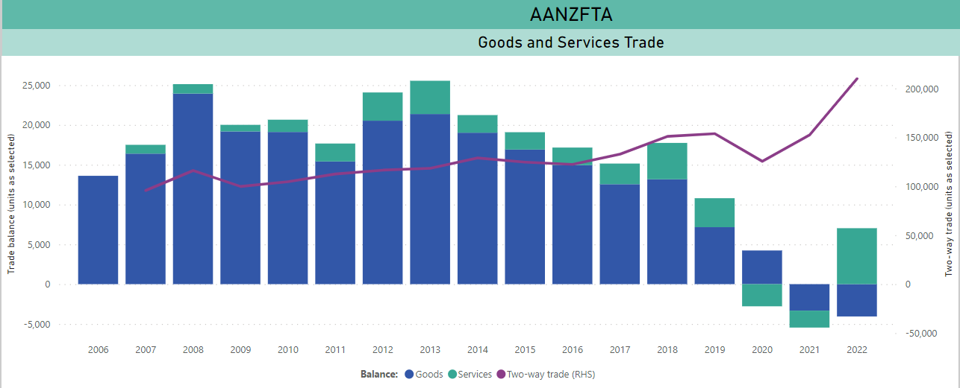

Figure 1: AANZFTA Goods and Services Trade

## 2.2 Why government action is required

Government action is required to ensure AANZFTA remains a competitive, relevant, contemporary agreement, which continues to deliver economic benefits to Australian businesses and consumers. Signing the AANZFTA Amendment ensures that AANZFTA will provide opportunities to further promote and facilitate trade and investment between Australia and ASEAN member states, improve business conditions specific to Australian commercial interests and enhance regional economic integration.

Government action is needed for the AANZFTA upgrade to enter into force. As stipulated under article 7 of Chapter 18 ‘Final Provisions’ of the Agreement, for the upgrade to come into effect it requires Australia, New Zealand, and at least four ASEAN Member States to ratify. To ensure that at least four ASEAN Member States (AMS) ratify in a timely manner, the Australian Government will advocate the benefits of the upgrade and provide support to countries requiring assistance (capacity building). Since some AMS do not have similar resources as Australia, it would most likely delay the upgrade’s entry into force, delaying Parties stakeholders in realising the benefits from the upgrade. To progress entry into force, Australia could entail translation assistance, which is a requirement in those countries for ratifying free trade agreements. Australia could provide marketing material and other advocacy documents for use of these least developed nations, helping them advocate internally to reassure their domestic decision makers and expedite the process.

**Figure 2** highlights the value of the ASEAN market to Australia’s economy, and therefore the value of upgrading AANZFTA to ensure that Australia remains a trading partner of choice for ASEAN.

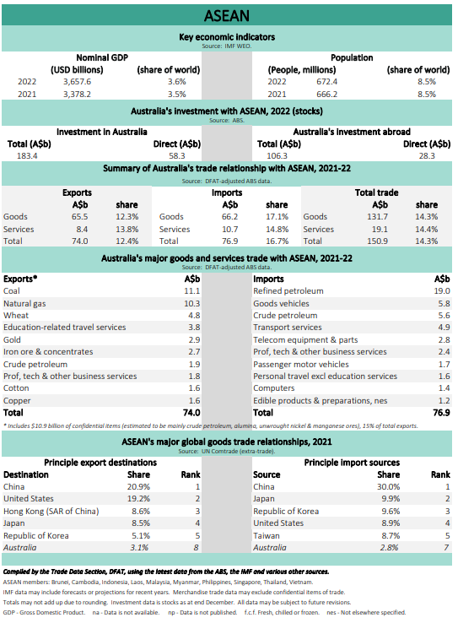

Figure 2: ASEAN Key Economic Indicators

## 2.3 Potential Implications of failure to take government action

Failure of the Government to implement the AANZFTA upgrade will forego the opportunity for Australian industry to benefit from improvements in market access and trade rules through the AANZFTA upgrade. Failing to sign the upgraded AANZFTA may also have negative implications for Australia’s relationship with ASEAN and ASEAN member countries and reduce Australia’s influence with ASEAN. Not signing will also undermine complementary effects such as the Southeast Asia Economic Strategy.

## 2.4 Alternatives to government action

DFAT assessed that there were not feasible alternatives to government action. Australian businesses and services are not able to seek trade enhancement, under AANZFTA, without the Australian Government’s intervention to upgrade the Agreement. As addressed above, the power to enter into treaties is an Executive power within section 61 of the Australian Constitution, which only the Australian Government, and not private actors, can do.

## 2.5 Barriers to government action

While Australia negotiates FTAs to benefit Australian exporters, importers, producers and investors by reducing and eliminating certain barriers to international trade and investment, these negotiations are always subject to the agreement and preferences of our negotiating partners. This is particularly true in the case of multilateral negotiations including countries with a variety of different priorities and sensitivities.

# 3. What policy options are you considering?

This Impact Analysis considers two options: to sign or not to sign AANZFTA Amendment.

## 3.1 Option 1 – Sign the upgraded AANZFTA

The upgraded AANZFTA addresses issues identified under the AANZFTA General Review and agreed by AANZFTA trade and economic ministers and also includes new outcomes on issues such as digital trade and sustainable development.

Signing the upgraded AANZFTA will provide opportunities to further promote and facilitate trade and investment between Australia and ASEAN Member States, improve business conditions specific to Australian commercial interests and enhance regional economic integration. The upgraded AANZFTA builds on RCEP outcomes, and ensures AANZFTA remains a relevant, contemporary agreement, which continues to provide commercial benefits to businesses and consumers.

To ensure AANZTFA is contemporary and delivers financial benefits and ease of access to Australian businesses and consumers, Australia achieved the following the key outcomes in the course of AANZFTA Upgrade negotiations.

### 3.1.1 Key AANZFTA Upgrade Outcomes

#### Rules of Origin

This chapter determines which goods are originating under AANZFTA and eligible for preferential tariff treatment. Key outcomes include enhanced, trade facilitating documentary evidence of origin arrangements (such as self-certification of origin); transit arrangements that reflect modern hubbing practices; and greater support for regional value chains, through more flexible rules on which regional inputs may count towards a good’s originating status.

The upgraded AANZFTA will establish new regional rules of origin that make it easier and less costly for businesses to access AANZFTA’s benefits. New cumulation rules will give traders more flexibility in sourcing and shipping inputs, promoting greater integration into regional and global supply chains. There is now a standalone consignment provision that provides for transhipment – this will provide clearer and broader scope for goods to retain their originating status when transiting through countries outside of AANZFTA.

The upgraded AANZFTA will also simplify and empower traders when it comes to completing documentation. Certificate of Origin arrangements, which are already familiar to Australian business will be maintained. The upgrade establishes an option for self-declaration (Declarations of Origin), with scope for proof of origin to be accepted in electronic format. Several AANZFTA Parties are familiar with Declarations of Origin through other FTAs. In addition, third party invoices will only require information to be provided where known, promoting ease of access to FTA benefits.

The Product Specific Rules (PSR) (which are the detailed Rules of Origin applying to individual products) have been upgraded to reflect specific treatment of chemical and technical rules. The PSR format will also be updated to be consistent with the current version of the HS (HS 2022). The AANZFTA PSR are currently recorded in a previous version of the HS (HS 2012). This causes unnecessary complexity for businesses and creates a risk that business will inadvertently make a mistake when claiming AANZFTA tariff preference.

#### Customs Procedures

The Customs Procedures chapter has been expanded to include trade facilitation arrangements, building on commitments under the World Trade Organization (WTO) Trade Facilitation Agreement and gains made in other negotiations. Key outcomes include modernised rules enhancing predictability, consistency, and transparency in the application of customs laws and regulations; and promoting more efficient administration of customs procedures (e.g. through expedited clearance of express consignments and perishable goods; an authorised operator’s scheme to reduce compliance burdens; and encouraging post-clearance audits a risk-based approach to customs compliance activities).

#### Services & Investment

**Figure 3** highlights the value of services trade to Australia’s economy. The services commitments and chapter text have been expanded in the upgrade, taking into account existing built-in agenda items and progress in other relevant FTAs. Key outcomes include building on ASEAN´s existing AANZFTA services commitments to achieve an RCEP parity agreement as a baseline, going beyond RCEP in areas of commercial interest for Australia such as education and professional services, including by further facilitating mutual recognition of professional qualifications, and ensuring greater regulatory coherence and harmonisation in the region. The two Annexes on Telecommunications and Financial Services have also been upgraded to build on RCEP standards.

Services trade marking services trade and  two-way trade from 2007 to 2022


Figure 3: AANZFTA Services Trade

The Investment chapter text has been expanded considering existing built-in agenda items and progress in other relevant FTAs. Key gains include investment outcomes that reflect, or where possible, build on RCEP outcomes, and exploring the inclusion of modern safeguards or other approaches to enhance certainty in the Investor-State Dispute Settlement mechanism.

The upgraded AANZFTA will provide a strong platform to expand trade in services and to promote investment throughout the region. AANZFTA will establish high quality rules for investment and the supply of services between AANZFTA parties, including obligations to provide access to foreign service suppliers (market access), to treat local and foreign suppliers and investors equally (national treatment) and to treat foreign suppliers and investors at least as well as suppliers and investors of any other non-AANZFTA country (most-favoured-nation or MFN).

The upgraded AANZFTA will include a forward-looking MFN provision in services, like that agreed in RCEP, and a significant improvement over the MFN provision that existed in the original AANZFTA.

Several parties will make use of the inherently more liberalising approach of negative listing for the first time for services market access. All parties to the original AANZFTA used the ‘positive list’ approach to scheduling services, while the upgraded agreement will see the ‘negative list’ used in AANZFTA for the first time by Australia, Brunei Darussalam, Indonesia, Malaysia, New Zealand, and Singapore.

All AANZFTA parties have scheduled investment commitments in a ‘negative list’, and AANZFTA parties that have used a ‘positive list’ for services commitments are required to transition to a negative list. This ensures clarity and consistency across regional agreements.

The upgraded AANZFTA will include a ‘ratchet-mechanism’ which locks in future unilateral liberalisation for selected sectors and will allow significant reduction of barriers to services and investment trade over time.

The upgraded AANZFTA enhances the protections for Australian investors through the Investor-State Dispute Settlement (ISDS) mechanism, guaranteeing Australians against unlawful expropriation and unequitable treatment and provides investors with the right to access an international tribunal to resolve international disputes. The upgrade will modernise ISDS through exempting the Foreign Investment Review Board (FIRB) and expanding security exceptions. Australia could not unilaterally remove ISDS from AANZFTA. However, under the AANZFTA package of outcomes, Parties will review AANZFTA’s existing ISDS mechanism through a work program that will commence 18 months after the entry into force of the upgraded AANZFTA. Further, the AANZFTA Amendment will disapply ISDS to AANZFTA’s “National Treatment” obligation for 30 months from the date of entry into force. Foreign investment screening under Australia’s Foreign Investment Review Board will also be exempt from the application of ISDS and state-to-state dispute settlement.

The sector-specific commitments provided by the other parties represent substantial improvements over those contained in the original AANZFTA agreement. These improvements will provide greater certainty for Australian service suppliers and investors and will benefit Australian businesses across a range of sectors, including in professional services; education services; financial services; communications services; healthcare services; construction and related engineering services; tourism, recreational, cultural and sporting services; transport services; and wholesale trade and retailing services.

The Annex on Professional Services (Annex 8C) facilitates cooperation on recognition of professional qualifications, licensing and registration requirements. It provides a framework for professional bodies to expand their links with AANZFTA counterparts, encouraging dialogue on recognition of qualifications, licences and registration, as well as encouraging development of mutual recognition arrangements in professions of mutual interest and alignment with international frameworks on standards and criteria for professions.

The Annex on Education Services Cooperation (Annex 8D) recognises the important role that education services play in enhancing growth and prosperity and deepening institutional and people-to-people links among the Parties. The Annex will encourage cooperation in education quality assurance processes and the recognition of qualifications. It will also encourage cooperation on the development of training, programs, and staff exchanges. The Annex provides an important signal of the Parties’ mutual priorities and interests in particular sectors or fields, and complements the specific, formalised rules contained in the market access schedules.

#### Movement of Natural Persons

The mobility market access commitments and chapter text has been expanded to further facilitate the movement of natural persons engaged in the conduct of trade and investment between the Parties, and improve transparency of procedures of visa applications – while protecting the integrity of Australia’s borders, domestic labour force and permanent employment.

The Movement of Natural Persons chapter and related schedules build on the original AANZFTA and RCEP commitments and provide certainty on temporary entry and stay for businesspersons to facilitate trade and investment in the region.

The upgraded Movement of Natural Persons chapter (chapter 9) builds on existing AANZFTA commitments, giving Australian businesspersons certainty on temporary entry and stay access in the region and greater certainty about the rules that will apply to them. The Movement of National Persons chapter establishes rules for the temporary entry and stay of natural persons between AANZFTA parties, including new obligations to facilitate and streamline immigration formalities. These include obligations to accept immigration formalities in electronic format, accept copies of authenticated documents, and to publish information in English. The chapter also includes new provisions to distinguish the Movement of Natural Persons chapter from other chapters of the agreement, removing ambiguity regarding obligations in other chapters applying to temporary entry and stay, especially as they relate to Trade in Services obligations such as Most-Favoured Nation. This provides additional protections for Australia’s, and other Parties’, immigration systems.

Australia’s Movement of Natural Persons schedule of commitments are consistent with original AANZFTA and RCEP commitments. Australia made commitments on business visitors, intra-corporate transferees, independent executives, contractual service suppliers and spouses. Consistent with AANZFTA and RCEP, Australia has retained the right to apply labour market testing for contractual service suppliers, to the extent that this is not inconsistent with commitments under the WTO. Consistent with more recent trade agreements, including RCEP, Australia has removed sectoral commitments under all categories, providing Australia more flexibility to modify its domestic visa arrangements, such as changes to occupation lists.

#### Electronic Commerce (E-Commerce)

The Electronic Commerce chapter text has been expanded to take into account developments at the international, regional and national level. Key outcomes include digital trade outcomes up to our best trade agreement practice, including high quality rules that improve on RCEP outcomes; and the application of dispute settlement to as much of the ecommerce chapter as possible.

The upgraded E-Commerce chapter will modernise AANZFTA to support the growth of the digital economy in Australia and reflect the substantial developments in the digital economy since AANZFTA was originally negotiated. The chapter will help provide certainty for businesses and consumers engaging in digital trade in the region by promoting interoperability of systems across borders, protecting consumer privacy and building trust in the online environment.

Several new articles have been adapted from RCEP (given its status as a shared precedent for AANZFTA Parties), but the upgraded chapter also extends beyond RCEP by including articles on digital inclusion, electronic invoicing, digital trade standards and open government data.

Specifically, the chapter includes obligations that promote a move towards paperless trading in the digital economy by requiring the acceptance of e-signatures and e-authentication, and by encouraging the adoption of interoperable electronic invoicing systems. The chapter also includes commitments that promote trust and confidence in the digital economy through rules on the protection of personal information, consumer protection, transparency and the prevention of unsolicited communications (e.g. spam).

The movement of data across borders continues to be a fundamental aspect of e-commerce between countries, with most transactions involving the creation and transfer of data. The chapter includes rules that support the free flow of data across borders and that prevent unjustified data localisation requirements, while maintaining appropriate regulatory space in certain areas, including for the protection of privacy.

Significantly, AANZFTA Parties agreed that the dispute settlement mechanism in chapter 17 will apply to the E-Commerce chapter subject to specific transitional periods for data rules (Articles 17 and 18.

#### Competition

The Competition chapter text has been expanded to build on RCEP standards to include new provisions on consumer protection, including regional cooperation on the development and implementation of matters covered by the revised chapter.

The Competition chapter (chapter 14) now contains obligations requiring AANZFTA parties to adopt or maintain competition laws and regulations to proscribe anti-competitive actions and enforce those laws accordingly. The chapter obliges AANZFTA parties to adopt or maintain laws or regulations to proscribe the use in trade of misleading practices or false or misleading deceptions. It also provides for cooperation between the AANZFTA parties on consumer protection and on competition law enforcement. The Competition chapter contains standard provisions that are similar to Australia’s previous FTAs and are consistent with the Competition and Consumer Act 2010.

#### Government Procurement

A Government Procurement chapter has been developed, without market access commitments, which supports improved transparency and cooperation in government procurement. Key outcomes include transparency, integrity and cooperation provisions reflecting our best trade agreement practice, building on the RCEP Government Procurement chapter, and establishing a platform for future negotiations on government procurement commitments through a built-in work programme.

The Government Procurement chapter (chapter 17) provides for commitments that recognise the importance of promoting enhanced transparency and integrity in government procurement processes; facilitating Micro, Small and Medium Enterprise participation in government procurement; promoting the concept of environmental sustainability in government procurement; and promoting the use of electronic procurement systems to facilitate easier access to ASEAN and New Zealand procurement opportunities for Australian suppliers. In addition, the chapter provides for capacity building and the development of cooperation among the AANZFTA Parties.

The chapter does not contain market access commitments and its scope is limited to the central government level (the Commonwealth Government in Australia). No legislative or regulatory changes are required for Australia.

#### Trade and Sustainable Development

The upgraded AANZFTA will include a new Trade and Sustainable Development chapter which will facilitate enhanced cooperation on labour rights, women’s economic empowerment and environmental protection. This chapter will facilitate Australia’s targeted economic cooperation activities under the Regional Trade for Development Program (RT4D).

The upgraded AANZFTA’s new Trade and Sustainable Development chapter is ASEAN’s first chapter on sustainable development issues in a trade agreement. For AANZFTA members not party to the CPTPP, it also contains their first commitments in a trade agreement on environment and labour standards. It contains all ASEAN members’ first commitment in a trade agreement on women’s economic empowerment.

The chapter recognises Parties’ commitment to sustainable development, environmental protection, labour protections and women’s economic empowerment. Parties also recall their commitment to multilateral environment and labour agreements to which they are individually a party, as well as to the 2030 Agenda for Sustainable Development and its Sustainable Development Goals. Parties additionally recognise that it is inappropriate to weaken or reduce levels of protection in their environmental or labour standards to encourage trade and investment. The chapter facilitates economic cooperation activities in these areas, including in climate, green and blue economy, energy and sustainable development broadly. Cooperation under the chapter is overseed by the FTA Joint Committee.

#### Micro, Small and Medium Enterprises (MSMEs)

A new MSMEs chapter has been developed to help address issues that MSMEs face, which other larger businesses don’t. Priorities include seeking a range of provisions aimed at fostering the growth and development of the sector: e.g., Information sharing – commitments that will make it easier for businesses to get the information they need to export/import; and cooperation provisions – to allow parties to work together on issues such as trade facilitation and digital trade.

The Micro, Small and Medium Enterprises chapter seeks to promote information sharing and cooperation among AANZFTA parties to enhance opportunities for their MSMEs to participate in the benefits created by the upgraded Agreement.

## 3.2 Option 2 – No action

The second option is for Australia to not sign the upgraded AANZFTA. DFAT has identified the below two limitations with this option.

#### 3.2.1 DFAT assess that declining to sign the upgraded AANZFTA would be inconsistent with Australia’s trade liberalisation agenda

Not signing the AANZFTA upgrade would be at odds with Australia’s trade liberalisation agenda and may have reputational risks for Australia’s relationship with ASEAN Member States. Not upgrading Australia’s most important FTA with ASEAN will not serve our strategic interests in promoting a prosperous and secure region. If we do not ensure our participation with ASEAN economic development and cooperation in the Indo-Pacific, Australia will reduce its influence and limit the potential opportunities for trade diversification and economic resiliency. We will reduce our ability to guide regional trade, such as enhanced supply chains, greater trade facilitation, and ease of doing business for all Parties. ASEAN is forecasted to grow 4.7 per cent in 2023 (ADB) with a nominal GDP USD 3.66 trillion and will continue to grow. ASEAN, as a combined economy, is projected to rank as the fourth-largest economy globally by 2050, and currently ranks as the seventh-largest economy (McKinsey). If we do not upgrade AANZFTA, Australia is projected to lose the economic opportunity of selling Australian products, services, and investments to ASEAN Member States.

#### 3.2.2 DFAT assess that declining to sign the upgraded AANZFTA or delays in Australia’s ratification would prevent the upgrade from entering into force for other AANZFTA members

Pursuant to Article 2(2) of the *Second Protocol to Amend the Agreement Establishing AANZFTA, t*he upgraded AANZFTA will only enter into force 60 days after the date on which Australia, New Zealand and at least four ASEAN member states have deposited their instruments of ratification, acceptance or approval. This means that if Australia fails to sign and ratify the upgraded AANZFTA, that it will prevent the upgraded AANZFTA from entering into force for all other AANZFTA members. This would prevent AANZFTA members, including less developed ASEAN members, from realising the benefits of the upgraded AANZFTA, despite the extensive resources these countries have extended to upgrade the Agreement.

Delays in any aspects of the legislative process could result in delays to entry into force of the upgraded AANZFTA. Depending on the reasons for these delays, this could result in reputational risks for Australia, as it could be perceived that Australia is stalling on its commitments.

Australia's bilateral engagement with the countries of Southeast Asia is strengthened by Australia’s engagement with ASEAN, the region's premier representative grouping. Government to government links between Australia and ASEAN are strong and reflect close to half a century of cooperation. Compromising these by not signing the upgrade which has been under negotiations since 2018 could be harmful to our bilateral relationships and people-to-people links between Governments. Not signing would also undermine efforts to implement and maximise benefits outlined in the Southeast Asia Economic Strategy 2040.

# 4. What is the likely net benefit of each option?

## 4.1 Option 1 – Sign the upgraded AANZFTA

Signing the upgraded AANZFTA will be a strong sign of the Government’s commitment to diversifying our trading relationships, creating new commercial opportunities for our exporters and driving inclusive economic growth for all Australians. The changes that will be made to AANZFTA through upgrade also complements the Government’s Southeast Asia Economic Strategy to 2040 by strengthening Australia’s economic engagement with the region. Once in force, the upgrade will maintain AANZFTA’s status as ASEAN’s highest-quality trade agreement and further reinforce the Indo-Pacific’s rules-based economic architecture.

### Impacts of key changes to AANZFTA through the upgrade process

#### 4.1.1 Rules of Origin

Benefits

The upgraded AANZFTA establishes new rules of origin that make it easier and less costly for business to access the Agreement’s benefits. The upgrade streamlines and modernises product origin documentation and transit agreements, making is easier and less costly for business to export products to ASEAN Member States.For example, new opportunities will be created for ASEAN exporters by enabling traders to have more flexibility in sourcing inputs for the products they sell. In turn, Australian exporters will gain greater demand for their inputs into ASEAN production. This provides for the future implementation of Declarations of Origin (DOOs), reducing time and cost for traders by allowing self-certification.

Costs

There is potential for some upfront implementation costs for business, including the costs associated with training staff to understand and implement new Rules of Origin processes. However, no longer term costs have been identified.

#### 4.1.2 Customs Procedures

Benefits

Key outcomes include modernised rules enhancing predictability, consistency, and transparency in the application of customs laws and regulations through promoting more efficient administration of customs procedures. For example, the upgrade will expedite clearance of express consignments and perishable goods and will put into place an authorised operator’s scheme to reduce compliance burdens. The upgrade will also encourage post-clearance audits a risk-based approach to customs compliance activities and includes provisions for trade facilitation of essential goods during crises, which streamlines trade procedures. These changes have the cumulative impact of reducing current compliance burdens, which will reduce broader operating costs for businesses.

Costs

There are limited costs associated with changes to customs procedures provisions, as the modernised rules will enhance and streamline compliance and regulatory administration. There may be limited upfront implementation costs for businesses.

#### 4.1.3 Services and Investment

Benefits

The upgraded AANZFTA modernises existing protection for investors, including guarantees against unlawful expropriation, and adds rules to provide further protections for investors, such as protecting investors from requirements to appoint nationals as the manager or to the board of their investment.

The upgrade also establishes high quality rules for investment and the supply of services between AANZFTA parties, including obligations to provide access to foreign service suppliers (market access), to treat local and foreign suppliers and investors equally (national treatment); and to treat foreign suppliers and investors at least as well as suppliers and investors of any other non-AANZFTA country (most-favoured-nation or MFN). Australian service suppliers and investors will benefit across a range of sectors, including in professional services; education services; financial services; communications services; healthcare services; construction and related engineering services; tourism, recreational, cultural and sporting services; transport services; and wholesale trade and retailing services.

Professional services will benefit from stronger rules and legal architecture by assisting business with a platform for the development of mutually acceptable professional standards. A ‘ratchet-mechanism’ which locks in future unilateral liberalisation for selected sectors and will also allow significant reduction of barriers to services and investment trade over time. This means that countries cannot walk back on existing market access commitments, providing businesses and consumers a guaranteed level of investment and services.

Costs

Some stakeholders held concerns on the Investor-State Dispute Settlement (ISDS) mechanism, which is still active in AANZFTA. However, Australia and New Zealand continue constructive engagement with existing commitments under ISDS. Under the AANZFTA package of outcomes, the Parties will review AANZFTA’s existing Investor State Dispute Settlement ISDS mechanism through a work program that will commence 18 months after the entry into force of the upgraded AANZFTA.

#### 4.1.4 Movement of Natural Persons

Benefits

The upgraded AANZFTA will improve transparency of procedures of visa application, through established rules and new obligations to facilitate immigration formalities (digitalised forms, documents and translated in English). The upgrade expands on existing commitments and provides certainty on temporary entry and stay for businesspersons to facilitate trade and investment in the region. Australia has removed sectoral commitments under all visa categories, providing Australia more flexibility to modify its domestic visa arrangements, such as changes to occupation lists.

**Figure 4** highlights the movement of persons over the previous decade between AANZFTA members and Australia. Please note the COVID19 pandemic impacted the number of arrivals in 2020, however, since travel restrictions have been lifted, returns are rebounding.

**Figure 4: Movement of persons between AANZFTA members and Australia[11]**

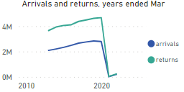

Costs

Nil costs have been identified.

#### 4.1.5 Electronic Commerce

Benefits

The upgraded AANZFTA provides improved certainty for business and consumers engaging in digital trade in the region by promoting interoperability of systems across borders, protecting consumer privacy, and building trust in the online environment. The Electronic Commerce chapter includes key obligations that promote a move towards paperless trading in the digital economy by requiring the acceptance of e-signatures and e-authentication, and by encouraging the adoption of interoperable electronic invoicing systems. The chapter moreover includes commitments that promote trust and confidence in the digital economy through rules on the protection of personal information, consumer protection, transparency and the prevention of unsolicited communications (e.g. spam), in addition to rules that support the free flow of data across borders

Costs

Nil costs have been identified from the new E Commerce chapter for Australia.

#### 4.1.6 Competition

Benefits

The upgraded AANZFTA includes new provisions on consumer protection, including regional cooperation on the development and implementation matters. These outcomes protect Australian business and consumers by requiring AANZFTA Parties to adopt or maintain competition laws and regulations an enforce laws accordingly.

Costs

Nil costs have been identified from these new commitments for Australia. Australia, already having high regulatory standards, is already compliant with these outcomes.

#### 4.1.7 Government Procurement

Benefits

The upgraded AANZFTA includes government procurement chapter including transparency, integrity, and cooperation provisions reflecting best trade practices. These outcomes promote the use of electronic procurement systems to facilitate easier access to Australian suppliers.

Costs

Nil costs have been identified. Advice taken from State and Territories consultations was to not include market access commitments in upgrade negotiations. As there are no changes to market access commitments under the Government Procurement chapter, there has been no changes to these settings when compared with the existing AANZFTA. This also means that the commitments under the chapter do not limit the Government’s ability to direct procurement to Australian small businesses, such as under the Buy Australia Plan.

#### 4.1.8 Trade and Sustainable Development

Benefits

The upgraded AANZFTA will be ASEAN’s first trade agreement to include outcomes on environmental protection, labour rights and women’s economic empowerment. The trade and sustainable development chapter intends to facilitate enhanced cooperation in these areas.

Costs

Nil costs for government are identified as emerging from the upgrade, as these are cooperation commitments that are implemented under Australia’s already in place Regional Trade for Development Initiative.

#### 4.1.9 Micro, Small and Medium Enterprises (MSMEs)

Benefits

The upgraded AANZFTA provides a facility for MSMEs to share information and best practices to foster growth and development in import/export sectors.

Costs

Nil costs are identified, as these are cooperation commitments.

#### Summary Table :Cost-Benefit Analysis

##### Key

|  |  |
| --- | --- |
| **Costs** | **Benefits** |
| Nil | Nil |
| Few-costs expected | Few benefits expected |
| Medium-costs expected | Medium benefits expected |
| **High costs expected** | High benefits expected |

|  |  |  |  |
| --- | --- | --- | --- |
| **Topic** | **Costs** | **Benefits** | **Net Benefit** |
| Rules of Origin |  |  |  |
| Customs Procedures |  |  |  |
| Services and Investment |  |  |  |
| Movement of Natural Persons |  |  |  |
| Electronic Commerce |  |  |  |
| Competition |  |  |  |
| Government Procurement |  |  |  |
| Trade and Sustainable Development |  |  |  |
| Micro, Small and Medium Enterprises |  |  |  |

As a bloc, ASEAN accounted for 14.3 per cent of Australia’s total trade in 2021-22, or A$150,875 billion. In its 2021 National Trade Survey, the Australian Chamber of Commerce and Industry found that businesses rated AANZFTA as the third most utilised free trade agreement for goods traders, behind FTAs with China and the US.[1] However, only 2.8 per cent of Australian investment goes to ASEAN Member States.[2] In 2021-22, Australia’s services trade with ASEAN was A$19,142 billion, with Singapore accounting for more than 59 per cent of that figure. When compared to Australia’s A$1.3 trillion plus services sector, there is room to grow.

There are multiple influences on international trade and investment flows, such as current economic conditions, exchange rate fluctuations, supply and demand factors, and environmental issues such as natural disasters. This has an impact on determining a causal relationship between an FTA and trade and investment outcomes.

While economic forecasting is not currently available on the potential net-benefits of the AANZFTA upgrade, the economic benefits of AANZFTA to Australia and its AANZFTA partners are nonetheless demonstrated by available data. We know that AANZFTA contains regional rules of origin and substantial tariff reduction and elimination commitments, as well as World Trade Organization (WTO)-plus commitments in other areas such as services, which provide commercially meaningful benefits to Australian business and further strengthen Australia's commercial ties with ASEAN. Improved access and certainty in ASEAN markets resulting from AANZFTA is commercially significant for Australian industry, particularly in the Indonesian, Philippines and Vietnamese markets. The Australian Chamber of Commerce and Industry have advised that they see AANZFTA as ‘Australia’s leading Free Trade Agreement’ and that AANZFTA has ‘provided benefits to our members and Australia in general.’ Demonstrating this, **Figure 5** highlights goods exports to ASEAN since 2017, including that there has been a steady increase in exports, with this increase being anticipated to continue in coming years.

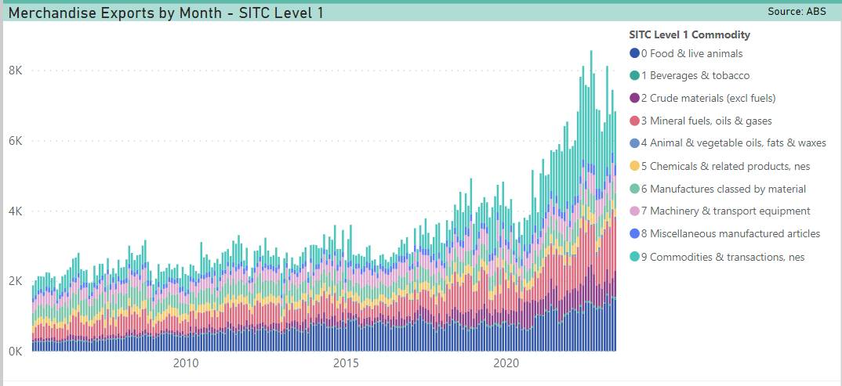

**Figure 5: Australia’s Monthly Goods Exports to AANZFTA[5]**

Australian industry peak bodies have highlighted the benefits of AANZFTA for their exports in addition to the net benefits of an upgrade. The Minerals Council of Australia (MCA) in their submission to the AANZFTA review highlighted the high value of Malaysia, Vietnam and Indonesia as export markets for Australian minerals, and the importance of addressing non-tariff barriers and barriers to services and investment in the AANZFTA upgrade to facilitate continued export growth to these markets.[6] The MCA have found that ASEAN imports of minerals and basic metals were more than USD94 billion in 2018 (compared to USD530 billion in 2022), with import growth from ASEAN countries being faster in aggregate than for China, India and Japan, and faster than for the rest of the world minus ASEAN. The AANZFTA upgrade will ensure Australia maintains its access to the ASEAN Minerals market, taking advantage of the growth in the region.[7] **Figure 6** also highlights the net benefits of goods and services trade under AANZFTA.

**Figure 6: Australia’s Goods and Services Trade with AANZFTA (Exports -ve / Imports +ve)[8]**

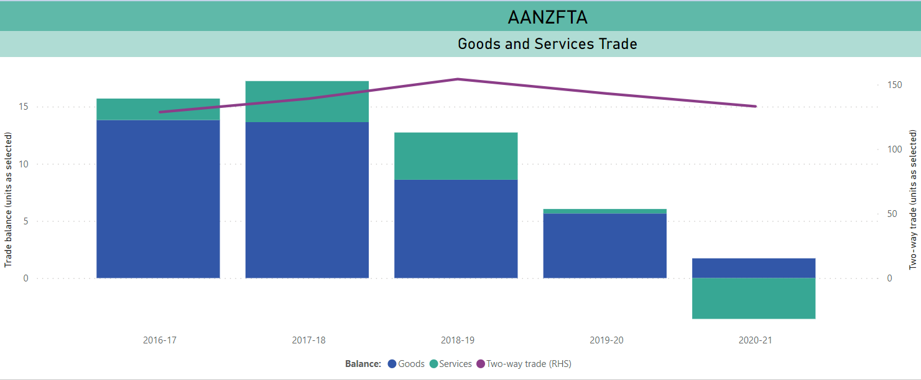

Table 1 below demonstrates the key sectors benefitting from Australia’s services trade under AANZFTA during 2021-22, including A$11.5 billion in exports and A$12.6 billion in imports.

**Table 1: Australia's services trade with AANZFTA, 2021-22**

|  |  |  |  |
| --- | --- | --- | --- |
| **Exports** | | **Imports** | |
| **Item** | **A$b** | **Item** | **A$b** |
| Education-related travel | 3.9 | Prof, tech & other business services | 3.5 |
| Prof, tech & other business services | 2.6 | Transport services | 5.5 |
| Transport services | 1.1 | Telecom & ICT services | 0.8 |
| Other services – details not provided | 3.9 | Other Services | 2.8 |
| **Total** | **11.5** | **Total** | **12.6** |

## 4.2 Option 2 – No action

There are no meaningful advantages to not signing the AANZFTA upgrade but there are many disadvantages.

#### 4.2.1 Declining to sign the upgraded AANZFTA would be inconsistent with Australia’s trade liberalisation agenda

As outlined in the problem identification and policy options sections, if Australia did not sign the upgraded AANZFTA, this would be at odds with Australia’s trade liberalisation agenda. Australia would forego the opportunity to benefit from improvements in market access and trade rules through the AANZFTA upgrade and Australian businesses would continue to face higher transaction costs for exporters, lower investment confidence and outdated digital trade standards.

#### 4.2.2 Declining to sign the upgraded AANZFTA would prevent the upgrade from entering into force for other AANZFTA members

Pursuant to Article 2(2) of the *Second Protocol to Amend the Agreement Establishing AANZFTA, t*he upgraded AANZFTA will only enter into force 60 days after the date on which Australia, New Zealand and at least four ASEAN member states have deposited their instruments of ratification, acceptance or approval. This means that if Australia fails to sign and ratify the upgraded AANZFTA, that it will prevent the upgraded AANZFTA from entering into force for all other AANZFTA members. This would prevent AANZFTA members, including less developed ASEAN members, from realising the benefits of the upgraded AANZFTA, despite the extensive resources these countries have extended to upgrade the Agreement.

This course of action may have tangible negative implications for Australia’s relationship with New Zealand, ASEAN and ASEAN member countries and reduce Australia’s influence with ASEAN. Australia's bilateral engagement with the countries of Southeast Asia is strengthened by Australia’s engagement with ASEAN, the region's premier representative grouping. Government to government links between Australia and ASEAN are strong and reflect close to half a century of cooperation.

## 4.3 Trade Impact Assessment of the AANZFTA Upgrade

The upgrade to AANZFTA will maintain Australia’s competitive edge in Southeast Asia and will enable Australian exporters to diversify. It will also boost investor confidence in the region. The upgrade to AANZFTA is consistent with Australia’s international commitments, including those under the World Trade Organisation (WTO).

As a bloc, ASEAN accounted for 14.3 per cent of Australia’s total trade in 2021-22 or A$150,875 billion. In 2021-22, Australia’s services trade with ASEAN was A$19,142 billion.

The upgrade to AANZFTA is likely to impact predominantly on services and investment between Australia, New Zealand and ASEAN Member States.

The main affected stakeholders in Australia will be:

* Consumers, who will be able to access more competitive goods and services and to transact on-line with enhanced protection.
* Australian businesses, who will benefit from enhanced transparency and integrity in the government procurement process which will create a more level playing field in bidding for contracts across the region.
* Professionals, who will benefit from mutually acceptable professional standards and streamlined licensing and registration systems, which will reduce costs and time for them and their clients.
* Traders, who will benefit from increased flexibility in sourcing and shipping inputs, promoting greater integration into regional and global supply chains. Additionally, traders will benefit from simplified documentation requirements from origin certification to invoicing.

The upgrade to AANZFTA will have a positive impact on services, trade and investment by simplifying documentation requirements and enhancing trader and consumer confidence in online and electronic business. The upgrade to AANZFTA does not contain any AANZFTA-minus commitments, meaning it only serves to improve services, trade and investment between Australia, New Zealand and ASEAN Member States.

The upgrade to AANZFTA would need to be notified to the WTO pursuant to Paragraph 14 of the Transparency Mechanism for Regional Trade Agreements (WT/L/671).

# 5. Who did you consult and how did you incorporate their feedback?

## 5.1 Submissions Received

DFAT provided stakeholders the opportunity to provide written submissions on the AANZFTA General Review process. Table 2 below outlines submissions received, which are also published on DFAT’s website.

Table 2: Summary of Stakeholder Submissions

|  |  |  |
| --- | --- | --- |
| **Stakeholder** | **Key Concerns & Recommendations** | **Addressed in Upgrade** |
| Export Council of Australia | * Simplified rules of origin | Yes – see 4.1 |
| * Trade facilitation measures | Yes – see 4.1 |
| * AANZFTA to be a more modern agreement, including progressive trade outcomes | Yes – the upgraded AANZFTA includes ASEAN’s first Trade and Sustainable Development chapter, outcomes on Government Procurement, and on MSMEs |
| Australian Chamber of Commerce and Industry | * No changes recommended | Not applicable |
| Freight and Trade Alliance and the Australian Peak Shippers Association | * Simplified rules of origin | Yes – see 4.1 |
| Victorian Chamber of Commerce and Industry | * Simplified rules of origin | Yes – see 4.1 |
| Minerals Council of Australia | * Trade facilitation measures | Yes – see 4.1 |
| * Restrictions on trade in services and investment | Yes – see 4.1 |
| * Need for skilled labour mobility | Yes – see 4.1 |
| * Impetus for competition outcomes | Yes – see 4.1 |
| Australian Pork Limited | * Technical market access for pork | No  Note technical market access for pork was not included in the AANZFTA upgrade as technical market access is approved through government-government negotiation of sanitary and phytosanitary measures.  Negotiation of specific technical market access protocols for animals and plants and their products do not form part of FTA negotiations. |
| Chamber of Commerce and Industry of Western Australia | * Simplified rules of origin | Yes – see 4.1 |
| Asia Business Trade Association | * Simplified rules of origin | Yes – see 4.1 |
| Dr Luke Nottage, Professor of Comparative and Transnational Business Law, University of Sydney | * Restrictions on trade in services and investment, including on education | Yes – see 4.1  Note Annex on Education Services Cooperation |

These submissions helped inform Australia’s position on the areas to be considered as part of the AANZFTA upgrade.

The submissions highlighted that AANZFTA has been a transformative trade agreement, benefitting both small and large companies within the member economies and endorsed the governments to position to upgrade AANZFTA. Australian Pork Limited commented on the fact that exports of Australian pork to the ten ASEAN economies rose from A$80.7 million in 2009 to A$87 million in 2016, growth of almost ten percent since the introduction of AANZFTA. The submissions also highlighted that and that upgrading AANZFTA will expand the benefits of the agreement for member economies, including through the removal of barriers to trade such as tariffs, quota restrictions and licensing and registration restrictions.

The upgrade to AANZFTA directly addresses concerns raised by these submissions, such as the Export Council of Australia’s requests to simplify rules of origin and introduce chapters on trade facilitation and government procurement. These amendments to AANZFTA support Australian businesses to fully utilise the benefits of the Agreement.

## 5.2 Stakeholder Engagement

DFAT also reached out to industry stakeholders and offered regular engagement opportunities throughout the ANZFTA upgrade negotiations, including engaging directly with representatives of the business sector and civil society on relevant aspects of the upgrade negotiations. DFAT held Biannual Peak Bodies Consultations, allowing Australian businesses, civil society, First Nations groups and unions to engage with the Department’s trade agenda. DFAT provided updates on the outcomes of the negotiation rounds through published articles on the DFAT AANZFTA website and stakeholder engagement sessions.

## 5.3 States and Territories

States and Territories were consulted throughout the negotiations. Consultations included 5 State and Territory information seminars. The main interest of States and Territories was changes to market access to government procurement, which was not included in the Government Procurement chapter review.

## 5.4 Whole of Australian Government Engagement

Throughout the negotiation period DFAT hosted regular interdepartmental meetings to keep whole of Australian Government stakeholders updated. DFAT subject matter negotiators also engaged continuously and directly with Australian Government policy leads throughout the negotiation process.

# 6. What is the best option from those you have considered?

Table 3 below summarises the costs and benefits of the two options. DFAT’s qualitative assessment is that signing AANZFTA Amendment will result in a net benefit for Australia.

|  |  |  |
| --- | --- | --- |
|  | **Option 1 – Sign the upgraded AANZFTA** | **Option 2- no action** |
| **Benefits** | Opportunities to further promote and facilitate trade and investment between Australia and ASEAN Member States and improve business conditions specific to Australian commercial interests.  Ensures AANZFTA (as in force for Australia) remains a relevant, contemporary agreement, which continues to provide commercial benefits to businesses and consumers in the long-term.  Enhances regional economic integration.  Alignment with Australia’s geostrategic interests in promoting ASEAN centrality in the rules-based regional architecture. | The AANZFTA Amendment would not have to pass through domestic legislative processes which would save time and financial resources.  Ministerial attendance at the ASEAN Economic Ministers Meeting (EMM) in August would no longer be required. Noting, however, that the EMM addresses a broad range of topics that Ministerial engagement will profit from. |
| **Costs** | The upgraded AANZFTA is unlikely to impose any additional regulatory costs on businesses or individuals and in many cases will improve productivity and easy of doing business. Including;  Professionals will benefit from streamlined licensing and registration systems, which will reduce costs and time for them and their clients.  Traders will also benefit from reduced costs resulting from simplified and documentation requirements from origin certification to invoicing. | Will prevent the upgraded AANZFTA parties (ASEAN and New Zealand) from entering into force for the 11 other AANZFTA members.  Damage to Australia’s international reputation, loss of influence with ASEAN and damage to Australia’s bilateral relationships with New Zealand and ASEAN member states.  Will prevent ASEAN members, including less developed ASEAN members, from realising the benefits of the upgraded AANZFTA.  In the medium term, AANZFTA will be overtaken by FTAs signed between ASEAN and third countries. |

## 6.1 Option 1 – Sign the upgraded AANZFTA

Taking into account submissions and consultations in combination with available data on the benefits of AANZFTA to the Australian economy, signing the upgraded AANZFA has been identified as the best option with the greatest net benefits. This includes a provision to make it easier for business to self-certify the origin of their goods, eliminating the need to pay a peak body to obtain a certificate of origin, which was a specific request of the Export Council of Australia.

Signing the upgraded AANZFTA will provide opportunities to further promote and facilitate trade and investment between Australia and ASEAN Member States, improve business conditions specific to Australian commercial interests, and enhance regional economic integration. Building on RCEP outcomes, the upgrade negotiations have ensured that the upgraded AANZFTA remains a relevant, contemporary agreement, which will continue to provide commercial benefits to businesses and consumers.

The upgrade is well aligned with the Government’s policy to improve business conditions for Australian exporters of goods and services, and Australian investors, and with our geostrategic interests in promoting transparent and rules-based approaches to trade and enhancing regional prosperity and integration.

The upgraded AANZFTA is consistent with Australia’s obligations under other international agreements, including the WTO. Chapter 21 (Final Provisions) provides that AANZFTA will coexist with AANZFTA parties’ existing international agreements with each other (which include, for example, the WTO Agreement and Australia’s bilateral FTAs with other AANZFTA Parties).

#### 6.1.1 Regulatory impacts

The upgraded AANZFTA entering into force is expected to result in a reduction in ongoing business compliance costs for Australian businesses trading with ASEAN due to simplified documentation requirements from origin certification to invoicing.

The upgrade will not result in changes to regulations that would adversely affect Australian businesses, community organisations, or individuals. The AANZFTA upgrade is unlikely to impose any additional regulatory costs to businesses or individuals.

# 7. How will you implement and evaluate your chosen option?

## 7.1 Implementation

In line with Australia’s treaty‑making processes the text of the AANZFTA upgrade will be tabled in Parliament. The Joint Standing Committee on Treaties (JSCOT) will then conduct an inquiry into the FTA and report back to the Parliament. Following consideration by the JSCOT, Parliament will consider any legislation, or amendments to existing legislation that may be necessary to implement the Agreement prior to treaty action being taken.

Article 2 of the Second Protocol provides that it shall enter into force 60 days after the date on which Australia, New Zealand and at least four of the ten ASEAN Member States have notified other AANZFTA Parties of the completion of their respective internal requirements necessary for entry-into-force. The Parties are aiming for entry-into-force in 2024.

Australia would need to make legislative changes in order to implement the obligations in AANZFTA, including amendments to the following:

1. *Customs Act 1901*
2. *Customs (International Obligations) Regulation 2015;* and
3. *Customs (ASEAN-Australia-New Zealand Rules of Origin) Regulations 2009* (for determining  
   the originating status of goods for the purpose of determining eligibility for preferential rates of customs duty)

DFAT will work closely with the relevant Australian Government departments to implement the necessary administrative and legislative changes, as outlined in the above paragraph, required to give effect to the proposed AANZFTA upgrade.

## 7.2 Evaluation

#### 7.2.1 Continued evaluation by DFAT

DFAT will continue to internally review and evaluate AANZFTA’s implementation in Australia, including in close coordination with DFAT’s Trade Data analytics area as new data on AANZFTA becomes available. DFAT will utilise relevant ABS and Home Affairs trade and mobility data, as available, in this monitoring.

#### 7.2.2 Evaluation in accordance with the Agreement

In accordance with Chapter 21, Article 10 of the proposed AANZFTA upgrade, AANZFTA will continue to undergo formal periodic reviews and upgrades to ensure it remains fit-for-purpose in an evolving regional trade and investment environment. Australia will continue to participate in AANZFTA review and upgrade processes, including through inviting submissions from and consulting with stakeholders in the course of these processes.

Evaluation metrics will include both quantitative and qualitative assessment and the extent to which the relevant committee, subsidiary bodies and working groups under AANZFTA are working effectively and meeting regularly.

The scheduled review of the upgraded AANZFTA may consider the following:

* each chapter, annex and appendix of AANZFTA;
* any elements of the built-in agenda that have not been completed;
* the role of economic cooperation in the ongoing implementation of the Agreement and negotiation of the built-in agenda, as well as advancing economic integration among the Parties (Annex 1: Economic Cooperation);
* supporting the ASEAN objectives of narrowing development gap, including facilitating the more effective economic integration of least developed ASEAN Member States;
* the outcomes from any reviews of other FTAs that ASEAN, Australia or New Zealand is a member of, and any RCEP outcomes, in assessing any implications for AANZFTA;
* improvements that could be made to areas of commitments already included in AANZFTA;
* options to enhance AANZFTA’s role in promoting closer economic integration among the Parties (e.g. regulatory cooperation); and
* the inclusion of any other issues that would ensure AANZFTA remains a high quality and ambitious agreement.

In support of this work, AANZFTA Parties may share trade data and other analysis, including tariff preference utilisation to the extent that such information is available. The findings of consultation and analysis undertaken individually by the Parties may be shared with the other Parties.

1. Joint Statement on the substantial conclusion of AANZFTA upgrade negotiations, <https://asean.org/wp-content/uploads/2022/11/04-Special-AEM-CER-Joint-Statement-Substantial-Conclusion-ADOPTED.pdf>.
2. Source: [Pivot – Parliament of Australia (aph.gov.au)](https://www.aph.gov.au/Parliamentary_Business/Committees/Joint/Joint_Standing_Committee_on_Trade_and_Investment_Growth/DiversifyingTrade/Report)