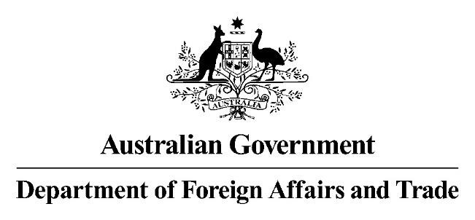

14 August 2023

Mr Jason Lange Executive Director

Office of Impact Analysis

Department of the Prime Minister and Cabinet 1 National Circuit

BARTON ACT 2600

*By Email:* [Helpdesk-OIA@pmc.gov.au](mailto:Helpdesk-OIA@pmc.gov.au)

Dear Mr Lange

**Regulation Impact Analysis –AANZFTA upgrade – Second Pass Final Assessment**

I am writing in relation to the attached Impact Assessment (IA) prepared for the signing of the Second Protocol to Amend the Agreement Establishing the ASEAN-Australia-New Zealand Free Trade Area (AANZFTA).

I am satisfied that the IA addresses the issues raised in your letter of 3 August 2023.

Specifically, I confirm DFAT has made extensive updates to the IA, under Question 4, to articulate the assessed costs and benefits of outcomes in the upgraded AANZFTA. At Question 5 DFAT has also added a table summarising stakeholder consultations.

DFAT confirms that the updated IA now: identifies impacted stakeholders and how their input shaped the AANZFTA upgrade process; includes evidence of the policy problem (that is, the impetus to upgrade AANZFTA); outlines the objectives of government action in signing the upgraded AANZFTA; and describes the status of the IA at major decision points in the AANZFTA upgrade process.

I am satisfied that the IA is now consistent with the six principles for Australian Government policy makers as specified in the *Australian Government Guide to Policy Impact Analysis.*

I submit the IA to the Office of Impact Analysis for formal final assessment. Yours sincerely

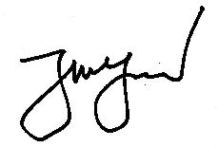

**Tim Yeend**