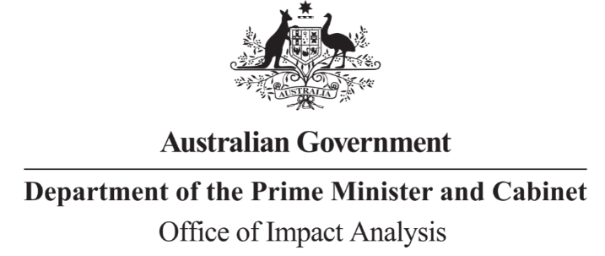

Reference: OBPR21-01084  
Telephone: 6271 6270  
e-mail: [helpdesk-oia@pmc.gov.au](mailto:helpdesk-obpr@pmc.gov.au)

Mr David Hallinan                                                        
Deputy Secretary, Infrastructure   
Department of Infrastructure, Transport, Regional Development, Communications and the Arts  
  
Dear Mr Hallinan  
  
**Impact Analysis – Second Pass Final Assessment – Reversing Aids**

Thank you for your letter submitting an Impact Analysis (IA) for formal Second Pass Final Assessment. I note the IA has been formally certified at the Deputy Secretary level consistent with the Australian Government Guide to Policy Impact Analysis (the Guide).

I appreciate the Department’s constructive engagement on the IA. The Office of Impact Analysis’ (OIA’s) assessment is that the quality of the analysis in the IA is good practice. To have been assessed as ‘exemplary’ under the Guide, the IA would have benefited from:

* Better aligning the stated objectives with the rationale for the best option; and
* Including metrics for evaluation for the stated objectives or alternatives, and for relevant success measures.

I note the IA indicates the Department had difficulty accessing the OIA Value of Statistical Life (VSL) guidance note published in August 2022 and has used a different VSL methodology. In addition to our guidance being available online at <https://oia.pmc.gov.au/sites/default/files/2023-05/value-of-statistical-life.pdf> , my officers are also able to provide copies by email or post on request.

**Next steps**

After a final decision has been announced, I ask that your agency work with OIA to finalise this material for public release. This includes providing a copy of the IA in Word and PDF format for web accessibility purposes. The IA must be included in any Explanatory Memorandum or Statement giving effect to the proposals in the IA.

If you have any further queries, please do not hesitate to contact me.

Yours sincerely

Jason Lange  
Executive Director  
Office of Impact Analysis  
2 June 2023

|  |  |  |  |
| --- | --- | --- | --- |
| |  | | --- | | **OFFICIAL**  **OBPR21-01084**  **DEPARTMENT OF THE PRIME MINISTER AND CABINET** | | |  | | --- | | 1 National Circuit, Barton ACT 2600 • Telephone 02 6271 6270 • Internet oia.pmc.gov.au | |