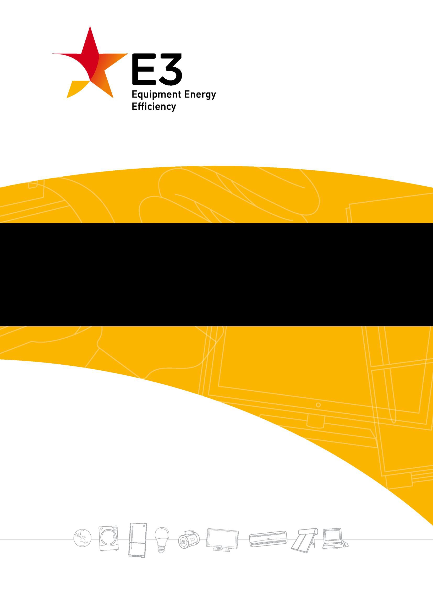

**Regulation Impact Statement for consultation on the energy efficiency of electronic displays**

**Televisions, computer monitors and digital signage displays**

**2023**

### A joint initiative of Australian, State and Territory and New Zealand Governments.

This work is licensed under the Creative Commons Attribution 3.0 Australia Licence. To view a copy of this license, visit [the creative commons website.](http://creativecommons.org/licences/by/3.0/au)

Content contained herein should be attributed to ‘Consultation Regulatory Impact Statement: Televisions, computer monitors and digital signage displays’, Australian Government Department of Climate Change, Energy, the Environment and Water 2023:



© Australian Government Department of Climate Change, Energy, the Environment and Water 2023.

The material in this publication is provided for general information only. While reasonable efforts have been made to ensure that the contents of this publication are factually correct, E3 does not accept responsibility for the accuracy or completeness of the content. It does not constitute legal or other professional advice. E3 disclaims liability, to the extent permitted by law, for any liabilities, losses, damages and costs arising directly or indirectly from any reliance on the information contained in this publication. Before any action or decision is taken on the basis of this material the reader should obtain appropriate independent professional advice.

This document is available at the Department of Climate Change, Energy, the Environment and Water’s [consultation website](https://consult.dcceew.gov.au/).

# Executive Summary

This Consultation Regulation Impact Statement (CRIS) has been prepared to consider whether to update Australia’s and New Zealand’s television and computer monitor energy efficiency requirements and harmonise these with European requirements. It also considers whether to introduce mandatory energy efficiency labelling and standby/network power requirements for digital signage displays to align with the new European requirements for electronic displays. The purpose of this CRIS is to seek comments and submissions from stakeholders on these options, as well as on the research, methodology and analysis underlying the options. The Australian Government Department of Climate Change, Energy, the Environment and Water (the Department) has prepared this RIS on behalf of the Equipment Energy Efficiency (E3) Program. Following feedback from stakeholders, this document will be expanded to produce a Decision Regulation Impact Statement (DRIS) for consideration and decision by Energy Ministers in 2023.

There are a combination of regulatory and market failures for the energy efficiency of televisions, computer monitors and digital signage displays that are contributing to unnecessary electricity use in Australia and New Zealand. Reductions in electricity consumption can lower greenhouse gas (GHG) emissions and help to meet government GHG emission commitments. Reduced electricity use can also reduce stress on electricity grids and reduce the risk of load shedding and blackouts, as well as reducing energy costs for end users.

This CRIS presents research, modelling and analysis showing that market failures and consumer behaviour in the electronic display market are acting to constrain the uptake of more energy efficient products and are imposing higher than necessary costs on consumers and society more broadly. These barriers and behaviours are inhibiting the market from moving to more efficient technologies and are contributing to unnecessarily high externality costs from GHG emissions, peak loads on electricity distribution networks and utility bills.

Some of the options considered in this CRIS to address the market and regulatory failures are as follows.

*Televisions and computer monitors*

* Adopt the European 2023 MEPS and labelling requirements for televisions and computer monitors.
* Adopt the European MEPS and labelling requirements in a staged approach, starting with the less stringent EU 2021 levels and then followed by adopting the more stringent EU 2023 levels at some later time.

*Digital signage displays*

* Adopt the European labelling requirements as well as the energy requirements for standby and networked standby modes.

## Summary of cost-benefit analysis

Below are the central estimates from the cost benefit analysis for the measures proposed in this CRIS, summarised for all 3 types of electronic displays installed up to 2035.

### Australia

|  |  |  |  |
| --- | --- | --- | --- |
| **Policy option** | **A) Adopt EU 2023 Regs in 2024** | **B) Adopt EU 2023 Regs in 2025** | **C) Staged introduction in 2024 and 2026** |
| Energy saved (cumulative GWh) | 12,800 | 12,000 | 11,200 |
| Emissions reduction (cumulative kt CO2-e) | 3,380 | 3,130 | 2,830 |
| Total costs (NPV $m - AUD) | -$386m | -$355m | -$332m |
| Total benefits (NPV $m - AUD) | $1,850m | $1,720 | $1,560m |
| **Benefit Cost Ratio** | **4.80** | **4.84** | **4.69** |

**New Zealand**

|  |  |  |  |
| --- | --- | --- | --- |
| **Policy option** | **A) Adopt EU 2023 Regs in 2024** | **B) Adopt EU 2023 Regs in 2025** | **C) Staged introduction in 2024 and 2026** |
| Energy saved (cumulative GWh) | 2,040 | 1,920 | 1,780 |
| Emissions reduction (cumulative kt CO2-e) | 108 | 101 | 94 |
| Total costs (NPV $m - NZD) | -$45m | -$42m | -$39m |
| Total benefits (NPV $m - NZD) | $152m | $141m | $129m |
| **Benefit Cost Ratio** | **3.34** | **3.36** | **3.27** |

These results show that there is an overall net benefit for introducing more stringent MEPS and labelling for electronic displays from Europe compared with keeping the current efficiency regulations in both Australia and New Zealand.

This CRIS also proposes the adoption of the equivalent to the current European electronic display test method standard for any new regulations in Australia and New Zealand. The CRIS also discusses how to set the star rating levels and one option is to adapt the European labelling Grades for energy rating labels (ERL) in Australia and New Zealand.

**Table of Contents**

Regulation Impact Statement for consultation on the energy efficiency of electronic displays 1

Executive Summary 1

Summary of cost-benefit analysis 2

1. Background and context 3
   1. Consultation Regulation Impact Statement 3
   2. Equipment Energy Efficiency (E3) Program 4
   3. Stakeholder questions 4

Televisions and computer monitors 4

Digital signage displays 5

1. What is the problem? 7
   1. Overview 7
      1. Recent stakeholder consultation 8
   2. Televisions and computer monitors 9
      1. Energy use and greenhouse gas emissions 9
      2. Barriers and behaviours – regulatory and market failures 13
      3. Superseded test methods 14
      4. Labelling implementation issues 15
      5. Scope of regulation coverage – size and screen resolution 15

2.2.8 Automatic brightness control for digital screens 19

* 1. Digital signage displays 19
     1. Scope 19
     2. Energy use and greenhouse gas emissions 22
     3. Barriers and behaviours – regulatory and market failures 24

1. Rationale for government action 26
   1. Overview 26
   2. Televisions and computer monitors 27
      1. Energy use and greenhouse gas emissions 27
      2. MEPS and labelling 31
      3. Superseded test methods 31
      4. Option for digital labelling in stores 32
      5. Scope of regulation coverage 32
      6. Automatic brightness control for digital screens 33
   3. Digital signage displays 33
2. Policy options under consideration 35
   1. Televisions and computer monitors 35
      1. MEPS 36
      2. Energy rating labelling – testing and algorithm 39
      3. Test methods for MEPS 40
      4. Energy rating labelling - implementation 41
   2. Digital signage displays 41
      1. MEPS 42
      2. Energy rating labelling – testing and algorithm 43
      3. Test methods 43

1



* + 1. *Implementation issues 44*

1. **Analysis of policy options 45**
   1. **Cost benefit analysis inputs and assumptions 45**
      1. *Stock models 48*
   2. **Benefit cost ratios – all screens 50**
   3. **Benefit cost ratios – televisions 51**

*5.4 Benefit cost ratios – computer monitors 54*

* 1. **Benefit cost ratios – digital signage displays 56**
  2. **Test method standards 57**
     1. *No change to current test method standards 57*
     2. *Latest IEC test method standard 58*
     3. *IEC 62087:2015 test method standard 58*
     4. *US test method approach for star ratings 58*
  3. **Star rating levels 59**
  4. **Transitional and implementation issues 60**
     1. *Labelling implementation issues in stores 60*
     2. *Digital signage displays – implementation 61*
     3. *Transitional arrangements 62*
  5. **Conclusion 63**

**Appendix A – MEPS and Energy rating labels 64**

*MEPS 64*

*Energy Rating Labelling 64*

**Appendix B – EU Ecodesign regulations – MEPS 66**

**Glossary 68**

# 1. Background and context

# Consultation Regulation Impact Statement

This CRIS has been prepared to consider whether to update Australia’s and New Zealand’s television and computer monitor energy efficiency requirements and harmonise these with European requirements. It also considers whether to introduce mandatory energy efficiency labelling and standby/network power requirements for digital signage displays to align with the new European requirements for electronic displays. The purpose of this CRIS is to seek comment, input and submissions from stakeholders on these proposals.

This document has been developed by the Australian Government Department of Climate Change, Energy, the Environment and Water (the Department) – on behalf of the Equipment Energy Efficiency (E3) Program1 - in accordance with the *Regulatory Impact Analysis Guide for Ministers’ Meetings and National Standard Setting Bodies2* and in consultation with the Office of Impact Assessment (OIA)3. The cost benefit analysis and technical advice were provided by Energy Efficient Strategies.

This document covers the first four of the seven standard RIS questions4:

1. What is the policy problem to be solved?
2. Why is government action needed?
3. What policy options are being considered?
4. What is the likely net benefit of each option?

After considering comments and submissions from stakeholders, this document will be expanded to produce a Decision Regulation Impact Statement (DRIS) for consideration and decision by Energy Ministers in 2023. The DRIS will cover all of the seven RIS questions, including the final three standard questions:

1. Who was consulted and was their feedback incorporated?
2. What is the best option from those considered?
3. How will the chosen option be implemented and evaluated? The following principles are considered in this CRIS:

* Harmonisation with regulatory requirements in the European Union (EU) that could be appropriate in the Australian and New Zealand contexts
* Reducing greenhouse gas emissions
* Reducing the regulatory burden on industry and government
* Enabling effective and efficient compliance.

1 [About the E3 program on energyrating website](https://www.energyrating.gov.au/about-e3-program)

2 [Regulatory impact analysis guide for Ministers' Meetings and national standard setting bodies, May 2021](https://obpr.pmc.gov.au/sites/default/files/2021-06/regulator-analysis-guide.pdf)

3 [Office of Impact Analysis](https://obpr.pmc.gov.au/) OIA was formerly known as the Office of Best Practice Regulation (OBPR).

4 [OIA 7 RIS questions](https://obpr.pmc.gov.au/resources/guidance-impact-analysis/7-ris-questions)

# Equipment Energy Efficiency (E3) Program

The Equipment Energy Efficiency (E3) Program is an initiative of the Australian Government, states and territories and the New Zealand Government. It provides for an integrated program of energy efficiency standards and energy labelling for appliances and equipment in Australia and New Zealand. The E3 Program operates under the *Greenhouse and Energy Minimum Standards Act 2012* (the GEMS Act) in Australia and the *Energy Efficiency (Energy Using Products) Regulations 2002* in New Zealand.

The E3 Program is overseen by Australian Government and State Energy Ministers, who are advised on energy efficiency matters by the Energy Efficiency Working Group (EEWG), which is made up of officials from participating jurisdictions and New Zealand. The Australian Government Department of Climate Change, Energy, the Environment and Water (the Department) prepared this CRIS on behalf of EEWG.

In Australia, televisions are regulated under the provisions of the *Greenhouse and Energy Minimum Standards (Television) Determination 2013 (No. 2)* and computer monitors under the *Greenhouse and Energy Minimum Standards (Computer Monitors) Determination 2014.*

In New Zealand, televisions and computer monitors are regulated under the *Energy Efficiency (Energy Using Products) Regulations 2002* (‘the Regulations’). The

New Zealand Regulations generally mirror the requirements in GEMS determinations. References to a *determination* in reference to the GEMS Act are assumed to apply in the equivalent manner under the regulations in New Zealand. In this paper, determinations and the regulations are collectively referred to as ‘efficiency regulations’.

# Stakeholder questions

Stakeholder input to these questions will be analysed and incorporated as appropriate into the Decision RIS.

## Televisions and computer monitors

1. Do you support the proposal to increase the stringency of MEPS for televisions and computer monitors and harmonise efficiency requirements with the European electronic display regulations?
2. One option is to introduce the EU 2023 requirements 1 to 2 years after introduction in Europe (Options A and B). The other option is a staged approach where the EU 2021 levels are introduced in 2024, followed by the EU 2023 levels in 2026 (Option C). Which of the options do you prefer and why?
3. Do you have a view on when any new requirements should be introduced or what transition arrangements should be considered in introducing new regulations? How much time would your company need to adjust to any change?
4. Are there any issues that need to be considered if the scope of the efficiency regulations for televisions and computer monitors is harmonised with the EU scope?
5. What issues need to be considered if the 2023 EU MEPS levels were adopted for televisions and computer monitors?
6. What issues need to be considered if a staged approach (EU 2021 followed by EU 2023 in Option C was adopted?
7. Do you agree with the assumptions and methodology described in Chapter 5 and the CRIS Technical Appendices for the cost benefit analysis?
8. Do you agree with the assumptions about the number of hours that televisions and computer monitors are used per day? Should the number of assumed hours of usage be changed from 10 hours per day for energy labelling to reflect more typical viewer habits?
9. What level of MEPS would be appropriate for 8k televisions? Are there any issues in including 8k televisions in a new efficiency regulation?
10. Do you have any data or information about the expected future market for 8k televisions that you can provide? Any such information will be treated confidentially by the Department.
11. What issues need to be considered if the 10% reduction in measured energy consumption is adopted for digital screens with active automatic brightness control (ABC)?
12. Are there any issues if the latest IEC62087 Part 2 and 3 (2023) standards are adopted as the test method standard for new efficiency regulations? The newly published IEC 2023 test method standard is equivalent to the current EU test method.
13. Do you have a view on the proposal to base new star ratings on the European label grades? Are there any other star rating issues that need to be considered?
14. How should labels be displayed in show rooms and shops? Would there be any issues with allowing suppliers and retailers to use a digital label displayed on screen instead of a printed label? Should other label options be considered, such as affixing the label to packaging?

## Digital signage displays

1. Do you support the proposal to introduce mandatory energy labelling for digital signage displays and harmonise efficiency requirements with the European electronic display regulations?
2. What opportunities or difficulties could mandatory labelling and energy requirements create for your company? Would your company be able to adjust to any change, if given sufficient time? How much time would your company need to adjust to a change?
3. Do you have a view on when any new requirements should be introduced or what transition arrangements should be considered in introducing new regulations?
4. Are there any issues that need to be considered if the scope of the efficiency regulations for televisions and computer monitors is harmonised with the EU scope?
5. Do you agree with the assumptions and methodology described in Chapter 5 and the CRIS Technical Appendices for the cost benefit analysis?
6. Do you agree with the assumptions about the number of hours that digital signage displays are used per day?
7. Are there any issues if the latest IEC62087 Part 2 and 3 (2023) standards are adopted as the test method standard for new efficiency regulations?
8. Do you have a view on the proposal to base new star ratings on the European label grades? Are there any other star rating issues that need to be considered?
9. How should labels be displayed in show rooms and shops? Would there be any issues with allowing suppliers and retailers to use a digital label displayed on screen instead of a printed label? Should other label options be considered, such as affixing the label to packaging?
10. How should digital signage displays be defined for registration and labelling purposes?

# What is the problem?

# Overview

There are a combination of regulatory and market failures in the energy efficiency of televisions, computer monitors and digital signage displays that are contributing to unnecessary electricity use in Australia and New Zealand. These failures are described in the sections below.

The operation of inefficient electrical appliances and equipment increases electricity demand above what it otherwise would be. This increased demand requires increased investment in electricity generation, transmission and distribution, which increases the cost of electricity supplied to all households and businesses. Increased electricity use also contributes to increased greenhouse gas (GHG) emissions, which contributes to climate change. At a consumer level, increased electricity use increases utility bills.

Reductions in electricity consumption can lower GHG emissions and help to meet government GHG emission commitments. Reduced electricity use can also reduce stress on electricity grids and reduce the risk of load shedding and blackouts. Energy efficiency can help reduce the need to add expensive new power generation or transmission capacity and reduce pressure on energy resources.

Energy efficient appliances use less electricity to achieve the same level of performance as similar models with the same size or capacity. The more energy efficient a model, the less energy it will use and the less it will cost consumers to run. While in Australia the emissions intensity of electricity has been steadily decreasing with the gradual decarbonisation of the electricity grid, significant emissions reductions can still be made from energy efficiency improvements, particularly where regulatory and market failures exist.

In Australia, the GEMS Act5 objectives include the promoting the development and adoption of products that use less energy or produce fewer greenhouse gases. In

New Zealand, the purpose of the *Energy Efficiency and Conservation (EEC) Act 2000*6

includes the promotion of energy efficiency and energy conservation.

This CRIS assesses whether the energy efficiency requirements for televisions and computer monitors should be revised and updated in order to better meet the policy objectives of the Australian GEMS and New Zealand EEC Acts (see Chapter 3 below), and to harmonise with major international markets. International harmonisation with test method standards reduces costs and trade barriers for manufacturers and suppliers.

5 [GEMS Act 2012](https://www.legislation.gov.au/Details/C2021C00481)

6 [EEC Act](https://www.legislation.govt.nz/act/public/2000/0014/latest/DLM54948.html)



*7*

This CRIS also includes an assessment of whether digital signage displays should be regulated for the first time. The European Commission included regulation of this product in its 2021 regulation for electronic displays. Section 2.3.3 describes the market failures for this type of display.

## Recent stakeholder consultation

### E3 Review of GEMS Computer Monitors Determination

The then Australian Government Department of Industry, Science Energy and Resources7, on behalf of E3, consulted on 4 GEMS determinations that at the time were assumed to expire after 10 years8. The GEMS Computer Monitors determination9 was reviewed and included in this public consultation. Since then, recent investigations have revealed that GEMS determinations do not expire10. However, the review findings are still valid and have informed this CRIS.

The *Public Consultation Paper: Review of the GEMS Computer Monitors Determination11* (the review) found that the determination is still effective and efficient. The benefits of the determination are greater than the cost of the regulation. It also found that the computer monitor MEPS are too weak to be effective but there is still value in retaining the energy rating label because it still allows consumers to differentiate between products.

The review stated that MEPS and the energy efficiency defined by each star rating could be increased following consideration in a full RIS process. The most common star rating for registered computer monitors was 6 stars with a small number registered above 8 stars and a few below 2.5 stars. The review also found that the scope of the determination could be expanded to include digital signage display screens, such as those used in stores to display menus. These screens can also be imported as computer monitors or televisions, if they have a television tuner.

Four stakeholder responses were received covering all 4 determinations that were included in the public consultation. These responses were from George Wilkenfeld and Associates, CHOICE, the Energy Efficiency Council (EEC) and the Consumer Electronic Suppliers Association (CESA). Three submissions supported the recommendations in the reviews, but the CESA expressed concerns at the time about expanding energy efficiency regulation to include digital signage displays. The European Commission successfully introduced energy efficiency requirements for digital signage displays in 2021. As a result, the Department included this type of display in an Issues Paper released in 2022.

7 A Machinery of Government change moved the Greenhouse and Energy Minimum Standards (GEMS) program to the new Department of Climate Change, Energy, the Environment and Water on 1 July 2022.

8 [E3 Program: GEMS determinations due to expire by 2025 consultation](https://consult.dcceew.gov.au/equipment-energy-efficiency-e3-program)

9 [Greenhouse and Energy Minimum Standards (Computer Monitors) Determination 2014](https://www.legislation.gov.au/Details/F2014L00780)

10 [News article on energyrating Sunsetting does not apply to GEMS Determinations September 2022](https://www.energyrating.gov.au/news-and-stories/sunsetting-does-not-apply-gems-determinations)

11 [E3 Program: GEMS determinations due to expire by 2025 consultation](https://consult.dcceew.gov.au/equipment-energy-efficiency-e3-program)

*8*

### E3 Issues Paper 2022 - Televisions, computer monitors and digital signage displays

The then Australian Government Department of Industry, Science Energy and Resources, on behalf of E3, released an Issues Paper12 on televisions, computer monitors and digital signage displays for public consultation. The consultation opened on 22 February 2022 and closed on 6 April 2022. The Department presented the Issues Paper to CESA on 16 March 2022.

Three submissions13 were received from CESA, the Australian Retailers Association (ARA), and the Australian Small Business and Family Enterprise Ombudsman (ASBFEO).

Commentary from these submissions is incorporated throughout this paper, but a high level summary is provided below:

* [**ARA**](https://consult.industry.gov.au/e3-program-televisions-computer-monitors-and-digital-signage-issues-paper/have-your-say/view/3)**’s** response includes 6 principles-based recommendations, a few of which appear to be outside the scope of this RIS process for televisions, monitors and signage displays. However, many of the principles (such as minimise complexity and barriers to adoption, international harmonisation) are in broad alignment with the Department’s preferred approach.
* The [**ASBFEO**](https://consult.industry.gov.au/e3-program-televisions-computer-monitors-and-digital-signage-issues-paper/have-your-say/view/1) response focuses on how implementation may affect small businesses, particularly changes to labelling.
* [**CESA**](https://consult.industry.gov.au/e3-program-televisions-computer-monitors-and-digital-signage-issues-paper/have-your-say/view/2)**’s** response was quite detailed and provided technical input on many of the questions from the Issues Paper. CESA supported the review of minimum energy performance standards (MEPS), labelling and test methods for TVs and screens. The submission expressed a strong preference to align with the EU regulations, rather than the US. CESA also stated that they now welcome the discussion on inclusion of digital signage displays14. As a result, the Department has included this type of display in this CRIS to explore the feasibility of adopting the EU requirements for this product.

# Televisions and computer monitors

## Energy use and greenhouse gas emissions

Televisions and computer monitors consume significant quantities of electricity. For example, more than 3% of the electricity use in the European Union in 2016 was from televisions15. Electricity costs are unnecessarily high because people continue to buy televisions and monitors that are not the most energy efficient on the market. The reasons for this are discussed below.

12 [E3 Program: televisions, computer monitors and digital signage issues paper consultation 2022](https://consult.dcceew.gov.au/e3-program-televisions-computer-monitors-and-digital-signage-issues-paper)

13 [E3 Program: televisions, computer monitors and digital signage issues paper consultation 2022 - List of](https://consult.dcceew.gov.au/e3-program-televisions-computer-monitors-and-digital-signage-issues-paper/have-your-say/list)  [responses](https://consult.dcceew.gov.au/e3-program-televisions-computer-monitors-and-digital-signage-issues-paper/have-your-say/list)

14 “*CESA supports the Departments review of the MEPS and Labelling requirements for televisions and computer monitors and welcomes the discussion on the inclusion of digital signage displays.”* [CESA comments on the](https://consult.dcceew.gov.au/e3-program-televisions-computer-monitors-and-digital-signage-issues-paper/have-your-say/view/2)  [Televisions, Computer Monitors and Digital Signage Displays Issues Paper - February 2022](https://consult.dcceew.gov.au/e3-program-televisions-computer-monitors-and-digital-signage-issues-paper/have-your-say/view/2)

15 [EU Regulation on electronic displays - Commission delegated regulation 2019/2013](https://eur-lex.europa.eu/legal-content/EN/TXT/?uri=uriserv%3AOJ.L_.2019.315.01.0001.01.ENG&amp;toc=OJ%3AL%3A2019%3A315%3ATOC)



*9*

After the initial introduction of MEPS and energy labelling in 2009 in Australia (2012 in New Zealand), the energy consumption of televisions fell dramatically for the first four years. This was due, in part, to the new labelling and MEPS requirements. The other driver was the rapid transition from fluorescent backlight to LED-backlight LCD technologies.

Registration data for televisions shows that energy consumption reached a minimum in 2013 and has been increasing since 2014-15. This is also reflected in the average star rating, which reached an average of 5 stars (2013 algorithm) in 2014 but has since stagnated or deteriorated as illustrated in Figure 1 below. Even though the labelling algorithm for televisions was regraded in 2013, many new products already achieve 5 stars or more making the label less effective. The 2013 MEPS levels are now weak and ineffective, leading to unnecessary energy consumption for consumers.

6

5

4

3

2

1

LCD

Average

LCD (LED) OLED

Plasma

0

-1

-2

2009 2010 2011 2012 2013 2014 2015 2016 2017 2018 2019 2020 2021 2022

**Year of registration**

**Average Star Rating Index (2013) by technology and year**

**Figure 1: Trends in star rating index for different television technologies by year of registration. This shows that star ratings have stagnated since approximately 2013-14.**

Electricity use per television has been increasing since 2014-15. Much of this is due to an increase16 in the average size and resolution of screens. Energy consumption is linked to screen area and resolution. The other contributing factor is increases17 in screen luminance18 (screen brightness), because brighter screens use more energy. Another issue is that while screen sizes are a major contributor to increased energy consumption and screen sizes are continuing to increase, the current star rating system for televisions is

16 GEMS registration database

17 GEMS registration database

18 ‘Luminance’ means the photometric measure of the luminous intensity per unit area, expressed in units of

candelas per square meter (cd/m2).

based on a simple power per unit of screen area, which does not place any direct constraints on screen area19.

Figure 2 below shows the trend in sales weighted screen size in Australia and NZ for each of the different television technologies.

70

60

50

40

30

20

AU Plasma

NZ Plasma AU OLED NZ OLED

AU LCD(LED) NZ LCD (LED) AU LCD

NZ LCD

AU CRT

10

0

**Year**

**Average screen diagonal (inches)**

**Figure 2: Televisions - trends in sales weighted screen size in Australia and NZ by screen technology**

2007

2008

2009

2010

2011

2012

2013

2014

2015

2016

2017

2018

2019

2020

Data from both Australia and New Zealand showed a decrease in energy consumption until about 2014, but has shown a steady increase since that time. The energy trends in both countries are similar, but Australia has been approximately 15% higher than New Zealand since 2015, as shown in Figure 3. The increasing screen luminance over time and the rapidly increasing screen size is driving up the energy consumption of televisions. (See the CRIS Technical Appendices document for details.) This is an indication that current regulations have become less effective in improving energy efficiency in recent years. This is supported by detailed market research in 2019 that showed that energy consumption and star rating is much less important in the choice of a television, than for other labelled appliances and equipment20.

19 The EU energy labelling and MEPS reference curves (and the previous Energy Star equations to V8) use a so- called progressive efficiency metric for electronic screens, where the screen technology has to effectively become more efficient as screen sizes increase in order to meet the same threshold.

20 Market research report titled *Understanding the use of the energy rating label with TVs* commissioned by the Department of the Environment and Energy, April 2019 and undertaken by Instinct and Reason.

**Figure 3: Sales weighted television energy consumption for Australia and New Zealand, based on analysis of GfK sales data for Australia and EECA registration data for NZ.**

400

350

300

250

200

AU

150

NZ

100

50

0

**Year**

**Sales weighted average energy kWh/year (CEC)**

2011

2012

2013

2014

2015

2016

2017

2018

2019

2020

2021

Figure 4 below shows that the sales weighted energy use for computer monitors in Australia has increased over time but is stable in New Zealand. Analysis of sales weighted data has shown that the size and energy characteristics of LCD versus LCD (LED) computer monitors are similar.

120

100

80

60

AU CEC

NZ CEC

40

20

0

**Year**

**Label energy CEC kWh/year**

**Figure 4: Trends in sales weighted computer monitor energy for Australia and New Zealand**

2014

2015

2016

2017

2018

2019

2020

2021

The energy efficiency of computer monitors is important because of the number of monitors sold and the amount of time they are in use. For example, in the Australian commercial sector, computer monitors use the most energy of any office equipment

(Figure 5 below)21. Monitors are also the third highest use of energy in office buildings after lighting and heating, ventilation and cooling 22. The Department’s 2021 review23 of the computer monitors determination recommended a full analysis be undertaken to determine the costs and benefits of increasing the MEPS and reviewing the labelling requirements.

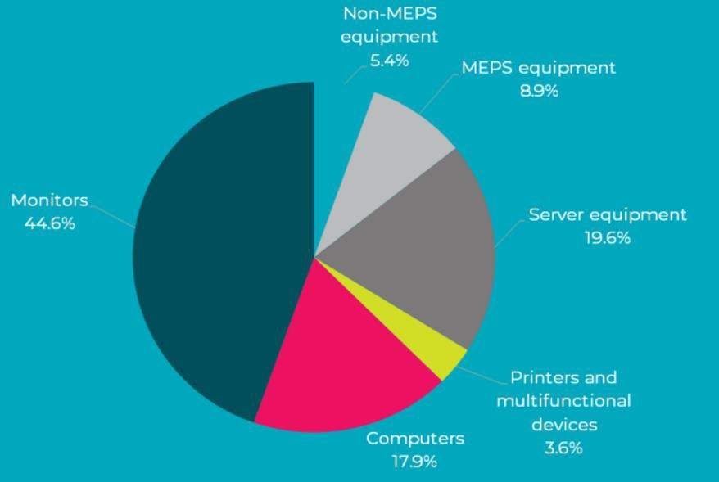

**Figure 5: This graph from Energy Efficiency Council research shows that monitors use the most energy of office equipment in office buildings.**

## Barriers and behaviours – regulatory and market failures

Consumer behaviour in the television and computer monitor markets act to constrain the uptake of energy efficient products and impose higher than necessary costs on consumers and society more broadly. These barriers and behaviours are preventing the television and monitor markets from moving to more efficient technologies and are contributing to unnecessarily high energy bills, high externality costs from GHG emissions and peak loads on electricity distribution networks.

Consumers appear to focus more on price, brand, size, features, resolution and picture quality when purchasing televisions, rather than energy efficiency, which is more prominent in decision making for other more utilitarian labelled appliances and equipment. This barrier to more energy efficient purchases is known as bounded rationality24. Televisions are a source of fun, escape, discovery and can also be a status symbol25. High performance computer monitors, which are excluded from the current efficiency regulations, are also likely to be purchased in a similar manner to televisions. However, while home television and computer monitor purchasing decisions are unlikely

21 [The Energy Efficiency Council, Energy Consumption Research, 2020, Website accessed 31 August 2022](https://www.energybriefing.org.au/research)

22 Ibid

23 [E3 Program: GEMS determinations due to expire by 2025 consultation](https://consult.dcceew.gov.au/equipment-energy-efficiency-e3-program)

24 “Decision making is normally characterised by bounded rationality — People face cognitive barriers to formulating and solving complex problems when there is uncertainty and/or information overload.” [*Behavioural*](https://www.pc.gov.au/inquiries/completed/consumer-policy/submissions/sub106.pdf) [*Economics: bridging the gap between theory and government policy,*](https://www.pc.gov.au/inquiries/completed/consumer-policy/submissions/sub106.pdf)Deborah Cope, PIRAC Economics 2017

25 Unpublished research by Instinct and Reason for the Department of the Environment and Energy, 2019.

to be made starting with the energy rating label, when all other things are equal, it is likely to tip the balance in favour of the more efficient product26.

Given that consumer behaviour is driven by bounded rationality when purchasing televisions and computer monitors, it is beneficial for consumers to have choices that are more energy efficient. By requiring improvement in the energy performance of high energy use appliances in the market, mandatory MEPS reduces the effect of market failures associated with bounded rationality. MEPS protects consumers from unnecessarily high running costs and provides the overall benefits associated with reduced total energy use to the whole economy.

There are likely to be different barriers and behaviours in the commercial sector for purchases of computer monitors. For example, the Energy Efficiency Council (EEC) recently surveyed27 27 commercial building tenants who were drawn from a group of tenants who are signatories to CitySwitch28, a voluntary emissions reduction program. The respondents could therefore be assumed to have a higher than average motivation to reduce energy use and a higher than average understanding of energy use and energy efficiency compared to commercial building tenants as a whole.

Despite this, the survey results demonstrate that the vast majority of respondents did not know the energy star rating of their monitors. The EEC report states that a medium-sized monitor (between 21 inches to 32 inches) with less than three energy stars consumes an average of 181 kWh per annum, while the same-sized monitor with more than six energy stars consumes an average of only 64 kWh per annum, a consumption reduction of nearly two thirds. This 2021 report concluded that computer monitors represent a significant opportunity to reduce office energy consumption. This demonstrates a likely underinvestment in cost effective energy efficient monitors and hence unnecessary electricity usage and costs.

Australia’s and New Zealand’s MEPS levels for televisions and computer monitors are lagging behind prevailing international standards. (See Chapter 3 for details.) The energy rating labelling algorithm is also out of date and doesn’t reflect the current international regulatory frameworks or technological developments. Both of these factors are contributing to the regulatory and market failures identified above.

## Superseded test methods

Australia and New Zealand have a long-standing policy of harmonising with international energy efficiency standards, wherever it is possible and reasonable to do so. This reduces trade barriers as well as costs to industry and consumers.

26 Unpublished research by Instinct and Reason for the Department of the Environment and Energy, 2019. 27 [Determining office tenancies energy end use, Energy Efficiency Council, published by the Australian](https://www.energy.gov.au/publications/determining-office-tenancies-energy-end-use)  [Government June 2021](https://www.energy.gov.au/publications/determining-office-tenancies-energy-end-use)

28 [City Switch webpage](https://cityswitch.net.au/)

The current television test method called up in the energy efficiency regulations was published in 2010 and is based on a now-superseded international standard29. This international test method is continuously reviewed and revised by the international standards committee. The latest edition of the test method standard was published on 17 February 2023, which is the third revision published since the current Australian and

New Zealand test method standard (IEC 62087:2008), so this is now very out of date. The current computer monitor test method was published in 201230 and is also out of date.

The current Australian and New Zealand test standards for televisions and monitors are a regulatory failure because they require television manufacturers and suppliers to use a unique test methodology to register and sell their products. It is a unique test method because it is no longer used in any of the major international markets for suppliers of these products. For globally traded products, such as televisions and computer monitors, having a unique test method standard in Australia and New Zealand adds to testing costs for suppliers, because they cannot re-use test results that are required in other markets. Use of these out of date standards, rather than an updated, internationally recognised and employed test methodology, imposes an unnecessary regulatory burden and cost on manufacturers and suppliers.

## Labelling implementation issues

For televisions and computer monitors, it is mandatory for a printed ERL to be displayed on the product at the point of sale, such as in a retail store. Appendix A below describes the energy rating labelling (ERL) requirements for televisions and computer monitors.

GEMS compliance officers have noted an increasing incidence of problems with the mandatory labelling requirements for televisions and computer monitors in Australian retail stores. These problems have become more common as frame sizes have shrunk or vanished and screen sizes have increased. Most television and monitors have narrow frames or are frameless, making it difficult for the printed label to stick and not fall off. While affixing the printed label directly to the screen is an option, it is generally not preferred by retailers due to potential screen surface damage. Other issues include covering the ERL with other store labels and promotional materials also stuck to the edge of the screen. Televisions and computer monitors may also be displayed for sale in the box.

## Scope of regulation coverage – size and screen resolution

The current scope of the Australian and New Zealand efficiency regulations is out of date and differs from European regulations. One of the scope issues for televisions and computer monitors is screen resolution. The screen resolution of televisions has increased over time, with 8k televisions being the most recent development. While there is minimal

29 IEC62087 Edition 2 published in 2008

30 AS/NZS 5815.1 Information technology equipment — Energy performance of computer Monitors Part 1: Methods of measurement of energy performance

8k content and 8k televisions are currently not common in Australia and New Zealand, this may change in the future. Figure 6 and Figure 7 show the historic and projected market share of televisions by size and resolution used in the analysis. The projected uptake of 8k televisions (dots in Figures 6 and 7) in this analysis is low. UHD 4k televisions size 52-72 inches are projected to make up approximately half of the market share for televisions from around 2030.

**Historical and projected market share by size and resolution - Australia**

60%

50%

40%

30%

20%

UHD-8k Diag≥72in

UHD-4k Diag≥72in

UHD-8k 52in≤Diag<72in UHD-4k 52in≤Diag<72in HD 52in≤Diag<72in

UHD-4k 35in≤Diag<52in

HD 35in≤Diag<52in

UHD-4k Diag<35in

10%

HD Diag<35in

0%

**Year**

**Market share by size and resolution**

**Figure 6: Historical and projected market share of televisions by size range and resolution, Australia. Sales weighted data to 2020.**

2010

2011

2012

2013

2014

2015

2016

2017

2018

2019

2020

2021

2022

2023

2024

2025

2026

2027

2028

2029

2030

2031

2032

2033

2034

2035

There are other scope issues for computer monitors. Only in-scope monitors up to

30 inches (76 cm) must comply with MEPS in on-mode and standby and display an energy rating label. Monitors between 30 to 60 inches (76 to 152 cm) need to comply with labelling requirements, but only need to comply with power limits in standby mode and off-mode31. MEPS for on-mode only apply to computer monitors with a screen diagonal of less than 30 inches (less than 76cm or a screen area of about 2,468 cm²). There was only 1 product registered in 2013-14 that was larger than 30 inches, but now there are 364 models in this size range which only have to comply with in low power modes but not the on-mode MEPS.

31 See [EECA information on computer monitor requirements](https://www.eeca.govt.nz/regulations/equipment-energy-efficiency/about-the-e3-programme/products-under-e3/monitors/) or [Greenhouse and Energy Minimum Standards](https://www.legislation.gov.au/Details/F2014L00780)  [(Computer Monitors) Determination 2014](https://www.legislation.gov.au/Details/F2014L00780) and *AS/NZS 5815.2:2013 Information technology equipment - Energy performance of computer monitors Part 2: Minimum energy performance standards (MEPS) and energy rating labels*

**Market share by size and resolution**

**Figure 7: Historical and projected market share of televisions by size range and resolution, New Zealand. Sales weighted data to 2021.**

**Historical and projected market share by size and resolution - New Zealand**

80%

70%

60%

50%

40%

30%

UHD-8k Diag≥72in

UHD-4k Diag≥72in

UHD-8k 52in≤Diag<72in UHD-4k 52in≤Diag<72in HD 52in≤Diag<72in

UHD-4k 35in≤Diag<52in

HD 35in≤Diag<52in

20%

UHD-4k Diag<35in

HD Diag<35in

10%

0%

**Year**

2010

2011

2012

2013

2014

2015

2016

2017

2018

2019

2020

2021

2022

2023

2024

2025

2026

2027

2028

2029

2030

2031

2032

2033

2034

2035

Figure 8 shows the historical and projected sales share for computer monitors by size range and resolution in Australia, and Figure 9 shows the same data for New Zealand. These figures show that the proportion of larger monitors is expected to continue to grow over time.

The current scope also doesn’t take into account the significant technology shifts that have occurred in recent years. High performance monitors typically use more energy than the types of monitors covered by the regulations. However, the efficiency regulations in Australia and New Zealand exclude these high performance monitors, which anecdotally are becoming more common, compared to when the efficiency regulations were first set in 2013. GfK sales data show that a large number of models are now marketed as “gaming” monitors as illustrated in

Figure below. These are usually larger, higher resolution screens with a higher refresh rate. This style of monitor is now commonly used for all applications, not just gaming. This also suggests that the current scope and categories for labelling and MEPS for computer monitors are becoming increasingly outdated.

**Figure 8: Historical and projected sales share for computer monitors by size range and resolution, Australia**

**Historical and projected market share by size and resolution - Australia**

80%

70%

60%

50%

40%

30%

20%

UHD-8k Diag≥30in

UHD-4k Diag≥30in HD Diag≥30in

UHD-8k 25.5in≤Diag<30in UHD-4k 25.5in≤Diag<30in HD 25.5in≤Diag<30in

UHD-4k 20.5in≤Diag<25.5in HD 20.5in≤Diag<25.5in

UHD-4k Diag<20.5in

10%

HD Diag<20.5in

0%

**Year**

**Historical and projected market share by size and resolution - New Zealand**

90%

80%

70%

60%

50%

40%

30%

UHD-8k Diag≥30in

UHD-4k Diag≥30in HD Diag≥30in

UHD-8k 25.5in≤Diag<30in UHD-4k 25.5in≤Diag<30in HD 25.5in≤Diag<30in

UHD-4k 20.5in≤Diag<25.5in

HD 20.5in≤Diag<25.5in

20%

UHD-4k Diag<20.5in

HD Diag<20.5in

10%

0%

**Year**

**Computer Monitor market share by size and resolution**

**Computer Monitor market share by size and resolution**

2010

2011

2012

2013

2014

2015

2016

2017

2018

2019

2020

2021

2022

2023

2024

2025

2026

2027

2028

2029

2030

2031

2032

2033

2034

2035

**Figure 9: Historical and projected sales share for computer monitors by size range and resolution, New Zealand**

2010

2011

2012

2013

2014

2015

2016

2017

2018

2019

2020

2021

2022

2023

2024

2025

2026

2027

2028

2029

2030

2031

2032

2033

2034

2035

**Figure 10: Share of gaming computer monitors in Australia32**

70%

60%

50%

40%

30%

20%

10%

0%

**Year**

**Gaming share of total computer monitor sales**

2010

2011

2012

2013

2014

2015

2016

2017

2018

2019

2020

## 2.2.8 Automatic brightness control for digital screens

Automatic brightness control (ABC), sometimes called dynamic backlight control, automatically adjusts a screen’s overall backlight intensity to account for ambient light conditions. When ABC is active, it adjusts the screen brightness (luminance) to better match the ambient light level. As the ambient light drops, the screen should compensate by making the picture less bright. As energy consumption of digital displays is strongly linked to screen brightness, ABC saves energy. It also improves the viewing experience for consumers who are unlikely to regularly adjust the settings to match their ambient lighting conditions.

ABC is taken into consideration in the current Australian and New Zealand efficiency regulations for computer monitors33, but not for televisions. The EU Ecodesign requirements provide for a 10% reduction in measured energy consumption, where a digital screen has a qualifying active ABC mechanism, which is a different approach to that in Australia and New Zealand. This is another example of where the Australian and

New Zealand efficiency regulations differ from major international markets.

# Digital signage displays

## Scope

The Australian and New Zealand energy efficiency regulations for televisions and computer monitors do not include digital signage displays. The scope of the current television and

32 From analysis of GfK computer monitor sales data.

33 For computer monitors with ABC active by default, the value for *Pavg* for assessment of MEPS is determined as the weighted average of the measured power with a room illuminance of 300 lux (80% of the time) and a room illuminance of 0 lux (20% of the time).

computer monitor efficiency regulations don’t take into consideration the convergence of these technologies and international trends to regulate these products together. The European Union (EU) 2021 and 2023 Ecodesign and labelling regulations for electronic displays cover televisions, computer monitors and digital signage displays together, because of the functional and technological convergence of these products34. The EU Explanatory Memorandum35 for the electronic display regulations states that this convergence was creating possible regulatory loopholes in the previous EU regulations for these products.

Figure 11 and Figure 12 show digital signage displays in use in different applications. Digital signage displays are a globally traded product. They are used in the commercial sector in similar ways in Australia and New Zealand. Their uses include advertising, informational displays and menus in fast food restaurants.

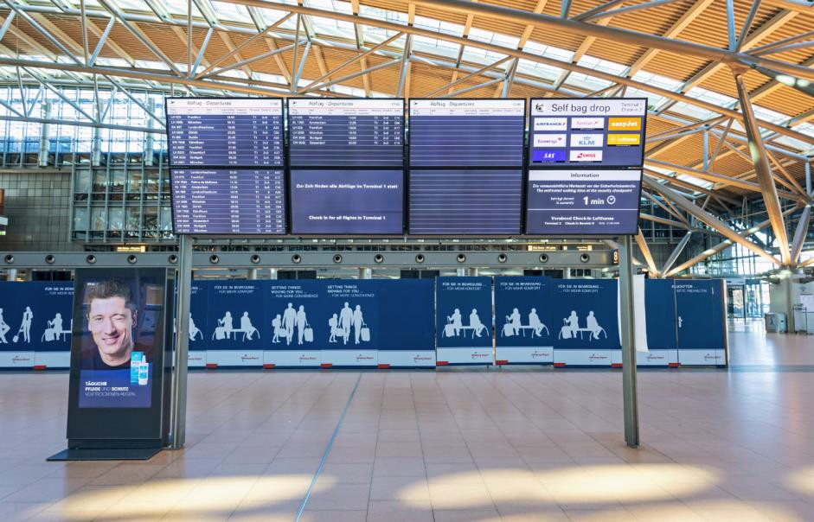

**Figure 11: A digital signage display in an international airport being used to show information to passengers. Another digital signage display in the left hand bottom corner is being used for advertising.**

34 [Revision of EU Ecolabel Criteria for Electronic Displays (previously Televisions) Final Technical Report,](https://ec.europa.eu/environment/ecolabel/documents/JRC121693_final_tr_displays_with_identifiers.pdf)  [European Commission, September 2020](https://ec.europa.eu/environment/ecolabel/documents/JRC121693_final_tr_displays_with_identifiers.pdf)

35 [EU Explanatory Memorandum for electronic displays regulations](https://eur-lex.europa.eu/legal-content/EN/TXT/HTML/?uri=PI_COM%3AC(2019)1796&amp;from=IT)

The European regulations36 for these products states that:

*Digital signage displays are used in public spaces such as airports, metro and train stations, retail stores, shop windows, restaurants, museums, hotels, conference centres or in prominent positions outside buildings and represent a relevant emerging market. Their energy needs are different and generally higher than those of other electronic displays because they are often used in luminous places and continuously on.*

Digital signage displays are defined in the European Regulations as:

*‘digital signage display’ means an electronic display that is designed primarily to be viewed by multiple people in non-desktop based and non-domestic environments. Its specifications shall include* ***all*** *of the following features:*

* + - 1. *unique identifier to enable addressing a specific display screen;*
      2. *a function disabling unauthorised access to the display settings and displayed image;*
      3. *network connection (encompassing a hard-wired or wireless interface) for controlling, monitoring or receiving the information to display from remote unicast or multicast but not broadcast sources;*
      4. *designed to be installed hanging, mounted or fixed to a physical structure for viewing by multiple people and not placed on the market with a ground stand;*
      5. *does not integrate a tuner to display broadcast signals.*

The European Regulations exclude the following types of digital signage displays which meet any of the following characteristics:

* + - * 1. *designed and constructed as a display module to be integrated as a partial image area of a larger display screen area and not intended for use as a standalone display device;*
        2. *distributed self-contained in an enclosure for permanent outdoor use;*
        3. *distributed self-contained in an enclosure with a screen area less than 30 dm² or greater than 130 dm²;*
        4. *the display has a pixel density less than 230 pixels/cm² or more than 3,025 pixels/cm²;*
        5. *a peak white luminance in standard dynamic range (SDR) operating mode of greater than or equal to 1,000 cd/m²;*
        6. *no video signal input interface and display drive allowing the correct display of a standardised dynamic video test sequence for power measurement purposes.*

Digital signage displays of less than 3000 cm² (nominal 16:9 diagonal of 83.8 cm or 33 inches) or more than 13000 cm² (nominal 16:9 diagonal of 174.4 cm or 68.7 inches) are outside the scope of mandatory energy labelling, but suppliers of these smaller or larger products may elect to label their products and commonly do so in Europe.

36 [European Commission Delegated Regulation (EU) 2019/2013 of 11 March 2019 supplementing Regulation (EU)](https://eur-lex.europa.eu/legal-content/EN/TXT/PDF/?uri=CELEX%3A32019R2021&amp;rid=5)  [2017/1369 of the European Parliament and of the Council with regard to energy labelling of electronic displays](https://eur-lex.europa.eu/legal-content/EN/TXT/PDF/?uri=CELEX%3A32019R2021&amp;rid=5)



*21*

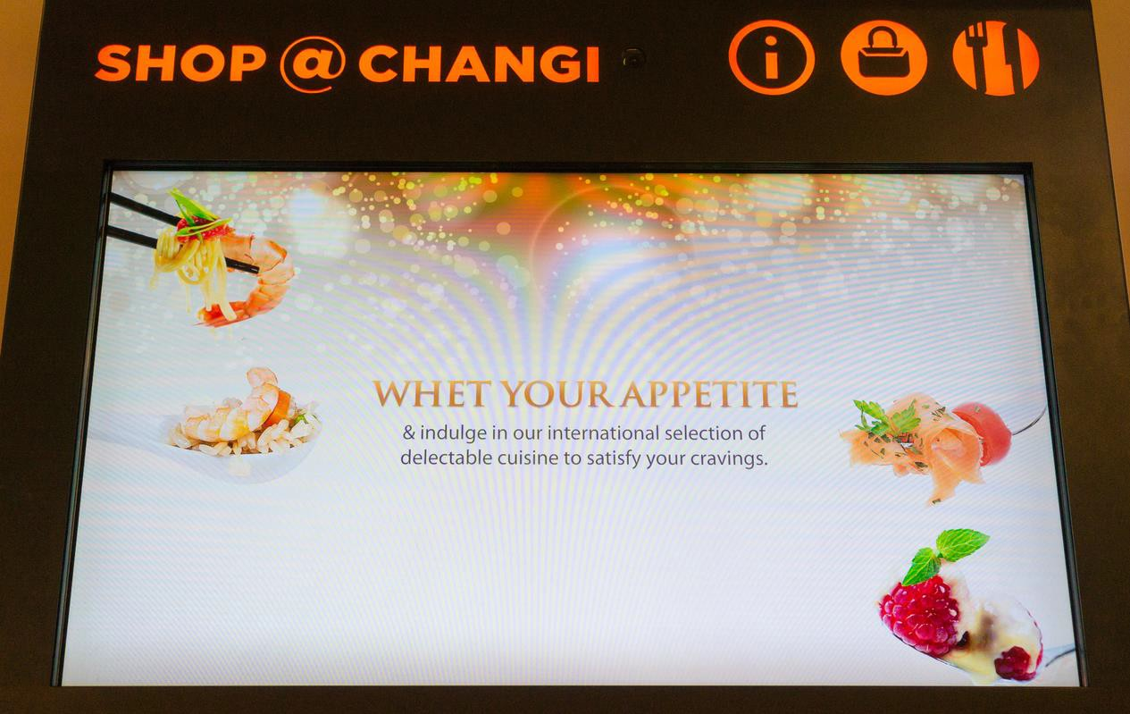

**Figure 12: A digital signage display in an international airport being used to advertise food in a food court.**

## Energy use and greenhouse gas emissions

Europe only mandates energy labelling and standby/network MEPS for digital signage displays that fall within the scope. Australia and New Zealand do not currently regulate digital signage displays for energy efficiency at all. Unpriced negative externalities, such as the cost of GHG emissions and greater demand on the electricity grid, apply to digital signage displays, just as they do to televisions and computer monitors. The rapidly progressing functional convergence between different electronic displays, such as televisions, computer monitors and signage displays creates possible regulatory loopholes for all three products if separately regulated, creating a strong case for a more integrated approach to this product group as a whole.

The EU found that digital signage displays will continue to account for a sizeable share of energy use for all electronic displays, unless corrective action is taken37. All electronic displays are becoming bigger and stock numbers are increasing quickly as prices fall. This is particularly the case for digital signage displays,38 which generally have higher luminance. Figure 13 from the EU Explanatory Memorandum shows increasing yearly energy use in the EU for digital signage displays in the absence of any energy efficiency requirements. This graph was produced prior to the introduction of the EU 2021 requirements for electronic displays.

37 [EU Explanatory Memorandum for electronic displays regulations](https://eur-lex.europa.eu/legal-content/EN/TXT/HTML/?uri=PI_COM%3AC(2019)1796&amp;from=IT)

38 The EU energy labelling metric for digital signage displays has a correction factor for screens that have a luminance of over 500 lm/m2 in the brightest on-mode configuration in recognition that many are used in high illuminance environments. Size for size, digital signage displays are generally 10% to 20% cheaper than televisions.

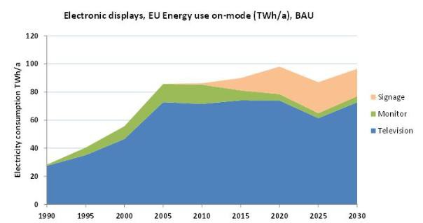

**Figure 13: Actual and predicted electricity use of televisions, monitors and digital signage displays in Europe39.**

According to a 2019 European Commission report40, most signage displays consume on average 2.5 times more energy than a television of the same size, because of the significantly higher luminance of digital signage displays, larger size and longer operating hours. These European trends of increased electricity consumption are likely to be mirrored in Australia and New Zealand without government intervention.

Digital signage displays are not a regulated product in Australia and New Zealand so there is little data available on their performance. It is assumed that the energy consumption of digital signage displays sold in Europe is similar to that sold in Australia and New Zealand. Figure 14 below shows the distribution of energy performance data from the European Product Registry for Energy Labelling41 (EPREL) as of September 2022. Only Label Grade F to C lines from the European labelling scheme have been shown in this Figure (energy must be below the line to reach the grade). Most products are currently rated Grade G (above the F Grade line). Products below the regulation size threshold (<30 dm²) have been excluded. Label grade lines are shown across the specified size range for the regulation for signage displays. The larger products shown in this graph have been voluntarily added to the EPREL database. The data shows a very wide range in energy consumption, with the most efficient models using 25% of the energy of the highest energy models for a given screen area. This illustrates that substantial energy savings are possible.

39 [EU Explanatory Memorandum for electronic displays regulations](https://eur-lex.europa.eu/legal-content/EN/TXT/HTML/?uri=PI_COM%3AC(2019)1796&amp;from=IT)

40 [EU Impact Assessment for electronic displays regulations](https://www.vhk.nl/downloads/Reports/2019/IA_report-swd_2019_0354.pdf)

41 [EPREL - European Product Registry for Energy Labelling - Televisions, monitors and other displays](https://eprel.ec.europa.eu/screen/product/electronicdisplays)

**SDR On Power W**

**Figure 14: Distribution of the Standard Dynamic Range (SDR) on-power of digital signage display models from the EPREL public database.**

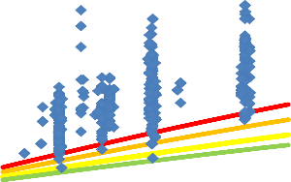

700

600

500

400

300

Models

Grade F Grade E Grade D Grade C

200

100

0

0

5000

10000

15000

**Screen area cm²**

20000

25000

30000

## Barriers and behaviours – regulatory and market failures

Purchasers of digital signage displays do not currently have easy access to energy efficiency information. For example, Australian websites selling digital signage displays typically do not mention energy or power consumption upfront, and where this information is available on the website, it is often not easy to find. Desktop research undertaken by the Department on Australian websites found that some companies sell digital signage displays via an online quote form. While it is possible that the quotes may include energy consumption information, the webpages advertising these products typically don’t mention energy use (or power). Other companies sell digital signage displays that are available for purchase immediately from the website with online delivery. Similarly, energy consumption information can be very difficult to find on these webpages (for example, for one signage display, this information was provided on page 58 of a hard-to-find online manual).

Having no agreed system of energy measurement or energy declaration means that organisations wishing to procure more efficient signage displays are unable to include this in their purchase specifications.

There is also the potential for split incentives in situations where the purchasers and installers of signage displays (such as specialised contractors) may not be responsible for electricity costs, resulting in underinvestment in cost effective energy efficiency measures. The European Commission’s ‘Working Document – Impact Assessment 201942’ for the EU’s electronic display regulation states:

42 [EU Impact Assessment for electronic displays regulations](https://www.vhk.nl/downloads/Reports/2019/IA_report-swd_2019_0354.pdf)

Without up to date energy efficiency requirements, the guarantee that the products will be cost- effective over their life-time is lost. This is especially important for a certain groups of consumers, in particular those in a landlord-tenant situations, where the landlord buys the appliance and the tenant pays the energy bill, which for this product group is particularly relevant for signage displays.

# Rationale for government action

# 3.1 Overview

Government action may be needed when the market fails to provide the most efficient and effective solution to a problem. A range of regulatory and market failures exist for the energy use of electronic displays in Australia and New Zealand. These were described in Section 2 and include:

* The MEPS levels for televisions and computer monitors in Australia and New Zealand are much less stringent than those in major international markets. This costs the Australian community up to $250 million every year in additional energy costs and $13 million every year in New Zealand43. Annual electricity consumption is 930 GWh higher in Australia and 148 GWh higher in New Zealand that it otherwise would be.
* There are no requirements for the energy use of digital signage displays in Australia and New Zealand. This costs the Australian community up to $6 million every year in additional energy costs and $1 million every year in New Zealand. Annual electricity consumption is 24 GWh higher in Australia and 5 GWh higher in New Zealand that it otherwise would be.
* Televisions and computer monitors are globally traded. The Australian and

New Zealand energy efficiency test methods for televisions and computer monitors are out of date. This adds regulatory burden and cost to suppliers who need to undertake additional testing just for the Australian and New Zealand markets, instead of being able to re-use results for markets in other jurisdictions.

In Australia, the GEMS Act objectives include promoting the development and adoption of products that use less energy and produce fewer GHG. The GEMS Act allows for mandatory minimum energy efficiency requirements to be set for appliances and equipment (called GEMS level requirements), which helps drive greater energy efficiency by excluding the poorest performing products from the market. It also allows for nationally-consistent labelling requirements to increase consumers’ awareness of options to improve energy efficiency.

In New Zealand, the purpose of the EEC Act 2000 includes the promotion of energy efficiency and energy conservation. Improved energy efficiency reduces energy consumption, energy costs and GHG emissions for consumers and businesses.

Without government action, the regulatory and market failures identified in Chapter 2 will persist and worsen over time and the objectives of the GEMS and EEC Acts will not be met. Regulatory and market failures such as those described in Section 2 can be resolved or

43 More than 80% of these costs in Australia and New Zealand would be in the residential sector, with the balance in the commercial sector. The calculation for energy costs in Australia is from a consumer perspective and is based on the retail tariffs applicable in the relevant sector (so includes public and private costs). In New Zealand, energy costs are calculated from a total societal perspective (public costs only) and therefore appear relatively lower.

reduced by mandatory labelling and more stringent MEPS to improve energy efficiency. Energy efficiency provides some of the most cost-effective GHG mitigation options, while reducing energy bills and strengthening energy security44. Energy efficiency improvements reduce the amount of energy use required to provide a service. These energy savings create economic, social and environmental benefits.

# Televisions and computer monitors

## Energy use and greenhouse gas emissions

Mandatory energy labelling and MEPS for televisions were introduced in Australia in 2009 and in New Zealand in 2012. The stringency of both was increased in 2013 in Australia45 and New Zealand. Mandatory energy labelling and MEPS for computer monitors were introduced in Australia46 in 2014 and New Zealand in 2013.

In 2021, the European Union (EU) increased the stringency of their MEPS levels for televisions and computer monitors and will increase the stringency again in 2023.

Australia’s and New Zealand’s MEPS levels are now lagging behind prevailing international standards and there is the potential for less efficient products to dominate in the market. While some efficient models are already sold in Australia and New Zealand, other less-efficient models continue to have a significant market share. Moving the market towards more efficient models available overseas would deliver considerable electricity savings, emissions abatement and energy cost savings for consumers.

Figure 15 shows that the current MEPS level in Australia and New Zealand (solid blue line) for televisions is weak, when compared to the Ecodesign MEPS levels (solid and dashed purple lines). This is not surprising for a product that is evolving rapidly and subject to out of date regulations. Figure 15 shows that the requirements for 4 stars for televisions are less stringent than any of the EU MEPS levels.

The European energy label has 7 label grades47 where A is the most efficient grade and G is the least efficient. Figure 15 also shows 4 of the European label grades. The red line is Grade F, the dark orange line is Grade E, light orange is Grade D and the green line is Grade C.

Figure 16 is a similar graph for computer monitors. The current Australian and

New Zealand on-mode MEPS levels for computer monitors only applies to monitors that are less than 30 inches (76 cm) measured diagonally. This is equivalent to a screen area of 2,458 cm2 (16:9 aspect ratio), which is why the blue MEPS lines stop at this point.

44 [IEA webpage on energy efficiency](https://www.iea.org/reports/energy-efficiency)

45 [Greenhouse and Energy Minimum Standards (Television) Determination 2013 (No. 2)](https://www.legislation.gov.au/Details/F2013L01500)

46 [Greenhouse and Energy Minimum Standards (Computer Monitors) Determination 2014](https://www.legislation.gov.au/Details/F2014L00780)

47 [European Commission information webpage on energy labelling and ecodesign regulations for electronic](https://commission.europa.eu/energy-climate-change-environment/standards-tools-and-labels/products-labelling-rules-and-requirements/energy-label-and-ecodesign/energy-efficient-products/electronic-displays-including-televisions_en)  [displays](https://commission.europa.eu/energy-climate-change-environment/standards-tools-and-labels/products-labelling-rules-and-requirements/energy-label-and-ecodesign/energy-efficient-products/electronic-displays-including-televisions_en)

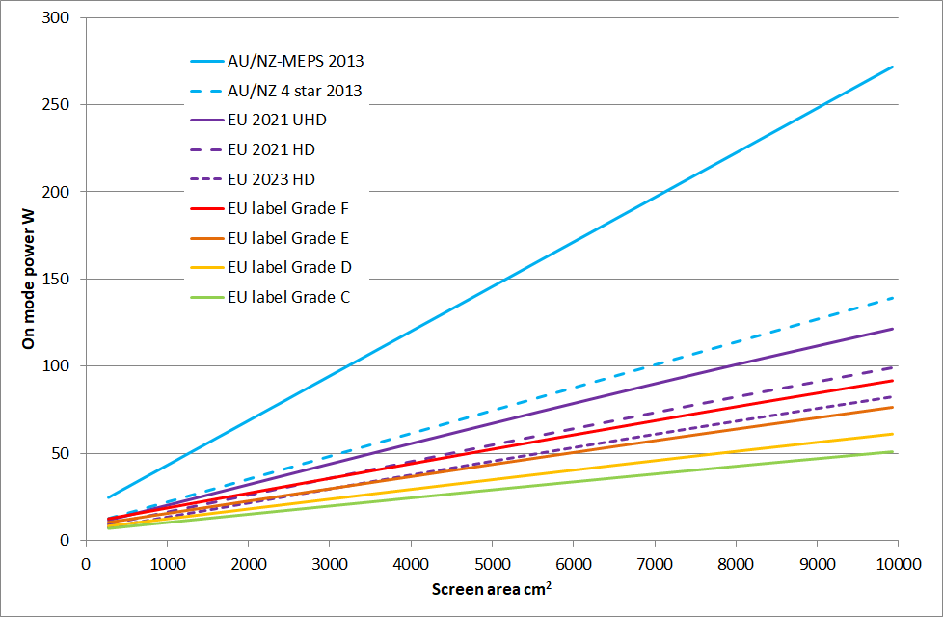

**Figure 15: Televisions - Comparison of Australian/New Zealand MEPS and labelling levels with EU Ecodesign MEPS and EU labelling.48**

Figure notes: The EU 2021 HD MEPS level is the same as the EU UHD 2023 MEPS level and therefore has not been shown as a separate line.

The Australian and New Zealand MEPS for computer monitors are different for different screen resolutions. Figure 16 shows the MEPS for 4 different screen resolutions: UHD

8 Megapixels (MPx), UHD 4 MPx, HD 2 MPx and SD 1 MPx.

Similarly to Figure 15 for televisions, Figure 16 also shows 4 of the European label grades. The red line is Grade F, the dark orange line is Grade E, light orange is Grade D and the green line is Grade C. One option for Australia and New Zealand is to use these EU label Grades as a basis for the star ratings on the energy rating label. For example, 2 stars on the ERL could be equivalent to Grade F, in which case 3 stars would be Grade E, 4 stars would be Grade D and 5 stars would be Grade C.

48 The EcoDesign and European energy labelling regulations provide for a flat 10% reduction in measured energy where the television has a qualifying Automatic Brightness Control mechanism that is active. EU EcoDesign for UHD in 2023 is the same as the HD level in 2021, so only the latter has been shown. EU EcoDesign 2023 levels are approximately one third of the power level set under the current Australia/New Zealand MEPS level.

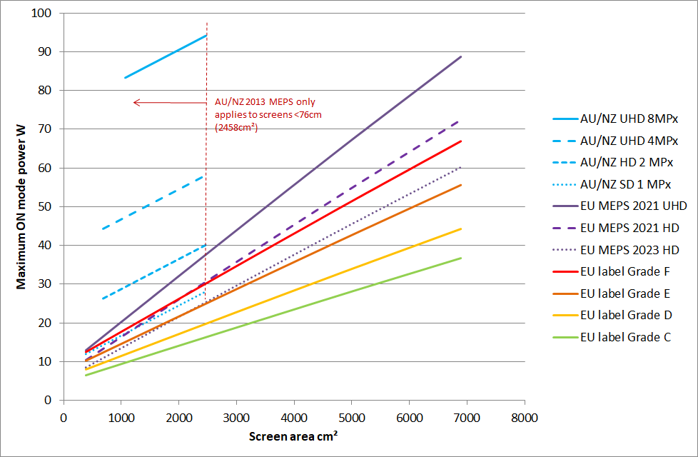

**Figure 16: Computer monitors - Comparison of Australian/New Zealand MEPS and labelling levels with EU Ecodesign MEPS and EU labelling**

Figure notes: The EU 2021 HD MEPS level is the same as the EU UHD 2023 MEPS level and therefore has not been shown as a separate line.

### Effectiveness of the efficiency regulations

While Australia’s and New Zealand’s MEPS levels were appropriate for the market

conditions in 2013, they have since become out of date because:

* Large markets such as the EU have tightened their MEPS and energy labelling requirements.
* The products supplied on the Australian and New Zealand market have changed significantly in terms of technology, features, screen size and energy efficiency.
* Australia and New Zealand’s test method standard has been superseded and is no longer used overseas.

The range of efficiencies of registered products is an indicator of the effectiveness of the determination. A broad range of efficiencies indicates that the determination is likely to be preventing some inefficient products from entering the market. It also indicates that there may be scope to make the MEPS requirement more stringent to increase the average efficiency of new products sold.

Figure 17 shows the distribution of television star ratings from E3 model registration data from 2019 to 2021. The ratings range from 1 star, which is the MEPS level, up to 7.5 stars. The most common star ratings are in the range of 4.5 to 5.5 stars.

400

350

300

250

200

150

100

50

0

1 1.5 2 2.5 3 3.5 4 4.5 5 5.5 6 6.5 7 7.5

**Star rating bin**

**Count of models registered 2019 to mid 2021**

**Figure 17: Distribution of television star ratings from new registrations49 2019 to mid-2021**

Figure 18 shows the number of GEMS registrations at each star rating for computer monitors. The most common star rating for registered computer monitors is 6 stars with a small number registered above 8 stars and a few below 2.5 stars50. There has been little variation in the energy efficiency of registered monitors over the life of the determination, except for a moderate increase in 5, 7 and 8 star monitors in the last few years.

New Zealand data51 shows a similar trend.

This data shows that the current MEPS for televisions and computer monitors are likely to be too weak to be effective, but the label is still providing consumers with useful information on energy efficiency. This means that there is likely to be value in increasing the MEPS levels.

Of the 1,582 television models that were registered in Australia and New Zealand after

31 December 2019, 61% of registrations pass the EU 2021 MEPS requirements and 26% of registrations pass the EU 2023 requirements. Of the 925 computer monitor models registered after 31 December 2019, 74% of registrations pass the EU 2021 MEPS requirements and 54% of registrations pass the EU 2023 requirements.

49 This figure includes all new registrations in Australia and New Zealand approved between 1 January 2019 and 30 June 2021.

50 [Sunsetting review of computer monitors determination](https://consult.dcceew.gov.au/equipment-energy-efficiency-e3-program)

51 [New Zealand E3 Programme sales and efficiency data](https://www.eeca.govt.nz/insights/eeca-insights/e3-programme-sales-and-efficiency-data)

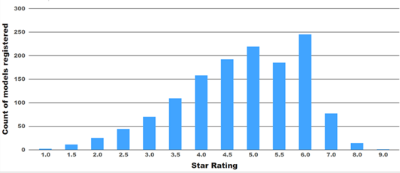

**Figure 18: Distribution of computer monitor star ratings from GEMS registrations**

## MEPS and labelling

Energy rating labels (see Appendix A) are an information tool designed to help consumers to compare the energy consumption of different products in a particular class. It may also be used as an information and marketing tool for suppliers to differentiate their product. However, it does not ensure the removal of high energy use products from the market.

Conversely, MEPS are performance based regulations that set minimum energy performance requirements. MEPS are an effective way to increase the energy efficiency of appliances and equipment. By specifying a minimum energy performance level, inefficient products are prevented from entering the marketplace, and manufacturers are given a signal to increase energy efficiency of the products they supply. For consumers, MEPS mean that products available in the market use less energy and have lower running costs over their lifetime. MEPS act as a consumer protection measure by ensuring that all models of a given product type available for sale meet minimum acceptable levels for energy performance and do not result in unnecessarily high running costs. MEPS can provide energy savings and avoid GHG emissions above those achieved from energy rating labelling alone.

Government intervention to update the MEPS and labelling requirements for televisions and computer monitors would reduce the regulatory and market failures identified in Chapter 2, which would reduce unnecessarily high electricity consumption for these products. Government intervention provides a level playing field for businesses and consumers and helps to ensure the integrity of the system.

## Superseded test methods

International harmonisation with test method standards reduces costs and trade barriers for manufacturers and suppliers. The test method standard for televisions used in Australia and New Zealand was last updated in 2010 and is based on a now-superseded international standard: IEC62087:2008 (Edition 2). The IEC test method standard was updated and published on 17 February 2023 with further revisions expected thereafter.

This means that there have been 3 revisions to the IEC standard since Edition 2 was adopted for Australia and New Zealand. The test method standard for computer monitors is AS/NZS 5815.1:2012 Part 1 and is also out of date, because it is based on ENERGY STAR v5, which was published in 200952.

Government action is required to update these regulatory test method standards. The Department notes that the Consumer Electronics Suppliers’ Association (CESA) supports adoption of the IEC 2015 test method for televisions. However, while the current EU test method (CENELEC EN 62087 Parts 1 to 3 (2016)) is based on the IEC 2015 test method standard, two elements are modified by the EU Regulations. In addition, the IEC 2015 test method has now been superseded by a new version published in February 2023, which includes the major EU modifications. Adopting the IEC 2015 test method standard without the EU modifications will create different testing requirements in Australia and New Zealand, from those applying in the EU.

## Option for digital labelling in stores

It is mandatory for energy labels to be displayed on televisions and computer monitors in showrooms and retail premises. The new EU labelling regulations53 for electronic displays allows suppliers and retailers to choose to display either a physical label or an electronic label, as long as the display is kept in on-mode54 when visible to customers. However, this is not currently an option in Australian and New Zealand energy efficiency regulations.

The Australian and New Zealand regulators are open to adopting this as an option but may need to undertake further analysis to see if the legislative frameworks can support digital labels. If this is an option under current regulatory frameworks, then the option of digital labelling may solve many of the in-store labelling issues identified by the GEMS compliance officers.

## Scope of regulation coverage

Technologies and features for televisions and computer monitors have changed and advanced significantly since 2013. The current regulatory framework is out of date and unable to deal adequately with some of the new products on the market. The scope of coverage is also not harmonised with major international markets. The scope of the efficiency regulations needs to be updated by the Australian and New Zealand governments in order to harmonise our requirements with those applying overseas.

52 [Computers and Computer Monitors Consultation Regulation Impact Statement – Ministerial Council on Energy](https://oia.pmc.gov.au/published-impact-analyses-and-reports/computers-and-computer-monitors-consultation-regulation)  [December 2010](https://oia.pmc.gov.au/published-impact-analyses-and-reports/computers-and-computer-monitors-consultation-regulation)

53 [European Commission information webpage on energy labelling and ecodesign regulations for electronic](https://commission.europa.eu/energy-climate-change-environment/standards-tools-and-labels/products-labelling-rules-and-requirements/energy-label-and-ecodesign/energy-efficient-products/electronic-displays-including-televisions_en)  [displays](https://commission.europa.eu/energy-climate-change-environment/standards-tools-and-labels/products-labelling-rules-and-requirements/energy-label-and-ecodesign/energy-efficient-products/electronic-displays-including-televisions_en)

54 ‘on-mode’ or ‘active mode’ means a condition in which the electronic display is connected to a power source, has been activated and is providing one or more of its display functions

## Automatic brightness control for digital screens

ABC can significantly reduce electricity consumption.55 The current treatment of ABC in the efficiency regulations in Australia and New Zealand is not aligned with international requirements, such as those in the EU.

Around 5% of registered computer monitors in Australia and New Zealand are noted as having some form of automatic brightness control. In Europe, about 3% of computer monitors are listed as having a compliant ABC feature56. The EU Regulations have a provision where televisions and computer monitors with ABC controls can earn a 10% credit on the measured energy. This effectively provides a 10% reduction in MEPS stringency and label thresholds. This allowance is provided on the basis that when ABC is active during normal use, that energy savings will be at least 10%, therefore no correction is needed in the energy modelled in the stock model.

# 3.2 Digital signage displays

Australia and New Zealand do not regulate digital signage displays for either MEPS or labelling. The EU, however, introduced an update to its MEPS and labelling regulations for electronic displays with effect from 1 March 202157. These new regulations include mandatory energy labelling requirements for digital signage displays58 within the scope (and voluntary labelling for other sizes) and set limits for electricity consumption for all low power modes (but no limits for on-mode).

The European Commission concluded that there was a need for new energy efficiency requirements for televisions and that the same requirements should also apply to other displays, such as computer monitors and digital signage displays, because of the increasing overlap in function between these products.

Digital signage displays are included in the EU labelling requirements for electronic displays. Stakeholder comment is welcome on whether these requirements should be introduced into the Australian and New Zealand markets.

Because digital signage displays are included in EU requirements, the Department has included them in this CRIS to explore whether Australia and New Zealand should also

55 See section 2.2.8 on page 19.

56 To qualify for the 10% ABC energy allowance in Europe, products need to meet several criteria. Firstly, ABC needs to remain active by default in other Preset Picture Settings in SDR mode. Secondly, the screen luminance and power consumed both need to reduce within a specified envelope as the room illuminance decreases from 100 lux to 60, 35 and 12 lux. These prescriptive requirements would rule out a number of models from qualifying for the EU ABC allowance for MEPS and energy labelling, even though the product nominally has some form of ABC functionality. While the presence of ABC for computer monitors is recorded in the Australia/New Zealand registration system, there is almost no qualification criteria for this claim, so it would be expected that some of the local products may not comply with the EU requirements if implemented locally.

57 [European Commission Regulation 2019/2021](https://eur-lex.europa.eu/legal-content/EN/TXT/PDF/?uri=CELEX%3A32019R2021&amp;rid=5)

58 An energy efficiency grade from A to G is awarded based on the power consumption in on-mode.

regulate this type of display. CESA has stated59 in their response to the Issues Paper that they welcome the discussion on inclusion of digital signage displays in this CRIS.

While digital signage displays are sold commercially and are not for domestic use, the Department believes that energy rating labelling will be used by purchasers as part of their product specifications in bulk procurement processes to purchase more efficient displays60. Aligning with the EU regulations would help to reduce the regulatory and market failures identified in Chapter 2 while placing minimal additional requirements onto suppliers.

While there is limited data on digital signage displays in Australia and New Zealand, the European database EPREL includes information about the power used by each model of digital signage display in on-mode61. All products must show Standard Dynamic Range data (power in watts and the label efficiency grade) and certain products must also show the same High Dynamic Range data. This is also discussed in Section 2.3.2 above.

59 [E3 Program: televisions, computer monitors and digital signage issues paper consultation - CESA response](https://consult.dcceew.gov.au/e3-program-televisions-computer-monitors-and-digital-signage-issues-paper/have-your-say/view/2) 60 Signage displays were included in the now elapsed EU-US Energy Star Agreement. After it lapsed, signage displays were no longer covered by any labelling programme in any region, even on voluntary basis, and no

labelling instrument existed to cover these products under public procurement criteria prior to the introduction of energy labelling for these products by the EU in 2021. This was a strong driver for including digital signage displays into the EU energy labelling program.

61 While the EPREL database for signage displays does improve access to energy information for some products, this only covers European models and configurations. There are many local models in Australia and New Zealand which are not included in the EU database (most of the models that are listed in Europe are not available locally).

# Policy options under consideration

In early 2022, the then Australian Government Department of Industry, Science Energy and Resources (the Department), on behalf of the E3 Program, released an Issues Paper62 on televisions, computer monitors and digital signage displays for public consultation. This Issues Paper included an overview of international energy policies for electronic displays, including the United States of America, the EU, China and Japan. Stakeholder feedback on the Issues Paper showed a strong preference to align with the EU Regulations, rather than other international policies. This CRIS therefore focuses on policy options that align with the EU approach.

The principles listed in Section 1.1 were used to finalise this list of options. For example, the option of creating new and unique MEPS levels was rejected because this would not meet the requirements for international harmonisation and reduced regulatory burden for industry.

The Business As Usual (BAU) scenarios all assume that the current situation of regulations continue without change.

# Televisions and computer monitors

The cost and difficulty for suppliers and sellers of electronic displays of adjusting to any new MEPS and labelling requirement is dependent, in part, on the timing of any new regulation. One possible approach may be to introduce more stringent requirements in a series of steps. This could involve starting with the lower EU 2021 requirements and moving to the higher EU 2023 levels at a later stage. Another option is a more streamlined approach where Australia and New Zealand move straight to the 2023 EU levels 1-2 years after their introduction in Europe. The Department would like to hear the views of suppliers and other stakeholders on the timing of any new regulations, particularly from smaller suppliers and retailers of electronic displays.

The following is a list of policy options for televisions and computer monitors analysed in this CRIS. These options are explained in more detail in the sections below this list. A detailed quantitative cost benefit analysis was undertaken on the MEPS and labelling options, and a qualitative analysis was used for the other options. This analysis is set in Chapter 5 of this CRIS.

**MEPS**

**Option 1)** BAU – no change to the MEPS levels as defined.

**Option 2)** Adopt EU MEPS 2023. Harmonise the scope of Australian and New Zealand regulation of televisions and computer monitors with the EU.

62 [E3 Program: televisions, computer monitors and digital signage issues paper consultation](https://consult.dcceew.gov.au/e3-program-televisions-computer-monitors-and-digital-signage-issues-paper)



*35*

**Option 3)** Staged introduction of EU MEPS levels. Initially, adopt EU 2021 levels followed by EU 2023 levels two years later. Harmonise the scope of Australian and New Zealand regulation of televisions and computer monitors with the EU.

**Energy testing and label rating algorithm**

**Option 1)** BAU – no change to the current energy rating labelling specifications in the GEMS determinations.

**Option 2)** Update labelling requirements using EU calculations and the equivalent EU test standard. Harmonise the scope of Australian and New Zealand regulation of televisions and computer monitors with the EU.

**Option 3)** Update labelling requirements using the US CTA-2037 test Standard and the television Energy Star specification (with modifications for computer monitors).

Harmonise the scope of Australian and New Zealand regulation of televisions and computer monitors with the EU.

**Test method for MEPS**

**Option 1)** BAU – no change to the current test method as specified in the GEMS determinations.

**Option 2)** Test method – Adopt the latest IEC test method (IEC 62087: Parts 2 and 3 (2023), which is equivalent to CENELEC EN 62087 Parts 1 to 3 (2016) with the amendments from EU Regulations) for electronic displays.

**Option 3)** Adopt IEC 62087:2015 for televisions.

**Energy rating labelling - implementation**

**Option 1)** BAU – no change to the current energy rating labelling requirements in the Australian and New Zealand regulations, including the requirement to display a printed label in stores.

**Option 2)** Allow the choice between digital labels and physical labels in stores. This would be similar to the approach in the EU regulations ([2019/2013](https://eur-lex.europa.eu/legal-content/EN/TXT/?uri=uriserv%3AOJ.L_.2019.315.01.0001.01.ENG&amp;toc=OJ%3AL%3A2019%3A315%3ATOC), article 4).

Independent of these 2 labelling options, the inclusion of QR codes (connected to a database) on the energy label is being considered, which would improve general accessibility to information. This has successfully been implemented in Europe and China.

## MEPS

The no change option for the scope of energy efficiency regulations for televisions and computer monitors (**Option 1**) is keeping the same energy use requirements as specified

in Section 6 in the current GEMS determinations for televisions63 and computer monitors64, and in the New Zealand Regulations65.

The original EU MEPS requirements came into effect in Europe on 1 March 2021 and this became more stringent on 1 March 2023. There are 2 options for MEPS that are modelled in this CRIS:

* Adopt the EU 2023 MEPS level (with the EU 2023 scope) and bypass EU 2021 MEPS levels
* Adopt a staged approach where Australia and New Zealand move to the EU 2021 MEPS level (with the EU 2021 scope) initially, followed 2 years later by adoption of the

EU 2023 MEPS level (with the EU 2023 scope).

The 2023 MEPS level for HD electronic displays has an increased stringency of 17%, compared with the 2021 level, while the MEPS level for UHD displays (for products where a pre-existing limit was in place) has been made more stringent by 18%.

The EU Regulations set on-mode requirements (called an energy efficiency index or EEI) as well as separate standby requirements. Both on-mode and standby requirements are considered in this CRIS.

The EU MEPS levels are defined below and are explained in more detail in Appendix B:

|  |  |  |  |
| --- | --- | --- | --- |
|  | Electronic displays with 2,138,400 pixels or less (HD) | Electronic displays with pixel count above 2,138,401 (HD) to  8,294,400 (UHD-4k). | Electronic displays with pixel count above 8,294,400 (UHD-4k),  and MicroLED displays |
| 2021 levels | Max EEI of 0.90 | Max EEI of 1.10 | No level |
| 2023 levels | Max EEI of 0.75 | Max EEI of 0.90 | Max EEI of 0.90 |

The EU regulations for electronic displays have 3 distinct resolution categories: high definition (HD), 4k, and 8k. From 2023, the EU requirements for 4k and 8k merge, leaving only two sub-categories. The EU 2023 EEI levels effectively reduce the EEI limit categories of digital displays to 2:

* Electronic displays with 2,138,400 pixels or less (HD), and
* Electronic displays with a pixel count of 2,138,401 or more (UHD).

**Option 2** Australia and New Zealand could adopt EU 2023 levels after they come into force in the EU, while allowing sufficient time for Australian and New Zealand suppliers to adapt. Chapter 5 shows the results of the cost benefit analysis for this option with a possible implementation date in either 2024 or 2025.

63 [Greenhouse and Energy Minimum Standards (Television) Determination 2013 (No. 2)](https://www.legislation.gov.au/Details/F2013L01500)

64 [Greenhouse and Energy Minimum Standards (Computer Monitors) Determination 2014](https://www.legislation.gov.au/Details/F2014L00780)

65 [Energy Efficiency (Energy Using Products) Regulations 2022 - New Zealand](https://www.legislation.govt.nz/regulation/public/2002/0009/latest/versions.aspx)

**Option 3** is a staged approach that would also allow long-term harmonisation with Europe. However, there would be increased cost and effort for retailers and suppliers to adapt and upgrade to comply with 2 different regulations within 2 years.

For both Options 2 and 3, Australia and New Zealand could adopt the same scope for energy efficiency regulation of televisions and computer monitors as the EU. This is broadly supported by the feedback from CESA and would enable harmonisation with a major international market. However, CESA states in their submission to the Department that larger models of computer monitors are similar to televisions, but smaller computer monitors should be regulated separately. The Department notes that this doesn’t appear to be the approach taken by the European regulations and that it is likely to be inconsistent with the goal of international harmonisation. The scope of the EU regulations is such that some high performance computer monitors that were previously excluded from the scope of MEPS and labelling would be included for the first time and larger monitors previously excluded from MEPS would now be covered.

There are some differences between the MEPS scope for the EU 2021 and 2023 levels. If Australia and New Zealand adopt the EU 2023 levels, then it would make sense to adopt the scope of the EU 2023 requirements at the same time.

### Summary of EU Scope and Exclusions for televisions and computer monitors

The scope of the European regulations covers televisions and computer monitors with a display with screen area of greater than 100 cm² (nominal 16:9 screen diagonal of more than 15.3 cm or 6 inches). The European regulations define a television as ‘an electronic display designed primarily for the display and reception of audiovisual signals and which consists of an electronic display and one or more tuners/receivers’. A computer monitor (or monitor or computer display) means an ‘electronic display intended for one person for close viewing such as in a desk-based environment.’ For further details on the scope, see the EU regulations [here](https://eur-lex.europa.eu/legal-content/EN/TXT/?uri=CELEX%3A02019R2021-20210501).

General exclusions from the scope include:

* + projectors
  + all-in-one video conference systems
  + medical displays and medical devices
  + virtual reality headsets
  + certain types of military and security equipment, research equipment, products intended for use in space, certain specialised industrial and transport equipment types
  + electronic displays that are components or sub-assemblies (not available separately)
  + broadcast displays
  + security displays
  + digital interactive whiteboards
  + digital photo frames
  + status displays and control panels

## Energy rating labelling – testing and algorithm

The no change option for the scope of energy efficiency regulations for televisions and computer monitors (**Option 1**) is keeping the labelling requirements as specified in Section 7 in the current GEMS determinations for televisions66 and computer monitors67, and in the New Zealand Regulations68.

**Option 2** is to regrade the star ratings on the energy rating labels using the EU test method (or equivalent) and calculations to underpin the star ratings. This would set the 1 star line at an equivalent of the European Grade G and additional stars would be added for a specified reduction in electricity consumption.

One option for Australia and New Zealand is to use these Grades as a basis for the star ratings on the energy rating label. There are 7 Grades on the European labels and Australia and New Zealand have 10 stars on our ERL. Several additional levels would need to be added to the pre-existing 7 European Grades. For the scenario of adopting the EU 2023 MEPS levels, one option that would highlight the efficiency of the best performing products is set out in the table below.

|  |  |  |  |
| --- | --- | --- | --- |
| Number of stars | EU Label Grade | Number of Stars | EU Label Grade |
| 1 | G | 6 | C |
| 2 | F | 7 | Halfway between B and C |
| 3 | E | 8 | B |
| 4 | D | 9 | Halfway between A and B |
| 5 | Halfway between D and C | 10 | A |

The half stars between 1 and 6 stars could be set at halfway between the full star ratings either side. So 3½ stars could be set halfway between E and D Grade.

**Option 3**, which was identified in the Issues Paper, would base the star ratings for televisions and computer monitors on the USA’s ENERGY STAR TV V9.0, which considers energy consumption across 3 Preset Picture Settings (including HDR) and camera to measure screen-average dynamic-luminance, while measuring power during video clip play. This is a new approach that rewards screens on the efficiency of light production. ENERGY STAR also uses the latest approach for the measurement of the effect of ABC controls on energy consumption. This would be based on the US CTA- 2037D69 test method. This test method takes a different approach to the EU test method standard and would require a different test sequence for MEPS and for labelling. However, a single test lab setup could be used to obtain all relevant test data that would be required

66 [Greenhouse and Energy Minimum Standards (Television) Determination 2013 (No. 2)](https://www.legislation.gov.au/Details/F2013L01500)

67 [Greenhouse and Energy Minimum Standards (Computer Monitors) Determination 2014](https://www.legislation.gov.au/Details/F2014L00780)

68 [Energy Efficiency (Energy Using Products) Regulations 2022 - New Zealand](https://www.legislation.govt.nz/regulation/public/2002/0009/latest/versions.aspx)

69 [The title is CTA-2037: Determination of Television Set Power Consumption.](https://shop.cta.tech/products/determination-of-television-set-power-consumption-cta-2037-d) CTA2037C is referenced by the Energy Star television specification V9.0, but the forthcoming Energy Star V9.1 will reference CTA2037D, which is also being endorsed by the American National Standards Institute and will therefore become the official US test method for televisions.



*39*

for ENERGY STAR and EU MEPS. As there is little test data available for the CTA-2037D test method at this stage, more investigation would be required to determine the energy labelling star ratings under this scheme. Another issue with this option is that CTA-2037D is intended for televisions and has not been used for computer monitors or digital signage displays to any great extent to date, but there is no reason why these products could not be assessed using this test method. However, some modifications and settings may need to be adjusted for the testing of these products.

## Test methods for MEPS

This CRIS uses the following principles to inform analysis of possible test methods for televisions and computer monitors:

* Harmonise internationally - aligning with Europe where appropriate.
* Keep the test method effective, but as simple and low cost as possible.
* Future-proof the test method standard where possible, for example, by exploring whether known future IEC developments can be incorporated.

The no change option for test methods for televisions and computer monitors MEPS (**Option 1**) is keeping the same energy use requirements as specified in Sections 6 and 7 in the current Australian GEMS determinations for televisions70 and computer monitors71 and in the New Zealand Regulations72. The test method used in Australia and New Zealand for televisions was published in 2010 and is based on a superseded international standard. This international test method is under revision and a new standard was published in 2023, meaning that the Australian and New Zealand televisions test method standard is even more out of date. The Australian and New Zealand computer monitors 2013 test method standard has also been superseded by the current EU test method for electronic displays.

One option is adopting the newly published IEC 62087 Parts 2 and 3 (2023), which are the equivalent of the current European test method73 (**Option 2**), which is used for televisions, computer monitors, and digital signage displays.

The IEC 2015 test method (**Option 3**) was CESA’s preferred test method for televisions. However, this test method has now been superseded by the IEC 2023 version. Adoption of IEC 2015 would not resolve the problem of different testing requirements in Australia and New Zealand from the current EU requirements, which undermines the overarching objective of aligning with European requirements, where possible.

70 [Greenhouse and Energy Minimum Standards (Television) Determination 2013 (No. 2)](https://www.legislation.gov.au/Details/F2013L01500)

71 [Greenhouse and Energy Minimum Standards (Computer Monitors) Determination 2014](https://www.legislation.gov.au/Details/F2014L00780)

72 [Energy Efficiency (Energy Using Products) Regulations 2022 - New Zealand](https://www.legislation.govt.nz/regulation/public/2002/0009/latest/versions.aspx)

73 This current EU test method is CENELEC EN 62087 Parts 1 to 3 (2016). It is an adoption of IEC 62087 Parts 1 to 3 (2015) but 2 elements are modified by the EU Regulations. This is equivalent to the newly published IEC 62087 (2023) standards.

## Energy rating labelling - implementation

This CRIS provides qualitative analysis of the problems faced by retailers in complying with energy labelling requirements for televisions and computer monitors. Stakeholders for labels include television and computer monitor suppliers, small and large retailers, consumers, and the Australian and New Zealand regulators, including compliance officers. The Department notes the concerns raised by the ARA and ASFBEO submissions and welcomes further feedback on how best to label televisions and computer monitors for energy efficiency, including the complexity for consumers in understanding the current label and the transition to a regraded label.

The BAU option is a printed label to be displayed on a product at the point of sale, such as a retail store (**Option 1**). This CRIS considers giving suppliers the option of choosing between digital labels (**Option 2**) and printed labels. The digital label option, which is an option under the current EU Regulations, would allow for the label to be part of the shop- mode74 video display on the screen. The EU Regulations require that electronic displays be kept in on-mode when visible to customers for sale, if the digital label option is chosen, instead of the printed option. Digital labels may save suppliers and retailers money75 and be more convenient to use, than printed labels.

Incorporation of a QR code on the energy rating labels is proposed as this has already been implemented successfully in the EU and China76. Consumers in these regions can scan the QR code with their mobile device and obtain more information about a particular model.

This option is compatible with both labelling Options 1 and 2 set out above.

Other label issues, such as a requirement for labelling of products sold online, are outside the scope of this CRIS, because this issue is being separately considered across all regulated products, not just televisions and computer monitors.

# Digital signage displays

This section lists the policy options for digital signage displays analysed in this CRIS. Stakeholder input is sought on each of these options, including cost benefit analysis and assumptions.

74 The [EU regulations](https://eur-lex.europa.eu/legal-content/EN/TXT/?uri=uriserv%3AOJ.L_.2019.315.01.0001.01.ENG&amp;toc=OJ%3AL%3A2019%3A315%3ATOC) call this ‘shop configuration’ and define it as “the configuration of the electronic display for use specifically in the context of demonstrating the electronic display, for example in high illumination (retail) conditions and not involving an auto power-off if no user action or presence is detected”.

75 Digital labels can avoid marks on the screen surface, which enables retailers to more easily sell display stock and it avoids the administration with obtaining replacement energy labels that may be removed from the product on display (intentionally or accidentally).

76 [Information about the EU QR code](https://ec.europa.eu/info/energy-climate-change-environment/standards-tools-and-labels/products-labelling-rules-and-requirements/energy-label-and-ecodesign/product-database/qr-code-new-energy-label_en)

**MEPS**

**Option 1)** BAU – no energy performance requirements for digital signage displays.

**Option 2)** Introduce standby and network MEPS requirements to match EU Regulation requirements. Adopt the equivalent of EU test Standard (either IEC 2023 or CENELEC plus amendments from EU Regulations if needed) for electronic displays. Harmonise the scope of Australian and New Zealand regulation of digital signage displays with the EU. This option does not include on mode power limits for digital signage displays.

**Labelling**

**Option 1)** BAU – no energy rating labelling requirements for digital signage displays.

**Option 2)** Introduce mandatory labelling requirements and use equivalent of EU test Standard (either IEC 2023 or CENELEC plus amendments from EU Regulations if needed) for electronic displays. Harmonise the scope of Australian and New Zealand regulation of digital signage displays with the EU. Consider labelling implementation dates of 2024 or 2025, depending on the first implementation date televisions and computer monitors.

## MEPS

Australia and New Zealand have not previously regulated digital signage displays, but the EU included this product in its electronic display regulation, which came into effect in 2021, because of the increasing technology convergence of digital display with televisions and computer monitors77. This CRIS explores whether the EU regulations for this product should be adopted in Australia and New Zealand.

The EU Regulations include mandatory power demand limits for off-mode, standby mode and networked standby mode for digital signage displays. These requirements reduce electricity consumption without affecting on-mode performance. If this option was adopted, then the Department proposes adopting the same scope as in the EU Regulations. The EU regulations78 define digital signage displays as electronic displays that are designed primarily to be viewed by multiple people in non-desktop based and non-domestic environments.

CESA states in their submission that digital signage monitors are often used in high ambient light situations, including broad daylight, which means their energy needs are different and generally higher that of other digital displays during on-mode. However, the EU regulations only impose MEPS on standby and networked modes, not on-mode.

77 [Revision of EU Ecolabel Criteria for Electronic Displays (previously Televisions) Final Technical Report,](https://ec.europa.eu/environment/ecolabel/documents/JRC121693_final_tr_displays_with_identifiers.pdf)  [European Commission, September 2020](https://ec.europa.eu/environment/ecolabel/documents/JRC121693_final_tr_displays_with_identifiers.pdf)

78 See [definition 5 in Article 2 Definitions - EU Regulations](https://eur-lex.europa.eu/legal-content/EN/TXT/?uri=CELEX%3A02019R2021-20210501)



*42*

## Energy rating labelling – testing and algorithm

Digital signage displays are included in the EU labelling requirements for electronic displays. While E3 does not typically require energy rating labels for non-domestic products, it may be beneficial to include star ratings so that purchasers can use them as specifications in procurement processes.

Similar to the proposal in section 4.1.2 for televisions and computer monitors, star ratings for digital signage displays could be based on the EU test method (or equivalent) and calculations to underpin the star ratings. This would set the 1 star line at an equivalent of the European Grade G and additional stars would be added for a specified reduction in energy consumption.

One option for Australia and New Zealand is to use these Grades as a basis for the star ratings on the energy rating label. There are 7 Grades on the European labels, while Australia and New Zealand have 10 stars on our ERL. So several additional levels could need to be added to the pre-existing 7 European Grades. One option which would maximise the spread of star ratings into the future is shown in the table below.

|  |  |  |  |
| --- | --- | --- | --- |
| Number of stars | EU Label Grade | Number of Stars | EU Label Grade |
| 1 | G | 6 | C |
| 2 | F | 7 | Halfway between B and C |
| 3 | E | 8 | B |
| 4 | D | 9 | Halfway between A and B |
| 5 | Halfway between D and C | 10 | A |

The half stars between 1 and 6 stars could be set at halfway between the full star ratings either side. So 3 1/2 stars could be set halfway between E and D Grades.

## Test methods

The Department proposes that Australia and New Zealand use the same principles to inform test method selection for digital signage displays, as for televisions and computer monitors:

* Harmonise internationally, aligning with Europe where appropriate.
* Keep the test method effective, but as simple and low cost as possible.
* Future-proof the test method standard where possible, for example, by exploring whether known future IEC developments could be incorporated.

One option is adopting the equivalent of the current European test method, which is used for televisions, computer monitors, and digital signage displays. This is CENELEC EN 62087 Parts 1 to 3 (2016). This is an adoption of IEC 62087 Parts 1 to 3 (2015), but two elements are modified by the EU Regulations. These modifications are included in the newly published IEC 62087 test method Parts 2 and 3 (2023).

## Implementation issues

Digital signage displays are non-domestic products and may have similar issues for administration and compliance with a GEMS determination as other commercial products, such as bespoke or customised products. E3 will need to have a good understanding of the market and range of products in Australia and New Zealand in order to effectively and efficiently regulate digital signage displays for energy efficiency. Implementation issues will need to be carefully considered and are discussed in more detail in Chapter 5.

# Analysis of policy options

This chapter discusses the central estimates from the cost benefit analysis for the MEPS and labelling measures proposed in this consultation RIS, as described in Chapter 4 above. This chapter also includes a qualitative discussion of the other proposed measures and implementation issues.

The modelling in this CRIS includes the following costs and benefits:

* Cost of electricity
* Regulatory costs for government and suppliers
* Price on GHG emissions
* Peak demand benefits
* Changes to the cost of products.

The modelling excludes the following benefits:

* Indirect health benefits from the reduction of fossil fuel generation produced from program energy savings
* Macroeconomic effects where expenditure and investment options are available using the monetary value of energy savings
* Effects of reduced household energy consumption leading to lower energy bills and reduced financial stress
* Changes in wholesale electricity prices or investment in generation caused by changes in future electricity demand resulting from the policy improved electricity system reliability.

These additional benefits haven’t been included because the effects are either relatively small within the context of this modelling or are highly specific to particular households (cohorts) and therefore difficult to quantify at the macroeconomic level.

# Cost benefit analysis inputs and assumptions

This section provides a high level overview of the main inputs and assumptions for the cost benefit analysis of the central estimates. A detailed, lengthy explanation of inputs, assumptions and methodology is provided in the separate CRIS Technical Appendices.

Savings are compared to the base case of no change to the current efficiency regulations and are cumulative for all new products installed up to 2035. The assumptions and inputs underlying the cost benefit analyses are conservative and therefore are likely to underestimate the benefits. The impact scenarios modelled in these central estimates for televisions and computer monitors are:

* Scenario A) Adopt EU 2023 MEPS and labelling in 2024
* Scenario B) Adopt EU 2023 MEPS and labelling in 2025



*45*

* Scenario C) Staged introduction: adopt EU 2021 MEPS and labelling in 2024 and then EU 2023 MEPS and labelling in 2026.

Scenario B) has been included in case implementation needs to occur in 2025 to allow industry sufficient time to adapt to the EU 2023 more stringent MEPS requirements. The modelling assumes that the scope of any new efficiency regulations would align with the scope in the EU regulations. The impact modelling quantifies the differences between the scenarios listed above and the base case of no change to the current Australian and

New Zealand efficiency regulations.

The analysis assumes that televisions and computer monitors will continue to have requirements for MEPS and labelling but aligned with EU regulations and scope. At these higher levels, MEPS will remove the lowest efficiency televisions and monitors from the market, but there will still be benefits for consumers and businesses in being able to compare performance of different products at different price points using the energy rating label. The effect of MEPS and labelling have been modelled together in this analysis. A conservative approach has been taken for the effect of labelling, given that online sales do not have mandatory labelling requirements.

For digital signage displays, the analysis assumes that the EU requirements for MEPS (mandatory power demand limits for off-mode, standby mode and networked standby mode, but not on-mode) and labelling are introduced for the first time in parallel with the first EU labelling and MEPS for televisions and computer monitors. At these low levels, MEPS for low power modes are unlikely to have much effect, unless supported by mandatory labelling. Again, the effect of MEPS for low power modes and labelling have been modelled together.

In Australia, the Office of Impact Analysis79 (OIA) requires the calculation of net present values at an annual central real discount rate of 7%, with sensitivity analysis conducted using a lower bound discount rate of 3% and an upper bound discount rate of 10%80. This is the same central value and range as used in the National Construction Code (NCC) 2022 DRIS81. The sensitivity analysis is shown in the CRIS Technical Appendices, as well as a sensitivity analysis of different emissions pricing scenarios. Similar sensitivity analyses for New Zealand are also included, but using the central and sensitivity rates specified by the New Zealand Treasury.

The following parameters have been included in the modelling, because they affect total energy consumption:

* Total stock installed and operating in each year over the modelling period
* Daily hours of usage and power characteristics in on-mode

79 Formerly known as the Office of Best Practice Regulation (OBPR)

80 [OIA guide to Environmental Valuation and Uncertainty, June 2021](https://obpr.pmc.gov.au/resources/guidance-assessing-impacts/environmental-valuation-and-uncertainty)

81 [ABCB NCC 2022 Residential Energy Efficiency - Final Decision RIS](https://abcb.gov.au/ncc-2022-residential-energy-efficiency-final-decision-ris)

* Daily hours in low power modes (24 minus daily usage) and power characteristics in other modes such as standby mode.

In order to assess the effect of the EU 2021 and EU 2023 requirements on televisions and computer monitors currently on the market in Australia and New Zealand, the main performance parameters as defined in the EU regulation were determined for each model with a current registration. These include:

* Screen resolution and EU electronic display resolution category: HD, UHD-4k, UHD-8k
* Determination of the applicable MEPS level for EU 2021 and EU 2023 (based on resolution and technology)
* The current on mode power in watts
* The maximum permitted power consumption for EU 2021 and EU 2023 in watts
* An assessment of whether the model passes EU 2021 and EU 2023 MEPS
* If the product does not meet the EU 2021 or EU 2023 MEPS requirements, the power target that the product would need to achieve in order to have a small margin below MEPS (nominally 5% better than the MEPS limit)82
* The EU labelling *EEIlabel* index for the product and the relevant EU label grade prior to the implementation of an EU MEPS level
* The EU labelling *EEIlabel* index after the EU 2021 MEPS is applied where the power level has been adjusted to meet the EU 2021 MEPS with a 5% margin
* The EU labelling *EEIlabel* index after the EU 2023 MEPS is applied where the power level has been adjusted to meet the EU 2023 MEPS with a 5% margin .

### Australian key economic inputs:

* Discount rate (central): 7% (medium/central case)
* Value of peak demand reductions – Base case, adapted from NCC 2022 DRIS ($500/kW)
* Energy-price coefficient of –0.1 (medium case, based on detailed analysis by EES)
* Residential electricity tariff – NCC 2022 DRIS tariffs – see Technical Appendices for details
* Commercial electricity tariff – adapted from NCC 2022 DRIS residential tariffs using national and state based sources to set commercial/residential tariff ratios – see Technical Appendices for details
* Emissions intensity of electricity from the grid – emission factors from NCC 2022 DRIS

– see Technical Appendices for details

* Cost of GHG emissions – Medium case from NCC 2022 DRIS societal cost of carbon –

see Technical Appendices for details

* Number of households and businesses.

82 The assumption is that suppliers will either re-engineer their models to meet MEPS or will source alternative models that meet MEPS to replace those models that are currently unable to meet MEPS.

### New Zealand key economic inputs:

* Discount rate (central): 5% (medium/central case)
* Carbon price – see Technical Appendices for details
* Value of peak demand reductions – Base case $230/kW reduction
* Energy-price coefficient of –0.1 (medium case, based on detailed analysis by EES)
* Residential electricity tariff – long run marginal cost83 of electricity
* Commercial electricity tariff – long run marginal cost of electricity
* Emissions intensity of electricity from the grid – Scenarios dataset for the NZ Climate Change Commission's 2021 Final Advice – see Technical Appendices for details
* Number of households and businesses
* Assumed exchange rate of NZ1.00 = AU$0.85 where applicable.

Australian values are in Australian dollars and New Zealand values are in New Zealand dollars throughout this CRIS.

**5.1.1 Stock models**

Five separate stock models were developed to operate in parallel in order to estimate the energy consumption of the target appliances in this CRIS:

* Residential sector televisions
* Commercial sector televisions
* Residential sector computer monitors
* Commercial sector computer monitors
* Digital signage displays (assumed to be only used by the commercial sector).

Each stock model used in this cost benefit analysis tracks the number of installed units in each state and territory in Australia and New Zealand each year from 1990 to 2035. A normal distribution retirement function was used to determine the number of units that remain in the stock each year after its initial installation, for a given average lifetime. This retirement function then weights the characteristics of each new cohort (year of installation) with all existing stock to calculate stock average characteristics each year over the modelling period. The stock model has inputs from as early as 1970, but as the policy impacts only occur from 2024 onwards, the differences between all scenarios is zero up to 2023. However, getting the magnitude of the stock correct is important as this has a direct bearing on the total energy consumption.

There is limited data on the expected lifetime for these products, but indirect evidence was used to determinate estimated lifetimes. A lifetime of 12 years for residential televisions and computer monitors and 10 years for commercial televisions and computer monitors generated a sales stream that was consistent with the available historical data, so this has been used as the basis for modelling. A lifetime of 10 years for digital signage displays has

83 Provided by the New Zealand [Ministry of Business, Innovation and Employment.](https://www.mbie.govt.nz/)

been assumed based on some typical maintenance contracts84 and is the value used by the European Commission in their analysis. A normal distribution retirement function was used in the stock model.

The approximate allocation of stock and sales by sector in the stock model is:

* Around 85% of televisions are in the residential sector, with about 15% in the commercial sector in both Australia and New Zealand
* In Australia, about half of the computer monitor sales are for the residential sector with half in the commercial sector. In New Zealand, the split is 40% residential and 60% commercial for sales. However, residential sector appears to make up about two thirds of the computer monitor stock in both Australia and New Zealand.
* 100% of digital signage displays are in the commercial sector.

It was assumed that New Zealand ownership for the residential sector and business sector is similar to Australia. The number of households per business is slightly higher in Australia.

The current energy label for televisions and computer monitors assumes on-mode of 10 hours per day (3,650 hours per year), with the remaining time in standby. Research undertaken for this CRIS indicates this assumption is likely to be too high to accurately

estimate the energy consumption during normal use85. The modelling in this CRIS used the following average usage assumptions for on-mode:

* Residential sector televisions – 3.7 hours per day
* Commercial sector televisions – 3.7 hours per day
* Residential sector computer monitors – 5 hours per work day (which equates to

2.7 hours across all days of the year)

* Commercial sector computer monitors – 6 hours per work day (which equates to

3.3 hours across all days of the year)

* Digital signage displays – 12 hours per day.

It is assumed that there was some shift in computer monitor usage hours in the commercial sector to the residential sector over the period 2020 to 2021 due to the pandemic and increased working from home, which is assumed to persist into the future. These hours are broadly consistent with EU assumptions for their modelling of these products. A wide range of data sources were used to establish the characteristics of new

84 For example, see signage displays maintenance company [Big Screen Video](https://www.bigscreenvideo.com.au/support/)

85 Long term monitoring of televisions in homes shows that average viewing hours of all media types is less than 40% of the current label assumption. Detailed calculations for office computers also shows that viewing hours for monitors (on average) to be at a similar level after taking into account activation of sleep mode during periods of inactivity. There will of course be a distribution of usage in all sectors – the modelling estimates the average only for the calculation of stock energy consumption. Full assumptions are documented in the CRIS Technical Appendices.

products sold into the Australian and New Zealand markets. These are briefly described below.

**Televisions** – key data sources include:

* Registration data submitted since 2009 (Australia and NZ)
* GfK sales data 2007 to 2020 – this covers the whole Australian retail market
* NZ sales data matched to registrations since 2013
* EU data for 10,331 models is also available as a reference (as at September 2022)
* Long term monitoring of television viewer habits from OzTam in Australia and a range of other end use data sources.

**Computer monitors** – key data sources include:

* Registrations data submitted since 2013 (Australia and NZ)
* GfK monitor sales data 2010 to 2020 – this covers the whole Australian retail market
* NZ sales data matched to registrations since 2014
* EU data for 3,625 models is also available as a reference (as at September 2022).

**Digital signage displays** – key data source includes:

* European EPREL database of signage displays which includes EU registration data and energy performance data for 664 models (as at September 2022)
* Data from local service providers and contractors.

Further information on all of these assumptions and other inputs is provided in the separate CRIS Technical Appendices.

# Benefit cost ratios – all screens

The results for the central analysis of televisions, computer monitors and digital signage displays are combined in this section and include both residential and commercial sector usage86. The staged introduction scenario means adopting EU 2021 regulations in 2024, followed by the introduction of EU 2023 regulations in 2026. Energy saved, emissions reductions, total benefits and costs are cumulative for the lifetime of all new products purchased between 2025-2035. They are modelled compared to the base case of retaining the current efficiency regulations for televisions and computer monitors, and no regulations for digital signage displays.

The effects of adopting the EU MEPS and labelling approaches have been modelled together. The main reason for this approach is because it would make little sense to adopt just one of either the EU MEPS or labelling requirements and not both.

86 In Australia, energy savings and increased equipment costs accrue to equipment end users. All other benefits accrue to the whole of society, for example reduced GHG emissions and peak demand requirements. In New Zealand, all costs and benefits are assumed to accrue to the whole of society.

### Australia

|  |  |  |  |
| --- | --- | --- | --- |
| **Policy option** | **A) Adopt EU 2023 Regs in 2024** | **B) Adopt EU 2023 Regs in 2025** | **C) Staged introduction** |
| Energy saved (cumulative GWh) | 12,800 | 12,000 | 11,200 |
| Emissions reduction (cumulative kt CO2-e) | 3,380 | 3,130 | 2,830 |
| Total costs (NPV $m - AUD) | -$386 | -$355 | -$332 |
| Total benefits (NPV $m - AUD) | $1,850 | $1,720 | $1,560 |
| **Benefit Cost Ratio** | **4.80** | **4.84** | **4.69** |

**New Zealand**

|  |  |  |  |
| --- | --- | --- | --- |
| **Policy option** | **A) Adopt EU 2023 Regs in 2024** | **B) Adopt EU 2023 Regs in 2025** | **C) Staged introduction** |
| Energy saved (cumulative GWh) | 2,040 | 1,920 | 1,780 |
| Emissions reduction (cumulative kt CO2-e) | 108 | 101 | 94 |
| Total costs (NPV $m - NZD) | -$45 | -$42 | -$39 |
| Total benefits (NPV $m - NZD) | $152 | $141 | $129 |
| **Benefit Cost Ratio** | **3.34** | **3.36** | **3.27** |

These results show that there is an overall net benefit for introducing more stringent MEPS and labelling for electronic displays compared with keeping the current efficiency regulations in both Australia and New Zealand.

All 3 scenarios have a similar benefit cost ratio for both countries. Scenario A) (adoption of EU 2023 requirements in 2024) produces slightly higher energy savings and reduced GHG emissions for both countries. However, given the stringency of the EU 2023 requirements, it is possible suppliers would need more time to adapt to these requirements. Scenario C) (staged introduction) has slightly lower energy and emissions savings, than either of the other 2 scenarios. The Department seeks industry’s views on these 3 scenarios and the timing of their implementation.

# Benefit cost ratios – televisions

This section looks at the benefit cost ratios for the central analysis of televisions. The scenarios, inputs and assumptions are described in sections 5.1 and 5.2.

### Australia

*Televisions – residential sector*

|  |  |  |  |
| --- | --- | --- | --- |
| **Policy option** | **A) Adopt EU 2023 Regs in 2024** | **B) Adopt EU 2023 Regs in 2025** | **C) Staged introduction** |
| Energy saved (cumulative GWh) | 10,000 | 9,470 | 8,700 |
| Emissions reduction (cumulative kt CO2-e) | 2,640 | 2,440 | 2,180 |
| Total costs (NPV $m - AUD) | -$276 | -$254 | -$236 |
| Total benefits (NPV $m - AUD) | $1,500 | $1,400 | $1,250 |
| **Benefit Cost Ratio** | **5.43** | **5.50** | **5.32** |

*Televisions – commercial sector*

|  |  |  |  |
| --- | --- | --- | --- |
| **Policy option** | **A) Adopt EU 2023 Regs in 2024** | **B) Adopt EU 2023 Regs in 2025** | **C) Staged introduction** |
| Energy saved (cumulative GWh) | 1320 | 1248 | 1150 |
| Emissions reduction (cumulative kt CO2-e) | 369 | 343 | 308 |
| Total costs (NPV $m - AUD) | -$41 | -$38 | -$35 |
| Total benefits (NPV $m - AUD) | $171 | $160 | $144 |
| **Benefit Cost Ratio** | **4.19** | **4.24** | **4.11** |

### New Zealand

*Televisions – residential sector*

|  |  |  |  |
| --- | --- | --- | --- |
| **Policy option** | **A) Adopt EU 2023 Regs in 2024** | **B) Adopt EU 2023 Regs in 2025** | **C) Staged introduction** |
| Energy saved (cumulative GWh) | 1,590 | 1,500 | 1370 |
| Emissions reduction (cumulative kt CO2-e) | 84 | 79 | 72 |
| Total costs (NPV $m - NZD) | -$31 | -$28 | -$26 |
| Total benefits (NPV $m - NZD) | $123 | $115 | $104 |
| **Benefit Cost Ratio** | **4.03** | **4.08** | **3.95** |

*Televisions – commercial sector*

|  |  |  |  |
| --- | --- | --- | --- |
| **Policy option** | **A) Adopt EU 2023 Regs in 2024** | **B) Adopt EU 2023 Regs in 2025** | **C) Staged introduction** |
| Energy saved (cumulative GWh) | 254 | 239 | 220 |
| Emissions reduction (cumulative kt CO2-e) | 13.4 | 12.7 | 11.6 |
| Total costs (NPV $m - NZD) | -6.2 | -5.7 | -5.3 |
| Total benefits (NPV $m - NZD) | 16.3 | 15.2 | 13.7 |
| **Benefit Cost Ratio** | **2.63** | **2.66** | **2.57** |

For both Australia and New Zealand, all of the benefit-cost ratios are above one. Scenario

B) has a slightly higher benefit-cost ratio, compared with the other 2 scenarios, but there are no significant differences for all 3 scenarios for televisions. The staged introduction scenario benefit-cost ratios are all slightly lower than for the other 2 scenarios. In both countries, the amount of energy and GHG emissions saved are both higher for the scenario of adopting the EU 2023 levels in 2024, compared with adopting them in 2025. The staged introduction scenario has slightly lower energy and emissions savings, than either of the other 2 scenarios.

Scenarios A) and B) would require only a single change to the regulations. This would be more straightforward and simpler for consumers and retailers, because there will only be one transition period to manage. Transitional issues for suppliers and retailers include supply chain management to ensure compliant product can be obtained by the date at which the new regulations come into effect, including ensuring new products are displaying the correct label and all products have been tested and registered, where appropriate.

Of the 1,582 television models that were registered in Australia and New Zealand after

31 December 2019, 61% of registrations pass the EU 2021 MEPS requirements and 26% of registrations pass the EU 2023 requirements. All size and resolution cohorts with some registrations had some models that could meet the EU 2023 requirements, except for UHD-8k, where no current models appear to be able to comply. This would affect 30 models in the 52-72 inch size category and 45 models in the greater than 72 inch size category. These models represented 0.5% of sales in Australia in in 2020 and 0.8% of sales in New Zealand in 2021.

It is not necessarily the case that the EU 2023 requirements would lead to no UHD-8k televisions being supplied in Australia or New Zealand. The European Product Registry for Energy Labelling (EPREL) database lists at least 151 models that are classified as 8k and 10 of these pass the EU 2023 requirements as at September 2022. This category of product

currently has low sales volumes in Australia and New Zealand and this is predicted to remain low for some years87.

Adopting the EU 2023 MEPS levels and labelling requirements are expected to reduce energy consumption attributed to TVs by 18% in Australia and 22% in New Zealand.

**5.4 Benefit cost ratios – computer monitors**

This section looks at the benefit cost ratios for the central analysis of computer monitors. The scenarios, inputs and assumptions are described in sections 5.1 and 5.2.

### Australia

*Computer monitors – residential sector*

|  |  |  |  |
| --- | --- | --- | --- |
| **Policy option** | **A) Adopt EU 2023 Regs in 2024** | **B) Adopt EU 2023 Regs in 2025** | **C) Staged introduction** |
| Energy saved (cumulative GWh) | 694 | 657 | 634 |
| Emissions reduction (cumulative kt CO2-e) | 180 | 168 | 160 |
| Total costs (NPV $m AUD) | -$39 | -$37 | -$35 |
| Total benefits (NPV $m AUD) | $85 | $79 | $76 |
| **Benefit Cost Ratio** | **2.16** | **2.17** | **2.18** |

*Computer monitors – commercial sector*

|  |  |  |  |
| --- | --- | --- | --- |
| **Policy option** | **A) Adopt EU 2023 Regs in 2024** | **B) Adopt EU 2023 Regs in 2025** | **C) Staged introduction** |
| Energy saved (cumulative GWh) | 445 | 421 | 405 |
| Emissions reduction (cumulative kt CO2-e) | 127 | 118 | 113 |
| Total costs (NPV $m AUD) | -$24 | -$23 | -$22 |
| Total benefits (NPV $m AUD) | $59 | $55 | $52 |
| **Benefit Cost Ratio** | **2.42** | **2.43** | **2.43** |

87 GfK sales share for 8k televisions was 0.4% in 2020 in Australia. While this share is growing (sales were close to zero in 2018), it is likely to remain low for some years as prices are still much higher than 4k televisions and there are currently no broadcast or on-line sources available in 8k native resolution. The value of the additional resolution is therefore still limited at this stage.

### New Zealand

*Computer monitors – residential sector*

|  |  |  |  |
| --- | --- | --- | --- |
| **Policy option** | **A) Adopt EU 2023 Regs in 2024** | **B) Adopt EU 2023 Regs in 2025** | **C) Staged introduction** |
| Energy saved (cumulative GWh) | 80 | 76 | 72 |
| Emissions reduction (cumulative kt CO2-e) | 4.2 | 4.0 | 3.8 |
| Total costs (NPV $m NZD) | -$4.6 | -$4.3 | -$4.1 |
| Total benefits (NPV $m NZD) | $4.8 | $4.6 | $4.3 |
| **Benefit Cost Ratio** | **1.05** | **1.06** | **1.04** |

*Computer monitors – commercial sector*

|  |  |  |  |
| --- | --- | --- | --- |
| **Policy option** | **A) Adopt EU 2023 Regs in 2024** | **B) Adopt EU 2023 Regs in 2025** | **C) Staged introduction** |
| Energy saved (cumulative GWh) | 62 | 58 | 55 |
| Emissions reduction (cumulative kt CO2-e) | 3.3 | 3.1 | 2.9 |
| Total costs (NPV $m NZD) | -$3.6 | -$3.4 | -$3.2 |
| Total benefits (NPV $m NZD) | $3.9 | $3.7 | $3.5 |
| **Benefit Cost Ratio** | **1.10** | **1.10** | **1.08** |

For both Australia and New Zealand, all of the benefit-cost ratios are above one88. While there are no significant differences between the 3 different scenarios, the staged introduction scenario benefit-cost ratios are all slightly lower than the other 2 scenarios. In both countries, the reductions in electricity consumption and GHG emissions are greater for the scenario of adopting the EU 2023 levels in 2024 compared with adopting them in 2025. The staged introduction scenario has slightly lower energy and emissions savings than either of the other 2 scenarios.

Scenarios A) and B) would require only a single change to the regulations. This would be more straightforward and simpler for consumers and retailers, because there will only be one transition period to manage. Transitional issues for suppliers and retailers include:

88 The economic analysis for New Zealand assumes that the value of saved energy is at the long run marginal cost (public costs only), which is considerably lower than the retail price that consumers pay for their energy (about one third of the cost). This means that the value of energy savings is also relatively low. While New Zealand assumes a wholesale cost price factor of 0.4 for this analysis, the assumed energy-cost coefficient used is very conservative and will likely overestimate increased purchase costs. Computer monitors are generally lower power, so the value of energy used is lower relative to the purchase cost of the equipment, which makes the benefit cost ratio appear to be lower in all scenarios.

supply chain management to ensure compliant product can be obtained by the date at which the new regulations come into effect; ensuring new products are displaying the correct label and all products have been tested and registered, where required.

Overall energy savings for computer monitors are expected to be 23% for Australia and 13% for New Zealand, if the EU 2023 MEPS levels were adopted. The percentage effect is larger for Australia, than for New Zealand. This is because the EU requirements are more stringent for larger screens, which are more prevalent in Australia, and the overall efficiency of the sales mix in New Zealand is better than the mix in Australia, so the impact of increased MEPS in New Zealand is lower.

Of the 925 computer monitor models registered after 31 December 201989, 74% of registrations pass the EU 2021 MEPS requirements and 54% of registrations pass the EU 2023 requirements, resulting in lower overall benefits for computer monitors, than for televisions.

# Benefit cost ratios – digital signage displays

As digital signage displays are not a regulated product in Australia and New Zealand, there is little data available on their performance. It is assumed that the market for signage displays in Australia and New Zealand is similar to the market in Europe for these products. On this basis, data from European Commission reports and the EPREL database90 were used to build the stock model and inform the modelling for this CRIS.

Only one scenario has been modelled for digital signage displays, because the EU 2021 and EU 2023 regulations are identical for this product category. The scenario is introducing labelling and MEPS for standby and network modes to match the EU requirements for digital signage displays. The results are shown for adopting the requirements in either 2024 or in 2025.

89 This includes larger monitors registered for energy labelling but currently exempt from MEPS, but does not include some high performance monitors that are exempted from the scope of the current labelling and MEPS program but that may be included within the EU scope.

90 [EPREL database for electronic displays](https://eprel.ec.europa.eu/screen/product/electronicdisplays)

### Australia

*Digital signage displays – commercial sector*

|  |  |  |
| --- | --- | --- |
| **Policy option** | **Adopt EU requirements in 2024** | **Adopt EU requirements in 2025** |
| Energy saved (cumulative GWh) | 286 | 245 |
| Emissions reduction (cumulative kt CO2-e) | 69 | 58 |
| Total costs (NPV $m AUD) | -$4.8 | -$4.5 |
| Total benefits (NPV $m AUD) | $33 | $28 |
| **Benefit Cost Ratio** | **6.89** | **6.17** |

### New Zealand

*Digital signage displays – commercial sector*

|  |  |  |
| --- | --- | --- |
| **Policy option** | **Adopt EU requirements in 2024** | **Adopt EU requirements in 2025** |
| Energy saved (cumulative GWh) | 59 | 51 |
| Emissions reduction (cumulative kt CO2-e) | 3.1 | 2.7 |
| Total costs (NPV $m NZD) | -0.49 | -0.44 |
| Total benefits (NPV $m NZD) | 3.5 | 3.0 |
| **Benefit Cost Ratio** | **7.22** | **6.68** |

The benefit cost ratios are positive and somewhat higher for an implementation year of 2024, compared with 2025, for both Australia and New Zealand. Similarly, the amount of electricity saved and GHG emissions reduced are greater for the scenario of adopting the EU 2023 levels in 2024, compared with adopting them in 2025. However, this product category has not been regulated in this way before and the Department seeks input from stakeholders on the practicality of implementation, including timeframes.

# Test method standards

Chapter 4 describes the policy options under consideration for test method standards for televisions, computer monitors and digital signage displays. This section provides a qualitative analysis of the various test method options for new efficiency regulations in Australia and New Zealand.

## No change to current test method standards

The current Australian and New Zealand test standards for televisions and computer monitors are superseded and out of date. Chapters 2 and 3 describe the problems caused



*57*

by these out of date standards. Use of these out of date standards, rather than an updated, internationally recognised and employed test methodology, imposes an unnecessary regulatory burden on manufacturers and suppliers.

In addition, these out of date test methods for televisions and computer monitors would not be practical, if the EU MEPS and labelling requirements were adopted in Australia and New Zealand. Therefore, this option can only be considered, if all the other existing energy efficiency regulations for televisions and computer monitors are retained without change.

## Latest IEC test method standard

One option is to adopt the recently published IEC62087 Part 2 and Part 3 standards (February 2023) which are equivalent to the current European test method used for televisions, computer monitors, and digital signage displays.

This approach is the Department’s preferred option, because it would resolve the problems identified in Chapters 2 and 3 and align with a major international market. It would also enable adoption of the EU MEPS and replication of EU grades in the ERL for televisions and computer monitors in Australia and New Zealand.

## IEC 62087:2015 test method standard

The IEC 2015 test method was CESA’s preferred test method for televisions. This test method, however, has been superseded by the IEC 2023 version and would mean different testing requirements in Australia and New Zealand from the current EU requirements, which undermines the objective of aligning with European requirements where possible.

Australia and New Zealand would, therefore, still have a unique test method with all of the related issues identified in Chapters 2 and 3. Adopting the IEC 2015 test method would increase costs for suppliers and manufacturers to comply with Australian and New Zealand regulations, compared with adopting IEC 2023.

## US test method approach for star ratings

The E3 Program Issues Paper: Televisions, Computer Monitors and Digital Signage Displays91 identified an option for the star ratings for televisions and computer monitors to be based on the USA’s ENERGY STAR TV V9.0. ENERGY STAR TV V9.0 incorporates energy consumption measurements across 3 Preset Picture Settings (including HDR) and a camera to measure screen-average dynamic-luminance, while measuring power during the video clip play. ENERGY STAR also uses the latest approach for the measurement of the effect of ABC controls on energy consumption. The US CTA-2037D92 test method could be used to underpin this approach. The CTA-2037D test method takes a different approach to the EU test method standard. It would require both sets of measurement test points for

91 [E3 Program: televisions, computer monitors and digital signage issues paper consultation 2022](https://consult.dcceew.gov.au/e3-program-televisions-computer-monitors-and-digital-signage-issues-paper)

92 [The title is CTA-2037D: Determination of Television Set Power Consumption.](https://shop.cta.tech/products/determination-of-television-set-power-consumption-cta-2037-d)

MEPS and for energy labelling if EU MEPS were adopted with the ENERGY STAR measurement approach for the determination of star ratings.

The strength of this approach is that the average screen luminance, when playing the standard test clip, is linked directly to the energy measurement. This allows the development of a more coherent energy efficiency metric that assesses the efficiency of light production from the electronic display. However, this option would mean labelling would be based on a different approach to MEPS and require two different test standards to be applied (CTA-2037D and IEC 62087 Parts 1 to 3 (2016/2023) or equivalent), noting that measurements to both test methods can be made using a single laboratory setup.

The basis for a new efficiency metric is defined in the Energy Star specification, but this has only been developed for an endorsement label and has not been used for a comparison label so far, such as a star rating system. Developing a new star rating system would require significant analysis and resources to develop. There is also little test data available from the new CTA method, although extensive testing is now being undertaken in the US, so data may become available during 2023.

CTA-2037D also requires significant additional testing for the Energy Star approach, because it includes 3 Preset Picture Settings (PPS) and 4 ambient light levels for products that have Automatic Brightness Control for each PPS, although the new test approach does lend itself to automated data collection and analysis. The ENERGY STAR approach was developed specifically for televisions and has not been applied to computer monitors or digital signage displays, but this should be possible. Also, CTA2037D has not been applied to computer monitors or digital signage displays before, so this may create some issues as well.

It is now apparent that these recent developments mean that testing to both EU and Energy Star requirements would be a significant testing burden for suppliers and may delay the implementation of EU MEPS levels. This option will, therefore, not be considered any further in this RIS process, nor will the option of using EnergyStar calculations for the star rating levels.

# Star rating levels

The current television MEPS in Australia and New Zealand are now ineffective and most products rate 5 stars or more, meaning the label is unlikely to be influencing suppliers to increase efficiency of their products or to provide much product differentiation for purchasers. Detailed market research commissioned by the Department93 regarding use of the Energy Rating Label for televisions found that purchasing behaviour for televisions was significantly different to other appliances that carry an Energy Rating Label. Buying a television was generally seen as fun, an escape and allowed the discovery of new

93 *Understanding use of the energy rating label with TVs – a qualitative debrief*, Instinct & Reason, April 2019

technology. The Energy Rating Label played a smaller role in the purchase process than for other more utilitarian appliance purchases, such as refrigerators.

As described in Chapter 3, one option under consideration is to use the EU labelling grades as the basis for the star ratings on the ERL for televisions, computer monitors and digital signage displays. This would be a significant regrade of the current ERL for televisions and computer monitors.

E3 using different star rating levels to the EU means that some products with the same rating in the EU could have different star ratings in Australia and New Zealand, which makes international comparisons and benchmarking more complex.

One potential issue in adopting the EU Grades is that the European approach sets limits on low power modes and bases the label efficiency grades on on-mode power only. This is a significant move away from the current approach in Australia and New Zealand, where the label energy rating broadly reflects the expected total energy consumption of the product in normal use. Another issue is that some higher power modes (such as smart-wake functions) may not be covered by the EU requirements at this stage and are not likely to be included in the overall label energy, if an unmodified EU approach is adopted. Recording the presence of any smart-wake modes and their non-operating power consumption is an option that is being considered as part of the labelling package to better understand the prevalence and effect of these features94.

|  |  |  |  |
| --- | --- | --- | --- |
| Number of stars | EU Label Grade | Number of Stars | EU Label Grade |
| 1 | G | 6 | C |
| 2 | F | 7 | Halfway between B and C |
| 3 | E | 8 | B |
| 4 | D | 9 | Halfway between A and B |
| 5 | Halfway between D and C | 10 | A |

The Department seeks stakeholder views on aligning star rating levels on the ERL with EU Grades, including any suggestions for other approaches star rating levels.

# Transitional and implementation issues

## Labelling implementation issues in stores

Chapters 2 and 3 describe some of the labelling issues for televisions and computer monitors. It is mandatory for a printed ERL to be displayed on the product at the point of sale, such as in a retail store. However, Australian compliance officers have noted that

94 In some cases where smart speakers are connected to the television (for example, equipment that allows remote voice activation of devices such as a television), this has resulted in the television staying in a higher energy mode (up to 20W) in order to maintain a suitable network reactivation mode. This allows a voice command at the smart speaker to turn the television on and even select a specific program. This would result in more energy used in smart-wake mode than on-mode over a normal viewing year.

compliance with this requirement is becoming more difficult, due to narrow frames and other promotional materials affixed to the product.

The new EU labelling regulations95 for electronic displays allows suppliers and retailers to choose to display either a physical label or an electronic label, as long as the display is kept in on-mode96 when visible to customers. The Australian and New Zealand regulators are open to adopting this as an option, if legislative frameworks allow this approach, because it could make it simpler for suppliers to comply with labelling requirements. Suppliers would still have the option of using printed labels, if they prefer.

Incorporation of a QR code in the energy rating labels is also being considered. A QR code can be scanned by shoppers with a mobile device to obtain more information about a particular model. This option is being considered independently of the adoption of an electronic labelling option set out above.

The Department seeks stakeholder views on this option, particularly from retailers and consumer groups.

## Digital signage displays – implementation

Digital signage displays have not previously been regulated for energy efficiency in either Australia or New Zealand. Digital signage displays are a commercial product; not a product purchased by households. Historically, regulating commercial and industrial products under the Australian legislative framework is more complex and has proved to be more difficult to do, than regulating household appliances for energy efficiency. Digital signage displays are effectively large televisions, generally without a tuner and they may or may not have a speaker but usually include more options for network connections. They are a mass produced international consumer good supplied by major television manufacturers and others. While they are not usually on display for sale in a retail store, they can be readily acquired through specialist wholesalers. Most systems will be installed by professionals to ensure that they link into the existing hardware and software networks and systems.

Registration of products is a mandatory requirement. Digital signage displays are sold as single displays97. The Department seeks stakeholder views on how products should be defined for registration purposes and for labelling. See section 2.3.1 for the proposed scope of coverage of possible new regulations.

Another issue to consider is compliance and enforcement. Compliance officers monitor the market to identify where products may be being offered for sale, without being registered.

95 [European Commission information on energy labelling and ecodesign requirements for electronic displays](https://ec.europa.eu/info/energy-climate-change-environment/standards-tools-and-labels/products-labelling-rules-and-requirements/energy-label-and-ecodesign/energy-efficient-products/televisions_en)

96 ‘on-mode’ or ‘active mode’ means a condition in which the electronic display is connected to a power source, has been activated and is providing one or more of its display functions

97 The scope of the EU regulations for digital signage displays applies to stand alone products and specifically excludes units designed and constructed as a display module to be integrated as a partial image area of a larger display screen area and not intended for use as a standalone display device. The scope of the EU regulations is set out in Section 2.3.1.

Products regulated for efficiency may also be purchased by compliance officers and check tested for compliance with the appropriate requirements. The Department seeks stakeholder views on the practicality of enforcing compliance on digital signage displays sold in the Australia and New Zealand.

## Transitional arrangements

Australia uses the GEMS Act and determinations to regulate products for energy efficiency, while New Zealand uses the EEC Act and the Energy Efficiency (Energy Using Products) Regulations 2002.

### New Zealand requirements

Products imported into New Zealand before the enforcement date can legally be sold after the enforcement date without meeting the requirements of the amended regulations but must meet the requirements of the Regulations on the day they were imported.

Products imported into New Zealand from the enforcement date must meet the requirements of the amended regulations, which includes meeting the appropriate MEPS levels and any labelling requirements.

Under the New Zealand Regulations, if a product is registered with the Australian (GEMS) regulator, it does not have to be registered with the New Zealand regulator. This does not affect the requirement of meeting the new MEPS levels and the new labelling requirements.

The Trans-Tasman Mutual Recognition Agreement (TTMRA) allows products that comply with the GEMS determination to be sold in New Zealand, without meeting the New Zealand Regulation requirements (and vice versa). For the TTMRA to apply, the product (each individual item to be sold in New Zealand) must be manufactured in or imported through an Australian jurisdiction.

### Registration Fees - Australia

In accordance with the Australian Government Charging Framework98, the GEMS Regulator charges fees for the registration of products. These fees recover the costs incurred in processing registration applications and monitoring compliance with the GEMS Act.

When developing new GEMS determinations, the GEMS Regulator will determine the appropriate registration fees99. This will be based on analysis of expected registration volumes and likely compliance activities and may include consultation with industry to ensure the analysis and proposed fees are a reasonable estimate of the cost of administering the program.

98 [Australian Government Charging Framework, Department of Finance](https://www.finance.gov.au/government/managing-commonwealth-resources/managing-money-property/managing-money/australian-government-charging-framework)

99 [GEMS Registration Fees instrument](https://www.legislation.gov.au/Details/F2022L00385)

Currently, products required to be registered under the GEMS Act are grouped into one of 4 fee bands100, ranging from $440 to $780, depending on the product type. Registrations in Australia are for a period of five years and the applicable fee is payable on lodgement of the application to register a product. GST does not apply to these fees.

The current fee for televisions and computer monitors is $440 per registration. This figure has been used as an indicative value for modelling purposes to support this CRIS. It does not indicate that the applicable fees would continue to be $440 per registration. In setting the fee for registration of products under any new determinations, the GEMS Regulator will take into account the expected costs of registration and testing products and the number of models that would need to be registered

Registration of models in New Zealand is free, but models registered only in New Zealand cannot be supplied in Australia, unless they are manufactured in or exported from

New Zealand (TTMRA).

# 5.9 Conclusion

Harmonising Australia’s and New Zealand’s regulations on the energy efficiency of electronic displays supplied in both countries would provide substantial benefits for consumers and the economy as a whole. Suppliers and retailers of electronic displays would be the stakeholders most affected by any changes to the regulations applying to the supply of these products.

The Department would like to hear industry views on the proposal to harmonise with EU energy efficiency requirements including:

* The adoption of either the EU 2023 requirements or a staged introduction of the EU 2021 and EU 2023 requirements for televisions and computer monitors.
* The introduction of mandatory energy labelling for digital signage displays and harmonisation of efficiency requirements with the European electronic display regulations.
* The time needed for suppliers and retailers to adjust to any new regulation.

100 <https://www.energyrating.gov.au/registration-fees-and-payment>

# Appendix A – MEPS and Energy rating labels

## MEPS

Minimum energy performance standards (MEPS) specify a minimum level of energy performance that an appliance must meet or exceed before it can be supplied of offered for sale in Australia and New Zealand. When applied appropriately, MEPS are an effective policy measure to increase appliance energy efficiency, limit inefficient appliances from entering the market and, in consultation with industry, provide a signal to manufacturers to increase appliance efficiency.

For consumers, MEPS guarantee all appliances available in the market meet minimum energy performance targets and have lower running costs over their lifetime. Notably, regardless of consumer purchasing decisions, MEPS deliver national benefits with significant energy savings and emissions reductions.

## Energy Rating Labelling

The ERL provides consumers with a visual display of the relative energy efficiency of one product compared with another. It reduces consumers’ ‘search costs’ by summarising highly technical information in a format that can be readily understood and is available to people at the point of purchase. The ERL helps consumers to understand how much a particular model will cost to run and also how energy efficient it might be in comparison to similar models. It also helps consumers to consider the total lifetime cost of owning and operating an appliance at the time of purchase.

The ERL, shown in Figure 19 was first introduced for televisions in 2009 and for computer monitors in Australia in 2014 and New Zealand in 2013. It is mandatory for the ERL to be displayed on a product at the point of sale, for example in a retail store. Label 1a is displayed on televisions (or computer monitors) rated from 1 to 6 stars and label 1b on those rated between 7 and 10 stars.

The labels on televisions, computer monitors, refrigerators, air conditioners, dishwashers, washing machines and dryers, can show a maximum of 10 stars. That is, the least efficient models have 1 star, while the most efficient models can have up to 10 stars. Where a model has 6 stars or less, it will be displayed on the label out of 6 stars, shown in half-star increments. Super-efficient models of 7 to 10 stars have the additional stars shown in a band above the regular 6 star label. There are no half star increments above 6 stars, so products with 6-10 stars are shown in single star increments.

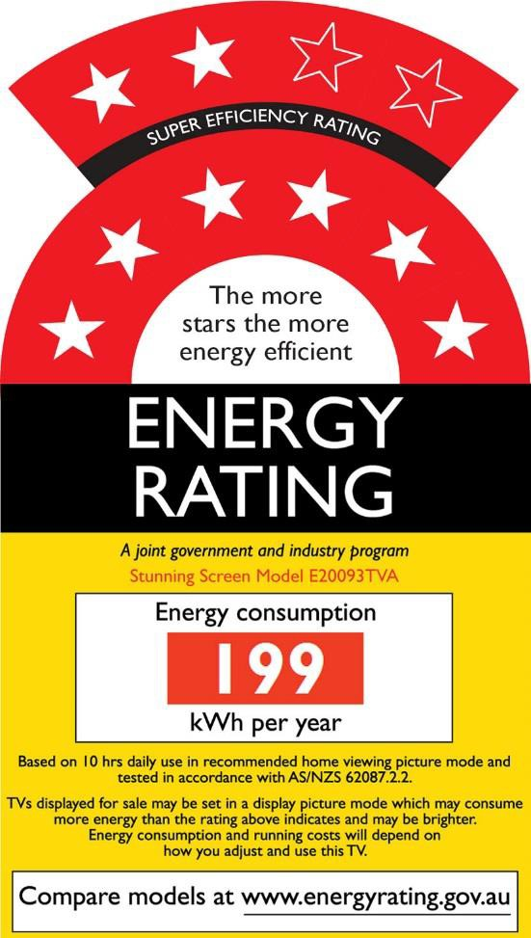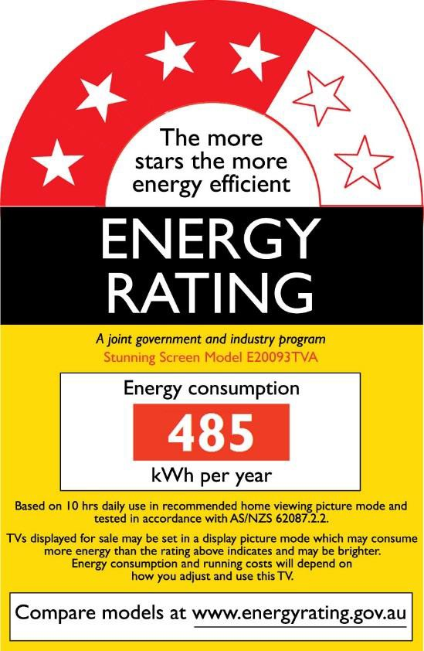

ERL 1a

ERL 1b



**Figure 19: Example 4 star and 8 star television Energy Rating Labels (ERL).**

# Appendix B – EU Ecodesign regulations – MEPS

One of the core policy options under consideration is the adoption of the European Commission Ecodesign Regulation101 for electronic displays. Essentially this is a MEPS level for the on-mode power for an electronic display. The regulation also defines maximum permitted power levels for various low power modes, such as Off mode, Standby mode and Networked standby mode, with adders for specific functions and an overall cap on the permitted power in each mode. This regulation effectively applies On mode limits to televisions and computer monitors only, and low power mode limits to all electronic displays within the scope (e.g. including digital signage displays). The regulation defines an energy efficiency index (*EEI*) for the appliance based on its screen area and On mode power consumption. The regulation then defines the maximum permitted *EEI* for specific products based on the screen resolution. The Ecodesign *EEI* is defined for a product using the following equation:

𝐸𝐸𝐼 =

(𝑃𝑚�𝑎�𝑢��� + 1)

(3 × [90 × tanh(0.02 + 0.004 × (𝐴 − 11)) + 4] + 3) + 𝑐𝑜𝑟𝑟

* *Pmeasured* is the on-mode power in Standard Dynamic Range (SDR) as measured in a

high ambient light setting in W

* A is the screen area in dm² (screen area in cm² divided by 100)
* *corr* is a correction factor of 10 for OLED electronic displays that do not apply the ABC allowance and this only applies until 28 February 2023. *corr* shall be zero in all other cases.

For products with complying ABC functions, then on-mode power may be reduced by 10% when assessing the product against Ecodesign and energy labelling requirements. To qualify for the ABC allowance, the ABC must meet all of the following requirements:

* ABC is enabled in the normal configuration of the electronic display and persists in any other standard dynamic range configuration available to the end-user;
* the value of *Pmeasured*, in the normal configuration, is measured with ABC disabled or, if ABC cannot be disabled, in an ambient light condition of 100 lux measured at the ABC sensor;
* the value of *Pmeasured* with ABC disabled, if applicable, shall be equal to or greater than the on-mode power measured with ABC enabled in an ambient light condition of 100 lux measured at the ABC sensor;
* with ABC enabled, the measured value of the on-mode power must decrease by 20% or more when the ambient light condition, measured at the ABC sensor, is reduced from 100 lux to 12 lux; and

101 See [COMMISSION REGULATION (EU) 2019/2021 of 1 October 2019](https://eur-lex.europa.eu/legal-content/en/TXT/?uri=CELEX%3A32019R2021) laying down Ecodesign requirements for electronic displays pursuant to Directive 2009/125/EC of the European Parliament and of the Council, amending Commission Regulation (EC) No 1275/2008 and repealing Commission Regulation (EC) No 642/2009.

* the ABC control of the display screen luminance meets all of the following characteristics when the ambient light condition measured at the ABC sensor changes:
* the measured screen luminance at 60 lux is between 65% and 95% of the screen luminance measured at 100 lux;
* the measured screen luminance at 35 lux is between 50% and 80% of the screen luminance measured at 100 lux; and
* the measured screen luminance at 12 lux is between 35% and 70% of the screen luminance measured at 100 lux.

The regulation sets limits on the value of EEI for an electronic display as set out in Table 1.

**Table 1: Maximum permitted EEI for electronic displays in Europe by tier**

|  |  |  |  |
| --- | --- | --- | --- |
| Applicable date | *EEImax* for electronic displays with resolution up to 2138400 pixels (**HD**) | *EEImax* for electronic displays with resolution above 2138400 pixels (HD) and up to 8294400 pixels  (**UHD-4k**) | *EEImax* for electronic displays with resolution above 8294400 pixels (UHD-4k) and for MicroLED displays  (**UHD-8k**) |
| 1 March 2021 | 0.90 | 1.1 | N/A |
| 1 March 2023 | 0.75 | 0.9 | 0.9 |

Table notes: Abbreviations in **BOLD** above are used to denote these product categories throughout this report. A resolution of 1080×1920 is 2.073 MPx which is defined as **HD**. A resolution of up to 2160×3840 is 8.2944 MPx is defined as **UHD-4k**. MicroLED displays are currently rare (only 1 model of a total of 14,841 registered in Europe claim to use microLEDs as of mid-September 2022 and the display category was “Other”). Any vertical resolution of greater than 2160 will generally be classified as **UHD-8k** above under EU Ecodesign (even though formal 8k is 4320×7680 = 33.177 MPx). These *EEImax* limits do not apply to signage displays (only televisions and computer monitors).

Although not directly referenced, the test method used for measurement is an EN version of IEC62087 in parts (Edition 1 in 2015) as follows:

* IEC 62087-1:2015 *Audio, video, and related equipment - Determination of power consumption - Part 1: General*
* IEC 62087-2:2015 *Audio, video, and related equipment - Determination of power consumption - Part 2: Signals and media*
* IEC 62087-3:2015 *Audio, video, and related equipment - Determination of power consumption - Part 3: Television sets*

The EU regulation makes a number of changes to the test method including:

* Use of an overhead LED lamp for setting room illuminance for ABC testing (in place of a horizontal halogen lamp)
* The inclusion of HDR10 and HLG media for energy
* Specification that Motion-based Dynamic Dimming (MDD) off.

These changes ensure that the current EU test is in alignment with Edition 2 of IEC62807 published on 17 February 2023.

# Glossary

|  |  |
| --- | --- |
| **Term** | **Definition** |
| $m | Million dollars |
| 4k televisions | A television with a horizontal resolution of approximately 4000 lines, normally 3840 |
| 8k televisions | A television with a horizontal resolution of approximately 8000 lines, normally 7680 |
| ABC | automatic brightness control |
| ARA | Australian Retailers Association |
| ASFBEO | Australian Small Business and Family Enterprise Ombudsman |
| BAU | Business as usual |
| cd | Candela (cd) is a unit of measurement of luminous intensity. It is the amount of light radiated in a given direction. |
| CESA | Consumer Electronics Suppliers Association (Australia) |
| CHOICE | magazine of the Australian Consumers’ Association (consumer advocacy group) |
| cm | centimetre |
| CO2-e | Carbon dioxide equivalent |
| Computer monitor | screen that displays visual information from a computer, workstation or server as its primary function |
| CRIS | Consultation Regulatory Impact Statement |
| CRT | cathode ray tube televisions |
| CTA | Consumer Technology Association (USA) |
| DCCEEW | Department of Climate Change, Energy, the Environment and Water |
| Digital signage display | Screen for public and/or non-focussed viewing, often long range.  The European regulations define a digital signage display as an electronic display that is designed primarily to be viewed by multiple people in non-desktop based and non- domestic environments. |
| dm2 | Square decimetre |
| E3 Program | Equipment Energy Efficiency Program (Australia and New Zealand) |
| EC | European Commission |
| EEC | Energy Efficiency Council (Australia) |
| EEC Act | Energy Efficiency and Conservation Act (New Zealand) |
| EECA | Energy Efficiency and Conservation Authority (New Zealand) |
| EEI | Energy efficiency index |
| EPREL | European Product Registry for Energy Labelling (EU) |
| ERL | Energy rating label |
| EU | European Union |
| EU 2021 | MEPS levels defined in Regulation (EU) 2019/2021 in force from 1 March 2021 to 28 February 2023. |
| EU 2023 | MEPS levels defined in Regulation (EU) 2019/2021 that come into force on 1 March 2023. More stringent than EU 2021. |
| GHG | greenhouse gas emissions |
| GWh | gigawatt hour – unit of electrical energy |
| HD | high definition (1080 lines or more) |
| HDR | high dynamic range |
| IEC | International Electrotechnical Commission |
| ISO | International Organization for Standardization |
| kt | kilo tonnes (thousand tonnes) |
| kWh | kilowatt hour – unit of electrical energy |
| LCD | liquid crystal display |

|  |  |
| --- | --- |
| **Term** | **Definition** |
| LED | light emitting diode |
| m2 | square metre |
| MEPS | minimum energy performance standards |
| Micro-LED | MicroLED is an emissive display technology where the light level of each red, green, or blue sub-pixel is a small LED light source that can be controlled individually. |
| Mini-LED | An LED display technology that uses a full-array of small backlights arranged in a grid to provide backlight for an LCD TV. Mini-LED displays differ from traditional LED displays in that they may have a couple of orders of magnitude (e.g. thousands) more backlights in the full-array backlight. This enables higher contrast ratios through more localised dimming. |
| Mt | Mega tonnes (million tonnes) |
| NPV | Net present value |
| On-mode | ‘on-mode’ or ‘active mode’ means a condition in which the electronic display is connected to a power source, has been activated and is providing one or more of its display functions |
| Preset Picture Setting (PPS) | A pre-programmed factory setting with pre-determined picture parameters such as brightness, contrast, colour, sharpness, etc. |
| SD | standard definition (up to 728 lines) |
| SDR | standard dynamic range |
| Shop configuration | ‘shop configuration’ means the configuration of the electronic display for use specifically in the context of demonstrating the electronic display, for example in high illumination (retail) conditions and not involving an auto power-off if no user action or presence is detected |
| Specialist display | screen with specific industry/professional applications (for example, in medical applications) |
| Televisions | an appliance102 for the display and possible reception of television broadcast and similar services for terrestrial, cable, satellite and broadband network transmission of analogue or digital signals, and includes:   1. a display or monitor with an inbuilt television tuner; 2. a display or monitor without an inbuilt television tuner sold in modular form; and 3. a television that has additional functions which are not required for its basic operation as a television |
| TTMRA | Trans-Tasman Mutual Recognition Agreement |
| TV | television |
| UHD | Ultra high definition (usually more than 2 Megapixels and includes 4k and 8k displays) |

102 Definition from [television determination](https://www.legislation.gov.au/Details/F2013L01500)

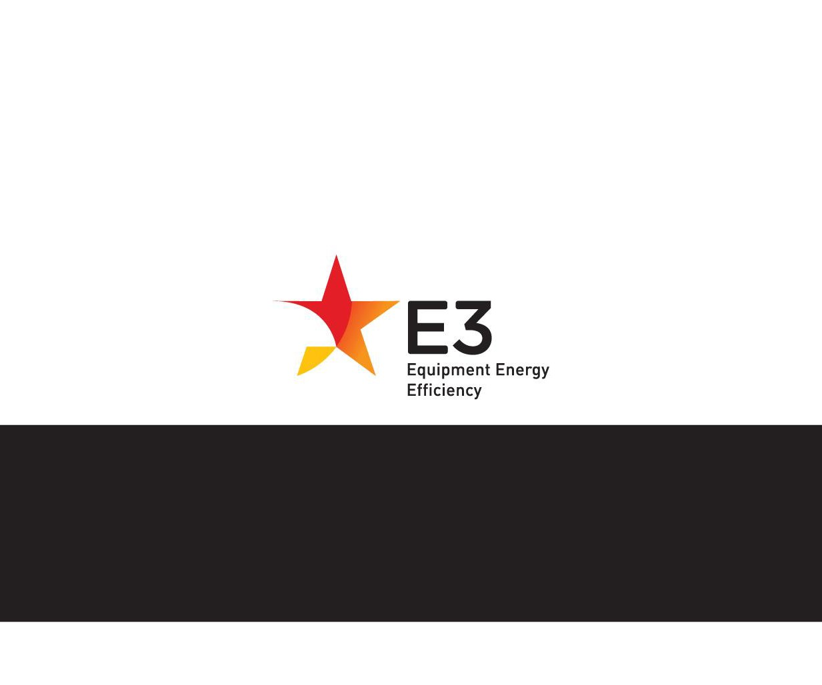

[**www.energyrating.gov.au**](http://www.energyrating.gov.au/)

**A joint initiative of Australian, State and Territory and New Zealand Governments**