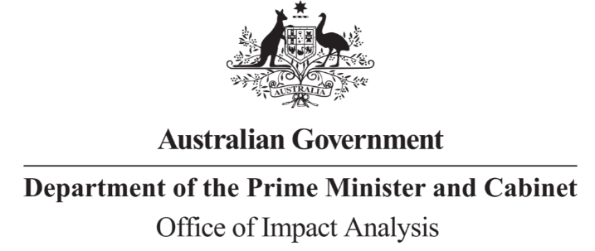

Reference: OBPR21-01290  
Telephone: 6271 6270  
e-mail: [helpdesk-oia@pmc.gov.au](mailto:helpdesk-obpr@pmc.gov.au)

Ms Linda Caruso  
General Manager  
Communications Infrastructure Division  
Australian Communications and Media Authority  
  
Dear Ms Caruso   
  
**Impact Analysis – Second Pass Final Assessment – 3.4-4 GHz remote allocation of area-wide licences**

Thank you for your letter submitting an Impact Analysis (IA) for formal Second Pass Final Assessment. I note the IA has been formally certified at the General Manager level as a transitional arrangement. For future IAs, I ask for certification at the Deputy Secretary level, consistent with the *Australian Government Guide to Policy Impact Analysis*.

I appreciate the Australian Communications and Media Authority’s constructive engagement on the IA. The Office of Impact Analysis’ (OIA) assessment is that the quality of the policy impact analysis in the IA is adequate.

**Next steps**

After a final decision has been announced, I ask that your agency work with OIA to finalise this material for public release. This includes providing a copy of the IA in Word and PDF format for web accessibility purposes. The IA must be included in any Explanatory Memorandum or Statement giving effect to the proposals in the IA.

If you have any further queries, please do not hesitate to contact me.

Yours sincerely

James Leslie  
A/g Executive Director   
Office of Impact Analysis  
20 April 2023