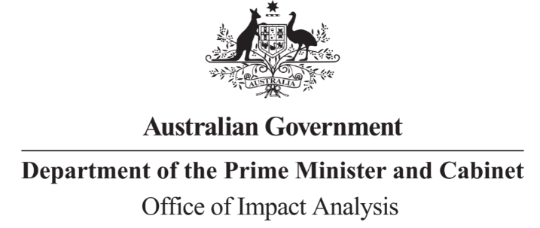

Reference: OBPR22-02448
Telephone: 6271 6270
e-mail: helpdesk-oia@pmc.gov.au
Ms Kath Rowley
A/g Deputy Secretary – Climate Change and Energy Group
Department of Climate Change, Energy, the Environment and Water
Dear Ms Rowley
Impact Analysis – Second Pass Assessment – Safeguard Mechanism Reforms

Thank you for your letter submitting an Impact Analysis (IA) for formal Second Pass Final Assessment, which was received on 19 April 2023. I note the IA has been formally certified at the Deputy Secretary level consistent with the Australian Government Guide to Regulatory Impact Analysis. The IA has been assessed against this version of the Guide because work commenced well ahead of the release of the updated Australian Government Guide to Policy Impact Analysis.

I appreciate the Department’s constructive engagement on the IA.

The Office of Impact Analysis’ (OIA’s) assessment is that the quality of the analysis in the Impact Analysis is adequate and therefore sufficient to inform a decision.

To be considered ‘good practice’ within the Government’s Impact Analysis framework, the IA would have benefitted from:
- inclusion of quantitative estimates of the likely substantive compliance costs in the regulatory burden estimate;
- additional detail, particularly quantitative estimates, on the full range of expected costs available at time of decision, including their distribution across facility types; and
- an additional assessment of the dependencies and cumulative impacts related to other relevant policies and broader drivers of abatement activity, with key assumptions identified and managed within the risk framework.
I note that the data collection proposed in the evaluation section of the IA should contribute towards a higher quality of quantitative analysis – including both primary and secondary impacts and their distribution – for future climate policy.
The IA may now be provided to the decision maker to inform their decision.

To support transparency, the IA must be included in any Explanatory Memorandum or Statement giving effect to the proposals in the IA.
After a final decision has been announced, I ask that your agency work with the OIA to finalise this material for public release. This includes providing a copy of the Impact Analysis in Word and PDF format for web accessibility purposes.

I also note that a Post Implementation Review is required for this policy within five years of implementation, and suggest that this can be combined with the proposed 2026/27 Review.
If you have any further queries, please do not hesitate to contact me.
Yours sincerely
Jason Lange
Executive Director
Office of Impact Analysis
21 April 2023

