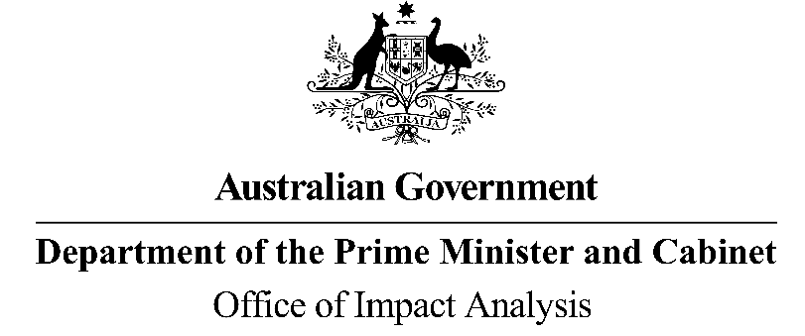

Reference: OIA23-04780  
Telephone: 6271 6270  
e-mail: [helpdesk-oia@pmc.gov.au](mailto:helpdesk-obpr@pmc.gov.au)

Mr Michael Lye

Deputy Secretary

Department of Health and Aged Care  
  
Dear Mr Lye

                                              
**Certification of the Response to the Royal Commission into Aged Care Quality and Safety and Supplementary Analysis as equivalent to an Impact Analysis**

Thank you for your letter dated 31 March 2023 certifying the Response to the Royal Commission into Aged Care Quality and Safety and supplementary analysis as having completed a process and analysis equivalent to an Impact Analysis (IA).

The Office of Impact Analysis (OIA) acknowledges the certification. Under the Government’s Impact Analysis process, the OIA does not assess the adequacy of independent reviews but does assess whether the options analysed in the independent review are relevant to the regulatory proposal. The OIA also assesses whether the independent review or certification letter identifies regulatory costs.  
  
In this case, the OIA’s assessment is that the options analysed in the independent review and supplementary analysis are sufficiently relevant to the regulatory proposal. The OIA also notes the Department has estimated there will be an increase in regulatory burden of $4.34 million per annum.

We would appreciate you advising us when a final decision has been announced and forwarding a copy of the independent review in a form meeting the Government’s accessibility requirements. The OIA will publish the independent review, along with your certification, on the OIA’s website at <https://oia.pmc.gov.au/>.

Yours sincerely  
  
  
  
Jason Lange  
Executive Director  
Office of Impact Analysis  
3 May 2023