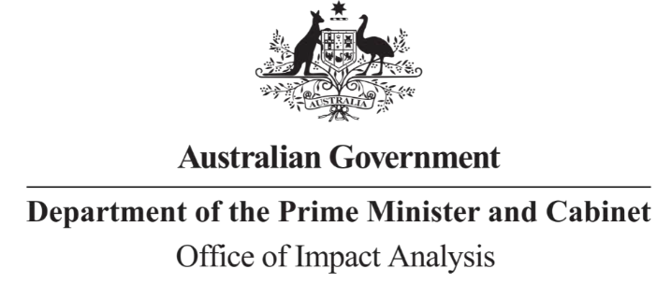

Reference: OBPR23-04073 Telephone: 6271 6270

e-mail: [helpdesk-oia@pmc.gov.au](mailto:helpdesk-oia@pmc.gov.au)

Dr Chris Locke

Deputy Secretary – Biosecurity and Compliance Department of Agriculture, Fisheries and Forestry

Dear Dr Locke

# Impact Analysis – Second Pass Assessment – Biosecurity Sustainable Funding

Thank you for your letter submitting an Impact Analysis (IA) for formal Second Pass Final Assessment, which was received on 4 May 2023. I note the IA has been formally certified at the Deputy Secretary level consistent with the *Australian Government Guide to Policy Impact Analysis*.

The Office of Impact Analysis’ (OIA’s) assessment is that the quality of the analysis is adequate and therefore sufficient to inform a decision.

To be considered ‘good practice’ within the Government’s Impact Analysis framework, the IA would have benefitted from:

* Further analysis of impacts, including quantification of costs, justification of costings, and description of qualitative impacts; and
* Further description of consultation, including the range of stakeholders consulted and areas of agreement and disagreement on the options.

OIA recognises that regulatory costs associated with this proposal are difficult to calculate but understands that the approach taken was designed to minimise any cost through leveraging existing mechanisms.

The formal levy review established by the enabling legislation would ensure that there is an opportunity to revisit regulatory costs if implemented.

# Next steps

After a final decision has been announced, I ask that your agency work with the OIA to finalise this material for public release. This includes providing a copy of the IA in Word and PDF format for web accessibility purposes.

If you have any further queries, please do not hesitate to contact me. Yours sincerely

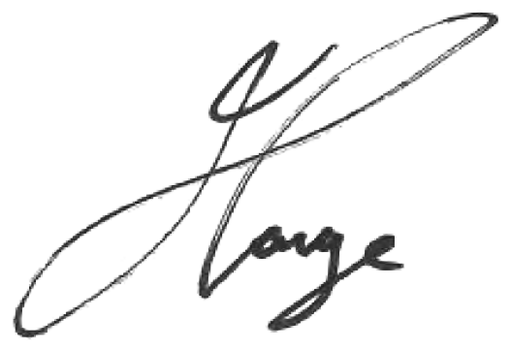

Jason Lange Executive Director

Office of Impact Analysis 8 May 2023