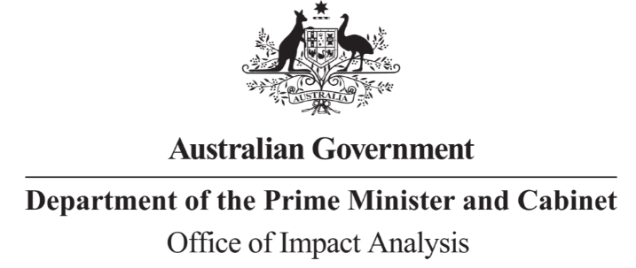
Reference: OBPR22-03028
Telephone: 6271 6270
e-mail: helpdesk-oia@pmc.gov.au
Ms Tania Rishniw
Deputy Secretary
Department of Health and Aged Care
Dear Ms Rishniw
Impact Analysis – Second Pass Final Assessment – Primary Health Care Reform (Voluntary Patient Registration)

Thank you for your letter received on 27 April 2023, submitting an Impact Analysis (IA) for formal Second Pass Final Assessment. I note the IA has been formally certified by you, consistent with the Australian Government Guide to Policy Impact Analysis (the Guide).

The Office of Impact Analysis’ (OIA’s) assessment is that the analysis in the IA is ‘adequate’, and therefore sufficient to inform a decision.

To have been assessed as ‘good practice’ under the Guide, the IA would have benefited from:
- More detailed analysis of the merits of the alternative options and why they were ultimately not considered.
- Further consideration of potential barriers to individuals registering with VPR; the resulting impacts to those who will be restricted from accessing services exclusively linked to VPR; and targeted strategies to address those barriers.

The IA may now be provided to the decision-maker to inform their decision.

We would appreciate you advising us when a final decision has been announced and forwarding a copy of the IA in a form meeting the Government’s accessibility requirements. The OIA will publish the IA, along with your certification and this assessment, on OIA’s website, https://oia.pmc.gov.au/.

If you have any further queries, please do not hesitate to contact me.

Yours sincerely

Jason Lange
Executive Director
Office of Impact Analysis
28 April 2023
1 National Circuit, Barton ACT 2600 • Telephone 02 6271 6270 • Internet oia.pmc.gov.au

