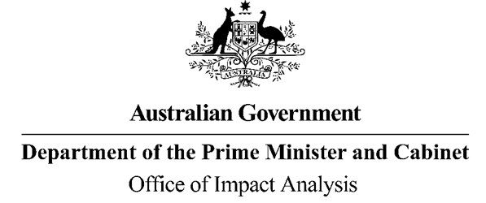

Reference: OBPR22-03771
Telephone: 6271 6270
e-mail: Helpdesk-OIA@pmc.gov.au
Ms Penny Shakespeare
Deputy Secretary
Health Resourcing Group
Department of Health and Aged Care
Dear Penny
Impact Analysis – Second Pass Assessment – Lowering the Costs of Medicines through Changes to Maximum Dispensing Quantities

Thank you for your letter received on 17 April 2023, submitting an Impact Analysis (IA) for Second Pass Final Assessment on Lowering the Costs of Medicines through Changes to Maximum Dispensing Quantities. I note the IA has been formally certified by you, consistent with the Australian Government Guide to Policy Impact Analysis (the Guide).
The Office of Impact Analysis’ (OIA’s) assessment is that the quality of the analysis in the IA is adequate, and therefore sufficient to inform a decision. To have been assessed as ‘good practice’ under the Guide, the IA would have benefited from more recent public consultations on potential stakeholder impacts, particularly for small businesses and pharmacies in rural and remote areas. Moreover, where stakeholder impacts are difficult to ascertain at this point in time (e.g., individual pharmacy-level financial impacts), the IA would have benefited from a more detailed evaluation plan that outlines metrics and data required to monitor the impacts on stakeholders following implementation.

The IA may now be provided to the decision-maker to inform their decision.

We would appreciate you advising us when a final decision has been announced and forwarding
a copy of the IA in a form meeting the Government’s accessibility requirements. The OIA
will publish the IA, along with your certification and this assessment, on OIA’s website, https://oia.pmc.gov.au/.

If you have any further queries, please do not hesitate to contact me.
Yours sincerely

Jason Lange
Executive Director
25 April 2023

