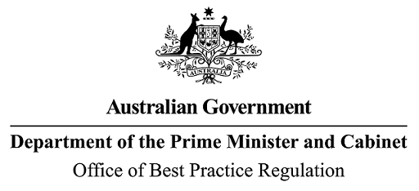

Reference: OBPR21-01359 Telephone: 6271 6270

e-mail: [helpdesk-obpr@pmc.gov.au](mailto:helpdesk-obpr@pmc.gov.au)

Rosemary Deininger Deputy Secretary

Department of Agriculture, Fisheries and Forestry Dear Ms Deininger

# Regulation Impact Statement – Second Pass Final Assessment – Improving illegal logging traceability and timber identification testing

Thank you for your letter of 20 July 2022 submitting a Regulation Impact Statement (RIS) for formal Second Pass Final Assessment. I note the RIS has been formally certified at the Deputy Secretary level consistent with the *Australian Government Guide to Regulatory Impact Analysis*.

I appreciate the Department’s constructive engagement on the RIS. The Office of Best Practice Regulation’s (OBPR’s) assessment is that the quality of the regulatory impact analysis in the RIS is Good Practice.

To be considered ‘Exemplary’ as per the *Australian Government Guide to Regulatory Impact Analysis*, the RIS would have benefitted from more quantification of the benefits in terms of reducing illegally logged timber entering Australia. The RIS may now be provided to the decision-maker to inform their decision.

# Next steps

After a final decision has been announced, I ask that your agency work with OBPR to finalise this material for public release. This includes providing a copy of the RIS in Word and PDF format for web accessibility purposes. The RIS must be included in any Explanatory Memorandum or Statement giving effect to the proposals in the RIS.

If you have any further queries, please do not hesitate to contact me on 02 6271 5945. Yours sincerely

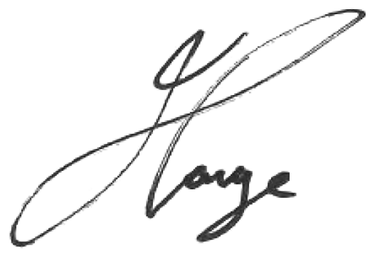

Jason Lange Executive Director 27 July 2022