

Mr Jason Lange Executive Director

Office of Best Practice Regulation Department of the Prime Minister and Cabinet 1 National Circuit

BARTON ACT 2600

Email: [helpdesk-OBPR@pmc.gov.au](mailto:helpdesk-OBPR@pmc.gov.au)

Dear Mr Lange

Regulation Impact Statement – Buy Now, Pay Later (BNPL) – Second Pass Final Assessment

I am writing in relation to the attached Impact Assessment (IA) prepared for proposals to regulate Buy Now, Pay Later (BNPL) products, following my earlier first pass certification letter of 12 April 2023.

I am satisfied that the IA addresses the concerns raised in your letter on 14 April 2023. Specifically, the IA now expands on the first pass assessment by including the status quo as an option for reform, providing additional analysis of the costs and benefits of each option and outcomes for affected stakeholders, setting out a more detailed explanation of how the policy will be executed and evaluated, and by including information on expected changes to the IA at future major decision points.

In regard to questions 3 & 4 of the IA, the net benefit of each option is now analysed against the status quo. Section 4 now contains more detailed analysis for each option, including on the likely outcomes for affected stakeholders and the economy.

* Option 1 would deliver a marginal net benefit to consumers compared to the status quo. While introducing a discrete unaffordability assessment in law would slightly increase consumer protection with minimal cost to industry, it would only marginally reduce the instances of unaffordable lending, such that significant consumer harm would persist. The total regulatory costs of this option are estimated to be $3.96 million per annum on a 10-year annualised basis.
* Option 2 delivers significant net benefits over the status quo. Option 2 applies the principle based Responsible Lending Obligation (RLO) framework to ensure BNPL is

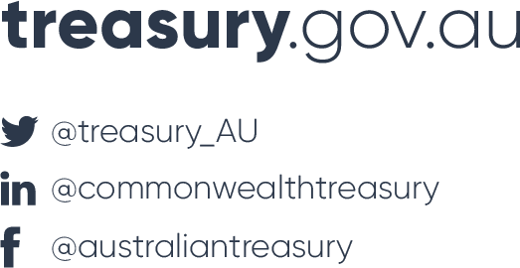Langton Crescent Parkes ACT 2600

Australia P: +61 2 6263 2111

not provided to those for whom it is unsuitable, while ensuring that regulation is proportionate to the risk of the product and will not unduly disrupt the business operations of BNPL providers. It also applies credit licencing and other Credit Act regulation to BNPL but modified in a way that is flexible and technologically neutral so that it is fit for purpose for the BNPL business model. This option will greatly increase protections for consumers over the status quo and is expected to reduce unaffordable lending markedly while ensuring that consumers can still access BNPL credit. The regulatory burden upon providers and merchants would increase moderately. The total regulatory costs of this option are estimated to be $15 million per annum on a 10-year annualised basis.

* Option 3, a wholesale application of existing credit regulation without any modification, would be expected to have a net benefit to consumers, but less so than under Option 2. The RLO framework would be instituted without amendment. This will increase consumer protections and significantly reduce unaffordable lending by a greater degree than other options. However, it would also significantly increase costs for industry compared to the status quo and may make many lower-value BNPL products economically unviable. Any benefit from increased consumer protections over those in Option 2 would be outweighed by the reductions in benefits to merchants, providers and consumers, including reductions in financial inclusion. The total regulatory costs are estimated to be $36.07 million per annum on a 10-year annualised basis.

Question 7 of the IA is now addressed in more detail. The performance of the policy would be measured through the collection of statistics indicative of consumer harm, such as financial stress measures, complaint numbers, changed spending behaviours on essentials, late payment rates and published bad debt provisions by firms. Post implementation evaluation would also include consideration of qualitative feedback from consumer groups, such as financial counsellors, to determine whether the instances of harm they are seeing from BNPL products has materially reduced as a result of the reforms. At present, a review date for the reform measure has not been set.

While it is not possible to estimate the regulatory benefits of an increase in consumer protection, it is anticipated that a significant reduction in unaffordable lending, among other benefits, would mean the benefits of regulatory intervention would outweigh the costs of regulation. Regulatory offsets have not been identified.

The IA will inform cabinet’s decision on the key policy framework for regulating BNPL. If necessary, the IA will be reviewed and revised following further expected consultations on the design of the reforms in late 2023, prior to the finalisation and introduction of any legislation.

Accordingly, I am satisfied that the RIS is now consistent with the six principles for Australian Government policy makers as specified in the *Australian Government Guide to Regulatory Impact Analysis*.

I submit the RIS to the Office of Best Practice Regulation for formal final assessment. Yours sincerely



Brenton Philp Deputy Secretary 19 April 2023