Australian Government



Department of Agriculture,

Fisheries and Forestry

Mr Jason Lange Executive Director

Office of Impact Analysis

Department of the Prime Minister and Cabinet 1 National Circuit

BARTON ACT 2600

Email: [helpdesk-OIA@pmc.gov.au](mailto:helpdesk-OIA@pmc.gov.au)

Dear Mr Lange

Ref: OBPR23-04073

**Impact Analysis - Towards a strengthened and sustainably funded biosecurity system - Second Pass Final Assessment**

I write in relation to the Impact Analysis (IA) prepared by the Department of Agriculture, Fisheries and Forestry (DAFF) for the revenue proposals in the Budget Package, *Towards a Strengthened and Sustainably Funded Biosecurity System.*

I am satisfied the IA addresses the majority of concerns raised in your letter of 14 April 2023, noting the challenges of quantifying regulatory costs and offsetting benefits. Our proposed consultation process with key stakeholders on implementation arrangements will provide greater clarity. It is our expectation that the annual regulatory cost of these revenue measures will be negligible (and less than $1 million per year).

I am satisfied the IA is consistent with the six principles for Australian Government policy makers as specified in the *Australian Government Guide to Policy Impact Analysis.*

The identified revenue proposals reflect measures remaining within the scope of this budget submission, noting advice from the Department of the Prime Minister and Cabinet and the Department of the Treasury regarding the handling for the Passenger Movement Charge.

Impact analysis will be prepared for any additional revenue proposals brought forward in later budget processes, consistent with existing authority.

I submit the IA to the Office of Impact Analysis for formal final assessment.

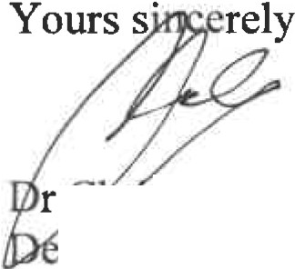

r is Locke puty Secretary

Biosecurity and Compliance

Department of Agriculture, Fisheries and Forestry

4 May 2023

Attachment: Biosecurity Sustainable Funding Impact Analysis