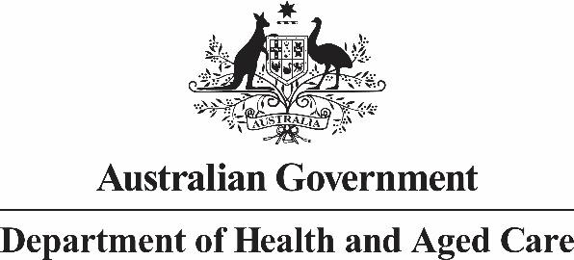

Deputy Secretary
Mr Jason Lange
Executive Director
Office of Impact Analysis
Department of the Prime Minister and Cabinet
1 National Circuit
BARTON ACT 2600

Dear Mr Lange
Regulation Impact Statement – Primary Health Care Reform (Voluntary Patient Registration) – Second Pass Final Assessment
I am writing in relation to the attached Impact Assessment (IA) prepared for the Voluntary Patient Registration (VPR) component of the Primary Health Care Reform Submission.
I am satisfied that the IA addresses the feedback provided in your letter of 5 April 2023. Specifically, we have:
- Restructured the IA to ensure that it is policy neutral and does not pre-empt a policy decision;
- Provided further detail on the ICT infrastructure that will underpin VPR in terms of why it is needed in the first instance, current system functionality, and additional functionality that is yet to be developed to meet policy objectives;
- Provided further detail on alternative options that were not considered in the IA including a targeted implementation approach and mandatory patient participation;
- Expanded the analysis of the risks and impacts to patients, who choose to, or are ineligible to register in VPR;
- Expanded the competition impacts analysis in relation to registered practices and unregistered practices; and
- Expanded the explanation around how practice efficiencies have been calculated.
The regulatory saving for the preferred option is $91.7 million over the first four years. This takes into account the business impact associated with establishing VPR which is calculated at $62.9 million and savings of $154.6 million.
Accordingly, I am satisfied that the IA is now consistent with the six principles for Australian Government policy makers as specified in the Australian Government Guide to Regulatory Impact Analysis.
I submit the IA to the Office of Impact Analysis for formal final assessment.
Given the IA refers to measures agreed but not identified for early announcement, we suggest that the IA be published following Budget night.

Yours sincerely

Tania Rishniw
Deputy Secretary
Department of Health and Aged Care
27 April 2023

