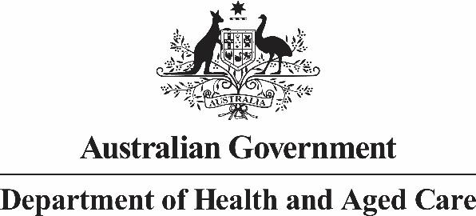
Mr Jason Lange
Executive Director
Office of Impact Analysis
Department of the Prime Minister and Cabinet
1 National Circuit
BARTON ACT 2600
Email: helpdesk-OBPR@pmc.gov.au

Dear Mr Lange

Impact Analysis – Changes to Maximum Dispensing Quantities – Second Pass Final Assessment
I am writing in relation to the attached Impact Analysis (IA) prepared for the proposal Lowering the Cost of Medicines through changes to Maximum Dispensing Quantities (MDQ).
I am satisfied that the IA addresses feedback provided in your letter of 6 April 2023.
Specifically:
- The estimated annual aggregate savings to consumers from avoided Pharmaceutical Benefits Scheme (PBS) co-payments has been included in the Executive Summary and relevant parts of Section 4.
- The Preferred Option section (Section 6) draws on quantitative analysis to support the comparison of policy options, underscoring the trade-off between patient benefits and business impacts.
- Clarification and additional context for the reader has been provided where appropriate and where the information is readily available.
The average regulatory savings for consumers are $138.4 million per year for the two month option (Option 2) and $171.6 million per year for the three month option (Option 3).
Accordingly, I am satisfied that the IA is consistent with the six principles for Australian Government policy makers as specified in the Australian Government Guide to Regulatory Impact Analysis.
I submit the IA to the Office of Impact Analysis for formal final assessment.
Yours sincerely

Penny Shakespeare
Health Resourcing Group
17 April 2023

