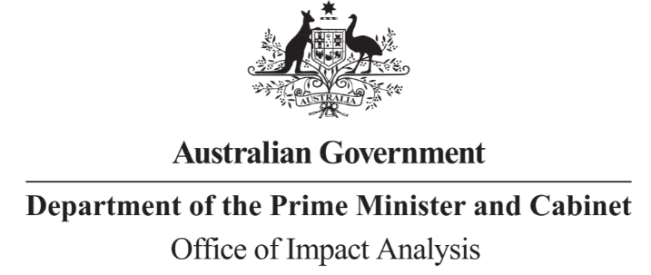

Reference: OBPR22-03226

Telephone: 6271 6270 e-mail: helpdesk-oia@pmc.gov.au

Ms Lyn O’Connell

Deputy Secretary – Biodiversity Markets, Economics and Environmental Science Department of Climate Change, Energy, the Environment and Water

Dear Ms O’Connell

**Impact Analysis – Second Pass Assessment – Nature Repair Market (NRM)**

Thank you for your letter submitting an Impact Analysis (IA) for formal Second Pass Final Assessment. I note the IA has been formally certified at the Deputy Secretary level consistent with the *Australian Government Guide to Policy Impact Analysis*.

I appreciate the Department’s constructive engagement on the IA. The Office of Impact Analysis’ (OIA) assessment is that the quality of the analysis in the IA is adequate, but that it could have been improved by a clearer description of key elements of the proposal.

The Impact Analysis would have achieved a ‘good’ rating if the following elements had been included:

* More detailed assessment of the viable options against a clear decision-making framework;
* Improved characterisation of relevant international and state/territory examples of comparable policies, and evaluation results from relevant national programs; and
* Greater detail within the evaluation plan on the scope and process for evaluation activities, including monitoring approaches for the specified risks, targets for objectives/environmental outcomes and the approach to measuring and reporting.

I acknowledge that a detailed estimate of likely costs and benefits was not possible as these impacts are highly dependent on the scope of the individual methodology determinations that will be established under the NRM. As such, the IA requirements for each draft methodology determination must be tested with the OIA.

I also note the IA states that a post-implementation review (PIR) will be prepared for this policy within two years of commencement of the legislation, and suggest that this can be combined with the proposed administrative review. Please note that the PIR for the previous, related policy: ‘*Pathway to a National Voluntary Biodiversity Stewardship Market’* is no longer required.

After a final decision has been announced, I ask that your agency work with OIA to finalise this material for public release. This includes providing a copy of the IA in Word and PDF format for web accessibility purposes. The IA must be included in any Explanatory Memorandum or Statement giving effect to the proposals in the IA.

If you have any further queries, please do not hesitate to contact me.

Yours sincerely

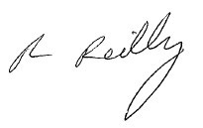

Rob Reilly

Executive Director (A/g)

Office of Impact Analysis

16 March 2023