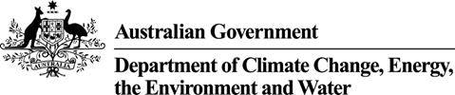

Mr Jason Lange

Executive Director

Office of Impact Analysis

Department of the Prime Minister and Cabinet

1 National Circuit

BARTON ACT 2600

Email: helpdesk-OIA@pmc.gov.au

Dear Mr Lange

**Policy Impact Statement – Nature Repair Market Bill – Second Pass Final Assessment**

I am writing in relation to the attached Policy Impact Analysis (PIA) prepared for the Nature Repair Market Bill 2023 (the NRM Bill).

I am satisfied that revised the PIA (Attachment A) addresses the comments raised in your letter of 22 February 2023, which focused around suggestions to:

* Better describe the method applied to demonstrate that the recommended configuration of the policy is the ‘best option’ to solve the specified problem
* Improve the quantitative description of impacts, including expected demand and costs to all parties
* Refine the structure and flow of the document, including by reducing repetition
* Elaborate on the evaluation plan to describe how the benefits of environmental outcomes will be measured, and
* Additional feasible options to solve the problem should be assessed, such as the comparison to a grants-based approach or other incentive mechanisms.

The revised PIA has also taken into account feedback from consultation on an exposure draft of the NRM Bill, which closed on 3 March 2023. Overall, feedback was positive with a range of suggestions for improvement to the NRM Bill.

Many of these suggestions relate to how to improve the effectiveness of the market, by increasing transparency and integrity, providing greater flexibility in how proponents can demonstrate the outcomes of their projects, and increasing efficiency for those projects that are registered under both the Carbon Credits (Carbon Farming Initiative) Act 2011 and the NRM Bill.

These suggestions have informed the final form of the NRM Bill.

**DCCEEW.gov.au**

John Gorton Building - King Edward Terrace, Parkes ACT 2600 Australia 1

GPO Box 3090 Canberra ACT 2601 ABN: 63 573 932 849

Accordingly, I am satisfied that the PIA is consistent with the six principles for Australian Government policy makers as specified in the Australian Government Guide to Policy Impact Analysis.

I submit the policy Impact Analysis to the Office of Impact Assessment for formal final assessment.

Yours sincerely

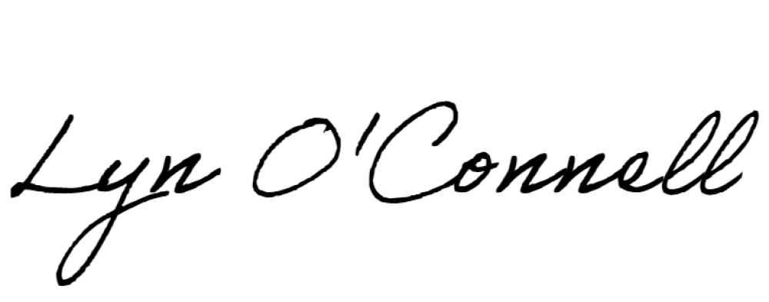

Lyn O’Connell

Deputy Secretary

Department of Climate Change, Energy, the Environment and Water

8 March 2023

Document title industry.gov.au 2