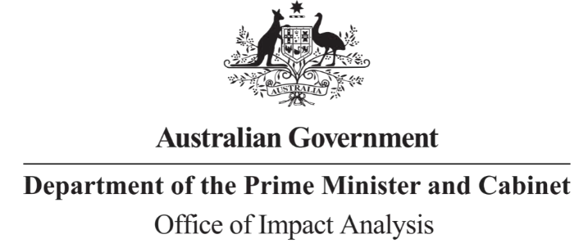

Reference: OBPR22-01519 Telephone: 6271 6270
e-mail: helpdesk-oia@pmc.gov.au

Dr. Megan Downie Director
Occupational Diseases and Hygiene Policy Safe Work Australia

Dear Dr. Downie

Decision Regulation Impact Statement – Managing the risks of respirable crystalline silica at work

Thank you for forwarding the amended draft of the above Decision Regulation Impact Statement (RIS) for assessment by the Office of Impact Analysis (OIA).

OIA’s assessment is that the quality of the regulatory impact analysis in the Decision RIS is compliant with the guidelines as set out in the Regulatory Impact Analysis Guide for Ministers’ Meetings and National Standard Setting Bodies (May 2021) (the Guide).

The RIS contains an adequate level of analysis, commensurate with the significance of the impacts for a Decision RIS.

Please note that, as per the Guide, OIA will publish your Decision RIS at oia.pmc.gov.au upon announcement of a decision.

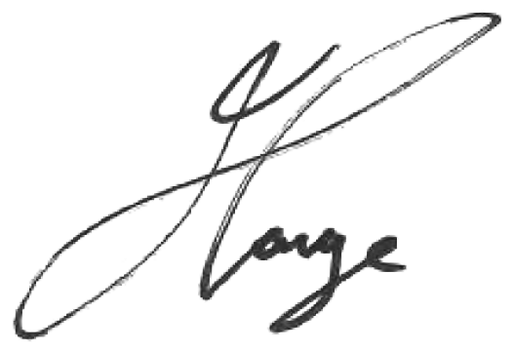If you have any queries please feel free to contact OIA. Yours sincerely

Jason Lange Executive Director
Office of Impact Analysis 2 February 2023

