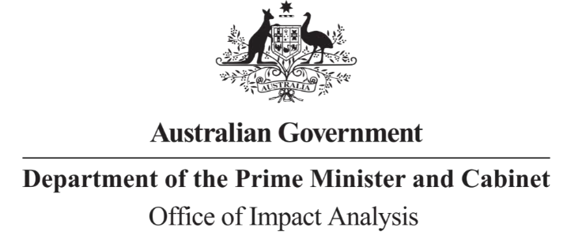

Mr Hamish Hansford Group Manager

Head – Cyber and Infrastructure Security Centre Department of Home Affairs

Dear Mr Hansford

Reference: OBPR22-02914 Telephone: 6271 6270

e-mail: [helpdesk-oia@pmc.gov.au](mailto:helpdesk-oia@pmc.gov.au)

# Impact Analysis – Second Pass Final Assessment – A risk management program framework for critical infrastructure assets

Thank you for your letter submitting an Impact Analysis (IA) for formal Second Pass Final Assessment. I note the IA has been formally certified at the Group Manager level consistent with the *Australian Government Guide to Regulatory Impact Analysis*.

I appreciate the Department’s constructive engagement on the IA. The Office of Impact Analysis’ (OIA’s) assessment is that the quality of the impact analysis in the IA is Good Practice. The IA contains exceptionally high quality analysis for each of the seven IA questions and follows an appropriate policy development process commensurate with the significance of the problem and magnitude of the proposed intervention. I acknowledge the considerable consultation undertaken, and that the proposed methodology and costing template was validated with industry.

An exemplary rating would have been achieved had an Early Assessment IA been undertaken and had the IA been assessed by the OIA and provided to decision makers prior to each major decision point.

The IA may now be provided to the decision-maker to inform a final decision.

# Next steps

Given the possible widespread impacts these measures may have on the Australian economy, a post-implementation review will need to be completed within five years following implementation.

After a final decision has been announced, I ask that your agency work with OIA to finalise this material for public release. This includes providing a copy of the IA in Word and PDF format for web accessibility purposes. The IA must be included in any Explanatory Memorandum or Statement giving effect to the proposals in the IA.

If you have any further queries, please do not hesitate to contact me. Yours sincerely



Jason Lange Executive Director

Office of Impact Analysis 1 December 2022