Reforms to Strengthening Aged Care Approved Provider Governance

**Supplementary Regulatory Impact Analysis**

**November 2022**

# Purpose of this document

This Supplementary Regulatory Impact Analysis has been prepared by the Department of Health and Aged Care (the Department) to inform Australian Government decision-making on subordinate legislative reforms to strengthen aged care approved provider governance.

This supplementary analysis complements the certification by the Department that independent reviews undertook a process and analysis equivalent to a Regulatory Impact Statement (RIS) for certain aged care quality measures (included the Strengthening Aged Care Approved Provider Governance reforms) contained in the [*Aged Care and Other Legislation Amendment (Royal Commission Response) Act 2022* (the Act).](https://www.legislation.gov.au/Details/C2022A00034) The Office of Best Practice Regulation (OPBR) found the scope of the certified review covered the policy proposals except for implementation and evaluation of measures **(refer Attachment A**).

As subordinate legislation is now being prepared to support the Act’s provider governance reforms, a supplementary RIS analysis is required for the implementation and evaluation of this measure. The implementation and evaluation measures address RIS *Question 7 - How Will You Implement and Evaluate Your Chosen Option?*

# Background

On 2 August 2022, the Government passed the Act which contains nine measures in response to recommendations of the Aged Care Quality and Safety (Royal Commission).

Schedule 5 of the Act amends the *Aged Care Act 1997* and the *Aged Car*e *Quality and Safety Commission Act 2018* to improve the governance of approved providers of Commonwealth-funded aged care. From 1 December 2022, new governance responsibilities will commence for approved providers in relation to the membership of their governing bodies and the establishment of new advisory bodies, as well as measures to improve leadership and culture. Schedule 5 also introduces new reporting responsibilities for approved providers, which will help care recipients and their families to understand the operations of providers.

These measures are aimed at improving transparency and accountability and ensuring the focus of approved providers, from the top down, is on the best interests of care recipients.

Schedule 5 of the Act aligns with Recommendations 88 to 90 of the Royal Commission, which noted the importance of good provider governance arrangements to the provision of high-quality care for care recipients.

The Act allows for extra details about how these governance arrangements are to be implemented. These legislative rules will be set out in subordinate legislation.

## The importance of provider governance

The governing body (for example, a Board) of a provider is responsible for the safe and quality care and services delivered to care recipients.

The governing body sets the strategic priorities for the provider’s organisation. It plays a critical role in setting the provider’s culture and whether this is focused on safety, quality and the best interests of care recipients.

The Royal Commission noted the need for aged care providers to have strong governance arrangements. Provider governance and management impacts all aspects of aged care.

The Royal Commission recommended introducing new legislation by 1 January 2022 to strengthen provider governance. The Act will place new requirements on providers from 1 December 2022 in relation to:

* the membership of governing bodies
* the provider’s constitution
* advisory bodies
* staff qualifications, skills and experience
* the suitability of key personnel in the provider’s organisation
* giving annual information to the Secretary of the Department.

### Membership of governing bodies

The reforms in the Act will introduce new responsibilities for the membership of governing bodies that will mean certain approved providers must have:

* a majority of the members on their governing body be independent non-executive members
* at least one member on their governing body who has clinical care experience.

These responsibilities will not apply to approved providers, if:

* the governing body has fewer than five members; and
* the approved provider provides care to fewer than 40 care recipients across their services; and
* the approved provider is a kind of body that is known as an Aboriginal Community Controlled Organisation.

This responsibility also does not apply to approved providers that are a State or Territory, a State or Territory authority, or a local government authority.

Under the arrangements in the Act, an approved provider may apply to the Aged Care Quality and Safety Commissioner (Commissioner) for a determination that either or both of the above responsibilities do not apply for a period of time.

When deciding that these responsibilities do not apply, the Commissioner may consider several matters such as:

* the number of care recipients,
* the location of the provider’s services, and
* any arrangements the provider has made to support members of the governing body in their decision making (such as seeking advice from a person with clinical care experience).

**Start date:** 1 December 2022. However, providers who are approved before 1 December2022, will have until 1 December 2023 to meet these new responsibilities.

### Provider’s constitution

The reforms in the Act will mean certain organisations need to ensure their constitution does not allow a director to act other than in the best interests of the approved provider. This responsibility will apply to certain approved providers who are:

* incorporated or taken to be incorporated under the *Corporations Act 2001*; or
* an Aboriginal and Torres Strait Islander corporation within the meaning of the *Corporations (Aboriginal and Torres Strait Islander) Act 2006*.

**Start date:** 1 December 2022. However, providers who are approved before 1 December2022, will have until 1 December 2023 to meet these new responsibilities.

### Advisory bodies

#### Quality care advisory body

The reforms in the Act will mean approved providers have to create, and maintain, a quality care advisory body. This body is to help keep the governing body informed about the quality of care delivered by the provider’s service/s.

The reforms will mean the quality care advisory body has to give the provider’s governing body a written report on the quality of the aged care provided for each aged care service at least once every six months. The quality care advisory body can also give feedback to the provider’s governing body about the quality of care of a service.

Under the reforms, the governing body will have to consider the report and any other feedback from the quality care advisory body when making decisions about the quality of care and tell the quality care advisory body in writing of how the feedback was considered.

#### Consumer advisory body

The reforms in the Act will mean that, at least once every 12 months, approved providers have to offer care recipients and their representatives the opportunity to create a consumer advisory body. Its purpose is to give the provider’s governing body feedback about the quality of care delivered at a provider’s service/s.

If the consumer advisory body is created, the governing body must consider its feedback when making decisions about the quality of care and tell the consumer advisory body in writing of how the feedback was considered.

**Start date:** 1 December 2022. However, providers who are approved before 1 December 2022, will have until 1 December 2023 to meet these new responsibilities.

### Staff qualifications, skills and experience

The new legislation will mean the governing body must ensure the approved provider’s staff members:

* have appropriate qualifications, skills or experience to provide the care or other services to care recipients through an aged care service; and
* have opportunities to develop their capability to provide that care or those other services.

**Start date:**1 December 2022. However, providers who are approved prior to 1 December2022, will have until 1 December 2023 to meet these new responsibilities.

### Suitability of key personnel

Under current aged care legislation, the key personnel of an approved provider include:

* people responsible for the nursing services who hold a recognised qualification in nursing, and
* any person who is responsible for the day-to-day operations of an aged care service.

For providers who are not a State or Territory it also includes:

* a member of the group responsible for executive decisions, and
* a person who has authority/responsibility for, or significant influence over, the planning, direction or control of the provider’s activities.

The reforms in the Act will mean that, at least once every 12 months, approved providers must consider the suitability of their key personnel and be satisfied that their key personnel are suitable to be involved in providing aged care. Providers must keep a record of this.

Key personnel must tell the provider of changes in their circumstances that may affect their suitability to provide aged care.

In addition, approved providers must tell the Aged Care Quality and Safety Commission (Commission) of any changes to key personnel within 14 days of the change. This includes a change of circumstances that is about the suitability of their key personnel involved in providing aged care.

The Commission will have the power to ask the approved provider for information relevant to the suitability of key personnel at any time.

The Commissioner may decide that an individual who is a key personnel of an approved provider is not suitable to provide aged care and that a provider must take action to stop the individual being one of their key personnel.

**Start date**: 1 December 2022 for all approved providers.

### Responsibility to give information and statements to the Secretary

The reforms in the Act mean approved providers will need to give the Secretary of the Department specified information and statements in relation to an annual reporting period. This information is intended to be published on My Aged Care to help care recipients and their families to better understand the provider’s operations.

**Proposed start date:** Approved providers will need to submit information for the 2022-23 financial year to the Department by 31 October 2023.

## Further issues to be addressed by subordinate legislation

Rules are also being prepared to support the application of the above requirements. These rules, to be contained in subordinate legislation, are to address the following issues:

* Membership of the quality care advisory body
* Quality care advisory body reports to the governing body
* Responsibilities relating to the giving of information relating to reporting periods
* Records to be kept by approved providers, including records about the suitability matters considered by an approved provider.

#### Membership of the quality care advisory body

The subordinate legislation will set out the membership requirements of the quality care advisory body. It is proposed that the legislation set out minimum requirements that apply to all approved providers and would allow providers to include extra members on their quality care advisory body if they wished.

#### Quality care advisory body’s report to the governing body

The subordinate legislation will set out the matters that the quality care advisory body report must consider as part of its written report given to the governing body of an approved provider about the quality of aged care that the approved provider provides through an aged care service The report is to include any concerns that the quality care advisory body has about the quality of aged care provided by the approved provider. concerns about care .

***Responsibility to give information and statements to the Secretary***

The subordinate legislation will set out the information the provider must give to the Secretary in relation to reporting periods . An information and communication technology (ICT) capability is to be developed to reduce duplication of reporting for providers where information has already been collected by the Department.

#### Proposed records to be kept by approved providers:

The subordinate legislation will set out the records a provider will need to keep as evidence they comply with the above proposed governance obligations. It is proposed that approved aged care providers be required to keep records regarding:

* Membership of the governing body
* Quality care advisory body
* Consumer advisory body
* Governing body responsibility for staff members
* Suitability of key personnel

Public consultation on subordinate legislation

Public consultation on the proposed subordinate legislation changes occurred during the period 21 December 2021 and 18 January 2022. Information on the public consultation is available at: <https://consultations.health.gov.au/aged-care-reform-compliance-division/strengthening-aged-care-provider-governance-consul/>

The Department undertook targeted consultation on provider governance initiatives with aged care stakeholder and consumer reference groups during the period of December 2021 to September 2022.

The Department published the draft subordinate legislation and the accompanying Explanatory Statement on the Department’s website on 31 October 2022 and provided a 14-day period for comment.

# Supplementary Assessment RIS Question 7 - How Will You Implement and Evaluate Your Chosen Option?

### Implementation

The Act includes details of the timeframes for implementation of the approved provider governance reforms. In summary, the implementation timeframes for the new approved provider reforms are:

* On 1 December 2022, proposed new responsibilities regarding the suitability of key personnel will commence for all approved providers.
* Approved providers need to submit information for the 2022-23 financial year to the Secretary by 31 October 2023.
* On 1 December 2022 the following reforms commence for new approved providers; however, providers who are approved before 1 December2022, will have until 1 December 2023 to meet these new responsibilities:
  + new responsibilities for the membership of governing bodies
  + reforms regarding provider’s constitution
  + reforms regarding a quality care advisory body and consumer advisory body
  + governing body responsibilities regarding staff qualifications, skills and experience.

A key challenge for implementation of the approved provider measures includes service providers not being prepared or unable to meet the new regulatory requirements. This may arise from the need for priority to be placed on responding to COVID-19, as well as the breadth of aged care reforms arising from the Royal Commission.

To help mitigate this risk, the timeframes commencing from 1 December 2022, are staggered. As indicated above, existing providers will have grace periods on some new responsibilities to acknowledge the time it may take for governing bodies to approve changes. Implementation will also include information and training for providers to support them to make the proposed changes.

Initial information about the proposed reforms has been provided to the sector through stakeholder and consumer reference groups. Broad consultation on the subordinate legislation changes (undertaken between 21 December 2021 and 18 January 2022) has also been used to inform the sector of the proposed approved provider governance measures being considered by Parliament and seek feedback on the areas to be covered in the proposed amended subordinate legislation. Information about the provider governance reforms is available on both the Department and Commission’s websites. On 7 November 2022, the Commission hosted a webinar for providers to discuss the new provider governance requirements. A recording of the webinar and a copy of the presentation slides are available on the Commission’s website.

Following the proposed legislative amendments being made law, implementation of the new arrangements will be further supported through broadcasts to providers through Department and Commission newsletters and websites, including guidance material.

In addition, a 'Governing for Reform in Aged Care' education program, led by the Commission has been launched to help aged care providers strengthen organisational governance and leadership. The program is designed to strengthen organisational and clinical governance capability across the aged care sector to ensure that all providers are well placed to participate in and progress the urgent calls for change in the aged care sector.

The program will specifically target leaders and members of governing bodies of approved aged care, aiming for approximately 3,700 participants. This program is available to providers irrespective of their corporate status, size or location of their service(s). Enrolment in the program is free and will continue until June 2023.

The program was announced on 20 December 2021 and by a letter from the Commissioner to each approved provider. Information on the program is available on the Commission’s website: <https://www.agedcarequality.gov.au/providers/provider-governance>

While the legislation allows for non-compliance actions to be utilised when a provider breaches its provider governance responsibilities, the initial focus of implementation will be to support providers to understand and implement the new provisions.

Regarding implementation of the annual reporting on providers’ operations, an information and communication technology (ICT) capability is being developed. This capability will enable the extraction of existing information held by the department, additional information to be submitted by providers, and for the information to be made publicly available on the My Aged Care portal. Stakeholders will be consulted during the development of the ICT solution to help enhance the user experience for providers in submitting data and for those accessing the annual statements on My Aged Care.

Aged care stakeholders will be supported to implement the ICT solution by:

* involvement in user testing
* online training for approved providers
* online support tools
* a Department staff member being available to respond to sector enquires regarding the annual reporting to the Secretary and review data quality.

A key challenge to the ICT capability is the development of an elegant solution to extract data that is currently held by the Department in multiple databases to minimise the need for providers to resubmit this data. The ICT solution will be developed in close consultation with owners of each source database to respond to this challenge.

### Evaluation

The evaluation of this measure will be undertaken as part of the Department’s overall approach to measuring key outcomes of aged care reforms that address the Royal Commission recommendations and improve aged care service delivery to care recipients.

The evaluative approach will use qualitative and quantitative metrics to measure success against the objectives of the provider governance reforms in support of broader aged care reform for senior Australians. This approach will also enable identification of whether additional reforms are required to deliver sustainable quality and safety in Australia’s home and residential aged care services. The approach will feed into Ministerial reporting and public reporting.

Specific components of the approved provider governance reforms will also be monitored using a mixed methods approach, drawing on quantitative and qualitative data sources. Monitoring activities will help keep track of sector performance against the new responsibilities and help to inform any decision to modify aspects of the approved provider responsibilities.

Where practicable the evaluation will utilise existing data. Where new systems are being developed (e.g. for submission of information about the providers’ operations) technical reporting mechanisms will be incorporated to allow monitoring and notifications.

Examples of data that may be tracked include:

* formal and informal feedback and consultation with the aged care sector on the impact of the reforms
* monitoring provider compliance, including provider performance against Aged Care Quality Standard 8 - Organisational Governance and Standard 7 - Human Resources;
* timely submission of annual statements of operations and updating of key personnel data
* user experience feedback regarding use of IT tools supporting submission of annual statements of operations
* analysis of complaints data for matters relating to organisational governance
* number of applications for determinations regarding provider membership of governing bodies.

### Estimate of Regulatory Burden

The regulatory burden to business, community or individuals is quantified using the Australian Government’s Regulatory Burden Measurement Framework and is provided below.

The net effect of this regulatory change is estimated as $ 8.91 million per annum, based on estimated costs across a 10-year timeframe. This is a refinement of costs for the approved provider governance matters addressed by the subordinate legislation. The certification letter (refer Attachment A) included an *in globo* estimate of these costs.

| Regulatory burden estimate table  Average annual regulatory costs (from business as usual) | | | | |
| --- | --- | --- | --- | --- |
| Change in costs ($ million) | Business | Community organisations | Individuals | Total change in costs |
| Total, by sector | $ 2.64 | $ 6.27 | $ - | $ 8.91 |

The arrangements for approved governance reforms addressed by subordinate legislation will increase the regulatory burden on business and community organisations. However, the Royal Commission into Aged Care Quality and Safety made strong links between the criticality of sound organisational governance and the quality and safety of services and many of the changes are regular consumer-centred practice with information and procedure able to be adapted from current business practice.

No offsets were identified to offset this regulatory burden, the Department remains alert to reduce the regulatory burden for affected stakeholders.

# Attachment A

# Certification of independent reviews: response to the Royal Commission into Aged care Quality and Safety

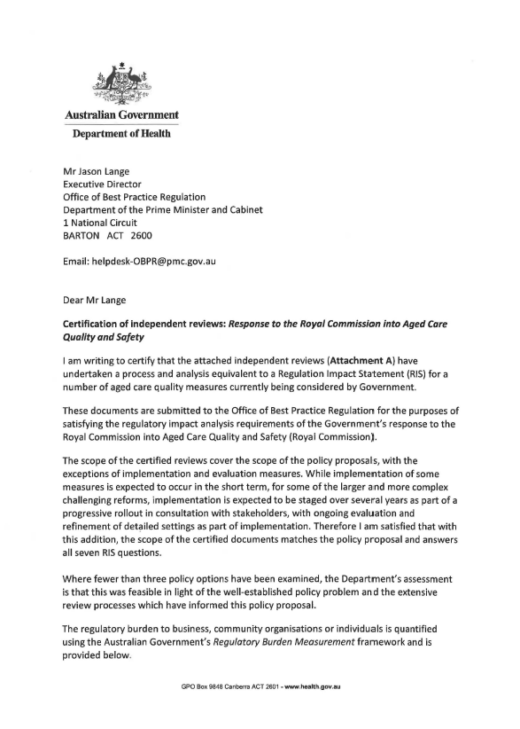

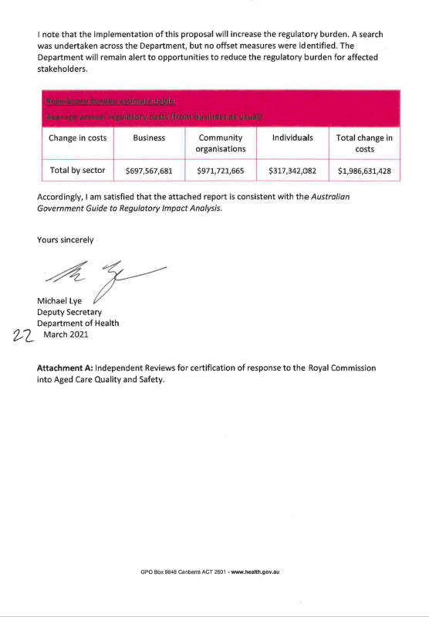

**Attachment A**

**Independent reviews for certification of response to the Royal Commission into Aged Care Quality and Safety**

1. Royal Commission into Aged Care Quality and Safety, *Final Report*, 26 February 2021

Available at: <https://agedcare.royalcommission.gov.au/publications/final-report>

1. Royal Commission into Aged Care Quality and Safety, *Counsel Assisting's Proposed Recommendations at Final Hearing*, 22 October 2020

Available at: <https://agedcare.royalcommission.gov.au/media/29098>

1. Royal Commission Aged Care Quality and Safety Hearing, *Interim Report*, 31 October 2019

Available at: <https://agedcare.royalcommission.gov.au/publications/interim-report>

1. Human Rights Watch, "*Fading Away" How Aged Care Facilities in Australia Chemically Restrain Older People with Dementia*, October 15, 2019

Available at: [https://www.hrw.org/report/2019/10/15/fading-away/how-aged-care­ facilities-australia-chemically-restrain-older-people](https://www.hrw.org/report/2019/10/15/fading-away/how-aged-care­%20facilities-australia-chemically-restrain-older-people)

1. Senate Community Affairs References Committee, *Effectiveness of the Aged Care Quality Assessment and accreditation framework for protecting residents from abuse and poor practices, and ensuring proper clinical and medical care standards are maintained and practised - Final Report* (April 2019)

Available at: [https://www.aph.gov.au/Parliamentary_Business/Committees/Senate/Community_Affa irs/AgedCareQuality](https://www.aph.gov.au/Parliamentary_Business/Committees/Senate/Community_Affa%20irs/AgedCareQuality)

1. *Review of National Aged Care Quality Regulatory Processes Report*, Carnell, K and Paterson, R, October 2017

Available at: [https://www.health.gov.au/resources/publications/review-of-national­ aged-care-quality-regulatory-processes-report](https://www.health.gov.au/resources/publications/review-of-national­%20aged-care-quality-regulatory-processes-report)

1. Australian Law Reform Commission, *Elder Abuse-A National Legal Response* {ALRC Report 131) June 2017

Available at: [https://www.alrc.gov.au/publication/elder-abuse-a-national-legal­ response-a Irc-report-131/](https://www.alrc.gov.au/publication/elder-abuse-a-national-legal­%20response-a%20Irc-report-131/)

1. *Legislated Review of Aged Care*, Final Report 2017

Available at: [https://www.health.gov.au/resources/publications/legislated-review-of­ aged-care-2017-report](https://www.health.gov.au/resources/publications/legislated-review-of­%20aged-care-2017-report)

1. Senate Community Affairs Reference Committee, *Care and management of younger and older Australians living with dementia and behavioural and psychiatric symptom of dementia - Final Report*, 2014

Available at: <https://www.aph.gov.au/Parliamentary_Business/Committees/Senate/Community_Affairs/Dementia/Report/index>

1. House of Representatives Standing Committee on Health and Ageing, *Thinking Ahead, Report on the inquiry into dementia: early diagnosis and intervention*, 2013

Available at: <https://www.health.gov.au/resources/publications/thinking-ahead-report­on-the-inquiry-into-dementia-early-diagnosis-and-intervention>

1. Department of Health, *Inquiry into Events at Earle Haven*, 2019

Available at: <https://www.health.gov.au/resources/publications/inquiry-into-events-at­earle-haven>

1. Productivity Commission, *Caring for Older Australians*, 2011

Available at:

[https://www.pc.gov.au/inquiries/completed/aged-care/report](https://www.pc.gov.au/inquiries/completed/aged-care/report )

1. Australian Skills Quality Authority, *Training for Aged and Community Care in Australia, A national strategic review of registered training organisations offering aged and community care sector training*, 2013

Available at:

<https://www.asqa.gov.au/sites/default/files/Strategic_Reviews_2013_Aged_Care_Report.pdf?v=1508135481>

1. Aged Care Strategy Taskforce, *A matter of care, Australia's aged care Workforce Strategy*, 2018

Available at:

<https://www.health.gov.au/resources/publications/a-matter-of-care-australias-aged-care-workforce-strategy>