FINAL ASSESSMENT
REGULATION IMPACT STATEMENT

Name of Department: Department of Foreign Affairs and Trade
OBPR Reference Number: OBPR22-02627
Name of Proposal: Proposed treaty action to implement the World Trade Organization (WTO) Joint Initiative on Services Domestic Regulation by modifying Australia’s General Agreement on Trade in Services (GATS) schedule.

CONTENTS

Introduction 2
RIS Question 1: What is the problem you are trying to solve? 4
RIS Question 2: Why is government action needed? 7
RIS Question 3: What policy options are you considering? 9
RIS Question 4: What is the likely net benefit of each option? 10
RIS Question 5: Who did you consult and how did you incorporate their feedback? 15
RIS Question 6: What is the best option from those you have considered? 18
RIS Question 7: How will you implement and evaluate your chosen option? 21

Introduction
- This Final Assessment Regulation Impact Statement (RIS) covers the proposed treaty action to implement the World Trade Organization (WTO) Joint Initiative on Services Domestic Regulation (“DR JSI”) by modifying Australia’s General Agreement on Trade in Services (GATS) schedule.

- The GATS is an agreement signed by all WTO Members, including Australia, that sets out the rules for international services trade. Under the GATS, each WTO Member specifies in its GATS schedule the access to its market by and treatment of foreign services providers. This locks-in market access, giving certainty to businesses, and allows improvements to access over time. Australia, which has a significant services trade sector, benefits from the open, predictable and transparent international services trade encouraged by GATS.

- In December 2017, Australia and 58 other WTO Members, launched negotiations on the DR JSI, a plurilateral agreement establishing a new set of trade rules (called ‘disciplines’) to reduce behind-the-border barriers and facilitate growth in global services trade. On 2 December 2021, the participating Members, led by Australia, the EU and Costa Rica (the Chair), adopted a Declaration announcing the successful conclusion of negotiations on the initiative. To be legally binding, participating Members’ GATS schedules must be updated to include the agreed disciplines.

- The DR JSI will establish a range of disciplines to reduce the costs and improve the transparency and predictability of services trade regulation among participating WTO members, which collectively represent over 92.5 per cent of global services trade. These disciplines include:

- requiring fees charged by authorities for authorisations to supply a service are reasonable and transparent
- ensuring that applications for authorisation to supply a service are processed without undue delay
- minimising the number of government agencies applicants must approach for an authorisation to supply a service
- ensuring that regulatory measures relating to the authorisation of a service are based on objective and transparent criteria and do not discriminate between men and women
- encouraging acceptance of electronic documentation and applications for authorisations to supply a service.

A summary of DR JSI disciplines is at Annex 1.

- On conclusion of the negotiations, Australia and the other 66 participants at the time committed to initiate the certification process to modify their respective GATS schedules to incorporate the DR JSI disciplines by 2 December 2022. Sixty-nine WTO Members are now participating in the DR JSI.

- In accordance with the Australian Government’s Guide to Regulatory Impact Analysis, the Department of Foreign Affairs and Trade (DFAT) has completed this RIS to analyse the impact of implementing the decision to modify Australia’s GATS schedule to incorporate the new disciplines contained in the DR JSI. A RIS to inform the decision to conclude negotiations on the DR JSI was prepared by DFAT and accepted by the Office of Best Practice Regulation (OBPR) in 2020 (RIS#25730).

- As this RIS sets out, there are significant benefits for Australia in implementing the DR JSI. These include greater regulatory transparency and certainty, with Australian services exporters potentially achieving regulatory compliance cost savings of up to USD1.87 billion annually. Implementing the DR JSI will also provide more opportunities for Australian service exporters and support the international rules-based trading system which underpins Australia’s prosperity.

RIS Question 1: What is the problem you are trying to solve?
- Australian services exporters face higher costs and uncertainty in overseas markets due to different regulatory environments which can be opaque, slow, costly, and subject to arbitrary decision-making. Services exporters are disproportionately affected by regulatory compliance costs compared with goods exporters.

- The services sector has been particularly affected by the COVID-19 pandemic and associated restrictions on travel and personal contact. Higher compliance costs and risks can act as a significant barrier to entering into new export markets and limit diversification options for services exporters, which in turn limit the capacity for the sector to recover from the COVID-19 induced slump.

- Multilateral trade reform, through the WTO, is the most effective way of creating and enforcing open and transparent rules which underpin Australia’s service trade. But the WTO has not been able to agree to new rules to facilitate services trade in over 25years.
Lowering trade costs & removing unnecessary barriers for Australian services exporters
- The WTO has found that costs in trade in services are almost double those in trade in goods. The impost on service exporters in navigating complex and opaque regulatory regimes or poor governance arrangements is a significant contributing factor to these costs. Unlike goods trade, it is often necessary for a services supplier to set up a commercial presence in the host economy (as a foreign affiliate) to provide the service, requiring a range of regulatory costs, authorisations and approvals. Small and medium-sized enterprises are disproportionately affected by these fixed costs because they have less capacity to address or absorb them.

- Figure 1 highlights that trade policy and regulatory differences, and governance quality account for a significant percentage of services trade costs.

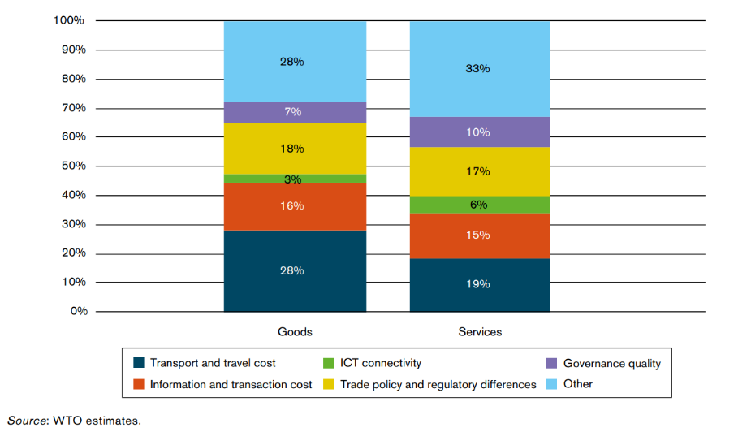
Figure 1: Contributing factors to goods and services trade costs - 2016
- Specific data on the regulatory compliance costs faced by Australian services exporters is not available. However, Australian services exporters which deliver the services directly into overseas markets, particularly those delivering services via foreign affiliates, are more likely to be affected than those delivering services to foreign consumers in Australia (such as tourism and education services supplied to foreign customers in Australia). In 2018-19, 81 per cent of Australia’s financial services exports, worth $20.7 billion; over 99 per cent of health services exports, worth $6.4 billion; and over 90 per cent of mining service, worth $3.2 billion, were delivered by foreign affiliates.

- Figure 2 shows the share of service sales by Australia’s foreign affiliates, broken down by sector.
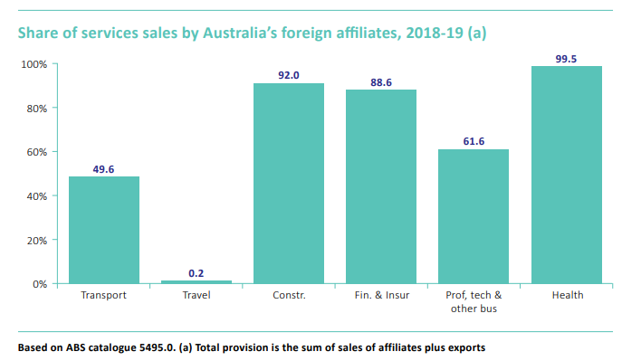
Figure 2: Share of services sales by Australia’s foreign affiliates

- The new disciplines in the DR JSI will remove unnecessary barriers and provide significant trade cost savings for services businesses. Joint WTO and Organisation for Economic Co-operation and Development (OECD) analysis indicates that full implementation of the new rules in the DR JSI could reduce global services trade costs by up to USD150 billion annually. The implications of these savings for Australia will be set out in RIS Question 4.
Australian services trade recovery
- Services trade is a key component of Australia’s economy. In 2018-19 services made up 20.7 per cent of Australia's total exports on a balance of payments assessment. Services are also embedded in all of Australia’s export sectors with Australia’s domestic services industries accounting for over 45 per cent of the value of all exports.
- Like many sectors, services trade fell sharply during the COVID-19 pandemic. In 2019, the value of Australia’s total services exports reached $102 billion - the highest measured by the Australian Bureau of Statistics. In 2020, services exports declined by 29 per cent to just under $72 billion.

- Figure 3 highlights the upward trend in Australia’s services exports (using month-on-month data) before a sharp decline at the beginning of the pandemic.
Figure 3: Australia’s services exports ($billion) seasonally adjusted- April 2022
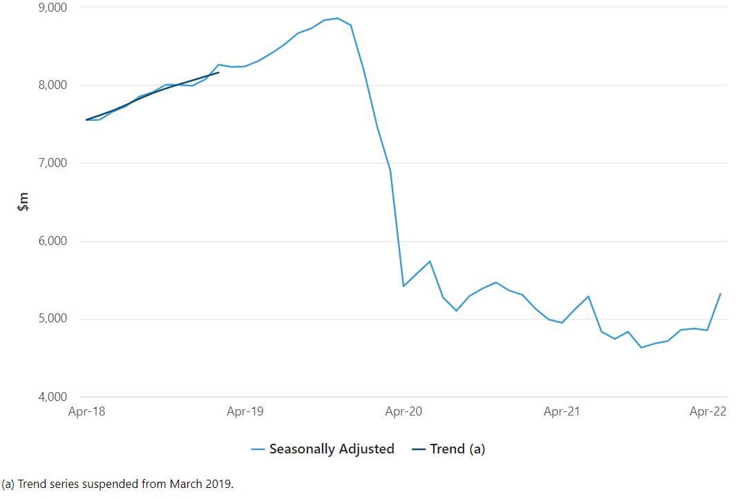

Support for the WTO
- As an open, medium-sized and trade-based economy, a strong and effective WTO is essential for Australia’s national interest and future prosperity. WTO rules provide certainty and predictability for business, underpinning all free trade agreements and 98 per cent of world trade.

- The WTO faces significant challenges. Multilateral rule-making and reform have largely stalled, leading some critics to argue that the organisation is unable to address current trade challenges in the modern geo-political landscape.

- Against this backdrop, services trade rules in the WTO require a refresh. The DR JSI is the first new set of services trade rules agreed at the WTO in over a quarter of a century. Once implemented, the DR JSI will demonstrate the ability of the WTO’s
rule-making function to deliver tangible results for businesses and consumers. In doing so, the DR JSI will form another important piece in WTO architecture, further reinforcing the rules-based international trading system.

RIS Question 2: Why is government action needed?

- The Australian Government has the constitutional authority to conclude treaties and other international agreements, which it exercises in the national interest. Government action is therefore needed to implement a binding agreement with other governments to adhere to the new regulatory best practice disciplines in the DR JSI to reduce regulatory compliance costs in overseas markets for Australian services exporters.

- Specifically, government action is needed to implement reciprocal binding of the
DR JSI commitments for Australia, in accordance with the Government’s decision in December 2020 to conclude negotiations on the DR JSI (RIS#25730 refers).

Services trade rules reform and the scope of the DR JSI disciplines
- Services trade rules require a refresh to reduce costs and provide greater transparency and certainty for service providers. Services trade between countries is regulated by the WTO GATS. The GATS establishes a legally binding set of rules covering international trade in services applying to all WTO Members. The GATS entered into force in January 1995, and, since that time, efforts to conclude new multilaterally agreed services trade rules in the WTO have been unsuccessful.

- Against this backdrop, in 2016, the Government agreed to pursue new plurilateral negotiating initiatives in the WTO to update the trade rulebook for the 21st century in line with Australia’s interests. The DR JSI was one of these initiatives. Australia has played a leading role in the DR JSI negotiations and, along with our partners in the WTO, was successful in securing an outcome which will advance Australia’s interests.

- To implement the DR JSI, Australia and the other participating Members must now modify their GATS schedules to incorporate the new commitments in the initiative. These new commitments apply to regulatory measures relating to licensing requirements and procedures, qualification requirements and procedures, and technical standards affecting trade in services. The full set of commitments are set out in Annex 2: Reference Paper on Services Domestic Regulation (“Reference Paper”), which must be inscribed into a Member’s GATS schedule to have legal effect.

- Implementing the DR JSI by amending Australia’s GATS schedule is considered a treaty action, for which government action is required. The proposed treaty action must be tabled in Parliament. The Joint Standing Committee on Treaties (JSCOT) considers tabled treaty actions and conducts an inquiry into whether the proposed treaty action is in Australia’s national interest. The final decision as to whether an agreement should be signed, and binding treaty action taken is made by the Executive Council.

Australian implementation of the DR JSI is needed to signal our support for the initiative, and for WTO rule-making

- Even though Australia already complies with the DR JSI rules, implementing the initiative through making international commitments has an important signalling effect. It will demonstrate our support for the international rule-making system; provide ballast to the initiative, encouraging other Members to join; and signal to business our support for effective regulation of services trade.

- Australia was a lead proponent of the DR JSI and is actively supporting increased participation by additional WTO Members. Completing our domestic implementation process within the timeframe committed will send an important signal to our trading partners of our continuing support for this initiative. It would also signal our continued support for WTO rule-making more broadly, providing another significant boost to confidence in the rules-based international trading system.

- Implementing the DR JSI promptly will also signal to business Australia’s continuing support for effective regulation of services trade, and underline Australia’s attractiveness as a destination for investment. The Reference Paper recognises the considerable amount of time and resources business must put into administrative compliance, which could otherwise be put into business development and expansion. It commits participating Members to more efficient and transparent regulatory measures relating to licensing requirements and procedures, qualification requirements and procedures, and technical standards affecting trade in services.

RIS Question 3: What policy options are you considering?
- This RIS considers two policy options: to implement or not to implement the DR JSI.

- Implementing the DR JSI, by modifying Australia’s WTO GATS schedule alongside the 68 other participating WTO Members, will improve the business environment, and reduce costs and uncertainty for Australian services exporters. This will provide critical support to the sector, which represents a significant proportion of Australian exports, to recover from the sharp decline resulting from the COVID-19 pandemic. It will also signal Australia’s support for rule-making through the WTO and reinforce the WTO’s role at the centre of the rules-based international trading system.

- Not implementing the DR JSI will undermine international efforts to reduce costs and uncertainty in international services trade. It will damage Australia’s international reputation and send the wrong signal to business about Australia’s commitment to a transparent and predictable regulatory environment and the rules-based international trading system.

- The costs and benefits of each option are set out below under RIS Question 4. A summary of these is in Table 2 on page 20.

RIS Question 4: What is the likely net benefit of each option?
Option 1: Implement the DR JSI by modifying Australia’s WTO GATS schedule

- A decision by the Government to implement the DR JSI by modifying Australia’s WTO GATS schedule would result in the agreement becoming legally binding for Australia. This would fulfil Australia’s commitment to the other DR JSI Members to implement the initiative by 2 December 2022 and support the domestic implementation of the DR JSI disciplines by those Members. The full benefits will be realised when all participating Members complete their domestic implementation.

Trade cost savings for Australian services exporters

- In November 2021, OECD-WTO analysis assessed that full implementation of the DR JSI would provide global services trade cost savings of up to USD150 billion annually. Based on this analysis, DFAT estimates Australian services exporters could potentially achieve regulatory compliance cost savings of up to USD1.87 billion annually.

- OECD analysis estimated that full implementation of the DR JSI disciplines would lead to a reduction of services trade costs for Australian services exporters of up to: 12.1 per cent with Brazil; 9.9 per cent with China; and 6 per cent with the United States. An Australian Services Roundtable (ASR) and Asia Pacific Services Coalition (APSCo) joint paper noted that implementation of the DR JSI would result in a 7 per cent cut in trade costs across all sectors in the APEC region with an additional 2-3 per cent reduction for small-to-medium-size enterprises.

- Figure 4 highlights the trade cost savings to the financial, business, communications, and transport services sectors between DR JSI participants, and with non-participants.

Figure 4: Annual trade cost savings in five broad services sectors, billion USD
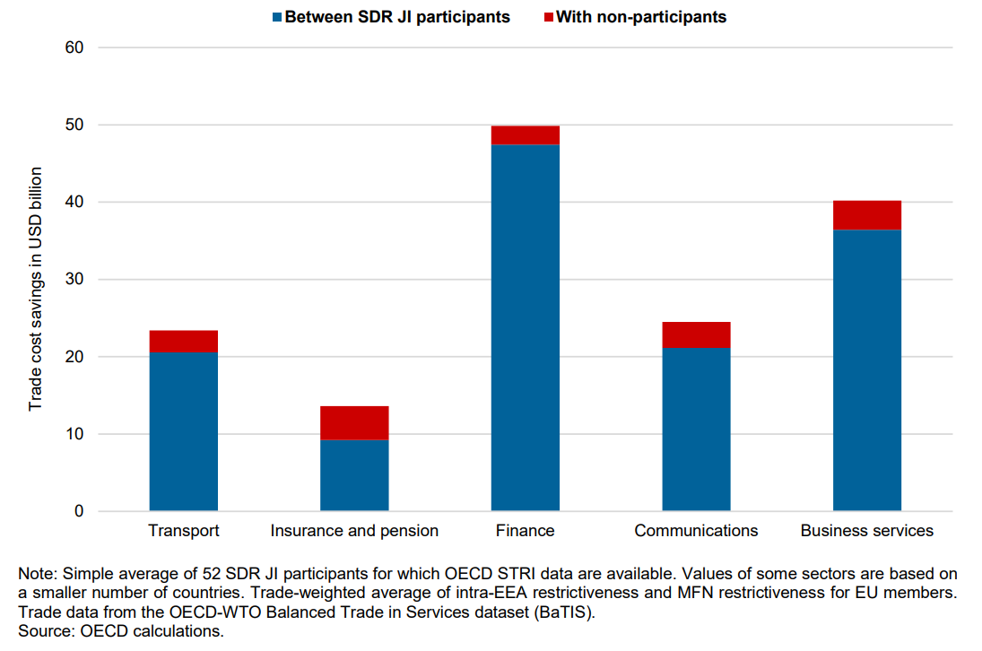

- The OECD Services Trade Restrictiveness Index (STRI) is a database measuring services trade restrictive policy measures across economies. Figure 5 demonstrates that impediments to services trade amongst DR JSI members could be lowered by an average of 11 per cent across all sectors for which STRI data is available.

Figure 5: Average percentage decrease in STRI values resulting from removal
of existing impediments (per implementation of the DR JSI disciplines)
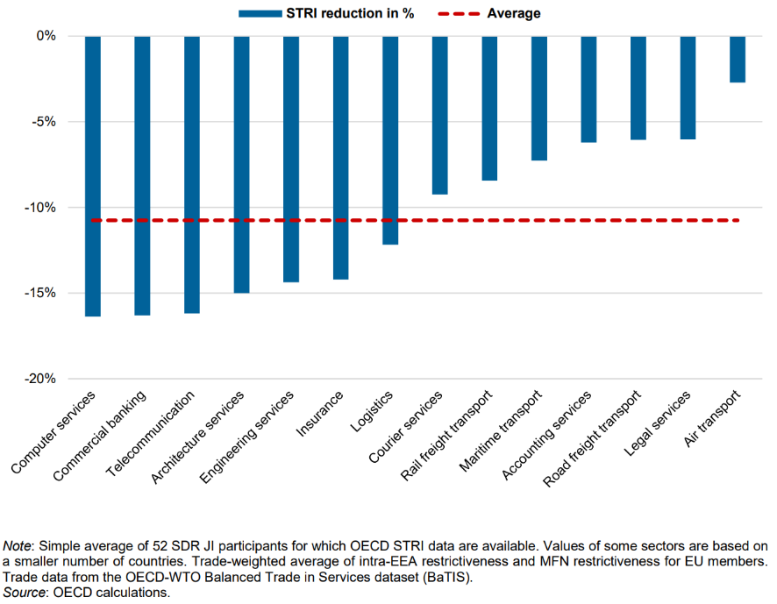

Support Australian services trade recovery and help services exporters take advantage of the projected growth in global trade in services

- As highlighted in RIS Question 1, Australian services exports declined by
29 per cent immediately following the COVID-19 pandemic. Implementing the
DR JSI will support Australian services trade recovery by cutting red tape and reducing complex and costly regulatory burdens in overseas markets. As noted in Annex 1, DR JSI disciplines include:
- requiring fees charged by authorities for authorisations to supply a service are reasonable and transparent
- ensuring that applications for authorisation to supply a service are processed without undue delay
- ensuring that regulatory measures relating to the authorisation of a service are based on objective and transparent criteria and made impartially
- minimising the number of government agencies applicants must approach for an authorisation to supply a service
- ensuring access to any required examinations for services authorisations are scheduled at reasonably frequent intervals, and, where practicable, examinations are accepted/conducted electronically
- encouraging acceptance of electronic documentation and applications for authorisations to supply a service.
- Implementing the DR JSI will play an important role in Australia’s taking advantage of the projected accelerated growth in trade in services, particularly with developing countries and emerging markets. In 2019, the WTO found that trade in services was growing faster (by an average of 5.4 per cent) than trade in goods and that the share of the services sector in global trade could increase by 50 per cent by 2040.

- Developing countries’ share of global services is also growing - reaching 25 per cent of global services exports and 34.4 per cent of services imports in 2017. As noted above, ASR APSCo paper suggests that implementation of the DR JSI would result in a 7 per cent cut in trade costs across all sectors in the APEC region.

- Clear and transparent global trade rules will provide an important foundation for Australian exporters to maximise their access to new and emerging markets. By supporting the widespread implementation of the DR JSI by WTO Members, particularly developing countries, Australia will help contribute to a more open and transparent global services market and foster new opportunities for Australian businesses.
Improving the global business environment for Australian services exporters

- Well-designed regulatory policies and domestic regulation play a crucial role in the global services market. Australia has a well-earned international reputation for transparent and predictable regulatory settings. Foreign service suppliers benefit from these settings when doing business in Australia. Australian services providers are accustomed to transparent and predictable regulatory settings and are not always well-prepared to do business in overseas markets which do not offer the same level of regulatory transparency and predictability.

- Implementing the DR JSI will improve the global business environment by creating a more enabling environment with greater regulatory transparency and certainty for service providers in participating Members, which comprise over 92.5 per cent of global services trade and 13 of Australia’s top 20 services export markets.

- These benefits were recognised by business groups from around the world, including the ASR, APSCo, the Coalition of Services Industries and the European Services Forum, which all welcomed conclusion of the DR JSI in December 2021.

Supporting the WTO and the rules-based international trading system

- Australia’s interests are well served by an open, stable trading system, with an effective WTO at its centre. The WTO provides a predictable framework for 98 per cent of world trade. It has delivered a progressively more open trade and investment environment for Australia’s exporters, producers, consumers and investors. However, with 164 members, many with divergent interests and levels of development, reaching consensus in the WTO has become increasingly difficult.

- In this challenging environment, the Government agreed to undertake new negotiating initiatives to pursue Australia’s policy and commercial interests. This included pursuing negotiations with groups of likeminded WTO Members on a ‘plurilateral’ basis. At the 11th WTO Ministerial Conference in Buenos Aires in 2017, Ministers launched negotiations on a number of ‘plurilateral’ initiatives, including the DR JSI. Australia has since played a leading role in DR JSI negotiations.

- Australia’s swift progress to conclude our treaty-making procedures and submit our GATS schedule for certification would reinforce our reputation as a reliable leader of the DR JSI. By giving legal effect to the DR JSI and incorporating the agreement into the WTO architecture, Australia would also encourage other WTO Members to join the initiative.

- Supporting the implementation of the DR JSI across the membership would demonstrate our leadership role in the WTO more broadly and our ongoing commitment to international rule-making during a time of significant challenges. As set out in Question 1, the implementation of the DR JSI will contribute to a strong and effective WTO, which is essential to Australia’s interests as a medium-sized economy.

Negligible costs of implementing DR JSI

- Implementing the DR JSI would have negligible costs for Australia. Other than the existing DFAT resources required to complete the treaty-making procedures, there will be no additional cost to implement the DR JSI. This is because there is no requirement to amend or enact legislation because Australia’s existing regulatory practices are consistent with the obligations in the text.

- As the DR JSI disciplines aim to reduce regulatory compliance costs, complexity, timeframes and uncertainty, we do not anticipate any additional compliance costs for business. Rather there would be an overall reduction in these costs for Australian services exporters of up to USD1.87 billion annually.

Option 2: Do not implement the DR JSI and breach Australia’s commitment to its trading partners
- There would be no benefit to Australia from a decision by Government to leave Australia’s GATS schedule unamended and not implement the DR JSI. This decision would also result in several negative consequences. While this option would allow for reprioritising of resources to focus on other Government objectives, it would come at significant cost, and ultimately result in a lost opportunity to reduce regulatory compliance costs and uncertainty for Australian service exporters.

Damage to Australia’s reputation in the WTO and loss of influence in rule-making

- The DR JSI membership represents 13 of Australia’s top 20 services export markets including China, the United States, the United Kingdom, the European Union, and Singapore. Australia has made a mutual reciprocal commitment to implement the DR JSI disciplines to these trading partners. If these Members implement the DR JSI while Australia, as one of the leaders of the initiative does not, we would suffer significant reputational damage in the WTO and with major trading partners. Given our public messaging and advocacy on the importance of the DR JSI to date, Australia would also lose credibility and significant influence in this area of rule-making in the future.

Damage to the WTO and the international rules-based trading system

- Australia has a long-standing reputation as a strong supporter of an open global economy and the rules-based international trading system. Numerous components of the global economy rely on the certainty and predictability inherent in a system based on rules. As trade continues to play a vital role in Australia’s continued economic success, a rules-based system centred on the WTO is fundamental to our interests.

- The DR JSI, the first new set of services trade rules in over a quarter of a century, will form an important piece in the rules-based trading system. For each Member who does not implement the DR JSI, the overall outcome for the rules-based system is weakened. A decision by Australia not to implement the DR JSI would contribute to this damage and could be interpreted as a decline in our long-standing support for this system, which we continue to rely on.

Sending the wrong signal to business and potential new DR JSI members

- As set out in RIS Question 5, the business community has supported the DR JSI throughout the negotiating process. Service industry groups such as the ASR and APSCo also directly supported DFAT’s advocacy to conclude negotiations on the DR JSI, as well as efforts to bring more WTO Members on board the initiative. A decision not to implement the DR JSI now would damage Australia’s credibility with business. It would send the wrong signal to Australian and international businesses about Australia’s commitment to a transparent and predictable regulatory environment and the rules-based international trading system.

- Failure to implement the DR JSI would also send a negative signal to potential new Members about the value of transparent and predictable rules to facilitate services trade in their economy. This would undermine the further expansion of DR JSI Members, limiting the benefit to Australian services exporters in those markets.

RIS Question 5: Who did you consult and how did you incorporate their feedback?

- DFAT is committed to a highly consultative approach throughout trade negotiations and recognises that stakeholder consultation is key to the development of negotiating positions that help achieve outcomes that reflect Australia’s interests. DFAT has undertaken stakeholder consultation on the DR JSI since 2017. This includes engagement with State and Territory government agencies as well as industry, professional and international bodies.

- Stakeholder views fed directly into Australia’s negotiation strategy for the DR JSI. This stakeholder feedback was ultimately reflected in the negotiated outcome both in terms of removing potentially adverse proposals and modifying proposals to ensure Australia’s interests were reflected. Further information on specific stakeholder feedback is below.

- Industry stakeholders provided positive feedback on the benefits of the DR JSI throughout negotiations. While DFAT did not receive quantitative analysis on the anticipated economic benefits to their specific sectors or businesses, industry did cite qualitative and international research in their advocacy. In a joint paper, industry groups, the ASR and APSCo welcomed the conclusion of the DR JSI, noting that “business stakeholder support for this services domestic regulation agenda is overwhelmingly strong.”

Specific feedback on the DR JSI disciplines
- Several stakeholders raised concerns around a text proposal which might reduce Australia’s flexibility to regulate in the public interest in certain circumstances. Based on this advice, Australia successfully advocated to remove this text to ensure sufficient regulatory flexibility was retained.

- Several stakeholders also provided feedback on the inclusion of the commitment not to discriminate between men and women when adopting or maintaining services trade authorisation measures (Article 22 (d) of the Reference Paper).

- Feedback on this commitment was positive. However, stakeholders raised concerns that there may be legitimate instances where it is necessary to provide differential treatment for women. For example, differential treatment may be legitimate in the development of measures relating to specific health, education and support services provided to women by non-government organisations in developing country Members. Australia ensured this commitment included sufficient flexibility to allow legitimate different treatment to address these policy issues.
- A summary of the stakeholders consulted is set out in Table 1 and paragraphs 66-68.
Table 1: stakeholders consulted on the DR JSI
Sector | Stakeholder
States and Territory Governments | Australian Capital Territory Government
 | New South Wales Government
 | Northern Territory Government
 | Queensland Government
 | South Australian Government
 | Tasmanian Government
 | Victorian Government
 | West Australian Government
Industry bodies | Asia Pacific Services Coalition
 | Australian Services Roundtable
 | Business Council of Australia
 | The Australian Industry Group
 | The Australian Chamber of Commerce and Industry
 | Universities Australia
 | Group of 8
Professional bodies | Architects Accreditation Council of Australia
 | Law Council of Australia
 | Engineers Australia
 | Chartered Accountants Australia & New Zealand
 | CPA Australia
 | Institute of Public Accountants
International organisations | APEC Business Advisory Council
 | The Business20 (B20)
 | The International Chamber of Commerce
 | Organisation for Economic Co-operation and Development
 | The World Economic Forum

- State and Territory governments were consulted on the DR JSI through the Trade and Investment Ministers Meeting, the Senior Officials Trade and Investment Officials’ Group (SOTIG) and the Commonwealth-State-Territory Standing Committee on Treaties (SCOT). DFAT also provided State and Territory officials regular email updates and opportunities to comment on the status of the negotiations.

- DFAT hosts a biannual International Trade Negotiations Update Meeting. This meeting provides an avenue to update industry and other stakeholders on the status of DFAT-led trade initiatives, including the DR JSI. Industry representatives and international organisations have also been consulted through meetings, roundtable discussions and updates, and email correspondence.

- As the scope and disciplines of the DR JSI are broadly consistent with the commitments Australia has already made in several of its trade agreements DFAT was also able to build upon a foundation of extensive consultations conducted previously.

RIS Question 6: What is the best option from those you have considered?

- The best option of those we have considered is to implement the DR JSI by modifying Australia’s WTO GATS schedule.

- DFAT took into account qualitative and quantitative evidence in considering the respective benefits and costs of option 1 – to implement the DR JSI and option 2 – not to implement the DR JSI. The available evidence demonstrated clearly that option 1 would result in significant benefits and negligible costs, even if some of those benefits were not fully quantified. The estimated benefits to Australian services exporters from reduced regulatory compliance costs alone outweigh the minimal costs that would be associated with implementing the DR JSI.

Assessment of Option 1– implement the DR JSI

Benefits of option 1

- A decision to implement the DR JSI would provide the following benefits for Australia:

- greater regulatory transparency and certainty, and trade cost savings for Australian services exporters of up to USD1.87 billion annually
- supporting Australia’s services trade recovery in the wake of the COVID-19 pandemic and helping Australian exporters take advantage of the projected growth in global services trade, particularly amongst developing countries
- improving the global business environment for Australian services exporters
- supporting the WTO and the rules-based trading system for the overall benefit of Australian businesses and consumers.

Costs of Option 1

- The costs of option 1 are negligible. There is no requirement to amend or enact legislation to implement the DR JSI because Australia’s existing regulatory practices are consistent with the obligations in the text. Australia would incorporate the DR JSI into its GATS schedule using existing DFAT resources.

Assessment of Option 2 – do not implement the DR JSI

Benefits of Option 2

- The benefits of option 2 are negligible. The only advantage would be that resources could be reprioritised to focus on other Government objectives.

Costs of Option 2

- If the Government decides not to modify Australia’s GATS schedule to incorporate the new rules in the DR JSI, there would be significant costs for Australia. These include:

- damage to Australia’s reputation in the WTO and loss of credibility and influence in trade rule-making in the future
- damage to the WTO and the rules-based international trading system in which Australia operates and relies
- negative impact on Australia’s business reputation and send the wrong signal to business, potentially harming existing arrangements and preventing new partnerships and investments
- negative impact on growing the DR JSI membership – limiting potential further benefits to Australian services exporters.

- Table 2 below sets out analysis of the respective benefits and costs of the two options considered and the method of assessment used to arrive at this judgment.

Table 2: Summary of the benefits and costs of Options 1 and 2
Benefits/Costs | Option 1 – implement the  DR JSI | Option 2 – don’t implement the DR JSI
Benefits | Greater regulatory transparency and certainty, and trade cost savings for Australian services exporters of up to USD1.87 billion annually.  Assessment method: QTA based on OECD-WTO data (see footnote 2, page 2) and QLA based on stakeholder feedback. | Negligible: reprioritisation of resources (DFAT staff time) to other Government objectives.  Assessment methodology: QLA based on DFAT analysis.
Support Australian services trade recovery following the COVID-19 pandemic and help exporters take advantage of the growth in global services trade.

Assessment method: QTA based on ABS data, and QLA based on DFAT analysis and stakeholder feedback.
Improve the global business environment for Australian services exporters.

Assessment method: QLA based on DFAT analysis and stakeholder feedback.
Support the WTO and the rules-based international trading system.

Assessment method: QLA based on DFAT analysis and stakeholder feedback.
Costs | Negligible: Existing DFAT resources would be used to implement the DR JSI.  Assessment method: QLA based on DFAT analysis and stakeholder feedback. | Damage to Australia’s international reputation and loss of influence in the WTO.  Assessment method: QLA based on DFAT analysis and stakeholder feedback.
Damage to the WTO and the rules-based international trading system.

Assessment method: QLA based on DFAT analysis and stakeholder feedback.
Negative impact on Australia’s business reputation/signalling

Assessment method: QLA based on DFAT analysis and stakeholder feedback.
Negative impact on additional DR JSI membership – limits benefit to Australian services exporters.

Assessment method: QLA based on DFAT analysis and stakeholder feedback.
*QTA: quantitative assessment
*QLA: qualitative assessment

RIS Question 7: How will you implement and evaluate your chosen option?

Implementation

- There is no requirement to amend or enact legislation to implement the DR JSI because Australia’s existing regulatory practices are consistent with the obligations in the text. However, to make the agreement binding for Australia, government action is required to amend its GATS schedule to incorporate the DR JSI disciplines.

- In accordance with Australia’s treaty-making procedures, Australia’s proposed GATS schedule modification and the Reference Paper on Services Domestic Regulation must be tabled in Parliament. JSCOT will then conduct an inquiry into the proposed treaty action and report back to Parliament on its findings.

- Following the JSCOT inquiry, and if approved by the Executive Council, Australia can submit its GATS schedule modification to the WTO Council for Trade in Services (CTS) to commence the certification process.

- Once Australia has submitted its GATS schedule modification to the CTS, all WTO Members are given 45 days to review the amendments to ensure they do not reduce the quality of Australia’s pre-existing GATS commitments. Provided no objection has been raised during this time, the WTO Secretariat will issue a communication stating the certification procedure has been concluded, indicating the date of entry into force of the modified schedule. At this time, Australia’s new GATS schedule incorporating the commitments of the DR JSI will be given legal effect.

Evaluation

- DFAT will evaluate our chosen option through industry feedback, ongoing stakeholder engagement, data evaluation and through increasing the number of participating members of the DR JSI.

- Engagement with stakeholders will continue after implementation of the DR JSI to raise awareness of the outcome and to evaluate industry feedback on the benefits of the initiative. Australia will also continue to support ongoing DR JSI evaluation and data collection methods, particularly in the WTO and OECD.

- Sixty-nine WTO Members are currently participating in the DR JSI. As one of the leaders of the initiative, Australia has an ongoing role to play in encouraging new members to join the initiative, particularly in the Indo-Pacific region. Expanding the DR JSI membership will increase the benefits for Australian exporters by extending the commitments to more markets. Expanding the membership will also serve as an important evaluation tool to monitor implementation of the disciplines in overseas markets.

WTO, Declaration on the Conclusion of Negotiations on Services Domestic Regulation, 2021.
In June 2022, Georgia and the United Arab Emirates announced that they would also join the DR JSI.
Estimate calculation based on 2019 OECD-WTO ‘Balanced Trade in Services’ dataset: Australian services exports comprise 1.2454 per cent of world services exports. A 1.2454 per cent share of the OECD-WTO projected savings of USD150 billion to global services trade is USD1.8681 billion. Actual trade cost savings to Australian services exporters could differ based on distribution of savings across sectors, jurisdictions, and between consumers and providers of the services exports.
OECD; WTO, Services Domestic Regulation in the WTO, 2021, pg.1.
World Trade Organization, World Trade Report 2019: The future of services trade, 2019, pg. 87.
Pre-COVID-19 figures are more representative of the long-term economic value and structure of Australia’s service exports due to the impact COVID-19 had on the services sector.
Department of Foreign Affairs and Trade, Australia’s Services Exports Action Plan, pg.14
Australian Bureau of Statistics, Australian Outward Foreign Affiliates Trade, 2018-19, Catalogue 5495.0.
World Trade Organization, World Trade Report 2019: The future of services trade, 2019,
Department of Foreign Affairs and Trade, Trade and Investment at a Glance, 2020.
Ibid.
Australian Bureau of Statistics, International Trade: Supplementary Information 2021
Ibid.
International Trade in Goods and Services, Australia- April 2022 release, ABS
OECD; WTO, Services Domestic Regulation in the WTO, 2021, pg.1.
See footnote 2, pg. 3.
OECD analysis requested by DFAT pursuant to OECD; WTO, Services Domestic Regulation in the WTO
Anthony Patrick et al, Back from the brink! The WTO gets on with serious business, 2021.
OECD; WTO, Services Domestic Regulation in the WTO, 2021, pg.5
OECD; WTO, Services Domestic Regulation in the WTO, 2021, pg.4
Australian Bureau of Statistics, International Trade: Supplementary Information 2021.
World Trade Organisation, World Trade Report 2019: The future of services trade, 2019, pg. 6.
Ibid, pg.4
Anthony Patrick et al, Back from the brink! The WTO gets on with serious business, 2021.
Department of Foreign Affairs, Direction of goods and services trade, August 2021, Canberra, Australia.
Productivity Commission, Trade and Assistance Review 2018-19, April 2020, Canberra, Australia.
See footnote 2, pg. 3
Anthony Patrick et al, Back from the brink! The WTO gets on with serious business, 2021.
Reference Paper on Services Domestic Regulation, Footnote 18: “differential treatment that is reasonable and objective, and aims to achieve a legitimate purpose, and adoption by Members of temporary special measures aimed at accelerating de facto equality between men and women, shall not be considered discrimination for the purposes of this provision”.
For example, the scope and disciplines of the DR JSI closely resemble the outcome reached in the Australia-United Kingdom Free Trade Agreement (A-UK FTA) signed on 17 December 2021. It also resembles the domestic regulation commitments agreed in the Comprehensive and Progressive Agreement for Trans-Pacific Partnership (CPTPP) and the Regional Comprehensive Economic Partnership (RCEP).
See footnote 2, pg. 3.

