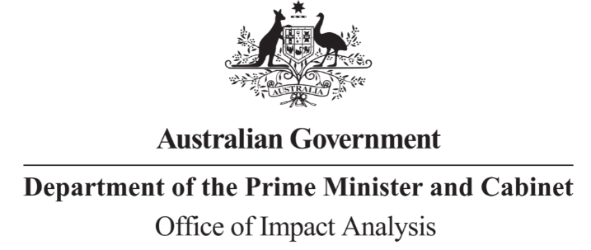

Reference: OBPR22-03689  
Telephone: 6271 6270  
e-mail: [helpdesk-oia@pmc.gov.au](mailto:helpdesk-obpr@pmc.gov.au)

Ms Sam Reinhardt and Mr Simon Duggan  
Deputy Secretary (Fiscal Group) and Deputy Secretary (Energy)   
Department of the Treasury and the Department of Climate Change, Energy, the Environment and Water  
  
Dear Ms Reinhardt and Mr Duggan

                                              
**Impact Analysis – Second Pass Final Assessment – Options to Provide Energy Price Relief**

Thank you for your letter received on 8 December 2022 submitting an Impact Analysis for formal Second Pass Final Assessment. I note the Impact Analysis has been jointly certified at the Deputy Secretary level consistent with the Australian Government Guide to Regulatory Impact Analysis.

I appreciate both Department’s constructive engagement on the Impact Analysis.

The Office of Impact Analysis’ (OIA’s) assessment is that the quality of the analysis in the Impact Analysis is adequate and therefore sufficient to inform a decision.

To be considered ‘good practice’ as per the *Australian Government Guide to Regulatory Impact Analysis*, the Impact Analysis would have benefitted from:

* A description of the role of new, complementary mechanisms in solving the specified problem.
* Additional detail on the impact modelling available at time of decision, including method, assumptions and detailed results.
* A description of the key metrics that will be used to monitor the performance of the policy against its objectives and help to manage unintended consequences. This could include tracking of the specified ‘flow on impacts’ to the electricity market (page 18), greenhouse gas emissions (page 29) and energy bills as share of household expenditure.

Given the difficulties of predicting and measuring the likely impacts of the measures in this Impact Analysis, and because the economic impacts are likely to be widespread and substantial, the OIA advises that a Post Implementation Review (PIR) is required within five years of the implementation. Having regard to the nature of the policy objectives, we suggest commencing the PIR approximately 18 months after the policy has been fully implemented. Further information is available in the *Post Implementation Review* Guidance Note on the OIA website.

The Impact Analysis may now be provided to the decision maker to inform their decision.

To support transparency, the Impact Analysis must be included in any Explanatory Memorandum or Statement giving effect to the proposals in the IA.

After a final decision has been announced, I ask that your agency work with the OIA to finalise this material for public release. This includes providing a copy of the Impact Analysis in Word and PDF format for web accessibility purposes.

If you have any further queries, please do not hesitate to contact me.

Yours sincerely

Jason Lange  
Executive Director  
8 December 2022