Mr Jason Lange Executive Director

Office of Best Practice Regulation

Department of the Prime Minister and Cabinet l National Circuit

BARTON ACT 2600

Email: [helpdesk-OBPR@pmc.gov.au](mailto:helpdesk-OBPR@pmc.gov.au)·

Dear Mr Lange

**Certification of independent review: *Respect@Work: National Inquiry into Sexual Harassment in Australian Workplaces Report 2020***

I am writing to certify that the attached Respect@Work: National Inquiry into Sexual Harassment in Australian Workplaces (the Report) has undertaken a process and analysis equivalent to a Regulation Impact Statement (RIS).

I certify that this document adequately addresses all seven RIS questions, and is submitted to the Office of Best Practice Regulation for the purposes of a final policy decision.

I am satisfied that the scope of the problem and the recommendations identified in the certified review are substantially the same as the identified problem and recommendations in the policy proposal.

**Respect@Work Report and recommendations**

In June 2018, the then Minister for Women, the Hon Kelly O'Dwyer MP, and the

Sex Discrimination Commissioner, Kate Jenkins, announced the National Inquiry into Sexual Harassment in Australian Workplaces. The National Inquiry was informed by a National Survey of more than 10,000 people conducted in 2018, as well as extensive public submissions, and group and individual consultations conducted by the Australian Human Rights Commission (AHRC). The National Inquiry was also supported by economic analysis undertaken by Deloitte Access Economics (Deloitte).

In March 2020, the AHRC released the Report which found that 33% of Australian employees have experienced sexual harassment in the workplace in the past five years (39% of women and 26% of men). While employees in some types of workplaces were more likely to experience harassment than others, the Report concluded that sexual harassment 'occurs in every industry, in every location and at every level, in Australian workplaces.'

The Report made 55 recommendations addressed to all levels of government, the private sector and the community with respect to preventing and addressing sexual harassment in Australian workplaces, and providing greater support when it does occur.

**Implementation of the Report**

The regulatory burden to business, community organisations or individuals of the Report is quantified using the Australian Government's Regulatory Burden Measurement framework and is provided below.

The Government has committed to fully implementing all recommendations of the Report. This includes introducing a positive duty on employers to prevent sex discrimination, sexual harassment, harassment on the ground of sex and victimisation in the Sex Discrimination Act 1984 (Sex Discrimination Act) with associated enforcement powers for the AHRC. A compliance cost has been identified as attaching to the positive duty.

The positive duty will apply to all employers given the broad application of the Sex Discrimination Act across the economy, and the pervasive nature of sexual harassment in all Australian workplaces. Australian employers already have responsibilities to prevent sexual harassment under existing laws: both to ensure they are not held vicariously liable for sexual harassment under the Sex Discrimination Act and to ensure the health and safety of their workers pursuant to the positive duty under Work Health and Safety laws. Consequently, the positive duty in the Sex Discrimination Act will not impose a substantially new or increased regulatory burden on employers. It is proposed that enforcement of the positive duty obligation will be scaled based on the size and circumstances of the business, as is currently the case with existing like obligations under the Sex Discrimination Act.

Nonetheless, in the short-term, small and medium businesses will incur minor start-up costs associated with understanding the legislative changes and updating their policies, which are unlikely to be formal or detailed. For larger businesses, costs will involve legal or human resources staff time to update existing internal policies and training materials to reflect legislative changes. These updates should be minimal given the existing responsibilities of Australian employers outlined above. For small and medium businesses, understanding the legislative changes will likely be based on information provided by third parties, such as industry and representative bodies. The AHRC will also make education and guidance materials available for all employers, tailored to small, medium and large businesses.

These initial costs will be offset in the longer term by the financial benefits accruing to business associated with the prevention of sexual harassment. Deloitte estimated that

sexual harassment costs the Australian economy approximately $3.8 billion in 2018, predominately through lost productivity in the private sector. Consequently, reducing the prevalence of sexual harassment in the workplace will drive increased productivity through improving employee job satisfaction and wellbeing, and decreasing staff absenteeism and turnover. It will also decrease costs associated with responding to sexual harassment complaints.

The primary purpose of introducing the positive duty into the Sex Discrimination Act is to shift the burden of addressing sexual harassment away from individuals making complaints, onto employers to take the preventative action already required under other legislative frameworks. Alleviating this burden will deliver compliance savings for individuals due to the shifting the responsibility for enforcing the law from individuals to businesses. The community will also benefit through safer and more productive workplaces, a reduction in complaints lodged with the AHRC over the long term, and reduced pressure on legal, advocacy and support services.

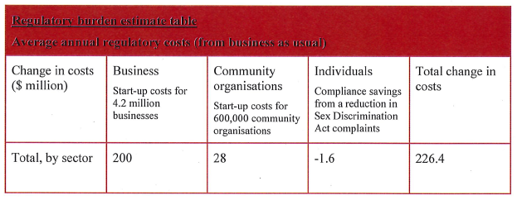

Accordingly, I am satisfied that the attached report is consistent with the Australian Government Guide to Regulatory Impact Analysis.

Yours sincerely

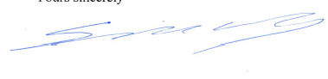

Simon Newnham

A/g Deputy Secretary

Integrity and International Group 9 August 2022