A proposed new capital framework for Private Health Insurance
December 2021
Response Paper

Response Paper

Disclaimer Text
While APRA endeavours to ensure the quality of this publication, it does not accept any responsibility for the accuracy, completeness or currency of the material included in this publication and will not be liable for any loss or damage arising out of any use of, or reliance on, this publication.
© Australian Prudential Regulation Authority (APRA)
This work is licensed under the Creative Commons Attribution 3.0 Australia Licence
(CCBY 3.0). This licence allows you to copy, distribute and adapt this work, provided you attribute the work and do not suggest that APRA endorses you or your work. To view a full copy of the terms of this licence, visit https://creativecommons.org/licenses/by/3.0/au/

Table of Contents
Executive summary 5
Feedback and APRA’s response 6
Next steps 9
Glossary 11
Chapter 1 - Introduction 12
1.1 Background 12
1.2 Integration of AASB 17 12
1.3 Consultation process 14
1.4 Balancing APRA’s mandate 15
Competition and contestability 15
1.5 Commencement and transition 18
Commencement 18
Transition 19
Chapter 2 - Applying the LAGIC principles to private health insurers 20
2.1 Structure of the PHI capital framework 21
2.1.1 Scope of the capital standards 22
2.1.2 Level of sufficiency 23
2.1.3 Defining the capital base 25
2.2 Prescribed capital and its components 28
2.2.1 Insurance Risk 31
2.2.2 Asset risk and asset concentration risk 37
2.2.3 Operational risk 38
2.2.4 Aggregation benefit 39
2.2.5 Minimum prescribed capital 40
2.3 Supervisory adjustments 40
2.4 Capital management planning in the ICAAP 41
Chapter 3 - Regulatory Reporting 43
3.1 APRA’s approach to regulatory reporting for PHI and relationship to AASB 17 43
Chapter 4 - Next steps and consultation 44
4.1 Request for submissions 44
4.2 Important disclosure requirements – publication of submissions 44
4.3 Request for cost-benefit information 45
4.4 Quantitative Impact Study (QIS) 45
Appendix A – Changes to prudential standards driven by AASB 17 and LAGIC updates 46
Appendix B - Reporting standards for consultation 49

Executive summary
Since assuming prudential regulatory responsibility for the private health insurance (PHI) industry in 2015, APRA has progressively reviewed and updated the prudential policy framework. The third and final phase of this process is the review of the PHI capital framework.
In December 2019, APRA released a discussion paper, Private Health Insurance Capital Standards Review, outlining a proposed structure for the revised PHI capital framework. Following consideration of industry submissions in response to that discussion paper, APRA has released for consultation draft prudential standards for capital adequacy and measurement for the PHI industry.
This Response to Submissions Paper sets out the rationale behind the updated proposals, additional context for the draft standards and the key design elements of the PHI framework. It should be read in conjunction with the summary Information Paper, Review of the Private Health Insurance Capital Framework.
Objectives of the framework
Capital adequacy is the foundation for financial safety and system stability, designed to ensure an insurer has sufficient financial resources available to meet its financial promises to policy holders, particularly in adverse conditions. APRA’s review of the capital framework for PHI has aimed to ensure that the prudential standards provide an appropriate level of financial resilience for the protection of policy holders.
APRA has observed that, in a number of respects, the current PHI capital standards are less robust than the life and general insurance capital framework (LAGIC framework). In particular, APRA is concerned that the current PHI capital framework does not appropriately reflect the risks faced by insurers, and does not adequately allow for consideration of adverse events that could affect their performance. APRA is also seeking to reduce the availability of discretion in the practices of insurers in determining capital requirements, to improve consistency of capital held for similar risks and comparability of performance between insurers, and limit practices which may detract from insurer financial resilience and policy holder protection.
The review of the PHI capital framework has three primary objectives:
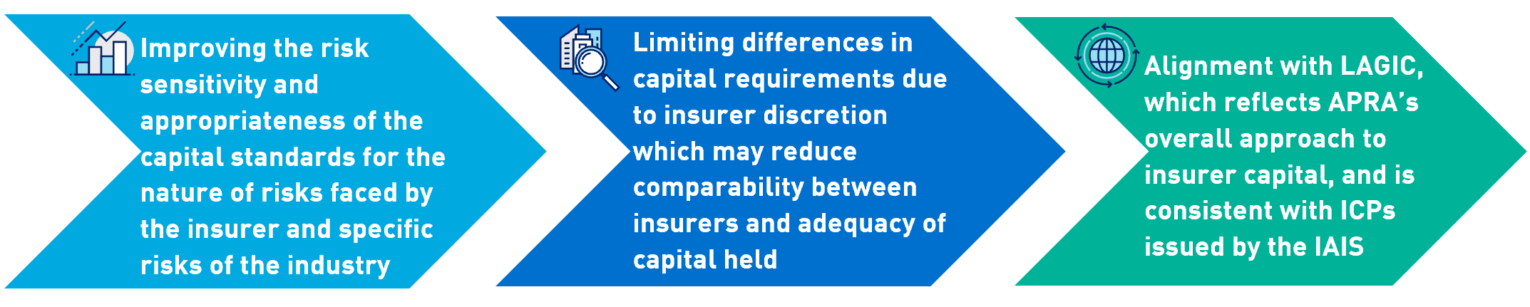
APRA’s proposed approach aims to increase the risk sensitivity of capital requirements to the activities of insurers, and improve the alignment of capital standards across prudentially-regulated insurance industries. APRA is therefore using the existing LAGIC framework as a starting basis to guide the design of the revised PHI capital standards.
Following the release of the discussion paper in 2019, APRA released a partial-Quantitative Impact Study (partial-QIS) for all insurers in March 2021, covering the Operational Risk Charge (ORC) and Insurance Risk Charge (IRC). Submissions received to both the discussion paper and partial-QIS have informed the development of APRA’s proposed prudential standards, and the calibration of capital levels. APRA seeks feedback on the draft standards by 31 March 2022.

Feedback and APRA’s response
Feedback received in response to the discussion paper and partial-QIS covered both the design and impact of the proposed PHI capital framework.

Design of the proposed PHI framework
Respondents to the 2019 discussion paper generally supported APRA’s intent to use LAGIC as a basis for developing the PHI framework, with necessary adjustments to fully reflect the specific characteristics of the industry.
As a result, APRA’s proposed structure for the PHI framework is largely unchanged from the discussion paper at a conceptual level. However, the framework has been further developed taking into account industry feedback, to ensure it appropriately reflects the risks of the PHI industry and the risks of individual insurers. The graphic below provides a high-level summary of APRA’s proposed revisions and the key areas where proposals have changed, remain unchanged, or have been further developed since the discussion paper and partial-QIS.
The structure of APRA’s proposed framework for private health insurers is outlined below.
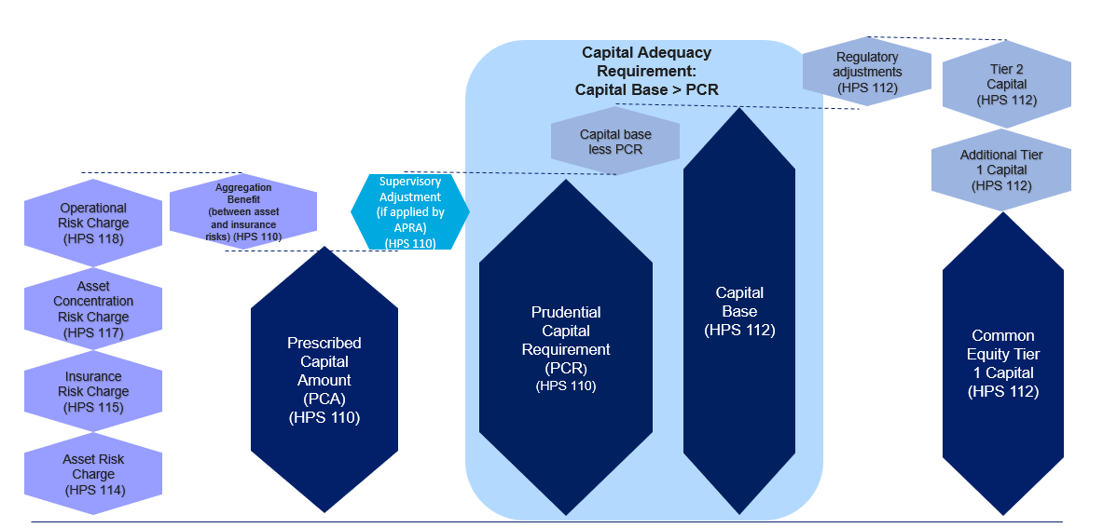

Summary of proposals
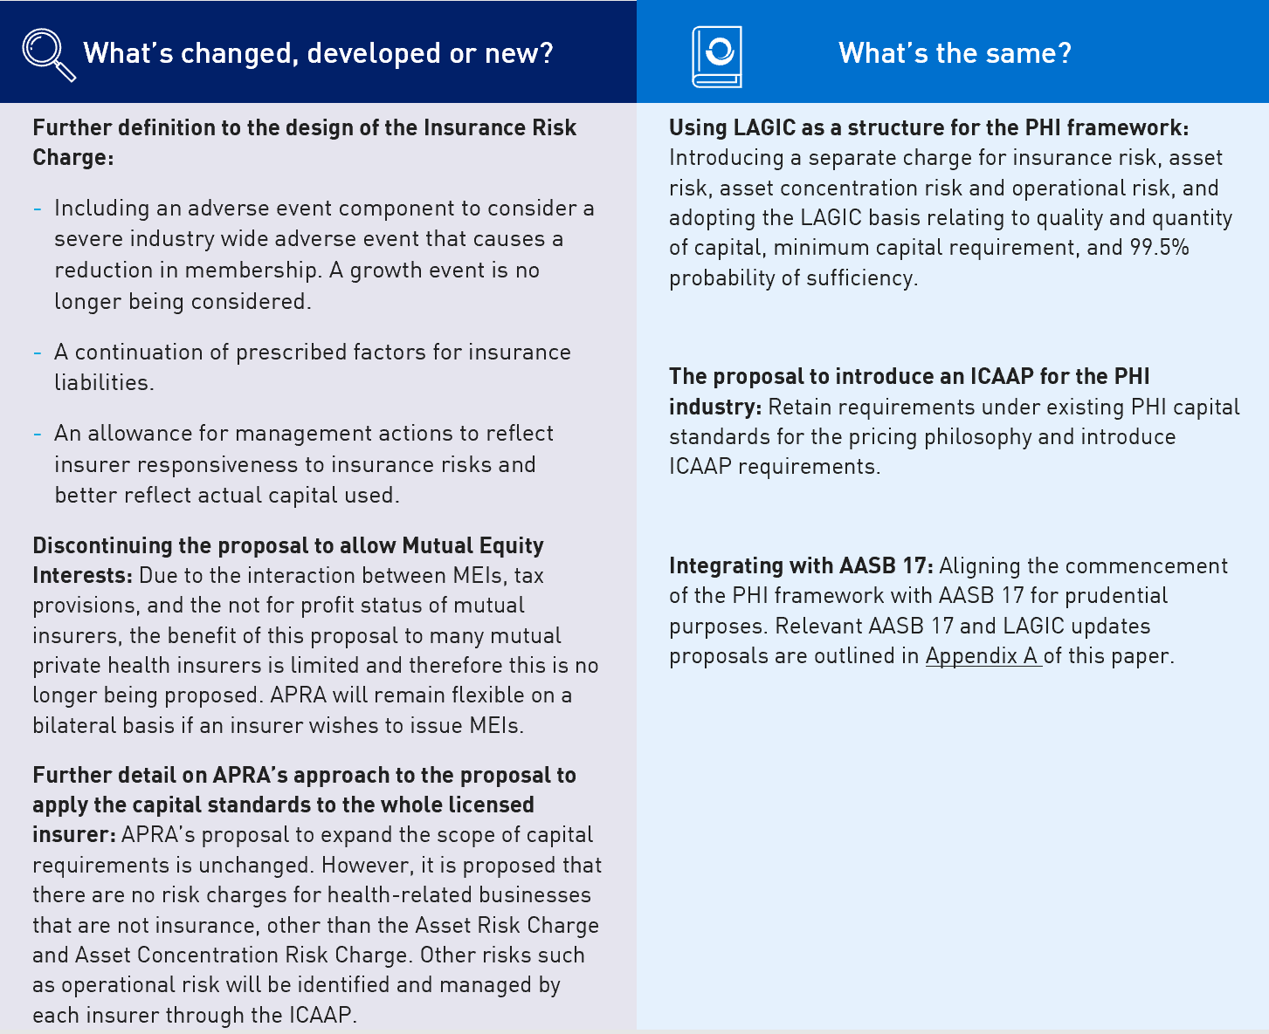

Impact of the proposed PHI framework
Several respondents to the partial-QIS and discussion paper commented on the broader impacts of APRA’s proposals on capital requirements, premium levels and competition within the industry.
Regulatory capital requirements and premium levels
APRA’s proposals will strengthen capital requirements for private health insurers, to support the long-term soundness of individual insurers and the industry as a whole. This review is not expected to provide a basis for increasing premiums. While APRA’s proposals will result in an increase in minimum capital requirements, the industry is well-capitalised and holds significantly in excess of the proposed Prescribed Capital Amount (PCA). On this basis, the industry is strongly positioned to absorb an increase in capital requirements without an increase in the actual overall levels of capital held, or targeted by insurers. If insurers seek to raise capital to maintain current coverage multiples, this is a decision taken by the insurer and not a consequence of APRA’s capital framework.

Competition impacts
When developing policy proposals, APRA seeks to balance the objectives of financial safety and efficiency, competition, contestability and competitive neutrality, and in doing so promote financial system stability in Australia. APRA considers, on the whole, the proposals in the response package will enhance prudential outcomes, improve financial safety and promote financial system stability while not unduly impacting other objectives. APRA has engaged with the Australian Competition and Consumer Commission (ACCC) and reviewed the design of certain elements of the framework, in particular the misestimation component of the IRC, to minimise adverse competition impacts.
Transition
APRA recognises the review of the PHI capital framework represents a fundamental shift in the determination of regulatory capital for the industry, and therefore is proposing to put transition arrangements in place based on consideration of insurer specific arrangements on a case by case basis.
APRA will consider allowing transitional arrangements if an insurer is unable to implement changes to its current arrangements, or mitigate the impacts of an increase in regulatory capital requirements before 1 July 2023. Insurers are encouraged to provide feedback on appropriate transitional arrangements in response to this consultation. Further information on transition arrangements will be provided alongside the release of final prudential standards in Q3 2022.

Aligning with broader revisions for insurers: AASB 17 and LAGIC updates
In the discussion paper, APRA signalled that the revised PHI capital standards would align with changes in the accounting standards for insurance contracts following the introduction of AASB 17 Insurance Contracts (AASB 17). APRA’s intent is to integrate AASB 17 into the PHI capital framework where possible and appropriate.
APRA’s most recent proposals on this alignment are outlined in the Response to Submissions Paper; Integrating AASB 17 into the capital and reporting frameworks for insurers and updates to the LAGIC framework (AASB 17 Response Paper), which can be found on APRA’s website. APRA encourages insurers to seek to understand and engage with APRA’s consultation on proposals for the integration of AASB 17 into capital and reporting frameworks.
APRA is also taking the opportunity to make updates to the LAGIC framework to reflect experience since it was introduced, and ensure it remains fit for purpose. The proposed revisions include updates to the Asset Risk Charge (ARC) to accommodate a low or negative interest rate scenario, updates to dollar value exposure limits to factor in the inflation that has occurred since the values were introduced, and adopting changes made for Authorised Deposit-Taking Institutions (ADIs) targeted at improving the simplicity and transparency of capital instruments. Given that the updated PHI framework has been developed using a LAGIC base, APRA is proposing to incorporate these updates within the revised PHI capital standards.

Next steps
APRA seeks feedback on the draft prudential standards which accompany this response paper, outlined below.
Draft Prudential Standard | Purpose
HPS 001 – Definitions | This standard outlines the definition of key terms across the PHI prudential standards.
HPS 110 – Capital Adequacy | This standard seeks to ensure that a private health insurer maintains adequate capital against the risk of its activities. This includes requirements relating to the PCA, Prescribed Capital Requirement (PCR) and the Internal Capital Adequacy Assessment Process (ICAAP).
HPS 112 – Measurement of Capital (new) | This standard sets out the characteristics that an instrument must have to qualify for inclusion in the capital base of a private health insurer, and other regulatory adjustments.
HPS 114 – Asset Risk Charge (new) | This standard sets out the method for calculating the Asset Risk Charge. This relates to the risk of adverse movements in the value of on-balance and off-balance sheet exposures.
HPS 115 – Insurance Risk Charge (new) | This standard sets out the method for calculating the Insurance Risk Charge and seeks to ensure an insurer maintains adequate capital against the insurance risks associated with insurance activities.
HPS 117 – Insurance Concentration Risk Charge (new) | This standard sets out the method for calculating the Insurance Concentration Risk Charge. This relates to the risk of a concentration in exposures to a particular asset, counterparty or group of related counterparties resulting in adverse movements in a private health insurer’s capital base.
HPS 118 – Operational Risk Charge (new) | This standard sets out the method for calculating the Operational Risk Charge. This relates to the risk of loss resulting in inadequate or failed internal processes, people and systems or external events.
HPS 310 – Audit and Related Matters | This standard outlines the roles and responsibilities that a private health insurer must require of its Appointed Auditor.
HPS 340 – Insurance Liability Valuation (new) | This standard sets out the requirements for the valuation of insurance liabilities of a private health insurer.

APRA is requesting submissions on this response package, and completed quantitative impact study (QIS) workbooks by 31 March 2021. Following consideration of feedback received, APRA expects to release final prudential standards in Q3 2022, with a proposed effective date of 1 July 2023. Indicative timing is set out below:
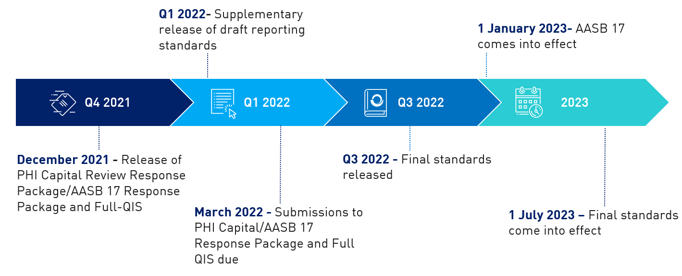

Glossary
AASB | Australian Accounting Standards Board
AASB 17 | AASB 17 Insurance Contracts
APRA | Australian Prudential Regulation Authority
APRA Act | Australian Prudential Regulation Authority Act 1998
ARC | Asset Risk Charge
ACRC | Asset Concentration Risk Charge
CMP | Capital Management Plan
Community rating | Community rating precludes insurers from charging members different premiums for the same level of cover due to factors including age (other than age at entry), claims history, gender or health status
Corporations Act | Corporations Act 2001
FOIA | Freedom of Information Act 1982
FSCODA | Financial Sector (Collection of Data) Act 2001
GPS 112 | Prudential Standard GPS 112 Capital Adequacy: Measurement of Capital
HBF | The health benefits fund (HBF) is established in the private health insurer for the purposes of operating health insurance business and, where relevant, health related business in accordance with the Private Health Insurance Act 2007
HPS 100 | Prudential Standard HPS 100 Solvency Standard
HPS 110 | Prudential Standard HPS 110 Capital Adequacy
IAIS | International Association of Insurance Supervisors
ICAAP | Internal Capital Adequacy Assessment Process
ICPs | Insurance Core Principles as adopted by the IAIS
LAGIC | Life and General Insurance Capital Standards
MEI | Mutual Equity Interest
PCA | Prescribed capital amount
PCR | Prescribed capital requirement
PHI | Private health insurance
Risk Equalisation | A system of sharing hospital treatment costs of high-risk groups and high cost claimants between insurers.
- Introduction
  - Background
APRA’s capital standards set minimum regulatory requirements for an insurer’s financial resilience, reflecting the type and size of the risks an insurer is exposed to in its business.
The current PHI capital framework comprises two prudential standards; Prudential Standard HPS 100 Solvency Standard (HPS 100) and Prudential Standard HPS 110 Capital Adequacy (HPS 110). The purpose of the capital adequacy standard is to ensure, as far as practicable, that the health benefits fund (HBF) of an insurer is able to meet the financial obligations of its operation. HPS 100 and HPS 110 represent a continuation of the capital standards introduced by the Private Health Insurance Administration Council (PHIAC) in 2014.
APRA signalled its intention and timeframes for a systematic review of the prudential policy framework, including capital standards, for private health insurers as part of the PHI Roadmap in a letter to industry on 4 August 2016. APRA’s capital framework review represents the third and final phase of that process. The review reflects APRA’s view that the current PHI capital framework does not appropriately reflect the risks faced by insurers, or adequately allow for the consideration of extreme, low probability, adverse events.

Outline of the framework
In a discussion paper in 2019, APRA outlined a proposal to adopt a LAGIC-based structure for the PHI capital framework. This reflects APRA’s view that the LAGIC framework has worked effectively to ensure capital requirements are tailored to specific risks faced by insurers.
However, APRA has carefully considered PHI industry specific characteristics in the design of the proposed framework. Insurance risk is a key example where industry specific characteristics heavily influence how the risk is experienced and managed in each insurance industry. On this basis, the treatment of insurance risk in the proposed PHI framework has been specifically designed to reflect industry specific characteristics, and PHI data has been used to calibrate the treatment of PHI risks.
  - Integration of AASB 17
The 2019 discussion paper proposed that the PHI capital standards would be based on the Australian Accounting Standards Board’s new standard AASB 17, which adjusts the accounting treatment of insurance contracts. The implementation of AASB 17 will alter the basis for measuring and reporting insurance assets and liabilities, and will therefore impact the way an insurer prepares its financial reports and monitors its financial performance. The measurement and reporting of insurance liabilities are fundamental building blocks of the LAGIC framework.
APRA is maintaining the proposal to align the commencement of the PHI capital framework with the implementation of AASB 17 for prudential purposes from 1 July 2023. The proposed PHI capital framework integrates AASB 17 where possible and appropriate. APRA is also taking this opportunity to make updates to the LAGIC framework to ensure it remains fit for purpose, and a number of these updates will therefore flow through to the PHI capital standards.
Details relating to the AASB 17 driven changes, and LAGIC updates, can be found in the AASB 17 Response Paper. This includes proposals across all insurance industries, including PHI. APRA encourages insurers to seek to understand and engage with the consultation on proposals for the integration of AASB 17 into capital and reporting frameworks, and LAGIC updates, as well as this consultation.
Key proposals driven by AASB 17 and LAGIC updates which are relevant to private health insurers, and the relevant section of the AASB 17 Response Paper, are outlined in the table below. Appendix A outlines a more granular list of relevant AASB 17 changes and LAGIC updates to the draft PHI capital standards. This paper outlines the proposed AASB 17 changes at a very high level only, and should be considered in conjunction with the AASB 17 and LAGIC updates response paper.
Proposals relevant to PHI | Relevant section of AASB 17 and LAGIC updates Response Paper
AASB 17: Introducing a range of regulatory adjustments in order to ensure AASB 17 impacts on the calculation of the capital base are approximately capital neutral. Broadly, these relate to the effects of accruals (i.e. accounts receivable and payable related items) which will be within the insurance and reinsurance contract liabilities and assets under AASB 17 but are currently recognised as separate assets and liabilities on the balance sheet under the existing accounting standards. | Section 2.2.1
AASB 17: Modifying the approach to the four quarters dividend test to respond to the impact of options that will be available to insurers on implementation of AASB 9 and AASB 17. | Section 2.2.2
AASB 17: Providing definitions and clarifications for claims handling expenses and policy administration expenses to drive better alignment within the industry. | Section 2.3.1
AASB 17: Clarifications to the regulatory adjustments to CET1 capital for deferred tax to ensure deferred tax assets and deferred tax liabilities include any tax effects resulting from the insurance liability adjustment, as well as the additional accounts receivable and accounts payable regulatory adjustments. | Section 2.3.4
AASB 17: The inclusion of definitions for accrued premium and claims incurred to distinguish them from AASB 17 concepts. | Section 2.4.2
Reporting: For reporting, clarifying the definition of health related (insurance) business to include overseas visitors cover and overseas student cover. | Section 3.5
LAGIC updates: Updates to the ARC to better accommodate the potential for low or negative inflation rates. | Section 4.1
LAGIC updates: Updates to dollar value exposure limits across the framework to reflect inflation since LAGIC was introduced. | Section 4.2
LAGIC updates: Updates and clarifications on APRA’s expectations relating to capital instruments to align with amendments to Prudential Standard APS 111 Capital Adequacy: Measurement of Capital. | Section 4.3
LAGIC updates: Updates to the default stress to reduce the double counting of risk in respect to business ceded under a whole of account quota share arrangement. | Section 4.5
LAGIC updates: Updates to clarify the intended application of fair value for capital base determination. | Section 4.6

  - Consultation process
APRA initiated the first round of consultation as part of the review of the PHI capital framework with the release of a discussion paper in December 2019. The discussion paper outlined proposals for the revised PHI capital framework at a conceptual level. APRA received twelve submissions in response to the discussion paper. Non-confidential submissions are available on APRA’s website.
In March 2021, APRA issued a partial-QIS to all insurers to enable an assessment of the quantitative impact on individual insurers of the intended insurance risk and operational risk components of the capital framework. This included both quantitative and qualitative questions on potential parameters for the insurance and operational risk charges.
APRA also sought information on the appropriateness and quantum of the charges. APRA received 21 responses to the partial-QIS, which included both qualitative and quantitative feedback. The partial-QIS was followed by a workshop with insurers, covering the proposals outlined in APRA’s discussion paper and providing more detailed context on the partial-QIS. Industry feedback has provided APRA with useful insights on the impact of the capital review, and has informed the development of the policy proposals outlined in this paper. APRA’s responses to the issues raised in submissions are detailed in this paper.
  - Balancing APRA’s mandate
When developing policy proposals, APRA seeks to balance the objectives of financial safety and efficiency, competition, contestability and competitive neutrality, and in doing so promote financial system stability in Australia. APRA considers that on the whole, the proposals in this response paper will enhance prudential outcomes, improve financial safety and promote financial system stability, while not unduly impacting other objectives.

Competition and contestability
A number of respondents to the discussion paper commented that some of APRA’s proposals could dampen competition and contestability, and therefore detract from policy holder outcomes and consumer choice. Submissions to the discussion paper and partial-QIS expressed concerns relating to the competition and contestability impacts of the following proposals:
- Misestimation factor in the IRC: A number of respondents to the partial-QIS commented that the misestimation factor, partly driven by growth, within the IRC may be a barrier to insurers wishing to grow organically and penalise merger activity.

- Expanding the scope of capital requirements: Some submissions to the discussion paper viewed that expanding the scope of capital requirements to the whole licensed insurer, including non-insurance related business, would increase costs for insurers seeking to diversify their business model and impair the ability of insurers to compete in markets outside the PHI industry.

- Introducing a $5m minimum capital requirement: One submission commented that the proposed increase in minimum capital requirements would raise barriers to entry, leading to a decreased number of insurers in the market and therefore reduced consumer choice and product innovation.
APRA’s assessment of the potential effects of its proposals on competition and contestability has been informed by stakeholder views, including those outlined above and input from the ACCC.

APRA’s response on potential competition impacts

Misestimation factor in the IRC
- APRA notes feedback from some respondents that the misestimation factor based on size and growth in the IRC may be perceived as a barrier or disincentive to expansion, particularly for smaller insurers. APRA recognises that a smaller insurer that gains new policy holders would need to hold more capital than a larger insurer gaining the same number of policy holders, as the increase in policy holders would result in proportionately higher growth for the smaller insurer.
- The current PHI capital framework recognises that changes in a fund’s policy holder growth rate contributes to net margin variability. APRA’s position is that a capital charge remains the most appropriate tool to address this risk, and to ensure that policy holder protection is not compromised by growth. This is because the claiming patterns of new policy holders are often not apparent for a number of years after joining a fund, due to waiting periods and other factors.
- APRA has taken steps to recalibrate the misestimation factor following stakeholder feedback, to reduce adverse effects on incentives for growth. This includes revising the growth range to focus on risks that are above trend levels for the industry, informed by the recent rate of growth as well as the longer-term growth rate. APRA’s proposal also seeks to minimise impacts on insurer decisions on growth arising from mergers, by excluding the application of the charge in these circumstances. The information on claiming patterns of new policy holders through the merger process reduces the risk of misestimation of future claims. Other adjustments to the design of the charge have been made to enhance the risk sensitivity and reduce the relative impact on smaller insurers. This seeks to strike a balance between achieving APRA’s prudential objectives, and limiting adverse competition impacts.
- APRA has deliberately sought to ensure that the increase in overall capital requirements is proportionate to the risk it seeks to address, and does not adversely impact a particular cohort of insurers. This review is expected to result in higher regulatory capital requirements at an industry level, and APRA views this as necessary to raise the level of financial resilience of the industry. APRA’s proposals are consistent with the level of sufficiency built within the LAGIC framework for life and general insurers.

Expanding the scope of capital requirements
- APRA acknowledges the concerns raised in submissions to the discussion paper that expanding the scope of capital requirements to the whole insurer may present a barrier to insurers seeking to diversify their business model. APRA considers the impact of this proposal on competition to be limited to markets outside of PHI. The impact will depend on the individual insurer and the market it is seeking to enter.
- APRA has adjusted this proposal so that there are no risk charges for health-related businesses that are not insurance, other than the ARC and Asset Concentration Risk Charge (ACRC). APRA’s proposal removes the current capital charge for non-insurance related business. This will provide more flexibility for insurers to adopt different business models and allow insurers to diversify their offerings and create additional value for policy holders through increased choice.
- APRA proposes that the business risks for non-insurance related business are instead addressed via the ICAAP. This approach was suggested in industry submissions to the discussion paper and seeks to balance achieving the prudential objectives of this proposal while minimising potential adverse impacts on diversification strategies and competition in markets other than PHI.
APRA’s response on potential contestability impacts

Minimum capital requirement
- APRA acknowledges that the proposed $5 million minimum capital amount may constitute a barrier to entry. However, APRA’s view is that this will not have a material impact on contestability for the reasons outlined below.
- Although there is currently no prescribed dollar minimum capital amount in place, APRA’s experience is that insurers entering the market have in excess of $5 million capital at the time of entry. All current private health insurers each have over $5 million in capital.
- The proposed $5 million minimum capital requirement reflects the expectation that there is a minimum capability, size and financial standing that will be able to satisfy risk management expectations, and have the ability to respond to shock events. This improves the future sustainability and long-term financial soundness of each insurer entering the market. The $5 million quantum is a proxy for these considerations. APRA’s position has been informed by experience with private health insurers and, to a lesser degree, experience with life and general insurers.
- Minimum capital requirements have been in place for life and general insurers for an extended period of time. Life insurers have had a $10 million minimum capital requirement since the commencement of the Life Insurance Act 1995, and general insurers have had a minimum capital requirement in place since 1973, initially through the Insurance Act 1973.
- APRA considers that a $5 million minimum capital requirement is appropriate given the nature of the PHI industry. This is covered further in Section 2.2.5 of this paper.
Overall, APRA’s view is that this review achieves an appropriate balance of APRA’s mandate, considering the points outlined above and the factors summarised below:
PRIMARY OBJECTIVES
Financial safety |  | Financial system stability
Improved: The proposals strengthen the prudential requirements for capital. The review is expected to improve the quality and strength of minimum capital requirements, and strengthen capital management practices to support the long-term financial soundness of regulated entities. |  | Improved: Proposals to ensure the capital standards provide for an appropriate level of protection for policy holders will build the financial resilience of insurers and hence support system stability.
OTHER CONSIDERATIONS
Efficiency | Increased: APRA’s proposals for the capital framework are expected to improve efficiency by determining capital requirements on a basis that better reflects the risks faced by each insurer. For example, insurers that can demonstrate enhanced risk management, governance, and a willingness and ability to take corrective action may reduce their capital requirements through incorporating management actions to reflect insurer responsiveness to insurance risks. This will better reflect actual capital used. Consistency in application and reduced availability of discretion in some aspects of the framework will also increase efficiency through greater comparability.
Competition | Neutral to reduced: While some of APRA’s proposals may adversely impact competition, the effects are primarily expected to occur at the margin or be comparatively minor in nature. APRA has sought to limit the potential for adverse impacts by adjusting the proposals based on stakeholder feedback, including the ACCC. The current proposals have been designed and calibrated to minimise the adverse effect on competition while still delivering APRA’s primary prudential objectives.  Any potential losses for consumers from any reduction in competition have been balanced against the gains from policy holders being better protected by the greater financial resilience of insurers.
Contestability | Reduced: The proposal to introduce a dollar minimum capital requirement may increase barriers to entry and restrict very small insurers from entering the market. APRA does not expect this to have a material impact given that APRA’s experience is private health insurers entering the market have held in excess of $5 million capital at the time of entry and all current private health insurers each hold over $5 million in capital.
Competitive Neutrality | No change: The proposed changes do not create advantages for public sector entities relative to other market participants.
  - Commencement and transition

Commencement
The review of the PHI capital framework coincides with the integration of AASB 17. AASB 17 has a commencement date of 1 January 2023, however insurers will be required to determine regulatory capital and submit regulatory reports under the existing prudential standards and reporting standards until the new prudential standards and reporting standards come into effect from 1 July 2023. This is to ensure APRA’s continued visibility on the reported capital strength, risks and operations throughout the transition period. Insurers are encouraged to indicate to APRA as early as possible if they will adopt AASB 17 prior to 1 January 2023.
Some stakeholders raised concerns with APRA’s proposal to have a single implementation date, as this will result in up to six months of dual reporting for a number of entities. The single implementation date is important to ensure like-for-like comparisons of reporting data and will provide APRA with robust and consistent data to inform prudential supervision. Further information on the implications of this for reporting are outlined in Chapter 3.

Transition
APRA recognises the review of the PHI capital framework represents a fundamental shift in the determination of regulatory capital for the industry. APRA is proposing to put in place transitional arrangements to allow for an orderly implementation of the new capital framework, consisting of consideration of insurer specific arrangements on a case by case basis.
Insurers are expected to comply with the current standards until the new standards take effect. APRA will consider allowing transitional arrangements if an insurer is unable to implement changes to its current arrangements, or mitigate the impacts of an increase in regulatory capital requirements before 1 July 2023. APRA welcomes industry feedback on appropriate transitional arrangements, and will provide further information on this alongside the release of the final prudential standards in Q3 2022.
APRA also recognises that capital instruments available to insurers under the current PHI capital standards do not align with definitions allowed under the LAGIC framework. APRA expects that insurers will no longer issue subordinated debt that does not fully meet the requirements of a Tier 2 Capital instrument. APRA proposes to allow transition for the existing stock of subordinated debt on a case-by-case basis. APRA expects that transition would generally be limited to the next available call date of the instrument.
- Applying the LAGIC principles to private health insurers
Capital requirements are a core component of the prudential framework for insurers. Having sufficient capital enables insurers to survive periods of stress without jeopardising their ability to meet commitments to their policy holders. The LAGIC framework reflects APRA’s overall approach to capital for insurers and has been the starting point for this review. This review will also more closely align PHI with the international prudential regulation of insurance as established through the Insurance Core Principles (ICPs), developed by the International Association of Insurance Supervisors (IAIS).
A PHI capital framework more closely aligned to LAGIC would better reflect risks faced by insurers and enable insurers to better absorb shocks due to extreme adverse events. The current framework also allows for significant discretion, resulting in a wide variation in its application across the industry. This has made it more difficult for APRA to compare performance between insurers and determine whether capital requirements adequately reflect the risks faced by an insurer.
APRA has identified several opportunities to strengthen the existing PHI capital framework to improve the financial resilience of insurers and better protect policy holders. While LAGIC remains the basis of the framework, APRA has carefully considered the risks of the PHI industry and the risks of individual insurers. This ensures that the capital requirements are not just appropriate at the industry level, but also for individual insurers. The information received through the partial-QIS has also been an important tool in providing APRA with this assurance.
Submissions to the discussion paper generally did not oppose the high-level application and principles of the LAGIC framework. On this basis, APRA is proposing to adopt the positions outlined in Table 1 below. Further detail on each topic is provided in this section. Where a proposal has been ‘further developed’, APRA’s overall position and intent remains unchanged, however detail has been either modified, added, or clarified in response to industry feedback.

Table 1. Applying the LAGIC framework to private health insurers: proposals
Topic | What was proposed | APRA’s current position
Structure of the framework | Adopting the structure of the LAGIC framework as the basis of PHI capital standards. | Maintained
Scope of capital standards | Expanding the scope of capital standards to the whole licensed insurer. | Further developed –no risk charges for health-related businesses that are not insurance, other than the ARC and ACRC.
Level of sufficiency | Increase probability of adequacy (POA) from 98 per cent to 99.5 per cent. | Maintained
Defining the capital base | APRA proposed taking the LAGIC framework as a starting base to determine the minimum proportions and quality of capital components and introducing regulatory adjustments consistent with GPS 112. | Maintained
Mutual Equity Interests | Incorporating provisions comparable to allow mutually owned insurers to issue Mutual Equity Interests (MEIs). | Changed – Due to the interaction between MEIs, tax provisions, and the not-for-profit status of several mutual insurers, the benefit of this proposal to many mutual insurers is limited and therefore this is no longer being proposed. APRA will remain flexible on a bilateral basis if an insurer displays the appetite to issue an MEI.
  - Structure of the PHI capital framework
The discussion paper outlined APRA’s proposal for PHI capital standards to align with the high-level structure of the LAGIC framework, which includes separate charges for insurance risk, asset risk, asset concentration risk and operational risk. APRA also proposed that PHI capital standards include explicit recognition of diversification impacts through an aggregation benefit.

Comments received
Submissions received were generally supportive of APRA’s proposal to use the LAGIC framework as the basis for the review of the PHI capital framework, and APRA’s intention to increase the risk sensitivity of the PHI capital standards. However, a number of submissions noted the importance of reflecting unique characteristics of the PHI industry within the capital framework by ensuring requirements are appropriately tailored.

APRA’s response
APRA intends to maintain the proposal to structure the PHI capital framework in accordance with the LAGIC framework and include a separate charge for insurance risk, asset risk, asset concentration risk and operational risk. While the structure of the PHI capital framework is proposed to align with LAGIC, APRA has sought to ensure that the capital charges are appropriately tailored to the characteristics of the industry. This is most evident within the design of the IRC, which has been developed specifically to reflect the nature of insurance risk within the industry. APRA has taken a number of steps to ensure that PHI-specific characteristics are appropriately considered, including:
- engaging with the Actuaries Institute in early 2019 for an assessment of the key risks in PHI;
- outlining a broad structure to capture PHI risks in the discussion paper, and reflecting industry feedback in the design of capital charges;
- only using data from private health insurers to set parameters for the proposed IRC; and
- issuing a partial-QIS to test early feedback on elements of the proposed capital framework. This has informed the design of charges proposed in this paper and the draft standards.
    - Scope of the capital standards
The current PHI capital standards apply to the HBF only. The discussion paper proposed broadening the scope of PHI capital standards to the whole licensed insurer. APRA expressed concerns that the narrow scope of current capital standards does not capture risks within the regulated entity if they are situated outside the HBF.
Activities outside the HBF can cause contagion risk to the health insurance business, whereby losses associated with those activities could adversely impact the security of policy holders. APRA proposed applying capital requirements to the whole licensed insurer, and applying capital standards separately to each HBF of the insurer, and also to any activities conducted by the insurer outside the HBF.

Comments received
Several submissions agreed in principle with the objective of this proposal, and recognised that APRA’s current framework does not capture the contagion risk arising from non-insurance business activities of the insurer on the HBF. However, a number of submissions questioned the approach of broadening the scope of capital requirements to also regulate the whole licensed insurer.
Several respondents expressed the view that APRA’s proposed approach would negatively impact competition within the industry and could result in excessively onerous or complex requirements. Respondents also commented that the proposal may drive actions by insurers to circumvent the capital requirements, such as through a corporate restructure. Several submissions encouraged APRA to consider whether contagion risk could be more appropriately dealt with through the ICAAP, rather than applying the full suite of capital requirements upon the whole licensed insurer.

APRA’s response
Having considered feedback received, APRA has further developed the proposal to expand the scope of the capital framework to the whole licensed insurer. APRA is proposing to apply PHI capital requirements on health insurance business, health-related insurance business and assets of the whole licensed insurer.
APRA proposes that all activities and assets outside the HBF will be contained within the concept of a ‘General Fund’ (GF). Under this approach, the same capital charges will apply to all assets and health-related insurance businesses as within the HBF. However, under APRA’s revised proposal, for health-related non-insurance businesses and other non-insurance businesses conducted in the GF, only the ARC and ACRC will be applied. APRA is also now proposing that other risks associated with these activities will be identified and mitigated by each insurer through their own assessment in the ICAAP and Risk Management Framework.
This is illustrated in Figure 1 below.

Figure 1. Proposed application of PHI capital standards
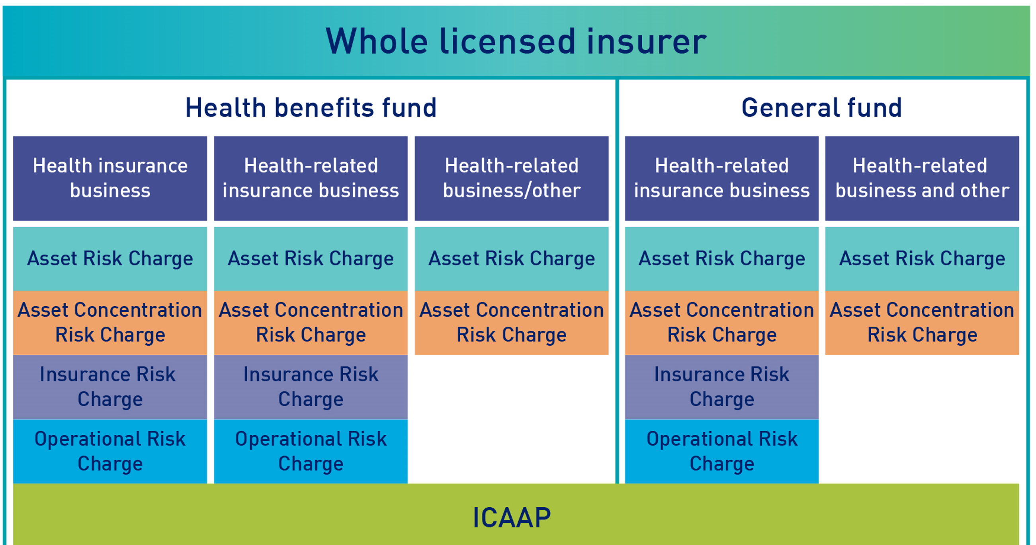
APRA’s view is that this approach strikes a balance between providing greater visibility of these business activities to enable more informed regulation of an insurer’s activities, without discouraging diversification or placing overly onerous capital requirements upon insurers for potentially very different risks arising from a range of different business activities.
    - Level of sufficiency
Aligning with LAGIC, APRA proposed that PHI capital standards target 99.5 per cent probability of sufficiency over a one-year period. This is an increase from the current setting, targeting 98 per cent probability of sufficiency for the HBF. This proposal seeks to ensure that an insurer has sufficient capital to absorb unexpected shocks which may arise in a 1 in 200 scenario conceptually, and continue to meet obligations to policy holders at the end of that period.

Comments received
Submissions were generally in favour of APRA’s proposal to move to a 99.5 per cent probability of sufficiency, noting that this is aligned with the approach taken for other insurance industries and internationally. However, several respondents commented that in practice, insurers often set target capital based on a multiple of regulatory capital requirements. Respondents observed that where target capital is set in the same way, this proposal could drive an increase in regulatory capital requirements, and therefore an increase in capital held by insurers, which may in turn result in increases in premiums.

APRA’s response
APRA’s proposal is unchanged from the discussion paper. A 99.5 per cent probability of sufficiency is consistent with international standards, reflects APRA’s risk appetite and delivers an appropriate level of assurance that an insurer will be able to meet the financial promises that it has made.
This review, and the proposed revised capital framework, is not expected to provide for a basis for increasing premiums. The direct impact of APRA’s proposals are on minimum capital requirements only, which remain well below the level of capital held across the industry. APRA’s proposals are not expected to lead to an increase in the actual overall levels of capital held, or targeted by insurers, and all insurers are expected to meet proposed regulatory minimum requirements.
Figure 2 below is an estimate based on information provided as part of the partial-QIS, and represents industry aggregate impact on both the expected PCA, and aggregate eligible capital for the industry. As the chart indicates, capital coverage for the industry following implementation of the proposed changes is expected to remain very strong.

Figure 2. Industry Capital Impact
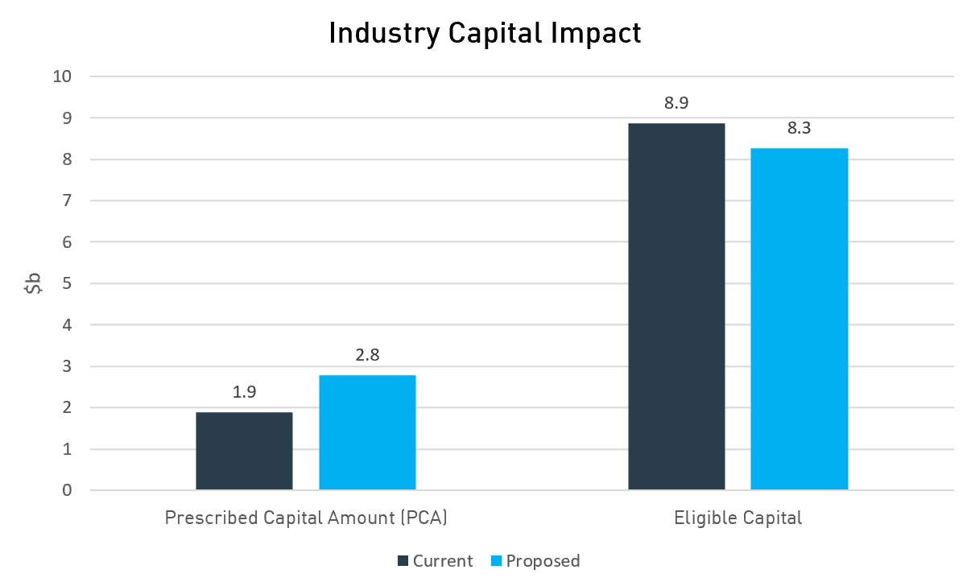
The level of capital targeted is a decision for each insurer and their board and should be considered and justified as part of the ICAAP. APRA recognises that capital targets are expressed in a number of different ways, including as a dollar amount, amount per policy holder, amount above regulatory capital or a multiple of regulatory capital. APRA expects that boards will review the appropriate level of target capital and how it is best expressed in light of the change in the way minimum capital requirements have been set.
The increased level of assurance provided by the revised capital standards will mean, for example, that a lower capital multiple is likely to be appropriate. Insurers are encouraged to engage their Appointed Actuary and undertake a thorough assessment, supported by robust scenario analysis, when reviewing their target capital in light of the proposed capital framework. If an insurer wishes to raise capital to maintain current high capital multiples, this is an insurer’s decision and not a consequence of this review or APRA’s capital framework.
APRA encourages insurers to consider this as part of their capital management planning through the ICAAP. Further guidance is also available in Prudential Practice Guide CPG 110 – Internal Capital Adequacy Assessment Process and Supervisory Review (CPG 110).
    - Defining the capital base

Admissible assets
In the 2019 discussion paper, APRA proposed that PHI capital standards adopt regulatory adjustments based on those specified in Prudential Standard GPS 112 Capital Adequacy: Measurement of Capital (GPS 112). These regulatory adjustments include those introduced as a result of AASB 17, relating to accounts receivable and accounts payable (for more details, see Section 2.2.1 of the AASB 17 Response Paper). Additionally, the discussion paper proposed that insurers would need to obtain APRA’s written approval prior to making any planned reduction in the capital base.

Comments received
Submissions did not comment on APRA’s proposal to adopt regulatory adjustments based on GPS 112. One submission sought clarity on APRA’s proposal to require written approval for a reduction in the capital base, and whether greater autonomy would be offered to insurers with greater excess capital. This submission also raised concerns relating to the potential subjectivity of approvals.

APRA’s response
APRA’s proposal is unchanged from the 2019 discussion paper. APRA’s requirements relating to approvals for a reduction in the capital base are outlined in HPS 110, which have been aligned with that of Prudential Standard GPS 110 Capital Adequacy (GPS 110). APRA’s view is that these requirements involve a risk assessment which has regard to factors such as the capital buffer remaining following the proposed capital base reduction. For insurers that will remain strongly capitalised, APRA’s assessment will more likely result in approval.

Capital quality
Under the LAGIC framework, eligible capital is subdivided into Tier 1 Capital, which includes the highest quality components of capital (Common Equity Tier 1 (CET1) and other Tier 1 capital), and Tier 2 Capital. Tier 2 includes other components of capital such as subordinated debt that, to varying degrees, fall short of the quality of Tier 1 capital but nonetheless contribute to the overall capital available to an entity.
APRA proposed introducing restrictions on the composition of an insurer’s capital eligible to be included in the capital base, based on the existing requirements in the LAGIC framework. Factors considered in determining the quality of a capital instrument under the LAGIC framework include whether the instrument satisfies all of the following essential characteristics:
- provide a permanent and unrestricted commitment of funds;

- be freely available to absorb losses;

- not impose any unavoidable servicing charge against earnings; and

- rank behind the claims of policy holders and creditors in the event of winding-up of the insurer.
Capital quality requirements seek to ensure that an insurer’s regulatory capital requirement only includes amounts which can be relied upon to meet policy holder claims in extreme events. It was proposed that this would follow the approach in the life insurance industry, and apply to the whole licensed insurer, as well as the HBF level where capital instruments are associated with the specific HBF.

Comments received
Submissions generally supported this change to align with other insurance industries. No specific concerns were raised in relation to this proposal.

APRA’s response
APRA’s proposal is unchanged from the 2019 discussion paper. APRA believes that this proposal will strengthen the capital base in the PHI industry.

Minimum proportions on the quality of capital components
The discussion paper proposed that insurers would be required to have minimum levels of CET1 and Total Tier 1 capital, sufficient to meet a high proportion of the Prescribed Capital Requirement (PCR). APRA proposed taking the LAGIC framework as a starting point to determine the minimum proportions and quality of capital components requiring:
- CET1 to exceed 60 per cent of the PCR;

- Tier 1 Capital in total to exceed 80 per cent of the PCR; and

- the remaining capital to meet the PCR to be able to be held as Tier 2 capital.
This is illustrated in Figure 3.

Figure 3. Proposed minimum proportions on the quality of capital components
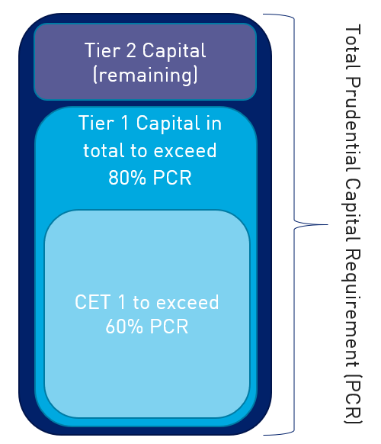

Comments received
Submissions generally supported APRA’s proposal to use LAGIC as a starting point for quality and quantity of capital components and supported consistency between insurance industries. Some submissions made overarching comments relating to APRA’s proposals to align with the LAGIC approach to the quality and quantity of capital, noting that there will be a cost to any insurers that need to transition to higher quality capital.

APRA’s response
APRA’s proposal is unchanged from the 2019 discussion paper. APRA recognises there may be challenges in moving to higher quality capital, and has sought to accommodate this through the proposed transition arrangements (see Section 1.5 – Commencement and Transition).

Mutual Equity Interests
The discussion paper proposed that the PHI capital standards incorporate provisions comparable with those in the ADI standards to allow mutually owned insurers to issue MEIs.

Comments received
Submissions supported APRA’s intent to allow the use of MEIs within the capital framework. However, concerns were raised relating to potential unintended consequences and operational impacts of the proposal. Submissions commented that MEI requirements may be inconsistent with the not-for-profit structure and tax-exempt status of many mutual insurers. It was noted that in order for this proposal to operate effectively, APRA would need to ensure that requirements are drafted to ensure that the not for profit status of insurers is protected.
Submissions also commented that many mutual insurers are companies limited by guarantee and are therefore only legally permitted to issue Mutual Capital Instruments (MCIs). A mutual insurer is required to amend their constitution in order to be eligible to issue an MCI. This must be done using a special procedure under the Corporations Act 2001. Insurers advised APRA that the option to use the special procedure will be expiring on 6 April 2022, and therefore requested that APRA provide any final draft MEI requirements by the first half of 2021.
Some insurers also noted that MEIs are not currently permitted for other insurance industries, and that if this proposal is pursued it should be applied consistently.

APRA’s response
Following consideration of stakeholder feedback, APRA has engaged with both the Australian Tax Office (ATO) and the Australian Securities and Investments Commission (ASIC) to better understand how the challenges raised in submissions could be addressed.
These discussions have confirmed that the proposal to allow insurers to issue MCIs would require amendments to an insurer’s governing documents, which would result in a breach of the non-profit special condition in the Income Tax Assessment Act 1997. No viable solution was identified to resolve this issue, and as a result APRA is no longer proceeding with this proposal. APRA recognises that MEIs may be a useful addition to a mutually owned insurer’s capital structure, and therefore intends to remain flexible on a bilateral basis and consider making allowances if an insurer has the appetite to issue MEIs.
While MEIs are currently not permitted for any insurance sectors, APRA is considering introducing MEIs for life and general insurers as part of LAGIC updates, as many of these mutual insurers are for-profit entities and therefore would not be restricted by these tax provisions.
  - Prescribed capital and its components
While APRA proposes to align components of prescribed capital with the broad structure of the LAGIC framework, APRA has sought to reflect the risks and features of the PHI industry within the design and parameters of each capital charge.
Insurance risk is an area where specific PHI industry characteristics heavily influence the level of risk, and differ to both life and general insurance. This includes but is not limited to the community rating system, premium round approval process, the risk equalisation pool, and the ability for insurers to adjust policy terms and conditions with reasonable notice. APRA has designed the IRC specifically to reflect the nature of insurance risk within the industry. Other components of the prescribed capital amount are largely aligned with the existing LAGIC charges, with adjustments as needed to reflect PHI specific risks.
The proposed structure of the PHI capital framework is outlined in Figure 4 below.

Figure 4. Proposed PHI Capital Framework
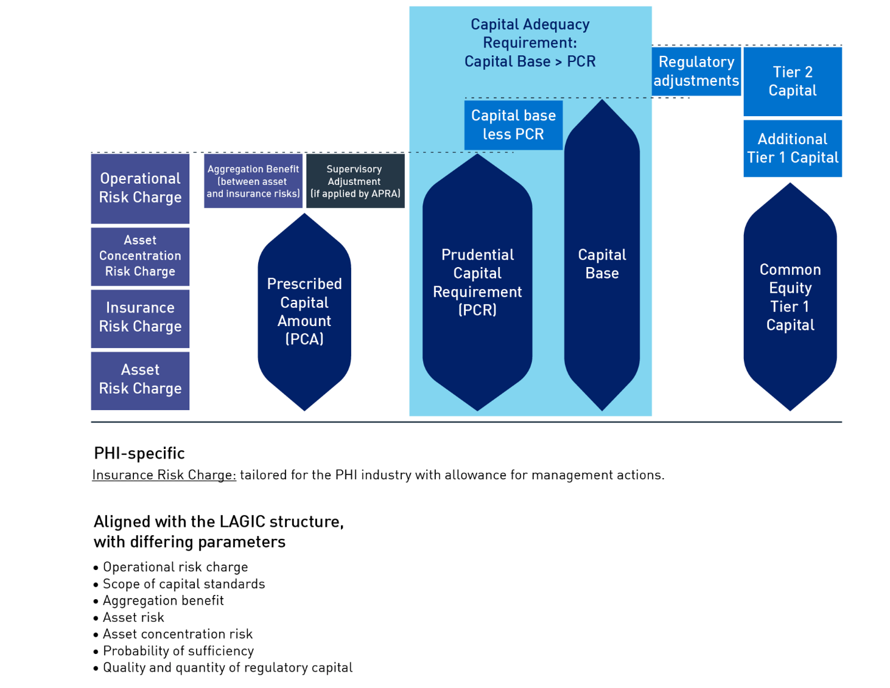
A summary of proposals is outlined in Table 2, and detailed further in this section.

Table 2. Prescribed capital and its components
Topic | What was proposed | APRA’s current position
Insurance Risk (designed for PHI)
Prescribed factor component | The IRC includes a prescribed factor component based on existing and future claims. | Further developed - APRA is retaining the use of prescribed factors for insurance liabilities and the stress for the risk that claims and expenses are materially higher than expected over the 12-month period following the reporting date. The stress to claims and expenses is now referred to as the prescribed benefit stress. APRA has added further definition to these charges following the partial-QIS.
Adverse event stress (AES) | Introduce a prescribed event considering lapse or growth of membership of between 30 per cent and 50 per cent within one year. | Further developed – APRA is retaining an adverse event component consisting of a prescribed lapse scenario of 25 per cent of under 65-year-old policy holders.
Insurer-specific adjustment/ management actions | Introducing an insurer-specific adjustment within the IRC to reflect idiosyncratic risks. | Further developed – APRA is proposing introducing an allowance for insurer-specific management actions within the IRC, consistent with the approach for life insurers. This is intended to reflect actions taken and insurer responsiveness to insurance risks and better reflect actual capital used.
Aggregation benefit | APRA sought feedback on the introduction of an aggregation benefit between the prescribed factor component and AES. | Further developed – APRA is proposing to not include an aggregation benefit within the IRC charge, to ensure that the overall IRC charge is appropriate. An aggregation benefit between asset and insurance risks will be retained.
Other components of the framework (parameters adjusted where appropriate for PHI)
Asset risk and asset concentration risk | APRA proposed adopting the LAGIC framework’s treatment of asset risk and asset concentration risk. | Maintained
Operational risk | The 2019 discussion paper proposed introducing a linear ORC, consistent with the approach in the LAGIC framework. | Further developed – APRA is proposing to use a similar approach to the LAGIC framework, however adopting a factor of 2.0 per cent rather than the 3.0 per cent applied in life and general insurance.
Aggregation benefit | APRA proposed recognising the independence between asset and insurance liability risks through an aggregation benefit. | Maintained
Minimum capital | APRA proposed introducing a $5m minimum capital requirement for all insurers and noted it was considering indexation to ensure the minimum remains appropriate over time. | Maintained – however APRA will not be indexing this requirement, and will revisit this when a broader review of dollar values across all insurance capital standards is undertaken.

    - Insurance Risk
The discussion paper recognised that APRA’s treatment of insurance risk in the LAGIC framework is tailored to the nature of each industry. Accordingly, APRA proposed to use the broad structure of the IRC for general insurers to inform the approach for the PHI industry, given the nature of the liabilities of both industries. APRA noted that specific characteristics that affect insurance risk in the PHI industry would also be considered.
The proposed structure for the IRC included two components:
- a prescribed factor approach, capturing the risk that individual insurers may experience a loss due to claims costs being higher than estimated; and
- an adverse event component to consider a severe industry-wide adverse event that causes a reduction in membership.
APRA proposed three options for determining the insurance risk component of the PCA, including adding the components, selecting the higher of the two components or making an allowance for an aggregation benefit in the sum of components.
The structure for the IRC was further tested in a partial-QIS. This was an important tool to enable APRA to understand the impact of the proposals, and test design elements of the IRC. Feedback received in response to the partial-QIS has helped shape the proposed design of the IRC. The updated overall proposed structure of the IRC as outlined in the sections below, is shown in Figure 5:
Figure 5: Proposed structure of the IRC 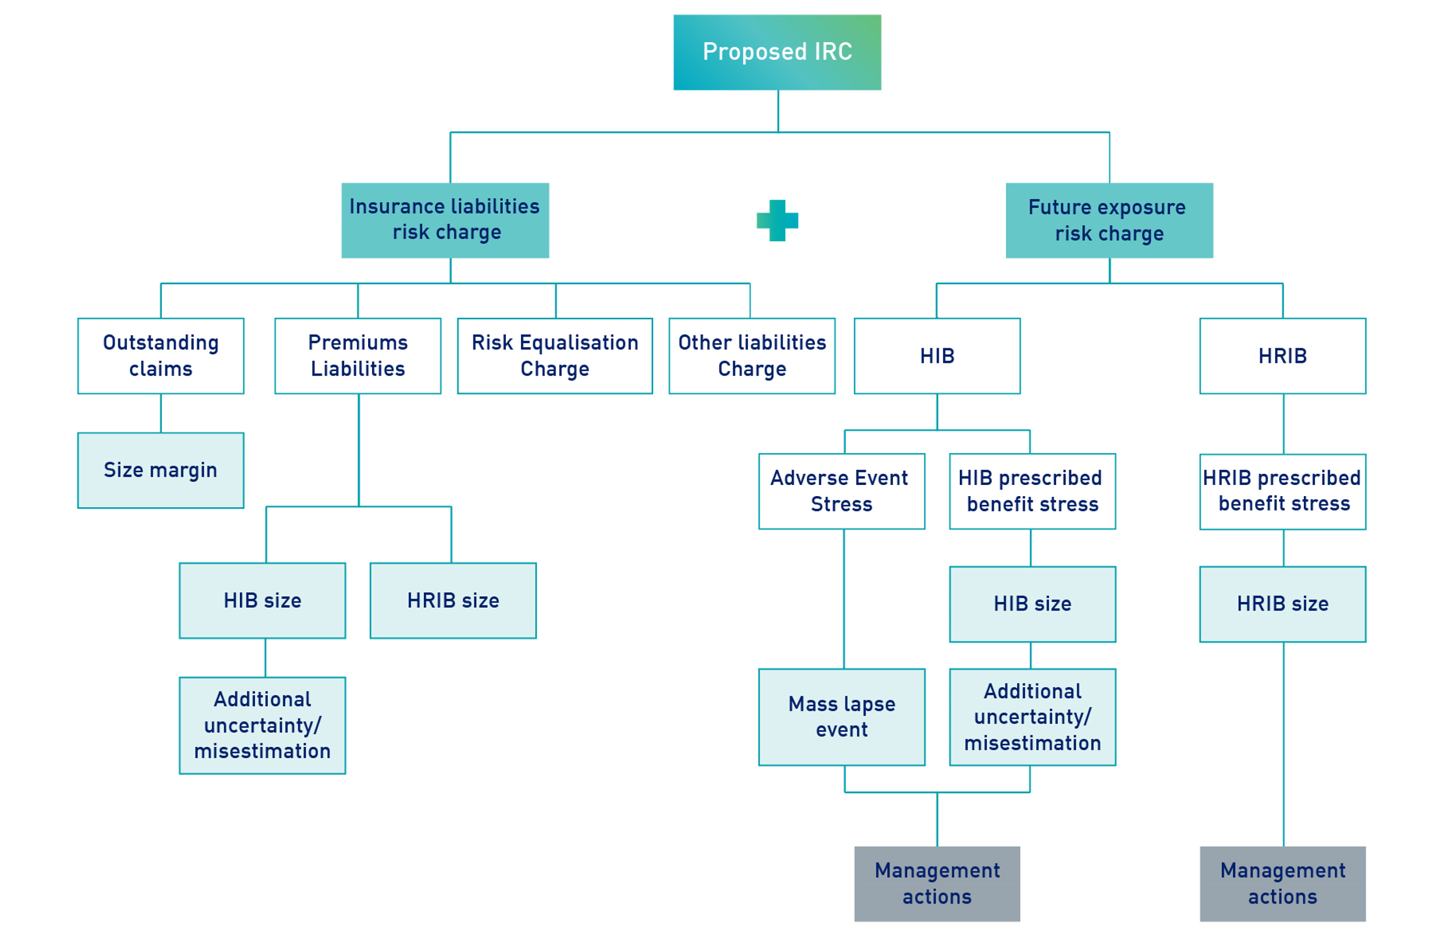

Prescribed factor component
The discussion paper proposed the IRC apply prescribed factors to outstanding claims and premiums liability, and apply a future claims stress. This would set separate factors for risk exposure relating to outstanding claims, future claims and premiums liability over a fixed period.
The prescribed factor component was further tested in the partial-QIS, which included two components.
- Existing Claims Risk Charge (ECR): This reflects the uncertainty related to claims that have already occurred and where premiums have been received. The formula for the ECR in the partial-QIS was proposed to be defined as the sum of an Outstanding Claims Risk Charge, Premiums Liability Risk Charge and Risk Equalisation Charge.
- Future Claims Risk Charge: This relates to the risk that claims are materially higher than expected over the 12-month period following the reporting date. It was proposed that the future claims risk charge be calculated as the reduction in an insurer’s forecast net margins as a result of applying a prescribed stress factor. The prescribed stress was set out as a function of insurer size and historical growth. It was also proposed that the current unlimited use of future tax benefits be replaced by a more restrictive requirement that future tax benefits can only be recognised to the extent that deferred tax liabilities at the reporting date can be written-off.

Comments received
Submissions to the discussion paper generally supported the inclusion of a standardised prescribed factor approach. One submission commented that the quantum should be either similar, or lower than short tail general insurers. Responses to the partial-QIS also generally supported the proposed parameters for the ECR. Submissions provided minimal comments on the proposed quantum of each component of the IRC.
A number of respondents expressed concerns relating to the design of the future claims risk charge. Some submissions commented that the proposed design of the growth margin within the charge did not adequately differentiate capital requirements between a stable insurer experiencing controlled growth and an insurer growing in a risky manner. One respondent commented that this would place an obstacle on smaller funds wishing to grow organically. A number of respondents also noted that the proposed design of the charge may penalise merger activities and industry consolidation.

APRA’s response
Existing Claims Risk Charge (ECR)
APRA intends to maintain the design of the ECR in substantively similar form to the partial-QIS. However, APRA is proposing minor adjustments to align the formulas used to determine premiums liabilities and the future claims risk. This includes basing the stress on health-related insurance business on the size of health-related insurance business, rather than the size of health insurance business. Further, to reflect that the inclusion of premiums liabilities does not relate to existing claims, APRA proposes to rename this component of the IRC to ‘Insurance Liability Charge’.
APRA is also proposing minor adjustments to the Insurance Liability Charge from the partial QIS, such that the stress to outstanding claims liabilities, premiums liabilities, risk equalisation liabilities and other insurance liabilities applies from the 75 per cent to the 99.5 per cent level of sufficiency. The process for valuing these insurance liabilities at the 75 per cent level of sufficiency is set out in draft Prudential Standard HPS 340 Insurance Liability Valuation.
APRA is also proposing to introduce an additional component within this charge named ‘Other Liabilities Charge’. This is intended to capture liabilities which do not fall within existing claims or premiums liabilities such as the Deferred Claims Liability (DCL). APRA believes that this will future proof the capital standards and provide insurers with a simple way to capture these liabilities as they arise.
Future claims risk charge
APRA’s growth margin is intended to reflect the heightened risk of misestimating future claims following periods of growth. The risk of insurers misestimating their claims is higher where there is limited data on the claiming pattern of its membership. Insurers who have experienced more recent and rapid growth in policy holders will have a larger proportion of their membership base without an established claiming pattern, as this data is not available for some time and is influenced by duration effects associated with waiting periods.
APRA notes that the risk of misestimating future claims has been reflected within capital standards for the PHI industry for an extended period of time. The size of membership base and variability of membership was a key factor included in the PHIAC standards. The changes in a fund’s policy holder growth rate is also a component of APRA’s current Capital Adequacy Standard. This reflects experience in the industry that growth is a key contributor to uncertainty in future claims and is consistent with APRA’s observations since taking over supervisory responsibility for the industry. As a result, APRA is proposing to maintain a future claims risk charge which captures both size and growth similar to the design in the partial-QIS.
APRA acknowledges concerns raised by insurers, particularly in relation to the potential impact of this charge on merger activity, and proposes to exclude membership growth due to mergers from the charge. APRA is also proposing a range of other adjustments to the design of the misestimation component of the future claims risk to enhance the risk sensitivity and appropriateness of the charge. These include:
- reflecting positive growth only, rather than the maximum magnitude of change given that the risk of a loss of members is captured in the proposed AES;
- adjusting the growth range from 0.5 per cent to 10.5 per cent tested in the partial-QIS, to a range of 2.5 per cent to 17.5 per cent. This focuses the charge on risks that are above the trend levels for the industry and captured in the size component;
- reducing the charge per percentage point from the 0.5 per cent tested in the partial-QIS to 0.33 per cent;
- calculating the growth rate as the membership increase in a given year, as a proportion of total current membership, to better reflect the extent of membership which is uncertain; and
- to accommodate merger activity, use total members in force across all merging entities as opposed to the transferee fund only.
As proposed in the Insurance Liability Charge, APRA intends to base the future claims stress for health-related insurance business on the size of health-related insurance business to better reflect the uncertainty for this business.
APRA is also proposing to rename this the ‘Future Exposure Risk’ Charge as the ‘Future Claims Risk’ Charge produces an acronym which is already frequently used by insurers.

Prescribed adverse event stress
The discussion paper proposed the prescribed AES would consider a sudden and significant lapse or growth of membership of between 30 per cent and 50 per cent within one year, with the lapses focused on the younger/healthier members who are generally at a higher risk of leaving the industry.
Feedback on the discussion paper informed refinements to the prescribed adverse event scenario incorporated into the partial-QIS. The mass growth event was not included in the partial-QIS, due to feedback suggesting this would not result in a capital loss within 12 months. Submissions noted that due to waiting periods and duration effects, new policy holder growth is unlikely to lead to a capital reduction within the 12-month timeframe for the standards. Some respondents also commented that a 30 per cent to 50 per cent lapse was excessive based on historical data.
Taking on board this feedback, the partial-QIS proposed a prescribed lapse scenario of an immediate 20 per cent reduction of the whole fund due to lapses from under 65-year-old policy holders across the industry.

Comments received
Submissions to the partial-QIS generally challenged the conceptual design of the mass lapse scenario. Several respondents questioned the likelihood of a mass lapse occurring on such a large scale and immediate fashion unless associated with government policy change. Additionally, submissions questioned the appropriateness of being required to hold capital against the risk of government policy change. Several submissions suggested APRA consider introducing a more graduated prescribed stress.

APRA’s response
Following consideration of feedback received, APRA is proposing to retain the proposed mass lapse scenario of an immediate 20 per cent reduction of the whole fund due to lapses from under 65-year-old policy holders across the industry. APRA is also proposing to make minor amendments to the application of the scenario, to enhance the risk sensitivity of the charge. This includes simplifying the stress so that 25 per cent of each insurers’ policy holders below the age of 65 lapse, which is equivalent to an overall 20 per cent lapse at an industry level.
APRA’s analysis of historical data in the PHI industry shows three distinct periods of experience. The period since 2003 has demonstrated stable gross margins and levels of membership, however the 1990s showed considerably more volatility and variations in gross margins, amounting to double the level observed since 2003. While there is no data available on gross margins prior to 1990, membership data is available and demonstrates significant volatility. APRA has considered this data in determining the appropriate event at a 99.5 per cent confidence level.
APRA’s view is that the data available since 2003, used in isolation, is not sufficient to accurately determine a one in 200-year event, particularly given the volatility observed in the preceding period. This would result in a scenario which is based on the most stable period in the available data, and create a charge that is well below an extreme event at a one in 200 level. On this basis, and to reflect the risk at a 99.5 per cent level, APRA views it appropriate to add an adverse event focused on a key risk to PHI, in this case a large lapse of younger policy holders.
APRA acknowledges that changes in government policy settings have historically been a key driver in large scale shifts in the number of insured persons within the PHI industry. However, APRA maintains a mass lapse event not associated with a change in government policy remains a plausible risk. Current affordability pressures, concerns of perceived value, and recent lapse experience, all support a mass lapse event being plausible in the industry at a one in 200 level. This is further supported by the fact that both affordability and value are recognised as leading risks within industry risk registers and insurer strategies. APRA also recognises that product innovations outside of PHI which appeal to younger policy holders may exacerbate this risk.
If a mass lapse event materialised, the lapse of lower claiming and younger members could have widespread financial impacts across the industry. In this scenario, the industry would have a significantly higher risk profile and higher claims per policy holder than the present state. The proposed adverse event component of the IRC is considered reasonable to ensure that insurers hold adequate capital against this risk.

Management actions and insurer specific adjustments
The discussion paper proposed that the IRC provide for an insurer specific adjustment, to allow APRA to adjust the charge to take account of idiosyncratic risks. This concept was further developed, and the partial-QIS introduced a module on management actions, to both reflect insurer responsiveness to insurance risks and better reflect the actual capital used in a stressed scenario.
The partial-QIS sought information from insurers on how management actions would be implemented in response to various stress scenarios, and views on the allowance of management actions generally to offset the IRC.

Comments received
Partial-QIS submissions included diverse feedback on the allowance for management actions. Supporting submissions commented that management actions would reflect the reality of what would occur in a stressed scenario, and that the IRC would be overstated without this allowance. Opposing submissions commented that management actions may introduce subjectivity, discretion and complexity into the framework and would be inconsistent with APRA’s desire to drive a more standardised approach to capital. A number of submissions suggested APRA could consider allowing actions within prescribed limits, to mitigate the risk of discretion.

APRA’s response
Following consideration of feedback received and quantitative responses to the partial-QIS, APRA is proposing to allow for management actions within the IRC within tightly defined parameters. This is intended to reflect the ability of private health insurers to take actions such as changing policy terms and conditions with 60 days’ notice, reducing coverage of products, and force migrating policy holders to other products to address deterioration in experience.
APRA observed a high degree of variability in the assumed timeframes and effectiveness of management actions in partial-QIS submissions, suggesting that controls are necessary to prevent insurers from assuming excessive capital relief from management actions. APRA’s proposed approach includes the following key controls:
- a minimum timeframe of nine months before actions can take effect, reflecting a realistic timeframe for performance to be assessed and for decisions to be made and implemented by insurers;
- incurred losses cannot be offset by assumed profit after management actions take effect; and
- a requirement for insurers to demonstrate the planned management actions are appropriate and justifiable.
The allowance for management actions more accurately reflects capital used by individual insurers in stressed scenarios, and enhances the risk-sensitivity of capital standards. APRA’s observations suggest that an insurer has the ability to take corrective action within 12 months if the governance processes, analytics and risk appetite enable decisions to be made within that timeframe.
While APRA recognises that an allowance for management actions inherently introduces the risk of increased discretion, this will be mitigated through: tight parameters surrounding the use of management actions; the requirement for insurers to demonstrate the actions are appropriate and justifiable; and by monitoring the appropriateness of actions through supervisory activity.
Management actions are proposed to be allowed to offset both the AES and future claims risk after nine months. APRA views that nine months reflects the minimum amount of time needed from the start of adverse experience before corrective actions taken can be expected to have a financial impact. This timeframe reflects the minimum period for an insurer to identify the adverse experience, assess the impact, plan a response, approve the action and for it to take effect.
The period of poor experience needed to justify an insurer acting, and the appetite to act on a short period of data is expected to vary across the industry. APRA encourages insurers to consider their process for identifying, and willingness to act upon claims stresses to ensure they are well positioned to respond to adverse experience in a timely manner.

Insurance risk diversification benefit
The discussion paper sought feedback on the proposed components of the IRC, the potential correlation between risks captured in each component and how components could be aggregated to calculate the overall IRC.

Comments received
Submissions to both the discussion paper and partial-QIS generally supported the inclusion of an aggregation benefit within the IRC to recognise the diversification of risks. Respondents commented that the stresses would be too high without diversification and viewed that there is imperfect correlation between the future claims risk and AES. One submission commented that a significant increase in claims costs and a significant lapse event are unlikely to occur at the same time.
Other submissions commented on the overall reasonableness of the IRC, and that an aggregation benefit may be necessary if the overall charge was too high. A number of respondents noted the importance of simplicity in the overall design of the IRC.

APRA’s response
APRA is proposing not to include an aggregation benefit within the IRC. The IRC has been calibrated to achieve a 99.5 per cent level of sufficiency overall, rather than each individual component. Given that a 20 per cent lapse event has occurred twice within the last 50 years, APRA views the AES is well within the 99.5 per cent level. However, the calibration of the AES combined with the future claims risk and ECR brings the overall IRC to the 99.5 per cent level. On this basis, an aggregation benefit has not been included in the IRC.
This approach is aligned to that used in general insurance capital standards and reflects that insurers operate a single line of business. It also reflects industry comments to ensure the IRC is appropriate at the one in 200 level and is designed as simply as possible.
    - Asset risk and asset concentration risk
APRA proposed adopting the LAGIC framework’s treatment of asset risk and asset concentration risk, as APRA did not identify specific characteristics in the PHI industry that would warrant deviation.

Comments received
Submissions generally supported consistent treatment of assets across insurance industries. A number of submissions commented that the prescribed stresses for LAGIC were set some time ago and should be reviewed and recalibrated to reflect changes in the financial environment.

APRA’s response
APRA’s proposal is unchanged from the discussion paper. APRA acknowledges feedback received recommending that asset risk charges be reviewed. This has been considered as part of APRA’s LAGIC updates project, and changes have been made to the real interest rate stress and expected inflation stress to better accommodate the low interest rate environment. Further detail is provided in the AASB 17 Response Paper.
As outlined in Section 2.1.1 of this paper, APRA is also proposing to expand the scope of capital requirements to the whole licensed insurer and all assets held within the HBF and GF will incur an ARC and ACRC. This is intended to reflect the potential reduction in the value of these assets in a stressed event, particularly in circumstances where health-related business is dependent on the health insurance business.
    - Operational risk
The discussion paper proposed introducing a linear ORC, consistent with the approach in the LAGIC framework. It was also proposed that the ORC for PHI capital standards capture the business activity of the whole licensed health insurer. An ORC would be applied to both the HBF and business conducted outside the HBF, with the aggregate ORC determined as the sum of the two.
The design of the ORC was further explored in the partial-QIS. The partial-QIS included an ORC using a similar approach as the LAGIC framework, adopting a factor of two per cent instead of a factor of three per cent as applied in the equivalent requirements for general insurers, to reflect the higher premium per policy and analysis of operational risk scenarios from various insurers.
The partial-QIS also sought feedback on capturing operational risks related to non-insurance business activities within the ICAAP, due to feedback that applying an ORC to all business activities of a licensed insurer would be overly complex and interfere with business diversification strategies.

Comments received
Submissions received in response to both the discussion paper and the partial-QIS generally supported the proposed formula for the ORC. A small number of respondents commented that the LAGIC approach to operational risk is outdated and should be revised. These submissions noted the importance of reflecting risk management capabilities within the ORC and suggested that this could be linked with operational risk assessment of insurers as part of the Supervision Risk Intensity (SRI) framework. Two submissions to the partial-QIS suggested that the proposed two per cent factor for the ORC is too high and that a one per cent factor would be more appropriate.
There were no opposing submissions in the partial-QIS to the proposal to reflect the risk arising from non-insurance business activities within the ICAAP.

APRA’s response
Following consideration of feedback received, APRA is proposing to retain the ORC formula and approach tested in the partial-QIS. APRA believes the proposed two per cent risk factor for PHI is appropriate based on data on estimated losses arising from operational events defined in recovery plans received and from operational risk assessments by insurers. While APRA recognises the limitations of the proposed linear formula, alternate approaches would introduce significant additional complexity.
APRA is also proposing to capture operational risks related to non-insurance business activities within the ICAAP, as proposed in the partial-QIS.
    - Aggregation benefit
The discussion paper proposed that the capital standards provide for an aggregation benefit to recognise the diversification between insurance and asset risks. APRA proposed the aggregation benefit be determined using the following formula:
Aggregation benefit = (A + I) - √(A^2 + I^2 + 2 × corr × A × I)
where:
A = the insurer’s asset risk charge
I = the insurer’s insurance risk capital charge
corr = the specified correlation factor
The value of the correlation factor was not yet defined, but proposed to be a number between zero and one. APRA sought feedback on whether the formula and correlation factor of 0.2 could be adopted without amendment.

Comments received
Submissions supported the inclusion of a correlation factor to reflect the diversification of asset and insurance risks. One respondent suggested that correlation factors should be periodically reviewed or provisions should be introduced to allow the application of the aggregation benefit to reflect the unique circumstances of each organisation. Several submissions commented that the correlation factor should not be higher than 0.2 and that a lower factor could be justifiable.

APRA’s response
APRA is proposing to retain the aggregation benefit formula outlined in the discussion paper, with a correlation factor of 0.2. This is consistent with the correlation factor used in life and general insurance, excluding lenders mortgage insurance where this business is more closely aligned to asset values.
    - Minimum prescribed capital
The discussion paper proposed setting an explicit minimum prescribed capital requirement of $5 million for the whole licensed insurer. APRA noted it was also considering indexation of the minimum capital amount to ensure it remains at an appropriate level over time.

Comments received
Submissions generally supported the proposed introduction of a minimum prescribed capital requirement. A number of respondents noted that this may act as a barrier to entry for new entrants compared with current standards, but had differing views on the impact of this on the industry. One submission commented that some insurers may need a longer transition period to meet this requirement, to avoid placing short term pressure on premiums.
An opposing submission commented that private health insurers do not exhibit the same risks as life and general insurers and therefore the overall capital for the industry should be lower than LAGIC counterparts.

APRA’s response
APRA is maintaining the proposal to introduce a $5 million minimum prescribed capital requirement for the whole licensed insurer. APRA views that having a dollar minimum capital requirement reflects that there is a minimum insurer size that is able to satisfy minimum risk management expectations, including having the ability to respond to shock events. A minimum capital requirement ($10 million) also applies in life insurance, and in GI ($5 million). APRA has considered impacts on existing insurers and expects only minimal impacts. No additional capital is expected to be required for insurers to meet the proposed $5 minimum capital requirement, as all insurers already hold capital exceeding this amount. However, some smaller insurers may seek to hold additional capital to build internal buffers above the prescribed minimum capital amount. APRA encourages insurers to consider this as part of their capital management planning and the ICAAP. APRA will consider transitional arrangements if insurers face challenges meeting this requirement.
APRA is proposing not to introduce an indexation mechanism for the minimum capital amount at this time. APRA will revisit this at a later time, when a broader review of dollar values across all insurance capital standards is undertaken.
  - Supervisory adjustments
APRA proposed that its supervisory review process include provision for it to determine supervisory adjustments to the PCA under either Pillar 1 or Pillar 2, consistent with the approach employed under LAGIC for other insurance industries. This includes:
- Pillar 1 supervisory adjustment: provision for APRA to adjust any aspect of calculation of a capital component in the PCA, where in APRA’s view the requirements in the standard do not produce an appropriate outcome.
- Pillar 2 supervisory adjustment: provision for APRA to add an adjustment to the overall PCA where APRA considers that it does not adequately account for all its risks (reflecting the quality of the insurers risk management, capital management and governance).
APRA also proposed that each insurer be required to disclose annually the individual components of the total amount of its capital base and PCA.

Comments received
APRA did not receive any comments in response to this proposal.

APRA’s response
APRA is maintaining the proposal outlined in the 2019 discussion paper.
  - Capital management planning in the ICAAP
Insurers currently must have a board endorsed capital management policy for each HBF, which includes a capital management plan (CMP). The CMP must outline target capital levels and trigger points, and is intended to provide the board with a framework for managing capital in accordance with its risk appetite and the risks facing their business. The CMP must also contain a pricing philosophy articulating the board’s appetite for the performance of products referable to the HBF.
The discussion paper proposed no longer requiring insurers to maintain a CMP, and instead adopting an ICAAP for the PHI industry to underpin capital management. APRA also proposed enhancing the ICAAP by retaining requirements under the current PHI capital standards for the insurer to maintain a pricing philosophy, investment rules and build on the circumstances in which the ICAAP will be reviewed. APRA proposed requiring the ICAAP to consider each HBF, as well as the insurer as a whole.

Comments received
Submissions generally supported the proposal to enhance capital management planning by incorporating elements of existing standards within the ICAAP. Some submissions sought additional detail around what the requirements for the ICAAP would be. One respondent commented that the ICAAP presents an unreasonable burden to industry, particularly given the intention to retain a pricing philosophy.

APRA’s response
APRA is maintaining the proposal to introduce the requirement for insurers to have an ICAAP in place, which considers the fund as well as the private health insurer as a whole. APRA views that an ICAAP provides an important nexus between strategic planning, risk management and capital management.
While APRA recognises that transitioning to the ICAAP may cause initial operational challenges for the industry, in the medium to long term APRA’s view is that this will not require significant additional work for insurers. APRA notes that an ICAAP may deliver benefit to insurers as a robust process to consider, endorse and justify lower capital multiples in the new regulatory environment. The proposed requirements for the ICAAP report are aligned with existing LAGIC requirements and are outlined in draft HPS 110. Further guidance is also available in CPG 110.
APRA is also proposing to retain the requirement for insurers to produce a board endorsed pricing philosophy for health insurance business. This requirement is aligned to existing practice in PHI and reflects the importance of appropriate governance and pricing decisions. APRA views that pricing decisions are critical to all organisations to remain financially viable and this is especially the case for PHI given that it is a community rated industry where the expected claiming patterns of individual policies are not known. The pricing philosophy is intended to complement rather than duplicate the ICAAP in enhancing the management of insurance business. APRA is proposing to no longer require insurers to provide investment rules, as this will broadly be covered as part of the ICAAP.
The existing requirements in HPS 110 are intended to be largely retained with some minor adjustments for experience since pricing philosophies were introduced in 2014.
- Regulatory Reporting
  - APRA’s approach to regulatory reporting for PHI and relationship to AASB 17
The discussion paper outlined the proposed approach to regulatory reporting for PHI. It was proposed that reporting requirements for the PHI industry would be compatible with AASB 17 measurement approaches, and reflect the changes to LAGIC to accommodate the introduction of AASB 17. APRA also indicated that reporting requirements for the PHI industry may include information on activities conducted outside the HBF, in line with APRA’s proposal that PHI capital standards capture the whole licensed insurer.

Comments received
Submissions to the discussion paper did not comment on specifics of the proposed changes to reporting requirements, but in line with some feedback from all insurance industries, noted the potential additional regulatory burden associated with dual reporting requirements during transition.

APRA’s response
As outlined in Section 1.5 of this paper, APRA’s proposed approach is that all insurers will commence reporting to APRA (for quarterly, interim and annual reports) and determining regulatory capital requirements on an AASB 17 basis from 1 July 2023. The single implementation date is important to ensure like-for-like comparisons of reporting data and will provide APRA with robust and consistent data to inform prudential supervision.
Where an insurer chooses to adopt AASB 17 prior to APRA’s proposed commencement date of 1 July 2023, the insurer must continue to determine regulatory capital and submit regulatory reports under the existing prudential and reporting standards. This is addressed in further detail in Section 1.6 of the AASB 17 Response Paper.
Alongside the release of the PHI capital and AASB 17 response packages, APRA is releasing reporting standards for the data to be submitted to APRA as part of the QIS, which will expand upon the previously outlined approach to regulatory reporting. This also includes a QIS-specific capital form which collects additional information relevant to the calculation of insurance risk capital charges. This information is expected to be included in ongoing collections through supplementary forms which will be provided for consultation in 2022.
The purpose of each reporting standard included in this consultation and the QIS is summarised in Appendix B of this paper. APRA invites feedback on the proposed data collection and reporting instructions, with a particular focus on reporting standard 115 which is significantly tailored for PHI from LAGIC. Following the enhanced scope of PHI capital requirements from the HBF to insurer level, reporting often applies at each level per specific reporting instructions.

- Next steps and consultation
  - Request for submissions
APRA invites written submissions on the proposals set out in this paper and the draft standards.
Written submissions on the prudential standards should be sent to insurance.policy@apra.gov.au by 31 March 2022 and addressed to:
General Manager
Policy Development
Policy and Advice Division
Australian Prudential Regulation Authority

Written submissions on the reporting standards should be sent to dataconsultations@apra.gov.au by 31 March 2022 and addressed to:
General Manager
Data Analytics and Insights
Cross-Industry Insights and Data Division
Australian Prudential Regulation Authority

  - Important disclosure requirements – publication of submissions
All information in submissions will be made available to the public on the APRA website unless a respondent expressly requests that all or part of the submission is to remain in confidence.
Automatically generated confidentiality statements in emails do not suffice for this purpose.
Respondents who would like part of their submission to remain in confidence should provide this information marked as confidential in a separate attachment.
Submissions may be the subject of a request for access made under the Freedom of Information Act 1982 (FOIA).
APRA will determine such requests, if any, in accordance with the provisions of the FOIA. Information in the submission about any APRA-regulated entity that is not in the public domain and that is identified as confidential will be protected by section 56 of the Australian Prudential Regulation Authority Act 1998 and will therefore be exempt from production under the FOIA.
  - Request for cost-benefit information
APRA requests that all interested stakeholders use this consultation opportunity to provide information on the compliance impact of the proposed changes and any other substantive costs associated with the changes. Compliance costs are defined as direct costs to businesses of performing activities associated with complying with government regulation. Specifically, information is sought on any increases or decreases to the compliance costs incurred by businesses as a result of APRA’s proposal.
Consistent with the Government’s approach, APRA will use the methodology behind the Regulatory Burden Measurement Tool to assess compliance costs. This tool is designed to capture the relevant costs in a structured way, including a separate assessment of upfront costs and ongoing costs. It is available at: https://rbm.obpr.gov.au/home.aspx.
Respondents are requested to use this methodology to estimate costs to ensure that the data supplied to APRA can be aggregated and used in an industry-wide assessment. When submitting their cost assessment to APRA, respondents are asked to include any assumptions made and, where relevant, any limitations inherent in their assessment. Feedback should address the additional costs incurred as a result of complying with APRA’s requirements, not activities that entities would undertake regardless of regulatory requirements in their ordinary course of business.
  - Quantitative Impact Study (QIS)
To evaluate APRA’s revised positions private health insurers have been invited to complete a QIS which has been issued alongside the draft standards. This will incorporate both changes driven by AASB 17, as well as those driven by the capital review. Insurers are asked to complete the QIS based on updated capital (including LAGIC update proposals) and reporting proposals outlined in the response paper, which are also reflected in the draft prudential and reporting standards.
APRA strongly encourages all insurers to participate in the QIS, as it will assist in ensuring that the sought prudential outcomes are being achieved and to minimise any unintended consequences and additional burden on industry.
Draft reporting standards on QIS data definitions, the associated workbooks, and frequently asked questions are available on the APRA website. Completed QIS workbooks should be provided to APRA by 31 March 2022. APRA will provide details on the method of submission early in the new year.

Appendix A – Changes to prudential standards driven by AASB 17 and LAGIC updates
Prudential standard | AASB 17 or LAGIC updates | Key APRA proposals
HPS 001 | AASB 17 | - Added definition for “Claims handling expenses” used in HPS 340, to clarify existing APRA requirements in light of different requirements from AASB 17.  - Added definition for “Policy administration expenses” used in HPS 340, to clarify existing APRA requirements in light of different requirements from AASB 17.
 | LAGIC updates | - No relevant changes.
HPS 110 | AASB 17 | - Clarified the four quarters dividend test through footnote (paragraph 47).
 | LAGIC updates | - Clarified existing requirement relating to APRA’s expectations of how frequently an ICAAP report must be provided. An ICAAP report must be provided to APRA no later than three months from the end of the reporting period to which it relates.
HPS 112 | AASB 17 | - Added definitions of additional regulatory adjustments (‘accounts receivables’ and ‘accounts payables’) to the interpretation section.  - Revised terminology to reflect revised terminology relating to AASB 17 insurance liabilities in footnote for technical provisions (paragraph 33).  - Added regulatory adjustments relating to ‘accounts receivables’ and ‘accounts payables’ CET1 capital to neutralise impact of AASB 17 on capital base (Attachment B, paragraph 7).  - Added clarification to deferred tax asset and deferred tax liabilities CET1 regulatory adjustment to allow for tax effects that would result from the technical provision adjustment as well as the additional accounts receivable and accounts payable adjustments. Intent was to prevent insurers from over-recognising tax benefit if they do not have the equivalent DTA/DTL balance. (Attachment B, paragraph 11).
 | LAGIC updates | - Clarified the application of fair value measurement for capital base determination.
HPS 114 | AASB 17 | - Added clarification that additional regulatory adjustments relating to ‘accounts receivable’ and ‘accounts payable be included in asset risk charge, gross of tax effects via footnote (paragraph 13).  - Added clarification that reinsurance assets and non-reinsurance assets per HPS 340 are to be stressed to ensure APRA’s capital framework is unchanged (via footnote (paragraph 17)).
 | LAGIC updates | - Clarified the application of fair value measurement for capital base determination.  - Introduced a three per cent floor to the real interest rate stress to ensure the standard produces appropriate results in a low or negative interest rate environment.  - Adjusted the parameters of the expected inflation stress test to ensure all insurers appropriately allow for expected inflation risk, even in a low or negative interest rate environment.  - Clarified that the inflation stress test applies for both explicit and implicit inflation assumptions.  - Updated dollar value exposure limit to reflect inflation since LAGIC was introduced.
HPS 115 | AASB 17 | - No relevant changes.
 | LAGIC updates | - No relevant changes.
HPS 117 | AASB 17 | - No relevant changes.
 | LAGIC updates | - Updated dollar value exposure limits to reflect inflation since LAGIC was introduced.
HPS 118 | AASB 17 | - Removed references to statutory accounts as ORC will not be linked to accounting balance sheet figures.  - Specified the “NL” term relates to that determined in accordance with HPS 340.  - Added definition of accrued premium for clarity for the calculation of the ORC.
 | LAGIC updates | - No relevant changes.
HPS 310 | AASB 17 | - Added clarification to note quarterly reporting standards to require limited assurance (paragraph 11 b) iii))  - Updated table 1 in Appendix A for level of assurance required for auditable returns.
 | LAGIC updates | - No relevant changes.
HPS 340 | AASB 17 | - Clarified definition for “claims handling expenses” and “policy administration expenses” via use of definition in HPS 001 (paragraphs 8 and 9).  - Added clarification that default risk should not be included in reinsurance recoverables and expected reinsurance recoveries to ensure no confusion with AASB 17 concepts (paragraph 14).  - Removed reference to profit due to differences under AASB 17 vs HPS 340 (paragraph 24).  - Replaced “reinsurance assets” with “reinsurance recoverables and expected reinsurance recoveries” to avoid confusion with AASB 17 “reinsurance assets” concept (various paragraphs).  - Distinguished risk of non-receipt of reinsurance recoveries from default risk (paragraph 14) through addition of term “material” (Attachment A, paragraph 2).  - Removed “deferred reinsurance expense” references as it is no longer a concept under AASB 17 (various paragraphs).  - Revised paragraph to address gap where reinsurance is in place but cost not as yet expensed (Attachment A, paragraph 6).
 | LAGIC updates | - No relevant changes.

Appendix B - Reporting standards for consultation
Below is a list of the proposed reporting standards being released for consultation. These reporting standards provide instructions associated with completion of the full QIS for PHI. Remaining standards (such as the more detailed Regulatory Profit & Loss and Balance Sheet) will be consulted on at a later stage.
Many PHI reporting standards are consistent in design to life and general insurance. This Appendix summarises key differences for PHI and the notes the key changes resulting from the AASB 17 and LAGIC updates.
Reporting standard | Key APRA proposals
HRS 110.0 Prescribed Capital Amount | - Largely consistent with design for general insurance.  - Provides summary of prescribed capital amount through risk charges, aggregation, tax benefits and adjustments.  - To be reported at each Insurer, HBF and GF levels.  - PHI Insurance Risk Charge component amounts to be reported.  - Tax benefits at Asset Risk, Insurance Risk and aggregated levels included, rather than within Asset Risk and Insurance Risk charges.
HRS 111.0 Adjustments and Exclusions | - Largely consistent with design for life and general insurance.  - Collects APRA-approved adjustments to risk charges and overall Prescribed Capital Amount, including whether the adjustment is transitional.  - To be reported at each HBF and GF levels.
HRS 112.0 Determination of Capital Base | - Largely consistent with design for life and general insurance.  - Collects Tier 1 and Tier 2 capital with necessary regulatory adjustments to determine capital base.  - Additional regulatory adjustments relating to accounts receivable and accounts payable to be captured.  - Regulatory adjustment for reinsurance assets is consistent with life insurance, being those not subject to an executed and legally binding contract, rather than those which do not meet the reinsurance documentation test or governing law requirements for general insurance.  - To be reported at each Insurer, HBF and GF levels.
HRS 114.0 Asset Risk Charge | - Largely consistent with design for general insurance.  - Collects amounts and capital impacts of stress scenarios on items subject to stress. Information is also collected on asset values pre and post credit spreads stress, and the yields used in stress scenarios.  - Additional regulatory adjustments relating to accounts receivable and accounts payable to be stressed.  - To be reported at each HBF and GF levels.
HRS 115.0 Insurance Risk | - To be reported at each HBF and GF levels*.  Prescribed benefit stress factors  - Design unique to PHI.  - Data to be reported relating to HIB membership and HRIB accrued premium for the calculation of HIB and HRIB stress parameters.  - HIB and HRIB stress parameters are used in the calculation of Premiums Liability Risk Charge and Future Exposure Risk Charge.  Insurance Liability Risk  - Design adapted from general insurance and current HPS 602_7 reporting.  - Outstanding Claims, Premiums Liabilities and Other Insurance Liabilities to be split by class of business.  - Outstanding claims components to be claims component, claims handling expenses, risk equalisation component, processed but not paid claims, other (including any reinsurance) and 75th POA risk margin. Processed but not yet paid component, is additional component from current reporting, such that this amount can be excluded from outstanding claims risk charge.  - Premiums liability to be reported on similar components of benefit component, claims handling expenses, policy administration expenses, risk equalisation component, other and 75th POA risk margin. Expenses are split into claims handling and policy administration, consistent with General Insurance.  - Unbilled calculated deficit is to be reported in calculating Risk Equalisation Charge. Unbilled gross deficit and risk equalisation risk margin at 75th POA are also to be reported.  - Other insurance liabilities to be estimated at 75th and 99.5th percentiles. Other insurance liability amounts reported will include deferred claims liabilities (DCL).  Future Exposure Risk  - Design unique to PHI.  - Central estimate forecasts provided as basis from which Future Exposure Risk stresses are applied.  - Financial forecasts to be performed on the Adverse Event Stress lapse event.  - Stress forecasts from the combined Adverse Event Stress and Prescribed Benefit Stress are calculatable amounts. The combined stress forecasts are provided in playback view and does not require insurer data entry.  - Updated financial forecasts to be reported for months 10-12 to reflect management actions.  - Items to be provided for each set of forecasts, where relevant, are SEU’s, accrued premiums, claims incurred, gross deficit, calculated deficit, state levies and management expenses.  - Items to be provided for each set of forecasts, where relevant, for each hospital treatment, general treatment and health-related insurance business classes.
HRS 117.0 Asset Concentration Risk Charge | - Largely consistent with design for general insurance.  - Collects large exposures and the Asset Concentration Risk Charge for reinsurance and non-reinsurance exposures.  - To be reported at each HBF and GF levels.
HRS 118.0 Operational Risk Charge | - Largely consistent with design for general insurance.  - Collects premium income and insurance liabilities for calculating Operational Risk Charge.  - To be reported at each Insurer, HBF and GF levels.  - Operational Risk Charge a function of accrued premium, consistent with Life Insurance, rather than Gross Written Premium in general insurance
HRS 300.0 Statement of Financial Position | - Introduction of a new balance sheet reflecting AASB 17 items and aligning to the statutory balance sheet structure.
HRS 310.0 Statement of Profit or Loss and Other Comprehensive Income | - Introduction of a new income statement reflecting AASB 17 items and aligning to the statutory income statement structure.
HRS 320.0 Liability Roll Forwards | - Introduction of a new liability roll forward to collects information relating to reconciliations of insurance contract liabilities required by AASB 17 Insurance Contracts (AASB 17).
Note: * For HRS 115.0, Table 1, 3, 4, 5, 6, 7 and 9 are to be completed for HBF and GF. Table 2 is to be completed for GF. Table 8 is to be completed for HBF

Private Health Insurance (PHI): prudential policy outlook (Industry Letter, August 2016) available at: Private Health Insurance – Prudential Policy Outlook
Private Health Insurance Capital Standards Review (Discussion Paper, December 2019), available at: Review of the private health insurance capital framework | APRA
Further information on the proposed misestimation factor, see Section 2.2.1 of this paper.
Paragraph 22, HPS 110. This is covered further in Section 2.2.1 of this paper.
To ensure alignment with Parliament’s original intention, APRA adopts the common usage of this term (for example, as found in the Commonwealth Competitive Neutrality Policy Statement).
This assessment has been published by the Actuaries Institute and is available here;
This illustrates the impact at an industry level; the impact for individual insurers will differ.
See CPG 110 here.
In June 2020, APRA issued private health insurers with guidance on how to treat the liability arising from claims deferred due to COVID-19, in circumstances where restrictions imposed due to COVID-19 limited access to health services. This guidance has been regularly updated and provides direction for the purposes of APRA reporting as to how private health insurers should calculate and report the Deferred Claims Liability (DCL).
Section 13(5): Capital Adequacy Standard (in force prior to 2014).
Section 22: Capital Adequacy Standard (HPS 110).
The CMP does not include requirements for stress testing and allows for greater insurer discretion when compared with the ICAAP – leading to wider variety of methods to articulate capital target levels, risk appetite and tolerances.
See CPG 110 here.

