
Mr Jason Lange
Executive Director
Office of Best Practice Regulation
Department of the Prime Minister and Cabinet
1 National Circuit
BARTON ACT 2600
Email: helpdesk-OBPR@pmc.gov.au
Dear Mr Lange

Regulation Impact Statement – Remaking the Broadcasting Service Definition Exclusion Determination – Second Pass Final Assessment
I am writing in relation to the attached Regulation Impact Statement (RIS) prepared for the proposal to make the Broadcasting Services (“Broadcasting Service” Definition – Exclusion) Determination 2022 (the Determination) in effectively the same terms as the Broadcasting Services (“Broadcasting Service” Definition — Exclusion) Determination 2019 (the 2019 Determination).
I am satisfied that the RIS addresses the issues raised in your letter of 8 September 2022. Specifically, the RIS has been amended to:
- Provide a clearer explanation of the stakeholders that are impacted by the 2019 Determination in the problem definition section, including by describing those parties that are directly affected (including broadcasters that provide online live-streamed services) and those parties that are indirectly affected, such as copyright owners, users and entities whose commercial arrangement rely on the statutory definition of a broadcasting service.
- Enhance the impacts section with specific stakeholder input, including by incorporating examples of anticipated impacts of the expiry of the 2019 Determination on stakeholders.
  - 23 submissions were received from stakeholders as part of the consultation process undertaken to support the consideration of the proposal to make a new instrument in essentially the same terms as the 2019 Determination.
  - These submissions provided unanimous support for the proposal, noting that remaking the Determination for a time-limited period would provide short-term certainty for industry and consumers, while allowing the Australian Government time to consult on broader regulatory reforms.
- Expand the implementation and evaluation sections to discuss next steps in the broader reform program and how the Determination will be reviewed prior to its expiry.
  - The RIS notes the Government’s intention, articulated in the Minister for Communication’s foreword to the consultation paper, to use the remaking of this Determination as the first step in a “program of work to modernise media regulations and fulfil the legitimate expectations of consumers and industry for consistency, transparency and equity in our regulatory environment.”
  - The Minister’s foreword goes on to note the Government’s reform agenda “will involve a number of parallel work streams” and “there will be multiple opportunities for interested stakeholders and individuals to contribute to these processes”.
- Amend the RIS in a number of areas to address the more detailed comments provided by OBPR in parallel with your letter of 8 September 2022.
The preferred option as stipulated in the RIS is expected to have nil impact on the current regulatory arrangements for industry and would have no material impact on the Australian community. This is because this option would effectively maintain the regulatory arrangements that have been in place for the past 22 years for a time-limited period. Therefore, by not imposing additional costs on industry, it would be expected no additional costs would be passed onto consumers.
Accordingly, I am satisfied that the RIS is now consistent with the six principles for Australian Government policy makers as specified in the Australian Government Guide to Regulatory Impact Analysis.
I submit the RIS to the Office of Best Practice Regulation for formal final assessment.
Yours sincerely
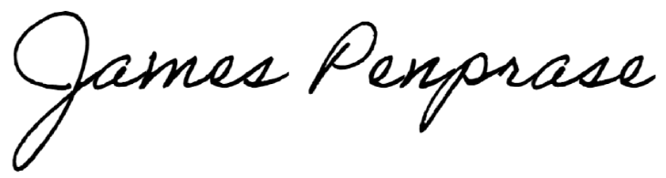
James Penprase
Assistant Secretary
Department of Infrastructure, Transport, Regional Development, Communications and the Arts
10 September 2022

