Reference: OBPR22-02648 Telephone: 6271 6270



e-mail: [helpdesk-obpr@pmc.gov.au](mailto:helpdesk-obpr@pmc.gov.au)

Mr James Penprase Assistant Secretary Media Reform

Department of Infrastructure, Transport, Regional Development, Communications and Arts Dear Mr Penprase

# Regulation Impact Statement – Second Pass Assessment – Remaking the Broadcasting Services Exclusion Determination

Thank you for your letter received on 10 September 2022, submitting a Regulation Impact Statement (RIS) for formal Second Pass Assessment. I note the RIS has been formally certified at your level, consistent with the delegation arrangement under the *Australian Government Guide to Regulatory Impact Analysis* (the Guide).

The Office of Best Practice Regulation’s (OBPR’s) assessment is that the quality of the regulatory impact analysis in the RIS is adequate and therefore sufficient to inform a decision on the proposed Determination.

To be considered ‘good practice’ as per the Guide, the RIS would have benefitted from additional analysis setting out:

* the benefits to community from the Broadcasting Services Act and why those benefits should continue to apply to traditional broadcasters but not providers of internet services;
* a more detailed quantified cost analysis of the market conditions created by the Determination; and
* a more thorough examination of the implementation and evaluation section to articulate next steps in the broader reform.

The RIS may now be provided to the decision-maker to inform a final decision.

# Next steps

We would appreciate you advising us when a final decision has been announced and forwarding a copy of the RIS in a form meeting the Government’s accessibility requirements. The OBPR will publish the RIS, along with your certification and this assessment, on the OBPR’s website https://obpr.pmc.gov.au/.

If you have any further queries, please do not hesitate to contact me. Yours sincerely

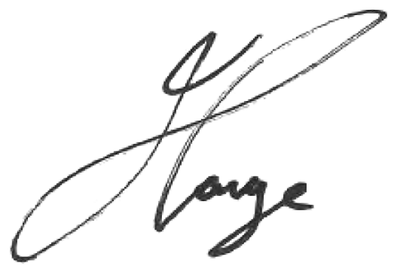

Jason Lange Executive Director 12 September 2022