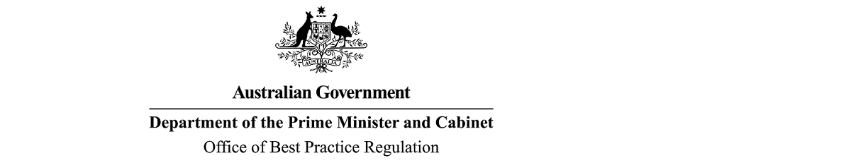

Reference: OBPR22-02423  
Telephone: 6271 6270  
e-mail: [helpdesk-obpr@pmc.gov.au](mailto:helpdesk-obpr@pmc.gov.au)

Ms Laura Berger-Thomson                                                             
A/g Deputy Secretary

Revenue, Small Business and Housing Group  
Department of the Treasury  
  
Dear Ms Berger-Thomson  
  
**Regulation Impact Statement – Second Pass Final Assessment – Regional First Home Buyer Support Scheme**

Thank you for your letter submitting a Regulation Impact Statement (RIS) for formal Second Pass Final Assessment. I note the RIS has been formally certified at the Deputy Secretary level consistent with the Australian Government Guide to Regulatory Impact Analysis. I further note this RIS is an addendum to, and should be read in conjunction with, the ‘Home Guarantee Scheme’ RIS, published 31 March 2022.

I appreciate the Department’s constructive engagement on the RIS. The Office of Best Practice Regulation’s assessment is that the quality of the regulatory impact analysis in the RIS is adequate.

However, I note the very constrained timeframes between the first and second pass assessment of the RIS was not conducive to giving due consideration to feedback on opportunities to improve the RIS to achieve a rating consistent with ‘good practice’.

The RIS may now be provided to the decision maker to inform their decision.

**Next steps**

After a final decision has been announced, I ask that your agency work with OBPR to finalise this material for public release. This includes providing a copy of the RIS in Word and PDF format for web accessibility purposes. The RIS must be included in any Explanatory Memorandum or Statement giving effect to the proposals in the RIS.

If you have any further queries, please do not hesitate to contact me.

Yours sincerely

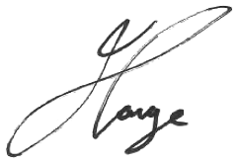

Jason Lange  
Executive Director  
4 August 2022