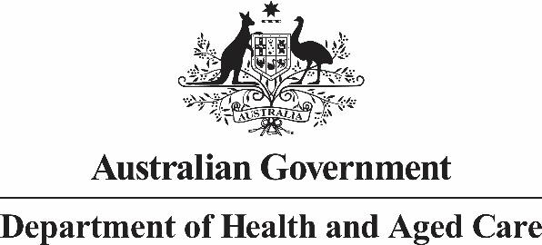

# Deputy Secretary

Mr Jason Lange

Executive Director

Office of Best Practice Regulation

Department of the Prime Minister and Cabinet

1 National Circuit

BARTON ACT 2600

Email: helpdesk-OBPR@pmc.gov.au

Dear Mr Lange

**Certification of independent reviews: Initial response to the Royal Commission (Quality and Safety) -Strengthening providers; New Aged Care Act.**

I am writing to certify that the attached independent review (Attachment A) has undertaken a process and analysis equivalent to a Regulation Impact Statement (RIS) for two aged care quality measures currently being considered by Government:

* the requirement for Registered Nurses (RNs) in residential aged care facilities 24 hours a day, 7 days a week (24/7) and
* increasing care minutes from 200 minutes (including 40 RN Minutes) per resident per day, from 1 October 2022, to 215 minutes (including 44 RN minutes) from 1 October 2024.

With further development of these reforms, anticipated to come into effect from 1 October 2023, a supplementary RIS addressing the implementation and evaluation of these measures is provided.

The Royal Commission into Aged Care Quality and Safety noted that the evidence is compelling that overall staffing levels in aged care are linked to quality of care, and that RN numbers are a particularly important factor in meeting an acceptable quality of care for care recipients.

These documents are submitted to the Office of Best Practice Regulation for the purposes of satisfying the regulatory impact analysis requirements of the Government's ongoing response to the Royal Commission into Aged Care Quality and Safety (Royal Commission).

The scope of the certified reviews covers the scope of the policy proposal, with the exceptions of implementation and evaluation measures. Given the Government's existing commitment to implementation of relevant Royal Commission recommendations, the Department will remain alert to opportunities to embed evaluation into the policy proposal. Therefore, I am satisfied that with this addition, the scope of the certified documents matches the policy proposal and answers six of the seven RIS questions.

The regulatory burden to business, community organisations or individuals is quantified using the Australian Government's Regulatory Burden Measurement framework and is provided below.

I note that the implementation of this proposal will increase the regulatory burden on private and not-for-profit providers. A search was undertaken across the Department, but no offset measures were identified. The Department will remain alert to opportunities to reduce the regulatory burden for affected stakeholders.

**Regulatory burden estimate table**

**Average annual regulatory costs (from business as usual)**

|  |  |  |  |  |
| --- | --- | --- | --- | --- |
| **Change in costs ($ million)** | Business | Community organisations | Individuals | Total change in costs |
| **Total, by sector** | 49 | 82 | 0 | 131 |

Accordingly, I am satisfied that the attached report is consistent with the Australian Government Guide to Regulatory Impact Analysis.

Yours sincerely

Michael Lye

Ageing & Aged Care

July 2022

**Attachment A:** Independent review for certification of ongoing response to the Royal Commission into Aged Care (Quality and Safety)

**Attachment A**

**Independent review for certification of ongoing response to the Royal Commission into Aged Care (Quality and Safety)**

1. Royal Commission into Aged Care Quality and Safety, Counsel Assisting's Proposed Recommendations at Final Hearing, 22 October 2020

Available at: <https://agedcare.royalcommission.gov.au/media/29098>