

BM45122547

Mr Jason Lange

Executive Director

Office of Best Practice Regulation

Department of the Prime Minister and Cabinet

1 National Circuit

BARTON ACT 2600

Email: helpdesk-OBPR@pmc.gov.au

Dear Mr Lange

REGULATION IMPACT STATEMENT FOR EARLY ASSESSMENT

I am writing in relation to the attached Early Assessment Regulation Impact Statement (RIS), prepared for the Explosives Act Thematic Review Project's consideration of reform of the Commonwealth explosives regulatory regime.

I believe the RIS meets the requirements set out in the *Australian Government Guide to Regulatory Impact Analysis* and is consistent with the six principles for Australian Government policy makers.

This Early Assessment RIS is a culmination of detailed analysis of all relevant legislation and subsidiary regulations, as well as close consultation with key stakeholders across government and industry. These activities have occurred as part of the Explosives Act Thematic Review (EATR) Project, which commenced in response to the upcoming sunsetting of the *Explosives Transport Regulations 2002* (Cth) and the *Explosives Areas Regulations 2003* (Cth). The EATR Project has been ongoing since 2019.

In particular, the RIS addresses the first four RIS questions:

l . What is the problem?

The RIS identifies that an ability to access, transport and use explosives in a safe and secure manner is essential for fulfilling the unique operational requirements of the Commonwealth Government Agencies, and may not be best achieved under the current regulatory framework.

1. Why is government action needed?

The RIS sets out four clear objectives for government. Firstly the creation of a Commonwealth explosives regulatory regime with modern, enduring mechanisms for accommodating Australia's strategic needs and responding to evolving risks. Secondly, a reduction in the likelihood of explosives-related safety and security incidents, through increased compliance and independent oversight. Thirdly, a reduction in regulatory burden, resulting in fewer costs, greater clarity, and improved competition across industry. Finally, a reduction in the likelihood of explosives-related safety and security incidents, through the simplification and removal of competing and ambiguous requirements across regulatory jurisdictions.

1. What policy options are you considering?

The RIS considers three viable options. Option l, allows the Transport and Areas

Regulations to sunset (a 'non-regulatory' option). Option 2, maintaining the *Explosives Act 1964* (Cth) in its current form and amending the subsidiary regulations only, represents a light-touch regulatory option. Finally, Option 3 considers the introduction of a new regulatory regime, through amendment to primary legislation, subsidiary regulation, and consequential amendments to other legislative frameworks as required.

1. What is the likely net benefit of each option?

The RIS, at this stage, offers detailed qualitative analysis on the overall impacts and regulatory costs associated with each of the above options. These costs will be quantified in a later version of this RIS, in line with the Regulatory Burden Measurement Framework, and will be supported by insights from relevant stakeholders. In addition, the RIS contains an appropriate consultation plan.

I submit the certified RIS to the Office of Best Practice Regulation for early assessment, consistent with best practice.

Yours sincerely

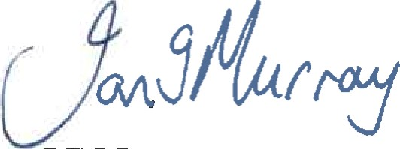

IG Murray

Rear Admiral, RAN

Acting Chief of Joint Capabilities

(02) 6265 6130

8 June 2022