Regulation Impact Statement

Spectrum Pricing Review  
2nd tranche reforms

july 2022

Canberra

Red Building   
Benjamin Offices  
Chan Street   
Belconnen ACT

PO Box 78  
Belconnen ACT 2616

T +61 2 6219 5555  
F +61 2 6219 5353

Melbourne

Level 32   
Melbourne Central Tower  
360 Elizabeth Street   
Melbourne VIC

PO Box 13112  
Law Courts   
Melbourne VIC 8010

T +61 3 9963 6800

Sydney

Level 5   
The Bay Centre  
65 Pirrama Road   
Pyrmont NSW

PO Box Q500  
Queen Victoria Building   
NSW 1230

T +61 2 9334 7700 or 1800 226 667  
F +61 2 9334 7799

Copyright notice

[Creative Commons logo](http://i.creativecommons.org/l/by/3.0/88x31.png)

<https://creativecommons.org/licenses/by/4.0/>

With the exception of coats of arms, logos, emblems, images, other third-party material or devices protected by a trademark, this content is made available under the terms of the Creative Commons Attribution 4.0 International (CC BY 4.0) licence.

We request attribution as © Commonwealth of Australia (Australian Communications and Media Authority) 2022.

All other rights are reserved.

The Australian Communications and Media Authority has undertaken reasonable enquiries to identify material owned by third parties and secure permission for its reproduction. Permission may need to be obtained from third parties to re-use their material.

Written enquiries may be sent to:

Manager, Editorial Services  
PO Box 13112  
Law Courts  
Melbourne VIC 8010  
Email: [info@acma.gov.au](mailto:info@acma.gov.au)

Executive Summary 1

1. What is the policy problem? 3

The administrative pricing formula 4

Addressing pricing deficiencies through analysis and industry feedback 8

2. Why is government action needed? 11

3. What policy options have been considered? 13

Option 1 (Status quo) 13

Option 2 (regulatory change - preferred option) 13

Proposals for updating the tax formula 13

Proposal to reform HPON taxes 22

Proposals to adjust tranche 1 reforms 25

4. Who did you consult and how did you incorporate their feedback? 29

Amalgamate the >30 to 403 MHz range into a single band 29

Increase weightings in high and medium density areas for the >2,690 to 5,000 MHz spectrum location 29

Apply the minimum tax in a new spectrum location band for services above 100 GHz 30

Cease annual CPI updates to taxes, and instead regularly update taxes based on annual population data updates 31

Expand the Perth and Adelaide medium density areas 32

Proposal to reform HPON taxes 33

Proposals to adjust tranche 1 reforms 34

5. What are the expected benefits of the options? 37

Option 1 (Status quo) 37

Option 2 (regulatory change - preferred option) 37

Proposals for updating the tax formula 39

Proposal to reform HPON taxes 42

Proposals to adjust tranche 1 reforms 42

6. What is the best option? 44

7. How will you implement and evaluate your chosen option? 46

Appendix A – Spectrum pricing review recommendations 47

Allocation decisions 47

Market-based allocations 47

Administered allocations 47

Legislative and cost recovery framework 47

Appendix B – Density areas 49

Map legend 49

Appendix C – The administrative pricing formula 50

# Executive Summary

The ACMA has proposed to update a number of existing pricing arrangements for radiocommunications licences following recommendations from the [spectrum pricing review](https://www.communications.gov.au/documents/spectrum-pricing-review) (SPR) made by the Department of Infrastructure, Transport, Regional Development and Communications (the Department), and endorsed by the government in February 2018.

The SPR made 11 recommendations (see **Appendix A**) intended to improve transparency, efficiency, and simplicity of prices (taxes[1]) for radiocommunications licences.

The Australian Communications and Media Authority (ACMA) implemented a [1st tranche of reforms](https://www.acma.gov.au/consultations/2020-12/response-implementation-spectrum-pricing-review-consultation-392020) in July 2021, which included:

guidelines on how the ACMA approaches its spectrum pricing decisions, to improve transparency.

a reduction in taxes based on the tax formula for services above 5 GHz, ranging from 25% to 90% and depending on the frequency range and the type of service. This is intended to provide better incentives for innovative services using large bandwidths in higher frequency ranges.

introducing a ‘systems price’ for earth stations (communicating with satellites) with multiple antennas, with the price more commensurate with the spectrum denial of those systems.

Introducing an additional price discount to enhance spectrum efficiency by encouraging more use of the land-mobile ‘micro’ services.

The ACMA conducted a regulation impact statement (RIS) self-assessment (OBPR reference number OBPR21-01227) that showed that all tranche 1 reforms had the impact of reducing taxes for affected licensees.

The ACMA [consulted on a 2nd tranche of SPR proposals](https://www.acma.gov.au/consultations/2021-10/response-implementation-spectrum-pricing-review-part-2-consultation-382021) in late 2021. The proposals included:

updating the administrative pricing formula by[2]:

simplifying the location weightings tables by consolidating the 3 bands within the >30–403 MHz frequency range into a single band, with a single set of prices.

increasing weightings for the >2,690 to 5,000 MHz spectrum location band for high and medium-density geographic areas to reflect the large increase in demand for this spectrum in these areas and the general increase in prices for similar spectrum.

adding a new spectrum location band >100 GHz where licences will generally incur the minimum tax (currently $41.37), reflecting the lower potential for interference at these higher frequencies, and facilitating the use of new services expected to require very large bandwidths.

changing the method for updating prices each year; cease annual consumer price index (CPI) updates, and instead update taxes based on population growth each year specific to each density areas.

updating density area definitions for Perth and Adelaide.

reducing tax rates for transmitter licences used to provide high-power open narrowcasting (HPON) services, to bring them more in line with commercial broadcasting taxes and charge different tax rates for television, FM and AM HPON licences.

adjusting some tranche 1 reforms based on stakeholder feedback.

Note that the prices for the radiocommunications licences affected by this review and these proposals are established as taxes in the following legislative determinations, thus the tranche 2 SPR reform proposals require amendments to these instruments:

[Radiocommunications (Transmitter licence tax) determination 2015](https://www.legislation.gov.au/Details/F2022C00158); and

[Radiocommunications (Receiver licence tax) determination 2015](https://www.legislation.gov.au/Details/F2021C00512).

The ACMA submitted a preliminary assessment of these proposals to the Office of Best Practice Regulation (OBPR) on 7 September 2021. The OBPR advised that it considered the proposals to be more than minor and that a RIS would need to be prepared.

This RIS details the regulatory analysis and impacts of the tranche 2 proposals and addresses the 7 RIS questions:

1. What is the policy problem?
2. Why is government action needed?
3. What policy options have been considered?
4. What are the expected benefits of the options?
5. Who did you consult and how did you incorporate their feedback?
6. What is the best option from those you have considered?
7. How will you implement and evaluate your chosen option?

The analysis shows that implementing these changes is expected to be net beneficial, however, stakeholder feedback has led to the ACMA modifying these proposals by:

Not proceeding with the proposed price increases in the >2690 to 5000 MHz band, but monitoring the band for any future potential congestion issues.

Implementing the new population-adjustment method for updating prices each year, but providing stakeholders with more information on the approach and consulting before implementing the first priced update based on the new method.

Delaying commencement of new boundaries by 3 years to give licensees some time to prepare for the higher taxes/absorb higher costs.

After taking these changes into account, the ACMA estimates the package of reform proposals to be net beneficial in the order of $1m annually over the next 10 years.

# 1. What is the policy problem?

**Spectrum management and the spectrum pricing review** Spectrum is essential to a digitally networked economy and a major contributor to Australia’s economic and social wellbeing. It is critical infrastructure enabling production for industrial, commercial, educational and other social services. The economic value of Australia’s spectrum to the national economy is estimated to be $177 billion over 15 years.[3]

As technology advances, there are increasingly novel ways to use spectrum to communicate and send information. Sector wide changes are challenging the efficiency, productivity and accessibility of the current arrangements for spectrum management. The extent to which the benefits of spectrum are realised or improved upon will depend in part on the ability of the spectrum management regulatory arrangements to accommodate this rapid technological change and respond to increasing demand.

The last major shift in the way spectrum in Australia is priced and allocated occurred in 1992. Prior to the commencement of the Radiocommunications Act 1992, spectrum was largely allocated through administrative mechanisms. As a finite resource, international regulators agree that a ‘command and control’ approach limits the efficient and flexible use of spectrum. The 1992 Act enabled market-based allocation for the first time. Markets are important in ensuring spectrum is efficiently allocated – that is, producing what society wants, at the least cost, over time as societies and technology change.

Spectrum management has been reviewed at two instances since the hallmark reforms. A Productivity Commission Review in 2002 made recommendations to see further use of the market in allocating spectrum, the majority of which were accepted by the Government at the time. The ensuing 2004 Australian Communications Authority review addressed the implementation of the Productivity Commission’s recommendations.

Incorporation of market-based mechanisms to spectrum allocation has been steady and is well utilised for bands used by mobile communication. Administered pricing mechanisms, in contrast, have remained largely unchanged during this period. The payment structures and taxation arrangements between the licensing systems remain different. While positive progress has been made further work can be done to implement a pricing approach in a consistent manner.

The Department of Communications released its Spectrum Review in March 2015. In August 2015 the Government announced it would implement the recommendations of the review, including agreement to:

1. replace the current legislative arrangements with new legislation that removes prescriptive process and streamlines licensing for a simpler and more flexible framework

better integrate the management of public sector and broadcasting spectrum to improve the consistency and integrity of the framework

review spectrum pricing to ensure consistent and transparent arrangements to support the efficient use of spectrum and secondary markets.

In October 2019 the Government announced that it would take a targeted approach to amending the *Radiocommunications Act 1992*, and the subsequent passage and commencement of the *Radiocommunications Legislation Amendment (Reform and Modernisation) Act 2020* which aimed to streamline and modernise the Radiocommunications Act 1992.

As an adjunct to the Spectrum Review, in 2017 the Department of Communications conducted this [Spectrum Pricing Review](https://www.communications.gov.au/file/34821/download?token=7jbYg1eg), and made 11 recommendations to adjust pricing of spectrum that would improve transparency and efficiency of allocation and use (see **Appendix A** for the SPR background and recommendations). In February 2018, the then Australian Government endorsed the recommendations.

The ACMA addressed a number of these recommendations in 2021 when it implemented a [1st tranche of reforms](https://www.acma.gov.au/consultations/2020-12/response-implementation-spectrum-pricing-review-consultation-392020). The most substantive remaining recommendation for the ACMA is recommendation 7[4], which is the focus of tranche 2 reform proposals and this regulation impact statement (RIS):

SPR Recommendation 7: The ACMA should undertake a detailed review of the administrative pricing formula’s parameters, including density areas, the number of pricing bands, and the number of power categories. The ACMA should implement regular updates to the location and band weightings to reflect changes in density, demography and demand.

The SPR acknowledged the value of the pricing formula in providing consistency, transparent calculations, clear guidelines, and the flexibility to adjust for individual situations. However, it noted that the current formula dates back to 1992, and had mainly been reviewed and changed in a piecemeal fashion since then. Given the age of the formula parameters, the SPR considered it not in line with the contemporary communications environment. Consequently, the SPR recommended the ACMA undertake a detailed review of the formula, including consideration of how the parameters used can be more responsive to the underlying value of the spectrum.

## The administrative pricing formula[5]

The administrative pricing formula is the primary way that the ACMA sets prices (taxes) for allocation of [apparatus licences](https://www.acma.gov.au/apparatus-licences). It is an incentive pricing approach whereby the prices are intended to provide incentives to licensees to only obtain spectrum that they need, and use it efficiently. Generally, the formula sets higher prices in locations of higher density/demand and vice versa. These relative prices can help to manage congestion by smoothing out demand across locations.

The review of the administrative pricing formula is important because it governs the taxes for 80% of the approximately 170,000 apparatus licences currently issued (see table 1)[6]. From a revenue perspective in 2020-21 the ACMA collected apparatus licence tax revenues of $258m. The breadth of the apparatus licence tax formula suggests that formula parameters not optimised for contemporary settings may hinder licensees in their access to spectrum, and consumers that use services with spectrum inputs.

These 170,000 apparatus licences affected by the taxation framework represent a diverse range of stakeholders including amateur licensees, government bodies, technology service firms, television and radio, and mobile network operators. They are affected through the taxes which are levied on the licences they hold with these designed to ensure the efficient pricing and allocation of spectrum.

Whilst the formula has changed over time to accommodate new services and to respond to acute supply and demand mismatches, it has not been holistically reviewed in around 20 years, so a review of it to ensure its overall efficiency is needed. Therefore, updates are required to the current taxing system to best reflect tax rates on licences that enable the most efficient use of spectrum, a limited natural resource.

The implementation of the SPR reforms will impact a subset of licensees subject to the administrative pricing formula since only some aspects of the formula need change (see section 5).

The magnitude of the problem for affected stakeholders can be very significant, given that these licences often form a key component of their operations. For example, mobile network operators cannot operate their key underlying business without the licences required.

1. Apparatus licences covered by the administrative pricing formula

|  |  |  |
| --- | --- | --- |
| **Apparatus licence type[7]** | **number of licences** | **prices derived from the formula?** |
| [Aeronautical - Aeronautical Assigned System](https://web.acma.gov.au/rrl/browse_licences.licence_list?pSV_ID=8&pSS_ID=800) | 2440 | y |
| [Aircraft - Aircraft Assigned](https://web.acma.gov.au/rrl/browse_licences.licence_list?pSV_ID=66&pSS_ID=660) | 11 | y |
| [Amateur - Advanced](https://web.acma.gov.au/rrl/browse_licences.licence_list?pSV_ID=6&pSS_ID=600) | 9694 |  |
| [Amateur - Amateur Beacon](https://web.acma.gov.au/rrl/browse_licences.licence_list?pSV_ID=6&pSS_ID=601) | 43 |  |
| [Amateur - Amateur Repeater](https://web.acma.gov.au/rrl/browse_licences.licence_list?pSV_ID=6&pSS_ID=602) | 510 |  |
| [Amateur - Foundation](https://web.acma.gov.au/rrl/browse_licences.licence_list?pSV_ID=6&pSS_ID=603) | 3149 |  |
| [Amateur - Standard](https://web.acma.gov.au/rrl/browse_licences.licence_list?pSV_ID=6&pSS_ID=604) | 2117 |  |
| [Broadcasting - Cat 3 DRMT](https://web.acma.gov.au/rrl/browse_licences.licence_list?pSV_ID=1&pSS_ID=113) | 8 |  |
| [Broadcasting - Commercial Radio](https://web.acma.gov.au/rrl/browse_licences.licence_list?pSV_ID=1&pSS_ID=108) | 634 |  |
| [Broadcasting - Commercial Television](https://web.acma.gov.au/rrl/browse_licences.licence_list?pSV_ID=1&pSS_ID=109) | 1038 |  |
| [Broadcasting - Community Broadcasting](https://web.acma.gov.au/rrl/browse_licences.licence_list?pSV_ID=1&pSS_ID=110) | 444 |  |
| [Broadcasting - Foundation Cat 1 DRMT](https://web.acma.gov.au/rrl/browse_licences.licence_list?pSV_ID=1&pSS_ID=114) | 13 |  |
| [Broadcasting - HF Domestic Service](https://web.acma.gov.au/rrl/browse_licences.licence_list?pSV_ID=1&pSS_ID=101) | 25 | y |
| [Broadcasting - HF Overseas (IBL) Service](https://web.acma.gov.au/rrl/browse_licences.licence_list?pSV_ID=1&pSS_ID=102) | 10 | y |
| [Broadcasting - Narrowband Area Service station(s)](https://web.acma.gov.au/rrl/browse_licences.licence_list?pSV_ID=1&pSS_ID=104) | 272 | y |
| [Broadcasting - Narrowcasting Service (Fixed Tax) / HPONs](https://web.acma.gov.au/rrl/browse_licences.licence_list?pSV_ID=1&pSS_ID=106) | 237 |  |
| [Broadcasting - Narrowcasting Service (LPON)](https://web.acma.gov.au/rrl/browse_licences.licence_list?pSV_ID=1&pSS_ID=105) | 2462 | y |
| [Broadcasting - Narrowcasting Service Station(s)](https://web.acma.gov.au/rrl/browse_licences.licence_list?pSV_ID=1&pSS_ID=118) | 20 |  |
| [Broadcasting - National Broadcasting](https://web.acma.gov.au/rrl/browse_licences.licence_list?pSV_ID=1&pSS_ID=107) | 1486 |  |
| [Broadcasting - Retransmission](https://web.acma.gov.au/rrl/browse_licences.licence_list?pSV_ID=1&pSS_ID=116) | 1734 |  |
| [Broadcasting - Retransmission (Out of Area)](https://web.acma.gov.au/rrl/browse_licences.licence_list?pSV_ID=1&pSS_ID=117) | 39 |  |
| [Broadcasting - Temporary Community Broadcasting](https://web.acma.gov.au/rrl/browse_licences.licence_list?pSV_ID=1&pSS_ID=119) | 106 |  |
| [Broadcasting - Temporary Transmission](https://web.acma.gov.au/rrl/browse_licences.licence_list?pSV_ID=1&pSS_ID=120) | 1 |  |
| [Datacasting Service Licence - Datacasting](https://web.acma.gov.au/rrl/browse_licences.licence_list?pSV_ID=93&pSS_ID=409) | 80 |  |
| [Defence - Defence](https://web.acma.gov.au/rrl/browse_licences.licence_list?pSV_ID=65&pSS_ID=650) | 78 | y |
| [Defence Receive - Defence Receive](https://web.acma.gov.au/rrl/browse_licences.licence_list?pSV_ID=165&pSS_ID=655) | 4 | y |
| [Earth - Fixed Earth](https://web.acma.gov.au/rrl/browse_licences.licence_list?pSV_ID=9&pSS_ID=900) | 610 | y |
| [Earth - Mobile Earth](https://web.acma.gov.au/rrl/browse_licences.licence_list?pSV_ID=9&pSS_ID=901) | 10 | y |
| [Earth Receive - Earth Receive](https://web.acma.gov.au/rrl/browse_licences.licence_list?pSV_ID=109&pSS_ID=950) | 809 | y |
| [Fixed - Point to Multipoint](https://web.acma.gov.au/rrl/browse_licences.licence_list?pSV_ID=2&pSS_ID=200) | 5378 | y |
| [Fixed - Point to Multipoint - Land Mobile Spec](https://web.acma.gov.au/rrl/browse_licences.licence_list?pSV_ID=2&pSS_ID=201) | 852 | y |
| [Fixed - Point to Multipoint System](https://web.acma.gov.au/rrl/browse_licences.licence_list?pSV_ID=2&pSS_ID=202) | 22 | y |
| [Fixed - Point to Point](https://web.acma.gov.au/rrl/browse_licences.licence_list?pSV_ID=2&pSS_ID=203) | 40698 | y |
| [Fixed - Point to Point (5.8GHz) Band](https://web.acma.gov.au/rrl/browse_licences.licence_list?pSV_ID=2&pSS_ID=204) | 243 |  |
| [Fixed - Point to Point (900MHz STL)](https://web.acma.gov.au/rrl/browse_licences.licence_list?pSV_ID=2&pSS_ID=205) | 495 | y |
| [Fixed - Point to Point (Self Coordinated)](https://web.acma.gov.au/rrl/browse_licences.licence_list?pSV_ID=2&pSS_ID=206) | 899 |  |
| [Fixed - Sound Outside Broadcast](https://web.acma.gov.au/rrl/browse_licences.licence_list?pSV_ID=2&pSS_ID=207) | 27 |  |
| [Fixed - Television Outside Broadcast](https://web.acma.gov.au/rrl/browse_licences.licence_list?pSV_ID=2&pSS_ID=208) | 30 | y |
| [Fixed - Television Outside Broadcast Network](https://web.acma.gov.au/rrl/browse_licences.licence_list?pSV_ID=2&pSS_ID=209) | 4 | y |
| [Fixed - Television Outside Broadcast System](https://web.acma.gov.au/rrl/browse_licences.licence_list?pSV_ID=2&pSS_ID=210) | 1 | y |
| [Fixed Receive - Fixed Receive](https://web.acma.gov.au/rrl/browse_licences.licence_list?pSV_ID=102&pSS_ID=250) | 957 | y |
| [Land Mobile - Ambulatory - Copy](https://web.acma.gov.au/rrl/browse_licences.licence_list?pSV_ID=3&pSS_ID=300) | 203 | y |
| [Land Mobile - Ambulatory - Initial](https://web.acma.gov.au/rrl/browse_licences.licence_list?pSV_ID=3&pSS_ID=301) | 1171 | y |
| [Land Mobile - Ambulatory System](https://web.acma.gov.au/rrl/browse_licences.licence_list?pSV_ID=3&pSS_ID=302) | 13930 | y |
| [Land Mobile - CBRS Repeater](https://web.acma.gov.au/rrl/browse_licences.licence_list?pSV_ID=3&pSS_ID=303) | 1001 | y |
| [Land Mobile - Land Mobile System - > 30MHz](https://web.acma.gov.au/rrl/browse_licences.licence_list?pSV_ID=3&pSS_ID=304) | 57082 | y |
| [Land Mobile - Land Mobile System 0-30MHz](https://web.acma.gov.au/rrl/browse_licences.licence_list?pSV_ID=3&pSS_ID=305) | 3768 | y |
| [Land Mobile - PABX Cordless Telephone Service](https://web.acma.gov.au/rrl/browse_licences.licence_list?pSV_ID=3&pSS_ID=306) | 15 |  |
| [Land Mobile - Paging System - Exterior](https://web.acma.gov.au/rrl/browse_licences.licence_list?pSV_ID=3&pSS_ID=307) | 1468 | y |
| [Land Mobile - Paging System - Interior](https://web.acma.gov.au/rrl/browse_licences.licence_list?pSV_ID=3&pSS_ID=308) | 538 | y |
| [Major Coast Receive - Major Coast Receive](https://web.acma.gov.au/rrl/browse_licences.licence_list?pSV_ID=105&pSS_ID=550) | 17 | y |
| [Maritime Coast - Limited Coast Assigned System](https://web.acma.gov.au/rrl/browse_licences.licence_list?pSV_ID=5&pSS_ID=501) | 1859 | y |
| [Maritime Coast - Limited Coast Marine Rescue](https://web.acma.gov.au/rrl/browse_licences.licence_list?pSV_ID=5&pSS_ID=502) | 469 |  |
| [Maritime Coast - Limited Coast Non Assigned](https://web.acma.gov.au/rrl/browse_licences.licence_list?pSV_ID=5&pSS_ID=503) | 1119 |  |
| [Maritime Coast - Major Coast A](https://web.acma.gov.au/rrl/browse_licences.licence_list?pSV_ID=5&pSS_ID=504) | 4 | y |
| [Maritime Ship - Ship Station Class B Assigned](https://web.acma.gov.au/rrl/browse_licences.licence_list?pSV_ID=67&pSS_ID=670) | 20 | y |
| [Maritime Ship - Ship Station Class B Non Assigned](https://web.acma.gov.au/rrl/browse_licences.licence_list?pSV_ID=67&pSS_ID=671) | 4398 |  |
| [Maritime Ship - Ship Station Class C Assigned](https://web.acma.gov.au/rrl/browse_licences.licence_list?pSV_ID=67&pSS_ID=672) | 6 | y |
| [Maritime Ship - Ship Station Class C Non Assigned](https://web.acma.gov.au/rrl/browse_licences.licence_list?pSV_ID=67&pSS_ID=673) | 627 |  |
| [Outpost - Outpost Assigned](https://web.acma.gov.au/rrl/browse_licences.licence_list?pSV_ID=68&pSS_ID=680) | 8 | y |
| [Outpost - Outpost Non Assigned](https://web.acma.gov.au/rrl/browse_licences.licence_list?pSV_ID=68&pSS_ID=681) | 1974 |  |
| [PTS - PMTS Class B](https://web.acma.gov.au/rrl/browse_licences.licence_list?pSV_ID=10&pSS_ID=125) | 917 |  |
| [PTS - PMTS Class B (870-890 MHz)](https://web.acma.gov.au/rrl/browse_licences.licence_list?pSV_ID=10&pSS_ID=127) | 13 | y |
| [PTS - PMTS Class C](https://web.acma.gov.au/rrl/browse_licences.licence_list?pSV_ID=10&pSS_ID=129) | 1 |  |
| [PTS 900 MHz - PMTS Class B (935-960 MHz)](https://web.acma.gov.au/rrl/browse_licences.licence_list?pSV_ID=110&pSS_ID=150) | 3 |  |
| [Radiodetermination - Radiodetermination](https://web.acma.gov.au/rrl/browse_licences.licence_list?pSV_ID=18&pSS_ID=181) | 3273 | y |
| [Radiodetermination - Radiodetermination - Body Scan](https://web.acma.gov.au/rrl/browse_licences.licence_list?pSV_ID=18&pSS_ID=182) | 1 | y |
| [Scientific - Scientific Assigned](https://web.acma.gov.au/rrl/browse_licences.licence_list?pSV_ID=69&pSS_ID=690) | 46 | y |
| [Scientific - Scientific Non Assigned](https://web.acma.gov.au/rrl/browse_licences.licence_list?pSV_ID=69&pSS_ID=691) | 316 |  |
| [Space - Space](https://web.acma.gov.au/rrl/browse_licences.licence_list?pSV_ID=75&pSS_ID=751) | 163 | y |
| [Space Receive - Space Receive](https://web.acma.gov.au/rrl/browse_licences.licence_list?pSV_ID=175&pSS_ID=756) | 135 | y |
| Total | 172235 | 139874 |
|  |  | 81% |

Data taken from the ACMA register of radiocommunications licences (RRL, <https://web.acma.gov.au/rrl/browse_licences.cat_listing>) on 25 March 2022.

The administrative tax formula covers a range of licence types (shown in the table above) and is used to encourage efficient use of spectrum by setting relatively higher taxes where there is higher demand and higher potential for congestion and interference, and vice versa. It is made up of five elements – location weighting, bandwidth, power, adjustment factors, and the normalisation factor. The annual tax for a particular assigned apparatus licence is calculated by multiplying these relevant formula factors in Table 2.

1. Factors in the administrative pricing formula

|  |  |
| --- | --- |
| **Formula factors** | **Description** |
| Location weightings | Each combination of spectrum location and density areas in (table 3) are assigned a different weighting based on the number of licence assignments, to reflect relative potential for congestion and interference.  The licence will take the relevant location weighting from table 3 as the basis of the tax calculation. |
| Bandwidth | the amount of spectrum used for the service in kHz[8]. |
| Power | Some low power services are eligible for discounts because they are using less spectrum in geographical space. |
| Adjustment factors | allow for tax adjustments for specific technologies and uses not covered by the other factors. For example scientific licences prices are set 90% lower than most licensing options to promote innovation. |
| Normalisation factor | The normalisation factor converts relative spectrum values to a dollar figure. The ACMA currently updates the normalisation factor each year for inflation (using the consumer price index - CPI). |

1. Current location weightings

|  |  |  |  |  |  |
| --- | --- | --- | --- | --- | --- |
|  | **Geographic location / density area** | | | | |
| **Spectrum location** | **Aus-wide** | **High** | **Medium** | **Low** | **Remote** |
| 30 MHz and below | 4.315 | 4.315 | 4.315 | 4.315 | 4.315 |
| >30 to 70 MHz | 9.747 | 3.807 | 2.025 | 0.437 | 0.218 |
| >70 to 399.9 MHz | 10 | 4.104 | 1.878 | 0.421 | 0.21 |
| >399.9 to 403 MHz | 10 | 5.6 | 2.562 | 0.437 | 0.218 |
| >403 to 520 MHz | 10 | 7.4114 | 2.562 | 0.437 | 0 |
| >520 to 960 MHz | 10 | 5.6 | 2.562 | 0.437 | 0.218 |
| >960 to 2,690 MHz | 9.985 | 2.241 | 1.036 | 0.521 | 0.26 |
| >2,690 to 5,000 MHz | 9.974 | 1.853 | 0.751 | 0.622 | 0.311 |
| >5.0 to 8.5 GHz | 8.421 | 1.557 | 0.725 | 0.33 | 0.16 |
| >8.5 to 14.5 GHz | 3.711 | 1.336 | 0.316 | 0.023 | 0.011 |
| >14.5 to 31.3 GHz | 3.711 | 0.988 | 0.217 | 0.023 | 0.011 |
| >31.3 to 51.4 GHz | 1.012 | 0.539 | 0.117 | 0.004 | 0.002 |
| Above 51.4 GHz | 0.1 | 0.01 | 0.01 | 0.001 | 0.001 |

The bandwidth and power factors reflect physical spectrum denial characteristics, location weightings reflect the density of services and demand for spectrum at different frequencies and geographic areas, and adjustment factors allow for tax adjustments for specific technologies and uses not covered by the other factors. The normalisation factor converts relative spectrum values to a dollar figure.

Further detail about the density areas is in **Appendix B**, and more detail about the formula is in **Appendix C**.

## Addressing pricing deficiencies through analysis and industry feedback

During the ACMA’s implementation of the SPR recommendations, the ACMA’s analysis and review of the formula showed that demand for spectrum had changed over time, suggesting that some parameters within the formula (such as the location weightings) should be updated/rebalanced.

For example, in the period from 2005–2020 the ACMA found an acceleration of new assignments in the >2,690 to 5,000 MHz spectrum location for high and medium-density geographic areas, which is significantly higher than in other spectrum locations. The location weightings in the tax formula are intended to provide relative price signals to balance and manage demand before congestion issues become acute, so we proposed to increase prices in the relevant spectrum locations to incentivise licensees to obtain substitute spectrum, where possible, in either lower-density areas or in neighbouring spectrum bands. The rebalancing of demand across spectral and geographic locations through these price changes ensures that spectrum use in these locations are less likely to reach levels that cause harmful interference and a degradation of the utility of spectrum.

The ACMA has also held several consultations seeking feedback on reform proposals and suggestions for further reforms.

In March 2020, the ACMA commenced the consultation process with the publication of the [Implementation of the Spectrum Pricing Review](https://www.acma.gov.au/consultations/2020-02/implementation-spectrum-pricing-review-consultation-072020) (the Consultation Paper). The Consultation Paper outlined the ACMA’s draft Spectrum Pricing Guidelines and several focus areas for reform. The ACMA received a total of 27 submissions. A list of individual submissions can be found in the link above to the Consultation Paper.

In December 2020, the ACMA published its [Response to Implementation of the Spectrum Pricing Review](https://www.acma.gov.au/consultations/2020-12/response-implementation-spectrum-pricing-review-consultation-392020) (the Response Paper) which confirmed the ACMA’s final Spectrum Pricing Guidelines, and detailed the first tranche of reform proposals. The ACMA received a total of 9 submissions (found in the link above). Subsequently, the ACMA implemented tranche 1 reforms, which came into effect on 12 July 2021.

In October 2021, the ACMA published its [Response to the Implementation of the Spectrum Pricing Review (part 2)](https://www.acma.gov.au/consultations/2021-10/response-implementation-spectrum-pricing-review-part-2-consultation-382021) (the Response Paper part 2) which detailed the second tranche of reform proposals concerning the administrative pricing formula (location weightings, geographic areas, the normalisation factor), high-power open narrowcasting licence taxes, and some refinements to tranche 1 reforms.

The ACMA has considered the feedback from submissions in these consultation processes that have helped us formulate policy proposals and refinements. Salient pricing issues raised in submissions included:

Several submissions received in previous SPR consultation processes commented on the discrepancy in tax rates between high-powered open narrowcasting (HPON) licences and comparable commercial broadcasting licences[9]. For example, the current annual HPON tax in Sydney and Melbourne is $41,134, which is up to 5 times more than similar commercial broadcasters pay in the same locales. Addressing this price disparity directly addresses the 2nd recommendation of the SPR (to ensure efficient use of spectrum, the Government and the ACMA should endeavour to charge users of similar spectrum at the same rate).

Submissions from the satellite industry stated that new optical communications systems operating in the very high frequencies (terahertz[10] frequencies) were being developed, and that despite current tax rates above 51.4 GHz being relatively low they were still a barrier for the new technologies using large bandwidths. For example, in a submission to the ACMA in February 2021, Goonhilly Earth Station made representations that it intended to operate an Earth>Space>Earth laser from a medium density location using 3 GHz bandwidth in the terahertz range. Even at the relatively low current tax rate of $0.0028/kHz, the high bandwidth means that the annual tax $16,800 was a barrier to obtaining the licence. Reducing prices in these high frequency bands will reduce these barriers to entry and enhance economic welfare when these new technologies are licensed for this spectrum.

Submissions argued against the normalisation factor on the basis that it was too general in its application for annual CPI updates. They pointed out that licensees in remote areas faced the steady rise in licence prices stemming from these CPI updates, despite the underlying demand and supply factors for spectrum remaining largely unchanged.

The definition of the ‘micro-power spectrum access’ introduced in the first tranche of reforms was not clear. Amending the definition is expected to provide greater clarity about eligibility for licensees.

Stakeholders lobbying for a minor change to the earth station system price introduced in the first tranche. They asked why co-located earth stations operating within the licenced bandwidth but on different centre frequencies[11] could not be included in the system price.

The ACMA developed the 2nd tranche of reforms (see section 3) in response to the SPR recommendations and this stakeholder feedback.

See section ‘4. Who did you consult and how did you incorporate their feedback?’ for more detail about stakeholder feedback.

# 2. Why is government action needed?

The use of spectrum is managed by government regulation because it is a scarce resource and a valuable factor of production that needs to be coordinated to ensure its operational utility (i.e. mitigate the risk of harmful interference). The objective of government in this space is to ensure the efficient allocation and use of spectrum,[12] a limited natural resource.

While markets are important in ensuring the efficient allocation of spectrum, spectrum’s commons nature means that there is a continuing role for governments in spectrum management. Like private goods, one person’s use of spectrum stops somebody else from using it. But unlike private goods where the user is also discernibly in possession of the good to the exclusion of others, it’s difficult to exclude people from using whatever spectrum they desire. In the absence of clear property rights and/or government intervention, there may be overuse, resulting in interference to other users and the [‘tragedy of the commons’](https://www.investopedia.com/terms/t/tragedy-of-the-commons.asp). Government therefore has a role to play in providing orderly and fair access to spectrum, while enabling market forces to operate as much as practicable.

The government’s spectrum management regulations include legislative instruments for spectrum planning, licensing frameworks, pricing structures and compliance and enforcement programs.

Pricing is one of the management tools that the ACMA uses to manage the spectrum in order to maximise its benefit to society.[13] Subsection 7(1) of the *Radiocommunications (Transmitter Licence Tax) Act 1983* and Subsection 7(1) of the *Radiocommunications (Receiver Licence Tax) Act 1983* provides that the ACMA may determine the amount of tax for apparatus licences. The tax levied on apparatus licences allows the ACMA to create economic incentives for efficient use of the spectrum. It also encourages licensees to use the minimum amount of bandwidth for their needs, to move to less congested bands, and to surrender licences that are no longer needed. The ACMA generally seeks to ensure efficient use of spectrum by allocating frequencies to licensees with the greatest willingness to pay. If a tax is too low, licensees with low-value uses can viably occupy frequencies, excluding more economically efficient uses.

The ACMA sets these taxes (prices) for apparatus licences in the following tax determinations:

Radiocommunications (Transmitter Licence Tax) Determination 2015.

Radiocommunications (Receiver Licence Tax) Determination 2015.

The Government’s use of efficient pricing methods can influence the allocation of spectrum between different users. The price determines which user will most likely put the spectrum to the highest value use. Such an approach by government enables the efficient allocation of spectrum while ensuring interference is managed. But spectrum markets and industries using spectrum in downstream markets are dynamic, so these prices need to adjust to changes in these markets over time.

Maintaining the pricing framework so that it is contemporary and relevant for the current technological environment is important for achieving the object of the Act. To date, the ACMA has adjusted prices in a piecemeal fashion, often setting prices for individual services or individual bands. The SPR has highlighted the need for a more holistic review of prices (recommendation 7). The spectrum pricing review and the implementation of amendments to the tax determinations is intended to and expected to enhance the long-term public benefit.

# 3. What policy options have been considered?

## Option 1 (Status quo)

No change. This is not a preferred course since there will be several SPR recommendations and pricing issues unaddressed, leaving potential benefits unrealised and forgoing the opportunity to update and improve the efficiency of prices. Note that section 5 details the costs and benefits of each option.

Regulation is required to alter and update the licensing and pricing framework for spectrum. These are the mechanisms by which the government ensures its efficient use. As such, there are no viable new non-regulatory options to be undertaken.

Notwithstanding, the ACMA has/is addressing a number of the SPR recommendations that don’t require regulation. For example, in the 1st tranche of reforms the ACMA published pricing principles that explain the foundation for the ACMA pricing decisions, providing stakeholders with more transparency about decision-making thereby promoting greater certainty and consistency for licensees (and satisfying SPR recommendation 1).

Similarly, the ACMA is already addressing SPR recommendation 4[14] as part of its normal spectrum management practices by regularly identifying spectrum bands expected to be auctioned and publishing them in the [annual workplan / Five-year spectrum outlook](https://www.acma.gov.au/publications/2021-09/plan/five-year-spectrum-outlook-2021-26).

Furthermore, to enhance transparency the ACMA has rebuilt its publicly available [online tax calculator](https://www.acma.gov.au/apparatus-licence-fee-calculator) and added more transparent features to help stakeholders estimate their likely taxes and explain understand the factors and variables that impact on taxes.[15] Whilst this initiative is not an explicit SPR recommendation, it contributes toward transparency which was one of the five pricing review principles and a recurring theme in the SPR report (see **Appendix A**).

## Option 2 (regulatory change - preferred option)

After reviewing the administrative pricing formula and considering the feedback of stakeholders, the ACMA has identified a number of policy proposals to update the formula, and address the salient pricing issues that stakeholders raised in past consultations. These proposals were published in the [October 2021 response paper part 2](https://www.acma.gov.au/consultations/2021-10/response-implementation-spectrum-pricing-review-part-2-consultation-382021), and are outlined below.

### Proposals for updating the tax formula

The ACMA proposed the following changes to the tax formula and the supporting tax structures:

* Amalgamation of the three spectrum location bands between >30 to 403 MHz to form a single band.
* Increasing weightings for the >2,690 to 5,000 MHz spectrum location band for high and medium density geographic areas to reflect the relatively large increase in demand in this spectrum and higher prices for spectrum in these areas.
* Introducing a new spectrum location band for services above 100 GHz, for which the amount of tax will be the minimum tax payable for any licence (currently, $41.37).
* Ceasing annual consumer price index (CPI) updates to taxes, and instead update taxes based on population growth specific to density areas.

Updating the definitions for Perth and Adelaide medium density areas.

These proposed changes are summarised in the proposed location weightings in Table 4 below. Grey highlighted cells denote changes already made in the first tranche of proposals, orange cells highlight proposed tax increases, and green cells highlight proposed tax decreases. These proposed location weightings can be compared with the current location weightings in Table 5.

1. Proposed location weightings

|  |  |  |  |  |  |
| --- | --- | --- | --- | --- | --- |
|  | **Geographic location / density areas** | | | | |
| **Spectrum location** | **Aus-wide** | **High** | **Medium** | **Low** | **Remote** |
| 30 MHz and below | 4.315 | 4.315 | 4.315 | 4.315 | 4.315 |
| >30 to 403 MHz | 9.747 | 3.807 | 1.878 | 0.421 | 0.21 |
| >403 to 520 MHz | 10 | 7.4114 | 2.562 | 0.437 | 0 |
| >520 to 960 MHz | 10 | 5.6 | 2.562 | 0.437 | 0.218 |
| >960 to 2,690 MHz | 9.985 | 2.241 | 1.036 | 0.521 | 0.26 |
| >2,690 to 5,000 MHz | 9.974 | 2.689 | 1.243 | 0.622 | 0.311 |
| >5.0 to 8.5 GHz | 4.2105 | 0.7785 | 0.3625 | 0.1650 | 0.0800 |
| >8.5 to 14.5 GHz | 0.3711 | 0.1336 | 0.0316 | 0.0023 | 0.0011 |
| >14.5 to 31.3 GHz | 0.3711 | 0.0988 | 0.0217 | 0.0023 | 0.0011 |
| >31.3 to 51.4 GHz | 0.1012 | 0.0539 | 0.0117 | 0.0004 | 0.0002 |
| 51.4 GHz to 100 GHz | 0.01 | 0.001 | 0.001 | 0.0001 | 0.0001 |
| Above 100 GHz | 0 | 0 | 0 | 0 | 0 |

Note: Green cells denote proposed changes to weightings that imply tax reductions. Red cells denote proposed changes to weightings that imply tax increases. Grey cells show weightings that were changed in the 1st tranche of amendments.

1. Current location weightings

|  |  |  |  |  |  |
| --- | --- | --- | --- | --- | --- |
|  | **Geographic location / density area** | | | | |
| **Spectrum location** | **Aus-wide** | **High** | **Medium** | **Low** | **Remote** |
| 30 MHz and below | 4.315 | 4.315 | 4.315 | 4.315 | 4.315 |
| >30 to 70 MHz | 9.747 | 3.807 | 2.025 | 0.437 | 0.218 |
| >70 to 399.9 MHz | 10 | 4.104 | 1.878 | 0.421 | 0.21 |
| >399.9 to 403 MHz | 10 | 5.6 | 2.562 | 0.437 | 0.218 |
| >403 to 520 MHz | 10 | 7.4114 | 2.562 | 0.437 | 0 |
| >520 to 960 MHz | 10 | 5.6 | 2.562 | 0.437 | 0.218 |
| >960 to 2,690 MHz | 9.985 | 2.241 | 1.036 | 0.521 | 0.26 |
| >2,690 to 5,000 MHz | 9.974 | 1.853 | 0.751 | 0.622 | 0.311 |
| >5.0 to 8.5 GHz | 8.421 | 1.557 | 0.725 | 0.33 | 0.16 |
| >8.5 to 14.5 GHz | 3.711 | 1.336 | 0.316 | 0.023 | 0.011 |
| >14.5 to 31.3 GHz | 3.711 | 0.988 | 0.217 | 0.023 | 0.011 |
| >31.3 to 51.4 GHz | 1.012 | 0.539 | 0.117 | 0.004 | 0.002 |
| Above 51.4 GHz | 0.1 | 0.01 | 0.01 | 0.001 | 0.001 |

The following sections provide more detail about these proposals.

#### Amalgamate the >30 to 403 MHz range into a single band

The ACMA proposed to simplify the location weightings table by combining the >30 to 403 MHz range (marked in blue in Table 6 below) into one spectrum location (a single line in the table), and use the lowest common location weighting for each geographic location (see Table 5).

The ACMA proposed this amalgamation because the number of licence assignments in the >30 to 70 MHz range (predominantly land mobile licences) and the >399.9 to 403 MHz range (mostly radiodetermination and fixed services) are much lower than neighbouring bands, and may not justify separate spectrum location weightings.

This view is further supported by the fact that the weightings for these bands differ only marginally with the location weightings for the >70 to 399.9 MHz range (see Table 5).

1. Total assignments (2020)

|  |  |  |  |  |  |  |
| --- | --- | --- | --- | --- | --- | --- |
|  | **Geographic location / density area** | | | | |  |
| **Spectrum location** | **Aus-wide** | **High** | **Medium** | **Low** | **Remote** |  |
| 30 MHz and below | 1,259 | 2,039 | 815 | 10,412 | 10,934 | **25,459** |
| >30 to 70 MHz | 602 | 147 | 28 | 429 | 60 | **1,266** |
| >70 to 399.9 MHz | 560 | 9,836 | 2,337 | 35,307 | 16,392 | **64,432** |
| >399.9 to 403 MHz | 62 | 9 | 8 | 33 | 72 | **184** |
| >403 to 520 MHz | 3,339 | 40,959 | 12,368 | 64,107 | 29,197 | **149,970** |
| >520 to 960 MHz | 10 | 1,738 | 569 | 6,749 | 1,933 | **10,999** |
| >960 to 2,690 MHz | 137 | 572 | 230 | 13,012 | 11,643 | **25,594** |
| >2,690 to 5,000 MHz | 14 | 4,494 | 1,487 | 15,680 | 2,386 | **24,061** |
| >5.0 to 8.5 GHz | 33 | 2,771 | 898 | 26,571 | 7,216 | **37,489** |
| >8.5 to 14.5 GHz | 50 | 3,714 | 1,973 | 28,978 | 4,400 | **39,115** |
| >14.5 to 31.3 GHz | 22 | 6,617 | 2,425 | 15,268 | 3,831 | **28,163** |
| >31.3 to 51.4 GHz | 8 | 4,238 | 81 | 370 | 130 | **4,827** |
| Above 51.4 GHz | 2 | 1,704 | 232 | 784 | 80 | **2,802** |
|  | **6,098** | **78,838** | **23,451** | **217,700** | **88,274** | **414,361** |

#### Increase weightings in high and medium density areas for the >2,690 to 5,000 MHz spectrum location

In addition to examining current assignments, the ACMA looked at assignment trends over time. In the period from 2005–2020 the ACMA found an acceleration of new assignments in the >2,690 to 5,000 MHz spectrum location for high and medium-density geographic areas, which is significantly higher than in other spectrum locations (see Table 7 below).[16] The location weightings in the tax formula are intended to provide relative price signals to balance and manage demand before congestion issues become acute, so we are considering increasing these location weightings. We proposed to increase prices in the relevant spectrum locations to incentivise licensees to obtain substitute spectrum, where possible, in either lower-density areas or in neighbouring spectrum bands.

In addition to these assignment trends and relativities, there are several factors that the ACMA could consider in determining an appropriate location weight. We note that recent high-value auctions in the band for services such as mobile broadband, might suggest a higher opportunity cost. For example, the 3.6 GHz band auction saw starting prices in metro areas set at $0.08/MHz/pop and average prices in the auction of $0.29/MHz/pop. These are relative price increases when compared to the $0.03/MHz/pop set by the Minister for Communications, Information Technology and the Arts for the reissue of spectrum licences in the 3.4 GHz band.

Consequently, given the information to date about assignments and demand for spectrum in the >2,690 to 5,000 MHz band, the ACMA proposed raising the weightings for high and medium-density areas relative to other bands to reflect contemporary spectrum uses and values.

1. Changes in assignments by location weighting over time (2005–20)

|  |  |  |  |  |  |  |
| --- | --- | --- | --- | --- | --- | --- |
|  | **Geographic location / density area** | | | | |  |
| **Spectrum location** | **Aus-wide** | **High** | **Medium** | **Low** | **Remote** |  |
| 30 MHz and below | 98% | 108% | 19% | 93% | 102% | 94% |
| >30 to 70 MHz | 98% | -60% | -64% | -27% | 36% | -8% |
| >70 to 399.9 MHz | 42% | 32% | 16% | 28% | 5% | 21% |
| >399.9 to 403 MHz | 1450% | 50% | 0% | 18% | -28% | 26% |
| >403 to 520 MHz | 101% | 42% | 33% | 24% | 30% | 32% |
| >520 to 960 MHz | 43% | -90% | -85% | -72% | -74% | -80% |
| >960 to 2,690 MHz | 76% | 10% | -4% | 209% | 42% | 93% |
| >2,690 to 5,000 MHz | 133% | 1287% | 1806% | 704% | 540% | 781% |
| >5.0 to 8.5 GHz | 3% | -21% | -5% | 63% | 113% | 55% |
| >8.5 to 14.5 GHz | -38% | 35% | 100% | 496% | 522% | 317% |
| >14.5 to 31.3 GHz | 267% | -64% | -57% | 78% | 184% | -17% |
| >31.3 to 51.4 GHz | 60% | -9% | -91% | -32% | 150% | -22% |
| Above 51.4 GHz | - | 879% | - | 4256% | - | 1359% |
|  | 90% | -8% | -5% | 49% | 35% | **42%** |

Note: The dark red in the Table 4 colour scheme denotes the highest increases; the darkest green denotes the largest reductions; the yellow denotes the midpoint, and shades between these colours denote grades between these points.

#### Apply the minimum tax in a new spectrum location band for services above 100 GHz

The ACMA proposed to create a new band above 100 GHz and set tax rates for these services at the minimum tax (currently $41.37). Submissions demonstrate that there are innovative services emerging in these high frequencies (such as optical communications for satellite services) that operate with very large bandwidths, although with a limited spectrum denial/geographical footprint[17]. Even with the tax reductions of 90% implemented above 8.5 GHz as part of the first tranche of tax reforms, services with bandwidths in the tens or hundreds of GHz have the potential for licence taxes to be prohibitive and stifling of innovation in this to date unused band.

A new band above 100 GHz is consistent with recent activity in other jurisdictions including the United Kingdom and United States to facilitate greater access to frequencies above this range. Charging the minimum tax in this band also acknowledges lower potential for interference in this range.

#### Cease annual CPI updates to taxes, and instead regularly update taxes based on annual population data updates

In the assigned licence tax formula, the normalisation factor is a constant that converts the relative spectrum values provided by the rest of the formula to a dollar figure. The ACMA has updated it in line with adjustments to the consumer price index (CPI) each year, with the aim of keeping licence taxes constant in real terms.

One of the issues with this approach to updating taxes is that it treats all licences equally regardless of the different demand for spectrum in different areas. This was highlighted by stakeholders in lower-density areas continuing to face increases on their licence taxes despite spectrum availability remaining high, and there being limited or no change to the spectrum denial characteristics of their spectrum use.

Based on this feedback, the ACMA considers that a better approach to regularly updating taxes is to link tax updates with underlying changes in population, rather than CPI, because population is a good proxy for spectrum demand. The following maps of Australia show this relationship. Figure 1 shows the population density of Australia and Figure 2 shows the spectrum density that accords well with population.

Figure 1: population density

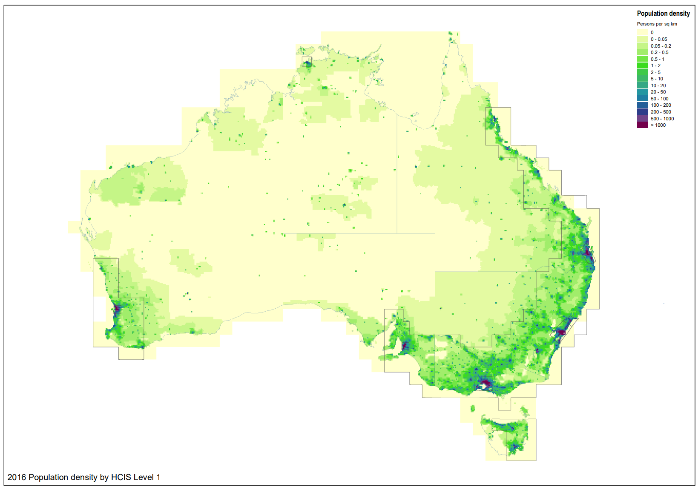

Figure 2: spectrum density

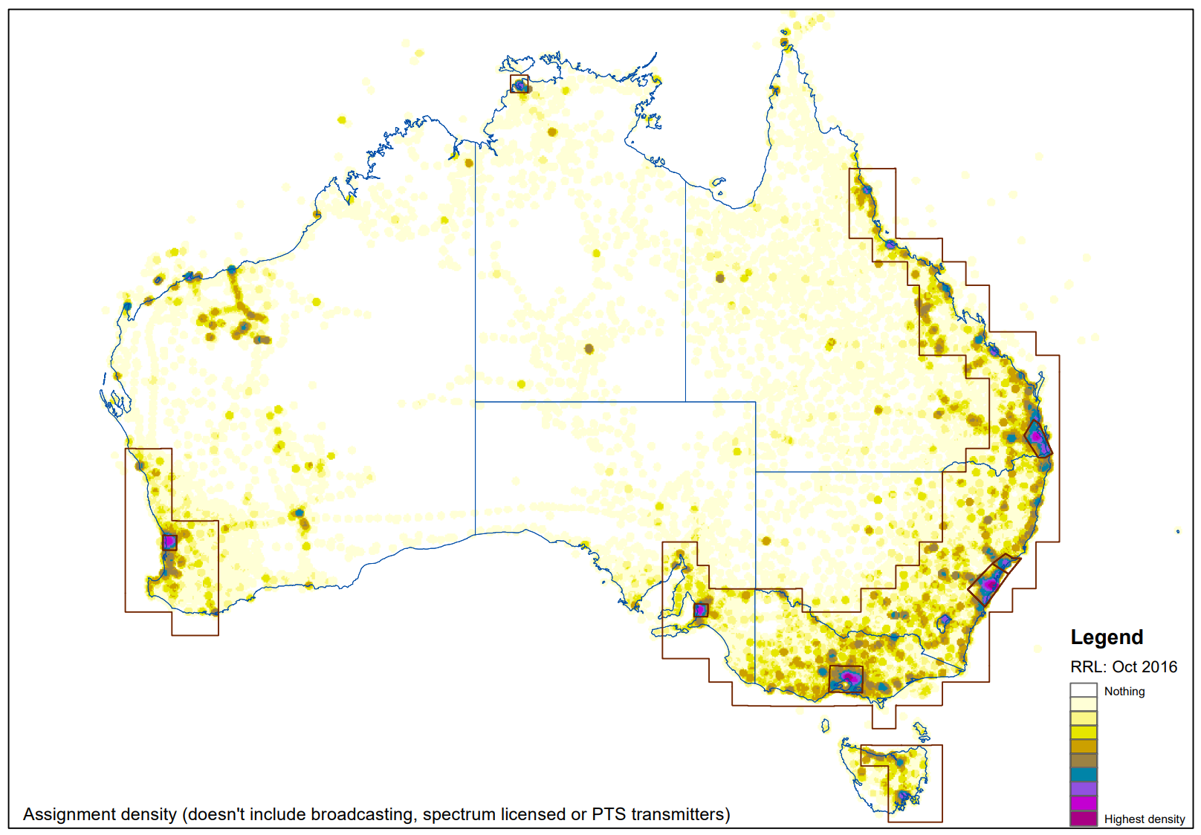

The ACMA’s proposed approach to updating taxes includes the following:

Removing the link between the normalisation factor and adjustments to CPI.

Introducing unique normalisation factors for high, medium, low and remote-density areas and Australia-wide linked to adjustments in population.

Adjusting each normalisation factor annually on a more granular level by changes in area-specific population for each density classification.

Using Australian Bureau of Statistics (ABS) dataset ‘Population estimates by significant urban areas’ to track annual changes in area-specific population.

These proposals will smooth annual changes to taxes since annual changes in population are more stable than CPI, and better reflect changes in demand for spectrum, since population is a good proxy for spectrum demand. Table 8 below shows that if we were to use the proposed ‘population-adjusted’ method, then the change in tax between the years 2010 and 2020 implied for each density area classification would be more granularly applied/targeted, reflecting that underlying change in population specific to each density area. This is compared to the uniform change across all density areas of 19.35% over the same period using CPI.

If these population changes move along a similar trajectory in future, adjusting prices based on population changes will mean that tax increases will be applied where there is higher likelihood of underlying demand for spectrum.

1. Population growth by density area (2010–20)

|  |  |  |  |  |
| --- | --- | --- | --- | --- |
| **Geographic location / density area** | | | | |
| **Australia-wide** | **High** | **Medium** | **Low** | **Remote** |
| 16.64% | 21.69% | 14.68% | 12.20% | 6.58% |

#### Expand the Perth and Adelaide medium density areas

Geographic density area classifications are used in tandem with location weightings to determine the tax for apparatus licences. Each geographic location in Australia is assigned a density of either high, medium, low, or remote, reflecting their spectrum and population densities, which then informs which location weighting is applicable when calculating taxes due. See **Appendix B** for density area details.

The ACMA has reviewed the density areas and considers that they continue to be useful in providing incentives for efficient spectrum uses by setting relatively higher taxes where there is higher demand and higher potential for congestion and interference, and vice versa.

However, it was apparent that there are some anomalies with how the density areas are defined. One observation is that the current Perth and Adelaide medium-density areas (see Figure 3 below) are drawn relatively close to their suburban boundaries, and do not capture the urban growth and increased density that has occurred in recent years. This is in stark contrast to the Melbourne, Sydney, and Brisbane high-density areas that are significantly larger and include the growth in these cities in the last two decades. For reference, the Adelaide area covers 3,179 sqm and the Perth area covers 3,852 sqm, while the Melbourne area covers 15,524 sqm and the Sydney area covers 15,538 sqm.

Figure 3: Current boundaries for Adelaide and Perth   
(classified as medium-density areas)

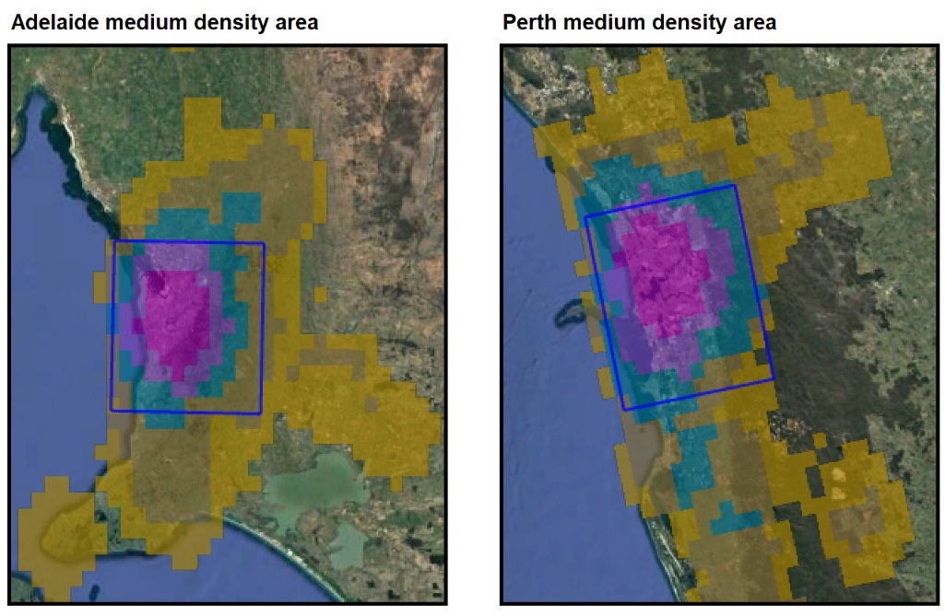

As a result of the current application of medium density, Perth and Adelaide stand out as anomalies when mapping each density area against total assignment density and population density. Given current geographic area classifications, Perth and Adelaide both have higher population density and assignment density compared to the high-density areas of Melbourne, Sydney, and Brisbane (see Figure 4 below).

Figure 4: Current transmitter and population density

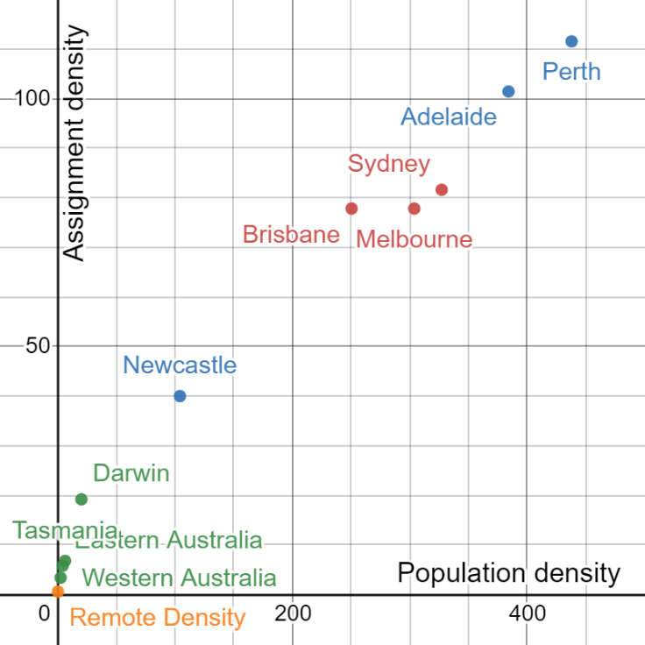

To align the densities of each of the areas and provide more coherent tax relativities, the ACMA proposed the following:

Increase of the geographic area for Perth and Adelaide to reflect the growth of these cities (primarily to the north and south of each city).

The proposed boundaries cover an area more comparable to Melbourne, Sydney and Brisbane. In redrawing these boundaries, the medium-density cities of Perth, Adelaide and Newcastle now have similar densities that cluster together below the high-density cities of Melbourne, Sydney and Brisbane (see Figure 5 below for proposed Adelaide and Perth areas, and Figure 6 for the new expected relative densities).

Publish the population density and assignment density metrics that we use to classify geographic areas. These metrics are intended to provide transparency of the density area definitions, and provide greater certainty for existing and potential licensees.

Figure 5: Proposed boundaries for Adelaide and Perth   
(classified as medium-density areas)

Figure 3: Proposed boundaries for Adelaide and Perth 
(classified as medium-density areas)


Figure 6: Proposed transmitter and population density

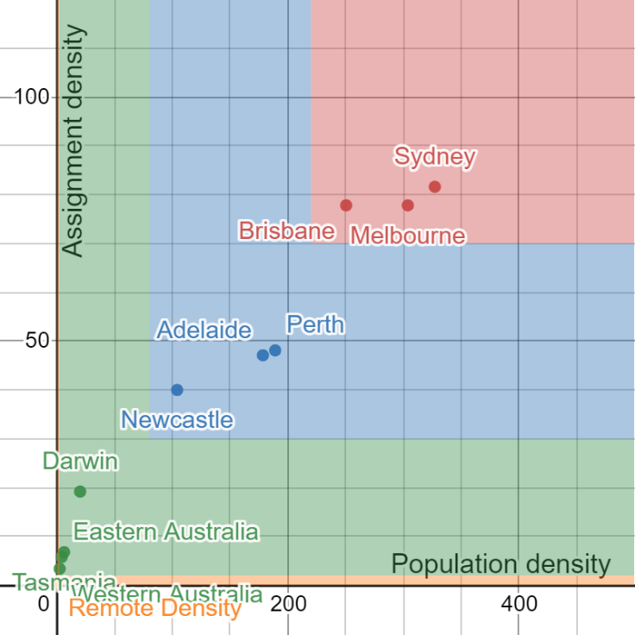

The ACMA proposes to classify geographic areas using the following metrics for population density and assignment density:

High-density areas are defined as an area with a population density of greater than 220 people per square km and an assignment density of greater than 70 per square km (red area in Figure 6).

Medium-density areas are defined as an area with a population density greater than 70 people per square km and an assignment density of greater than 30 per square km, that does not meet the definition of a high-density area (blue area in Figure 6).

Low-density areas are defined as an area with a population density greater than 2 people per square km and an assignment density of greater than 2 per square km, that does not meet the definition of either medium or high-density area (green area in Figure 6).

Remote-density areas are defined as areas that do not meet the definition of low, medium, or high-density areas (small orange area in the lower part of Figure 6).

The ACMA believes that these proposed changes provide a logical framework for the density areas. However, we acknowledge that this is complex and may not fully account for potential spectrum denial of services which can be influenced by different technologies, geography and topography. As such, it is difficult to have a completely formulaic approach to the setting of geographic density areas.

### Proposal to reform HPON taxes

One of the salient pricing issues that stakeholders highlighted in submissions to the ACMA, was the disparity of taxes for high-powered open narrowcasting (HPON) licences.

Narrowcasting services[18] are broadcasting services which are limited in reception in one or more ways, including by being targeted to special interest groups or intended for limited geographical locations.

For example, reception may be limited because the program content is:

targeted to special interest groups – for example, people choosing to follow a particular religion

intended for reception in limited locations – for example, arenas or business premises

provided during a limited period to cover a special event – for example, a community fair

of limited appeal – for example, a language program other than English.

HPON licences are transmitter licences which authorise the operation of a transmitter for the provision of an open narrowcasting service at a maximum power which exceeds:

if the transmitter is operated in a residential area – 1 watt;

if the transmitter is operated in a non-residential area – 10 watts.

The ACMA currently applies generally applies higher tax rates for more populated locations (see table 9 below). We also apply the same tax rate regardless of whether services are FM or AM. Several submissions commented on the discrepancy in tax rates between HPON licences and comparable commercial broadcasting services[19] using similar spectrum. Current HPON licence tax rates are, at times, orders of magnitude higher than those charged for commercial broadcasting services.

1. Current HPON taxes

|  |  |
| --- | --- |
| **Location** | **HPON tax** |
| Sydney | $41,134 |
| Melbourne | $41,134 |
| Brisbane | $14,930 |
| Adelaide | $14,930 |
| Perth | $14,930 |
| Perth city | $14,930 |
| Newcastle | $3,809 |
| Canberra | $3,809 |
| Wollongong | $3,809 |
| Gold Coast | $3,809 |
| Gosford | $3,809 |
| Penrith | $3,809 |
| Hobart | $1,677 |
| Geelong | $1,677 |
| Nambour | $1,677 |
| Townsville | $1,677 |
| Cairns | $1,677 |
| Elsewhere | $989 |

HPONs provide broadcasting services using similar spectrum, but are taxed via different regulation. Commercial broadcasting services are taxed under the *Commercial Broadcasting (Tax) Act 2017*, whereas HPON services are taxed under the *Radiocommunications (Transmitter Licence Tax) Act 1983* and the *Radiocommunications (transmitter licence tax) determination 2015*.

One of the key recommendations of the SPR was that services using similar spectrum should be charged a similar tax rate. Consequently, the ACMA proposes to reduce HPON taxes to bring them closer in line with commercial broadcasting taxes. The proposal specifically includes:

Identifying the location served by a HPON licence using significant urban areas as defined by the ABS.

Updating HPON licence tax rates by aligning them with the commercial broadcasting taxes (CBT). We use a $0.077/MHz/pop price (which approximates current CBT price levels) that can be easily translated to HPON licences using the formula:

Population (of the specific locations) x Bandwidth (MHz) x $0.077/MHz/pop x 0.1 Scaling factor.

The scaling factor is used to scale down the tax to individual HPON licences.

Distinguishing between television (7 MHz), FM (200 kHz) and AM (18 kHz) tax rates to adjust for the different bandwidth.

Changing the minimum tax to $41.37 in line with other apparatus licence taxes.

Using ABS dataset ‘Population estimates by significant urban areas’[20] to update the tax rates each year, instead of CPI.

These proposals are summarised in Table 10 below.

1. Proposed HPON taxes

|  |  |  |  |
| --- | --- | --- | --- |
| Item | Location of open narrowcasting service (significant urban area) | FM/TV[21] | AM |
| 1 | Melbourne | $7,653 | $689 |
| 2 | Sydney | $7,649 | $688 |
| 3 | Brisbane | $3,813 | $343 |
| 4 | Perth | $3,209 | $289 |
| 5 | Adelaide | $2,091 | $188 |
| 6 | Gold Coast – Tweed Heads | $1,093 | $98 |
| 7 | Newcastle – Maitland | $767 | $69 |
| 8 | Canberra – Queanbeyan | $716 | $64 |
| 9 | Sunshine Coast | $536 | $48 |
| 10 | Central Coast | $519 | $47 |
| 11 | Wollongong | $476 | $43 |
| 12 | Geelong | $435 | $41 |
| 13 | Hobart | $337 | $41 |
| 14 | Townsville | $282 | $41 |
| 15 | Cairns | $239 | $41 |
| 16 | A place in Australia not otherwise specified in this table | $41 | $41 |

### Proposals to adjust tranche 1 reforms

Since implementing the first tranche of reforms, the ACMA received useful additional feedback on them. Consequently, we proposed some changes to the tranche 1 reforms by amending the definition of low-power and micro-power spectrum accesses, and allowing for more flexible system configurations eligible for the ‘system price’.

#### Definitions of low-power and micro-power spectrum accesses

The ACMA introduced a tax discount for ‘micro-power spectrum access’ in the first tranche of reforms. In doing so, we updated the definition of the ‘low-power spectrum access’ for consistency of wording across the two service models. However, we have received feedback that the new definitions were unclear.

Our intent was and continues to be that the low-power discount (90% discount) applies to the low-power land mobile radio system (LPMRS) service model, and the ‘micro-power’ discount (95% discount) applies to the ‘Enclosed and short-range digital service model’ (see Table 11 below, and see [Radiocommunications Assignment and Licensing Instruction (RALI) LM8](https://www.acma.gov.au/publications/2019-09/publication/rali-lm8-land-mobile-service) for detail of the service models). The intent is that, for those services that use a low power and for which the licensee acknowledges that interference protection will be limited to a small radius, a discount will be applied to the tax rates.

1. Land mobile services models and price factors

|  |  |  |  |
| --- | --- | --- | --- |
| **Land mobile service model** | **Notional service area radius (km)** | **Reuse distance (km)** | **Price factor** |
| Land mobile radio systems (LMRS) | 40 | ~100 | 1 |
| Low-power land mobile radio systems (LPMRS) | 2 | 10 | 0.1 |
| ‘Micro’ model  (Enclosed and short-range digital service) | 0.2 | 0.5 | 0.05 |

The ACMA received feedback that the current definition (introduced in 2021 as part of the 1st tranche of SPR reforms) was confusing for current assignment practice. Consequently, the ACMA proposed the revised definitions below which are more in line with the definitions before implementation of tranche 1 and clearer for current assignment practice.

**Current definitions (see Dictionary in the** [**Radiocommunications (Transmitter Licence Tax) Determination 2015, compilation no. 15**](https://www.legislation.gov.au/Details/F2022C00158)**):**

***micro power spectrum access*** means a spectrum access that:[22]

(b)    permits the operation of 1 or more devices:

(i)        each with a maximum permitted radiated power level of 1.7 watts EIRP; and

(ii)      radio emissions from each of which do not, or are not likely to, cause interference to radiocommunications at any point more than 200 metres from:

(A)       if the spectrum access involves a particular site – that site; or

(B)       if the spectrum access involves a particular area – the centre of that area.

***low power spectrum access***means a spectrum access that:[23]

(b)    permits the operation of 1 or more devices:

(i)        each with a maximum permitted radiated power level of 8.3 watts EIRP; and

(ii)       radio emissions from each of which do not, or are not likely to, cause interference to radiocommunications at any point more than 2 kilometres from:

(A)    if the spectrum access involves a particular site – that site; or

(B)     if the spectrum access involves a particular area – the centre of that area; and

(c)    is not a micro power spectrum access.

**Proposed definitions:**

***micro power spectrum access*** means a spectrum access that:

(b) permits the operation of 1 or more devices, each with a maximum permitted radiated power level of 1.7 watts EIRP; and:

(ba) is authorised under a licence in relation to which either:

(i) the applicant, in its application for the licence; or

(ii) the licensee, in writing given to the ACMA;

requests that the ACMA treats the licence as having a notional service area that consists of every point no more than 200 metres from:

(iii) if the spectrum access involves a particular site – that site; or

(iv) if the spectrum access involves a particular area – the centre of that area; and

Note: For paragraph (ba):

* a request of an applicant or a licensee may be made, on their behalf, by an accredited person;
* no form of words is prescribed or required to be used for making the request;
* the ‘notional service area’ is used by the ACMA and accredited persons in planning and coordinating radiocommunications.

***low power spectrum access***means a spectrum access that:[24]

(b) permits the operation of 1 or more devices, each with a maximum permitted radiated power level of 8.3 watts EIRP; and:

(ba) is authorised under a licence in relation to which either:

(i) the applicant, in its application for the licence; or

(ii) the licensee, in writing given to the ACMA;

requests that the ACMA treats the licence as having a notional service area that consists of every point no more than 2 kilometres from:

(iii) if the spectrum access involves a particular site – that site; or

(iv) if the spectrum access involves a particular area – the centre of that area; and

Note: For paragraph (ba):

* a request of an applicant or a licensee may be made, on their behalf, by an accredited person;
* no form of words is prescribed or required to be used for making the request;
* the ‘notional service area’ is used by the ACMA and accredited persons in planning and coordinating radiocommunications.

#### Adjustment to the earth station systems price

In tranche 1 the ACMA also introduced a ‘systems' price for apparatus licences with multiple co-located co-frequency earth stations (GSO or NGSO)[25] communicating with related satellite systems filed with International Telecommunication Union, without incurring a higher rate of tax.

The ACMA received feedback from stakeholders asking why co-located earth stations operating within the licenced bandwidth but on different centre frequencies could not be included in the system price. We agree that these earth stations should be included, so we propose removing the clause requiring earth stations to have the same centre frequency to be eligible for the discount.

**Current clause (see clause 804AA in the** [**Radiocommunications (Transmitter Licence Tax) Determination 2015, compilation no. 15**](https://www.legislation.gov.au/Details/F2022C00158)**):**

                     (b)  each of the co-located earth stations is authorised to operate:

                              (i)  on the one centre frequency; and

                             (ii)  using the same bandwidth.

**Proposed clause:**

(b) the spectrum access for each of the co-located earth stations is within a frequency range within which the licence authorises the operation of a radiocommunications transmitter.

We expect that the proposed change will allow for more flexibility with earth station system configurations.

# 4. Who did you consult and how did you incorporate their feedback?

As mentioned in section 1 the ACMA has consulted on a number of aspects of its implementation of the SPR. This includes the ACMA consulting on tranche 2 proposals in October 2021 in its [Response to the Implementation of the Spectrum Pricing Review (part 2)](https://www.acma.gov.au/consultations/2021-10/response-implementation-spectrum-pricing-review-part-2-consultation-382021) (the Response Paper part 2).

The ACMA received [10 submissions](https://www.acma.gov.au/consultations/2021-10/response-implementation-spectrum-pricing-review-part-2-consultation-382021#submissions). This section provides detail about those submissions and how the ACMA has considered that feedback.

### Amalgamate the >30 to 403 MHz range into a single band

The ACMA received two submissions that commented on the proposal to amalgamate some location weightings, both of which were supportive.

*The proposal to amalgamate location weightings is supported.*

* DB Telecommunications supports the proposed of bands in the range 30 to 403 MHz for licence tax purposes. (DB Telecommunications)
* We see no issues involved in this proposed change. (Australian Radio Communications Industry Association)
* No submissions disagreed or opposed the proposal.

### Increase weightings in high and medium density areas for the >2,690 to 5,000 MHz spectrum location

The ACMA received two submissions that commented on the proposal to increase some location weightings, one of which was supportive and another not supportive.

*The proposed increase will cause an unbalanced additional cost for satellite services provided to remote areas.*

* We believe the proposed increase in the location weightings for FSS services provided in this frequency range should not be applied to high and medium-density areas as it will cause an unbalanced additional cost for satellite services provided to remote areas. The ACMA should instead consider applying the same fees established for low density areas to high and medium density areas for satellite services in the greater than 2,690 to 5,000 MHz range or at least the same fees as established for above 5,000 MHz. (Communications Alliance – SSWG)

*The proposed increase should assist in reducing congestion.*

* Optus supports changes that seek to optimise the use of spectrum in high demand frequency ranges. Optus considers that the proposed changes should assist in reducing the potential for congestion in the >2,690 to 5,000 MHz range and ultimately supporting any reallocation of key spectrum to maximise its use for 5G services. Accordingly, Optus supports the ACMA’s proposed changes to the location weightings in these spectrum locations. (Optus)
* The remaining submissions did not comment on this proposal.

**ACMA response:**

The ACMA does not intend to proceed with the proposed increase. After receiving submissions we relooked at assignment levels in the band. Updated analysis shows that growth in the band in recent years had been driven by NBN PMTS Class B licences in the 3.4 GHz band. These licences have since been converted to spectrum licences and the number of frequency assignments for apparatus licences in this band have returned to levels seen in the early 2000s.

The ACMA is also currently administering a number of large changes in this band including the recent conversion of NBN’s 3.4 GHz licences to spectrum licences, future allocation of new spectrum licences, and future allocation of area-wide licences (AWLs) later in 2022. Consequently, the ACMA prefers to monitor the band to see where licence assignments stabilise.

### Apply the minimum tax in a new spectrum location band for services above 100 GHz

The ACMA received four submissions that commented on the proposal to set services above 100GHz at minimum tax, all of which were supportive.

*Applying the minimum tax to services above 100GHz is appropriate.*

* Given the limited communications distances that will apply to services above 100 GHz and the greater scope for frequency re-use, DB Telecommunications believes that it would be appropriate to set the licence tax at the minimum level for these services. DB Telecommunications does not believe that it should be necessary to restrict the minimum tax to particular technologies or types of services. Perhaps services above 100 GHz could be classified as self-coordinated, in a similar vein to millimetre wave services in the 57 to 86 GHz range. (DB Telecommunications)
* A fee-free structure for greater than 100 GHz would seem appropriate provided it is supported with a form of technical structure that would ensure a single or a few applications would not prevent others from operating. 100 GHz is at such a high frequency, that antenna performance is excellent and propagation losses are high. Provided some power limits are adopted that would allow economic use of the band there is no reason to limit the minimum tax to optical devices. (Communications Alliance – SSWG)
* Optus supports the proposal to create a new band above 100 GHz and set tax rates for these services at the minimum tax rate. Optus agrees there is a lower interference potential in these frequency ranges and considers that the proposed amendment will facilitate greater access to frequencies above 100 GHz and ultimately support the business case for technology onboarding in high band spectrum across Australia. Optus notes that, in general, 100 GHz is at such a high frequency, antenna performance is excellent and propagation losses are high, so provided some power limits are adopted that allow economic use of the band, Optus considers there may be no reason to limit use to optical devices. (Optus)
* ANU InSpace welcomes the proposal to introduce a new spectrum location band for services above 100 GHz with a tax rate at the minimum tax. However, there is still a significant disparity between ACMA's treatment of optical communications spectrum compared to that of other countries and the International Telecommunications Union (ITU). ACMA regulates and taxes spectrum up to 420 THz, whereas the ITU only regulates for frequencies up to 3 THz. While the proposed minimum tax for the new >100 GHz band is a positive step forward, the requirement to apply for a licence still places a burden on companies and universities wanting to establish optical ground stations in Australia that is not present in other countries. (ANU Inspace).

### Cease annual CPI updates to taxes, and instead regularly update taxes based on annual population data updates

The ACMA received seven submissions that commented on the proposal to replace the use of CPI with population data in updating the normalisation factor each year. Of the submissions received, five were supportive and two were unsupportive.

*The proposal to use population data to update the normalisation factor is appropriate and supported.*

* nbn supports the proposed method to update taxes by reference to population change based on the available information. We note that nbn is required under the satellite class licensing regime to acquire Australia-wide licences for our space stations given the need to generally ensure coverage to Australians where other nbn technologies are not available. (nbn)
* ANRA supports the removal of CPI and the use of ABS dataset ‘Population estimates by significant urban areas’ to update the tax rates each year where the HPON LAP covers the whole of the licensed city/town. It should be noted that there are some HPON services that only cover a portion (half or third) of the city or town and, therefore, this should be taken into account when determining the population. (Australian Narrowcast Radio Association)
* We support the removal of CPI as noted in ANRA’s submission. (Sports Entertainment Network)
* This is in line with our support of $/MHz/pop fee structures for area-based licensing. Therefore, the SSWG supports this approach. (Communications Alliance – SSWG)

*The ACMA should provide greater transparency with regards to exactly how the normalisation factor will be updated.*

* While Optus agrees in principle that the introduction of normalisation factors reflecting local population density and ultimately spectrum demand should help promote the efficient use of spectrum, this support is conditional on the ACMA providing greater transparency over what the normalisation factors will be and how the annual adjustments may be made and communicated. (Optus)

*The proposal has the potential to significantly increase fees in high and medium density areas and thus there are strong reservations.*

* DB Telecommunications has strong reservations about the proposed changes. Unlike services such as cellular mobile networks servicing the mass consumer market, DB Telecommunications does not believe that the demand for spectrum for land mobile services and the like can be as easily correlated to changes in population density. Linking licence tax increases to population changes has the potential to significantly increase licence fee costs in high density areas, which could begin to significantly impact the economic viability of these businesses. (DB Telecommunications)
* We have serious concerns around this proposal. It would almost seem as though the ACMA have decided that after several years of small increases in CPI factors that there needs to be an alternate measuring methodology to give greater income from the spectrum. There are also serious concerns regarding the fact that proposed licence fee increases will be based on reference to population density which is not a factor in any/many other relevant calculations. The CPI reference is utilised in almost every commercial contract and is a reference that is easily available. (Australian Radio Communications Industry Association)

**ACMA response:**

The ACMA has decided to implement the proposed approach to updating taxes based on population changes.

The ACMA acknowledges the concern that some stakeholder have expressed about potentially higher taxes in some areas under the proposed methodology over some periods, however, the long-term data (see figure 7 in section 5) shows that it is unlikely for the proposed methodology to result in relatively higher taxes in the long term. The ACMA will also provide more information on the approach in a consultation paper when implementing the first priced update based on the new method.

If it becomes apparent that the new methodology is consistent producing higher taxes, then the ACMA may relook at the approach.

### Expand the Perth and Adelaide medium density areas

The ACMA received five submissions that commented on the proposal to expand the Perth and Adelaide medium density areas, one of which was supportive and four of which were neutral.

*The proposal to expand Perth and Adelaide medium density areas is appropriate and supported.*

* nbn supports the proposed density area framework, density area definitions and changes to the Perth and Adelaide medium-density areas based on the available information. We note that nbn’s fixed wireless network coverage areas fall within the existing geographic boundaries for Perth and Adelaide and also the adjacent areas proposed to be included in the larger geographic boundaries for Perth and Adelaide. (nbn)

*Though the reasoning and framework for the proposal is understood, the ACMA should consider the implementation to minimise the shock and provide greater clarity around density area classifications.*

* DB Telecommunications does not have any major objections to this proposal, but in order to minimise the economic shock of the changes on the affected licensees, would recommend that the changes be phased in over a 2–3-year period. (DB Telecommunications)
* Optus acknowledges that the realignment of the geographic boundaries more accurately reflect the growth of Adelaide and Perth and results in a more up to date geographic area classification for these cities. Optus welcomes the publication of the population and assignment density metrics that the ACMA intends to use to classify geographic areas. However, Optus would welcome further information on the source of these definitions. (Optus)
* Although we do understand the logic behind this proposal, we feel that it is important that we at least look towards the longer-term impacts on the existing licensees that have services in the affected area. We would suggest that if the change to area boundaries is to go ahead, then the fee increase for existing licensees should be phased in over a five year period with equal increases each renewal over that time. (Australian Radio Communications Industry Association)

*Density areas as a concept are a course measure and a more granular approach should be utilised.*

* Density areas are a very coarse measurement of spectrum denial. A more granular approach, such as that used in the 28 GHz AWL pricing would enable better use of area-based licensing systems which, in themselves, more accurately reflect the opportunity cost of the spectrum area ‘denied’ by a system and thus are a more efficient form of licensing. (Communications Alliance – SSWG)

**ACMA response:**

The ACMA acknowledges that the tax increase on impacted licensees as a result of the Perth and Adelaide boundary change is large (a jump from low density area prices to medium density area prices). Consequent we have decided to delay the implementation of this change by 3 years so that affected licensees have some time to absorb the higher cost of licences.

The ACMA will flag this change in the [five-year spectrum outlook](https://www.acma.gov.au/five-year-spectrum-outlook) (FYSO) so that stakeholders remain aware in the lead up to this change in mid 2025.

### Proposal to reform HPON taxes

The ACMA received three submissions that commented on the proposal to introduce a new set of HPON tax tables, both of which were supportive.

*The proposal to introduce new HPON tax tables is appropriate and supported.*

* ANRA supports the Proposal for reduced tax rates for HPON licences. From the outset when the Spectrum Pricing Review was raised, ANRA has maintained the view that HPON fees and taxes were in need of a review. (Australian Narrowcast Radio Association)
* SEN supports the ACMA proposal to reduce tax rates on transmitter licences used to provide high-power open narrowcasting (HPON) services to bring them closer in line with commercial broadcasting taxes and charge different tax rates for television, FM and AM HPON licences. (Sports Entertainment Network)
* Glenn Duncan supports the proposal.

### Proposals to adjust tranche 1 reforms

The ACMA received several submissions commenting on adjustments to the first tranche of Spectrum Pricing Review reforms that have been implemented.

*The earth station systems price is supported but with caveats.*

* nbn supports the proposed adjustment to the earth station systems price to enable co-located earth stations operating within the licenced bandwidth but on different centre frequencies to also obtain the discount offered by way of the ‘systems’ price. nbn agrees that the proposed change will allow for more flexibility with earth station system configurations. (nbn)
* The SSWG supports the proposed change to the Earth Station Systems Licence that would enable all earth stations within a frequency band to be covered by a single licence. (Communications Alliance – SSWG)
* We strongly support the removal of the condition for the spectrum accesses to have the same centre frequency, as per page 19 of the ACMA’s October 2021 consultation paper. We support this approach and we note that it accommodates for spectrum accesses which are only partially overlapping. The point is that licence tax is only paid for once for each MHz of licensed bandwidth, for multiple co-located earth station antennas. However, to fully support this approach, it is also necessary to make changes to sub-section (2) of s804AA/s404A. (Open Spectrum)

*Adjustments to HPON tax structures are requested.*

* ANRA suggest that where a HPON has an output power of 10 Watts or less, that no matter where the HPON is located, the minimum fee should apply as the service would be limited in its coverage area. (Australian Narrowcast Radio Association)
* We provide our support for ANRA’s submission as they have noted. (Sports Entertainment Network)

*The introduction of a micro power discount is supported but the definition of micro power should be altered*

* With regard to Clause 16 (ba) (iv) in Attachment A, how appropriate is it to classify the service to be operating within a 2 km radius of the centre of that area. What if it was an Australia-wide or Victoria wide licence, that service could be operating anywhere within a large geographic area. This definition requires further thought. With regard to Clause 16 (ba) (iv), micro powered services are supposed to operate within an enclosed site or very specific geographic location. Option (iv) is really not applicable. (DB Telecommunications)
* ARCIA supports the proposals outlined for the LMR services, this is as per the position our Association has been pressing for over recent years. (Australian Radio Communications Industry Association)

**ACMA response:**

The ACMA received useful feedback to improve the utility and clarity of some of the SPR tranche 1 reforms. The ACMA will remove the requirement for co-located earth station to operate on the same centre frequency in order to be eligible for the system price. The ACMA expects this change will provide satellite operators with greater flexibility in their system design and configuration when accessing this price.

Based on feedback from an accredited person, the ACMA will also amend the clauses that explain the way that the earth station system price is calculated, so that it is consistent with the policy intent and licensing practice.

**Other comments**

The ACMA received several submissions commenting on other aspects of spectrum management and pricing.

*The pricing for Fixed/Point to Point 900MHz is disproportionate*

* ANRA would like to raise the issue of Fixed/Point to Point 900MHz STL (studio to transmitter link) Licences. The current fees and taxes pricing, particularly in regard to Narrowcast licences, is disproportionate to the pricing of the actual licence under which the service operates. By way of example: LPON licence fee $45 pa, Fixed/Point to Point fee $638 pa. ANRA would request that the fees and taxes for 900MHz STL Licences be included as part of the ACMA Spectrum Pricing Review. (Australian Narrowcast Radio Association)
* We would only suggest that as part of the ACMA research into the market for private LTE/5G services that the spectrum pricing considerations should not be gauged in direct comparison with the spectrum prices paid at auction by the public carriers. (Australian Radio Communications Industry Association)

*Licence tax changes are not the most effective way to encourage spectrally efficient technologies*

* DB Telecommunications is of the view that use of licence tax changes is not the most effective way of encouraging the uptake of more spectrally efficient technologies. For many operators the increased license fee costs may be less significant than the capital cost of upgrading to a more spectrally efficient system, particularly where those licence fee increases can be passed on to customers. (DB Telecommunications)

*The ACMA should investigate AWLs for FSS gateways in the 18 GHz band and MSS feeds in 7 GHz and to introduce a population-based fee structure*

* The SSWG would like to encourage the ACMA to investigate a similar form of area-based licensing for FSS gateways in the 18 GHz band and MSS feeders in 7 GHz and to introduce a population-based fee structure, so as to truly represent the very low opportunity cost of spectrum denial of these systems. Also, the current tax system does not adequately take account of situations when satellite network operators must use broad bandwidth because of the configuration of satellite systems, requiring use of the whole Ku band (or a substantial part thereof). Other than for area-wide systems, the use of ‘density area’ and bandwidth are a very coarse method of calculating spectrum fees. (Communications Alliance – SSWG)

*Spectrum pricing should have no role other than to ensure efficient allocation and cost recovery*

* Optus wishes to reiterate a number of points that it has raised in previous submissions relating to the Spectrum Pricing Review. Optus stresses that spectrum pricing and tax arrangements serve as a tool to manage spectrum efficiently and effectively. Consistent with the requirements under the Radiocommunications Act, spectrum pricing should have no role other than to ensure the efficient allocation and use of spectrum; and to recover the cost of spectrum management. (Optus)

*When considering the market for private LTE/5G services the ACMA should not compare with prices paid at auction by public carriers.*

* We would only suggest that as part of the ACMA research into the market for private LTE/5G services that the spectrum pricing considerations should not be gauged in direct comparison with the spectrum prices paid at auction by the public carriers. (Australian Radio Communications Industry Association)

# 5. What are the expected benefits of the options?

## Option 1 (Status quo)

No regulatory change means that there will be a number of SPR recommendations and pricing issues left unaddressed, leaving potential benefits unrealised.

The consequences of maintaining the status quo are that the pricing structure will not be reflecting the most up-to-date efficient use of spectrum. Therefore, a reassessment will necessarily yield at least an improvement over the status quo because if the status quo did represent the optimal parameterisation, then no change would be necessary or proposed.

However, the ACMA has/is addressing a number of the SPR recommendations that don’t require regulation:

in the 1st tranche of reforms the ACMA published pricing principles that explain the foundation for the ACMA pricing decisions, providing stakeholders with more transparency (satisfying SPR recommendation 1[26]).

regularly identifying spectrum bands expected to be auctioned and publishing them in the annual workplan / Five-year spectrum outlook (satisfying SPR recommendation 4[27])

rebuilt its publicly available tax/ calculator and added more transparent features to help stakeholders estimate their likely taxes, and explain the factors and variables that impact on taxes.[28]

These initiatives benefit licensees and other interested stakeholders with enhanced transparency of the ACMA pricing principles, plans, processes, and decisions about spectrum pricing. This is expected to reduce time and costs associated with understanding spectrum pricing and planning for auctions, give these stakeholders greater confidence in the pricing framework, and facilitate greater stakeholder understanding and engagement.

However, this option does not include the benefits associated with the regulatory proposals in option 2. The ACMA is pursuing all non-regulatory initiative that it can but believe that regulatory change is also required to make price setting more contemporary and fit for the current environment.

The benefits of option 2 is compared to the status quo.

## Option 2 (regulatory change - preferred option)

The ACMA has adjusted the regulatory proposal in Option 2 based on stakeholder feedback (discussed in Chapter 4). The analysis here reflects the expected costs and benefits associated with the modified proposals.

This section shows that each of the discrete regulatory proposals impact different licensees compared with the status quo. Table 12 below shows that the overall direct effect on licensees is net beneficial to licensees in the order of around $1m each year.

These proposals adjust relative incentive pricing signals in the administrative pricing formula to better reflect current demand relativities and over time intends for demand to be smoothed across spectrum locations (e.g. to flow toward the >30 to 403 MHz, and >100 GHz bands) and geographic locations (find a new equilibrium across the new borders of Perth and Adelaide consistent with other density areas across Australia).

No compliance costs or delay costs are expected from these proposals since licensing procedures remain the same. The proposals, however, will change the mix of licence tax rates for some existing apparatus licence holders. For licensees that renew their licences each year some licensees will enjoy tax reductions (i.e. licences in the >30 to 403 MHz band), while others will face tax increases (i.e. licensees that will fall within the Perth and Adelaide medium density areas as a result of the boundary changes). The technical details of existing licences will not change, but the new taxes will be automatically reflected in licence renewals; licensees will not be required to do anything differently. The ACMA will provide licensees with information about when and why tax rates are changing.

Table 12 summarises the expected annual impacts on existing licensees over the next 10 years.

1. summary of annual costs/benefits on existing licensees.

|  |  |
| --- | --- |
| **Regulatory proposal** | **Costs/benefit (to nearest $100,000)** |
| Location weights | $188,000 |
| Annual update of taxes (based on population changes) | $736,000 |
| Expand Perth and Adelaide MDAs | -$324,000 |
| HPON tax reforms | $420,000 |
| Adjustments to tranche 1 | Increased clarity and flexibility of micro/low power, and earth station system licensing options. |
| Total | $1,020,000 |

A key assumption in this analysis is that future quantitative figures largely follow current trends. However, over time the ACMA expects the tax reductions to encourage more uptake of licences where we have reduced prices (in the >30 to 403 band and the >100 GHz band) deriving more producer and consumer surplus. Similarly, uptake of licences may decrease where we have increased prices. We don’t currently have price elasticity information to precisely predict that change, but the ACMA intends to measure the impact of these price changes on licence volumes to inform future pricing proposals.

Further detail about direct impacts to licensees is provided below.

### Proposals for updating the tax formula

#### Estimated Impact of changes to location weights

The ACMA has estimated the direct financial impact of the adjustments to location weights (see Table 13) to existing licensees. Given the ACMA’s inclination not to proceed with price increase in the 2,690 to 5,000 MHz spectrum location band for high and medium density geographic areas, the expected impacts are isolated to licensees in the >30 to 403 band. The ACMA found that the degree of price granularity across this range was unnecessary and consolidation of the range is also intended make the broader tax regime simpler and easier to use, and more efficient for licensees and the ACMA.

Table 12 shows the estimated direct annual impact on licensees due to the consolidated location weightings (we’ve used the lowest comment location weight within this range)

Note that there are no measurable impacts in the >100 GHz band as yet because there are no licences that currently exist in that range. The ACMA is aware of emerging demand for spectrum in these bands, and the ACMA have plans to make these accessible. The ACMA expects that the new low tax removes any potential barriers to entry for new services in this band, and that these services will generate benefits to those licensees and downstream customers.

These changes directly link back to the SPR’s stated objective of the efficient use of spectrum based on data-driven analysis.

1. Expected benefit to licensees due to location weight changes



We expect these changes to impact a small number of licence assignments (2,390 out of approximately 170,000 apparatus licence assignments) and licensees (461). The average expected tax reduction is $79 affecting different licence types in different ways:

1. distribution of impact by apparatus licence type

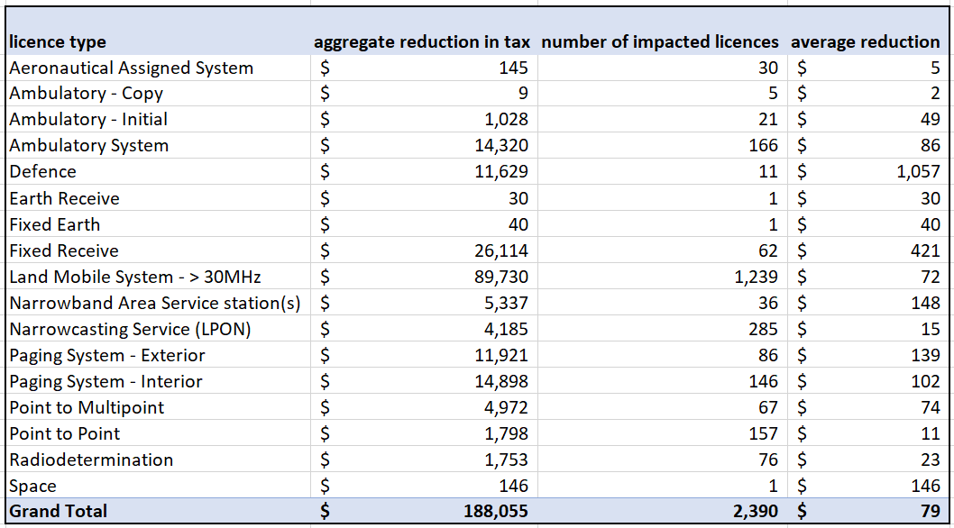

This analysis is a static comparison of existing licensees with the current v proposed prices. i.e. it assumes that the number of licences in this band remain the same over time. This analysis is likely to underestimate the annual benefit each year given that the lower prices are likely to stimulate more demand for licences in this band.

#### Cease annual CPI updates to taxes, and instead regularly update taxes based on annual population data updates

The ACMA has historically updated taxes each year for inflation, using the consumer price index (CPI). The ACMA proposes to abandon this practice and instead update taxes based on changes in population (as a proxy for changes in demand). This proposal will mean that annual changes to taxes will no longer be uniform across density areas but instead be based on the population growth specific to those density areas (see table 15). This is compared to the uniform change across all density areas of 19.35% over the same period using CPI.

1. changes in tax rates by location weightings using population (2010–20)

|  |  |  |  |  |
| --- | --- | --- | --- | --- |
| **Geographic location** | | | | |
| **Australia-wide** | **High** | **Medium** | **Low** | **Remote** |
| 16.64% | 21.69% | 14.68% | 12.20% | 6.58% |

Assuming that these historical changes in prices and population persist into the next decade and growth in assignments continue on the trajectory over the past 20 years[29], we expect that price rises will be concentrated higher density areas, and vice versa. Consequently, we expect annual price updates to be more efficient as they will be more commensurate with the underlying population demand drivers. Table 16 shows a projection of licence tax revenues of CPI adjusted taxes v population adjusted taxes. This historical data shows that licensees in high-density areas would be worse off if the trend continued in the same fashion over time. This is a concern that licensees expressed (see section 4).

1. Projected difference in tax by density area (CPI v pop method)

|  |  |  |  |  |  |
| --- | --- | --- | --- | --- | --- |
| Density area | apparatus licence revenues  2020-21 | projected growth to  2029-30 (CPI) | projected growth to  2029-30 (pop) | difference | annual difference |
| AUS Wide | $ 50,174,599 | $ 113,759,774 | $111,176,707 | $2,583,067 | $258,307 |
| High | $ 121,984,404 | $ 133,256,289 | $135,868,938 | -$2,612,649 | -$261,265 |
| Low | $ 54,549,789 | $ 96,985,057 | $93,190,166 | $3,794,891 | $379,489 |
| Medium | $ 17,265,558 | $ 19,549,404 | $18,378,242 | $1,171,162 | $117,116 |
| Remote | $ 14,025,650 | $ 22,677,951 | $20,251,496 | $2,426,455 | $242,645 |
| Total | $ 258,000,000 | $ 386,228,474 | $378,865,550 | $7,362,925 | $736,292 |

However, the ACMA expects that in the long run all licensees will be better off given that historical data shows that the long run aggregate %-change to population in each density area classification is much lower than the long run aggregate %-change to general prices. Figure 3 shows that in the years between 1975 to 2015 the high-density areas of Sydney, Melbourne and Brisbane, CPI growth was significantly larger than population growth.

Figure 7: population growth in high density areas v CPI

These changes directly link back to the SPR’s stated objective of frequent updates to tax rates based on changes in demography and demand.

We acknowledge uncertainties with our projected benefits to licensees given we are now entering a period of higher-than-normal inflation, and we are still living with the realities of the covid-19 pandemic that has changed how populations flow between geographies. However, the long-term divergence of CPI and the population growth suggests that this will likely be net beneficial to licensees, particularly so for licensees in lower density areas.

#### Expand the Perth and Adelaide medium density areas

The current Perth and Adelaide boundaries don’t adequately capture the population and spectrum assignment density around the cities’ fringes. The ACMA proposes to expand the Perth and Adelaide density area boundaries to make them more commensurate with other density areas and prevent acute congestion in those areas.

The ACMA intends to publish the definitions in the Apparatus licence Fees Schedule to give licensees transparency of the boundary area framework.

As a result of this proposal some licensees will face higher prices, but they are the same prices that other licensees face in similar density areas. We expect that approximately 954 existing spectrum accesses (owned by 132 licensees) will shift from a low-density area tax to a medium density area tax and face an increase in tax of $340 on average (see Table 17).

1. direct financial impact to licensees affected by the expansion of Perth and Adelaide medium density areas

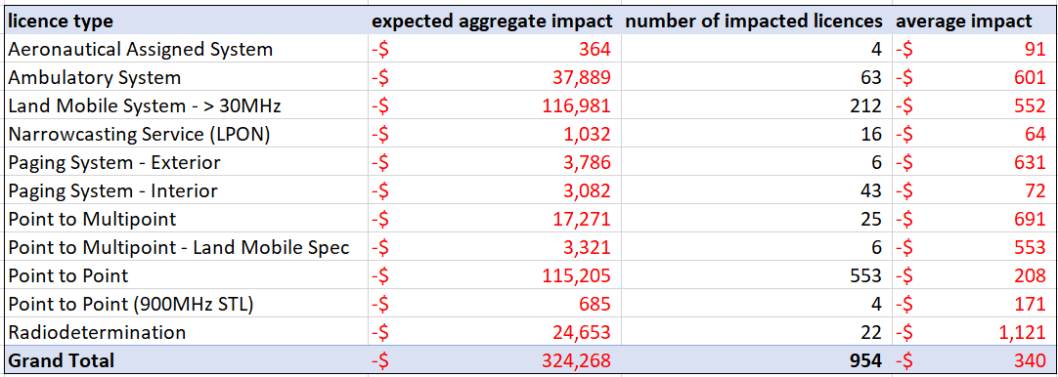

This analysis is a static comparison of existing licensees with the current v proposed prices. i.e. it assumes that the number of affected licence remain the same over time. This analysis may underestimate the annual costs each year given that the increased prices may lead to some licensees surrendering their licences in these areas, resulting in more economic losses.

These changes directly link back to the SPR’s stated objective of consistency and transparency in terms of how licences are priced.

Despite the estimated costs to incumbent licensees, similar to proposals about changes to the location weightings, in the longer term this proposal is intended to smooth out demand across locations, to mitigate the risk of harmful interference and a degradation of the utility of spectrum.

### Proposal to reform HPON taxes

HPON operators are expected to benefit from proposed tax reductions intended to align HPON taxes more closely with commercial broadcasting taxes. Many HPON licensees are expected to benefit from tax discounts of more than 90%. Aggregate annual taxes paid by HPON licensees is expected to fall by approximately $400,000 each year. The reduction in price is not expected to increase the number of HPONs operating because the availability of spectrum for HPONs is limited and the ACMA allocates HPON licences very occasionally (via price-based allocations).

The wholesale reduction in HPON taxes means that HPON licensees will be paying more comparable taxes as commercial broadcasters. This is both more equitable and efficient.

These changes directly link back to the SPR’s stated objective of charging similar uses of spectrum at a similar tax rate.

### Proposals to adjust tranche 1 reforms

#### Definitions of low-power and micro-power spectrum accesses

The proposed change is intended to provide more clarity and does not change the policy intent, so no material changes to benefits is expected.

The ACMA expects that the introduction of the low-power discount introduced in tranche 1 creates an incentive for land mobile services to adopt service configurations with smaller geographical footprints, freeing up spectrum and to be used by other parties.

#### Adjustment to the earth station systems price

Similarly, the adjustment to the earth station systems price (removing the need for co-located co-frequency earth stations to be operating on the same centre frequency) allows for more flexibility in earth station system configurations and provides the incentive to co-locate to more satellite operators. More spectrally efficient co-locate earth stations also frees up spectrum which can be used by other parties.

# 6. What is the best option?

Based on the analysis in section 4, the ACMA considers it net beneficial to implement the 2nd tranche of reform proposals (option 2). The ACMA has adjusted the proposals based on stakeholder feedback, and estimated direct costs and benefits to licensees in the order of $1m each year over the next 10 years.

To do nothing (option 1 - status quo) or only proceed with non-regulatory initiatives (option 2) forgoes both the direct net benefits accruing to licensees as a result of changes to licence taxes, as well as the longer term benefits associated with more contemporary pricing signals encouraging more efficient use of spectrum in targeted areas.

Stakeholders were broadly supportive of the ACMA’s proposals, so we plan to implement all proposals. However, we will incorporate useful stakeholder feedback (detailed in section 5):

1. Summary of adjustments to tranche 2 proposals

|  |  |
| --- | --- |
| **Regulatory proposal** | **Adjustment to proposal?** |
| Location weights | Do not proceed with the proposed tax increases in the medium and high-density areas of the >2690-5000MHz band.  The satellite industry expressed concern about the proposed tax increases in this band, and argued for lower taxes.  This band is currently undergoing several spectrum allocations including new spectrum licences and area wide licences (AWLs) to facilitate 5G services.  Given this activity, the ACMA does not consider a tax increase to be prudent at this stage.  The ACMA will continue monitoring the band to see if any regulatory measures are needed to manage demand levels once they stabilise. |
| Normalisation factor /  Annual update of taxes (based on population changes) | Proceed with implementing the new population-adjustment method for updating prices each year, but provide stakeholders with more information in a consultation paper before implementing the first priced update based on the new method.  This is intended to allay concerns from licensees about potentially incurring higher taxes due to the changed methodology. |
| Expand Perth and Adelaide MDAs | Delay commencement of new boundaries 3 years to give licensees some time to prepare for the higher taxes/absorb higher costs.  Licensees understood the rationale for change, however, many asked for some time to transition to the new high taxes as a result of the boundary change. |
| HPON tax reforms | Implement as proposed. |
| Adjustments to tranche 1 | Amend the clauses that explain the way that the earth station system price is calculated, so that it is consistent with the policy intent and licensing practice. |

# 7. How will you implement and evaluate your chosen option?

The ACMA intends to implement these reforms by amending the tax determinations in July 2022, and registering them with the [Federal Register of Legislation](https://www.legislation.gov.au/). Shortly after, the ACMA will also publish a decision paper explaining these changes to stakeholders.

Most of the tax amendments will take effect in August. The delayed commencement of the tax amendments will give the ACMA time to load, test and implement these changes in the ACMA’s licence management system. It will also allow time for apparatus licence renewal notices to reflect the new taxes. Renewal notices are sent to licensees 40 days before the expiry of licences.

The ACMA intends to apply the new approach for annual tax updates in 2023. We will consult on the new taxes and provide stakeholders with more information in a consultation paper before implementation.

The ACMA intends to introduce the expanded Perth and Adelaide density areas in mid 2025. The ACMA will include this work the [five-year spectrum outlook](https://www.acma.gov.au/five-year-spectrum-outlook) (FYSO) so that stakeholders remain aware in the lead up to this change.

The 2nd tranche of SPR reforms will mark the end of the ACMA’s implementation of the SPR review. However, the ACMA acknowledges that pricing will need to continue to evolve with the radiocommunications industry. The ACMA will continue to address salient pricing issues as they arise, and implement fit for purpose pricing frameworks to facilitate efficient spectrum management and use consistent with the object of the Act.

**Evaluation**

The ACMA intends to monitor the impact of the spectrum pricing review reforms. We are keen to understand how the price changes will impact licences and the broader market. We will do this primarily through monitoring licence volumes over time to discern the degree of how demand is smoothed over locations in response to the pricing reforms. For example, have potential licensees such as Goonhilly obtained licences above 100 GHz to facilitate their business plans? Have the new Perth and Adelaide boundaries shifted licence assignments over into lower density areas?

The ACMA will also be receptive to stakeholder feedback which we regularly obtain through our [annual workplan / Five-year spectrum outlook](https://www.acma.gov.au/publications/2021-09/plan/five-year-spectrum-outlook-2021-26) processes.

This analysis will assist with any other future potential price changes that the ACMA may consider for other pricing problems.

# Appendix A – Spectrum pricing review recommendations

The Department of Communications released its Spectrum Pricing Review consultation in May 2017 as a major review of the spectrum pricing framework, since the Productivity Commission’s review of radiocommunications in 2002. The consultation paper proposed a number of draft recommendations for improving the pricing framework.

The department finalised these recommendations (listed below) in March 2018. In developing these recommendations the Department was guided by the principles of efficiency, cost recovery, consistency and simplicity, and transparency.

### Allocation decisions

1. The ACMA should publish guidelines on how it approaches its spectrum pricing decisions.
2. To ensure efficient use of spectrum, the Government and the ACMA should endeavour to charge users of similar spectrum at the same rate.
3. Bespoke pricing arrangements will sometimes be necessary. Where spectrum fees are determined other than by auction or by the administered pricing formula, the ACMA, or the Government where it directs the ACMA on pricing, should publish the reasons for this decision.

### Market-based allocations

1. The ACMA should further identify bands to transition from administratively set fees to competitive market-based allocations in its annual work program.
2. In setting reserve prices, the ACMA and the Government should consider the influence of the reserve price on competitive behaviour, and the scope for price discovery through upward movement toward the market value of the spectrum.
3. For spectrum access charges determined by auction, the ACMA should generally require upfront lump-sum payments. There may be circumstances where instalment payments are warranted shortly after the beginning of a licence term. In considering use of instalments, the ACMA should assess the risks to the state of default and the potential impact on competition.

### Administered allocations

1. The ACMA should undertake a detailed review of the administrative pricing formula’s parameters, including density areas, the number of pricing bands, and the number of power categories. The ACMA should implement regular updates to the location and band weightings to reflect changes in density, demography and demand.
2. The ACMA should apply opportunity cost pricing to a greater number of spectrum bands, especially where it is impractical to competitively allocate spectrum. This work should be identified in the ACMA’s annual work program. The ACMA should consider more time effective approaches to implement these, and review fees as market conditions change over time.

### Legislative and cost recovery framework

1. The Government should consolidate the three existing spectrum tax Acts into one tax Act. The ACMA should continue to have the power to make determinations on the amount of tax under this Act. There should be no changes to the direct charges framework. In addition to the consolidation of the tax Acts, provisions of the separate *Radiocommunications Taxes Collection Act 1983* and the Radiocommunications Taxes Collection Regulations 1985 should be consolidated with the remaining legislation.
2. The apparatus licence taxes and spectrum access charges for spectrum licences should be combined into a single spectrum access charge. This existing apparatus licence tax formula should become the administered incentive pricing formula and should dictate the price paid for administered prices under the spectrum access charge. This formula would be adjusted to remove the minimum tax constraint.
3. The spectrum licence tax and the minimum tax constraint of the apparatus licence taxes should be subsumed into one radiocommunications licence tax. The ACMA should continue to recover direct costs through charges. The ACMA should explore if there are any additional costs that should be recovered through the direct cost mechanisms. The use of charges should be consistent with the Australian Government Charging Framework.

# Appendix B – Density areas

### Map legend

|  |  |
| --- | --- |
| **Density area** | **Description** |
| High density areas | Red areas  Brisbane, Sydney, Melbourne HDAs |
| Medium density areas | Dark blue areas  Perth, Adelaide, Newcastle HDAs |
| Low density areas | Light blue areas  East Australia LDA, Western Australia LDA |
| Remote density areas | No colour  Remaining parts of Australia |

Precise definitions and coordinates can be found in Appendix F of the [Apparatus Licence Fee Schedule](https://www.acma.gov.au/publications/2020-06/guide/apparatus-licence-fee-schedule).

# Appendix C – The administrative pricing formula

The administrative tax formula is made up of five elements – normalisation factor, bandwidth, power, location weighting, and adjustment factor. The annual tax is calculated by multiplying the relevant formula factors:

|  |  |  |
| --- | --- | --- |
| **X** | **Location weighting** | |
| **Bandwidth** | |
| **Power** | |
| **Adjustment factor** | |
| **Normalisation factor** | |
| **= Annual tax** | |

**Location weighting**

There are 65 spectrum and geographic location combinations, which have each been assigned a location weighting. The location combinations reflect the density of services and demand for spectrum at different frequencies and geographic areas. Higher taxes in locations of higher density and demand encourage efficient spectrum use. See maps in Appendix B for precise area boundaries.

1. Location weighting

|  |  |  |  |  |  |
| --- | --- | --- | --- | --- | --- |
|  | Geographic location | | | | |
| Spectrum location | Australia-wide | High density | Medium density | Low density | Remote density |
| 30 MHz and below | 4.3150 | 4.3150 | 4.3150 | 4.3150 | 4.3150 |
| >30 to 70 MHz | 9.7470 | 3.8070 | 2.0250 | 0.4370 | 0.2180 |
| >70 to 399.9 MHz | 10.0000 | 4.1040 | 1.8780 | 0.4210 | 0.2100 |
| >399.9 to 403 MHz | 10.0000 | 5.6000 | 2.5620 | 0.4370 | 0.2180 |
| >403 to 520 MHz | 10.0000 | 7.4114 | 2.5620 | 0.4370 | 0.0000 |
| >520 to 960 MHz | 10.0000 | 5.6000 | 2.5620 | 0.4370 | 0.2180 |
| >960 to 2,690 MHz | 9.9850 | 2.2410 | 1.0360 | 0.5210 | 0.2600 |
| >2,690 to 5,000 MHz | 9.9740 | 1.8530 | 0.7510 | 0.6220 | 0.3110 |
| >5.0 to 8.5 GHz | 4.2105 | 0.7785 | 0.3625 | 0.1650 | 0.0800 |
| >8.5 to 14.5 GHz | 0.3711 | 0.1336 | 0.0316 | 0.0023 | 0.0011 |
| >14.5 to 31.3 GHz | 0.3711 | 0.0988 | 0.0217 | 0.0023 | 0.0011 |
| >31.3 to 51.4 GHz | 0.1012 | 0.0539 | 0.0117 | 0.0004 | 0.0002 |
| Above 51.4 GHz | 0.0100 | 0.0010 | 0.0010 | 0.0001 | 0.0001 |

**Bandwidth**

Taxes also vary depending on the bandwidth within which a service is licensed to operate. The more spectrum a service uses the higher the tax. Taxes in the formula are normally quoted in $/kHz.

**Power**

The power factor allows a reduced tax for low-power spectrum accesses and ‘micro’ service models, which deny spectrum to other users over a small area. Spectrum accesses that are not low power or micro power have a power factor of one.

Low-power spectrum accesses permit the operation of one or more devices, each with a radiated power level of 8.3 watts EIRP or less and designed for operation within a radius of 2 kilometres.[30] These types of services pay one-tenth of the annual tax that would otherwise apply (subject to the minimum tax of $41.37).

The low-power factor does not apply to point-to-point, point-to-multipoint above 960 MHz, point-to-multipoint system, television outside broadcast, or licences that attract a fixed fee. For these licensing options, there is weak correlation between the power level and the area over which spectrum is denied to other users.

A ‘micro-power’ factor is eligible for enclosed and short-range land mobile services that permit the operation of one or more devices, each with a radiated power level of 1.7 watts EIRP or less and designed for operation within a radius of 200 metres.[31] These types of services pay one-twentieth of the annual tax that would otherwise apply (subject to a minimum tax of $41.37).

**Adjustment factors**

There are numerous adjustment factors that modify the tax levels of some licensing options. This introduces the flexibility to vary taxes according to parameters that are not included in the tax formula.

1. Adjustment factor

|  |  |  |  |
| --- | --- | --- | --- |
| Division | Licensing option | Frequency/notes | Adjustment factor |
| Division 1 | Most licensing options |  | 1 |
| Division 1A | Scientific assigned |  | 0.1 |
| Division 2 | Fixed point-to-point | Below 960 MHz except remote density | 18.484115 |
| Below 960 MHz remote density | 11.737205 |
| Above 960 MHz | 0.436933 |
| Division 3 | Fixed point-to-multipoint | Below 960 MHz except remote density | 73.93646 |
| Below 960 MHz remote density | 46.351636 |
| Above 960 MHz | 0.436933 |
| Division 4 | Licences in high demand frequency bands |  | 73.93646 |
| Division 5 | Television outside broadcast station | All geographic areas except high density | 0.513008 |
| High-density areas | 0.38762490649539 |

**Normalisation factor** (0.28209675121524)

The constant converts the relative spectrum values provided by the rest of the formula to an actual dollar figure. It is updated by consumer price index (CPI) adjustments every year to keep licence taxes constant in real terms.

1. The terms ‘price’ and ‘tax’ are used interchangeably throughout this RIS.
2. Also known as the assigned apparatus licence tax formula.
3. Centre for International Economics (2015) *The economic value of spectrum*, Research report prepared for the Department of Communications
4. Recommendation 1 was done as part of the tranche 1 reforms. Many of the other recommendations are guiding principles relevant to the ACMA in its ongoing management of spectrum i.e. recommendations 2, 3, 4, 5, 6, and 8. Recommendations 9, 10, and 11 were matters for the Government which intended to amend the cost recovery framework in primary legislation.
5. Also known as the assigned licence tax formula.
6. Licences outside of the formula have bespoke pricing arrangements. E.g. high-powered open narrowcasting (see Division 8 of the [Apparatus licence fee schedule | ACMA](https://www.acma.gov.au/publications/2020-06/guide/apparatus-licence-fee-schedule)), or assigned licences subject to fixed taxes (see Division 6 of the [Apparatus licence fee schedule | ACMA](https://www.acma.gov.au/publications/2020-06/guide/apparatus-licence-fee-schedule)).
7. Further information about specific licence types can be found at [Apparatus licences | ACMA](https://www.acma.gov.au/apparatus-licences).
8. Hertz (Hz) is a measure of the frequency of the spectrum, and a measure of the amount of bandwidth used for a radiocommunications service. A kilohertz (kHz) is 1000 Hz.
9. Commercial broadcasting licensees may be subject to tax imposed by the *Commercial Broadcasting (Tax) Act 2017*.
10. 1 terahertz equals 1,000,000,000,000 hertz.
11. In other words, operating in different parts of the licensed bandwidth.
12. The ACMA’s spectrum management decisions are guided by the object of the *Radiocommunications Act 1992* to promote the long-term public interest derived from the use of the spectrum
13. The ACMA’s spectrum management decisions are guided by the object of the *Radiocommunications Act 1992* to promote the long-term public interest derived from the use of the spectrum
14. Recommendation 4: The ACMA should further identify bands to transition from administratively set fees to competitive market-based allocations in its annual work program.
15. The calculator has been offline for a few years.
16. The ACMA notes that there were similarly large relative changes in assignments for >399.9 to 403 MHz in Australia-wide and in the band above 51.4 GHz. However, we consider these changes are not statistically significant given a low base number of initial assignments in 2005.
17. When the ACMA licenses a specific device or service then the licensing and planning frameworks effectively deny other potential licensees from using that same spectrum. Some services will deny more spectrum than others. Generally higher frequency spectrum propagate or travel shorter distances and have lower interference potential/spectrum denial across geography. This means that there is greater spectrum re-use opportunities (i.e. more ‘supply’ of spectrum in any one location).
18. A narrowcasting service is defined in section18 of the *Broadcasting Services Act 1992.* 
19. Commercial broadcasting licensees may be subject to tax imposed by the *Commercial Broadcasting (Tax) Act 2017*.
20. A ‘significant urban area’ is the area of that name described by the Australian Bureau of Statistics as a significant urban area in 1270.0.55.004 – Australian Statistical Geographic Standard (ASGS): Volume 4 – Significant Urban Areas, Urban Centres and Localities, Section of State, July 2016. Significant Urban Areas (SUAs) represent individual Urban Centres or clusters of related Urban Centres with a core urban population over 10,000 people. Urban Centres and Localities (UCLs) are aggregations of SA1s which meet population density criteria or contain other urban infrastructure.
21. Note that there are only a handful of HPON licences that authorise the provision of open narrowcasting television services. Despite television using larger channels than radio, for simplicity the ACMA proposes to tax these HPON licences on an equivalent basis as HPON licences used to provide FM radio services.
22. Clause (a) remains the same for current and proposed definitions and is excluded here for simplicity.
23. Clause (a) remains the same for current and proposed definitions and is excluded here for simplicity.
24. Clause (a) remains the same for current and proposed definitions and is excluded here for simplicity.
25. Geostationary or non-geostationary.
26. Recommendation 1: The ACMA should publish guidelines on how it approaches its spectrum pricing decisions.
27. Recommendation 4: The ACMA should further identify bands to transition from administratively set fees to competitive market-based allocations in its annual work program.
28. The calculator has been offline for a few years.
29. Disaggregated data was not readily available before 2010.
30. Local terrain clutter may reduce practicably achievable ranges to substantially less than a 2-kilometre radius.Frequency re-use distances applicable to low power spectrum accesses are such that ranges will ultimately be interference limited to a maximum of approximately 2 kilometres.
31. See [RALI LM8](https://www.acma.gov.au/publications/2019-09/instruction/rali-lm8-land-mobile-service).