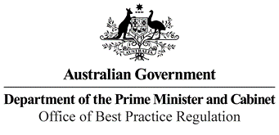

Reference: 25766

Telephone: (02) 6271 6270

Email: [helpdesk-obpr@pmc.gov.au](mailto:helpdesk-obpr@pmc.gov.au)

Sharon Gudu

Executive Director, Quality Assurance and Regulatory Services NSW Department of Education

105 Phillip Street

Parramatta NSW 2150 Dear Ms Gudu

**Decision Regulation Impact Statement – 2019 National Quality Framework Review**

Thank you for your letter on 16 December 2021, submitting a Decision Regulation Impact Statement (RIS) for the 2019 National Quality Framework Review to the Office of Best Practice Regulation (OBPR) for formal assessment.

I note our two teams have engaged closely in the development of this RIS. In particular, I would like to acknowledge and thank your staff in the NQF Review team for their regular and open engagement with the OBPR.

The OBPR’s assessment is that the RIS is adequate to inform a final decision in accordance with the requirements of the *Regulatory Impact Analysis Guide for Ministers’ Meetings and National Standard Setting Bodies*.

The RIS may now be provided to the decision-maker to inform their decision.

We would appreciate you advising us when a final decision has been announced and forwarding a copy of the RIS in a form meeting the Australian Government’s accessibility requirements. The OBPR will publish the RIS, along with your certification and this assessment, on the OBPR’s website, https://obpr.pmc.gov.au/.

If you have any further queries, please do not hesitate to contact me. Yours sincerely

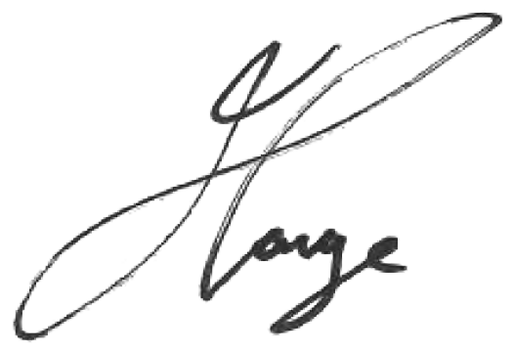

Jason Lange Executive Director 7 January 2022

1 National Circuit, Barton ACT 2600 • Telephone 02 6271 6270 • Internet https://obpr.pmc.gov.au