INFORMATION PAPER

INFORMATION PAPER

Post-implementation review of the Basel III liquidity reforms

June 2022

Disclaimer Text

While APRA endeavours to ensure the quality of this publication, it does not accept any responsibility for the accuracy, completeness or currency of the material included in this publication and will not be liable for any loss or damage arising out of any use of, or reliance on, this publication.

**© Australian Prudential Regulation Authority (APRA)**

This work is licensed under the Creative Commons Attribution 3.0 Australia Licence (CCBY 3.0). This licence allows you to copy, distribute and adapt this work, provided you attribute the work and do not suggest that APRA endorses you or your work. To view a full copy of the terms of this licence, visit <https://creativecommons.org/licenses/by/3.0/au/>

Contents

Executive summary 4

Chapter 1 - Background 6

Chapter 2 - Impact of the reforms 10

Chapter 3 – Looking forward 18

Annex A - Policy options considered 21

Annex B - Regulatory costing analysis 22

Annex C - Technical areas for review 23

# Executive summary

In March 2022, APRA initiated a post-implementation review (PIR) of the Basel III liquidity reforms in Australia. The key findings and next steps of the PIR are set out below.

On the basis of the feedback and analysis in the PIR, APRA’s overall assessment is that the reforms have been effective in strengthening liquidity risk management and the financial resilience of the banking system, and the benefits of regulation have significantly outweighed the associated costs. There remain, however, some potential opportunities to improve the efficiency of the prudential framework, which APRA will review next year.

### Background: Basel III reforms

In response to learnings from the global financial crisis (GFC), the Basel III liquidity reforms were introduced eight years ago in Australia with the commencement of the revised *Prudential Standard APS 210 Liquidity* (APS 210) in 2014. The two core measures of the reforms, the Liquidity Coverage Ratio (LCR) and the Net Stable Funding Ratio (NSFR), became effective from 2015 and 2018 respectively.

The revised standard for liquidity, APS 210, aimed to address deficiencies in the previous liquidity framework, align APRA’s liquidity regime with international best practice, and reduce the likelihood of the need for (and degree of) government intervention or support in any future liquidity crisis.

The liquidity reforms were important in reinforcing financial safety and system stability and requiring higher standards for bank liquidity management to address weaknesses that emerged internationally during the GFC.

### Key findings of the PIR

The purpose of the PIR is to evaluate whether the implemented policy is operating as intended and is effectively and efficiently meeting the objectives in addressing the original problem. A key focus is on assessing the impact of the LCR and NSFR and understanding the costs and benefits of the measures. APRA issued a discussion paper to seek feedback from industry stakeholders, and held discussions with a range of banks, industry associations, rating agencies, and national and international regulatory agencies.

The key findings from the PIR are:

* the liquidity reforms have been effective in strengthening financial resilience, improving liquidity risk management, and raising standards in Australia to meet international best practice;
* as part of these reforms, the LCR and NSFR have been effective in promoting both short-term and longer-term resilience in bank funding and liquidity, with increased levels of liquidity and more stable funding profiles;[1] and
* the costs of the liquidity reforms have been broadly in line with APRA’s original estimates that forecast a net benefit from the reforms, although the costs have varied by bank depending on the level of enhancements needed to improve systems and processes.

All stakeholders consulted throughout the PIR supported the liquidity reforms, assessing the LCR and NSFR to be important elements in strengthening financial resilience. There were, however, a number of suggestions raised during the PIR which would improve the liquidity standard and guidance, and their operation. The key issues, which were consistently raised across consulted stakeholders, included:

* ***Usability of liquidity buffers:*** consistent with international experience and observations, there may be a reluctance by banks to draw on their liquid assets during times of stress, despite the intent of the framework;
* ***Consolidating liquidity requirements:*** industry stakeholders called for a clearer and more consolidated approach to liquidity requirements to support compliance, rationalising APRA’s expectations and advice which are currently spread across the prudential standard, prudential practice guide, FAQs and other industry letters;[2] and
* ***Technical areas for review:*** stakeholder submissions also put forward a number of potential technical adjustments to APS 210 to improve the efficiency of the standard, by enabling closer comparability to international practices, and clarifying existing requirements.

In conclusion, the findings of the PIR confirm the LCR and NSFR are operating effectively, but that there are potential improvements that could be made to improve efficiency.

### Next steps

The feedback gained through the PIR process has been very valuable in identifying areas for improvement in the liquidity framework and will be used to inform the scope of APRA’s upcoming review of APS 210 next year. APRA plans to consult on draft revisions to APS 210 in 2023, with a view to the revised standard coming into effect from 2025 onwards.

1. Background

The global financial crisis (GFC) revealed significant weaknesses in the management of liquidity risks by banks internationally. The availability of funding from wholesale markets dried up during the period of stress in 2007-2009, placing pressure on the banking system domestically and overseas, and requiring government intervention and support in many jurisdictions.

As APRA’s original Regulation Impact Statement (RIS) for the LCR noted: *At the height of the crisis, the market lost confidence in the solvency and liquidity of many banks, including banks that were otherwise sound. Weaknesses in a number of banking systems were rapidly transmitted to the rest of the financial system and the real economy, resulting in a contraction of liquidity and credit availability. In many countries, the public sector had to intervene with unprecedented injections of liquidity, capital support and guarantees, exposing taxpayers to large contingent liabilities and losses.[3]*

There were a range of deficiencies in liquidity risk management practices identified, including:

* insufficient board oversight of liquidity risk, weaknesses in the operating management of liquidity risk, and inadequate forecasting and reporting;
* a relatively high reliance on offshore and short-term wholesale debt, which proved to be unstable during the crisis, and a need to strengthen on-balance sheet liquidity with a number of securities that banks were holding in their liquid portfolios turning out to be of limited liquidity value; and
* a need to raise standards for testing crisis preparedness, with APRA’s prudential requirements at the time based on a five-day name crisis, while the GFC showed that five days was not a sufficient period to address a severe liquidity stress event.

Following the GFC, there was a global move to strengthen the liquidity risk profile of banks. In line with APRA’s mandate to protect the Australian community by maintaining a stable financial system, APRA sought to embed these changes and ensure these deficiencies were addressed through the implementation of the Basel III liquidity reforms.

Basel III liquidity reforms

In December 2010, the Basel Committee for Banking Supervision released an international framework for liquidity risk measurement, standards, and monitoring: the Basel III liquidity reforms.[4] APRA introduced these requirements through revisions to the prudential standard for liquidity, *Prudential Standard APS 210 Liquidity* (APS 210), which included the Liquidity Coverage Ratio (LCR) and Net Stable Funding Ratio (NSFR). A summary timeline for the implementation of these reforms is outlined below.

1. Timeline of the Basel III liquidity reforms in Australia

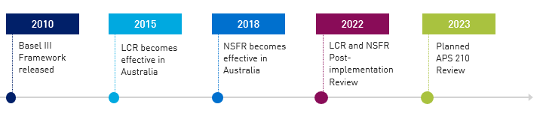

The key objectives of the reforms were to:

* address deficiencies in the previous liquidity framework, both qualitative and quantitative, which were highlighted by the more extreme phases of the GFC;
* align APRA’s liquidity regime with international best practice, maintaining the high international reputation of the Australian financial system and helping to ensure that funding markets stay open to banks; and
* reduce the likelihood of the need for (and degree of) government intervention or support in any future financial crisis.

APS 210 applies to all banks in Australia. It covers both qualitative and quantitative requirements for liquidity risk management. 13 domestic banks are currently subject to the LCR and NSFR, and an additional 42 foreign bank branches are subject to the LCR.

LCR and NSFR

The LCR and NSFR are the two key funding and liquidity metrics in APS 210.[5] These are complementary measures that focus on short-term and longer-term resilience. An overview of the LCR and NSFR is set out below.

1. Overview of the LCR and NSFR measures

|  |  |  |
| --- | --- | --- |
| **Measure** | **Intended objectives** | **Definition** |
| **LCR** | The LCR is intended to promote short-term resilience of a bank’s liquidity profile by ensuring that it has sufficient high-quality liquid assets to survive a significant stress event lasting for one month. | The LCR requires banks to hold high-quality liquid assets at least equal to an estimate of short-term net cash outflows under a stress scenario, to build resilience to liquidity shocks. |
| **NSFR** | The NSFR is intended to promote longer-term resilience in a bank’s funding profile through requiring more stable sources of funding on an ongoing basis. | The NSFR requires banks to maintain an amount of available stable funding at least equal to their required stable funding, to promote sustainable funding structures. |

As previously detailed in APRA’s RIS in 2013 and 2016, APRA considered a number of options to address the issues arising from liquidity risk, ranging from maintaining the existing framework to implementing some or all of the Basel III reforms.

APRA’s preferred option was to implement the Basel III framework with a focus on proportionality, applying the LCR and NSFR to large banks and simplified liquidity requirements for smaller ones. This approach was consistent with the capabilities and needs of the Australian banking system, while strengthening resilience and ensuring Australian banks remained in line with international best practice. A more detailed summary of the options considered in developing APS 210 and designing the LCR and NSFR metrics is provided in Annex A.

PIR process

On 3 March 2022, APRA released a Discussion Paper to initiate the PIR of the LCR and NSFR.[6] The aim of the PIR was to evaluate whether the implemented policy was operating as intended, and effectively and efficiently meeting the objectives in addressing the original problem. Feedback gained through the PIR would be used to inform potential improvements to the LCR and NSFR as part of APRA’s planned review of APS 210 in 2023.

The Discussion Paper sought feedback from stakeholders on the benefits to financial safety and system stability, compliance and financial costs, and the impacts on competition. To enable an informed assessment, APRA considered a range of evidence and used several approaches, summarised below.

1. Sources

APRA received 11 written submissions in response to the Discussion Paper and held discussions with a range of banks (including majors, regionals, and a subsidiary of a foreign bank), industry associations, rating agencies, and national and international regulatory agencies. Non-confidential submissions, as listed in the table below, are available on the APRA website.

1. Non confidential submissions

|  |  |
| --- | --- |
| **Stakeholder** | **Type** |
| **Australian Banking Association** | Industry Association |
| **Australian Financial Markets Association** | Industry Association |
| **Australian Small Business and Family Enterprise Ombudsman** | Government Ombudsman |
| **Kevin Davis** | Academic |
| **National Australia Bank** | Bank |

In the analysis below, where possible, APRA has sought to attribute findings to sources, noting that most submissions received were confidential and views expressed within submissions were generally consistent across stakeholders.

1. Impact of the reforms

This chapter assesses the impact of the reforms and analyses the costs and benefits. It also examines the impact on competition.

Overview of the reforms

As part of the consultation undertaken when implementing the Basel III liquidity reforms, the key benefits and costs of the reforms were outlined in the RIS; these have been tested through the PIR process. The chart below summarises the key considerations, which were assessed in the original RIS to provide an overall net benefit.

1. Key benefits and costs Key benefits: greater resilience to liquidity problems for entities and system, reduced likelihood or government intervention or support, better access to international markets. 
   Key costs: initial and on-going compliance costs, higher funding costs due to balance sheet management changes, other potential impacts. 

On the basis of feedback from industry stakeholders gained during the PIR, and analysis of funding and liquidity risk profiles since implementation, APRA has assessed that APS 210 more broadly, and the LCR and NSFR specifically, have met their objectives and delivered the intended net benefit. The PIR also found that compliance and financial costs were largely consistent with APRA’s original expectations, albeit with some variation across banks.

Since implementation, the Basel Committee has assessed APS 210, including the requirements for the LCR and NSFR, to be compliant with the Basel III standard.[7] APRA has monitored APS 210 through ongoing supervision, and provided clarifications on interpretation through a range of frequently asked questions (FAQs). APRA has also evaluated the effectiveness of the LCR and NSFR based on a range of metrics and feedback received from stakeholders, as set out below.

LCR and NSFR in practice

Since the introduction of APS 210, all banks in Australia have operated with LCR and NSFR ratios above the regulatory level of 100 per cent, and there has been a demonstrable improvement in liquidity management practices. As shown in the charts below, the average industry level of the LCR has been around 130 per cent, and the NSFR above 110 per cent. Banks have targeted and operated at these levels based on a range of factors, including their assessment of market expectations and the level of liquidity buffers they consider prudent to maintain.

1. LCR and NSFR industry averages

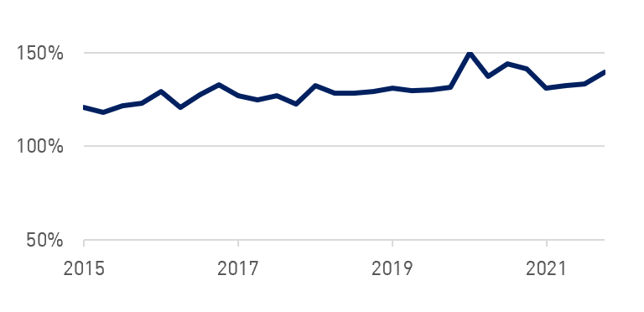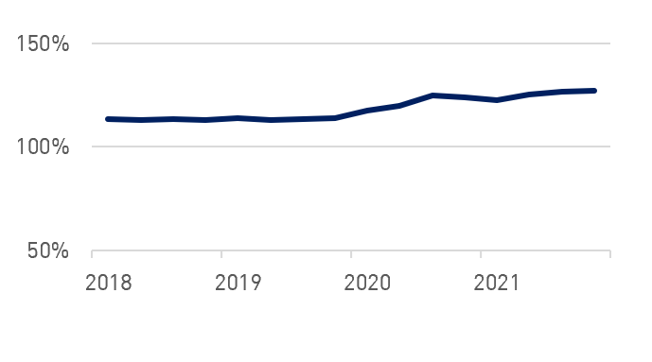 LCR NSFR

*Source: APRA*

Benefits of the LCR and NSFR

In assessing the benefits of the LCR and NSFR, APRA has identified improvements in the short- and longer-term resilience of banks and in their ability to withstand and manage stressed market conditions, such as those during COVID-19. These improvements, while already beginning to emerge after the GFC, were embedded by the reforms. Australian banks have been able to maintain strong credit ratings and ongoing funding access to international markets through periods of stable conditions as well as during periods of market volatility. The improved liquidity position of banks has also reduced the likelihood of government intervention or support being needed.

The table below summarises these benefits, with further detail provided in the remainder of this section.

1. Meeting the objectives of the LCR and NSFR

|  |
| --- |
| **Objectives** |
| ✔ **Strengthened short-term resilience** of banks and the Australian financial system, with an increase in high-quality liquid assets from six per cent of total assets prior to the GFC to around 15-20 per cent on average since the LCR was introduced.[8] This increase was broadly in line with the intended level of the reforms. |
| ✔ **Improvements in the longer-term resilience** of banks and the Australian financial system, with more stable funding profiles, reduced reliance on short-term wholesale funding, ongoing access to international markets and, for the major banks, global-leading credit ratings of AA-. These trends are evident based on data reported to APRA and feedback from the PIR. |
| ✔ **Stronger liquidity management practices**, with increased rigour and more prudent approaches to measuring, monitoring, and reporting liquidity risk, including through internal transfer pricing models. These more prudent management practices have been observed during APRA supervisory reviews and liaison meetings over the period since the reforms, as well as evidenced in feedback gained during the PIR. Examples include the ability of banks to quickly produce a daily snapshot of their liquidity position, if needed, during a crisis period.[9] |

##### Strengthened short-term resilience

There has been a significant increase in liquid assets since the GFC, which has led to an improvement in short-term resilience and extension of survival horizons for banks in periods of stress. As illustrated in the chart below, liquid asset holdings have increased from six per cent prior to the GFC, to around 15-20 per cent since the LCR was introduced; this equates to an increase in liquid assets from $98 billion to $480 billion in this period, inclusive of the Committed Liquidity Facility (CLF), the additional liquidity facility provided by the Reserve Bank of Australia (RBA).[10] [11]

1. 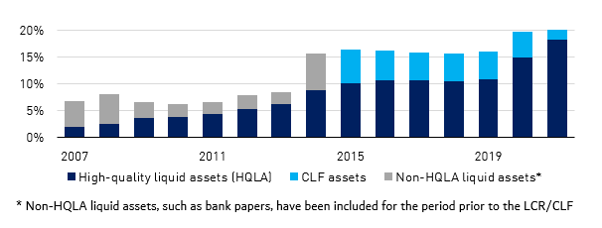LCR-eligible liquid assets as a percentage of total assets

*Source: Reserve Bank of Australia and APRA*

The LCR has helped embed this shift in short-term resilience since its implementation in 2015, as banks have grown and maintained high levels of liquid assets as part of maintaining the ratio. By its definition, maintaining an LCR above 100 per cent, as banks have consistently been able to do, has demonstrated an ability to survive a severe stress period of at least 30 days.

##### Improvements in longer-term resilience

Complementing the increase in liquid assets has been a change in the composition of bank funding profiles. In the wake of the GFC, banks had begun to move away from their reliance on short-term offshore wholesale funding because of its higher risk in a liquidity stress, and towards more stable sources such as deposits and longer-term funding. A consistent theme from submissions received during the PIR was that actions taken by banks following the GFC demonstrated that these risks are now firmly embedded in how banks consider their funding composition.

Short-term wholesale funding as a proportion of funding had decreased from more than 30 per cent during the GFC, to approximately 22 per cent by the time of the implementation of the reforms. The reduced reliance on short-term wholesale funding was further embedded by the NSFR, which ensured that the improvements implemented by industry in response to market expectations were maintained through higher regulatory standards. Short term debt has been replaced by domestic deposits, which are a more stable source of funding.

1. 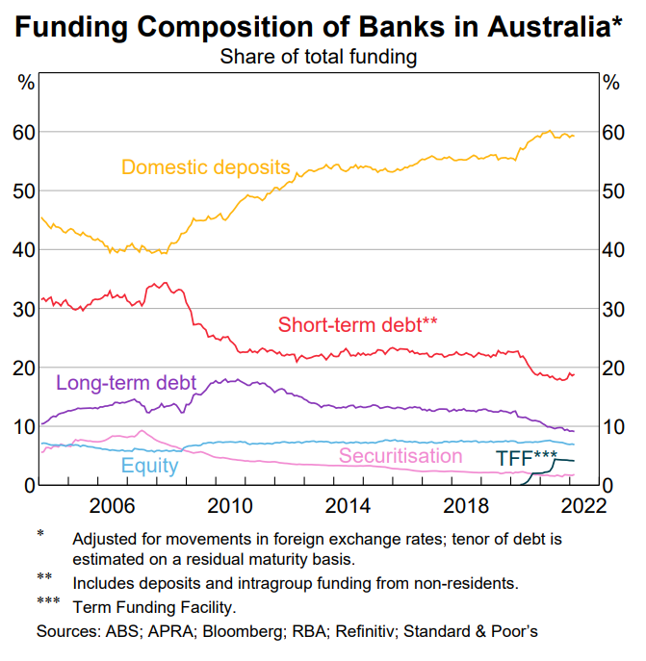Funding composition of banks in Australia

*Source: Reserve Bank of Australia*

The culmination of these actions has led to sustained NSFRs since implementation in APS 210 in 2018, well above the regulatory minimum of 100 per cent. The improvements in funding profiles have also been demonstrated by ongoing access to international markets and, for the major banks, global-leading credit ratings of AA-.[12]

##### Stronger liquidity management practices

There has been a growing maturity in liquidity risk management, which has been evident in more prudent approaches to measuring, monitoring, and reporting liquidity risk, as well as more granular and accurate stress testing and improved decision making around funding profile composition.

This was demonstrated during the COVID-19 period of stress, and banks’ response to initial funding pressures. Banks were much better positioned to withstand funding market stresses compared to previous downturns and retained significant reserves and contingency actions to be able to respond if the stress had become even more heightened or prolonged.[13] Australian banks retained sound liquidity and funding positions through the period and maintained investor confidence.

While banks were better positioned to withstand liquidity stresses, the actions of the Government and RBA in response to the COVID-19 pandemic, in particular the Term Funding Facility (TFF), further assisted their position.[14] The average LCR increased from 131 per cent in December 2019 to 139 per cent in December 2021 and the average NSFR from 114 per cent to 127 per cent over the same period.

Costs

APRA has also analysed and assessed the costs of the LCR and NSFR. Total costs have arisen from three main sources:

* up-front implementation and ongoing compliance costs;
* financial costs, such as costs incurred as a result of changing liquidity and funding profiles; and
* impacts on competition resulting from the reforms.

The theme from the industry submissions and discussions during the PIR has been that while costs have varied across banks, the overall cost outcomes have been broadly within expectations, and in line with what has been needed to achieve the benefits of the reforms.

In quantifying and analysing costs, both APRA and industry stakeholders have faced several challenges. These challenges include separating out the costs specifically related to the LCR and NSFR from other costs incurred during the implementation timeframe, as well as generating cost data. While some stakeholders sought to provide specific quantitative data, others were only able to share estimates of cost impacts on a qualitative basis.[15] Even where banks sought to provide qualitative data, there was inconsistency between banks in approach and content. An additional challenge was the limited number of submissions received by non-major banks. To ensure a more representative outcome, APRA has adjusted cost estimates proportionally for these entities in line with adjustments to major bank figures. The costing analysis below includes these assumptions made by APRA.

##### Compliance costs

For the LCR, the compliance costs for the industry were originally estimated to average around $50.5 million per year over a 10-year period, and for the NSFR $2.4 million per year over a 10-year period. Industry estimates, provided on a best endeavours basis, were broadly consistent with this.

A broad comparison of the up-front implementation and ongoing compliance costs for the LCR is discussed in the table below. Regulatory costs for the NSFR were absorbed into business-as-usual costs, and as such clear data is not available.

1. Total costs provided by entities

|  |  |
| --- | --- |
|  | **Estimated costs** |
| Up-front implementation costs | For the LCR, the one-off upfront costs of changes to liquidity systems and framework enhancements were originally estimated to be around $30m for an average major bank. There was significant variation in costs between entities, depending on the scope of system upgrades being undertaken at the time. For some major banks, estimates of actual costs incurred were broadly in line with the original average estimate. There were higher costs in cases where substantial system enhancements were made in parallel. |
| Ongoing compliance costs | For the LCR, ongoing compliance costs were originally estimated to be around $5 million per annum for an average major bank. Submissions indicated average ongoing compliance costs to be broadly consistent, albeit slightly higher than this original estimate. |

It should be noted, the table above represent the full implementation costs; that is, costs associated with implementing the reforms including any Australian-specific requirements, and costs that would have been incurred in the absence of the reforms. In assessing regulatory compliance costs as per the methodology set out by the Office of Best Practice Regulation (OBPR), APRA has assumed implementation of the international framework as a baseline cost, given Australia’s G20 commitments to implement the reforms and to preserve banks continued ability to participate in international markets. On this basis, the updated regulatory compliance costs per year averaged over a ten-year period was estimated to be $9.3 million. For a fuller analysis, see Annex B.

Finally, banks viewed there was sufficient implementation time for the LCR and NSFR, and there was no specific cost impact due to the implementation timeline.

##### Financial costs

To implement the LCR and NSFR, banks have experienced increases to their financial costs. These increases were anticipated and have been broadly in-line with expectations. There have been two main sources of increased financial costs:

* banks holding a greater amount of liquid assets, which generally earn less than non-liquid assets, such as loans; and
* increased funding costs from the shift in funding mix towards more stable and longer-term sources of funding.

As noted above, it is difficult to separate out these cost impacts from other changes in market conditions at the time, such as changes in pricing and the availability of funding more generally.

Prior to implementation, to assess the impact of the LCR, APRA estimated the re-pricing of non-liquid assets that would be needed for a bank to recoup the cost of holding more liquid assets to meet the LCR. As shown in the table below, APRA initially estimated that banks would need to hold an additional $435 billion in liquid assets and would need to re-price their non-liquid assets by 8.6 basis points to recoup the cost of this move. Of this, APRA estimated an incremental 2.9 basis point cost associated with the LCR, with the remaining cost being a product of changes that would have happened in the absence of the reforms.

Examining changes over 2015 to 2019, the period of implementation following the introduction of the LCR and prior to impacts from COVID-19, it appears that total liquid asset holdings were higher than originally envisaged. At around 5.4 basis points, this is a slightly higher impact on the cost of additional liquidity than APRA’s original estimates. A key driver of the higher cost was the decision by banks to operate LCR ratios significantly higher than the 100 per cent minimum level, to align to market expectations and their own risk appetites, as well as allowing a buffer to manage any volatility in the metric.

1. Estimated cost of increased liquid asset holdings

|  |  |  |  |  |
| --- | --- | --- | --- | --- |
|  | **Total liquid assets**  **($b)** | **Cost of carry for liquid assets**  **($b per annum)** | **Cost of liquid assets over non-liquid assets (basis points)** | |
| **Total** | **Due to Basel III** |
| APRA previous estimate | 435 | 1.8 | 8.6 | 2.9 |
| 2015-2019 average | 480 | 2.7 | 11.0 | 5.4 |

The average annual impact of the NSFR was originally estimated to be around $60-67.5 million for a major bank and $7.5-8 million for regional and other banks, based on the cost of replacing short-term with longer-term funding to meet the requirements. To assess the impact of the NSFR, APRA has updated its estimate to $92-103 million for a major bank and $13–15 million for other banks. This difference is due to structural movements on bank balance sheets in the lead-up to the implementation of the NSFR, such as loan growth outpacing deposit growth. As a result, banks required more stable funding to meet the NSFR requirements, increasing the cost of obtaining additional long-term funding above original estimates, as outlined in the table below.

1. Estimated actual cost of increased longer-term funding

|  |  |  |  |
| --- | --- | --- | --- |
| **Cohort type** | **Cost of replacing short term with longer-term funding (basis point)** | **Additional longer-term funding required per bank ($bn)** | **Total additional cost per bank per annum ($m)** |
| Major banks | 40-45 | 22.9 | 92-103 |
| Regional/other banks | 75-80 | 1.8 | 13-15 |

##### Impacts on competition

The PIR assessed whether the implementation of the liquidity reforms had an effect on competition or resulted in any other unintended market outcomes. Overall, industry stakeholders only noted mild effects to the competitive environment, such as:

* proportionally higher costs for smaller entities in complying with the LCR and NSFR; and
* potential pricing and competition impacts due to the application of different interpretations of APRA requirements, such as those around operational deposits.

These impacts will be considered alongside other feedback received, outlined in Chapter 3 below, as part of the APS 210 review.

Chapter 3 – Looking forward

As part of the PIR, APRA received feedback and proposals to increase efficiency and address issues in the operation of the LCR and NSFR in APS 210. The key issues are detailed below.

Usability of liquidity buffers

The LCR and NSFR have improved investor confidence by providing clear and internationally comparable measures of liquidity risk. A key issue raised in the PIR, across all consulted stakeholders, was the usability of liquidity buffers and how the LCR operates during stress: where banks are discouraged to use their liquidity buffers where this would result in the LCR falling relative to peers or below 100 per cent. This may be driven by concerns around crossing internal targets and limits, or the market signalling of such a drop. Some industry respondents noted that even where APRA would be comfortable with a bank using their buffers in a period of stress, it may be difficult to convince Boards, shareholders, investors, and other key stakeholders.

This potential reluctance to use buffers diminishes the intent of the framework for banks to have excess liquidity to draw upon in times of stress and means there may be scope to make the reforms more effective. Banks may decide to take defensive actions to maintain ratios in stress, such as curtailing loan growth, rather than using the liquidity as intended when it is needed to be used. These issues have also been identified in other jurisdictions, with the Bank of England and the Basel Committee both examining the useability of buffers in stress in recent papers.[16]

APRA will further explore this issue by:

* continuing to monitor international developments;
* considering enhancements to guidance on the usability of buffers in times of stress; and
* considering other potential changes to requirements and guidance as part of the review of APS 210, including reporting and disclosure requirements, liquidity stress testing thresholds, and the setting of internal management targets and Board limits.

In the interim, APRA encourages banks to consider what steps they can take to improve the useability of buffers, and to engage with APRA on possible industry-wide approaches. APRA notes, in particular, the existing requirements in APS 210, which will continue to apply: *during a period of financial stress, an authorised deposited-taking institution (ADI) may need to liquidate part of its stock of high-quality liquid assets (HQLA) and/or draw on its Committed Liquidity Facility (CLF) with the Reserve Bank of Australia (RBA), using the cash generated to cover cash outflows; as a consequence, the LCR may fall below the minimum level required under paragraph 55 of this Prudential Standard [of 100 per cent for a locally incorporated ADI].*[17]

Consolidation of liquidity requirements

A large proportion of industry respondents in the PIR called for consolidation and rationalisation of APRA’s liquidity requirements, guidance and advice. Respondents noted the difficulty in navigating APS 210, its accompanying guidance Prudential Practice Guide APG 210 *Liquidity*, the associated 26 FAQs, and other relevant industry letters.

APRA will review opportunities to consolidate and better explain the prudential framework in its review of APS 210, and more broadly as part of its strategic goal to *modernise the prudential architecture*.[18] This is important in ensuring that entities can clearly understand and meet prudential requirements and can focus on risk management rather than complexities in compliance.

## Other technical areas for review

Through the PIR, APRA received submissions related to several technical aspects of the LCR and NSFR. At a high level, these submissions included:

* suggested changes to APS 210 to reduce compliance burden on banks or adjust the operation of the framework;
* suggested areas of review to promote further international alignment, while noting that APRA’s liquidity standard also needs to account for the nuances of the Australian market; and
* suggested areas for clarification, with a number of submissions requesting further clarity around how certain aspects of the existing framework are to be interpreted and applied.

A more detailed list of suggestions made during the consultation process is included in Annex C. APRA will consider this feedback, assess the pros and cons of potential changes to requirements, and respond as part of the APS 210 review next year.

During the consultation process, APRA received feedback on the phase out of the CLF. In line with APRA’s letter published in September 2021, bank usage of the CLF is expected to be phased out by the end of 2022, given there is now sufficient government debt in the market to count towards banks’ liquid asset requirements.[19] However, the option to establish a facility for future contingency purposes will remain in APS 210, and may be reactivated where market conditions warrant.

## Next steps

APRA’s overall assessment is that the LCR and NSFR are operating effectively in achieving the objectives of the reforms, but that there are potential improvements that could be made to improve efficiency. Feedback received will be further reviewed and factored into the review of APS 210. APRA intends to release a Discussion Paper and accompanying draft standard in 2023. The planned timeline for the review is set out below.

1. Proposed timeline for APS 210 review

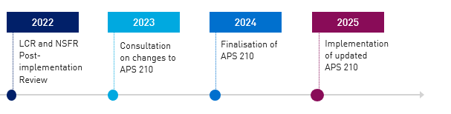

# Annex A - Policy options considered

The following tables detail the options considered in the RIS at the time of implementation. The bolded option in each table indicated the chosen option.

1. LCR policy options

|  |  |
| --- | --- |
| Option | Summary |
| Option 1: maintain APRA’s existing prudential framework | The RIS concluded that the effect of maintaining the existing prudential framework would severely limit the resilience of banks in overcoming liquidity stresses without public sector support, as well as increase funding costs for Australian banks. Australian banks would fall short of international best practice and be subject to negative market perception; as compared with the full implementation of Basel III liquidity measures. |
| Option 2: implement some of the Basel III liquidity measures | The RIS concluded that a partial implementation of Basel III liquidity, such as implementing an LCR that allows for a lower compliance threshold for high quality liquid asset eligibility, would not materially benefit banks, with any regulatory cost benefits offset by higher funding costs. |
| **Option 3: fully implement the Basel III liquidity framework** | The RIS concluded that a full implementation of Basel III liquidity is consistent with the capabilities and needs of the Australian banking system, and that banks were well placed to meet the minimum requirements of the Basel III liquidity standard. |

1. NSFR policy options

|  |  |
| --- | --- |
| Option | Summary |
| Status-quo option: Non-implementation of the NSFR | The RIS concluded that non-implementation of the NSFR was not a viable option given the commitment of reforms by all the G20 governments, the high costs to Australian financial institutions of complying with the requirements of multiple foreign jurisdictions that would otherwise apply, as well as the risk to market fragmentation and reduced access to global markets in the absence of the requirement. |
| **Option 1: apply the NSFR to larger banks, consistent with the Basel framework** | The RIS concluded this as the preferred option: to apply the NSFR to the locally incorporated banks that use the LCR to determine their short-term liquidity requirement. These banks have comparatively more complex operations and generally access international capital markets to fund a portion of their funding requirements. |
| Option 2: apply the NSFR to all locally incorporated banks | The RIS concluded this option would result in a net cost on an industry-wide basis, with a moderate to material cost for individual smaller, less complex banks. These banks would be forced to bear the costs of implementation but without any further material benefits, given their funding profiles would generally already be aligned with the funding stability objectives of the NSFR. |

# Annex B - Regulatory costing analysis

This annex assesses the regulatory compliance costs incurred in implementing the LCR and NSFR, which are part of the overall compliance costs outlined in Chapter 2.

The regulatory compliance costs reflect the specific additional cost of implementing APS 210 over and above the implementation cost of the Basel III reforms. This identifies the specific regulatory cost of APRA regulatory adjustments for Australian banks, rather than the implementation costs for the Basel III reforms overall. Banks are considered to need to meet international requirements as part of business-as-usual costs, given the international linkages of financial systems and Australia’s G20 commitment to implement the Basel reforms.[20]

APRA has made the following key assumptions in undertaking the regulatory costing analysis:

* as part of updating the analysis on regulatory costs for this PIR, APRA has assumed that 90 per cent of the total compliance costs related to the implementation of the Basel III reforms or would have been incurred in the absence of the reforms as banks made their own decisions to improve risk management and resilience;
* APRA has assumed that 10 per cent of the total compliance costs are attributable to APS 210 implementation and reflect Australian adjustments over and above the Basel reforms. This 10 per cent assumption is based on APRA’s implementation being largely in line with the international approach, with most differences in the technical detail which are unlikely to lead to material additional compliance costs; and
* to derive an industry-level figure, the cost for non-major banks has been proportionately scaled up from estimates included within the original RIS, in line with the difference between estimates and actual costs for a major bank.

The updated regulatory cost across both the LCR and NSFR on an industry basis based on these assumptions is provided in the table below.

1. Regulatory costs

|  |  |  |  |  |
| --- | --- | --- | --- | --- |
| Annual regulatory costs, averaged over 10 years | | | |  |
| Change in costs ($m) | Business | Community organisations | Individuals | Total change in costs |
| Total by sector | 9.3 | Nil | Nil | 9.3 |

Annex C - Technical areas for review

The following table details feedback on specific issues provided by stakeholders during the consultation. APRA will consider these issues below as part of the APS 210 review.

1. Suggested framework changes

|  |  |
| --- | --- |
| **Submission** | **Summary of suggested change** |
| **HQLA** | Broadening the definition of HQLA to include covered bonds, zero per cent risk weighted Australian dominated debt securities issued by Public Sector Entities and supranational, sovereign and agency bonds, as well as certain ASX200 equities. |
| **Deposit run-off rates** | Re-calibration of the LCR run off-rates for non-stable deposits. |
| **LCR currency limit** | Removal of the Australian-bank specific AUD LCR currency limit. |
| **Maturity profile funding** | Removal of requirement where funding is profiled as at call where the borrower has a continuous right to repay. |
| **Superannuation deposits** | Reconciliation of the difference in liquidity treatments between Self-Managed Superannuation Fund and by larger fund deposits. |
| **Collateral look-back** | Refining of definitions related to the two-year historical lookback to be more forward-looking. |
| **Personal Investment Entities** | Review of categorisation of personal investment entities as financial institutions. |
| **Retail scorecard** | Review of the retail scorecard for complexity. |
| **Minimum Liquidity Holdings (MLH) approach** | Application of the MLH approach to foreign bank branches. |
| **Level 2 LCR** | Removal of exclusions such as non-transferable liquid assets within a group. |
| **Deposit-related definitions** | Refining the definitions of ‘operational deposits’, ‘heavily rate-driven deposits’, and ‘established relationship’. |
| **FAQ 17 (Accelerated repayment of funds)** | Clarity on the requirement for consistency between the LCR and NSFR treatment of 31-day notice period documents. |
| **Retail look-through** | Greater guidance to ensure consistency. |



1. This is evident in an increase in high-quality liquid assets, reduced reliance on short-term wholesale funding and more mature approaches to liquidity risk management (as demonstrated during the COVID-19 period).
2. APRA’s strategic initiative to *Modernise the prudential architecture* will examine the scope for improvements in the design of the prudential framework more broadly, seeking to ensure that the rules are easy to understand, find and navigate. The issues raised in the PIR are therefore useful for this broader review of the prudential framework.
3. See *RIS Basel III liquidity reforms in Australia* (December 2013) and *RIS: Basel III liquidity: the net stable funding ratio and the liquid assets requirement for foreign ADIs* (December 2016), [Regulation impact statements | APRA](https://www.apra.gov.au/regulation-impact-statements)
4. See [Basel III: The Liquidity Coverage Ratio and liquidity risk monitoring tools (bis.org)](https://www.bis.org/publ/bcbs238.pdf) and [Basel III: the net stable funding ratio (bis.org)](https://www.bis.org/bcbs/publ/d295.htm)
5. The LCR and NSFR are defined in more detail in APS 210 Attachments A and C, with guidance in APG 210 Chapters 2 and 4 and reporting required as per ARS 210 (forms 210.1A, 210.1B and 210.6).
6. See [post-implementation review of Basel III liquidity reforms | APRA](https://www.apra.gov.au/post-implementation-review-of-basel-iii-liquidity-reforms)
7. Conducted in 2017 and 2019 respectively, the Basel Committee noted that the quality of intended regulatory outcomes for the LCR and NSFR were considered ‘compliant’, the highest grade provided under a RCAP process. See [Regulatory Consistency Assessment Programme (RCAP) - Assessment of Basel III LCR regulations - Australia (bis.org)](https://www.bis.org/bcbs/publ/d419.htm) and [Regulatory Consistency Assessment Programme (RCAP) - Assessment of Basel NSFR regulations – Australia (bis.org)](https://www.bis.org/bcbs/publ/d469.htm)
8. Data sourced from RBA and APRA data, presented in Figure 2 below.
9. As per ARF 210.5.
10. In order to assist banks in building their holdings of high-quality liquid assets as a result of low levels of government debt in the market, the CLF was introduced in 2015. The facility, committed by the RBA, provided liquidity to banks at fee, with a specific bank limit approved by APRA.
11. Liquid assets help to provide resilience against liquidity stresses, as they can be converted to cash quickly if needed to meet financial obligations.
12. The four major banks, [ANZ](https://www.anz.com/debtinvestors/centre/credit-ratings/), [CBA](https://www.commbank.com.au/about-us/investors/credit-ratings.html), [NAB](https://capital.nab.com.au/disclaimer-area/credit-ratings-79.phps) and [Westpac](https://www.westpac.com.au/about-westpac/investor-centre/fixed-income-investors/credit-ratings/), all maintain a credit rating of AA- by S&P, Aa3 by Moody’s and A+ by Fitch.
13. Based upon bank submissions received during consultation and internal APRA data.
14. The TFF was a mechanism provided by the RBA to provide low-cost, three-year funding to banks. This formed part of the RBA’s comprehensive policy response to the COVID-19 pandemic.
15. Further, most submissions received by APRA during the consultation process did not use the Regulatory Burden Measurement tool to assess compliance costs.
16. Bank of England: [*DP1/22 – The prudential liquidity framework, Supporting liquid asset usability*](https://www.bankofengland.co.uk/prudential-regulation/publication/2022/march/prudential-liquidity-framework-supporting-liquid-asset-usability?utm_source=Bank+of+England+updates&utm_campaign=beba92fef8-EMAIL_CAMPAIGN_2022_03_31_09_03&utm_medium=email&utm_term=0_556dbefcdc-beba92fef8-111023901); Basel Committee[*Early lessons from the Covid-19 pandemic on the Basel reforms*](https://www.bis.org/bcbs/publ/d521.pdf)
17. APS 210, Attachment A, paragraph 5.
18. For further details on Modernising the prudential architecture, see Chapter 1 of [Information Paper: APRA’s Policy Priorities](https://www.apra.gov.au/sites/default/files/2022-02/Information%20Paper%20-%20APRA%E2%80%99s%20Policy%20Priorities%20February%202022.pdf)
19. See [Aggregate Committed Liquidity Facility | APRA](https://www.apra.gov.au/aggregate-committed-liquidity-facility-0)
20. In the original LCR RIS, APRA followed a different methodology which aimed to identify the distinction between the cost of implementing the Basel reforms and the changes that would have incurred anyway due to investor and other pressures to enhance liquidity management. APRA attributed 80 per cent of the total compliance costs to the implementation of the Basel III liquidity reforms in Australia, with the residual 20 per cent representing costs that would have been incurred due to investor and other pressures.