Logo: Australian Government, Department of Infrastructure, Transport, Regional Development and Communications.

www.infrastructure.gov.au


# Regulation Impact Statement for proposed reform to Remotely Piloted Aircraft noise regulations

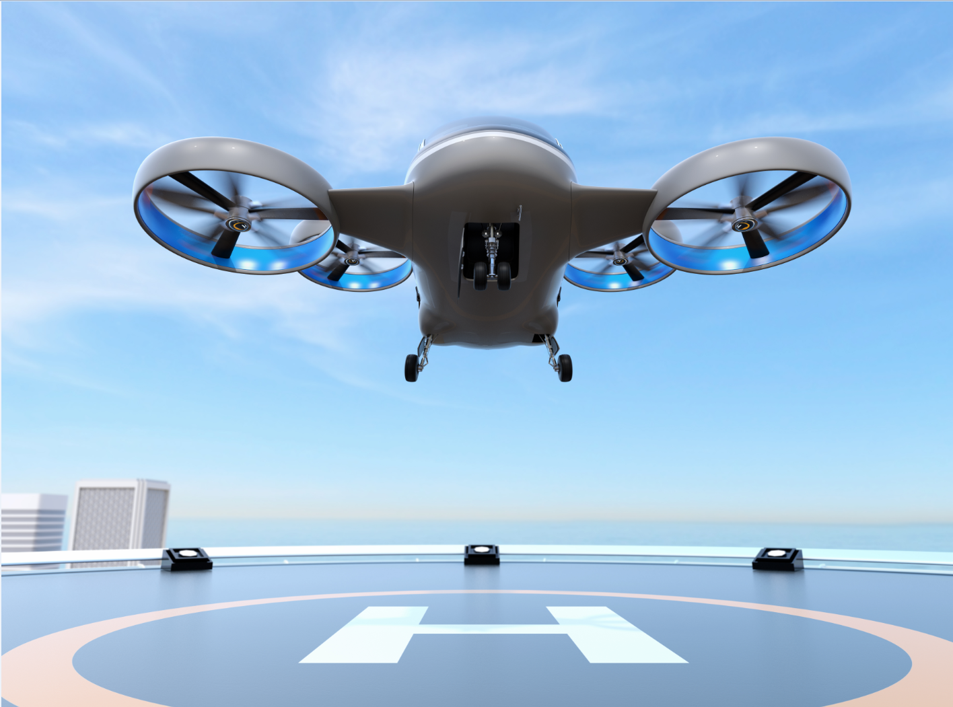

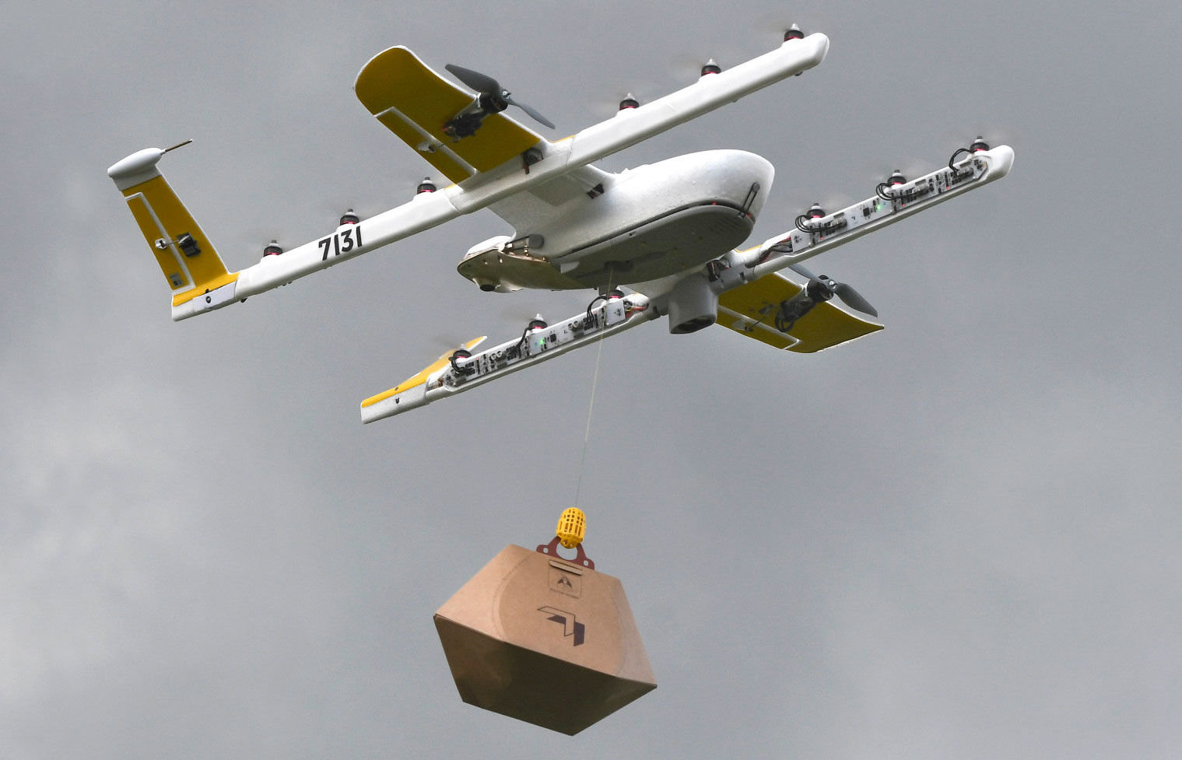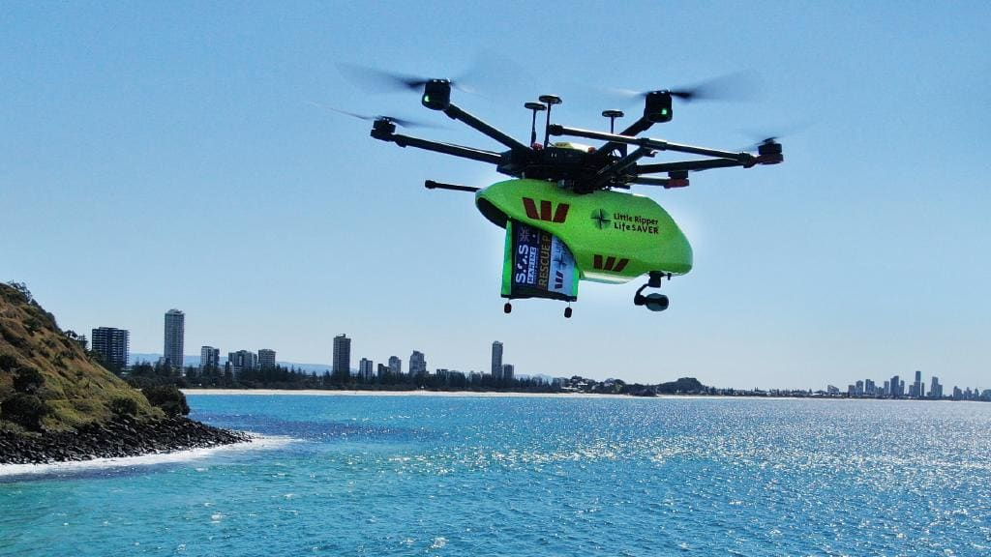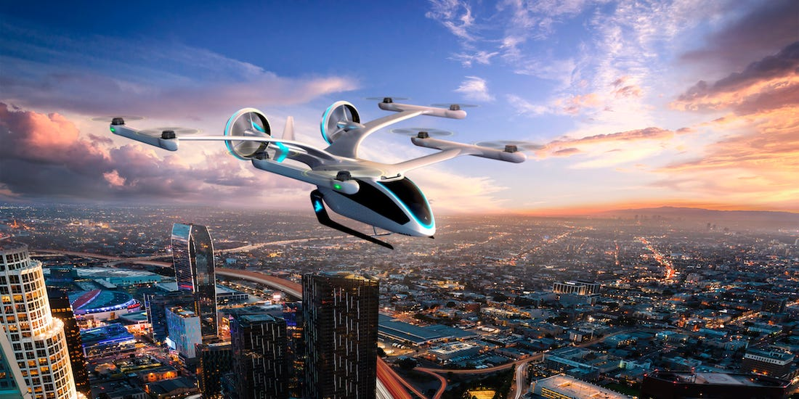

© Commonwealth of Australia 2021

Ownership of intellectual property rights in this publication

Unless otherwise noted, copyright (and any other intellectual property rights, if any) in this publication is owned by the Commonwealth of Australia (referred to below as the Commonwealth).

Disclaimer

The material contained in this publication is made available on the understanding that the Commonwealth is not providing professional advice, and that users exercise their own skill and care with respect to its use, and seek independent advice if necessary.

The Commonwealth makes no representations or warranties as to the contents or accuracy of the information contained in this publication. To the extent permitted by law, the Commonwealth disclaims liability to any person or organisation in respect of anything done, or omitted to be done, in reliance upon information contained in this publication.

Creative Commons licence

With the exception of (a) the Coat of Arms; (b) the Department of Infrastructure, Transport, Regional Development and Communications photos and graphics; and (c) [OTHER], copyright in this publication is licensed under a Creative Commons Attribution 4.0 Australia Licence.

Creative Commons Attribution 4.0 Australia Licence is a standard form licence agreement that allows you to copy, communicate and adapt this publication provided that you attribute the work to the Commonwealth and abide by the other licence terms.

Further information on the licence terms is available from <https://creativecommons.org/licenses/by/4.0/>.  
This publication should be attributed in the following way: © Commonwealth of Australia 2021.

Use of the Coat of Arms

The Department of the Prime Minister and Cabinet sets the terms under which the Coat of Arms is used. Please refer to the Commonwealth Coat of Arms — Information and Guidelines publication available at [www.pmc.gov.au](http://www.pmc.gov.au).

Contact us

This publication is available in hard copy or PDF format. All other rights are reserved, including in relation to any Departmental logos or trademarks, which may exist. For enquiries regarding the licence and any use of this publication, please contact:

Director— Internal Communications and Creative Services   
Communication Branch  
Department of Infrastructure, Transport, Regional Development and Communications  
GPO Box 594  
Canberra ACT 2601  
Australia

Email: [creative.services@infrastructure.gov.au](mailto:creative.services@infrastructure.gov.au)

Websites: [www.infrastructure.gov.au](http://www.infrastructure.gov.au)

Contents

INTRODUCTION 6

BACKGROUND 8

Drone operations 8

Future opportunities 8

Regulatory oversight 9

PROBLEM IDENTIFICATION 11

Problem 1: Current regulations are not fit for purpose 11

Problem 2: Inconsistent current legislation and regulation 12

Problem 3: Community acceptance of drone operations 12

Problem 4: Ground based impact of drone noise 13

Problem 5: Measurement of drone noise 14

Problem 6: Complaints Management/Enforcement 14

Current measures to address these problems 15

THE NEED FOR GOVERNMENT ACTION 16

POLICY OPTIONS 17

Option 1 – No change to the current Regulations 17

Option 2 – Deregulation 17

Option 3 – Flexible reform 18

Proposed interim framework 18

Applicability 19

Option 4 – Classification standards 19

Drone noise classification tool 20

IMPACT ANALYSIS 20

Option 1 – No change to the Regulations 22

Positive Impacts 22

Negative Impacts 22

Stakeholder Impacts 22

Public Impacts 22

Offsets 23

Option 2 – Deregulation 24

Positive Impacts 24

Negative Impacts 24

Stakeholder Impacts 24

Public Impacts 24

Option 3 – Flexible reform 26

Positive Impacts 26

Negative Impacts 26

Stakeholder Impacts 26

Public Impacts 26

Offsets 27

Option 4 – Classification standards 28

Positive Impacts 28

Negative Impacts 28

Stakeholder Impacts 28

Public Impacts 28

Offsets 29

OUTCOME ANALYSIS 30

Analysis of options 30

CONSULTATION 32

PREFERRED OPTION 33

IMPLEMENTATION 34

APPENDIX 1: REGULATORY BURDEN ESTIMATE (RBE) TABLE 36

APPENDIX 2: OPTION 1 APPLICATION PROCESS 37

APPENDIX 3: OPTION 3 APPLICATION PROCESS 38

APPENDIX 4: OPTION 4 APPLICATION PROCESS 40

Definitions and acronyms

Aircraft Aircraft means any machine or craft that can derive support in the atmosphere from the reactions of the air, other than the reactions of the air against the earth’s surface. (Civil Aviation Act 2018).

Airservices Airservices Australia is Australia’s Air Navigation Service Provider and is a government-owned organisation. It is responsible for the safety of 11 per cent of the world’s airspace the safe and efficient management of Australian skies and the provision of aviation rescue fire-fighting services at Australia’s busiest airports. Airservices works closely with customers and industry to support long-term growth of aviation services.

CASA Civil Aviation Safety Authority. CASA is a Commonwealth corporate entity that regulates Australian aviation safety and airspace. CASA licenses pilots, registers aircraft, oversees and promotes safety. CASA works with the aviation industry, Department of Infrastructure, Transport, Regional Development and Communications (the Department) and Airservices Australia to achieve a vision of safe skies for all.

CASR Civil Aviation Safety Regulations 1998

Drone Remotely Piloted Aircraft (RPA). Another common term is an un-crewed aerial vehicle or UAV, or an un-crewed aircraft system (UAS).

ICAO International Civil Aviation Organisation is a specialised agency of the United Nations. Its mission is to serve as the global forum of States for international civil aviation. ICAO develops policies and Standards, undertakes compliance audits, performs studies and analyses, provides assistance and builds aviation capacity through many other activities and the cooperation of its Member States and stakeholders.

Operator A person, organisation, or other legal entity engaged in, or offering to engage in, an aircraft operation.

ReOC Remotely pilot aircraft operator’s certificate. A remotely piloted aircraft operator’s certificate (ReOC) issued by CASA that authorises a person (to operate RPA for commercial purposes).

Regulations Air Navigation (Aircraft Noise) Regulations 2018

RPA Remotely piloted aircraft.

SOCs Standard RPA operating conditions (SOCs) – operating limitations expressed in regulation 101.238 of the Civil Aviation Safety Regulations 1998.

UTM Un-crewed traffic management system

## INTRODUCTION

In June 2019, the Department of Infrastructure, Transport, Regional Development and Communications (the Department) undertook a review of the Air Navigation (Aircraft Noise) Regulations 2018 (the Regulations) to determine how best to regulate the noise of Remotely Piloted Aircraft (drones) and other specialised aircraft operations.

The review noted that there are no specific standards or noise accreditation procedures for drones in the Regulations. The Regulations were drafted to suit traditional aviation aircraft and do not adequately account for new aviation technology such as drones. Currently, drone noise is being managed under section 17 of the Regulations which requires approval for aircraft to which no standards apply. The unintended result is a high rate of non-compliance with the Regulations among drone operators, leading to negative noise impacts on the community.

To address this issue, the review recommended the development of an interim regulatory framework for the management of Remotely Piloted Aircraft (drone) noise, as well as the commencement of work on a long‑term drone noise management framework.

This RIS presents options for interim solutions to regulate drone noise in an outcome focused, transparent and proportionate manner which meets community needs. Robust regulation will also assist the drone sector to grow in a manner that encourages noise minimisation and is safe, secure and considerate of community needs and the environment.

The preferred approach to addressing drone noise is Option 3: flexible reform. Under this option, the amended Regulations would create a process for certain drone users to seek noise approval for their operations. Only operations likely to cause a significant noise impact would require approval through the use of an online self-assessment tool. This approach also supported by stakeholders during consultation, would address the regulatory gap in drone noise management while minimising the administrative burden on operators.

In parallel with the development of interim noise regulations, the Department is developing a long-term noise framework as part of the Government’s National Emerging Aviation Technology (NEAT) policy. This long-term noise framework will likely rely on systems such as un-crewed traffic management (UTM) which are still in development.

Ensuring that drone noise is properly regulated will strengthen Australia’s leadership in the emerging aviation technology and associated regulatory frameworks. Australia possesses rapidly developing drone market with competitive advantages such as world-class research capabilities, established international partnerships, proximity to growth markets and unique geography, climate and expansive land area.

**Changes from the Consultation RIS**

On 30 August 2021, the Department published a consultation version of this RIS for public feedback, with submissions closing 4 October 2021. This consultation RIS proposed that the interim regulatory noise framework address both drones and electric vertical take-off and landing (eVTOL) aircraft.

Submissions to the consultation RIS noted there are significant differences in noise impacts, operating profiles and timelines for commercialisation of drone and eVTOL aircraft. eVTOL aircraft are still undergoing certification and in the short term (2-3 years), it is most likely that the eVTOL operations in Australia will be limited to testing and trialling in locations that will not have a noise impact on the community.

In response to feedback provided by public submissions, the Department has limited the scope of the interim noise regulations to drone noise. eVTOL aircraft noise will be captured in the long-term noise framework being developed as part of NEAT policy.

**Matters not covered**

There are several issues that are beyond the scope of this RIS, including safety regulation, security issues and the privacy impacts of emerging aviation technologies.

In addition, under the Regulations:

* state aircraft, hot air balloons and propeller-driven aircraft specifically designed for exclusive use in aerobatic purposes, fire-fighting purposes, agricultural operations or environmental operations are excluded (section 5 Application (2))
* model aircraft are effectively defined as recreational drones under the Civil Aviation Safety Regulations 1998 (CASR).

It is important to note that any amendments to noise impacts in the Regulations do not confer exemption from other laws, regulations and procedures such as Occupation Health and Safety Act 2004 and regulations and the Privacy Act 1988. The Department is developing guidance to assist drone operators to understand their obligations under privacy law.

## BACKGROUND

### Drone operations

Drones are emerging and innovative aviation technologies. Drones are already being used in a range of activities, including the agricultural sector, emergency services, infrastructure inspections and surveys, surf lifesaving, delivery of medical supplies, aerial photography and commercial and residential deliveries. There is great potential for emerging aviation technologies to be used for passenger and cargo transportation, either autonomously or with a pilot. Numerous aircraft prototypes are under development globally, however these aircraft are not currently operating commercially in Australia.

There are many examples of Australia leading the way with world first operations. The Little Ripper Lifesaver has been tailored for search, rescue and lifesaving operations including shark and crocodile spotting, and deploying rescue devices[1], and Swoop Aero, an Australian company, has been delivering vaccines in hard to reach places such as Vanuatu[2]. There has also been rapid growth in agricultural applications with drones being used to conduct power line surveys, for agricultural spraying and in aerial mustering in regional and remote areas.

Wing Aviation has been operating its drone delivery service in Australia since 2017. Following a trial period in the Australian Capital Territory, Wing commenced commercial operations in the Canberra region in 2018 before expanding to Logan in Queensland in 2019[3].

At the end of 2020, over 2,000 operators held a Remotely Piloted Aircraft (RPA) Operator’s Certificate as one of the ways to permit commercial drone operations. The alternative means to conduct commercial operations is to operate under the Excluded RPA category that permits simple commercial operations, such as videography and is dependent on the aircraft weight. It is estimated that there were over 15,000 Excluded RPA operators at the end of 2020.

There is currently less certainty around the number of recreational drones in operation. Based on sales over the last three years, the number of recreational drones is estimated to currently be over 1 million.

This RIS proposes amendments to the Regulations which will ensure that drone noise is properly managed to minimise community impacts and provide certainty to operators and individuals regarding drone noise requirements. Larger, heavier emerging aviation would be subject to the current section 17 noise approval process.

### Future opportunities

Emerging aviation technologies such as drones will significantly benefit the Australian economy and have the potential to transform the aviation sector, transportation, health and emergency services as well as the mobility and settlement patterns over coming decades. The predicted growth of the sector will provide more jobs and opportunities for small businesses to diversify and adopt new technology to carry out tasks in a safer and more efficient way.

Recent research commissioned by the Australian Government found that following a medium-growth scenario, new aviation technologies could add $14.5 billion to gross domestic product (GDP) over the next 20 years and create around 5,500 additional jobs (full-time equivalent). This includes over $4.4 billion in GDP for regional Australia and cost savings of $2.95 billion for the agriculture, forestry and fisheries sector, $2.45 billion for mining and $1.34 billion for construction[4].

Given this predicted growth and to ensure Australia can fully realise the benefits of this new technology, Australia must adopt an approach that is flexible enough to minimise the noise impacts of these aircraft and can evolve as the technology inevitably evolves. Countries across the world are currently grappling with these issues. Some countries are more advanced in their approach and have incentives in place for testing and trialling of new technology. To be competitive in this market, Australia must move swiftly and take a considered approach.

Through collaboration with industry via programs such as the Emerging Aviation Technology Partnerships Program, the government is seeking to support the use of emerging aviation technology as a means of meeting community needs. Not only will this fast-track Australia’s ability to unlock the projected economic benefits, it will also create jobs and boost efficiency and reduce emissions as outlined in the NEAT Policy statement.

One of the NEAT policy initiatives includes the development of a drone rule management system which will outline the non-safety guidelines for impacts of drones. This will include noise impacts to sensitive infrastructure, such as prisons, and national security issues.

### Regulatory oversight

Noise regulation for conventional aircraft is largely established through International Civil Aviation Organization (ICAO) standards and this has been the basis for the current Australian regulatory approach. However, there are currently no ICAO aviation noise standards for drones[5].

The Department administers the Regulations which are made under section 26 of the Air Navigation Act 1920.

A key requirement under the Regulations is for certain aircraft to hold either a noise certificate or an approval to operate[6] without the certificate. Under the Regulations, drones are classified as ‘aircraft’ and are therefore subject to this requirement, to the extent the aircraft engages in or affects:

* international air navigation
* air navigation conducted in relation to trade and commerce with other countries and among the States
* air navigation conducted by a constitutional corporation
* air navigation within a Territory or to or from a Territory
* air navigation that consists of landing at, or taking off from, a Commonwealth place
* air navigation in which a Commonwealth aircraft is engaged

In Queensland and Victoria the Regulations only apply to operations that are within the above categories. In all other states and territories the Regulations apply to all drone operations.

Furthermore, most drones are not constrained by the same geographical positioning and limitations as traditional aircraft, which adds complexity to the traditional measurement of noise impact and exposure.

Drones operated for recreational or commercial purposes are subject to aviation safety regulations that include limitations on where drones may be operated (for example, the distance away from airports and built-up areas, height restrictions and other operating procedures[7].

In addition to aviation specific legislation, environmental legislation also covers noise impacts. The Commonwealth administers the *Environmental Protection and Biodiversity Conservation Act 1999*, while each state and territory administers its own environmental legislation.

## PROBLEM IDENTIFICATION

Under the Regulations, noise impacts from drones and other emerging aviation technologies are treated under the same framework as traditional aircraft noise. The Regulations do not provide an effective framework for managing the noise associated with drone operations and are not considered fit-for-purpose. Appropriate, flexible amendments to the Regulations tailored for drone users have the potential to increase compliance, reduce unnecessary administrative burden and encourage growth in the industry by providing certainty to users and the community.

Drones are part of an emerging market, and despite rapid growth in recent years the sector has only realised a fraction of its economic potential. As the market grows there will undoubtedly be further opportunities and growth in the number of services that can be provided.

However, risks and impacts associated with noise and other issues will also continue to emerge and may increase in significance. As experience in traditional aviation has shown, aircraft noise can have significant negative impacts on individuals and communities. Compared to traditional aircraft, drones fly much closer to the ground and in places where the public may not expect them. Noting there may already more than 1 million drones in operation in Australia, drone noise must be properly managed to ensure community needs are respected and the industry is able to grow in a sustainable manner.

The key issue this RIS is seeking to address is that the current Regulations were drafted to suit traditional aviation and do not adequately account for new aviation technology such as drones. The current gap in the Regulations has been identified by concerned individuals and communities impacted by drone noise as well as recreational and commercial drone operators, who are seeking certainty and clarity regarding their obligations as it relates to noise impacts.

A secondary problem is that the perception of drone noise is quite subjective and there are currently no standards against which to measure drone noise. This presents challenges when developing policies around the management of drone noise.

The following section outlines key problems associated with the management of drone noise in more detail, noting many of the problems are interrelated and difficult to separate.

### Problem 1: Current regulations are not fit for purpose

Current aircraft noise regulations were designed for traditional aircraft and focus on managing noise impacts around aerodromes. Under the Regulations traditional aircraft (e.g. jet and propeller aircraft/helicopters), drones are all defined as ‘aircraft’, meaning these vastly different types of aircraft have the same requirements. As a result, the emerging aviation technology sector is somewhat constrained by a traditional approach to noise regulation (e.g. decibel limits and noise certification for different classes of aircraft, curfews and movement caps at some airports and requirements to conduct community engagement in flight path design) that does not align with new types of aviation technology and operating models.

The most significant misalignment between the Regulations and emerging aviation technology is the requirement for aircraft to have a noise certification. There is currently no process for drones to obtain noise certification, and no criteria or guidance on how approvals should be applied for these aircraft. Furthermore, there is no standard against which to measure drone noise. Noting that drone designs are constantly iterated and improved upon, with new models regularly entering the market, it is not feasible for drone manufacturers to seek and receive noise certification for their products.

When granting approvals to date, the Department has used an application process similar to that used for historical and adventure aircraft. This process utilises Section 17 “Approval for other aircraft to which no standards apply“ of the Regulations. To date, Section 17 approvals have only been granted to Wing for their drone delivery services, and as such the majority of drone operators are operating without a noise certificate or an approval, and are therefore non-compliant with the Regulations.

Approvals under section 17 of the regulations impose operating conditions and reporting requirements for the operator, which aim to minimise noise impacts of their operations. Section 17 would not be suitable for recreational drone users, as it would impose a high regulatory burden, stringent operating conditions (possibly beyond the capability of a small recreational drone) and onerous reporting requirements.

### Problem 2: Inconsistent current legislation and regulation

There are various pieces of Commonwealth, state and territory legislation and regulations covering aviation noise. There are also inconsistencies in the application of the Regulations across the states and territories noting the Regulations do not apply of its own force or by force of state law in all states (specifically Queensland and Victoria).

In addition, state/territory environmental protection legislation regulates noise intrusion into commercial, group centres (major shopping districts) and residential suburbs. While these regulations are not uniform across jurisdictions, the majority of noise regulations cover similar noise intrusions within an urban environment, including from motor vehicles, gardening equipment, construction tools, domestic animals, urban social gatherings and municipal services.

If not addressed, inconsistency across jurisdictions will reduce interoperability, enforcement and compliance and impact operators wishing to operate across borders or in multiple jurisdictions. Different rules, requirements and allowances increase compliance burdens on operators and their operations.

### Problem 3: Community acceptance of drone operations

Perception is critical when it comes to defining drone noise. Noise is highly subjective. The complexities of people and their reactions to sound in a given scenario are difficult to predict. This makes assessing the impact of noise and determining appropriate solutions, including the setting of standards, difficult[8].

The public may be willing to accept an inconvenience like drone noise if it is linked to activities they desire and their understanding of the purpose of the drone services and recreational activities is increased. The public may embrace the new technology and transport modes.

This is easily illustrated by the public acceptance of helicopter noise near a trauma hospital, when in other settings it may trigger complaints. Furthermore, if a drone cannot be easily identified, the public do not know if is delivering life-saving medicines, or making a food delivery.

Commercial businesses can help mitigate these issues by being proactive with community outreach to ensure the community understands the purpose of their operation. Feedback gained through outreach can also lead to modification of operations where it is possible to address community concerns through things such as dynamic routing. These approaches enhance the likelihood of drone operations being accepted and commercially viable in communities.

### Problem 4: Ground based impact of drone noise

Traditional approaches to noise management includes setting limits on the noise emissions from aircraft and mitigating impacts around aerodromes through flight path design. This approach does not accurately reflect the actual noise impact for drones, leading to an increasing risk of regulations that are either unnecessarily restrictive for operators, or ineffective in ensuring drones operate within community expectations regarding noise impacts.

A large number of variables determine the noise impact from a drone. The following diagram provides an example of the number of variables that combine to determine the total noise impact for a particular ground-based location.

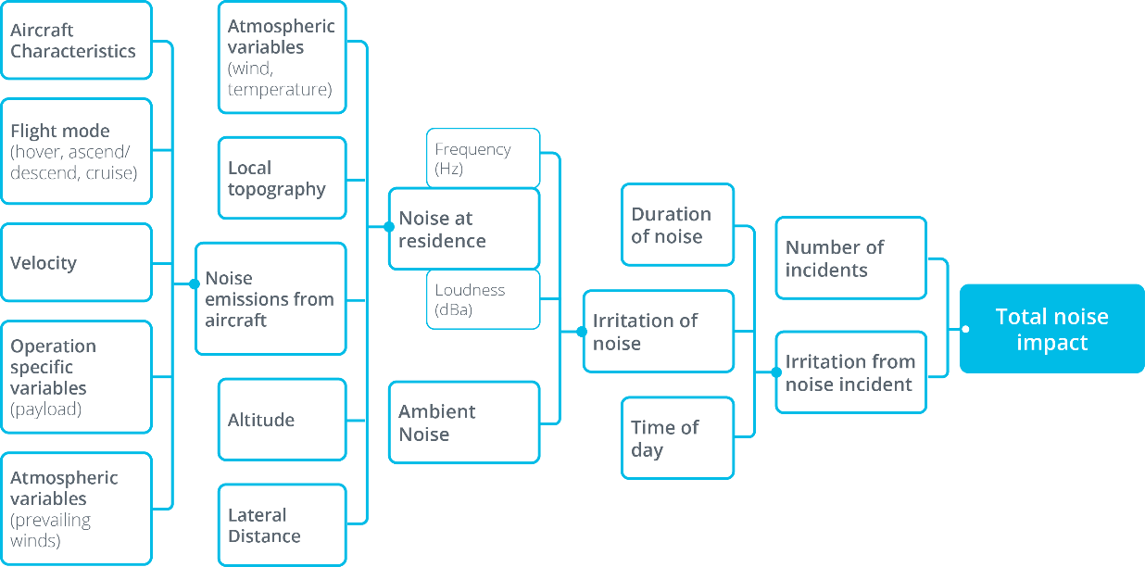

A number of environmental variables, including distance, affect how much noise is experienced at a point on the ground. Some of these variables include noise cancellation effects, reverberation, angle of propulsors, air density, air temperature, vegetation density and local geology. The total number of variables combine to give an overall level of noise impact and this cumulative impact element is extremely important. Occasional or one-off noise occurrences, even if moderately loud, generally do not generate much concern. Frequent and regular noise tends to generate the most concern, and varies by time of day.

As the sector develops, there is expected to be increasing variance in the size and function of drone and emerging aviation operations. For this reason, drone noise is being considered as part of a single framework. Trying to draw a distinction between classes of aircraft (based on size, weight, altitude and noise output) and regulating these aircraft types differently would create new challenges. It could also likely result in overlapping or inconsistent regulatory frameworks that are not effective in managing the total noise impact from different aircraft operations.

### Problem 5: Measurement of drone noise

Most drones currently in use emit less noise (typically between 55dB and 69dB) than most other aircraft (typically between 65dB and 95dB[9]) or road vehicles, however they emit an atypical noise at an uncommon frequency that is often described as ‘annoying’[10]. This has raised concerns in some communities and has been a matter of focus in recent discussions on drone regulation in Australia[11].

The operating profile of a drone tends to be:

* significantly quieter with a more contained noise profile than traditional manned aircraft; and
* more agile within a smaller operating volume.

There are different forms of sound measurement that can be used in the analysis of aviation noise. These range from weighted sound pressures to effective perceived noise levels through to the Sound Exposure Level[12]. However measurement of drone noise is not entirely straightforward and the impact of drone noise is further influenced by the environment in which the aircraft is operating and the conditions on any given day.

While there is no easy single measurement tool or threshold, it is possible to obtain a noise measurement via an acoustic specialist, however the associated costs are high (approximately $120 per hour). This may be appropriate of a large-scale operator with a large noise impact but is not a reasonable request of a recreational or small-scale commercial operator. The Regulations do not make a distinction between types of operators, again highlighting the inflexibility and unsuitability of the Regulations when applied to drones and other emerging aviation technology.

### Problem 6: Complaints Management/Enforcement

Noise complaints related to drones are challenging as they are often combined with issues such as privacy and environmental impacts, as well as personal opinions on drone use in general.

A number of Commonwealth agencies have a role to play in the management of drones and there are many avenues for submitting drone noise complaints. This can lead to confusion around which agency is responsible for handling noise complaints.

Currently, complaints and concerns can be directed to the individual or commercial operator, if known. It is important to note that safety related concerns are addressed by CASA. The Department also takes complaints as does the Noise Complaint Information Service (NCIS) managed by Airservices Australia. Refer to <https://www.aviationcomplaints.gov.au/aircraft-noise#The_complaint_process>.

Between January and September 2021, the NCIS recorded 70 drone noise complaints. This number is minimal given there are estimated to be over 1 million drones in operation across the country, with tens of thousands of commercial drone flights occurring each month. Note that this number does not include complaints submitted directly to operators or via other avenues.

Resolving a drone noise complaint can be challenging if the operator is not easily identifiable. Commercial operators may be identified based on the company’s operating conditions, locations and design of their drone. However, identifying the operator of a recreational drone is not as straightforward.

As technology advances and with the introduction of drone registration and systems such as un‑crewed traffic management and remote identification (which provides limited identifying information about a drone operator), investigating noise complaints should become easier. As this technology is not likely to be implemented for a number of years, a process is required in the interim for investigating and resolving noise complaints.

### Current measures to address these problems

Currently, the Department can, in certain circumstances, issue drone operators an approval to operate without a noise certificate under section 17 of the Regulations. Approvals are typically issued in situations where the operator may have a significant noise impact on the community. Approvals can include a number of operating conditions to ensure operator flexibility while balance community needs/concerns. Conditions on operations can include matters such as:

* limited days and/or hours of operation
* requirements to notify the Department before commencing operations in new locations
* requirements to report numbers of flights
* requirements to report community feedback and complaints
* limitations on numbers of flights per day (only where necessary to ensure noise impacts remain acceptable to the community).

In addition to these conditions, operators are encouraged to reduce noise impacts and avoid flights over sensitive areas.

## THE NEED FOR GOVERNMENT ACTION

Noting the international nature of the aviation sector, multilateral bodies such as ICAO have long identified a need for the management of aircraft noise. Since the 1970s, ICAO has set noise limits for aircraft through the Standards and Recommended Practicies contained in Annex 16 to the Convention on International Civil Aviation.

The Government’s capacity to regulate aircraft noise is well demonstrated. In Australia, all civil aircraft operating are required to comply with the Regulations regardless of size, purpose or ownership.

The 2019 review of the Regulations indicated strong support from all stakeholders across industry, the community and individuals for the Commonwealth to manage drone noise, particularly as it relates to larger drones and commercial operations that operate in urban and residential areas.

There are currently no international noise standards for drones. Countries and regions across the world are considering what regulations and standards may be appropriate, noting the drone industry is rapidly evolving and any regulation needs to take account of advances in technology. For the Australian industry and the public to fully take advantage of emerging aviation technology such as drones, our regulations must keep pace with this rapidly changing sector.

The Government’s objective in intervening in drone noise regulation is to put in place appropriate policies to minimise drone noise impacts on communities, thereby building public acceptance of drones and creating a transparent, consistent regulatory environment to encourage the sector to grow. As set out in the review of the Regulations, the public seeks assurance that the Government is appropriately responding and regulations new technologies, ensuring economic benefits are weighed against noise and amenity impacts.

The alternative to government intervention is to deregulate the sector and expect drone operators to self-regulate. The Department considers self-regulation will not achieve consistant and effective regulation of noise in a way in which would meet public expectations. Even in the case that most operators are considerate of the noise impact of their drones on the public, a small number of drone users operating loud drones with disregard to community expectations could significantly disrupt the public’s general amenity.

The current barrier to effective drone noise management is that the current Regulations were not intended to cover drone operations, leading to an unintended regulatory failure. The Government is seeking to ensure new regulations are established that are both achievable and appropriate for the industry and benefit the broader community.

As regulatory change is complex and as the industry is still emerging, an interim solution is required while a longer-term approach is being developed as part of the NEAT policy framework[13]. An interim solution will ensure community expectations are met as the long-term approach, informed by emerging systems such as UTM, is developed.

## POLICY OPTIONS

This RIS considers four options:

1. No change to the Regulations.
2. Deregulation of drone noise – exclusion of drones from the Regulations.
3. Reform the Regulations – to include flexible and fit-for-purpose drone requirements.
4. Establish classifications under the Regulations – establish a benchmarking tool for all drones.

### Option 1 – No change to the current Regulations

Option 1 is to make no change to the Regulations. However, this does not address the problems identified and would continue the prohibitive requirement for a noise certificate or an approval under Section 17 of the Regulations to operate without a certificate for certain drone operators.

As has been noted, the Department only provides these approvals where it identifies that drone operations are likely to have a significant noise impact (e.g. for commercial drone delivery operations). Enforcing the current Regulations on all drone users would impose an extreme amount of regulatory burden; all usages of a drone, even recreational, would require the operator to request and receive noise approval. In addition to imposing a regulatory burden on every drone operator in Australia, processing these applications would require substantial resourcing from the Department.

Noting the above issues, universally enforcing the Regulations as currently written is not feasible. Accordingly, this option would entail the Department continuing to make ad hoc policy decisions regarding which drone operators require Section 17 approval. The Department’s ad hoc decisions would not be informed by any guidance set out in the Regulations. This would create significant uncertainty for both operators and the community. In addition, it is likely that some drone operations with significant noise impacts would fall through the cracks, leading to ongoing negative impacts on communities and individuals.

As large scale commercial drone operations are projected to increase over the coming years, this option would involve some additional administrative burden on those operators the Department decides to require approval under Section 17 of the Regulations.

This option does not address the objectives of Government intervention in this space, as it does not put in place a consistent, transparent approach to regulating drone noise.

Appendix 2 sets out the current application process used for granting Section 17 approval which would be retained for this option.

### Option 2 – Deregulation

Option 2 proposes that the noise impacts from the drone industry could be completely deregulated. This would remove all requirements around noise certification and approval to not have noise certification and effectively exclude drones from the Regulations.

Full deregulation creates the potential for irresponsible operators to enter the market, without regard for their noise impact. Given the sensitivities around drone noise, one irresponsible operator could tarnish the whole industry and undo the goodwill generated with communities through extensive outreach by responsible operators. Without some level of regulation in place, the Government would have no recourse for managing such a scenario.

The absence of the Commonwealth’s leadership in regulation may see jurisdictions implement alternative regulatory mechanisms resulting in inconsistencies across jurisdictions making compliance complex for operators.

Furthermore, the lack of appropriate regulatory oversight may impede and discourage international investment and would lead to inconsistent treatment compared to traditional aviation.

This option does not address the objectives of Government intervention in this space, as deregulation leaves Government no tools to manage drone noise.

### Option 3 – Flexible reform

The Regulations could be amended to implement a flexible regulatory approach to better account for emerging aviation technology. Amendments would remove requirements for approvals for drone operations unlikely to have a significant noise impact on the community. Drone operations likely to have a noise impact may require approvals subject to conditions designed to mitigate noise impacts.

This would be implemented using a flexible approach that allows for management of noise impacts on a case-by-case basis. This approach would be sustainable for operators, promote industry innovation, encourages operators with a significant noise profile to be accountable for their noise and balances the needs of the community. While this is an interim solution, it is likely to be an iterative process with further potential variations occurring over time to stay in touch with the emerging market.

This option fulfils the Government’s objective of managing drone noise, as well as the recommendation of the Review for an interim drone noise solution. This flexible interim approach would create a clear regulatory processes for managing drone noise. By taking a risk-based approach, where operations that are unlikely to have significant noise impacts do not need to seek approval, the Department would be able to focus regulatory efforts on those operations most likely to affect individuals and communities.

A future long-term noise management framework may require further changes to the Regulations, and would therefore be subject to a separate RIS process.

#### Proposed interim framework

The framework would:

* be based on noise risks and focus on operations that are likely to have a significant noise impact (due to location of operations, frequency and density of aircraft operations and noise output of aircraft)
* be flexible and proportionate, to reflect a range of different concepts of operation for drones.
* Allow operators the opportunity to refine their concepts of operations to reduce noise impacts where they occur
* encourage continuous improvement by operators to reduce noise impacts.

The framework would include consideration of:

* noise impacts during operations, with a view to establishing comparable measurements.
* community feedback mechanisms, to ensure that local community sentiment regarding drone operations can be effectively monitored.
* operating limits (such as time of day, operating distance, volume of flights), where necessary, to ensure noise impacts remain within levels acceptable to the local community.

#### Applicability

The Regulations would be amended to create specific approval processes for drone operations. Some drone operations would be exempt from requiring an approval, including:

* drones used for recreational purposes
* drones used for agricultural purposes
* drones used for commercial purposes within the standard operating conditions
* drones used for fire fighting, medical and policing purposes
* drones weighing under 250g.

The categories of exempt drones is informed by public consultation, including feedback on the consultation RIS earlier in 2021, and comments on the review of the Regulations in 2019.

The proposed application would consist of a five step process of self-assessment, application, assessment of the application, additional information requested (if required) and approval (including conditions). Appendix 3 sets out the proposed application process for this option.

### Option 4 – Classification standards

Standards and classifications of drone aircraft noise could be used to both inform operators of their impact and protect sensitive areas. This option proposes developing a drone noise classification tool to classify drone aircrafts according to their noise profile and would be the basis for issuing an approval to operate without a noise certificate.

The proposed method of benchmarking revolves around determining allowable noise levels based on the land-use-areas affected and noise level of similar appliances. The application of “land‑use-area” in determining noise compliance could enhance operations (allowing noisier drone operations) but could also add undue complexity to the airspace, making operational requirements/compliance unnecessarily complex.

The proposed drone noise classification tool could take into consideration the type of drone operations undertaken and weight limits. Therefore operations under current standard operating conditions would not require drone noise classification. Accordingly, drone operations would only be noise classified where:

* a drone weight-criteria is exceeded and/or
* operations revolve around delivery and high density operations.

Drone weights would align with the CASA definitions of micro, very small, small, medium and large[14].

This option fulfils the Government’s objective of managing drone noise, as well as the recommendation of the Review for an interim drone noise solution. The use of a drone noise classification tool will ensure that the Department can focus its regulatory efforts on those operations most likely to have significant noise impacts.

#### Drone noise classification tool

The drone noise classification tool should be based on the specific flight characteristics of the aircraft such as take‑off, landing, slow-stationary flight and rapid movement operations. The tool should take acoustic weighting and the potential for tonal characteristics into consideration rather than use a generic comparable noise value e.g. noise from a lawn mower (can vary between 40dB and 85dB), which has only one function and tone (versus a drone which has many functions, operating abilities and tones) (ranging from 55dB to 69dB).

Localised ground-based noise limits could be set having regard to the surrounding environment and needs. This will serve to set a noise standard at ground level, giving drone operators greater flexibility in how they meet the standard through aircraft design (quieter drones), dynamic routing, and operating altitude. Ensuring operations are conducted consistent with the various ground based levels would provide certainty for drone operators and the broader community.

It is expected the tool would not apply to drone operations with minimal noise impacts, applying only to larger types of aircraft or aircraft that operate in high-trafficked areas.

This option could increase regulatory complexity as setting noise limits based on classes of aircraft is problematic given the rate at which technology is advancing. Additionally, once a limit is set, the incentive for companies to keep innovating to reduce the noise emissions from their aircraft is removed. For example, if the certification requirement for a type of drone is set at 65-decibels, it is likely the market will be filled with 65-decibel drones given there is no incentive to make them quieter.

Linking noise classifications to ground impact could also discourage competition. If one drone aircraft is operating in an area at the maximum tolerated classification level there is little to no space for competitors to enter the same airspace. In a situation such as this, the original drone operator could potentially be discouraged from making their drone quieter as a means of keeping competitors out of the same airspace.

The application process for the categorisation tool would consist of six steps: establish the type of operations; provision of noise management data; application; assessment of the application; noise certificate issued and modifications or revisions (if required). Appendix 4 sets out the proposed application process for this option.

## IMPACT ANALYSIS

Conservative estimates of the regulatory costs and savings associated with each option have been provided.

In line with the Office of Best Practice Regulation’s Regulatory Burden Measurement Framework, opportunity costs have not been included or considered. The total average annual regulatory costs (from business as usual) are included in the regulatory burden estimate (RBE) table in Appendix 1.

The assumptions used to derive these cost estimates are outlined below:

* Business number assumptions relate to those small, medium and large businesses[15] currently in the market and expected growth over the next 10 years.
* For those businesses or community groups completing the applications processes for commercial use the default hourly cost is based on average weekly earnings, but adjusted to include income tax.[16] This provides an economy-wide value for employees of $41.74 per hour.[17] This value needs to be scaled up using a multiplier of 1.75 (or 75 per cent as it is input into the Regulatory Burden Measure) to account for the non-wage labour on-costs (for example, payroll tax and superannuation) and overhead costs (for example, rent, telephone, electricity and information technology equipment expenses). This results in a scaled up rate of $73.05 per hour ($41.74 multiplied by 1.75). This default should be used in cases where regulation cuts across a number of sectors, or where more appropriate labour rates are unknown or would add undue complexity to the costing process.
* For those businesses or community groups completing the applications processes, the noise measurement wage assumption has been doubled as it assumes acoustic experts and specialists will need to be engaged and paid for their services.
* Initially, noise testing would be a start-up cost however, additional testing may be required if significant modifications were made to the drone. This would only be necessary for businesses and community organisations as it is assumed recreational operators are unlikely to require noise approvals.
* For individuals completing the application processes for their recreational drone the default value that should be used for an individual’s leisure time is based on average weekly earnings and has been estimated at $32 per hour
* As a delay cost has to be assumed in application processes, the delay is only estimated to be one day. This assumption has only been applied to businesses and community organisations given a delay could potentially result in a loss of revenue. Individuals would not have a monetary loss if a delay were experienced.
* Any potential or actual amenity impacts are not considered as part of this noise regulation RIS.
* Future residential land uses may be subjected to noise impacts which were not assessed at the time an approval was granted. This can be addressed by limiting longer term approvals where there is potential for future noise sensitive development reporting requirements for approvals include reporting on changes to development within the areas of operation.
* Regulatory reform will streamline the process while classification rules and flight zones could be useful for compliance and to minimise amenity impacts in the future.

### Option 1 – No change to the Regulations

#### Positive Impacts

* Minimal increase in costs.
* Less administration and management with minimal applications for noise approvals.
* Recreational drone operators de facto unregulated, which could be viewed as positive by some drone operators.

#### Negative Impacts

* Regulatory gap with a failure to regulate drone noise appropriately. The Government would have minimal ability to address noise impacts from drone operations.
* Leaving the regulations unchanged is likely to have a negative impact on the general public. As drone usage becomes more widespread, the number of drone operators that are non‑compliant with noise regulation will increase, and a lack of appropriate regulation increases the risk of noise impacts on individuals’ and communities’ general amenity.
* All operations without Section 17 approval would be non-compliant with the Regulations.
* Regulations would not address public concerns about evolving noise and amenity impacts.
* The drone industry may not increase at the expected rate (anticipated growth of $14.5 billion in GDP over the next 20 years and an additional 5,500 jobs) as new entrants, including international investors, may be deterred due to onerous compliance requirements and lack of regulatory clarity.

#### Stakeholder Impacts

This option continueswith the current regulatory framework. This will involve some **minor regulatory impacts** on businesses and community organisations which are conducting operations with a very large number of drones, as these are the only operators that the Department will require to submit a request for noise approval under Section 17. The total regulatory impact of this option is set out in Table 1 below.

Beyond the immediate regulatory impacts on industry, this option has significant potential flow-on impacts:

* The growth of the drone sector may be inhibited, with new entrants deciding not to enter the market due to the lack of consistent and transparent noise regulations.
* Some operators that pose significant noise risks may slip through the cracks due to the lack of consistent regulations. This would lead to negative noise impacts for communities and individuals.

#### Public Impacts

The Government would have limited legislative mechanisms to effectively manage drone noise or enforce non-compliance; the Section 17 approval process set out in the Regulations is cumbersome and difficult to apply to drones, particularly recreational operations or low scale commercial operations. As noted on page 11, drone noise is commonly perceived to be annoying, and a lack of appropriate regulation will mean that potentially annoying noise impacts are not dealt with. Accordingly, The degree to which this option addresses publics concerns regarding drone noise impacts is very low.

Requirements:

* Approval process for operators of very large numbers of drones – annually.
* Delay costs – annually for relevant operators.
* Noise testing – assumed for relevant operators as a start-up cost but would need to be redone if significant modifications were made to an aircraft.
* Reporting – monthly for relevant operators.

**Table 1: Total regulatory impact of Option 1**

|  |  |
| --- | --- |
| **Option name** | No Change |
| **Option description** | Continuation of the current Regulations |
| **Businesses affected** | 5 (estimate of current numbers and expected growth; assuming only very large operators will be requested to submit an application;) |
| **Individuals affected** | 0 (assuming no individuals would be requested to submit an application) |
| **Community organisations affected** | 1 (estimate assuming only very large operators will be requested to submit an application) |

|  |  |  |  |  |  |  |
| --- | --- | --- | --- | --- | --- | --- |
|  | **Cost per  business** | **Total cost for all business** | **Cost per  individual** | **Total cost for individuals** | **Cost per  community organisation** | **Total cost for all community organisation** |
| **Start-up cost** | $7,342 | $36,710 | $0 | $0 | $7,342 | $7,342 |
| **Ongoing compliance cost per year** | $1,497 | $7,487 | $0 | $0 | $1,497 | $1,497 |
| **Start-up time** | 11 hr | 11 hr | 0 hr | 0 hr | 11 hr | 11 hr |
| **Ongoing compliance time per year** | 1 hr | 1 hr | 0 hr | 0 hr | 1 hr | 1 hr |

#### Offsets

No offset is required as this option maintains the status quo.

### Option 2 – Deregulation

#### Positive Impacts

* No administrative burden for operators.
* Drone safety rules may still provide some mitigation of noise impacts from drones.

#### Negative Impacts

* Removes any ability for Commonwealth to manage noise impacts. The Government would have no ability to take action to address noise impacts from drone operations.
* Deregulation is very likely to have a negative impact on the general public. In the absence of any noise regulation, as drone usage becomes more widespread, there would be a very high risk of substantial noise impacts on individuals’ and communities’ general amenity.
* State and territory governments may feel the need to regulate in the absence of Commonwealth regulations, resulting in inconsistent drone noise management across jurisdictions.
* Lack of operator accountability may lead to irresponsible operators causing significant noise impacts, negatively impacting the public.
* Community concerns about noise and amenity impacts unaddressed.
* Lack of certainty among international investors due to absence of regulatory framework.
* The drone industry may not increase at the expected rate (anticipated growth of $14.5 billion in GDP over the next 20 years and an additional 5,500 jobs) as new entrants, including international investors, may be deterred due to onerous compliance requirements and lack of regulatory clarity.

#### Stakeholder Impacts

This option involves **no regulatory impacts** on any operators. The total regulatory impact of this option is a cost saving of $8,982 on an ongoing basis compared to Option 1.

Beyond the immediate regulatory impacts, this option has significant potential flow-on impacts:

* The growth of the drone sector may be inhibited, with new entrants deciding not to enter the market due to the lack of consistent and transparent noise regulations.
* Some operators that pose significant noise risks may slip through the cracks due to the lack of consistent regulations. This would lead to negative noise impacts for communities and individuals.

#### Public Impacts

The Government would not be able to manage any drone noise impacts. As noted on page 11, drone noise is commonly perceived to be annoying, and a lack of regulation may be perceived as Government unwillingness to address concerns raised by the community about noise impacts.

Deregulation would also entirely remove the ability for Government to place conditions on drone operations to manage noise impacts on the public. Operators would be allowed to:

* fly at all hours, including during the night
* fly an unlimited number of flight hours
* fly without regard to community consultation and engagement.

Accordingly, this option does not address publics concerns regarding drone noise impacts at all.

Requirements:

* Nil

### 

### Option 3 – Flexible reform

#### Positive Impacts

* Regulatory activities are targeted towards those drone operators most likely to pose significant noise impacts.
* Public impacts of drone noise are minimised by regulation that ensures that operations with significant potential noise impacts require approval from the Government, and this approval may include conditions to ensure drone noise is minimised, such as:
  + restrictions on when drone operations may take place
  + restrictions on the number of flight hours
  + requirements to consult with communities before commencing full-scale operations
  + requirements to report complaints to the Department
  + requirements to tailor flight plans to minimise impact on any individual resident.
* Flexible approach encourages operators to innovate to reduce noise impacts and aims to reduce regulatory burden.
* Provides clarity for operators and the general public.
* Results in fit-for-purpose regulations that provide flexibility for operators.
* Comprehensive framework would help realise potential economic benefits stemming from the sector (anticipated growth of $14.5 billion in gross domestic product (GDP) over the next   
  20 years and an additional 5,500 jobs).

#### Negative Impacts

* Slightly increased administrative burden on certain operators compared to Option 1.

#### Stakeholder Impacts

This option involves **minor regulatory impacts** on businesses and community organisations which are conducting operations with a large number of drones. The amended regulations will exempt users with a low risk of noise impacts (such as recreational users and commercial users operating within standard operating conditions) from noise regulations. Operators with a large number of drones, which would present the highest potential for noise impacts, will be required to submit a request for noise approval. The total regulatory impact of this option is set out in Table 2 below.

#### Public Impacts

This approach ensures that the Government has a fit-for-purpose process designed specifically for drones to manage noise and ensure compliance with noise regulations. Apart from exempt categories, which have the lowest risk of noise impact, the Government would have oversight over the noise impact of drone operations. Where an issue is identified and operations are causing significant noise impacts for the public, for example where an operator does not follow their conditions, the Government would have the power to investigate and revoke an operator’s approval.

Requirements:

* Application process for operators of large numbers of drones – annually.
* Delay costs – annually for relevant operators.
* Noise testing – assumed for relevant operators as a start-up cost but would need to be tested again if significant modifications were made to an aircraft.
* Reporting – monthly for relevant operators.

**Table 2: Total regulatory impact of Option 3**

|  |  |
| --- | --- |
| **Option name** | Reform the Regulations |
| **Option description** | Flexible and fit-for-purpose drone regulations |
| **Businesses affected** | 10 (estimate of current numbers and expected growth and assuming only large operators will need to fulfil the full application process) |
| **Individuals affected** | 0 (assuming most individuals will be exempt) |
| **Community organisations affected** | 2 (estimate assuming only large operators will need to complete the full application process) |

|  |  |  |  |  |  |  |
| --- | --- | --- | --- | --- | --- | --- |
|  | **Cost per business** | **Total cost for all businesses** | **Cost per individual** | **Total cost for individuals** | **Cost per community organisation** | **Total cost for all community organisations** |
| **Start-up cost** | $7,342 | $73,420 | $0 | $0 | $7,342 | $14,684 |
| **Ongoing compliance cost per year** | $1,497 | $14,970 | $0 | $0 | $1,497 | $2,994 |
| **Start-up time** | 11 hr | 11 hr | 0 hr | 0 hr | 11 hr | 11 hr |
| **Ongoing compliance time per year** | 1 hr | 1 hr | 0 hr | 0 hr | 1 hr | 1 hr |

#### Offsets

This option represents a modest increase in costs for a small number of drone operators (i.e. those operators which are using a significant number of drones, such as for delivery services). The Department’s remit as it applies to aircraft regulation is limited to noise management, and so offsets for this additional cost was unable to be identified.

### Option 4 – Classification standards

#### Positive Impacts

* Regulatory activities are targeted towards those drone operators most likely to pose significant noise impacts.
* Public impacts of drone noise are minimised by regulation that only provides approval for drones which are assessed to have an appropriately small noise impact for their weight.
* Flexible approach encourages operators to innovate to reduce noise impacts and aims to reduce regulatory burden.
* Provides clarity for operators and the general public.
* Results in fit-for-purpose regulations that provide flexibility for operators.
* Comprehensive framework would help realise potential economic benefits stemming from the sector (anticipated growth of $14.5 billion in gross domestic product (GDP) over the next   
  20 years and an additional 5,500 jobs).

#### Negative Impacts

* Implementation delay due to significant amount of time required to develop noise assessment processes and tools.
* Additional administrative application/re-application process and retesting process required following significant modifications which may disincentivise the development of quieter or lighter aircraft.
* No incentives to decrease noise if weight stays the same.
* Slightly increased administrative burden on certain operators compared to Option 1.

#### Stakeholder Impacts

This option involves **moderate regulatory impacts** on businesses and community organisations. The amended regulations will only apply to drones within specific weight classes, and only operators with a medium or large number of drones, presenting the highest potential for noise impacts, will be required to undergo noise testing. The total regulatory impact of this option is set out in Table 3 below.

#### Public Impacts

This approach ensures that the Government has a fit-for-purpose process designed specifically for drones to manage noise and ensure compliance with noise regulations. The Government would have oversight over the noise impact of drone operations through a robust classification and noise measurement scheme.

Requirements:

* Application process for operators of large numbers of drones – annually.
* Delay costs – annually for relevant operators.
* Noise testing – assumed for relevant operators as a start-up cost but would need to be tested again if significant modifications were made to an aircraft.
* Reporting – monthly for relevant operators.

**Table 3: Total regulatory impact of Option 4**

|  |  |
| --- | --- |
| **Option name** | Classification standards |
| **Option description** | Establish a benchmarking tool for all drones |
| **Businesses affected** | 25 (estimate based on current numbers and expected growth) |
| **Individuals affected** | 0 (assuming most individuals will be exempt) |
| **Community organisations affected** | 5 (estimate assuming only medium and large operators will need to fulfil the process) |

|  |  |  |  |  |  |  |
| --- | --- | --- | --- | --- | --- | --- |
|  | **Cost per  business** | **Total cost for all business** | **Cost per  individual** | **Total cost for individuals** | **Cost per  community organisation** | **Total cost for all community organisation** |
| **Start-up cost** | $7,342 | $110,488 | $0 | $0 | $7,342 | $36,708 |
| **Ongoing compliance cost per year** | $1,497 | $37,438 | $0 | $0 | $1,497 | $7,487 |
| **Start-up time** | 11 hr | 11 hr | 0 hr | 0 hr | 11 hr | 11 hr |
| **Ongoing compliance time per year** | 1 hr | 1 hr | 0 hr | 0 hr | 1 hr | 1 hr |

#### Offsets

This option represents a modest increase in costs for a small number of drone operators (i.e. those operators which are using a significant number of drones, such as for delivery services). The Department’s remit as it applies to aircraft regulation is limited to noise management, and so offsets for this additional cost was unable to be identified.

## OUTCOME ANALYSIS

**Table 4: Outcomes-based analysis of options**

|  |  |  |  |  |
| --- | --- | --- | --- | --- |
|  | **Option 1** | **Option 2** | **Option 3** | **Option 4** |
| **Reduces unnecessary regulatory burden** | Not supported | Partially supported | Well supported | Moderately supported |
| **Improves Regulations**  **(addresses regulatory gap)** | Not supported | Not supported | Very well supported | Very well supported |
| **Addresses community concerns** | Not supported | Not supported | Very well supported | Very well supported |
| **Improves regulatory clarity** | Not supported | Partially supported | Well supported | Very well supported |
| **Encourages drone industry growth** | Not supported | Well supported | Very well supported | Moderately supported |
| **Increases flow on economic benefits** | Not supported | Moderately supported | Very well supported | Moderately supported |
| **Increases adherence to government regulations** | Not supported | Not supported | Very well supported | Well supported |

#### Analysis of options

Maintaining the status quo (Option 1) will not address the 6 problems identified at the start of the RIS. A lack of regulatory certainty and transparency will lead to negative outcomes for the general public, as the high number of drones operating without noise approvals have the potential for significant drone noise impacts. Option 1 has minimal regulatory costs for operators ($8,982 on an ongoing basis, as set out in Appendix 1), but these minimal costs are outweighed by the potential negative impacts on individuals and communities.

Deregulation (Option 2) provides regulatory certainty by removing any Australian Government controls on drone noise, reducing costs for operators (a saving of $8,982 compared to the status quo). While the Department is confident that many drone operators would endeavour to minimise noise impacts even in the absence of explicit regulation, deregulation would remove any ability for the management of irresponsible operators, leading to negative outcomes for the general public. A lack of regulation also leads to a lack of incentive for industry to innovate and develop quieter, less intrusive drone designs.

Additionally, in the absence of Australian Government regulation on drone noise, state and territory governments may identify a need to develop jurisdiction-specific drone noise regulation. Differing regulatory frameworks across states and territories would lead to uneven management of drone noise across Australia, creating uncertainty for both communities and industry. While Option 2 provides administrative cost savings to operators, the significant negative impacts on both the general public and industry mean that it is not a recommended approach.

Flexible reform (Option 3) would amend the Regulations to introduce a drone-specific process for noise management. In this approach, drone usage which is unlikely to lead to noise impacts, such as operations using a microdrone or agricultural operations, would be exempt from requiring noise approval from the Department. For drone usage which requiring noise approval, a self‑assessment form would be used to determine the potential extent of any noise impacts, and only those operations with significant noise impacts would be required to apply for approval.

While Option 3 imposes a modest increase in administrative costs for operators (an additional $8,982 compared to the status quo), the exemptions and self-assessment process will be designed to minimise regulatory burden. The Department views that this option strikes the right balance between managing noise, reducing impacts on the general public and meeting community expectations, while minimising the administrative impact on operators.

Development of classification standards (Option 4) also involves amending the Regulations, by introducing a weight-based noise measurement tool to classify drones based on their noise profile. Similar to Option 3, this approach would address the current regulatory gap as it relates to drone noise management, leading to better outcomes for the general public and resolving uncertainty for industry. However, the noise measurement process and tool would take time and specialised expertise to develop, leading to a delay in implementation of this option. Additionally, the administrative burden this option poses to industry is greater than any other option presented in this RIS (an additional $35,943 compared to the status quo).

## CONSULTATION

This version of the RIS incorporates public feedback from:

* public submissions to the 2021 consultation RIS for improving drone and eVTOL noise regulations; and
* the Department’s stakeholder engagement forums with industry, state and territory governments and Australian Government agencies.

The consultation RIS for improving drone noise regulations was open for public consultation from 30 August 2021 to 4 October 2021. The Department promoted the consultation RIS on its website and through its stakeholder forums highlighting the opportunity for submissions to be lodged.

Ten submissions were received from Commonwealth, state, territory and local governments, and industry bodies. Five submissions were from Queensland, two from New South Wales, two from the Australian Capital Territory and one from Western Australia. Seven submissions preferred Option 3’s approach to regulation, and three submissions did not identify a preferred approach; in these three submissions, there were no objections to Option 3.

The majority of submissions received viewed that Option 1 (no change), Option 2 (deregulation) and Option 4 (imposing classification standards) appeared problematic given the constantly evolving and advancing technology and the need to continually update the legislation as new technology emerges. Option 3 (flexible reform) was viewed as the most appropriate approach to amending the legislation.

The August to October consultation period coincided with COVID-19 lockdowns in a number of states and territories, making broad public consultation challenging. As work continues to implement the preferred option, the Department will work with drone operators, local governments and community groups to ensure the regulations are understood and are being followed.

This version of the RIS incorporates changes to address feedback from public submissions, and the submissions have informed the drafting of amendments to the Regulations. Most significantly, the earlier version of the RIS recommended amending the Regulations to address the noise impacts of both drones and drones and eVTOL aircraft. Submissions advised that noting the different properties, operating profiles and timelines for commercialisation of drone and eVTOL aircraft, the noise impacts of these two types of aircraft should be regulated separately.

The Department has taken on board the advice provided by the public submissions, and has decided not to amend the Regulations to address the noise impacts of eVTOL aircraft at this stage. eVTOL aircraft are still undergoing certification and in the short term (2-3 years), it is most likely that the only operation of eVTOL aircraft in Australia will be testing and trialling a small number of aircraft in locations that will not have a noise impact. Noting the nature of these trial operations and the small number of aircraft, the Section 17 approval process under the current Regulations remains fit for purpose for eVTOLs.

The regulation of eVTOL noise will form a part of the Department’s longer-term approach to noise regulation as part of the NEAT policy.

## PREFERRED OPTION

The objective of any policy response by the Australian Government is to define and establish a drone noise regulatory framework that reflects the fundamental changes in the emerging industry, and enables and encourages industry growth and innovation.

Informed by the outcomes of consultation and the impact and outcome analysis above, the preferred option of the Department is **Option 3 (flexible reform)** will ensure an approach to noise regulation that is sustainable for operators, facilitates innovation in the industry, balances community expectations and enables growth in the industry. This approach minimises the regulatory burden for most operators and only imposes requirements on operators that are likely to have a significant noise impact.

This optionwill provide certainty to operators around their obligations and include requirements that are achievable and appropriate for the unique operating environment of drones, ultimately leading to higher rates of compliance. This approach will also incentivise innovation and the development of quieter drones, without having any undue effects on competition. To this end, this option will likely help realise the forecasted industry growth and the flow on benefits for the economy. This option also aligns with feedback received from public consultation.

The approach outlined in Option 3 will remain in place until a longer-term approach to noise regulation is developed as part of the NEAT policy. The Department will lead the development of a long-term outcomes based noise framework for emerging technologies utilising UTM systems in consultation with state, territory and local governments. This will include consistent processes, modelling noise impacts at ground level, regulation based on noise impacts at ground level and a defined agreed standards for noise thresholds. Noise impacts associated with take-off and landing sites will also be considered as part of the infrastructure planning framework.

## IMPLEMENTATION

Option 3 will be implemented through an amendment to the Regulations. The amended regulations will:

* define RPA as separate category of aircraft
* define the types of RPA that are exempt from requiring noise approvals, specifically:
  + drones used for recreational purposes
  + drones used for agricultural purposes
  + drones used for commercial purposes within the standard operating conditions
  + drones used for fire fighting purposes
  + drones weighing under 250g
* require that non-exempt RPA receive noise approval from the Department.

The amendments will allow for noise approvals to be granted by a computer system, allowing for automatic approval following the self-assessment process as set out in Appendix 3.

The amendments will include transition arrangements to ensure that current approvals issued under Section 17 for drone operations are maintained under the new regulatory process. Once the amendments have been made, the Department will update its website with the self-assessment form and application process. The Department will also communicate the changes through its stakeholder networks and forums, including with industry bodies; drone operators; state and territory governments; and Commonwealth agencies.

The Department will institute a grace period to allow time for operators who are not exempt from noise requirements to understand their obligations under the amended regulations and to use the self-assessment form.

Noise approvals for eVTOL aircraft will still function under the Section 17 approval process. As noted in the Consultation section, the Section 17 process remains suitable for eVTOL operations, as eVTOLs will not be operated at a commercial scale for some years. Commercial usage of eVTOLs at scale will be addressed by the long-term noise framework currently in development as part of NEAT policy.

The implementation of the amended regulations will be monitored by the Department, and the amendments’ impact will be discussed at the Department’s regular consultative forums with industry, state and territory governments and Australian Government agencies. The Department will also assess how best to engage with communities, particularly those where high intensity drone operations are occurring (for example, in the ACT and Logan in Queensland) to ensure that the amended regulations are addressing public concerns regarding drone noise.

The success of the amended regulations will be evaluated against the outcome-based government objectives in Table 4. Consultation with the general public will inform whether community concerns about drone noise are being adequately addressed. Consultation with industry will provide an avenue for the flow-on economic impacts to the sector to be assessed. Evaluation of the operations of the amendments will be assessed on an ongoing basis, with key milestones at three months and twelve months after operation.

Compliance with the amended regulations will be assessed by analysing the number of self-assessment forms completed and the number of written applications to the Department for noise approval. This information can be cross-referenced against applications to CASA for permission to operate outside of standard conditions. Operations outside of standard operating conditions are almost certain to require noise approval, so where this cross-referencing identifies non-compliance with the amended Regulations, the Department will be able to undertake enforcement action.

## APPENDIX 1: REGULATORY BURDEN ESTIMATE (RBE) TABLE

**Table 5: Start-up costs**

|  |  |  |  |  |  |
| --- | --- | --- | --- | --- | --- |
|  | **Business** | **Individuals** | **Community Organisations** | **Total** | **Change compared to Option 1** |
| **Option 1** | $36,710 | $0 | $7,342 | $44,052 | - |
| **Option 2** | $0 | $0 | $0 | $0 | -$44,052 |
| **Option 3** | $73,420 | $0 | $14,684 | $88,104 | $44,052 |
| **Option 4** | $110,488 | $0 | $36,708 | $147,196 | $103,146 |

**Table 6: Ongoing costs**

|  |  |  |  |  |  |
| --- | --- | --- | --- | --- | --- |
|  | **Business** | **Individuals** | **Community Organisations** | **Total** | **Change compared to Option 1** |
| **Option 1** | $7,485 | $0 | $1,497 | $8,982 | - |
| **Option 2** | $0 | $0 | $0 | $0 | -$8,982 |
| **Option 3** | $14,970 | $0 | $2,994 | $17,964 | $8,982 |
| **Option 4** | $37,438 | $0 | $7,487 | $44,925 | $35,943 |

Note: Negative dollar figures present a cost saving.

An assessment of compliance costs in itself do not provide an answer to the most effective and efficient regulatory proposal. Rather, it provides information that needs to be considered alongside other factors when deciding between policy options.

## APPENDIX 2: OPTION 1 APPLICATION PROCESS

The Regulations do not prescribe a formal process to apply for Section 17 approval, however the general process that has been followed to date is outlined below.

**Step 1: Contact the Department**

Provide the following detail:

* operator details
* aircraft make/model
* maximum take-off weight (kgs)
* description of proposed operation
* area/s of operation
* proposed times of operation (daylight hours/weekdays)
* consultation and notification of operations to the community and relevant authorities in proposed area of operations
* CASA Instrument of Approval for unmanned aircraft in an approved area reference number, in accordance with the Civil Aviation Safety Regulation 1998 reg 101.030
* noise measurements from an acoustic expert as confirmed by Airservices.

**Step 2: Assessment of application**

The Department assesses application and negotiates any operating conditions.

**Step 3: Noise certificate approval is issued**

The Department issues an approval to operate without a noise certificate, which requires quarterly reporting of movements and complaints. Reporting requirements and operating conditions may be increased if community tolerance is unfavourable.

**Step 4: Modification or revision**

Modifications to the approval would need to be sought if there were proposed updates to the previously agreed operations or if the aircraft is modified. Reapplication must be sought annually.

## APPENDIX 3: OPTION 3 APPLICATION PROCESS

Changes could be made to the Regulations to outline an application process for other drone operations to obtain an approval to operate under the noise regulations.

**Step 1: Self-assessment**

Step 1 would consist of a self-assessment process where operators determine whether they need to continue to Step 2 and apply for approval. This process would use criteria to determine whether their operations would be likely to have a significant noise impact on the community. This would include factors such as:

* the noise sensitivity of the area in which operations occur (for example, residential areas, public parks)
* whether the operation takes place over the operator’s own land
* the frequency of operations in a particular area
* noise mitigation strategies being used by the operator
* the noise output of the drone.

Operations that are unlikely to have any significant noise impact would be automatically approved on the basis of the self-assessment. Operations that may have an impact would be required to proceed to step 2 and apply for an approval.

Where an operator has self-assessed as not requiring an approval, the operator may still be required to provide further information or seek an approval if the Department deems it to be necessary.

**Step 2: Application process**

The operator would apply to the Department for an approval. The application would include information such as:

* operator details
* aircraft make/model
* maximum take-off weight
* description of proposed operation
* area/s of operation
* proposed times of operation (daylight hours/weekdays)
* CASA Instrument of Approval for unmanned aircraft in an approved area reference number, in accordance with the Civil Aviation Safety Regulations 1998 reg 101.030, if one is held.

Where this information is contained within ReOC applications, applicants can provide their ReOC application.

**Step 3: Initial assessment of application**

The Department determines if the application includes enough information or if further information is required. This also provides an opportunity for further quality assurance processes.

If it is determined that enough information has been provided, proceed to Step 5.

**Step 4: Additional information provided (if required)**

If more information is needed for a full application process, additional information would be sought, which may include:

* details on the consultation undertaken and notification of operations in proposed area of operations (including consultation with local councils)
* noise measurements from an acoustic expert.

**Step 5: Approval (including conditions)**

The Department assesses the application and grants an approval to operate without a noise certificate. Approvals may include operating conditions as necessary to ensure the noise impacts from the applicant’s drone operations remain within a level that is acceptable to the community (such as restricted days and hours of operations, operating locations areas/suburbs).

Modifications to the application may need to be sought if operators change the nature of their operations which could lead to an increased noise impact.

Approvals would typically have a duration of 12 months, unless special circumstances apply.

## APPENDIX 4: OPTION 4 APPLICATION PROCESS

Initially an agreed drone-noise-classification tool would need to be established. This would need to be agreed across jurisdictions with relevant regulatory/legislative powers and reflected in the Regulations. It is likely that an ICT tool would need to be developed for this complex system and it would be a resource intensive process for development and implementation of option 4.

The proposed process for applying for a noise certificate as per a classification is outlined below.

**Step 1: Establish requested operations**

Establish if the drone fits within the exempted categories:

* operations under current SOCs should not require drone noise classification
* other operations should only be noise classified where a drone weight-criteria is exceeded and/or
* the drone operations revolve around delivery and continuous high density operations.

The aim is to encourage noise level reductions from relevant commercial emerging aviation technology. If one of the above categories are met, a noise certificate/approval is not required.

If the operation does not meet the above, proceed to Step 2.

**Step 2: Establish noise measurements**

The Department would request operators to provide noise measurement data for their aircraft from an acoustic expert. Measurements should be based on the specific flight characteristics such as take-off, landing, slow-stationary flight and rapid movement operations, having consideration for acoustic weighting and potential for tonal characteristics.

This data would correlate with the established and agreed drone-noise-classification tool.

**Step 3: Application process**

Contact the Department and provide information required for Step 1 and 2 in addition to the information below:

* operator details
* aircraft make/model
* maximum take-off weight (kgs)
* description of proposed operation
* area/s of operation
* proposed times of operation (daylight hours/weekdays)
* CASA Instrument of Approval for unmanned aircraft in an approved area reference number, in accordance with the Civil Aviation Safety Regulation 1998 reg 101.030, if one is held.

Where this information is contained within ReOC applications, applicants may be provided to65 the Department their ReOC application.

**Step 4: Assessment of application**

The Department assesses application and negotiates any operating conditions.

**Step 5: Noise certificate issued**

Noise certificate would have standard reporting requirements. Reporting requirements and operating conditions may be increased if community tolerance is unfavourable.

**Step 6: Modifications or revisions**

Modifications to the application would need to be sought if the aircraft is modified which may change which classification the aircraft could be classed in. Reapplication would need to be sought annually initially but mechanisms will be established for longer-term approvals as needed.

1. The Ripper Group International. The Little Ripper Life Saver. [online]. Available at:

   <https://thelittleripper.com.au/> [accessed 6 April 2021].
2. Swoop Aero. The world’s first two-way medical drone logistics network in Vanuatu. [online]. Available at: <https://swoop.aero/stories/vanuatu> [accessed 8 April 2021]
3. Wing. Celebrating one year of drone delivery in Logan. [online]. Available at: <https://blog.wing.com/2020/09/celebrating-one-year-of-drone-delivery.html> [accessed 8 April 2021]
4. Deloitte Access Economics, *Economic Benefit Analysis of Drones in Australia, Final Report*, 2020, <https://www.infrastructure.gov.au/aviation/technology/files/economic-benefit-analysis-of-drones-to-australia-final-report.pdf>
5. International Civil Aviation Organization. *ICAO Model UAS Regulations*. [online]. Available at: <https://www.icao.int/safety/UA/Pages/ICAO-Model-UAS-Regulations.aspx> [accessed 6 April 2021]
6. Australian Government Federal Register of Legislation. Air Navigation (Aircraft Noise) Regulations 2018. [online]. Available at: <https://www.legislation.gov.au/Details/F2019C00285> [accessed 2 April 2021]
7. Civil Aviation Safety Authority. *Drone Safety Rules*. [online]. Available at: <https://www.casa.gov.au/drones/rules/drone-safety-rules> [accessed 2 April 2021].
8. Kloet, N., Watkins, S., and Clothier, R. (2017). *Acoustic signature measurement of small multi-rotor unmanned aircraft systems.* International Journal of MicroAir Vehicles 9(1).
9. Airservices Australia (n.d.). *Measuring aircraft noise.* [online] Available at: <https://aircraftnoise.com.au/causes-of-aircraft-noise/measuring-aircraft-noise/> [accessed 11 May 2021].
10. John A. (2017). *What’s the Buzz,* RAND Corporation. [online] Available at: <https://doi.org/10.7249/RR1718> [accessed 2 April 2021]
11. Queensland Government. (2018). *Queensland Drones Strategy*. [online] Available at <https://www.premiers.qld.gov.au/publications/categories/plans/queensland-drones-strategy.aspx> [accessed 6 April 2021]
12. Cabell, R., McSwain, R., and Grosveld, F. (2016). *Measured Noise from Small Unmanned Aerial Vehicles.* Conference paper, Noise-Con 2016, Rhode Island. [online] Available at <https://ntrs.nasa.gov/api/citations/20160010139/downloads/20160010139.pdf> [accessed 8 April 2021]
13. The Department of Infrastructure, Transport, Regional Development and Communications. *National Aviation Policy Issues Paper on Emerging Aviation Technologies*. [online] Available at: <https://www.infrastructure.gov.au/aviation/drones/files/drone-discussion-paper.pdf> [accessed 2 April 2021]
14. The Civil Aviation Safety Authority. *Types of drone*. [online] Available at: <https://www.casa.gov.au/drones/rules/drone-types> [accessed 30 April 2021]
15. As defined by the Australian Taxation Office definition e.g. small businesses is a business that has an aggregated turnover (excluding GST) of less than $2 million.
16. Average weekly earnings estimates are published by the Australian Bureau of Statistics (ABS) before tax.
17. Based on [ABS Cat. No. 6306.0 Employee Earnings and Hours, Australia, May 2018](https://www.abs.gov.au/statistics/labour/earnings-and-work-hours/employee-earnings-and-hours-australia/latest-release). Data Cube 13 - Average weekly total cash earnings and hours paid for: full-time non-managerial employees paid at the adult rate (weekly ordinary time). Calculated using the [ATO’s online Simple Tax Calculator](https://www.ato.gov.au/Calculators-and-tools/Simple-tax-calculator/), 2017-18 tax rates.