
DEPUTY SECRETARY
Mr Jason Lang
Executive Director
Office of Best Practice Regulation
Department of the Prime Minister and Cabinet
1 National Circuit
BARTON ACT 2600

Dear Mr Lange

Regulation Impact Statement – Options to manage the consequences of high prices in the private carbon market to participants in the Emissions Reduction Fund -– Second Pass Final Assessment.
I am writing in relation to the attached Regulation Impact Statement (RIS) prepared for the proposal “Options to manage the consequences of high prices in the private carbon market on fixed delivery contracts under the Emissions Reduction Fund and associated implications”.
I am satisfied that the RIS addresses the concerns raised in your letter of 17 February 2022. Specifically, the following key changes have been made in response to your comments:
The policy problem is better defined. In particular, the revised RIS focuses on the consequences of high prices and price instability in the Australian carbon market to particular stakeholders, rather than the risk of high prices and price instability itself.
Stakeholders and specific impacts are clearly linked. Stakeholder groups have been identified based on the risks as identified above, with the possible flow-on effects from the risk occurring described for each. As suggested, this is now presented in a tabular format and is informed by a range of factors including stakeholder feedback and government analyses. Where impacts are uncertain we have employed a risk framework to provide a sense of relative impact to stakeholders.
The objective of Government action is clear. The objective has been modified in line with the improved problem definition, and now also includes potential core performance metrics along with broader impact indicators. As suggested, the language used to describe the costs of options is now consistent with the Regulatory Burden Measurement Framework (RBMF).
The options assessment is more balanced. Additional reasoning and sources have been added to the discussion of options and the rationale for exclusion of other options, including the decision to forgo up-front consultation and trial period options. Further amendments were made with a mind to demonstrate the impact to specific stakeholder groups rather than to the carbon market itself.
Guidance on best available data for impacts. The sources of data that may inform the implementation of the proposed measure are identified in the discussion of net impacts. Estimating the likely impacts of the measure in quantitative terms is challenging as there are also broader indirect impacts of each option for the government and other market participants, which are out of scope of the regulatory burden estimate in accordance with the OPBR guidance. As suggested, this section now clarifies that multiple economic and behavioural factors are a barrier to generating a net benefit figure and that a decision on the preferred option is guided by a qualitative evaluation of costs and benefits, balancing regulatory burden with administrative simplicity and capacity to achieve the stated policy objective. The regulatory burden has been estimated in accordance with the RBMF and assumptions have been made explicit.
Stakeholder feedback to date is incorporated and future consultation is outlined. As suggested, this section outlines how feedback received from stakeholder groups differed, how consultation has shaped the options being presented to government, and where suggestions for additional options were not considered feasible. Further, it is explained how the design parameters of the mechanism will be informed by the proposed targeted consultation, including stakeholder roles.
The decision-making process and other implementation and evaluation arrangements have been clarified. A set of factors that may inform the Minister’s decisions is now included. Design parameters that will not be finalised at the time of the decision and announcement have been made explicit and details of the process for their resolution made clear. The RIS now identifies implementation risks and adequate management arrangements, including reference to existing governance resolution measures. The RIS now explicitly states a time bound period for when the mechanism will be internally reviewed to ensure it is fit-for-purpose. As suggested the rationale for the proposed evaluation of the mechanism and additional scope and process details have been provided. Further, this section now describes how the mechanism will be considered within broader evaluations of the ERF and the Long Term Emissions Reductions Plan.
The regulatory costs of the preferred option are estimated at $372,555 per year until 2032-33. This is significantly lower than the regulatory costs associated with taking no action. The Department’s assessment is that the benefits of the proposal justify the regulatory costs, which are considered to be very low. As per guidance, direct financial costs and indirect costs and impacts were excluded from the regulatory burden estimate. These costs are more than offset by ongoing actions by the Clean Energy Regulator to streamline ERF participation and reduce regulatory burden on project proponents.
Accordingly, I am satisfied that the RIS is now consistent with the six principles for Australian Government policy makers as specified in the Australian Government Guide to Regulatory Impact Analysis. I submit the RIS to the Office of Best Practice Regulation for formal final assessment. If you have any further queries, please contact Ms Alannah Pentony, General Manager of the Emissions Reduction Branch at Alannah.Pentony@industry.gov.au.
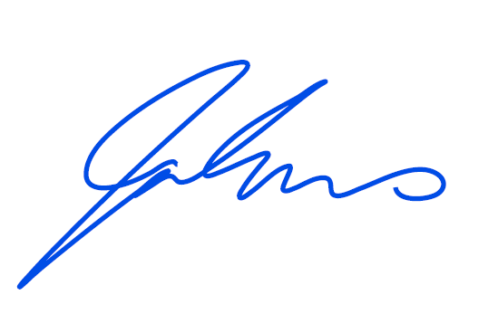
Yours sincerely

Jo Evans
Deputy Secretary
1 March 2022

