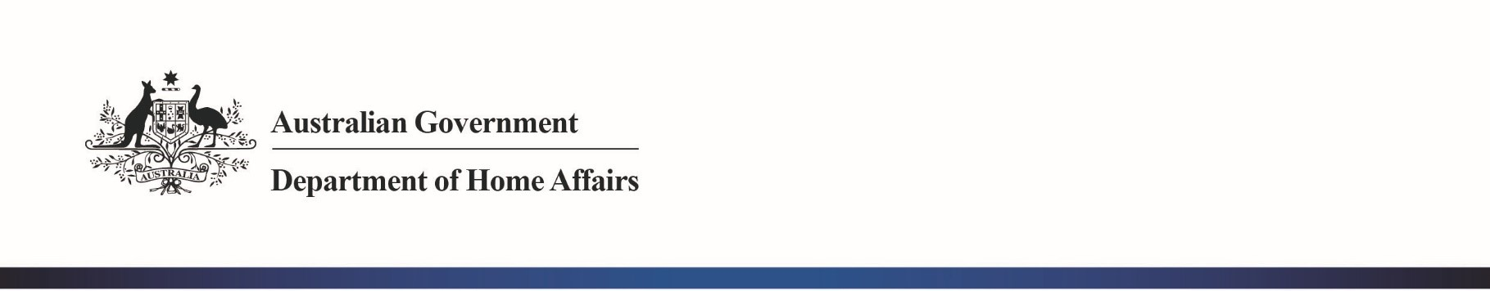

OFFICIAL

Mr Jason Lange

Executive Director

Office of Best Practice Regulation

Department of the Prime Minister and Cabinet

1 National Circuit

BARTON ACT 2600

Email: helpdesk-OBPR@pmc.gov.au

Dear Mr Lange

# Regulation Impact Statement – *Agreement between the Government of the United States of America and the Government of Australia on Access to Electronic Data for the Purpose of Countering Serious Crime* (AUS-US CLOUD Act Agreement) – Second Pass Final Assessment

I am writing in relation to the attached Regulation Impact Statement (RIS) prepared for the *Agreement between the Government of the United States of America and the Government of Australia on Access to Electronic Data for the Purpose of Countering Serious Crime* (commonly referred to as the AUS-US CLOUD Act Agreement).

I am satisfied that the RIS enclosed addresses comments raised in your First Pass Assessment letter of 23 July 2021. To assist with your Second Pass Final Assessment, I have outlined below the key changes made in response to your comments.

*Comment one – Better articulate the Australia-United States problem specifically*

We have amended sections 1, 2 and 4 to better articulate Australia’s reliance on electronic data held in the United States. We have given more prominence to the nature of modern communications services, including the domination of United States-based providers in the global communications services market.

To support this, we have referenced data showing a quarter of all mutual legal assistance requests made by Australia globally between 2007 and 2020 go to the United States for electronic data. We have also referenced studies demonstrating the cumbersome nature of the mutual legal assistance process and the likelihood that significant delays may cause investigations to be abandoned without using the mutual legal assistance process.

Finally, we have clarified the AUS-US CLOUD Act Agreement has been prioritised due to the majority of the electronic data being held in the United States. Agreements with other countries could follow and would be supported by the domestic legal framework put in place through the *Telecommunications Legislation Amendment (International Production Orders) Act 2021* (IPO framework.

*Comment two – likelihood of United States communications service providers complying with the AUS-US CLOUD Act Agreement*

We have also amended section 4 (Option 3) to reiterate that many of the largest United States communications service providers (including Apple, Facebook, Google, Microsoft and Oath) have expressed public support for CLOUD Act agreements with the United States. We anticipate that a significant number of Australian orders and requests made under the AUS-US CLOUD Act Agreement will be made to these communications service providers. We have outlined Australia’s enforcement mechanism for international production orders made by Australian agencies to United States communications service providers under the IPO framework, while also noting that in light of the United States’ industry’s stated intention to cooperate, we anticipate formal enforcementis not likely to be required.

With the amendments made addressing the above, I am satisfied that the RIS is consistent with the six principles for Australian Government policy makers as specified in the *Australian Government Guide to Regulatory Impact Analysis*, and includes the further analysis requested by the OBPR.

I submit the RIS to the Office of Best Practice Regulation for Second Pass Final Assessment.

Yours sincere

**Cath Patterson**

Deputy Secretary

Strategy and Law Enforcement Group

Department of Home Affairs

2 August 2021