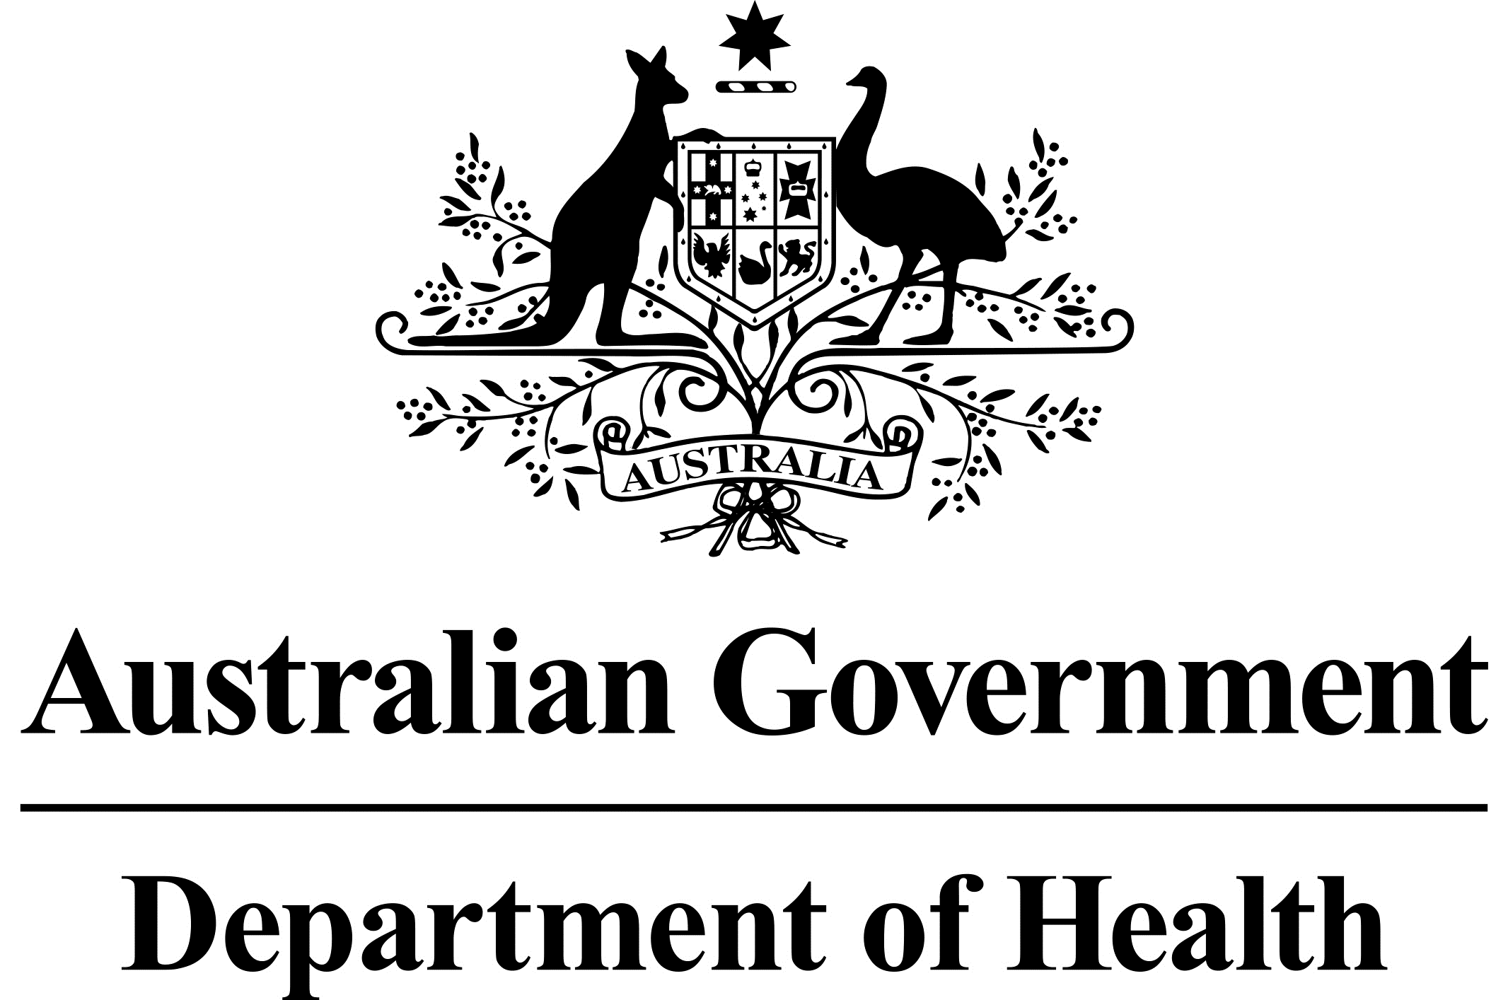

# Deputy Secretary

Mr Jason Lange

Executive Director

Office of Best Practice Regulation

Department of the Prime Minister and Cabinet

1 National Circuit

BARTON ACT 2600

Email: [helpdesk-OBPR@pmc.gov.au](mailto:helpdesk-OBPR@pmc.gov.au)

Dear Mr Lange

# Regulation Impact Statement – Pilot program to allow the commercial importation of kava – Second Pass Final Assessment

I am writing in relation to the attached Regulation Impact Statement (RIS) prepared for one of Australia’s current foreign policy priorities, that of improving Australian and Pacific Island relations by increasing access to kava in Australia.

I am satisfied that the RIS addresses the concerns raised in your letter of 11 October 2021. Specifically, the following points raised by the Office of Best Practice Regulation (OBPR) have been responded to below.

**The RIS would benefit from greater consideration of how the supply and distribution of kava might be expected to occur in a commercial import setting.**

* The RIS includes references on how the market for kava is considered as a growth opportunity considering the number of people with Pacific Islander heritage residing in Australia. Until the commercial import pilot commences, it is difficult, however, to ascertain what the market opportunities in Australia might be for non-Pacific communities. Standard market forces would allow for the appropriate supply and distribution to meet the demand for kava. The RIS now explains that kava products may be stocked and available for sale in some health food stores, supermarkets, and shops which focus on goods associated with Pacific Island communities.

**We would expect more detailed analysis of the potential economic and social impacts to be available following by the completion of the pilot, for any subsequent RIS.**

* It is challenging to precisely determine the value of Australia’s market for kava since kava exports to Australia have been non-existent since 2007. While there has been an increase in the size of Pacific communities in Australia, as well as increasing numbers of seasonal workers from the Pacific, it is anticipated that standard market forces will allow for the demand for kava to be met in Australia.
* In relation to the social impacts of the kava pilot, the monitoring and evaluation component will assess not only some of the social impacts of kava in the Australian community, but also health, cultural and economic impacts. While negative social impacts have previously been reported as a result of kava use, the monitoring and evaluation of the pilot will provide critical data and information for the Australian Government in considering whether the kava pilot has been successful.

**Given the criteria for success outlined at page 18 and the underlying assumption the commercial pilot will provide Pacific Islander communities in Australia with better access to kava, the RIS would benefit from further analysis of how supply and distribution of kava might be expected to occur in a commercial import setting. This could consider:**

* **Broad supply pathways that might be expected, given geographic clustering of Pacific communities in Australia and periodic movements associated with the Seasonal Worker Programme and the Pacific Labour Scheme.**
* **The extent to which it is reasonable to assume normal market forces will provide the desired access to kava for Pacific Islander communities in Australia.**
* **What the market might look like if 100 businesses applied for a permit in the first year as has been assumed for Option 3.**
* **Any inherent risks to achieving the policy objective – for example, whether access to commercially imported kava might be expected to be difficult for Pacific Islander cohorts under certain circumstances, such as when doing transient agricultural work.**
* The RIS explains that while standard market forces should allow for adequate levels of kava to be supplied to interested consumers, it is unclear as to the existing or likely demand for kava as a food in the Australian community.
* While it is understood that kava use outside of Australia is primarily associated with persons of Pacific Island heritage, the monitoring and evaluation component of the kava pilot will provide critical information on whether supply pathways have been effective, and whether there has been adequate opportunity for interested consumers to access kava in Australia.
* It is not possible to determine what the market would look like if a certain number of businesses applied for a permit in one year, however the monitoring and evaluation component of the pilot will be able to determine how effective the current arrangements are in allowing businesses and consumers to import and access kava.

**The RIS should cite evidence to support the assertion that the shortage of kava supply in Australia from the import ban and border closures has driven up the cost of kava significantly, and that this has had an impact on diaspora cultural engagement and important ceremonies**.

* The RIS now cites a relevant article which explains how persons of Pacific Island heritage have struggled to access kava following international border closures. The article provides anecdotal evidence which suggests that prices for kava in Australia have increased significantly, restricting access to consumers who do not have the willingness to pay market prices. The article references how persons of Pacific Island heritage have struggled with changes in the kava market in Australia, and how this has impacted access to kava, and impacted cultural ceremonies in Australia. The article also states that there has been a reported increase in kava being sent illegally through the mail.

**You may wish to consider rewording the reference to Australia’s capacity to influence its closet neighbours in what will ultimately become a public document when the final RIS is published.**

* The RIS now contains amended wording to better reflect Australia’s engagement with Pacific partners. The RIS states that the kava pilot will help support economies impacted by the COVID-19 pandemic, and better connect Australia with the culture of the Pacific.

**In the Consultation discussion (page 26), it would be useful to briefly clarify that the monitoring and evaluation arrangements for the pilot reflect the need for frequent review and reporting as raised by stakeholders.**

* The monitoring and evaluation component of the pilot will provide information on certain aspects of the pilot, which will allow relevant agencies to consider whether any processes or communication changes are required to support the intentions of the pilot more effectively. The RIS states that the monitoring component of the pilot will provide much needed data on the demand for kava in the Australian community, that consultation with key stakeholders will occur at all stages of the evaluation, and that formal progress reports will be provided every six months, with a final report due by the end of 2023.

**The RIS would benefit from a robust proof read – for example, at page 16, the statement about the ‘risk that the use of kava as a food in Australia will not spread…’ appears intended to refer to the risk that it will spread.**

* The RIS has been amended to better reflect the intention of that statement. The RIS now clearly states that there is a risk that kava use in Australia may spread to the broader community.

**We recommend removing points which are unnecessarily repeated in the RIS (e.g. the definition of ‘dermopathy’, which is provided three times).**

* Any unnecessary repetition of information has been reduced throughout the RIS. Among other things, unnecessary definitions of dermopathy have been removed.

I confirm the RIS identifies the regulatory costs of each option and identifies offsets. The regulatory cost for Option 3 is $1300 per year.

Accordingly, I am satisfied that the RIS is now consistent with the six principles for Australian Government policy makers as specified in the *Australian Government Guide to Regulatory Impact.*

I submit the RIS to the Office of Best Practice Regulation for formal final assessment.

Yours sincerely

Adj. Professor John Skerritt

Health Products Regulation Group

November 2021