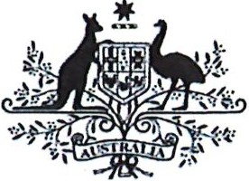

Australian Government

**Department of Infrastructure, Transport, Regional Development and Communications**

Mr Jason Lange Executive Director

Office of Best Practice Regulation Depaiiment of the Prime Minister and Cabinet Email: [helpdesk-OBPR@pmc.gov.au](mailto:helpdesk-OBPR@pmc.gov.au)

Dear Mr Lange

*Resale Royalty Right for Visual Artists Regulations 2011*

I am writing to the Office of Best Practice Regulation (OBPR) regarding the *Resale Royalty Right for Visual Artists Regulations 2011,* which, as per the *Legislation Act 2003,* had been scheduled to sunset on 1 April 2022. However, it has been decided that the instrument is to be remade without significant amendment.

The Depaiiment of Infrastructure, Transp01i, Regional Development, and Communications ce1iifies that the *Resale Royalty Right for Visual Artists Regulations 2011* is operating effectively and efficiently, and that therefore a Regulation Impact Statement is not required for this regulation to be remade.

The assessment that the Regulation is operating effectively and efficiently has been info1med by consultation with Copyright Agency Ltd, which was appointed the collecting society and has been administering the scheme since 2010.

I also note that the regulatory burden to business, community organisations or individuals has beeri quantified using the Australian Government's *Regulatory Burden Measurement framework.* These are provided below.

|  |  |  |  |  |
| --- | --- | --- | --- | --- |
| Change in costs  ($ million) | Business | Community organisations | Individuals | Total change in costs |
| Total, by sector | nil | nil | nil | nil |

I acknowledge that OBPR will publish this letter for transparency purposes.

2 Phillip Law Street, Canberra ACT 2601, Australia GPO Box 594, Canberra ACT 2601, Australia

* telephone +61 (0)2 6271 1000 • websites infrastructure.gov.au I communications.gov.au I arts.gov.au

If you have any queries about this advice, please contact Laurine Kelson, Director, Visual Arts and Design on 02 6271 1175, or [laurine.kelson@arts.gov.au.](mailto:laurine.kelson@arts.gov.au)

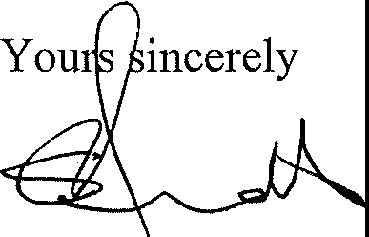

Stephen Arnott

Acting Deputy Secretary Creative Economy and the Arts

Department of Infrastructure, Transpmi, Regional Development and Communications

***2,1*** September 2021