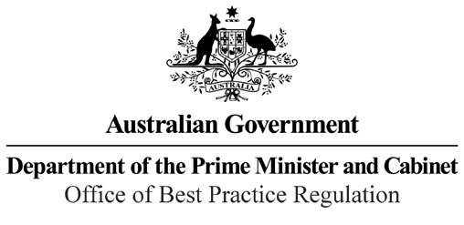

Reference: 23481

Telephone: 6271 6270

e-mail: [helpdesk-obpr@pmc.gov.au](mailto:helpdesk-obpr@pmc.gov.au)

Ms Meghan Quinn PSM Deputy Secretary Markets Group

The Treasury Dear Ms Quinn

**Regulation Impact Statement – Second Pass Final Assessment – Retirement Income Covenant**

Thank you for your letter received on 3 November 2021 submitting a Regulation Impact Statement (RIS) on the Retirement Income Covenant for formal Second Pass Final Assessment. I note the RIS has been formally certified at the Deputy Secretary level consistent with the *Australian Government Guide to Regulatory Impact Analysis*.

I appreciate the Department’s constructive engagement on the RIS. The Office of Best Practice Regulation’s (OBPR’s) assessment is that the quality of the regulatory impact analysis in the RIS is adequate and therefore sufficient to inform a decision.

To be considered ‘good practice’ as per the *Australian Government Guide to Regulatory Impact Analysis*, the RIS would have benefitted from comprehensive consultation on all options, as well as the quantification of regulatory costs for each option.

Including descriptions of the underlying assumptions for regulatory costs and testing these with stakeholders would have provided more rigour to the impact analysis.

The RIS may now be provided to the decision-maker to inform their decision.

I would appreciate you advising the OBPR when a final decision has been announced and forwarding a copy of the RIS in a form meeting the Government’s accessibility requirements. The OBPR will publish the RIS, along with your certification and this assessment, on the OBPR’s website https://obpr.pmc.gov.au/.

If you have any further queries, please do not hesitate to contact me. Yours sincerely

Jason Lange Executive Director 4 November 2021

1 National Circuit, Barton ACT 2600 • Telephone 02 6271 6270 • Internet https://obpr.pmc.gov.au/