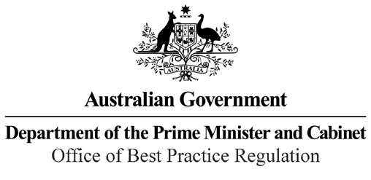

Reference: 18069

Telephone: 6271 6270

e-mail: [helpdesk-obpr@pmc.gov.au](mailto:helpdesk-obpr@pmc.gov.au)

Ms Meghan Quinn PSM Deputy Secretary Markets Group

Department of the Treasury Dear Ms Quinn,

**Regulation Impact Statement – Second Pass Final Assessment – Corporate Collective Investment Vehicles**

Thank you for your letter received on 17 October 2021 submitting a Regulation Impact Statement (RIS) on Corporate Collective Investment Vehicles for formal second-pass Final Assessment. I note the RIS has been formally certified at the Deputy Secretary level consistent with the *Australian Government Guide to Regulatory Impact Analysis*.

I appreciate the Department of the Treasury’s constructive engagement on the RIS.

The Office of Best Practice Regulation’s (OBPR’s) assessment is that the quality of the regulatory impact analysis in the RIS is good practice and therefore sufficient to inform a decision. The analysis in the RIS is good quality overall. The RIS addresses the seven RIS questions and follows an appropriate policy development process commensurate with the significance of the problem and magnitude of the proposed intervention.

The RIS may now be provided to the decision-maker to inform a final decision.

I would appreciate your Department advising the OBPR when a final decision has been announced and forwarding a copy of the RIS in a form meeting the Government’s accessibility requirements. The OBPR will publish the RIS, along with your certification and this assessment, on the OBPR’s website at https://obpr.pmc.gov.au/.

If you have any further queries, please do not hesitate to contact me. Yours sincerely

Jason Lange Executive Director 20 October 2021

1 National Circuit, Barton ACT 2600 • Telephone 02 6271 6270 • Internet https://obpr.pmc.gov.au/