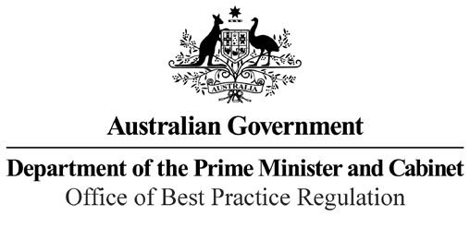

Reference: 43447

Telephone: 6271 6270

e-mail: [helpdesk-obpr@pmc.gov.au](mailto:helpdesk-obpr@pmc.gov.au)

Michele Bullock Assistant Governor Financial System Group Reserve Bank of Australia

Dear Ms Bullock

**Regulation Impact Statement – Second Pass Final Assessment – Review of Retail Payments Regulation**

Thank you for your letter received on 8 October 2021 submitting a Regulation Impact Statement (RIS) on the Review of Retail Payments Regulation for formal Second Pass Final Assessment. I note the RIS has been formally certified at the Deputy Secretary-equivalent level consistent with the *Australian Government Guide to Regulatory Impact Analysis*.

I appreciate the Department’s constructive engagement on the RIS.

The Office of Best Practice Regulation’s assessment is that the quality of the regulatory impact analysis in the RIS is good practice and therefore sufficient to inform a decision.

The analysis in the RIS is good quality overall. The RIS addresses the seven RIS questions and follows an appropriate policy development process commensurate with the significance of the problem and magnitude of the proposed intervention. In particular, the OBPR notes that the analysis of the problem and consultation on options was of an exceptional standard.

However, the RIS process would have benefited from the incorporation of an assessed RIS at each major decision point, such as an Early Assessment RIS completed and used as a basis for consultation.

The RIS may now be provided to the decision maker to inform a final decision.

We would appreciate you advising us when a final decision has been announced and forwarding a copy of the RIS in a form meeting the Government’s accessibility requirements.

1 National Circuit, Barton ACT 2600 • Telephone 02 6271 6270 • Internet https://obpr.pmc.gov.au/

The OBPR will publish the RIS, along with your certification and this assessment, on the OBPR’s website https://obpr.pmc.gov.au/.

If you have any further queries, please do not hesitate to contact me. Yours sincerely

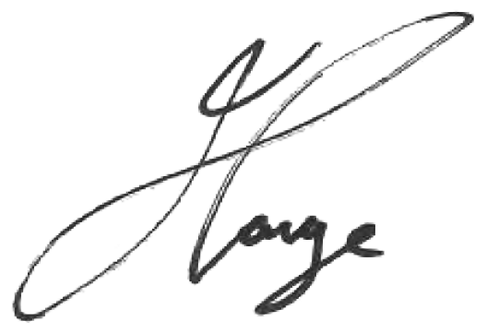

Jason Lange Executive Director 12 October 2021