**Australian Government**



.1-: '"J\ '

**Department of Industry, Science, Energy and Resources**



Mr Jason Lange Executive Director

Office of Best Practice Regulation

Depaiiment of the Prime Minister and Cabinet 1 National Circuit

BARTON ACT 2600

Dear Mr Lange

**Regulation Impact Statement - Offshore Electricity Infrastructure Regulatory Framework - Second Pass Final Assessment**

I am writing in relation to the attached Regulation Impact Statement (RIS) prepared for the Offshore Electricity Infrastructure Regulatory Framework (reference 42703), for fonnal Second Pass Assessment.

I am satisfied that the RIS addresses the concerns raised in your letter of 12 January 2021. Specifically, this includes using less definitive language regarding the proposed framework, the enabling nature of the framework, and noting decommissioning obligations for infrastructure in light of the lessons learned from the Northern Endeavour floating production storage and offtake facility. --

The RIS addresses viable policy options: to either maintain the status quo and not progress development of a regulatory framework; or the development and implementation of an offshore electricity infrastructure regulatory framework.

Due to the range of uncertainties in establishing the offshore electricity sector in Australia, the RIS undertakes a qualitative assessment of regulatory costs to establish the relative merit for progressing regulatory reform.

Accordingly, I am satisfied that the RIS is now consistent with the six principles for Australian Government policy makers, as specified in the Australian Government Guide to Regulatory Impact Analysis.

I submit the RIS to the Office of Best Practice Regulation for formal final assessment. Yours sincere!y

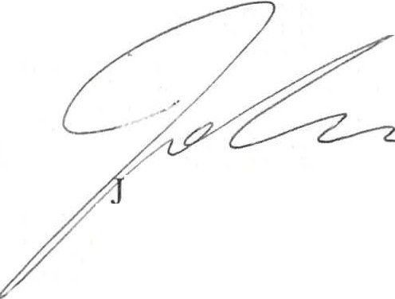

o Evans

Deputy Secretary 21 April 2021



Industry House - 10 Binara Street, Canberra City, ACT 2601 - GPO Box 2013 Canberra ACT 2601 - [www .industry.gov.au](http://www.industry.gov.au/) - ABN : 74 599 608 295