

**RULE**

**Australian Energy Market Commission**

**DRAFT RULE DETERMINATION**

NATIONAL ELECTRICITY AMENDMENT (PRIMARY FREQUENCY RESPONSE INCENTIVE ARRANGEMENTS) RULE 2021

**PROPONENT**

AEMO

16 SEPTEMBER 2021

## INQUIRIES

Australian Energy Market Commission GPO Box 2603

Sydney NSW 2000

E [aemc@aemc.gov.au](mailto:aemc@aemc.gov.au) T (02) 8296 7800

Reference: ERC0263

## CITATION

AEMC, Primary frequency response incentive arrangements, Draft rule determination, 16 September 2021

## ABOUT THE AEMC

The AEMC reports to the Energy Ministers’ Meeting (formerly the Council of Australian Governments Energy Council). We have two functions. We make and amend the national electricity, gas and energy retail rules and conduct independent reviews for the Energy Ministers’ Meeting.

This work is copyright. The Copyright Act 1968 permits fair dealing for study, research, news reporting, criticism and review. Selected passages, tables or diagrams may be reproduced for such purposes provided acknowledgement of the source is included.

# EXECUTIVE SUMMARY

1. As we move towards a lower emissions energy future, system security is the most critical issue in the National Electricity Market (NEM). Lower cost, variable inverter connected generation is displacing dispatchable thermal generation and this is creating challenges for how the security of the power system is managed. New and evolved ways to deliver the essential system services are needed in order to maintain the system in a secure operating state, and at lowest cost to consumers, as the energy sector transitions.
2. The Australian Energy Market Commission (AEMC or Commission) along with the Energy Security Board (ESB) and other market bodies see work focusing on the security of the power system as a priority. The ESB’s post-2025 work is to advise on a long-term, fit for purpose market framework to support security and reliability, modifying the NEM as necessary to meet the needs of future diverse sources of non-dispatchable generation and flexible resources, including demand side response, storage and distributed energy resource participation. In July 2021, the ESB submitted its final advice to Energy Ministers for their consideration. As part of its final advice, the ESB has made a number of recommendations for reform to manage the orderly exit of old technologies and pave the way for new technologies. A key component of these recommendations is the need to support the availability and investment in essential system services.
3. Frequency control is one of the four key services that the ESB has considered through its program of work. The ESB identified new markets for fast frequency response as an immediate area of reform to help manage system frequency following contingency events with reducing system inertia, and the Commission published a final rule in July 2021 to implement arrangements to address this and to complement the thinking and assessment done through the ESB work program.1 The ESB has also identified the development of enduring primary frequency response (PFR) arrangements as another immediate reform needed to support frequency control during normal operation. This draft determination on AEMO’s *Primary frequency response incentive arrangements* rule change request will address this need.
4. The AEMC has made a more preferable draft rule to support system security and deliver reduced costs for frequency control over the long term, as compared with the continuation of the current arrangements. The draft rule would confirm the Mandatory PFR arrangements put in place through a change to the NER in March 2020 as permanent and enduring. These arrangements require all scheduled and semi-scheduled generators to automatically respond to changes in power system frequency to a narrow response band. The draft rule also includes reforms to better value plant behaviour that helps to control power system frequency. The Commission considers that the combination of these two reforms will provide AEMO with the tools it needs to manage the secure operation of the power system while at the same time delivering more efficient operation of power system plant and encouraging investment in new capability to help control power system frequency, thereby lowering costs

1 The rule and final determination is available at: [https://www.aemc.gov.au/rule-changes/fast-frequency-response-market-ancillary-](https://www.aemc.gov.au/rule-changes/fast-frequency-response-market-ancillary-service) [service](https://www.aemc.gov.au/rule-changes/fast-frequency-response-market-ancillary-service)

for consumers.

#### Overview of the draft rule

1. The draft rule is consistent with AEMO’s proposed solution to change the NER to remove disincentives to the voluntary provision of PFR. However, the draft rule also introduces frequency performance payments to reward positive frequency support behaviour, including the provision of PFR. The draft rule also introduces reporting obligations on AEMO and the AER to improve transparency around the objectives and efficacy of the enduring PFR arrangements, both for individual market participant behaviour and power system frequency performance.
2. The draft rule includes the following key elements:
   * Confirmation that the mandatory arrangements will endure beyond 4 June 2023. This would mean that all scheduled and semi-scheduled generators would continue to be required to support the secure operation of the power system by responding automatically to changes in power system frequency.
   * Reforms to the ‘causer pays’ process for the allocation of regulation FCAS costs to deliver improved valuation and pricing of plant behaviour that impacts on power system frequency. These changes include the introduction of frequency performance payments to value positive contributions, the alignment of the sample and application periods for the determination of participant contribution factors, and further changes to improve the transparency of the causer pays process. These changes are expected to better align the economic incentives for plant active power performance, with the impact of that behaviour on the need for corrective action through the deployment of regulation services to rebalance supply and demand and restore power system frequency to 50Hz. By incentivising the provision of primary frequency response, this is expected to lead to more efficient outcomes in relation to the operation of the power system by encouraging all market participants to operate their plant in a way that reduces the need for regulation services and helps to control power system frequency.
   * New reporting obligations for AEMO and the AER in relation to the levels of aggregate frequency responsiveness in the power system and the costs of frequency performance payments. This change supports the principle of transparency and would provide relevant information to market participants and stakeholders to assess the effectiveness and efficiency of the frequency control frameworks over time.

#### Background

1. In order to maintain the power system in a secure operating state and avoid unplanned system or plant outages, power system frequency must be controlled within a narrow range around 50Hz. This is achieved by dynamically balancing electricity generation and consumption under both normal system conditions and in response to sudden larger changes in frequency caused by contingency events.
2. Continuous primary frequency control helps to control system frequency during normal operation by responding to small frequency variations. In the period 2014 to 2019, the control of power system frequency during normal operation degraded, such that the power

system frequency was spending more time further away from the target frequency of 50Hz than had historically been the case.

1. AEMO identified the degradation of frequency control in the NEM as being driven by a decline in the responsiveness of generation plant to system frequency combined with an increase in the variability of generation and load in the power system.
2. In response to a rule change request submitted by AEMO, and a similar request made by Dr Peter Sokolowski, the Commission made a rule in March 2020 that introduced an obligation for all scheduled and semi-scheduled generators in the NEM to support the secure operation of the power system by responding automatically to small changes in power system frequency (the Mandatory PFR rule).2 In its final determination, the Commission noted that a mandatory requirement for primary frequency response was required to address an immediate need to restore effective frequency control in the NEM but that, on its own, it is not a complete solution and that further work needed to be done to understand the power system requirements for maintaining good frequency control. The Commission noted that it would be preferable to introduce alternative or complementary arrangements that incentivise and reward the provision of PFR. As a result, the Commission determined that the Mandatory PFR rule would be an interim arrangement which would sunset on 4 June 2023.
3. Since the making of the Mandatory PFR rule, AEMO has been in the process of coordinating changes to generator control systems. The monitoring of plant and power system impacts due to the roll out of the mandatory PFR requirement has been helpful in informing the Commission’s draft determination on the PFR incentive arrangements rule change request.
4. To further support the rule change process, AEMO has prepared formal advice on the technical requirements for PFR as well as a discussion paper on the feasibility of market and incentive arrangements for frequency control services during normal operation, including potential reforms to causer pays.3 The Commission also engaged Greenview Strategic Consulting to conduct analysis on the impacts of mandatory PFR on the power system and affected plant. Independent advice was also sought from GHD on the relative benefits, risks and costs of each of the potential pathways for enduring PFR arrangements.

#### A continuation of the mandatory arrangements

1. The Commission considers that there is sufficient justification for the continuation of the mandatory requirement for narrow band frequency response from scheduled and semi- scheduled generation plant. The key basis for this position is that the power system requires a high ratio of proportional active power response to changes in power system frequency. High aggregate system levels of frequency responsiveness control frequency close to 50Hz. The aggregate level of frequency responsiveness is directly related to the distribution and variation of power system frequency during normal operation and, as such, this active power response is best delivered by a large proportion of generation plant.
2. The mandatory narrow band PFR arrangements are a particularly effective mechanism given
3. The rule and final determination are available at: <https://www.aemc.gov.au/rule-changes/mandatory-primary-frequency-response>
4. These reports are available on the PFR incentive arrangements rule change request project page - <https://www.aemc.gov.au/rule-changes/primary-frequency-response-incentive-arrangements>

the current generation mix at delivering high levels of aggregate active power response. This has been evidenced through data showing improvements in frequency performance since the Mandatory PFR rule was made, and the implementation of this requirement, which has largely focused to date on requiring large-scale centralised generation to provide narrow- band PFR.

1. The mandatory PFR arrangements provide a clear signal to those parties who are entering the market that they are expected and required to provide primary frequency response, which effectively sets a ‘standard’ for the provision of primary frequency response by registered generators in the NEM.
2. The Commission’s decision to continue the mandatory narrow-band arrangements is supported by expert advice received from AEMO and independent advice received from GHD.

#### Improved incentive arrangements to lower costs to consumers

1. However, the Commission does not consider that the mandatory arrangements, on their own, are a complete and enduring solution. This is because the changing nature of technologies on the power system are likely to present challenges to the effectiveness of the mandatory arrangements on their own. As the generation mix changes from large, centralised units to inverter-based generation such as wind, solar and batteries, the prevailing operational conditions of the new resources may impact on their ability to provide PFR (despite having a requirement), which may reduce the effectiveness of the arrangements over time. For example, a wind or solar farm operating at full generation output, has limited headroom to provide a balanced response to changes in power system frequency. Under conditions where these generators are generating to their maximum available raw energy capability, they have limited ability to provide an effective raise response. When combined with the significant uptake of distributed resources, such as roof top solar (which currently provides minimal PFR), the primary control of frequency in the power system could be substantially diminished.
2. The Commission considers that there needs to be accompanying arrangements to incentivise the provision of primary frequency response going forward. The draft rule therefore includes reforms to the causer pays arrangements to better value plant behaviour that helps to control power system frequency. The improved incentive arrangements are expected to deliver more efficient operation of power system plant along with investment in new capability to help control power system frequency. Over time, costs to consumers are expected to be lower than they otherwise would be under a do-nothing approach, as the reliance on central procurement of regulation FCAS decreases from improvements in the frequency responsive behaviour of generators and active loads. As the power system continues to see greater uptake of Variable renewable generation (VRE), large scale batteries and distributed energy resources (DER), the importance of arrangements to value plant behaviour that helps to control power system frequency is expected to increase.
3. The combination of mandatory primary frequency response with incentive arrangements will together provide the outcomes of a secure system, while minimising costs to consumers. The two elements will work together to promote efficient outcomes and make sure that primary frequency response arrangements can be enduring, and their effectiveness maintained, as well as being adaptive to both changes in the power sector and technological change.

#### Potential complementary future arrangements

1. The Commission recognises that an alternative to introducing incentive arrangements would be to have a specific procurement arrangement to deliver the required levels of frequency responsiveness to control power system frequency. However, the Commission does not consider that this is preferred at the current time. Not only would this have higher implementation costs than the arrangements set out under the draft rule, but it also has significant risks and competition concerns that would need to be worked through. For these reasons, the Commission’s draft rule for enduring arrangements comprises the two elements discussed above.
2. However, the Commission recognises that the effectiveness of the combination of the mandatory arrangements and incentives will need to be monitored on an ongoing basis. The Commission considers that the arrangements in the draft rule can be enduring and provide what the market needs to maintain effective primary control of power system frequency. Nevertheless, the Commission notes GHD’s advice that additional procurement arrangements may be required to deliver sufficient levels of frequency responsiveness to control power system frequency in the future.

#### Additional reporting arrangements

1. To support the ongoing monitoring task, the draft rule includes additional monitoring and reporting arrangements, which will inform further consideration by the market bodies as to whether there is any need for changes to the nature of these arrangements in the future. The new reporting arrangements will include additional reporting from AEMO on levels of aggregate frequency responsiveness in the power system and additional reporting from the AER on the costs of frequency performance payments. The Commission recognises that going forward it will be important to monitor the effectiveness of the arrangements under the draft rule for any unintended consequences and to verify that these arrangements are appropriate to efficiently support the control of power system frequency.

#### Implementation

1. The implementation and transitional arrangements for the revised frequency performance payments and cost allocation process include:
   * 9 months from the commencement of the final rule for AEMO to prepare and consult on a frequency contribution factors procedure to replace the existing ‘causer pays’ procedure; and
   * 18 months for AEMO to make the necessary changes to its internal processes and systems to implement the new frequency performance process following the publication of the frequency contribution factors procedure.
2. This means that the final rule will commence on a date which is two years and three months from the date the final rule is made.
3. The Commission has also proposed to amend the existing date for the publication of the final Primary frequency response requirements document (PFRR) which was required under the Mandatory PFR rule, and which AEMO is currently required to complete by 6 December 2021,

to be a date which is six months from the date that the final rule is made. This will allow time for AEMO to consult on the final PFRR that will replace the interim PFRR and apply under the enduring arrangements.

#### Consultation

1. The AEMC invites submissions on any aspect of this draft determination by **28 October 2021**.
2. Stakeholder input on this draft determination will further inform the AEMC’s analysis of the issues and the development of final rules, which will be reflected in a final determination in December 2021.
3. The AEMC also welcomes individual meetings with interested stakeholders. Those wishing to meet with the AEMC should contact Ben Hiron on (02) 8296 7855 or [ben.hiron@aemc.gov.au.](mailto:ben.hiron@aemc.gov.au)

**Table 1: Summary of the Commission’s draft determination (elements of the draft rule)**

|  |  |  |
| --- | --- | --- |
| **TOPIC** | **DRAFT CHANGE** | **RATIONALE** |
| ***Confirmation of Mandatory PFR as enduring*** | | |
| Maintain the mandatory PFR arrangements | Revoke schedule 2 of the Mandatory PFR rule to sunset this obligation on 4 June 2023. | Mandatory PFR has delivered improvements in power system frequency performance. AEMO has advised it requires widespread, narrow band PFR to support effective frequency control of the power system.  Independent advice and analysis suggests that the mandatory arrangements have proven effective and that the costs on generators have been minimal. |
| Revised timing for the publication of a final PFRR by AEMO | Requires AEMO to publish the Primary Frequency Response Requirement (PFRR) by 6 months from the date the rule is made.  The interim PFRR will now apply until this date. | The NER currently requires AEMO to publish the final PFRR by 6 December 2021. AEMO needs time to consult on the enduring arrangements on the basis of the requirements of the final rule. |
| ***Supported by reforms to the ‘causer pays’ process...*** | | |
| Clearer link between price signals and plant behaviour that  impacts power | Introduction of frequency performance payments to be made to participants that reduce the need for regulation services. | Rewarding PFR provision and other behaviour which reduces the need for regulation services during normal operation should encourage all  market participants to support power |

|  |  |  |
| --- | --- | --- |
| **TOPIC** | **DRAFT CHANGE** | **RATIONALE** |
| system frequency | Separate treatment of costs and payments for the regulating raise and regulating lower services. | system frequency performance. |
| Scaling of frequency performance payments and cost allocations by the requirement for regulation services | Provides a payment premium for positive contributions when more regulation FCAS is required than AEMO enabled.  Allocation of costs for regulation services that are enabled and used, to market participants who contributed to the need for those services.  Spreads the cost of regulation FCAS, enabled and not used, across all market participants. | When AEMO requires more regulation FCAS than it enabled, there is greater value for market participants who reduce the need for these services. This should be reflected in the frequency performance payments.  Market participants with negative contributions should face the proportional cost of their actions. All market participants should share the costs for the remaining unused regulation FCAS costs. |
| Alignment and shortening of the sample and application periods | Requires AEMO to use data from each trading interval, where practical, as the basis for determining participant contribution factors that reflect the contribution to the need for regulation services. | For these arrangements to effectively incentivise market participants to contribute positively, the signal must accurately reflect the impact of their behaviour on frequency performance. Market participants must be able to achieve better outcomes if they align their behaviour to the power system needs. |
| Increased transparency | Requires AEMO to produce a frequency contribution factors procedure. This must include:   * a formula that describes the objective for frequency control in sufficient detail that market participants can estimate the need for regulation services. * the method to determine a reference trajectory for each market participant.   AEMO must publish the related | Market participants must be able to understand and estimate whether their intended behaviour will be seen to contribute positively or negatively to inform operational decisions, and potentially investment decisions. This requires market participants to understand the method and have access to the data required to estimate their performance (contribution factor). |

|  |  |  |
| --- | --- | --- |
| **TOPIC** | **DRAFT CHANGE** | **RATIONALE** |
|  | parameters, and historical data. |  |
| Other changes to the causer pays process to support the frequency contribution factors procedure | A number of other changes are made to reform causer pays:   * Separate treatment of asynchronous regions * Allocation of local regulation costs based on local contribution factors. * Inclusion of non-scheduled generators and non- scheduled loads in the residual. * Plant which is operated by an MNSP may be allocated a contribution factor * Non-scheduled participants with appropriate metering may provide information to inform their individual plant baseline | All market participants who contribute to, (or reduce) the need for regulation services should face the cost, (or be rewarded for) the behaviour.  Non-scheduled generators, who do not have appropriate metering to measure their individual impact on system frequency, shall be allocated a share of regulation costs, in the same way that costs are allocated to non-scheduled loads.  Additionally, non-scheduled market participants, that do have appropriate metering, may provide information to AEMO to inform the reference trajectory against which their individual performance is assessed. |
| ***And new reporting obligations for AEMO and the AER*** | | |
| AEMO reporting on aggregate frequency responsiveness (PFR) | Assessment of the level of aggregate frequency responsiveness in each region | This additional reporting on aggregate frequency responsiveness will help to monitor the efficacy of the enduring PFR arrangements, flag the need for potential additional actions in the future, and inform the nature of such actions should this need arise.  Reporting will also provide greater transparency to market participants on the objective of PFR and regional variations to inform operational and investment decisions. |
| AER to report on the cost of incentivising PFR provision | Include total costs of frequency performance payments for each region | This will accompany the AER’s reporting on market ancillary service markets to help customers understand the full cost of the different regulation services required  to achieve frequency control. |

# CONTENTS

1. AEMO’s rule change request 1
   1. The rule change request 2
   2. The rule making process 4
   3. Energy Security Board post-2025 market design interactions 5
   4. Consultation on this draft rule determination 6
   5. Structure of this draft determination 6
2. Context and external advice 7
   1. Current arrangements 7
   2. Pathways for primary frequency response 10
   3. AEMO’s expert technical advice - Power system requirements for PFR 13
   4. AEMO’s discussion paper - Market and incentivisation options 15
   5. Overview of independent advice 17
3. Draft rule determination 19
   1. The Commission’s draft rule determination 19
   2. Rule making test 22
   3. Assessment framework 23
   4. Summary of reasons 25
4. Elements of the draft rule 35
   1. The confirmation of the mandatory PFR arrangement as enduring 36
   2. Reforms to Causer pays 45
   3. Additional reporting obligations for AEMO and the AER 65
   4. Implementation and transitional arrangements 68
5. Other issues that are not part of the draft rule 71
   1. Future review of the Frequency operating standard 71
   2. Potential for future procurement arrangements for narrow band PFR 72

Abbreviations 75

APPENDICES

1. Legal requirements under the NEL 76
   1. Draft rule determination 76
   2. Power to make the rule 76
   3. Commission’s considerations 76
   4. Civil penalties 77
   5. Conduct provisions 77
2. ‘Causer pays’ cost allocation 78
3. The method for the valuation of positive contribution factors 81
4. Implementation of Mandatory PFR 85
5. Estimated short term financial impact of changes to Causer pays 90
   1. Estimated scale of frequency performance payments 90
   2. Historical regulation costs 94
   3. Projected need for regulation services 96

1. Explanation of aggregate frequency responsiveness 98

## TABLES

Table 1: Summary of the Commission’s draft determination (elements of the draft rule) vi

Table C.1: Regulation FCAS cost allocation example – current arrangements 82

Table C.2: Regulation FCAS cost allocation — proposed arrangements — Example 1: FPP scaling factor = 1 83

Table C.3: Regulation FCAS cost allocation — proposed arrangements — Example 2: FPP scaling factor = 1.2 83

Table C.4: Regulation FCAS cost allocation — proposed arrangements — Example 3: FPP scaling factor = 0.5 84

Table F.1: Equivalent arrangements to deliver similar levels of aggregate frequency response (PFR) 100

FIGURES

|  |  |  |
| --- | --- | --- |
| Figure 2.1: | Generation deviation for scheduled and semi-scheduled plant | 9 |
| Figure 3.1: | Planning, Procuring, Pricing and Paying for system services | 24 |
| Figure 3.2: | Daily frequency crossings – under 49.85 Hz, across 50 Hz, beyond 50.15 Hz | 28 |
| Figure 3.3: | Projected solar and wind dependent regulation FCAS requirements | 31 |
| Figure 4.1: | Two different arrangements with similar levels of aggregate frequency responsiveness | 38 |
| Figure 4.2: | Separate transactions for raise and lower response | 50 |
| Figure 4.3: | Reference trajectory for scheduled and semi-scheduled plant | 58 |
| Figure 4.4: | Reference trajectory for non-scheduled plant (with appropriate metering) | 59 |
| Figure 4.5: | Dispatch target plus regulation component — Vales Point Unit 6 | 60 |
| Figure B.1: | Market Participant cost allocation | 79 |
| Figure B.2: | Market Participant contribution factor | 79 |
| Figure D.1: | Implementation of Mandatory PFR - Cumulative MWs of responsive plant | 86 |
| Figure D.2: | Month on month change in frequency | 87 |
| Figure D.3: | System frequency and PFR settings (PFRP) implementation | 88 |
| Figure E.1: | Historical analysis - valuation and scaling of positive contributions | 93 |
| Figure E.2: | Historical costs for regulating raise services | 94 |
| Figure E.3: | Historical costs for regulating lower services | 95 |
| Figure E.4: | New NEM VRE build, solar (left), wind (middle), and Central scenario split (right) | 96 |
| Figure E.5: | Projected FCAS requirements for increasing penetration of solar and wind generation | 97 |
| Figure F.1: | Droop equation - proportional active power response to change in frequency | 98 |
| Figure F.2: | Droop equation - rearranged for change in active power | 98 |
| Figure F.3: | Aggregate system droop equation | 99 |

# AEMO’S RULE CHANGE REQUEST

Maintaining system security through the energy transition is a critical issue for the National Electricity Market (NEM) today. As cheaper, variable inverter-connected generation displaces dispatchable thermal generation at great speed, challenges are arising in the management of a secure power system. Essential power system services, such as voltage control, frequency control, and inertia, that are provided inherently by traditional forms of power generation are not necessarily provided to the same extent by new generation technologies. This means new ways to procure enough essential services to keep the power system stable and secure are needed that can utilise the capability of traditional and newer generation technologies.

Establishing new ways to support power system security is a priority for the Australian Energy Market Commission (AEMC or Commission), the Energy Security Board (ESB) and other market bodies.

Accordingly, the Commission has been focusing on two rule change requests that relate to frequency control to complement the thinking and assessment done by the ESB on the energy transition underway, as well as technical input from AEMO through its Renewable Integration Study. These two rule changes that relate to frequency control are:

* + **Infigen Energy — *Fast frequency response market ancillary service*** — This rule change request proposed the introduction of spot-market arrangements for fast frequency response (FFR) to help efficiently manage system frequency following contingency events during low inertia operation. In July 2021, the Commission made a final rule, *Fast frequency response market ancillary service Rule 2021*, to introduce these FFR markets. The new market ancillary service arrangements will commence on 9 October 2023.
  + **AEMO — *Primary frequency response incentive arrangements*** — This rule change request proposes changes to the NER to support improved frequency control during normal operation. This rule change request is the subject of this draft determination.

The Commission has made a draft rule, which is a more preferable rule, in response to AEMO’s *Primary frequency response incentive arrangements* rule change request, which:

* + confirms the mandatory primary frequency response (PFR) arrangements that were established in March 2020 as enduring beyond the sunset date on 4 June 2023
  + introduces incentives, through frequency performance payments, for market participants to operate their plant in a way that helps to control power system frequency
  + improves the efficiency and effectiveness of the arrangements that exist to recover the costs of regulation FCAS by making them more transparent and by better aligning incentives to participant behaviour
  + includes additional reporting requirements for AEMO and the AER in relation to frequency performance and the costs of frequency performance payments.

These arrangements will help to efficiently manage system frequency during normal operation on an enduring basis, allowing the system to be securely and reliably operated in a cost-effective way for consumers.

The Commission’s assessment of AEMO’s *Primary frequency response incentive arrangements* rule change request follows on from a final rule that was made in March 2020 with respect to another rule change request from AEMO, *Mandatory primary frequency response arrangements*. This final rule addressed an immediate need to improve the frequency performance of the power system by placing an obligation on all scheduled and semi- scheduled generators to automatically respond to changes in power system frequency.

The Commission concluded that the deterioration in system frequency performance under normal operating conditions necessitated the introduction of the mandatory arrangements, but noted at that time, that this was not a complete solution, and that further work was required to determine and implement arrangements to incentivise market participants to support frequency control in the NEM.4

This draft rule is the result of this further work and has been supported by expert technical advice received from AEMO and independent advice commissioned from GHD. The Commission expects the draft rule to reduce costs for consumers by providing AEMO with the tools it needs to manage the secure operation of the power system while at the same time introducing arrangements that will drive more efficient behaviour in market participants.

This chapter:

* + provides an overview of AEMO’s *Primary frequency response incentive arrangements* rule change request, including the problem statement and proposed solution
  + sets out the Commission’s process for making this draft determination
  + outlines the process of coordination with the ESB
  + outlines the process for making submissions on this draft rule determination and draft rule, and
  + sets out the structure of this draft rule determination

### The rule change request

On 3 July 2019, AEMO submitted a rule change request to the AEMC seeking changes to the NER to address perceived disincentives to the voluntary provision of PFR by participants in the NEM.5 This rule change request was initiated under the project name: *Removal of disincentives to primary frequency response*. In July 2020, the project name was changed to *Primary frequency response incentive arrangements* to reflect the scope and objectives for this rule change request following on from the final determination for the *Mandatory primary frequency response rule*.

The rule change request included a proposed rule.

1. The final rule and determination for the interim PFR arrangements are available at: [https://www.aemc.gov.au/rule-](https://www.aemc.gov.au/rule-changes/mandatory-primary-frequency-response) [changes/mandatory-primary-frequency-response](https://www.aemc.gov.au/rule-changes/mandatory-primary-frequency-response)
2. Rule change request available on project web page: [https://www.aemc.gov.au/rule-changes/primary-frequency-response-](https://www.aemc.gov.au/rule-changes/primary-frequency-response-incentive-arrangements) [incentive-arrangements](https://www.aemc.gov.au/rule-changes/primary-frequency-response-incentive-arrangements)
   * 1. **Rationale for the rule change request**

In the rule change request, AEMO sought to improve the performance of system frequency control through the removal of disincentives to the provision of PFR from generators.

The fundamental problem identified in AEMO’s rule change request was the degradation of frequency performance in the NEM under normal operating conditions over the five-year period from 2015 to 2019.6 AEMO claimed that the degradation of frequency performance during normal operation had resulted in the power system frequency spending more time further away from the target frequency of 50Hz than had historically been the case. This was evidenced as a flattening of the frequency distribution in the power system during normal operation.

AEMO also reported an increased incidence of exceedance events, where the power system frequency falls outside the normal operating frequency band (NOFB).7 Many of these excursions have occurred under normal operating conditions in the absence of a contingency event.

AEMO identified the degradation of frequency performance during normal operation as being caused by:

* + - * a decline in the provision of PFR by Generators, exacerbated by elements of the NER
      * an increase in the variability of generation and load in the power system
      * the inappropriateness of secondary regulation services to effectively control system frequency in the absence of PFR.8
    1. **Proposed solution**

AEMO sought to resolve the issues discussed above by proposing a rule (proposed rule) to remove disincentives to the voluntary provision of PFR.

Through consultation with market participants, AEMO identified the following aspects of the NER as being perceived to provide disincentives to the voluntary provision of PFR:

1. Certain aspects of the arrangements for the allocation of costs associated with regulation services, known as ‘causer pays’ (NER Clause 3.15.6A).
2. A focus by generators on prioritising strict compliance with dispatch instructions over operating their plant in a frequency response mode and providing PFR (NER Clause 4.9.8).
3. A perception that the NER requires generators to provide PFR only when they are enabled to provide a Frequency control ancillary service (FCAS) (NER Clause 4.9.4 & Clause S5.2.5.11).
4. AEMO, *Primary frequency response incentive arrangements - Electricity rule change proposal*, 3 July 2019, p.14.
5. The frequency operating standard requires that, in the absence of contingency events, the power system frequency is maintained within the normal operating frequency band (49.85 Hz - 50.15Hz) for 99% of the time. The frequency may exceed the normal operating frequency band for 1% of the time, but, in the absence of a contingency event, it must not exceed the normal operating frequency excursion band (49.75 – 50.25Hz).
6. AEMO, *Primary frequency response incentive arrangements — Electricity rule change proposal*, 1 July 2019, p.16.

AEMO’s proposed rule sought to address these perceived disincentives in the NER to remove barriers to the provision of voluntary PFR during normal operation and thereby halt the decline of frequency performance during normal operation.

#### Issues addressed in the Mandatory PFR rule

The *Mandatory primary frequency response* rule 2020 (Mandatory PFR rule) included changes to NER clause 3.15.6A, cl 4.9.4, cl 4.9.8 and cl S5.2.5.11 to clearly acknowledge that it is expected and acceptable for generation output to vary from dispatch targets when providing PFR. These changes to the NER were made to address the latter two of the three disincentives set out above (items 2 and 3).

To address the disincentives created through item 1, AEMO’s rule change proposed further changes to clause 3.15.6A such that providers of PFR, in accordance with parameters defined by AEMO, would not be allocated any share of regulation costs.9 This proposal was not addressed by the Mandatory PFR rule. Rather, the Commission noted that further changes to the NER in relation to the causer pays arrangements would be considered through the assessment of the *Primary frequency response incentive arrangements* rule change request.10

### The rule making process

This section provides an overview of the rule making process for the draft rule - *Primary frequency response incentive arrangements.*11

#### Consultation papers

On 19 September 2019, the Commission published a consultation paper to commence the rule making process and consultation in respect of this rule change request, *Primary frequency response incentive arrangements*.12 The Commission received 33 submissions in response to this consultation paper. On 2 July 2020, the Commission published another consultation paper seeking further stakeholder input on this rule change request and how it should be assessed in the context of six other rule change requests that relate to the provision of system security services in the NEM.13 The Commission received 43 submissions as part of this consultation.

##### Directions paper

On 17 December 2020, the Commission published a directions paper for both rule change requests that relate to the arrangements for frequency control in the NEM, *Fast frequency response market ancillary service* and *Primary frequency response incentive arrangements*.14 The directions paper set out the Commission’s initial views and high-level policy directions on

1. AEMO, *Primary frequency response incentive arrangements — Electricity rule change proposal*, 1 July 2019, p.27.
2. AEMC, *Mandatory primary frequency response — Rule determination*, 26 March 2020, p.127.
3. *The documents and submissions referenced below are available on the project web page:* [*https://www.aemc.gov.au/rule-*](https://www.aemc.gov.au/rule-changes/primary-frequency-response-incentive-arrangements)[*changes/primary-frequency-response-incentive-arrangements*](https://www.aemc.gov.au/rule-changes/primary-frequency-response-incentive-arrangements)
4. This notice was published under s.95 of the National Electricity Law (NEL).
5. AEMC, *System services rule changes - consultation paper*, 2 July 2020. Available at: [https://www.aemc.gov.au/rule-](https://www.aemc.gov.au/rule-changes/primary-frequency-response-incentive-arrangements) [changes/primary-frequency-response-incentive-arrangements](https://www.aemc.gov.au/rule-changes/primary-frequency-response-incentive-arrangements)
6. AEMC, Frequency control rule changes — Directions paper, 17 December 2020. Available at: [https://www.aemc.gov.au/rule-](https://www.aemc.gov.au/rule-changes/primary-frequency-response-incentive-arrangements) [changes/primary-frequency-response-incentive-arrangements](https://www.aemc.gov.au/rule-changes/primary-frequency-response-incentive-arrangements)

key issues in relation to the arrangements for fast frequency response and primary frequency response in the NEM. The Commission received 29 submissions which have informed the development of this draft rule determination. In making this draft determination and draft rule, the Commission has considered all issues raised by stakeholders in submissions in relation to AEMO’s rule change request. Issues raised in submissions are discussed and responded to throughout this draft rule determination.

##### Technical working group

The Commission has continued to engage with experts from industry, and consumer groups through the frequency control technical working group, which was formed in October 2019 to discuss issues related to the frequency response rule change requests. Further technical working group meetings were convened on 8 October 2020, 4 March 2021, and 21 May 2021 to discuss the frequency control rule change requests. Technical working group meetings dedicated to the *Primary frequency response incentive arrangements* rule change request have since been held on 23 and 29 July 2021.

### Energy Security Board post-2025 market design interactions

In July 2021, the Energy Security Board (ESB) submitted its final advice to Energy Ministers for their consideration. The ESB’s post-2025 work is to advise on a long-term, fit for purpose market framework to support reliability, modifying the NEM as necessary to meet the needs of future diverse sources of non-dispatchable generation and flexible resources, including demand side response, storage and distributed energy resources. System security is a priority for this work as lower marginal cost variable inverter connected generation is displacing dispatchable thermal generation at great speed, making maintaining power system security more difficult.

As part of its final advice, the ESB has made a number of recommendations for reform to manage the orderly exit of old technologies and pave the way for new technologies. A key component of these recommendations is the need to support the availability and investment in essential system services.

Frequency control is one of the four key services that the ESB has considered through its program of work. The ESB identified new markets for fast frequency response as an immediate area of reform to help manage system frequency following contingency events with reducing system inertia. The AEMC published a final rule in July 2021 to implement arrangements to address this and to complement the thinking and assessment done through the ESB work program, as well as technical input from AEMO through its Renewable Integration Study and subsequent Engineering Framework.

The ESB has also identified the development of enduring primary frequency response (PFR) arrangements as another immediate reform needed to support frequency control during normal operation. This draft determination on AEMO’s Primary frequency response incentive arrangements rule change request will address this.

### Consultation on this draft rule determination

The Commission invites submissions on this draft rule determination, including a more preferable draft rule, by 28 October 2021.

Any person or body may request that the Commission hold a hearing in relation to the draft rule determination. Any request for a hearing must be made in writing and must be received by the Commission no later than 23 September 2021.

Submissions and requests for a hearing should quote project number ERC0263 and may be lodged online at [www.aemc.gov.au.](http://www.aemc.gov.au/)

### Structure of this draft determination

The remainder of this draft determination is structured as follows:

* Chapter 2 sets out relevant context for the assessment of AEMO’s rule change request.
* Chapter 3 sets out the Commission’s draft rule determination, provides a summary of reasons, and outlines how the Commission made its decision with respect to its assessment framework.
* Chapter 4 provides further detail on the principal elements of the draft rule, including stakeholder feedback and the Commission’s analysis and conclusions.
* Chapter 5 discusses a number of issues related to the Commission’s determination which are not part of the draft rule.

# CONTEXT AND EXTERNAL ADVICE

This section outlines the current arrangements for mandatory primary frequency response (PFR), causer pays cost allocation for regulation services, and AEMO’s relevant reporting obligations. To inform consideration of potential changes to these arrangements, the Commission obtained advice from AEMO, Greenview Strategic Consulting (Greenview), and GHD. This external advice regarding these arrangements and proposed improvements to inform consideration of potential enduring arrangements for PFR are summarised later in this section.

### Current arrangements

The Commission’s draft rule builds on the current arrangements for primary frequency response and cost allocation processes for frequency market ancillary regulation raise and lower services (colloquially known as ‘causer pays’). The draft rule also amends AEMO’s current reporting obligations to make these processes more transparent, predictable, and simple. Therefore, it is important stakeholders understand the current arrangements under the NER.

* + 1. **Mandatory primary frequency response rule**

In March 2020, the Commission made a final rule introducing mandatory obligations for all scheduled and semi-scheduled generators in the NEM to help control power system frequency, giving AEMO greater confidence that it is maintaining the power system in a secure operating state.15 The rule required AEMO to develop interim primary frequency response requirements (PFRR) and for all scheduled and semi-scheduled generators to operate in accordance with AEMO’s interim PFRR when their dispatch instruction was to generate greater than 0 MW.

When all generators operate in accordance with AEMO’s interim PFRR, AEMO is able to obtain the required level of aggregate frequency responsiveness across the system. As discussed in appendix F, aggregate frequency responsiveness relates to the proportional change in active power (MW) across the system in response to a change in system frequency (Hz). This may also be referred to as frequency bias, aggregate system droop, or MW/Hz. High aggregate system levels of frequency responsiveness control frequency close to 50Hz. This is the objective of the mandatory obligation to respond if frequency is more than +/- 0.015 from 50 Hz, also known as widespread narrow-band primary frequency response.

While this obligation applies whether or not each plant (generator) is enabled to provide frequency responsive reserves through the FCAS markets, there is no obligation to maintain headroom/footroom for the purposes of providing mandatory PFR.16 This means that narrow- band PFR is only required from generators dispatched for more than 0MW but below their full

1. The rule and final determination are available at: <https://www.aemc.gov.au/rule-changes/mandatory-primary-frequency-response>
2. Headroom refers to the ability for a generator to increase its delivered generation in response to a change in system frequency. It is supported by available stored energy within the generation system that can be rapidly converted into electricity in a short time period, typically within a matter of seconds. Similarly, footroom refers to the ability for a generator to reduce its delivered generation.

capacity. Additionally, the rule allows for generators to apply to AEMO for exemptions or modifications to their obligations subject to the processes outlined in the interim PFRR.

The mandatory narrow-band PFR arrangements were made to address an immediate need for large-scale centralised generation in the energy market to provide the required plant-level response. At the time, the Commission noted that the mandatory PFR obligation was not a complete solution. This obligation was set to sunset on 4 June 2023 to allow time for enduring arrangements to be developed which would value (and thus incentivise) frequency control services to support efficient operation of, and investment in, power system plant.

AEMO was also required to develop the first enduring version of the PFRR by 6 December 2021.

* + 1. **‘Causer pays’ cost allocation for regulation services**

The NER sets out a process for the allocation of the costs of regulation services based on the measurement of plant performance and the degree to which a market participant contributes to, or ‘causes’, the need for regulation services. This procedure is commonly referred to as the ‘causer pays’ procedure. Allocating costs to those causing the need for frequency control aims to incentivise market participants to act to minimise the need for frequency control services.

This allocation is calculated using contribution factors that reflect the extent to which a market participant contributed to the need for the regulation services (i.e. contributes negatively). A negative contribution factor reflects plant behaviour that causes the need for regulation services, while a positive contribution factor reflects plant behaviour that reduces the need for regulation services. A market participant will not be considered to have contributed to the deviation in the frequency of the power system if they:17

* + - * are a scheduled or semi-scheduled participant who is providing PFR in accordance with the Primary frequency response requirements,
      * respond to a control signal for a market ancillary service to AEMO’s satisfaction
      * behave in a way that reduces the need for regulating services.

The current arrangements allow for positive contributions to offset negative contributions within a market participant’s portfolio of plant with appropriate metering. However, any net positive contribution factor is zeroed out and therefore positive contributions are not fully valued under the existing arrangements.

The methodology for determining contribution factors for each market participant is set out by AEMO in its causer pays procedure.18 Further detail on the current causer pays process is set out in appendix B, but at a high level the process is based on two key elements:

* + - * plant active power deviation, which is the difference between expected and actual plant behaviour; and

17 NER Cl. 3.5.6A(k)

1. This is referred to as the procedure for determining contribution factors in the NER. The current version is available at: [https://www.aemo.com.au/-/media/Files/Electricity/NEM/Security_and_Reliability/Ancillary_Services/Regulation-FCAS-](https://www.aemo.com.au/-/media/Files/Electricity/NEM/Security_and_Reliability/Ancillary_Services/Regulation-FCAS-Contribution-Factors-Procedure.pdf) [Contribution-Factors-Procedure.pdf](https://www.aemo.com.au/-/media/Files/Electricity/NEM/Security_and_Reliability/Ancillary_Services/Regulation-FCAS-Contribution-Factors-Procedure.pdf)
   * + - a measure of the need for regulation services, frequency indicator (FI).

Plant active power deviation can be illustrated using the figure below which shows the plant initially providing less than the dispatch target trajectory (equivalent to regulation lower) and then above (regulation raise). Whether these are good or bad contributions depends on the frequency performance during this dispatch interval.

#### Figure 2.1: Generation deviation for scheduled and semi-scheduled plant

0

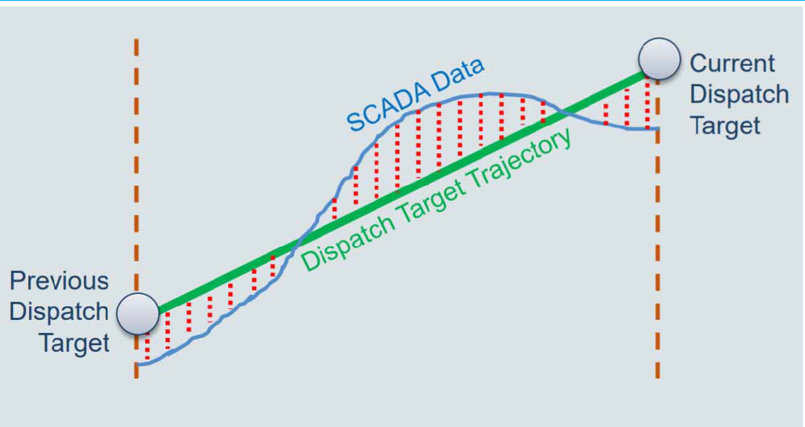

Source: AEMO, Regulation FCAS contribution factor procedure - Determination of contribution factors for regulation FCAS cost recovery, 9 November 2018

The frequency indicator (FI) indicates whether more or less generation is required to adjust the frequency towards 50 Hz. This is not a direct measure of system frequency, but rather AEMO’s estimate of the correction required to return power system frequency during normal operation to 50 Hz. Currently, AEMO makes this variable (FI) available to market participants at a slight delay (typically 15-30 minutes) through AEMO’s data subscription service.19

Not all Market participants have appropriate metering to determine individual contribution factors for the allocation of regulation costs. Under the current arrangements, market customers that do not have appropriate metering are allocated a share of regulation costs based on the total energy consumed in a period in proportion to the total customer energy for a period. These participants, which are typically not controlled through central dispatch or able to respond to correct power system frequency deviations, are referred to collectively as the ‘residual’. The current framework limits the residual component to market customers only.

1. The data is also available publicly at [http://www.nemweb.com.au/Reports/Current/Causer_Pays_Scada/](https://protect-au.mimecast.com/s/Pmd4C71ZQkcp3MZS8WE0O)

As such, non-scheduled generators that do not have appropriate metering are not allocated a share of the costs for regulation services. 20

* + 1. **AEMO’s existing frequency performance reporting obligations**

The Commission introduced reporting obligations for AEMO and the AER in relation to frequency performance and the costs of frequency control services in 2019. These obligations were introduced in response to rule change requests from AEMO and the AER to action the recommendations made to address a lack of transparency and help inform market participants’ investment and operational decisions that impact frequency control, as well as a lack of regular, readily available information for participants.21 This rule requires AEMO to report statistical data on a weekly basis and accompany this with more qualitative reporting on a quarterly basis.22 The AER is required to report on market ancillary service costs on a quarterly basis.23

In addition to these obligations, AEMO has undertaken further work to better communicate with stakeholders. For example, by voluntarily developing additional reporting around primary frequency control, such as the monthly updates on PFR implementation24 to complement the required interim primary frequency response requirements and additional commentary in the Quarterly Frequency and Time Error Monitoring report.25

### Pathways for primary frequency response

In December 2020, the Commission published a directions paper on the frequency control rule change request which set out the view that the pricing of PFR is an integral component of enduring and complete arrangements for PFR. This is because it is the pricing arrangements that provide the economic signals to market participants to invest in and operate power system plant in an efficient way to meet system needs and reduce the overall costs of power system operation over the long term.

* + 1. **Pathways for enduring PFR arrangements**

In the directions paper, the Commission identified three viable pathways towards enduring PFR arrangements. These three pathways are defined by three different settings for the

1. In its 2018 Causer pays consultation, AEMO noted that including non-metered generation in the residual component was a potential improvement to the process for the allocation of regulation costs. Ref. AEMO, Regulation FCAS contribution factor (Causer Pays) procedure consultation, November 2018, p.14.
2. Frequency control frameworks review final report Pages 10 - 11 Available at: [https://www.aemc.gov.au/sites/default/files/2018-](https://www.aemc.gov.au/sites/default/files/2018-07/Final%20report.pdf) [07/Final%20report.pdf](https://www.aemc.gov.au/sites/default/files/2018-07/Final%20report.pdf)
3. NER cl. 4.8.16 AEMO reporting on frequency performance
4. This requirement is introduced under NER cl. 3.11.2A. The AER has chosen to incorporate this reporting into their quarterly wholesale markets report available at: [https://www.aer.gov.au/wholesale-markets/performance-](https://www.aer.gov.au/wholesale-markets/performance-reporting?f%5B0%5D=field_accc_aer_sector%3A4&f%5B1%5D=field_accc_aer_report_type%3A318) [reporting?f%5B0%5D=field_accc_aer_sector%3A4&f%5B1%5D=field_accc_aer_report_type%3A318](https://www.aer.gov.au/wholesale-markets/performance-reporting?f%5B0%5D=field_accc_aer_sector%3A4&f%5B1%5D=field_accc_aer_report_type%3A318)
5. Available on AEMO’s dedicated PFR webpage: <https://aemo.com.au/en/initiatives/major-programs/primary-frequency-response>
6. Available on AEMO’s dedicated webpage: [https://aemo.com.au/en/energy-systems/electricity/national-electricity-market-](https://aemo.com.au/en/energy-systems/electricity/national-electricity-market-nem/system-operations/ancillary-services/frequency-and-time-deviation-monitoring) [nem/system-operations/ancillary-services/frequency-and-time-deviation-monitoring](https://aemo.com.au/en/energy-systems/electricity/national-electricity-market-nem/system-operations/ancillary-services/frequency-and-time-deviation-monitoring)

Primary frequency control band (PFCB) and related frequency response bands for mandatory PFR.26

In summary, the three pathways to enduring PFR arrangements were defined as:

1. **Maintain** the existing mandatory PFR arrangements with improved PFR pricing
2. **Revise** the mandatory PFR arrangements by widening the PFCB and developing new FCAS arrangements for the provision of PFR during normal operation
3. **Remove** the mandatory PFR arrangements and replace them with alternative arrangements for PFR

The Commission’s initial position, set out in the Directions paper, was that pathway two was likely to provide a balance between providing operational certainty and system resilience while also incorporating new market arrangements that are likely to promote efficient investment in, and efficient operation and use of, electricity services for the long-term interests of electricity consumers. The arrangements under pathway two incorporate elements of both mandatory and market-based procurement, which provides AEMO with additional operational tools and is likely to provide greater flexibility to future power system developments.

The Commission also considered that pathway three is not preferred given that a mandatory PFR arrangement provides a valuable safety net against the potential impacts associated with significant non-credible contingency events.

At the time, the Commission noted that it would consider stakeholders’ views and would seek input from AEMO and independent advice from technical consultants to inform its determination on the most appropriate pathway forward.

In preparing this draft determination, the Commission considered, and sought advice on, the benefits and risks of each of these pathways along with a number of alternative and complementary arrangements for the procurement and pricing of continuous narrow-band PFR. An overview of the shortlisted options for pricing of PFR is set out in section 2.2.2.

* + 1. **Pricing PFR**

The directions paper set out the following PFR pricing arrangements for further consideration through the *PFR incentive arrangements* rule change request.27

#### Pricing through the competitive dispatch of market ancillary services

This pricing arrangement would apply under an enduring PFR pathway that includes the development of market ancillary services focused on the delivery of narrow band PFR.

These pricing arrangements would operate in a similar way to the existing FCAS market arrangements, in which market participants bid to provide frequency responsive reserves

1. Further information on the these pathways is contained in the AEMC’s directions paper - ht[tps://www.aemc.go](http://www.aemc.gov.au/sites/default/files/2020-12/Frequency%20control%20rule%20changes%20-)v[.au/sites/default/files/2020-12/Frequency%20control%20rule%20changes%20-](http://www.aemc.gov.au/sites/default/files/2020-12/Frequency%20control%20rule%20changes%20-)

%20Directions%20paper%20-%20December%202020.pdf

1. Further information on these pricing arrangements is contained in the AEMC’s directions paper - ht[tps://www.aemc.go](http://www.aemc.gov.au/sites/default/files/2020-12/Frequency%20control%20rule%20changes%20-)v[.au/sites/default/files/2020-12/Frequency%20control%20rule%20changes%20-](http://www.aemc.gov.au/sites/default/files/2020-12/Frequency%20control%20rule%20changes%20-)

%20Directions%20paper%20-%20December%202020.pdf

and are enabled through a competitive dispatch process coordinated by AEMO. As for the existing FCAS arrangements, the ancillary service price is determined for each dispatch interval on a regional basis and enabled providers are paid the product of their enabled quantity and the ancillary service price.

#### Pricing using regulation FCAS contribution factors - double-sided causer pays

The current arrangements for the recovery of the costs of regulating FCAS seeks to allocate those costs to the participants that give rise to the need for the service. A principal objective of the regulating FCAS cost recovery arrangements is to place a financial incentive on market participants to act in a way that minimises the need to procure regulating services. By imposing the costs of the services on those market participants that give rise to the greatest need for the services, there is an incentive for those market participants to minimise adverse impacts to system frequency, and therefore minimise the overall requirements for the services.

However, the strength of this incentive is limited in that it currently only seeks to allocate costs to those participants that cause frequency deviations. It does not reward participants that help to minimise frequency deviations.

The double-sided causer pays approach would reward market participants whose facilities respond to small frequency deviations through valuation of positive contribution factors determined through AEMO’s causer pays procedure. The causer pays procedure determines a contribution factor for each market participant facility with four-second metering. This contribution factor is a measure of the average performance of a generator with respect to how closely it follows its dispatch targets and whether any deviation from its dispatch target helps to control system frequency or not.

#### Pricing through a separate measure of plant frequency response - frequency response deviation pricing

During the *Frequency control frameworks review* the Commission explored the concept of deviation pricing as a model for a transparent performance-based incentive regime to reward market participants that help restore frequency deviations back to the target value of 50Hz. Under this approach, payments made to plant that help to correct frequency deviations would be balanced out by charges levied on market participants whose plant performance contributed to the frequency deviations.

The deviation pricing concept is similar in concept to the existing process for determining participant contribution factors for the allocation of regulation costs. The key differences are that the:

* + - * + existing causer pays process does not value or reward positive contribution factors
        + causer pays process measures plant performance with respect to frequency indicator (FI) rather that a direct measurement against system frequency28

1. FI is a parameter used within AEMO’s systems to indicate the amount of generation required to be added or removed to restore the frequency to 50 Hz.
   * causer pays process incorporates a temporal disconnect between a market participant’s performance and the application of contribution factors to allocate costs to that participant

As described above, a double-sided causer pays process would value and reward positive contribution factors and bring the causer pays process closer to a deviation pricing approach.

A key component of the deviation pricing mechanism is the price function that is used to set the price that participants are paid for supporting frequency or are charged for contributing to frequency deviations. The price function sets the economic value of helpful and harmful active power deviations from dispatch with respect to controlling power system frequency.

#### Regulated pricing for PFR provided outside of the existing FCAS market arrangements

Regulated pricing for PFR is a potentially simpler alternative arrangement that could respond to the under-pricing of PFR under the mandatory narrow band regime. Under such an approach, a regulated price would be determined by the AER which would provide a top-up payment for providers of PFR who are not enabled to provide frequency response through the market ancillary service arrangements. The regulated pricing regime may also include performance scalars which would apply as price multipliers to reflect the range of value provided by responsive plant, due to plant characteristics, such as speed of response, or the requirement for PFR based on time of day or location in the power system.

### AEMO’s expert technical advice - Power system requirements for PFR

The Commission requested that AEMO provide expert technical advice on the system requirements for primary frequency response to inform the Commission’s decision on the most appropriate pathway for enduring PFR arrangements.

In its advice, AEMO notes that the implementation of near universal (mandatory) narrow band frequency response has re-established stable frequency control in the NEM and re- aligned the operating practices with comparable international power systems. AEMO considers that PFR is not a service, but rather a parameter (aggregate frequency responsiveness) that must be maintained. As such, AEMO recommends that the technical outcomes of the Mandatory PFR arrangements (tightly managed control with widespread response) be preserved in any future arrangements.29

AEMO’s rationale for the continuation of the technical outcomes derived from the existing mandatory narrow-band PFR arrangements can be summarised as:

1. AEMO, *Enduring PFR requirements for the NEM*, August 2021, pp.3,18.

* **Mandatory:** The need for PFR is large, distributed, and expected to grow over time. A high aggregate level of frequency responsiveness is critical to achieving stable and effective control of power system frequency close to 50Hz. This requires:
  + Contribution from a large fraction of the power system equipment which is distinctly different to existing FCAS markets which can allocate reserve requirements to a smaller number of providers.30
  + Geographic diversity in provision given NEM experience with regional requirements resulting in market concentration challenges and system resilience during abnormal system events and network outages/contingencies.31
* **Narrow-band:** Effective PFR is essential for robust power system frequency control. PFR is an integral part of an integrated chain of control actions. Near universal narrow band frequency response improves the effectiveness of other elements of the broader frequency control framework and increases the predictability of generating system response to disturbances. This provides a sound control base for system operation and supports AEMO’s analysis and modelling of power system performance which feeds the design of system, control, and protection arrangements.32

Effective, tight control of frequency is a necessity today and will be more so in the transition towards a power system that is increasingly dependent on variable and inverter-based generation. AEMO acknowledges that there are expected to be future operating conditions where large scale centralised generation is increasingly displaced by variable renewable generation and distributed roof top solar power, which provide limited or no PFR. During these future operating conditions, the level of PFR provided by generating resources under the mandatory arrangements may reduce. Additional arrangements may be required to deliver sufficient levels of frequency responsiveness to control power system frequency.33

To help determine the need for additional actions, AEMO proposes monitoring frequency performance under normal operating conditions. AEMO considers this would require the frequency operating standard (FOS) to be updated to clearly specify acceptable frequency performance during normal operating conditions. AEMO recommends an explicit normal operating primary frequency band (NOPFB) be established and proposes a definition of 49.95 Hz – 50.05 Hz with power system frequency maintained within this range 10% of the time in the mainland NEM and 15% of the time in Tasmania. This would provide AEMO with a benchmark against which power system frequency performance could be monitored and tracked.34 The Commission’s commentary on the future review of the FOS by the Reliability Panel is included in section 5.1.

30 Ibid., pp.22-24.

31 Ibid.

32 Ibid., p.18.

33 Ibid., pp.32-34.

34 Ibid., pp. 25-28.

### AEMO’s discussion paper - Market and incentivisation options

The Commission also asked AEMO to consider the feasibility of different options to incentivise primary frequency response to support enduring arrangements for PFR. AEMO built on its consultation to date on potential improvements to the causer pays process, engagement with the frequency control frameworks review, and further analysis, to produce a discussion paper.35

AEMO’s discussion paper presents its interpretation of the problem to be solved, which is correcting incentives to provide PFR, assuming control (high aggregate frequency responsiveness) is delivered through mandatory narrow-band PFR. AEMO links this to both introducing rewards for good behaviour that improves power system frequency and more clearly signalling the cost of bad behaviour driving the need for frequency support services. Using this problem definition, AEMO then considered whether FCAS style procurement, double-sided cost allocation, or frequency deviation pricing would be the preferred approach.36

#### AEMO’s preferred approach — Mandatory PFR plus improved incentives

AEMO’s preferred approach is for the continuation of mandatory narrow band PFR, combined with the implementation of improved incentives through reform of the regulation FCAS — causer pays cost allocation mechanism (including making it double-sided). 37 AEMO considers that the poor frequency control, which drove the need to introduce mandatory PFR, demonstrates that the current cost allocation approach has not sufficiently discouraged ‘poor performance’. Additionally, (as mentioned above) the current approach also does not fully value ‘good performance’ which could help to reduce the need for frequency control services. By introducing payments and sharpening the incentives, such as using more real time data (5-minute trading intervals), AEMO considers that market participants will be incentivised to align their behaviour more closely to frequency control objectives. The proposed approach would not directly price PFR, but instead would provide a double-sided payment and cost allocation arrangement based on the contribution of market participants to the costs of procuring regulation FCAS. AEMO estimates that the implementation of such a mechanism would cost in the range of $3 million to $8 million.38

#### AEMO’s consideration of PFR FCAS procurement

While not its preferred method, AEMO does consider FCAS style procurement for PFR could work:39

a new service may be feasible to integrate into dispatch, but it would not simply be a

1. AEMO outlines the body of work informing its assessment of options to incentivise the provision of PFR in section 1.2 of the Discussion Paper. ref. AEMO, *Primary Frequency Response Incentive arrangements - Discussion Paper*, August 2021, pp.6-7.
2. AEMO included a detailed appendix in its discussion paper, outlining how FCAS style procurement could be approached, such as by accounting for variation in droop across plants to provide MW/Hz not just MW reserves. A separate appendix considers the merit of different incentive options that could complement the continuation of mandatory PFR with narrow or moderate deadband settings. Ref. Ibid., pp.27-35.

37 Ibid., pp.24-25.

38 Ibid., p.26.

39 Ibid., p.34.

replica of the existing FCAS which uses the security constrained economic dispatch to “require” a MW reserve quantity from resources where the quantity of FCAS is already specified.

AEMO notes that FCAS markets do not procure frequency control but instead procure technical services that contribute to the outcome of good frequency control. AEMO notes that there is likely to be complexity in defining the technical service PFR offers as MW/Hz rather than MW and including this in security constrained economic dispatch optimisation. AEMO suggests that this approach risks a degraded frequency control outcome as provision is reduced to the procured level, which may deliver a lower level of aggregate frequency response, than is provided through the current mandatory arrangements.40 AEMO is concerned that this “minimal, rationed” availability may not be appropriate.41 AEMO also notes that one element of a PFR FCAS arrangement may be the procurement of more response from units with more aggressive droop (response) settings. Such an approach is considered undesirable at this time as it brings with it its own risks to effective frequency control.

However, AEMO does note that if there is a scarcity of reserves which have primary droop control, PFR-FCAS may be a preferred option. 42Further work would need to be undertaken to develop such arrangements. As per the Commission’s identified pathways for enduring PFR arrangements, PFR-FCAS could have a similar cost allocation mechanism to the current regulation FCAS approach or both mechanisms could be improved, including double-siding and use of more granular data.

#### AEMO’s consideration of frequency-based deviation pricing

AEMO does not consider frequency deviation pricing which is akin to the sale and purchase of frequency deviations to be an appropriate measure. This is because frequency deviation pricing does not provide direct control of reserves or redispatch and does not include a requirement to recover costs.43 Instead of imposing control through, security constrained economic dispatch, frequency deviation pricing uses a price signal weighted according to a measure of power system frequency performance to incentivise positive contributions. AEMO considers this is not consistent with the continuation of mandatory narrow-band PFR to establish control. AEMO also suggests that the use of different arrangements to procure and to allocate the costs of regulation FCAS implies it is a public good. This implies market-based mechanisms may undervalue and under-produce frequency control. AEMO notes that while double-sided causer pays could be considered to be a form of frequency deviation pricing, it is targeted solely at cost allocation rather than procurement of the required service.

40 Ibid., p.30.

41 Ibid. p.19.

42 Ibid., pp. 20, 30.

1. AEMO, *Primary Frequency Response Incentive arrangements - Discussion Paper*, August 2021, p.14.

### Overview of independent advice

The Commission engaged Greenview strategic consulting (Greenview) to provide analysis of the impacts of mandatory PFR on the power system and affected plant, and GHD to provide independent advice on the relative benefits, risks and costs of each of the pathways for enduring PFR arrangements.44

* + 1. **Greenview analysis**

Greenview surveyed a range of generators in the NEM to better understand the impact of the changes required to implement mandatory PFR. While Greenview did not produce a formal report to support the draft determination, the results of Greenview’s analysis were used as a key input for GHD’s advice and were presented to the Frequency Control Technical Working Group on 23 July 2021. The analysis can be summarised as:

* + - * Month on month change in frequency has been significant with clear improvements in the amount of time frequency has spent closer to 50 Hz across all hours of the day in both the Mainland and in Tasmania
      * Adjustments made to the deadband (and in some cases droop) from October 2020 made the most significant difference in power system frequency performance improvements
      * Survey respondents noted increased power system frequency stability made it easier to synchronise to the system and improvements in contribution factors have been observed
      * While frequency is kept to a tighter band, plants have been moving/activating/responding to power system frequency more than was previously the case which can create wear and tear on the plant
      * Generally, wear and tear costs have been negligible to date, although some generators noted that they considered it likely these costs will be accrued in the future
      * Loss of energy revenue from the provision of PFR was considered the most significant issue across generation types, followed by headroom management.
    1. **GHD advice**

In developing its advice to the Commission, GHD considered a number of factors, including the level of collective effort required from responsive plant, the impact of individual plant capabilities and limitations (including Greenview’s analysis), and international precedent. GHD then developed a multi-criteria assessment framework and used these considerations to assess the ‘maintain’ and ‘revise’ pathways identified in the Commission’s December 2020 Frequency control rule changes directions paper (noting the Commission dismissed the ‘remove’ pathway).

GHD noted an observed progressive improvement in power system frequency performance since mandatory PFR commenced, supported by AEMO’s parallel adjustments to AGC settings for regulation FCAS. While it is difficult to tell how much PFR was enabled from online generation at any point in time, GHD notes that the improved frequency performance was mainly derived from coal generating fleet with only two wind farms and no solar enabled for

1. These can be summarised as pathways to (1) maintain, (2) revise, or (3) remove the current mandatory PFR arrangements.

PFR over most of this period. GHD comments that while this may have implications for the volume of PFR required for effective frequency control, mandatory PFR is consistent with international best practice.45

GHD concludes that mandatory narrow-band PFR should be permanently continued as it may provide some reserves (pending generation and demand levels) and potentially adds some benefits to regional capability. GHD considers pathway one (maintain) to be the preferred method to deliver effective frequency control in the NEM over the short to medium term.

GHD notes that aggregate PFR to effectively manage frequency during normal operating conditions will mean smaller, albeit more frequent movement of individual generator active power, which is less likely to create adverse impacts on plant. Mandatory narrow-band PFR should also provide additional security and power system resilience to increasingly frequent large system disturbances and allows other FCAS market services to operate most effectively, avoiding distortions.46

GHD also identifies a need for improved pricing in the short run and a potential need for market arrangements in the longer term to incentivise the provision of sufficient PFR. This includes double-siding the causer pays arrangements to positively influence (reduce) regulation FCAS requirements, and reward generators for positive contributions to correct any cumulative frequency error incurred during normal system operation.47

GHD considers that the centralised procurement of PFR capacity is not necessary in the short term because sufficient PFR reserve is available at present with a significant amount of synchronous generation still online. However, this may change beyond 2030 with expected technological changes in the power system challenging the effectiveness of the mandatory PFR arrangement. At this point, GHD considers that market arrangements may be necessary to incentivise provision of PFR reserve from new technologies, BESS, and renewable generation. GHD also notes that with these market arrangements it is feasible that DER may provide PFR in the future through VPP arrangements. However, without market-based procurement, GHD considers it possible that insufficient headroom will be made available to provide PFR which could see a return to the level of performance experienced prior to the mandatory PFR rule change.48

1. GHD, *Enduring Primary Frequency Response - CT2 – Power system operation and strategic regulatory advice*, 16 September 2021, p.18.
2. Ibid. p.i-iii.
3. Ibid.
4. Ibid.

# DRAFT RULE DETERMINATION

### The Commission’s draft rule determination

The Commission’s draft rule determination is to make a more preferable draft rule. This more preferable rule (draft rule) continues the mandatory PFR arrangements, develops incentives to encourage provision of PFR, and improves transparency through increased publication of data, reporting obligations, and requirements for AEMO’s frequency contribution factors procedure. The draft rule has been drafted using the post 5-minute settlement version of Chapter 3 of the NER.49

The draft rule recognises, based on advice from AEMO and GHD, that widespread narrow- band PFR is required to effectively control power system frequency. Therefore, the draft rule revokes the schedule in the *National Electricity Amendment (Mandatory primary frequency response)* rule that would have ended the existing Mandatory PFR arrangements on 4 June 2023. Those arrangements are therefore enduring.

At the same time, the Commission recognises that the Mandatory PFR arrangements are not a complete solution on their own and that there is an opportunity to improve the incentive arrangements for plant behaviour that impacts on the control of power system frequency.

Incentive arrangements in relation to provision of frequency control services are likely to be efficient and effective where:

* + - there is scope for credits to be made for helpful contributions and debits for harmful contributions
    - there is an alignment in relation to the timing for the measurement of participants’ impacts on system frequency and the financial implications they incur
    - the incentive process is transparent and allows participants to understand the financial implications associated with the operational performance of their plant.

The draft rule is attached to and published with this draft rule determination. The draft rule:

* + - revokes Schedule 2 of the *National Electricity Amendment (Mandatory primary frequency response)* rule which would have ended the existing Mandatory PFR arrangement on 4 June 2023. This allows these arrangements to continue indefinitely.
    - makes changes to the process for the allocation of regulation FCAS costs to value plant behaviour within a 5-minute trading interval that helps to maintain a balance between supply and demand and therefore helps to control power system frequency. These changes will allow for clearer incentives for market participants and include:
      * that only the costs of regulation services that are used by AEMO would be allocated through the performance based ‘Causer pays’ process as set out in the new frequency performance procedure. This reflects that Market participants do not individually contribute to the need for regulation service that are not required or used during a trading interval.

1. the five-minute settlement rule (5MS) will commence from 1 October 2021 and will be in place when the PFR arrangements are introduced. Therefore, all references to trading intervals in this document and the draft rule are to 5-minute trading intervals.
   * that the proportional costs for regulation services that are not used by AEMO within a trading interval be smeared across all market participants in proportion to the energy consumed or generated by that market participant in that trading interval.
   * that frequency performance payments be made to market participants whose plant helps to reduce the need for regulation services. The size of these performance payments would be based on a participant’s positive contribution factors, scaled by the costs of the relevant regulating raise or regulating lower service and the requirement for the relevant regulation service in proportion to the amount of the respective regulation services enabled at the start of the trading interval. The costs for these frequency performance payments in a trading interval would be recovered from market participants with negative contribution factors and the residual from unmetered market participants in that trading interval.
   * that AEMO prepares *frequency contribution factors procedure* which describes the process for the determination of participant contribution factors. The *frequency contribution factor*s *procedure* will replace the procedure for the determination of regulation FCAS contribution factors currently described in clause 3.15.6A(k) of the NER and known colloquially as the “causer pays procedure”.
   * that a negative contribution factor for a market participant should reflect the extent to which that market participant contributed to the need for regulation services, and a positive contribution factor should reflect the extent to which the market participant helped reduce the need for regulation services.
   * that AEMO determines, in accordance with the frequency contribution factors procedure, separate contribution factors with respect to the need for the regulating raise service and the regulating lower service which reflect a market participant’s contribution to the need for those services.
   * that if a region is operating asynchronously in a trading interval, AEMO will determine separate contribution factors for that region to apply during the period of asynchronous operation that reflect the effect of the separation of the region on power system frequency control and the need for regulation services in that region.
   * the removal of the 10-day notice period for publication of participant contribution factors. This allows for the alignment of the sample and application periods.
   * that the participant contribution factors applied in a trading interval be determined by AEMO based on plant performance over the same trading interval, where it is practical to do so.
   * that AEMO must define in the frequency contribution factors procedure a formula that AEMO will use in each trading interval to describe the objective for controlling power system frequency. This formula must be defined in sufficient detail to enable a market participant to estimate the need for regulation services in that trading interval. AEMO must publish the data relating to the need for regulation services as soon as practicable following the trading interval to which it applies.
   * that the frequency contribution factors procedure describes the method for determination of a reference trajectory for plant that has appropriate metering. The

reference trajectory must be informed by the dispatch target, or level, for relevant plant along with any information provided by non-scheduled market participants with appropriate metering in determining their reference trajectory. The reference trajectory may also be informed by electronic signals provided by AEMO for the delivery of market ancillary (regulation) services.

* + - sets out the process and timing for the implementation of the first frequency contribution factors procedure, which allows for sufficient time for AEMO to consult on the procedure and make the related changes to its internal processes and systems. This procedure and the required contents will provide increased transparency for market participants. The implementation timeframes are:
      * AEMO to consult on and prepare a frequency contribution factors procedure by a date which is nine months from the date the final rule is made.
      * The revised process as set out in the final rule will commence on a date which is two years and three months from the date the final rule is made.
    - introduces a new reporting obligation on the AER in its quarterly report in respect of market ancillary services to report on the total costs of frequency performance payments for each region. This will help market participants understand the cost of the incentives required to encourage market participants to behave in a manner which supports power system frequency control. This requirement would commence from the date which is two years and three months from the date the rule is made.
    - introduces new reporting obligations on AEMO in its quarterly report on power system to report on AEMO’s assessment of the level of aggregate responsiveness in the power system provided by frequency responsive plant in each region. This will enable the effectiveness of these arrangements to be monitored and provide early indications of emerging needs for further actions which may arise in the future. This requirement would commence from the date the final rule is made.
    - changes the date by which AEMO must consult on and prepare the Primary Frequency Response Requirements (PFRR) under clause 4.4.2(a) of the NER from the current date of 6 December 2021 to a date which is 6 months from the date the final rule is made. This allows AEMO time to align the PFRR with the final rule and consult with stakeholders on their proposed approach.

The Commission’s reasons for making this draft rule determination are set out in section 3.4. This chapter outlines:

* + - rule making test: for changes to the NER, including the more preferable rule test
    - assessment framework: for considering the rule change request
    - summary of reasons: outlining the rationale for the draft rule

Further information on the legal requirements for making this draft rule determination is set out in Appendix B.

### Rule making test

* + 1. **Achieving the NEO**

Under the NEL, the Commission may only make a rule if it is satisfied that the rule will, or is likely to, contribute to the achievement of the national electricity objective (NEO).50 This is the decision-making framework that the Commission must apply.

The NEO is:51

to promote efficient investment in, and efficient operation and use of, electricity services for the long term interests of consumers of electricity with respect to:

* + - 1. price, quality, safety, reliability and security of supply of electricity; and
      2. the reliability, safety and security of the national electricity system.
    1. **Making a more preferable rule**

Under s. 91A of the NEL, the Commission may make a rule that is different (including materially different) to a proposed rule (a more preferable rule) if it is satisfied that, having regard to the issue or issues raised in the rule change request, the more preferable rule will or is likely to better contribute to the achievement of the NEO.

In this instance, the Commission has made a more preferable rule.

The draft rule is consistent with AEMO’s proposed solution to change the NER to remove disincentives to the voluntary provision of PFR. But the draft rule also introduces frequency performance payments to reward the provision of PFR and other behaviour to support power system frequency, weighting these payments by the need for this support. Additionally, the draft rule introduces reporting obligations on AEMO and the AER to improve transparency around the objectives and efficacy of the enduring PFR arrangements, both for individual market participant behaviour and power system frequency performance.

The reasons are outlined in more detail in section 3.4.

* + 1. **Rule making in relation to the Northern Territory**

The NER, as amended from time to time, apply in the Northern Territory, subject to derogations set out in regulations made under the Northern Territory legislation adopting the NEL.52 Under those regulations, only certain parts of the NER have been adopted in the Northern Territory.53

As the draft rule either relates to parts of the NER that currently do not apply in the Northern Territory, or have no practical application in the Northern Territory, the Commission has not

1. Section 88 of the NEL.
2. Section 7 of thence.
3. The regulations under the NT Act are the National Electricity (Northern Territory) (National Uniform Legislation) (Modifications) Regulations.
4. The version of the NER that applies in the Northern Territory is available on the AEMC website.

assessed the rule against the additional elements required by the Northern Territory legislation.54

### Assessment framework

In assessing AEMO’s rule change request against the NEO the Commission has considered the system services objective. This objective was developed and set out in the *System services rule changes* consultation paper and adapted to incorporate stakeholder feedback.55 It provides a means to assess the system services rule change requests against the NEO and reflects the trade-offs related to the provision of system services.

The system services objective seeks to:

Establish arrangements to optimise the reliable, secure and safe provision of energy in the NEM, such that it is provided at efficient cost to consumers over the long-term, where ‘efficient cost’ implies the arrangements must promote:

* + - efficient short-run operation of,
    - efficient short-run use of,
    - efficient longer-term investment in,

generation facilities, load, storage, networks (i.e. the power system) and other system service capability.

To achieve the system services objectives the Commission considered service design options for market and regulatory frameworks based on how system services can be planned for, procured, priced and paid for (the ‘4Ps’ service design framework). Within these categories, there exist a range of options, which are explored in Figure 3.1 below:

1. From 1 July 2016, the NER, as amended from time to time, apply in the NT, subject to derogations set out in regulations made under the NT legislation adopting the NEL. Under those regulations, only certain parts of the NER have been adopted in the NT. (See the AEMC website for the NER that applies in the NT.) National Electricity (Northern Territory) (National Uniform Legislation) Act 2015.
2. Consultation paper available on the project web page: [https://www.aemc.gov.au/rule-changes/fast-frequency-response-](https://www.aemc.gov.au/rule-changes/fast-frequency-response-marketancillary-service) [marketancillary-service](https://www.aemc.gov.au/rule-changes/fast-frequency-response-marketancillary-service)

#### Figure 3.1: Planning, Procuring, Pricing and Paying for system services

0

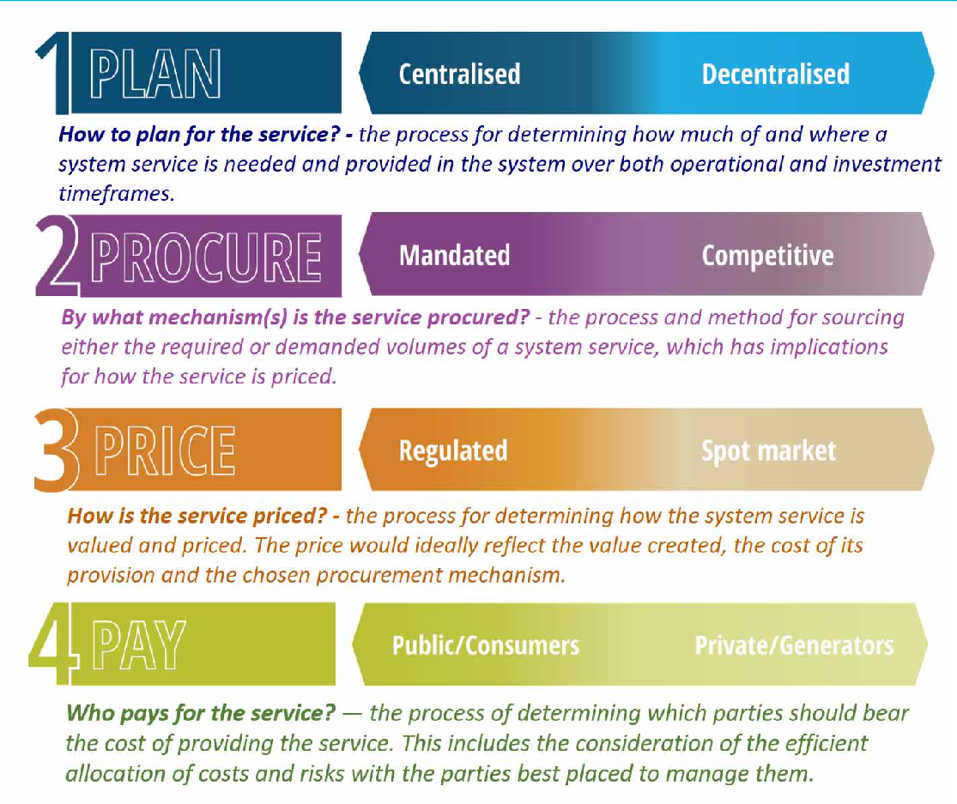

Source: AEMC

The Commission then developed the following principles to assess whether the preferred rule change developed through the above service design framework is likely to support and improve the security of the power system, as well as improve the effectiveness and efficiency of frequency control frameworks:

* **Promoting power system security and reliability:** The operational security of the power system relates to the maintenance of the system within predefined limits for technical parameters such as voltage and frequency. System security, including frequency, underpins the operation of the energy market and the supply of electricity to consumers. Reliability refers to having sufficient capacity to meet consumer needs. It is therefore necessary to have regard to the potential benefits associated with improvements to system security and reliability brought about by the proposed rule change, weighed against the likely costs. These costs are likely to be minimised through workably competitive markets; where this is not the case, that is where providers of these services lack viable competition resulting in inefficient prices that exceed the marginal cost of

providing these services, regulatory arrangements will be required to limit the exercise of market power.

* **Appropriate risk allocation:** The allocation of risks and the accountability for investment and operational decisions should rest with those parties best placed to manage them. The arrangements that relate to frequency control should recognise the technical and economic characteristics and capabilities of different types of market participants to engage with the system services planning, procurement, pricing and payment. Where practical, operational and investment risks should be borne by market participants, such as businesses, who are better able to manage them. Risks, where allocated to market participants, are often managed through contracts. The impact of regulatory changes on the contract market, and the resulting ability of market participants to manage risk, is an important consideration.
* **Technology neutral:** Regulatory arrangements should be designed to take into account the full range of potential market and network solutions. They should not be targeted at a particular technology, or be designed with a particular set of technologies in mind. Technologies are changing rapidly, and, to the extent possible, a change in technology should not require a change in regulatory arrangements.
* **Flexibility:** Regulatory arrangements must be flexible to changing market and external conditions. They must be able to remain effective in achieving security outcomes over the long-term in a changing market environment. Where practical, regulatory or policy changes should not be implemented to address issues that arise at a specific point in time. Further, NEM-wide solutions should not be put in place to address issues that have arisen in a specific jurisdiction only. Solutions should be flexible enough to accommodate different circumstances in different jurisdictions. They should be effective in facilitating security outcomes where required, while not imposing undue market or compliance costs.
* **Transparent, predictable and simple:** The market and regulatory arrangements for frequency control should promote transparency and be predictable, so that market participants can make informed and efficient investment and operational decisions. Simple frameworks tend to result in more predictable outcomes and are lower cost to administer and participate in.
* **Implementation costs:** Regulatory change typically comes with some implementation costs for regulators, the market operator and/or market participants. These costs are ultimately borne by consumers. The cost of implementation should be factored into the overall assessment of any change.

### Summary of reasons

In assessing whether the proposed rule is likely to meet the NEO, the Commission has balanced the power system needs and related benefits associated with improving system security, resilience and power system frequency control against the cost of delivering those outcomes. The need to provide clear, consistent signals to market participants about the impact of their behaviour on power system frequency performance to inform operational and investment decisions was also an important factor.

In making its draft determination, the Commission has taken into account the proponent’s views, stakeholder views, engagement with the technical working group, and expert technical advice provided by AEMO, Greenview Strategic Consulting (Greenview), and GHD. To support the rule change process, AEMO prepared formal advice on the technical requirements for PFR as well as a discussion paper on the feasibility of market and incentive arrangements for frequency control services during normal operation, including potential reforms to causer pays.56 The Commission also commissioned analysis from Greenview on the impacts of Mandatory PFR on the power system and affected plant and independent advice from GHD on the relative benefits, risks and costs of each of the pathways for enduring PFR arrangements.

Based on the advice received from AEMO, Greenview and GHD, and our analysis outlined in chapter 4, the Commission is of the view that:

* + - widespread PFR is required within a tight frequency control band to support power system security and resilience, and to give AEMO greater confidence that it is maintaining the power system in a secure operating state. The current mandatory requirements for scheduled and semi-scheduled generators to automatically respond to changes in system frequency has improved frequency performance in the power system and there would be benefits in a continuation of these arrangements. AEMO’s advice also highlights the costs and risks that arise without these arrangements.57
    - Greenview’s survey of a range of generators in the NEM noted once reasonable aggregate frequency responsiveness was achieved with more plant providing PFR, the implementation of Mandatory PFR has not had an adverse impact on affected generation plant. Although early adopters initially noticed more significant plant movements.58
    - a continuation of the current mandatory arrangements is not a complete solution and, on its own, will not incentivise the provision of sufficient or efficient levels of primary frequency response, nor will the existing arrangements support investment in additional capability to efficiently meet future requirements. While mandatory PFR has been delivering improved frequency performance, affected participants are concerned with the potential for losses due to foregone energy market revenue and increased wear and tear on plant.59
    - there are improvements that can be made to the current causer pays arrangements to better allocate costs to those causing the need for the management of system frequency, as well as to incentivise and reward better performance60

1. These reports are available on the PFR incentive arrangements rule change page: [https://www.aemc.gov.au/rule-](https://www.aemc.gov.au/rule-changes/primary-frequency-response-incentive-arrangements) [changes/primary-frequency-response-incentive-arrangements](https://www.aemc.gov.au/rule-changes/primary-frequency-response-incentive-arrangements)
2. AEMO, Enduring primary frequency response requirements for the NEM, 31 August 2021
3. Greenview Strategic Consulting presentation to the Frequency Control Technical Working Group, Understanding the impacts of Mandatory PFR on generation plant, 23 Jul 2021
4. GHD, *Enduring Primary Frequency Response - CT2 - power system operation and strategic regulatory advice*, 16 September 2021, p.31
5. AEMO, *Primary Frequency Response incentive arrangements- Discussion paper*, August 2021
   * + improved transparency in relation to the causer pays process will help generators better understand and respond to the economic signals through the causer pays arrangements promoting system security in the most efficient manner.
     + in the future, as the generation technology mix continues to evolve, further measures may be required to ensure sufficient aggregate frequency responsiveness (MW/Hz) in the power system to deliver effective frequency control.61This may require changes to the frequency operating standard (FOS) by the Reliability Panel along with new monitoring and reporting arrangements to identify any related emerging needs.62

The Commission considers that the benefits of addressing these issues through the draft rule outweighs the expected costs. These benefits include optimised frequency control, more efficient use of regulation FCAS, and efficient investment, operation and use of PFR from a diverse set of technologies.

* + 1. **Reasons for confirming the Mandatory PFR requirement as enduring**

The Commission’s decision to maintain the current mandatory PFR arrangements is informed by expert technical advice received from AEMO and GHD. AEMO’s expert technical advice makes the case that the required PFR service is aggregate frequency responsiveness (MW/Hz), i.e. the sum of the change in megawatts (MW) in the power system in response to a change in system frequency (Hz).63 As discussed in section 2.3, AEMO advised there is a need for this service (PFR) to be widespread and tightly controlled around 50 Hz. AEMO considers that this can be best achieved through a continuation of the mandatory narrow- band obligation. This is supported by independent advice provided by GHD, summarised in section 2.5.2, which also concludes that mandatory, narrow-band PFR should be continued for promoting power system security. AEMO identifies a number of challenges and risks that would result from removing these arrangements, including but not limited to the impact on the quality of AEMO’s forecasts and interactions with other ancillary services.

Another factor supporting this approach is that the costs and challenges associated with the plant and system changes required to comply with the mandatory PFR capability for different technologies has already been incurred through the current mandatory PFR arrangements due to sunset on 4 June 2023.64 This means there is no additional cost to maintaining these arrangements along with introducing incentives to help them make the most of the capabilities enabled by these sunk costs. Additionally, GHD’s advice, supported by investigation and analysis provided by Greenview strategic consulting, was not able to find conclusive evidence of increased wear on tear at plant at this stage.65

1. GHD, *Enduring Primary Frequency Response - CT2 - power system operation and strategic regulatory advice*, 16 September 2021, p.ii.
2. See section 4.3 for more detail on the additional reporting obligations for AEMO and the AER and section 5 for information on the FOS
3. AEMO, *Enduring Primary frequency response requirements for the NEM*, August 2021, p.16.
4. More information on AEMO’s work with generators to implement this rule change is available at: <https://aemo.com.au/en/initiatives/major-programs/primary-frequency-response>
5. GHD, *Enduring Primary Frequency Response - CT2 - power system operation and strategic regulatory advice*, 16 September 2021, p.31.

##### Improved frequency control and power system resilience

The interim mandatory PFR arrangements introduced in 2020 have delivered a noticeable improvement in frequency performance under normal operating conditions.66 This is illustrated in the following figure.

#### Figure 3.2: Daily frequency crossings – under 49.85 Hz, across 50 Hz, beyond 50.15 Hz

0

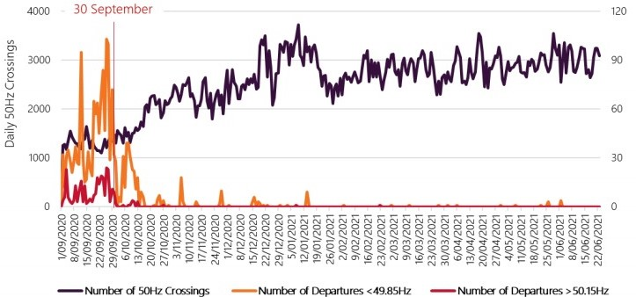

Source: AEMO PFR Implementation Report V16, 25 June 2021.

While the Commission has undertaken further analysis and obtained advice from AEMO and GHD, the rationale for the interim arrangements still applies. This can be summarised as enabling AEMO to more accurately measure and predict the system operating state which should improve market operation, as well as decreasing the risk of generation shedding and unserved energy associated with load shedding.67 The Commission also maintains its position that it is not appropriate to require generators to maintain additional headroom or stored energy for the purposes of providing PFR.

Recent events on the power system also indicate that narrow-band PFR has increased the resilience of the power system to large, non-credible contingency events. Examples of this include the automatic reconnection of Queensland and the rest of the NEM when the interconnector (QNI) tripped following the Callide event in May 2021, and behaviour of generators following the significant failure of AEMO’s SCADA system in January 2021. In its expert technical advice, AEMO noted these events as examples of the improvements in system resilience due to widespread narrow band PFR for example, by enabling QNI to reclose automatically.68 However, the role of PFR during these events (or absence thereof) cannot be isolated from a range of other factors.

1. GHD outlines the observed improvements in frequency performance reported by AEMO in section 4.2 of its advice
2. The mandatory primary frequency response determination and rule are available at: [https://www.aemc.gov.au/rule-](https://www.aemc.gov.au/rule-changes/mandatory-primary-frequency-response) [changes/mandatory-primary-frequency-response](https://www.aemc.gov.au/rule-changes/mandatory-primary-frequency-response)
3. AEMO, Enduring primary frequency response requirements for the NEM, August 2021, pp.40 - 43.
   * 1. **Reasons for reforming the causer pays framework**

The Commission considers that reforming the causer pays arrangements as outlined in section 4.2 will deliver net benefits for electricity consumers. This will help to ensure that scheduled and semi-scheduled generators who are required to have the capability to provide PFR are incentivised to do so, consistent with the Commission’s long-term vision for the provision of primary frequency response.

In making a draft determination to incentivise the provision of PFR through a revision of the causer pays arrangements, the Commission has considered the benefits this would provide to the ongoing frequency performance of the power system and weighed this against the expected costs of implementation and potential ongoing costs to market participants.

#### Potential NEM-wide benefits from the draft rule

The Commission considers that there are a number of benefits that are likely to arise from the draft rule, which will outweigh both the implementation and ongoing costs that were discussed above. Most importantly, the draft rule will efficiently incentivise improved plant performance to help control power system frequency during normal operation. There are also expected benefits from enabling more targeted use of FCAS (particularly regulation services) and incentivising the efficient availability and use of generation technologies to support power system frequency.

***Incentivising the efficient availability and use of diverse system service capabilities***

The proposed enduring PFR arrangements should provide more transparent and targeted pricing and incentive arrangements to incentivise the efficient availability and use of diverse generation technologies to support system frequency.

AEMO has noted that the absence of more targeted incentives and cost allocation in the current arrangements means that bad performers do not face the true cost of their behaviour. This results in cross-subsidies from either consumers accepting worse frequency performance than desired or other generators bearing the additional burden to provide the desired frequency performance. The Commission considers that markets participants that face a more accurate reflection of the impact of their behaviour in closer to real-time will have substantially more incentive to innovate and improve the operation of their plant to help system frequency. This should result in an overall superior frequency response to the imposition of mandatory PFR arrangements alone.

The revised double-sided frequency performance will encourage generators to innovate beyond improving performance to avoid charges towards more proactive provision of PFR. This form of double-sided incentive should strengthen the motivations for all market participants to contribute positively to the frequency performance of the power system. This includes some market participants with other competing financial incentives. For example, depending on the nature of any power purchase agreements (PPAs) they have may have, inverter-based resource (IBR) operators may also face requirements to maximise revenue which restricts their ability to maintain capacity for PFR provision. Additionally, as noted by GHD, it cannot be assumed that IBR capacity, that has been curtailed due to wider system

issues such as network thermal limits, will be available to provide primary frequency response if required.69 Incentivising PFR provision encourages generators to engage with these challenges and find solutions that suit their unique technology, investment and operational conditions.

Double-sided causer-pays arrangements also allow non-scheduled generators and consumers with appropriate metering to be rewarded even if they aren’t registered for FCAS markets, thereby incentivising a greater variety of resources to provide the required aggregate frequency responsiveness. There is also the potential for other participants to install appropriate metering and/or develop new projects to enable them to be rewarded for operating in a manner which further supports aggregate frequency responsiveness. This means that the proposed arrangements could incentivise behavioural change that will reduce total frequency performance payments for contribution factors and enable more market participants to benefit.

The combined impact of these benefits will tend to increase the prevalence of power system plant that helps to control power system frequency which will help to counteract the expected increase in regulation services predicted by AEMO as the proportion of variable renewable generation in the NEM increases.

***Addressing a projected need for increased regulation services***

Incentivising more efficient and effective primary frequency control also allows more targeted use of regulation FCAS services. AEMO’s expert technical advice notes that effective PFR provides a complementary effect by allowing secondary control like regulation FCAS to operate over slower timescales, correcting energy balances and forecast error, and minimising frequency drift accumulation of time error within the dispatch interval.70 This is challenging to value but indicative analysis from the AER and AEMO can provide some useful insights.

The AER’s 2021 State of the Energy Market report notes the sustained deterioration of frequency performance in the NEM contributed to (although was not the sole cause of) a 70- 75% increase in requirements for regulation services on the mainland in 2019 which led to record levels of FCAS costs.71

AEMO advises that there is a risk of greater imbalances between generation and load as inverter connected variable renewable energy generation technologies displace synchronous generation.72

Distributed energy resources, such as solar PV, are also likely to contribute to greater imbalances between generation and load which will require more and faster frequency control services to manage. To help demonstrate the magnitude of this issue, AEMO’s

1. Page 10 of GHD’s advice provides further discussion around when curtailed capacity may not be available to provide PFR.
2. AEMO, *Enduring primary frequency response requirements for the NEM*, August 2021, pp.19, 47-57.
3. See Section 2.10.2 Frequency control markets from pp.112-115 of the AER’s 2021 State of the Energy Market report. Available at: <https://www.aer.gov.au/system/files/State%20of%20the%20energy%20market%202021%20-%20Full%20report_1.pdf>
4. Section 4 of AEMO’s technical advice on the enduring PFR requirements discusses consideration of future frequency control needs and provision of PFR. ref. AEMO, *Enduring primary frequency response requirements for the NEM*, August 2021, pp.30-46.

technical advice highlighted analysis from its 2018 Integrated System Plan of regulation FCAS requirements with increasing uptake of inverter connected (grid-scale) solar and wind generation.:73

#### Figure 3.3: Projected solar and wind dependent regulation FCAS requirements

0

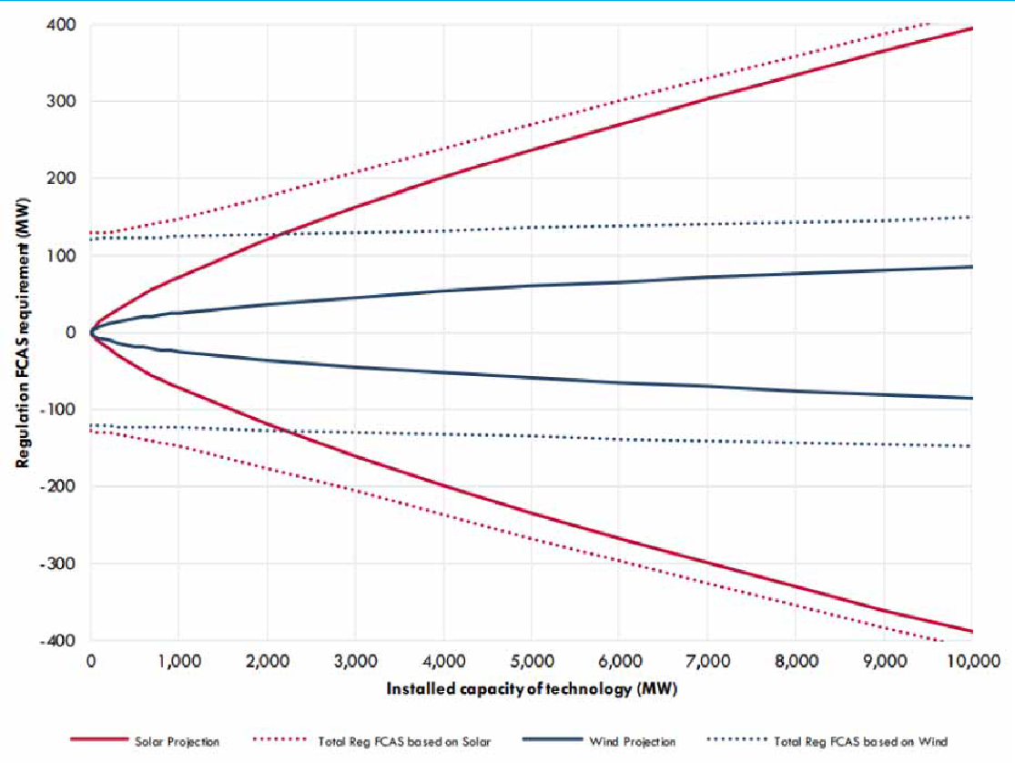

Source: AEMO, *Enduring primary frequency response requirements for the NEM*, August 2021, p.57.

These forecasts were made before PFR obligations were introduced and AEMO noted in its advice that this analysis assumes no improvement in the behaviour of grid-scale solar generators and likely underestimates diversity in their output. However, to provide context for the scale of this requirement, the AER’s 2021 State of the Energy Market reports more than 5000 MW of grid scale solar installed in the NEM as at 30 June 2021.74 This would equate to a 300 MW increase in regulation FCAS requirements absent behavioural change which is significant considering that the typical volume of regulation FCAS procured is 200-250 MW. 75 The introduction of double-sided causer pays (DSCP) should incentivise better behaviour from grid-scale solar to help mitigate the projected need for increased levels of regulation services. Over time the framework set out under the draft rule should lead to lower costs for

73 Ibid., p.57.

1. AER, State of the Energy Market, 2021, p.74.
2. AER, 2021 Wholesale statistics – Electricity Frequency control ancillary services. Available at: [https://www.aer.gov.au/wholesale-](https://www.aer.gov.au/wholesale-markets/wholesale-statistics?f%5B0%5D=field_accc_aer_stats_category%3A1076) [markets/wholesale-statistics?f%5B0%5D=field_accc_aer_stats_category%3A1076](https://www.aer.gov.au/wholesale-markets/wholesale-statistics?f%5B0%5D=field_accc_aer_stats_category%3A1076)

frequency regulation, than would otherwise be the case under a continuation of the existing arrangements for the allocation of regulation costs.

#### Estimated costs due to the reforms to Causer pays

The main costs associated with the draft rule are:

* + - * expected costs arising from the development and implementation of the revised Causer pays procedure; and
      * ongoing costs due to payments made to market participants based on positive contribution factors.

***Implementation costs***

The development and implementation of the PFR incentive arrangements will be a regulatory obligation imposed on AEMO which will result in expenditure to undertake technical studies, consultation on the *Frequency contribution factor procedure*, and changes to AEMO systems. AEMO has advised that the costs of implementing new causer pays arrangements is likely to be around $5 million (between $3 million and $8 million) depending on the specific design of that procedure. However, prior to this rule change AEMO had already identified potential changes to the rules and improvements to its procedures. For example, addressing calculations when regulation FCAS requirements apply, differing treatment of contingency events, and reviewing the reference trajectory.76 This means some of these costs would likely be incurred irrespective of the draft rule, albeit with potentially less impetus. These additional costs will be recovered from market participants through AEMO’s market fees.77

***Ongoing costs***

Under the draft rule, market participants with positive contribution factors would receive payments (frequency performance payments) that are proportional to the costs of regulation FCAS. These payments would then be recovered from participants with negative contribution factors and the residual from unmetered market participants.

The Commission has undertaken analysis to estimate the potential short-term financial impacts as a result of the valuation of positive contribution factors and other changes to the Causer pays process, as set out in the draft rule. This analysis indicates that the short term increase in costs for frequency regulation are estimated to be approximately 10% of the total costs of regulation services, or in the order of $9 Million per year. This is based on average regulation FCAS costs of around $91.9 million over the period 2018 - 2020.

Appendix E provides further detail on the Commissions’ analysis to estimate the financial impacts of the proposed changes to the causer pays process.

1. See section 5.2 Subsequent work program in AEMO’s consultation document available at: [https://aemo.com.au/-](https://aemo.com.au/-/media/files/stakeholder_consultation/consultations/nem-consultations/2018/causer-pays/final-determination---causer-pays-consultation.pdf?la=en&hash=1E9B2333C57273E0DC16034A7DA1F5A3)

[/media/files/stakeholder_consultation/consultations/nem-consultations/2018/causer-pays/final-determination—-causer-pays-cons](https://aemo.com.au/-/media/files/stakeholder_consultation/consultations/nem-consultations/2018/causer-pays/final-determination---causer-pays-consultation.pdf?la=en&hash=1E9B2333C57273E0DC16034A7DA1F5A3) [ultation.pdf?la=en&hash=1E9B2333C57273E0DC16034A7DA1F5A3](https://aemo.com.au/-/media/files/stakeholder_consultation/consultations/nem-consultations/2018/causer-pays/final-determination---causer-pays-consultation.pdf?la=en&hash=1E9B2333C57273E0DC16034A7DA1F5A3)

1. AEMO’s recovery of its budgeted revenue requirements through participant fees (including its expenditure requirements relating to power system operation activities and expenditure relating to the electricity industry generally) is addressed in rule 2.11 of the NER, and which sets out that AEMO can recover development and implementation costs through electricity participant fees.

It is important to note that these additional costs are not expected to be borne by unmetered (residual) load alone. The draft rule would allocate the costs for regulation services, that are not used, to all market participants, in proportion with the total energy consumed or generated during the trading interval. The costs for regulation services that are used, and any frequency performance payments would be borne by market participants that contribute to the need for these services, due to the relative impact of their active power deviations from dispatch trajectory, relative the power system need for frequency regulation.

These estimates of short-term cost increases do not account for behavioural changes that are expected to occur as a consequence of the improved incentive arrangements set out in the draft rule. The Commission expects that the double-sided frequency performance payments set out in the draft rule will lead to an increase in plant operating behaviour that tends to reduce the need for regulation services. A reduction in the need for regulation FCAS (all else being equal) would likely reduce the total costs of regulation FCAS over the long term, as compared with the continuation of the current arrangements for the allocation of regulation costs.

* + 1. **Reasons for additional reporting obligations for AEMO and the AER**

The Commission has also introduced additional reporting obligations (see section 4.3) on AEMO to support the principle of transparent and predictable outcomes, as well as improving efficient outcomes over time. The arrangements require AEMO to provide greater clarity on how it will calculate the incentive payments, allocate costs, and performance of system frequency.78 This reporting will be accompanied by further reporting on the cost of frequency performance payments for each region from the AER.79 These reporting arrangements will complement the changes to the causer pays arrangements to more clearly signal the impact of a market participant’s behaviour on system frequency. They will also help track the efficacy of the incentive arrangements to help identify whether further interventions (e.g. procuring or scheduling responsive plant and reserves) is required to ensure sufficient PFR is obtained.

For the incentives to be effective, market participants must be able to understand and respond in the intended manner, at the intended time. The Commission considers this requires greater transparency around the approach used to assess market participant performance, as well as consistent publication of more data. These requirements should enable informed market participants to create indicative expected values to inform operational decisions.

There is also a need for greater transparency around what the enduring PFR arrangements are intended to achieve and how success can be identified. This will help those developing new generation projects to form clearer expectations of system requirements, as well as help to identify potential shortcomings in the provision of PFR and aggregate frequency responsiveness. The additional reporting will allow this risk to be monitored and provide early indication if it eventuates.

1. This reporting includes amendments to the weekly and quarterly reporting on frequency performance under clause 4.8.16 of the NER
2. To complement its quarterly reporting on market ancillary services markets under clause 3.11.2A of the NER

The draft rule requires AEMO to monitor the performance of system frequency, as well as the aggregate frequency responsiveness and provision of PFR underpinning this performance.

This should help identify any deterioration in frequency performance and indicate whether this deterioration could be associated with provision of PFR (e.g. lack of geographic spread) or insufficient aggregate frequency responsiveness in the system. This information will also provide an evidence base to design and develop market-based arrangements should they be required in the future.

# ELEMENTS OF THE DRAFT RULE

The draft rule includes the following key elements:

* + **Confirmation that the mandatory PFR arrangements** will endure beyond 4 June 2023.

This is achieved by the draft rule revoking Schedule 2 of the *National Electricity Amendment (Mandatory primary frequency response)* rule which would have ended the existing Mandatory PFR arrangement on 4 June 2023. This means that all scheduled and semi-scheduled generators would continue to be required to support the secure operation of the power system by responding automatically to changes in power system frequency.

* + **Reforms to the causer pays process** for the allocation of regulation FCAS costs to deliver improved valuation and pricing of plant behaviour that impacts on power system frequency.

These changes include the introduction of frequency performance payments to value positive contributions, the shortening and alignment of the sample and application periods for the determination of participant contribution factors, and further changes to improve the transparency of the causer pays process. These changes are expected to better align the economic incentives for plant active power performance, with the impact of that behaviour on the need for corrective action through the deployment of regulation services to rebalance supply and demand and restore power system frequency to 50Hz. By incentivising the provision of primary frequency response this is expected to lead to more efficient outcomes in relation to the operation of the power system by encouraging all market participants to operate their plant in a way that reduces the need for regulation services and helps to control power system frequency.

* + **New reporting obligations for AEMO and the AER** in relation to the levels of aggregate frequency responsiveness in the power system and the costs of frequency performance payments. This change supports the principle of transparency and would provide relevant information to market participants and stakeholder to assess the effectiveness and efficiency of the frequency control frameworks over time.
  + **Implementation and transitional arrangements** for the new Causer pays process which would provide a transparent timeline for the implementation of the related changes while allowing sufficient time for AEMO to consult on the frequency contribution factors procedure and make the related changes to its internal processes and systems. The Commission has also proposed to amend the existing date for the publication of the final *Primary frequency response requirements* document (*PFRR*), which AEMO is currently required to complete by 6 December 2021 to be a date which is 6 months from the date that the final rule is made, in order to allow time for AEMO to consult on the final *PFRR* that will apply under the enduring arrangements.

Each of these elements is described in further detail in the following sections.

### The confirmation of the mandatory PFR arrangement as enduring

The draft rule revokes Schedule 2 of the *National Electricity Amendment (Mandatory primary frequency response)* rule which would have ended the existing Mandatory PFR arrangement on 4 June 2023. Therefore, the mandatory narrow band PFR arrangements will endure. This would mean that all scheduled and semi-scheduled generators would be required to continue to provide primary frequency response in accordance with AEMO’s specification set out in the *Primary frequency response requirements*.

The Commission’s draft determination is based on expert technical advice received from AEMO and the independent advice provided by GHD that widespread (mandatory) PFR within a tight (narrow) band around 50 Hz is required to provide a secure and resilient power system. This advice is consistent with international power system operating practice where almost all generation plant are required to provide narrow-band PFR.80AEMO has consistently advised this level of PFR is a priority for secure and stable power system operation.81 Independent advice from GHD also supports the continuation of mandatory narrow band PFR arrangements as the preferred method of delivering effective frequency control in the NEM over the short to medium term.82 The Commission considers that the risks of a substantial impact to the system from removing the requirement for generators to provide primary frequency response would be significant.

* + 1. **AEMO’s expert advice**

AEMO’s expert advice is that the implementation of near universal narrow band frequency response has re-established stable frequency control in the NEM and re-aligned the operating practices in the NEM with comparable international power systems. In response to the AEMC’s consideration of enduring PFR arrangements:83

A high aggregate level of frequency responsiveness is a critical prerequisite for optimal frequency control outcomes as the supply mix continues to become increasingly decentralised, inverter-based, and variable. AEMO considers this is best delivered through a narrow deadband response from all generators.

AEMO’s rationale for the importance of the narrow band frequency response arrangements is:84

* + - * Effective PFR is essential for robust power system frequency control
      * The need for PFR is large, distributed, and expected to grow over time

The following sub-sections provide a more detailed summary on each of these points.

1. AEMO, *Enduring PFR requirements for the NEM*, August 2021, pp.3-4, 58.
2. AEMO, *Mandatory Primary Frequency Response - Electricity rule change proposal*, 16 August 2019, pp.55-56.
3. GHD, *Enduring Primary Frequency Response - CT2 - power system operation and strategic regulatory advice*, 16 September 2021, p. i-iii.
4. AEMO, Enduring primary frequency response requirements for the NEM, August 2021, p.4.
5. AEMO, Enduring primary frequency response requirements for the NEM, August 2021, p.4-5.

#### Effective PFR is essential for robust power system frequency control

AEMO expert advice is that PFR is an important part of an integrated chain of control actions that also includes secondary (regulation) control, contingency reserves and emergency frequency control schemes. Tight control of system frequency complements and improves the effectiveness of each of the other elements of this integrated control framework. Near universal narrow band frequency response also increases the predictability of generating system response to disturbances which supports AEMO’s analysis and modelling of power system performance which feeds into the design of system control and protection arrangements.85

AEMO considers that universal narrow band PFR is required as this delivers the maximum ratio of MW response to frequency deviations (MW/Hz), which is the most effective for system security. This ratio is maximised through the coordinated control action of many unit controllers and results in a stabilising effect that actively ‘controls’ system frequency and maintains it close to 50Hz. Any reduction of the aggregate level of frequency response or “aggregate droop” will result in system frequency being further away from 50Hz more often.86

AEMO provides analysis and commentary on different potential operational arrangements with similar levels of aggregate droop. In the example set out in Figure 4.1, 6 x 250MW units operating at 1% droop and +/-0.15 Hz dead band would provide a similar degree of aggregate frequency responsiveness to 30 x 250MW units operating at 4% droop, also operating with a +/-0.15 Hz deadband.87 AEMO notes that, where the droop response is spread across more units, the proportional response from each individual unit is significantly reduced.

1. Ibid.
2. Ibid.
3. A lower droop setting represents a more aggressive frequency response.

#### Figure 4.1: Two different arrangements with similar levels of aggregate frequency responsiveness

0

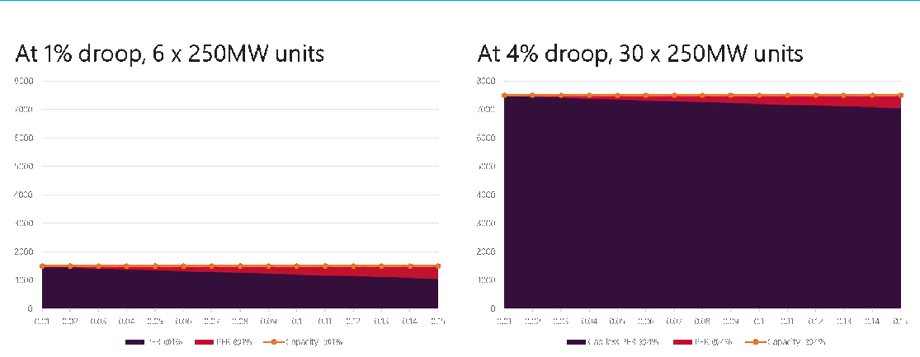

Source: AEMO, Enduring primary frequency response requirements for the NEM, August 2021, p.71.

Note: Further explanation of the concept of “aggregate frequency responsiveness” is included in appendix F

#### A narrow deadband setting is required for effective frequency control

AEMO provides the following commentary on the three proposed frequency response deadband settings, as they relate to the enduring PFR pathways identified by the AEMC in the directions paper:88

Deadbands in a control system determine the point at which control action begins. The larger the deadband in frequency response controls, the larger the permitted level of uncontrolled frequency variation. The AEMC’s alternative policy pathways for enduring PFR arrangements involve different deadband options for frequency responsiveness.

The options differ materially from a system design point of view and in terms of their ability to provide effective frequency control outcomes under normal operating conditions:

* Narrow deadband (between 0 and ± 0.015 Hz) provides the most stable control of frequency, and the most robust response to and damping of disturbances. This improves the overall resilience of the power system during major system events and abnormal operating conditions, and enhances the effectiveness of secondary control.
* Moderate deadband (± 0.15 Hz) by itself provides no control of frequency within the NOFB and is not consistent with best practice internationally. PFR would act only after frequency has significantly departed from 50 Hz, reducing the weight of the system to arrest rate of change of frequency (RoCoF), resulting in a less resilient power system following contingency events. Adjusting reserve and

1. AEMO, Enduring primary frequency response requirements for the NEM, August 2021, p.18.]

secondary control parameters alone would be unable to establish control within the NOFB under normal operating conditions.

* + Wide deadband (± 0.5 Hz) by itself would provide no control of frequency over a 1 Hz range. PFR would operate only after a very large deviation of frequency, with a material risk of not arresting high RoCoF events, and a significant reduction in resilience. The Frequency Operating Standard (FOS) would be consistently breached. Such a lack of control is an unacceptable way to operate a national power system.

#### The need for PFR is large, distributed, and expected to grow over time

AEMO considers that a high aggregate level of frequency responsiveness is critical to achieving effective control of power system frequency. This requires:89

* + Contribution from a large fraction of the fleet: this is a distinctly different situation to existing FCAS markets, which can allocate [contingency] reserve requirements to a smaller number of providers.
  + Geographic diversity in provision: fundamental to power system performance under normal conditions (given NEM experience with regional requirements resulting in market concentration challenges) and system resilience during abnormal system events and network outages/contingencies.

AEMO notes that market and technological changes are expected to increase the importance of broad-based frequency control. This is based on an expectation of increasing variability of generation and load due to:90

* + - * Increasing generation variability due to ongoing entry of generation that relies on variable raw energy inputs, including large scale wind and solar power (VRE) and distributed solar generation (DPV).
      * Increasing price-driven movement in both generation and load (especially following the introduction of five-minute settlement in October 2021).91

At that same time AEMO expects that there will be drivers that will tend to reduce the available supply of frequency responsive plant and the ability for that plant to provide effective PFR. These drivers include the increased supply from large scale inverter-based generation such as renewables and the reduction in operational demand due to the increase of behind-the-meter distributed energy resources, particularly rooftop solar PV (that currently is not required to provide narrow band PFR).

AEMO considers that it is important for large scale variable renewable generation to provide narrow band PFR as this form of generation will make up an increasing proportion of the

1. AEMO, Enduring primary frequency response requirements for the NEM, August 2021, p.4.
2. AEMO, Enduring primary frequency response requirements for the NEM, August 2021, p.31.
3. The AEMC has received a rule change request from AEMO on a proposed contingency plan if an event occurs to delay the implementation of five-minute settlement. Information related to the rule change request, Contingency arrangements for five minute settlement implementation, is available on the AEMC project webpage: [https://www.aemc.gov.au/rule-](https://www.aemc.gov.au/rule-changes/contingency-arrangements-five-minute-settlement-implementation) [changes/contingency-arrangements-five-minute-settlement-implementation](https://www.aemc.gov.au/rule-changes/contingency-arrangements-five-minute-settlement-implementation)

future generation mix. AEMO acknowledges that effective PFR requires plant to be online, responsive to small frequency variations and be carrying sufficient headroom and footroom to provide active power response.92 AEMO notes that:93

In some future energy dispatch scenarios, there could be much lower levels of frequency responsive generation online as part of normal energy market dispatch and, therefore, reduced capacity to meet any aggregate PFR requirement.

An aggregate level of PFR delivery requires plant to be capable of frequency response and to be online, and also to be carrying enough headroom or footroom to provide the response. This headroom/footroom could be provided from BESS, curtailed VRE generation, or synchronous generation, and sourced through FCAS arrangements.

Importantly, this relies on IBR (VRE or BESS) having PFR capability enabled in the first place.

AEMO also recognises that future periods where almost all demand is met by distributed energy resources (DER) will be particularly challenging, as DER currently do not provide narrow-band PFR and are not covered by the mandatory PFR requirement. AEMO notes that:94

One potential solution is to mandate narrow deadband PFR from DER devices, particularly DPV and BESS. Other comparable international standards now allow for specification of narrow frequency deadbands as the default, within a wide permissible range, with some independent system operators (ISOs) now specifying narrow frequency deadband settings for DER. AEMO is undertaking further investigation into the feasibility of similar requirements in Australia.

* + 1. **GHD’s expert advice**

GHD’s expert advice is that mandatory narrow-band PFR should be implemented permanently beyond the sunset for the existing arrangement (4 June 2023). GHD sets out the following reasons in support of its recommendation for the permanent implementation of mandatory narrow band PFR:95

* + - * Aggregate PFR from all online generating systems to effectively manage frequency during normal operating conditions will mean less movement of individual generator active power. We expect more frequent lower magnitude movement which is less likely to create adverse impacts on individual plant.

1. Headroom refers to the ability for a generator to increase its delivered generation in response to a change in system frequency. It is supported by available stored energy within the generation system that can be rapidly converted into electricity in short time period, typically within a matter of seconds. Similarly, footroom refers to the ability for a generator to reduce its delivered generation.
2. AEMO, Enduring primary frequency response requirements for the NEM, August 2021, p.4.
3. AEMO, Enduring primary frequency response requirements for the NEM, August 2021, p.5. For the avoidance of doubt, the Commission is not currently considering any changes to the NER to mandate provision of PFR by DER.
4. GHD, *Enduring primary frequency response advice,* 20 August 2021, p.i.
   * Aggregate narrow band PFR will provide additional security and power system resilience to increasingly frequent large system disturbances.
   * Allows other FCAS market services to operate most effectively and avoids distortion of those services e.g. regulation, contingency.

GHD notes that there has been an observed progressive improvement in the performance of system frequency since the implementation of mandatory PFR arrangements. There was a noticeable reduction in the number of excursions outside the normal operating frequency band within a few months, but GHD’s analysis suggests that from December 2020 there were only limited improvements in frequency performance as further plant was brought online.

GHD comments that this has implications for the volume of PFR required for effective frequency control, although it is difficult to tell how much PFR was enabled from online generation at any point in time.96

GHD notes that this improved frequency performance was mainly derived from the coal generating fleet with only two wind farms and no solar farms enabled for PFR in this period.97

GHD advises that mandatory narrow band PFR is consistent with international best practice, noting that ERCOT in the United States and UK National Grid both require mandatory narrow- band PFR, albeit with slightly different objectives and specific arrangements.98 GHD concludes that mandatory narrow-band PFR should be permanently continued as it is an effective mechanism to provide the required level of aggregate frequency responsiveness to support effective control of power system frequency.

GHD’s high level advice is:99

We recommend a policy pathway to support mandatory narrow band PFR that ensures sufficient responsive plant and reserves will be available. As the NEM generation mix evolves, we propose that the market arrangements should similarly evolve through:

* + Initially, establishment of **improved pricing through Double Sided Causer Pays** arrangements that incentivise the provision of PFR from generators to counter frequency deviations.
  + Later on, the potential development and implementation of additional market procurement arrangements towards the end of this decade, or earlier if required, that is best facilitated through an **additional primary regulation service** (PFR- FCAS) in combination with continuing DSCP.

GHD considers that improved pricing through double-sided causer pays (DSCP) will support more efficient outcomes. GHD notes that: 100

96 Ibid, p.23-26.

1. Ibid, p.26.
2. Ibid, p.13.
3. Ibid, p.ii.
4. Ibid.

While DSCP will not provide certainty in relation to the volume or availability of frequency control services in the same way that an enablement market does, its implementation is expected to:

* 1. incentivise good behaviour in terms of following dispatch targets more closely and
  2. incentivise the voluntary provision of PFR to counter frequency deviation in the normal operating frequency band.

GHD considers that over the longer term, stronger arrangements may be required to provide greater assurance in relation to the provision of sufficient levels of PFR.101

Looking further ahead, we see that there may be a need to establish stronger market arrangements that provide a greater level of certainty for system operation and send the right price signals to the market for provision of future PFR capacity (reserves), particularly in the lead up to the retirement of a large number of the NEM’s coal fired generating fleet at the end of this decade, and beyond.

The potential future need for additional PFR procurement arrangements is discussed in section 5.2.

* + 1. **Stakeholders’ views**

The Commission is aware of a wide range of stakeholder views in relation to the arrangements for PFR in the NEM. Representatives from transmission networks along with power system engineers and AEMO have advocated for mandatory PFR and the associated benefits from broad based active power control.102 At the same time, many stakeholders have expressed concern that the mandatory PFR requirement is unlikely to be the most efficient option for valuing primary frequency response in the long-term. These stakeholders reasoned that incentive or market-based arrangements to provide PFR would likely be more efficient and effective over the longer term.103

Stakeholders highlighted a number issues with the existing mandatory arrangements framework which they believe could be more efficiently addressed through an incentive- based mechanism for PFR, including:

* + - * PFR should be valued to reflect the costs to generators of providing the service
      * Generators should be incentivised to maintain headroom if a PFR mechanism is to be technically effective
      * PFR should be procured at economically efficient levels

1. Ibid.
2. Submissions on the directions paper - Frequency control rule changes, 17 December 2020: AEMO, p.2.; UNSW, p.19.; Hydro Tasmania, p.5. Submissions on the Consultation paper - PFR rule changes, 19 September 2019: AEMO, p.1.; Ergon Energy and Energex, p1; Kate Summers, p.2; TasNetworks, p.3.
3. Submissions on the directions paper - Frequency control rule changes, 17 December 2020: Alinta Energy, p.5.; AGL, p.8.; CEC, p.2.; Delta Electricity, p.13.; Infigen, p.7.; Neon, p.1.; Origin, p.5.; Snowy Hydro, p.8. Submissions to the consultation paper – PFR rule changes, 19 September 2019: CS Energy, p. 2, Delta Electricity, p. 6, Neoen p.1, Enel X, p. 8, IES, p.2, Enel Green Power, p. 2, ARENA, p.3.
   * + - Appropriate economic signals should exist for investment and innovation

Further detail on each of these points is included in section 5.3.1 of the Directions paper.

* + 1. **Commission’s analysis**

As set out in the directions paper, the required technical outcomes for PFR identified by AEMO could be achieved by either **maintaining** the current narrow band Mandatory PFR arrangements (Pathway 1) or, theoretically, by **revising** the mandatory arrangements through widening the frequency response setting and introducing procurement arrangements for narrow-band PFR services (pathway 2). In making its decision, the Commission has drawn on advice received from AEMO and GHD, and input from stakeholders, to make a draft rule that retains the current mandatory narrow band PFR arrangements (Pathway 1). In support of this draft determination, the Commission notes that:

* + - * AEMO’s advice is that the current narrow band mandatory arrangements have achieved the required level of PFR to deliver effective frequency control. These arrangements are expected to continue to support secure and resilient operation of the power system until the provision of PFR from thermal generation starts to noticeably decline.
      * The development of procurement arrangements for narrow-band PFR services is a relatively new concept, both domestically and internationally, and while market arrangements for frequency responsive reserves have been effective, there is little precedent for procuring an aggregate level of frequency responsiveness in the power system. The procurement of an aggregate level of frequency responsiveness requires arrangements that address the requirement to solve operational challenges related to scheduling of sufficient frequency responsive plant as well as the provision of sufficient MW reserves to support effective active power response. In this way there are both similarities with the existing FCAS market arrangements and differences in relation to the potential design for procurement arrangements to provide adequate levels of frequency responsive plant and reserves to meet the future system requirements for PFR.
      * Procurement arrangements would need to take a number of factors into account, such as the imposition of market constraints, which could compromise the economic efficiency of the market. For example, AEMC analysis suggests around 30 – 60% of the generation fleet would be required to be responsive to provide the required level of aggregate frequency responsiveness (droop). Additionally, minimum procurement volumes may be required for each region of the NEM and possibly sub-regions as well.

GHD’s advice offers similar rationale on the basis of broader system performance and plant impacts.104 GHD notes that continuing mandatory narrow-band PFR will deliver increased resilience to increasingly frequent system disturbances, less (albeit potentially more frequent) movement for individual generators minimising the impact on their active power, and allow other FCAS market services (e.g. regulation and contingency) to operate more effectively and avoid potential distortions.

1. GHD, *Enduring primary frequency response advice,* 20 August 2021, pp.i-iii, 45-46.

The Commission considers that there is sufficient justification for the continuation of the mandatory requirement for narrow band frequency response from scheduled and semi- scheduled generation plant. The key basis for this position is that the power system requires a high ratio of proportional active power response to changes in power system frequency.

High aggregate system levels of frequency responsiveness lead to frequency being well controlled close to 50Hz.105 The aggregate level of frequency responsiveness is directly related to the distribution and variation of power system frequency during normal operation and, as such, this active power response is best delivered by a large proportion of generation plant.

The mandatory narrow band PFR arrangements are a particularly effective mechanism given the current generation mix at delivering high levels of aggregate active power response. This has been evidenced through data showing improvements in frequency performance since the mandatory primary frequency response rule was made, and the implementation of this, which has largely focused to date on requiring large-scale centralised generation to provide narrow-band PFR.

These mandatory PFR arrangements provide a clear signal to those parties who are entering the market that they are expected and required to provide primary frequency response, which effectively sets a ‘standard’ for the provision of primary frequency response by registered generators in the NEM.

However, the Commission does not consider that the mandatory arrangements, on their own, are a complete and enduring solution. This is because the changing nature of technologies on the power system are likely to present challenges to the effectiveness of the mandatory arrangements on their own. As the generation mix changes from large, centralised units to inverter-based generation such as wind, solar & batteries, the prevailing operational conditions of the new resources (despite having a requirement) may impact on their ability to provide PFR, which may reduce the effectiveness of the arrangements over time.

For example, a wind or solar farm operating at full generation output, has limited headroom to provide a balanced response to changes in power system frequency. Under conditions where these generators are generating to their maximum available raw energy capability, they have limited capability to provide an effective primary raise response.

This limitation is removed when the plant is curtailed, such that it is generating at a level that is below the available raw energy that could be drawn from the wind or the sun. In such a situation, there is ‘spare capacity’ available to increase the active power output and provide a response that acts to raise system frequency. When combined with the significant uptake of distributed resources, such as roof top solar (which currently provide minimal PFR), the primary control of frequency in the power system could be substantially diminished.

The Commission considers that there needs to be accompanying arrangements to incentivise provision of primary frequency response going forward. The draft rule therefore includes reforms to the causer pays arrangements to better value plant behaviour that help to control

1. This concept of frequency responsiveness is also referred to as “droop control” for individual generators and “frequency bias” for power system operation. The concept and its implications are described further in appendix F .

power system frequency. The improved incentive arrangements are expected to deliver more efficient operation of power system plant along with investment in new capability to help control power system frequency. Over time, the importance of arrangements to value plant behaviour that helps to control power system frequency is expected to increase.

The combination of mandatory primary frequency response with incentive arrangements will together provide the outcomes of a secure system, while minimising costs to consumers.

The two elements will work together to promote efficient outcomes and make sure that primary frequency response arrangements can be enduring, effective and adaptive to both changes in the power sector and related technology.

The Commission recognises that an alternative to introducing incentive arrangements would be to have a specific procurement arrangement to deliver the required levels of frequency responsiveness to control power system frequency. However, the Commission does not consider that this is preferred at the current time. Not only would this have higher implementation costs than the option set out under the draft rule, but it also has significant risks and competition concerns that would need to be worked through. For these reasons, the Commission’s draft rule for enduring arrangements comprises the two elements discussed above.

However, the Commission recognises that the effectiveness of the combination of the mandatory arrangements and incentives will need to be monitored on an ongoing basis. The Commission considers that the arrangements in the draft rule can be enduring and provide what the market needs to maintain effective primary control of power system frequency.

Nevertheless, the Commission notes GHD’s advice that additional procurement arrangements may be required to deliver sufficient levels of frequency responsiveness to control power system frequency in the future. To support this task, the draft rule includes additional monitoring and reporting arrangements, described in section 4.3, which will inform further consideration by the market bodies as to whether there is any need for changes to the nature of these arrangements in the future. The Commission recognises that going forward it will be important to monitor the effectiveness of the arrangements under the draft rule for any unintended consequences and to verify that these arrangements are appropriate to efficiently support the control of power system frequency.

Further detail on the Commission’s considerations in relation to the potential future development of PFR procurement arrangements is included in section 5.2.

### Reforms to Causer pays

The Commission accepts that the Mandatory PFR requirement is a necessary component of the enduring arrangements to deliver effective control of power system frequency. However, the Commission considers that there are a number of potential shortcomings of the narrow band mandatory PFR arrangements that could arise if these arrangements were to be continued on their own. These shortcomings include:

* A risk that sufficient stored energy to support effective frequency control may not be available into the future due to changes in the generation technology mix.
* A concern that the mandatory PFR arrangement leads to under-pricing of frequency control services, as generators are required to be frequency responsive but the provision of frequency control services is not fully valued, especially where it is provided by plant that are not enabled to provide FCAS.
* Limited incentives for generators to provide frequency response that is superior to the obligations placed on them through the mandatory arrangements.
* As the generation mix changes in the future, and in the absence of additional regulatory, market or incentive-based arrangements, there is a risk that sufficient frequency responsive plant may not be available and online to meet the power system requirements. Economic signals for PFR are expected to provide clear investment signals for new participants to provide these services to efficiently meet the power system requirements.

These shortcomings will be fully or partly addressed by improved pricing arrangements for plant behaviour that helps to control power system frequency, and if required, procurement arrangements for active PFR. The draft rule includes reforms to the causer pays framework to provide improved pricing of frequency control services along with additional obligations on AEMO to report on the level of aggregate frequency responsiveness provide by frequency responsive plant. These incentives will work hand in hand with the mandatory primary frequency response requirement to ensure that the system stays secure, at lowest cost to consumers.

The draft rule would reform the existing causer pays process to deliver improved valuation and pricing of plant behaviour that impacts on the balance between supply and demand in the power system, as measured by system frequency. Following on from consideration of reforms to the causer pays process through the 2018 *Frequency control frameworks review,* and as set out in the AEMC’s directions paper, the draft rule includes the following elements to reform the causer pays process:

* Performance payments to be made to those participants with positive contribution factors
* The shortening and alignment of the sample and application periods
* Improved transparency
* Other changes to improve the causer pays process.

These reforms to causer pays under the draft rule are discussed in section 4.2.

The additional reporting requirements under the draft rule are discussed in section 4.3.

* + 1. **Performance payments to be made to participants with positive contribution factors**

The draft rule would reform the existing causer pays process to enable payments to be made to market participants with positive contribution factors, with the effect of incentivising provision of primary frequency response. The existing causer pays process determines a contribution factor for each market participant, which reflects the degree to which that market participant contributed to the need for regulation services. Participant contribution factors can be positive, for those participants that reduced the need for regulation services, or negative, for those participants that increased the need for regulation services. The

current framework recovers the costs of regulation services from participants with net negative contribution factors but does not support any payments being made to market participants with net positive contribution factors. Payments made to participants with positive contribution factors would support the valuation of plant behaviour that helps to reduce the aggregate deviation of power system frequency.

The draft rule would establish a double-sided framework for frequency performance payments which would incentivise market participants to operate their plant in a way which tends to reduce the need for regulation services. These frequency performance payments would be made to any market participant that receives a positive contribution factor, in accordance with the frequency contribution factors procedure. It is expected that responsive participants with appropriate metering would typically be the beneficiaries of frequency performance payments as these participants are more likely to receive positive contribution factors. However, the draft rule is written in a way that allows participants that do not have appropriate metering (the residual), to also receive a credit in the event that the residual deviation from forecast acts to reduce the need for regulation services.106

As set out in section 3.4.2, over the long term, the proposed framework is expected to result in lower costs for frequency regulation, than would otherwise be the case under the continuation of the existing arrangements for the allocation of regulation service costs.

#### AEMO’s view

AEMO’s discussion paper on incentive arrangements sets out its preferred approach to incentivise plant behaviour that helps to control system frequency through reform of the ‘causer pays’ framework. AEMO’s preferred approach is for the continuation of the mandatory narrow-band PFR arrangements with the addition of new arrangements to enable payments to be made to market participants based on positive contribution factors determined in a method similar to the current ‘causer pays’ framework. AEMO recognises that this approach will:107

encourage positive performance and to discourage poor performance, thus improving the cost allocation and to a reasonable extent maximising both the effectiveness of secondary control and, in turn, primary controls.

AEMO supports the introduction of frequency performance payments to deliver a double- sided cost allocation system and considers that the financial value of these positive contributions should be based on the costs of regulation services.108

Introducing both debit and credit transactions would mean the cost allocation system becomes double-sided. If this were to be done for the Regulation FCAS cost allocation system, the credits would be valued directly against the debits, which recover a share of Regulation FCAS costs. This means a credit for good performance is valued using

1. This could occur, in theory, if there was a need for frequency to be reduced and, at the same time, the impact of the residual forecast error acted to reduce system frequency, i.e. reduce the need for regulating lower services.
2. AEMO, *Primary Frequency Response Incentive arrangements - Discussion Paper*, August 2021, p.24. 108 Ibid. pp.15,27.

Regulation FCAS.

#### Stakeholders’ views

All stakeholder submissions supported the valuation of positive contribution factors, albeit with debate over how this could best be achieved. Some stakeholders focused on the need to incentivise renewable energy generators, who usually operate at full output given their weather dependent nature, to maintain headroom to ensure sufficient available capacity to provide PFR.109 While others noted that all generators need to be incentivised to provide capacity and respond, rather than curtail or change commitment to avoid facing charges for frequency support services.110 A number linked these concerns to the ESB’s recommendation to value missing markets.111 SACOME noted that insufficient provision of PFR could result in an inefficient level of AEMO interventions in the market.112

A number of stakeholders also noted the need to compensate participants for the wear and tear on their plants from providing PFR, the generation sacrificed to ensure sufficient capacity, and to address challenging market conditions, such as prices below the plant’s marginal cost or low demand.113 Some stakeholders suggested that valuation is also required to ensure investment and operational decisions to enable sufficient PFR provision in the long run.114

#### Commission’s analysis and draft conclusion

The draft rule includes a framework for payments to market participants based on positive contribution factors to incentivise the provision of primary frequency response. The proposed framework is expected to result in lower costs for frequency regulation, than would otherwise be the case under the continuation of the existing arrangements for the allocation of regulation service costs. The draft rule:

* would require AEMO to determine separate contribution factors with respect to a participant’s contribution to the need for the regulating raise service and the regulating lower service.
* sets out a process to define the financial value of performance payments to be made to market participants with positive contribution factors. The size of these payments would be based on:
  + the size of a participant’s positive contribution factors relative to the aggregate of other participants’ negative contribution factors
  + the costs of the relevant regulation service

1. See for example submissions to the December 2020 Directions Paper from CEC (p.2.) and Enel Green (p.1.).
2. See for example submissions to the December 2020 Directions Paper from UNSW (p.29.), PIAC (p.1.), IES (p.2.), Snowy Hydro (p.1.), Infigen (p.11.), and CS Energy (p.20.).
3. See for example submissions to the December 2020 Directions Paper from Alinta (p.5.), UQ (p.7.), Engie (p.1.).
4. SACOME, submission to the December 2020 Directions Paper, p.2.
5. See for example submissions to the December 2020 Directions Paper from CEC (p.2.), SA Dept for Energy & Mining (p.3.), ACCIONA (p.2.), Neoen (p.1.), ERM Power (p.4.), and CS Energy (p.20.).
6. See for example submissions to the December 2020 Directions Paper from CS Energy (p.20.), Energy Australia (p.6.), Enel X (p.5.), AGL (p.8.), Delta Energy (p.18.), and ERM Power (p.5.).
   * the proportional requirement for the relevant raise or lower regulation service with respect to the amount of each service enabled through dispatch.

* would allocate the costs for the performance payments to market participants with negative contribution factors
* scale the down the costs of regulation FCAS allocated through the performance-based process based on the usage of the relevant regulation service during the dispatch interval.

Each of these parts of the draft rule are described in further detail below.

***Determination of separate contribution factors for the regulating raise and lower services***

To the extent that it is practical to do so, the Commission considers that it is appropriate to separate payments and cost allocations for raise response (plant behaviour that acts to increase system frequency) from those for lower response (plant behaviour that acts to lower system frequency). As noted by AEMO, the costs of regulating raise and regulating lower services are typically very different, and it is appropriate that the allocation of these costs be treated separately to reflect the value or cost impact of the related plant behaviour and its impact on power system frequency.

The separation of raise and lower response under the performance pricing arrangements will require AEMO to calculate two sets of participant contribution factors for each 5-minute trading interval- one based on the costs and value of plant behaviour with respect to the need to raise system frequency, and another based on the costs and value of plant behaviour with respect to the need to lower system frequency.

The implications of this approach for the range of different scenarios of plant behaviour and system requirement are set out in Figure 4.2:

#### Figure 4.2: Separate transactions for raise and lower response

0

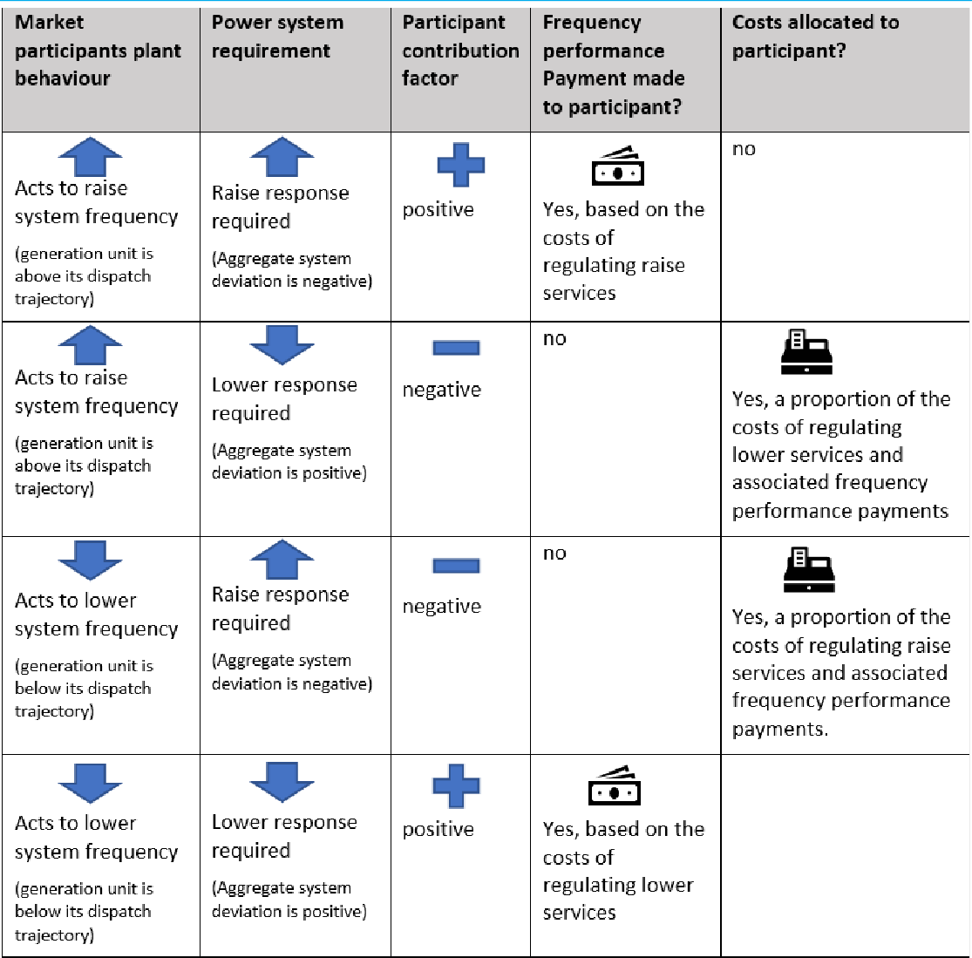

Source: AEMC

***The method for the valuation of positive contribution factors***

The draft rule would introduce a framework for market participants to be paid through ‘frequency performance payments’ based on positive contribution factors.

The NER does not currently set out a framework for the valuation of positive contribution factors, nor for any related payments. However, the ‘causer pays’ process does include an implicit value for positive contribution factors through the portfolio-based netting of positive and negative contribution factors. The existing causer pays procedure measures individual plant performance and determines plant contribution factors which may be positive or negative. The plant contribution factors are then netted out across a market participant’s

portfolio of generation and load facilities and any net positive contribution factor is zeroed out. The draft rule would remove this step where net positive contribution factors are zeroed out, thereby providing a means to determine the value of positive contributions as a basis for making payments to market participants.

Consistent with AEMO’s advice, the size of the frequency performance payments would be based on the costs of the relevant regulation service, scaled by the aggregate positive contributions relative to the aggregate negative contribution, and then scaled by the requirement for the regulation service during the trading interval as a proportion of the amount of the service enabled at the start of the trading interval.

The scaling of frequency performance payments by the aggregate negative contribution factors has the effect of applying an equal financial value to a positive contribution factor, as is implied through the allocation of regulation costs to negative contribution factors. For example, if the aggregate positive contribution factors are 10% of the size of the aggregate negative contribution factors, then the total value of frequency performance payments would be 10% of the value of costs allocated to negative contribution factors. In the absence of any further scaling, this would lead to a short term uplift on total costs for frequency regulation of 10%.

Under the draft rule, the value of frequency performance payments would also be scaled by the relative regulation requirement. This approach recognises that the quantity for each of the regulation services, and therefore the price and costs of each service set through dispatch at the start of the interval, may differ from what the system needs during the dispatch interval. Where the regulation requirement is less than the enablement amount, this has the effect of moderating the short term cost increases due to frequency performance payments.

For example, if AEMO enables 200MW of the regulating raise service at the start of the trading interval, and sends signals to enabled participants for 100MW of regulating raise service to be delivered during the trading interval, then the proportional requirement for the regulating raise service is 50%. In this instance, the size of the aggregate frequency performance payments would be scaled down by 50%. If the regulation requirement for the same period was 300MW, then the aggregate frequency performance payments would be scaled up by 150%.

Further detail and worked examples of the proposed approach for the valuation of positive contribution factors is included in appendix C.

***The allocation of costs for performance payments***

The draft rule would allocate the costs associated with frequency performance payments to market participants with negative contribution factors. This aligns with the current ‘Causer pays’ approach to the allocation of regulation service costs and provides an incentive for market participants to improve their plant performance with respect to the requirement for regulation services. All else being equal, it is expected that payments to market participants with positive plant performance will reduce the need for regulation FCAS over time, which should drive down costs to consumers.

***Scaling of performance-based regulation FCAS cost allocation based on service usage***

As noted above, the Commission agrees with AEMO’s proposal that the valuation of frequency performance payments be scaled based on the requirement for the relevant regulation service as a proportion of the amount of the relevant service enabled at the start of the dispatch interval. This allows for the value of frequency performance payments to be scaled up where the requirement for the relevant regulation service exceeds the enabled amount, and scaled down where the requirement for the relevant regulation service is less than the enabled amount.

AEMO’s discussion paper noted a further potential improvement to the Causer pays process that would recognise that there is effectively no ‘Causer’ for a regulation requirement that is not required, or used, during the dispatch interval. This occurs where the regulation requirement is less than the enablement amount. AEMO’s proposal is that, where the regulation requirement is less than the enabled amount, the costs allocated through the frequency contribution factor procedure could be scaled down by the proportional requirement for regulation services relative to the enabled amount.115

The Commission agrees with AEMO’s proposal and recognises that the scaling of regulation costs recovered through the performance-based process better reflects the principle that the costs of regulation services be allocated to those market participants that have ‘caused’ the need for those services.

As there is no causer for regulation services that are not required, it is more appropriate that the costs of any regulation services that are enabled, but not used, be apportioned as broadly as possible, across all market participants in alignment with the market design principles in the NER.116

The Commission’s analysis of recent causer pays outcomes, included in Appendix C, shows that the scaling of regulation costs by usage would moderate the magnitude of frequency performance payments, where regulation usage is significantly less than the enablement amount. In this case there would also be an overall reduction in the amount of costs allocated to metered and non-metered market participants through the performance-based payment and cost allocation arrangements. The remaining costs for regulation services, not used, would be recovered separately from all market participants in proportion to the total energy sent out or consumed.

The draft rule would:

* recover the costs of regulation services, that are used by AEMO within the trading interval, from market participants with negative contribution factors.
* recover any remaining costs for enabled but not used regulation services from all market participants in proportion with the energy consumed or generated by that market participant within the trading interval.

1. AEMO, Primary Frequency Response Incentive arrangements - Discussion Paper(Draft), July 2021, p.40. 116 NER Cl 3.1.4(a)(8)

This change would more closely delivers on the principle of allocating costs of ancillary services to Market participants that have caused the need for the service, this incentivises behaviour that helps to reduce the need for regulation services. At the same time costs for services that are not required would be recovered across the broadest possible set of Market participants in proportion to total energy consumed and generated. This approach recognises that no individual participant causes the need for a regulating service that is not used, but rather that the costs should be borne by all market participants. Further reasoning for the changes set out in the draft rule is set out in section 3.4.2.

* + 1. **Shortening and alignment of sample and application periods**

Currently, the causer pays process allocates the costs of regulation services in one period (the application period) based on measured plant performance in a historical period (the sample period).117 The draft rule would make changes to the NER to allow for participant contribution factors to be determined and applied over the same, 5-minute, trading interval. This would be achieved through the removal of the requirement for AEMO to publish contribution factors ten days prior to their application and revised guidance that contribution factors should be determined by AEMO every trading interval, unless it is impractical to do so.

This change would align economic incentives to the real time need for regulation services in the power system and the associated costs which vary based on market outcomes each trading interval.

#### Current arrangements

Under the current causer pays process, there is a contribution factor determined for each trading interval. The contribution factor is based on historical plant performance over a period of time which is different from the period that the contribution factors apply. This process is appropriate at providing a smooth incentive for generators to generally avoid contributing to the need for regulation services. However, it does not reflect the real time need for frequency control in the power system and the associated costs which vary based on market outcomes each dispatch interval.

Under the current NER, AEMO may determine the period of time over which the contribution factors are determined and is required to provide market participants with at least 10 days notice of the participant contribution factors, prior to the application of those factors.118AEMO has chosen to measure participant plant performance over a 28-day period to determine an average participant contribution factor for the allocation of regulation costs to each trading interval within the following 28-day period.119 Under the current process, the sample and application periods are each 28 days long, but the sample period commences around seven weeks earlier than the application period.120

117 AEMO has chosen to measure participant plant performance over a 28-day sample period to determine an average participant contribution factor for the allocation of regulation costs to each trading interval within the following 28-day application period.

118 NER Cl. 3.15.6A(k)(4), (na)

1. AEMO, Regulation FCAS contribution factor procedure – Determination of contribution factors for regulation FCAS cost recovery, 9 November 2018
2. The current time frames under the ‘ Causer pays’ process include a four week sample period plus one week calculation and a two-week notice period.

The result of the 28-day averaging and misalignment of sample and application periods is that the volatility of regulation FCAS cost allocations is reduced. However, this also means that the price signal for market participants to help to control frequency in any single dispatch interval is muted.

#### AEMO’s view

AEMO supports the alignment of the sample and application period to the trading interval. AEMO’s view on the timing of the sample and application periods for the causer pays process is expressed in its discussion paper, *PFR incentive arrangements*, as:121

Real timing the calculation to five minutes sharpens the incentive;

#### Stakeholders’ views

The proposal to align the sample and application periods was considered through the 2018 *Frequency control frameworks review* and then discussed again in the *Directions paper* for the frequency control rule changes, including the PFR Incentive arrangements rule change. The majority of stakeholders supported the AEMC’s intention to align and shorten the period over which performance is measured.122It was noted that this would ensure those causing the need for frequency responsive services face the cost of their actions which promotes more efficient and fairer outcomes.123

ERM Power noted that there is a need to balance a desire for more granular price signals with the potential for a generator to trigger the need for regulation services in one period and then avoid paying for the remediation of its impact by improving its performance in subsequent periods.124 AEC also requested greater clarity on the potential unintended incentives from broadly recognising how well generators perform on average over time rather than directly reflecting behaviour at each point in time.125

#### Commission’s analysis and draft conclusion

The Commission considers an efficient framework is one in which there is an alignment of participants’ impacts on system frequency and the costs they incur. As such, the draft rule would support the alignment of the sample and application periods under the revised performance pricing arrangements based on the reform of the current ‘causer pays’ process. The period over which plant performance is measured to determine a contribution factor should ideally be the same period as the trading interval over which the costs of regulation services are incurred. Following the commencement of the 5-minute settlement rule on 1 October 2021, trading intervals will be 5 minutes.

1. AEMO, *Primary Frequency Response Incentive arrangements - Discussion Paper*, August 2021, p.25.
2. See for example submissions to the December 2020 Directions Paper from AEC (p.9), AGL (p.12), IES (p.1), UNSW (p.28) and Delta Energy (p.19)
3. See for example submissions to the December 2020 Directions Paper from Alinta (p.8), Infigen (p.13), ERM Power (p.8), Energy Australia (p.9), and Delta Energy (p.16).
4. ERM Power, submission to the December 2020 Directions Paper, p.9.
5. AEC, submission to the December 2020 Directions Paper, p10.

***Consideration of market and system impacts***

The Commission notes a concern, raised through the Frequency control technical working group meetings, that the increased volatility of costs associated with the alignment and shortening of the sample and application periods, may lead to be behaviour from some market participants which is unexpected or contrary to the interests of good frequency performance. For example, there may be situations in which participants, who expect to receive negative contribution factors, face an incentive to reduce their capacity to limit their exposure to causer pays costs during periods of high regulation FCAS prices.

The Commission recognises that there may be some unintended consequences of amending incentives arrangements. However, the Commission considers that the proposed reforms are more likely to improve incentives for participants to match their dispatch targets and avoid acting in unexpected ways. The proposed alignment of periods is likely to encourage participants to match their dispatch trajectory more closely, for example through improved self-forecasting of plant capacity, in order to reduce the size of their negative contribution factors. Furthermore, participants may employ strategies to mitigate the associated financial risks, such as implementing operational changes to improve their contribution factors. This may include the voluntary maintenance of stored energy to provide headroom and deliver improved frequency response, which would be expected to deliver a reduced allocation of regulation costs or even increase the potential for payments based on any positive contribution factors.

* + 1. **Improved transparency**

The draft rule includes new provisions that would improve the transparency of the Causer pays process, such that market participants would have a better understanding of the requirement for regulation services in real time and the economic impacts associated with the operational performance of their plant with respect to the need for regulation services. This will assist participants (both existing and new entrants) make efficient decisions to improve their investment and operation to assist delivery of primary frequency response over time.

The key elements of the draft rule that provide improved transparency are:

* + - * Additional requirements related to the process for determining participant performance with respect to the frequency contribution factors procedure, including:
        + that AEMO must define in the frequency contribution factor procedure a formula that it will use in each trading interval to describe the objective for controlling power system frequency. This formula must be defined in sufficient detail to enable a market participant to use the formula to estimate the need for regulation services in that trading interval. The data calculated by AEMO using the formula must be published by AEMO as soon as practicable following the trading interval to which it applies. AEMO must publish any parameters related to the frequency performance formula at least five business days prior to AEMO applying those factors.
        + that AEMO set out in the frequency contribution factor procedure, the method for determining the reference trajectory for each item of plant that has appropriate metering to allow its individual impact on power system frequency to be assessed.
      * Additional requirements for AEMO to publish historical data used to determine the contribution factors.

#### Current arrangements

The current causer pays arrangements allocate the costs of regulation FCAS to each participant in proportion to the extent to which its deviations from its dispatch trajectory contribute to the need for regulation services. AEMO’s causer pays procedure outlines the approach used to calculate contribution factors and to allocate costs. However, a common complaint of the procedure has been that it does not provide sufficient details for participants to calculate their own contribution factors. This lack of transparency may give rise to inefficient and potentially unintended consequences, as participants may misinterpret the likely costs associated with their actions.

#### Stakeholders’ views

Stakeholders supported greater transparency and clarity in the causer pays arrangements with some noting that generators should be able to understand how they can change their behaviour to avoid charges and/or receive rewards.126 SACOME also noted the need to help large users better understand and budget for the costs of these services to address the pressure they currently feel from the cost of unexpected AEMO interventions.127 EnergyAustralia noted that greater transparency will improve the economic incentives to provide capacity for PFR response and promote a more efficient outcome, particularly if supported by the publication of more accurate and timely information.128

A few stakeholders explicitly addressed the question of whether system frequency or the frequency indicator (FI) should be used. A number of participants supported the use of system frequency instead of FI noting this is what generators respond to.129 Stakeholders also noted that FI is the sum of filtered signals (integral) so may not reflect the harm or assistance (proportionate response) provided by generators at each point in time.130

#### Commission’s analysis and draft conclusion

***The objective for controlling frequency***

Under the current procedure, the performance of market participants is measure against frequency indicator (FI). In its procedure, AEMO provides the following description of Frequency indicator:131

Frequency Indicator (FI)

1. See for example submissions to the December 2020 Directions Paper from EnergyAustralia (p8), Origin (p7), Tesla (p7), ERM Power (p8), Infigen (p12-13), and ACCIONA (p3).
2. SACOME, submission to the December 2020 Directions Paper, p2
3. EnergyAustralia, submission to the December 2020 Directions Paper, p2 and p9
4. See for example submissions to the December 2020 Directions Paper from UNSW (p.28), CS Energy (p24), Infigen (p19), and AGL (p12).
5. See for example submissions to the December 2020 Directions Paper from UNSW (p.28) and CS Energy (p24)
6. AEMO, Regulation FCAS contribution factor procedure – Determination of contribution factors for regulation FCAS cost recovery, 9 November 2018, p.5.

The parameter from AEMO’s AGC indicating the extent to which more or less generation is required to adjust the frequency towards 50 Hz. The sign of FI indicates the direction of regulating capability required at a given time (positive for a regulating raise service, negative for a regulating lower service).

This value is capped and has positive and negative limits of +/- 1560.

It can be calculated by summing the published GenRegComp_MW values in the area.

Currently, AEMO make the FI values available to market participants at a slight delay from real time as part of AEMO’s data subscription service. The Commission understands that this value is published through the Market management system data subscription service with a delay of 15-30 minutes.132 This helps market participants to have visibility of the performance metric against which their plant performance is measured. However, it would be preferable for the frequency control objective to be made available to market participants in real time.

One potential simplification that has previously been proposed is for plant performance to be measured against system frequency rather than frequency indicator. However, measurement against raw frequency error, as proposed in the basic form of frequency deviation pricing, does not fully reflect the control objective for frequency in the power system. For example, AEMO’s automatic generation control system currently uses two main elements to determine the need for active power correction to restore system frequency to 50 Hz. These two elements are area control error (ACE) and the time integral of area control error (ACEI).

Therefore, it is likely to be more appropriate that AEMO determines the specific frequency control objective, and that it is described in the frequency contribution factor procedure. This approach will allow market participants to estimate the need for regulation services in real time, while also maintaining the central administration of the performance objective for frequency control within AEMO’s systems.

Under the draft rule, AEMO’s frequency contribution factor procedure must define a formula used to describe the objective for controlling power system frequency. The formula would need to be described in sufficient detail to enable a market participant to estimate the need for regulation services in each trading interval.

***The method for determining a frequency reference trajectory***

Measurement of plant performance with respect to frequency requires an active power reference trajectory against which actual plant behaviour can be compared to determine deviations from expected active power generation or consumption. To provide transparency as to how plant performance is measured, the reference trajectory must be clearly defined and understood by market participants.

The ‘reference trajectory’ describes the expected performance for the relevant plant over the dispatch interval. AEMO currently determines and describes the reference trajectory for different categories of registered plant in the Causer pays procedure.

1. Further information on AEMO’s Market Management system data subscription is available at: [https://www.aemo.com.au/energy-](https://www.aemo.com.au/energy-systems/electricity/national-electricity-market-nem/data-nem/market-management-system-mms-data) [systems/electricity/national-electricity-market-nem/data-nem/market-management-system-mms-data](https://www.aemo.com.au/energy-systems/electricity/national-electricity-market-nem/data-nem/market-management-system-mms-data)

The current method for determination of the plant reference trajectory for scheduled and semi-scheduled plant is based on the dispatch trajectory created through the application of a linear ramp between the dispatch target at the end of the previous dispatch interval and the dispatch target at the end of the dispatch interval. The reference trajectory for scheduled and semi-scheduled plant used under the current revision of the Causer pays procedure is shown below in Figure 4.3, represented in the figure by the dispatch target trajectory.

#### Figure 4.3: Reference trajectory for scheduled and semi-scheduled plant

0

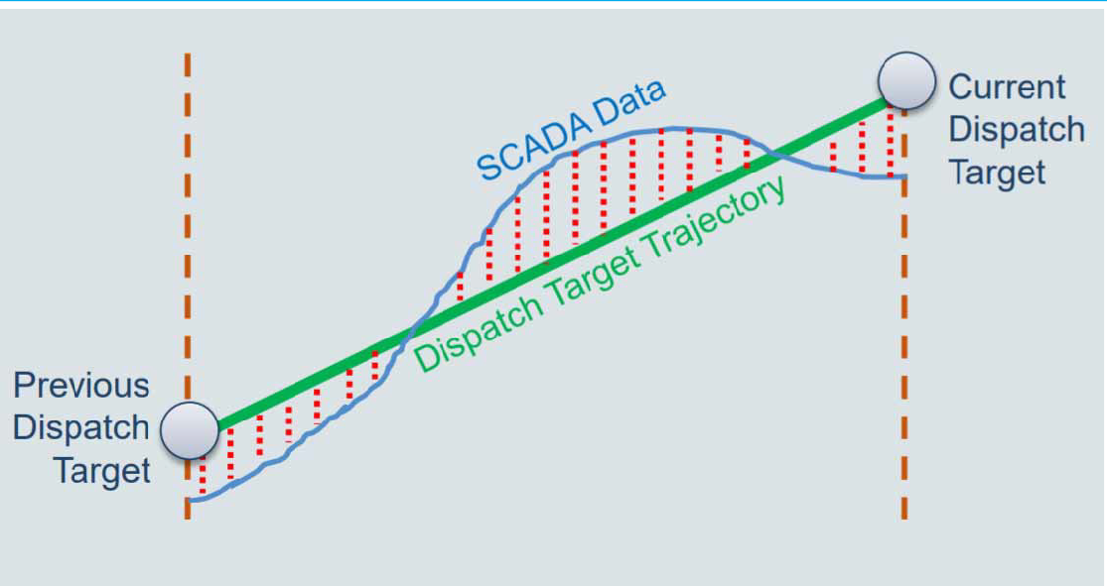

Source: AEMO, Regulation FCAS contribution factor procedure – Determination of contribution factors for regulation FCAS cost recovery, 9 November 2018, p.12.

The current method for the determination of the plant reference trajectory for non-scheduled plant, with appropriate metering, is based on the continuation of the initial metered MW level at the start of the dispatch interval. The reference trajectory for non-scheduled plant, with appropriate metering, used under the current revision of the Causer pays procedure is shown below in Figure 4.4, represented in the figure by the initial value trajectory.

#### Figure 4.4: Reference trajectory for non-scheduled plant (with appropriate metering)

0

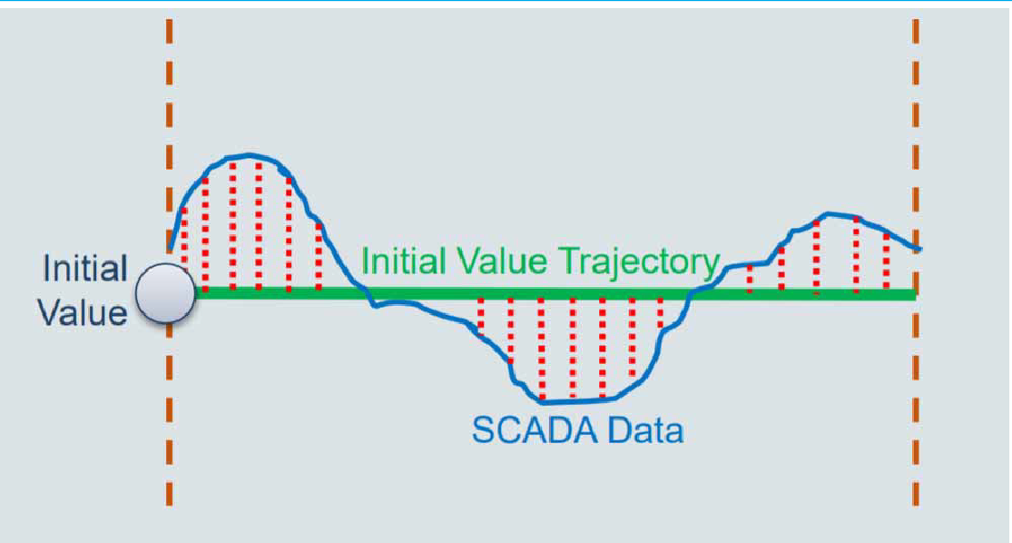

Source: AEMO, Regulation FCAS contribution factor procedure – Determination of contribution factors for regulation FCAS cost recovery, 9 November 2018, p.13.

The Commission is aware that other factors, in addition to a participant’s dispatch target, may be relevant to the determination of a plant reference trajectory. One such additional factor is the regulation FCAS requirement allocated to individual plant through electronic signals via AEMO’s AGC system. The individual plant regulation requirement is referred to as the regulation component. The regulation component is added to the linear dispatch trajectory for a unit enabled to provide a regulating raise service or a regulating lower service. An example of this is shown in Figure 4.5 for Vales Point Unit 6, based on AEMO’s publicly available ‘Causer pays’ data.

#### Figure 4.5: Dispatch target plus regulation component — Vales Point Unit 6

0

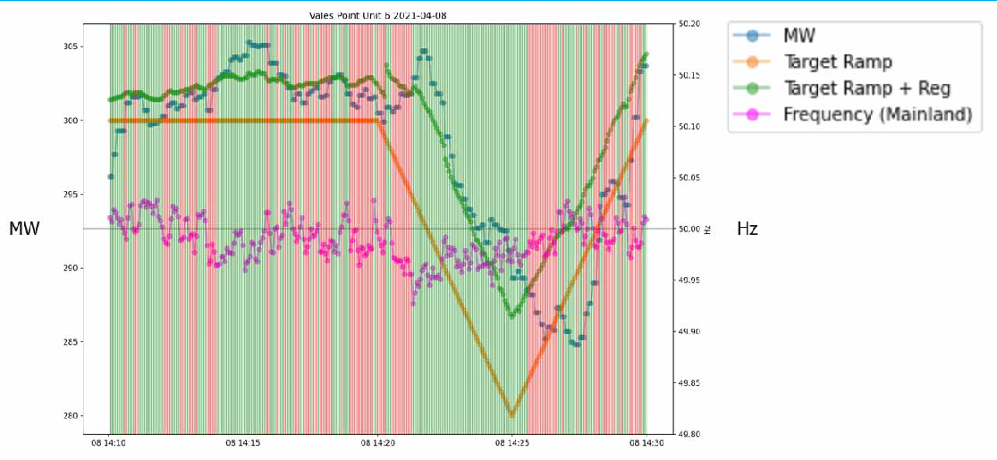

Source: AEMC analysis of AEMO causer pays data available at: [https://aemo.com.au/en/energy-systems/electricity/national-electricity-](https://aemo.com.au/en/energy-systems/electricity/national-electricity-market-nem/data-nem/ancillary-services-data/ancillary-services-market-causer-pays-data) [market-nem/data-nem/ancillary-services-data/ancillary-services-market-causer-pays-data](https://aemo.com.au/en/energy-systems/electricity/national-electricity-market-nem/data-nem/ancillary-services-data/ancillary-services-market-causer-pays-data)

Note: Target Ramp is based on the unit dispatch targets for each dispatch interval. Note: Target Ramp + Reg. includes the unit regulation component.

The Vales Point example shows the impact of the regulation component in guiding the active power output of power system plant that is enabled to provide a regulation service.

The Commission considers that it may be appropriate for the plant reference trajectory to include the regulation component, in addition to the dispatch trajectory. However, the Commission is aware that there are practical considerations and limitations in relation to the application of this in the causer pays process. These practical considerations include delays within the AGC and associated communication systems that can result in a unit receiving its regulation component up to 30 seconds after it is sent from AEMO.

Whether or not a plant reference trajectory includes the regulation component, the Commission considers that the economic incentives are likely to balance out either way. If the regulation component were not included in the reference trajectory, then it would be expected that plant enabled to provide regulation services would often be seen to respond more positively with respect to its reference trajectory and therefore be paid more frequency performance payments. The provision of these payments would then be expected to reduce the marginal cost of providing regulation services and put downward pressure on the market prices for regulation FCAS. In comparison, if the regulation component were included in the reference trajectory, then plant enabled to provide regulation FCAS would be no more likely to receive a positive contribution factor than any other responsive market participant. As such, they would be no more likely to receive positive performance payments and the regulation costs may be expected to be higher than if the regulation component were not included in the reference trajectory. In either case, the combined costs for regulation enablement and frequency performance payments would be expected to be relatively similar, as the fundamental costs for provision of the service are unchanged.

In light of these potential practical challenges, and noting that the economic impact is expected to be similar either way, the Commission considers that it is appropriate for AEMO to determine how best to include the regulation component in the determination of a participant reference trajectory for frequency performance measurement.

The Commission also notes that there may be situations where non-scheduled market participants, with appropriate metering, are able to provide information to AEMO that gives a more accurate prediction of their generation or consumption behaviour over the upcoming trading interval, as compared to the current practice. As shown in Figure 4.4, the current practice for determining participant contribution factors assumes that consumption or generation from a non-scheduled plant will not change over a trading interval. The Commission considers that, where a non-scheduled market participant opts to provide a self- forecast of its expected generation or consumption over the upcoming trading interval, this information should be used by AEMO to inform the reference trajectory for that non- scheduled plant for the purpose of determining an individual participant contribution factor.

The draft rule requires AEMO to describe in the frequency contribution factors procedure the method AEMO will use to determine a reference trajectory performance for plant with appropriate metering to assess its individual impact on the deviation of power system frequency. AEMO’s determination of the plant reference trajectory must be informed by:

* + - * the dispatch target for scheduled generation
      * the dispatch level for semi-scheduled generation
      * information provided by a non-scheduled market participant, that relates to its expected trajectory over the trading interval.

The reference trajectory may also be informed by other relevant information including the unit regulation component determined by AEMO and sent electronically via AEMO’s AGC system. The draft rule provides AEMO with discretion as to how such information, where relevant, would inform the reference trajectory against which plant performance is measured to inform the determination of participant contribution factors.

***The publication of information related to participant frequency performance***

The publication of information used by AEMO for the determination of participant contribution factors is an important element of the arrangements to provide increased transparency to the causer pays process.

Under the existing arrangements, AEMO must publish historical data used to determine the participant contribution factors.133 AEMO must also publish the contribution factors used for the allocation of regulation costs.134

Further to the existing requirement for AEMO to publish historical data used to determine the contribution factors, the draft rule builds on these existing arrangements and require AEMO to publish:

133 NER Cl. 3.15.6A(n)

134 NER Cl. 3.15.6A(na)

* + - * any parameters relating to the formula for describing the need for regulation services, at least five business days before the parameters are applied by AEMO
      * the measured data for plant with appropriate metering that is used to determine the participant contribution factors
      * data calculated by AEMO that expresses the need for regulation services, by AEMO in accordance with the frequency contribution factors procedure, as soon as practicable after the end of the relevant trading interval.
      * the contribution factors, as determined by AEMO in accordance with the frequency contribution factors procedure, as soon as is practicable after the relevant trading interval.

The publication of this information is intended to provide improved transparency in relation to the frequency contribution factors procedure where it is practical to do so. This will assist participants (both existing and new entrants) make efficient decisions to improve their investment and operation to assist delivery of primary frequency response over time.

* + 1. **Other reforms to improve the causer pays process**

The draft rule includes a number of other changes to the causer pays process that do not directly relate to the valuation of positive performance, alignment of sample and application periods, or improved transparency. These other changes are:

* + - * Separate treatment of asynchronously operated regions - The NER currently requires AEMO to publish estimated contribution factors for application to islanded NEM regions as a result of network separation.135 The draft rule would remove the requirement for AEMO to publish estimated contribution factors to apply for operation of asynchronous regions. This is replaced with new provisions such that where a region of the power system is operated asynchronously, AEMO must determine contribution factors to apply for those regions during the period of asynchronous operation which reflect the effect of the separation on the control of power system frequency and the need for regulation services in that region. These separate contribution factors will then be used by AEMO when calculating the transactions for allocation of regulations costs and frequency performance payments in that region during the period of asynchronous operation.
      * The draft rule also allows for any Market Participant, including an MNSP, to be included in the process for the frequency performance payments and cost allocations.
      * Calculation of local contribution factors for local FCAS requirements - The NER currently inhibits AEMO’s ability to determine contribution factors separately for each NEM region

136. The draft rule includes revised drafting to remove any limitation on the determination of separate contribution factors for each NEM region.

* + - * Inclusion of non-metered generation in the residual component - The NER currently excludes non-metered generation from the allocation of the residual share of regulation FCAS costs, effectively excluding this class of participant from any regulation cost liability.

Under the draft rule, non-metered generation would be treated the same as non-metered loads for the purposes of allocation of regulation costs and costs for frequency performance payments.

#### AEMO’s view

AEMO has expressed support for a number of these additional changes to the Causer pays arrangements.

In its discussion paper on PFR incentive arrangements, AEMO expressed support for the scaling of regulation FCAS costs allocation.137

In its 2018 consultation of the causer pays procedure, AEMO proposed the calculation of local contribution factors for local requirements and the inclusion of non-metered generation in the residual component.138

#### Stakeholders’ views

Most stakeholder responses expressed support for changes to the NER for AEMO’s ‘causer pays’ procedure to be revised to allow for non-metered generation to be included in the residual component for causer pays purposes and for AEMO to be able to determine local contribution factors to apply for the recovery of local regulation requirements.139

The Commission is interested in stakeholders’ views in response to the additional changes included in the draft rule, in relation to the scaling of the costs of regulation services allocated through the performance-based process and the separate treatment of asynchronous regions for performance-based cost allocations and payments.

#### Commission’s analysis and draft conclusion

The following outlines the Commission’s considerations in relation to the additional changes to improve the Causer pays framework.

***Treatment of islanded (asynchronous) regions***

The NER currently requires AEMO to publish estimated contribution factors for application to islanded NEM regions as a result of network separation.140

There are similar considerations that relate to the treatment of the Tasmanian region, which is effectively an asynchronous island that operates separately from a frequency control and regulation perspective.

Through discussions with stakeholders, it has been proposed that separate contribution factors be calculated for any asynchronous island that forms and for the recovery of costs for local regulation FCAS to be based on the new factors related to the islanded region. This would mean that the contribution factors would be determined separately for Market participants in any region that is operated asynchronously from the rest of the NEM. This

1. AEMO, *Primary Frequency Response Incentive arrangements - Discussion Paper*, August 2021, p.24.
2. AEMO, *Regulation FCAS contribution factor (Causer Pays) procedure consultation*, November 2018, p.12.
3. Stakeholder submissions to the Directions paper: AGL, p.12.; CS Energy, p.24.; Origin, p.7.

140 NER Cl. 3.15.6A(nb)

includes the operation of Tasmania, under the current operating arrangements. Tasmania is a separate AGC system, with Basslink transferring frequency between systems. Currently, Tasmanian factors are combined with mainland factors, weighted by the total energy of each over the sample period, to derive a set of global factors.

The separation of the Tasmanian region for the purposes of the Causer pays process, would allow for the performance of Basslink to be measured in both Tasmania and the Mainland and for it to be included in the performance-based payment and cost allocation process. This would support the valuation of the Basslink frequency controller function, which uses inverters at either end of the DC inter-connector to adjust power delivered or consumed to help control power system frequency in both regions. Due to the ability for the Basslink frequency controller to deliver highly precise and powerful active power control, it is expected that Basslink will tend to receive a net positive financial impact through being included in the causer pays process. More generally this change to the Causer pays framework will allow for any future Market network service provider (MNSP) that connects two asynchronous regions of the NEM to be included in the performance-based payment and cost allocation arrangements.

The Commission considers it to be appropriate that the revised performance incentive and cost allocation framework would need to recognise the special operating conditions that relate to the operation of islanded regions. Therefore, the draft rule removes the requirement for AEMO to publish estimated contribution factors to apply for the operation of asynchronous regions. This is replaced with new provisions such that where a region of the power system is operated asynchronously, AEMO must determine contribution factors to apply for those regions during the period of asynchronous operation which reflect the effect of the separation on the control of power system frequency and the need for regulation services in that region. These separate contribution factors will then be used by AEMO when calculating the transactions for allocation of regulations costs and frequency performance payments in that region during the period of asynchronous operation.

The draft rule would also allow for any Market Participant, including an MNSP that facilitates the connection of two asynchronous regions (e.g. Basslink), to be included in the process for the frequency performance payments and cost allocations.

***Calculation of local contribution factors for local FCAS requirements***

Through its 2018 consultation on the causer pays procedure, AEMO identified that the approach to allocation of regulation costs associated with local requirements could be improved to reflect a participant’s share of regional FCAS costs more accurately.141 AEMO noted that the existing drafting of NER Cl. 3.15.6A (i-k) inhibits its ability to determine contribution factors separately for each NEM region.

This issue is described further in section 5.9.4 of the AEMC’s directions paper.

The draft rule removes any limitation on the determination of separate contribution factors for each NEM region. This approach is an extension of the principles that underpin the causer

1. AEMO, Regulation FCAS Contribution Factor Procedure: Final Report and Determination, 9 November 2018, p.14.

pays process for the allocation of regulation costs. The Commission considers that it is not appropriate for a market participant’s plant in one NEM region to be allocated costs for a local requirement for regulation services in another region. Therefore, it is appropriate that the NER be revised to support AEMO’s proposed change.

##### Inclusion of non-metered generation in the residual component

Through its 2018 consultation on the causer pays procedure, AEMO identified a potential improvement to the Causer pays process that would address what AEMO perceived to be an inconsistency in the cost allocation process. The change relates to the inclusion of non- metered market generation within the allocation of costs through the residual component of the causer pays process.142

The Commission agrees with AEMO that it is not appropriate for non-metered market generation to be excluded from the allocation of the residual share of regulation FCAS costs, effectively excluding this class of market participant from any regulation cost liability.

This issue is described further in section 5.9.5 of the AEMC’s directions paper.

Under the draft rule, non-metered market generation would be treated the same as non- metered market loads for the purposes of the allocation of regulation costs and costs for frequency performance payments.143

### Additional reporting obligations for AEMO and the AER

To support the efficient and effective operation of these reforms, the Commission considers that amendments to the NER are required in relation to AEMO’s reporting obligations, as well as the AER’s reporting on ancillary services markets. As discussed above, it is important that market participants have sufficient data and information to understand and estimate the incentives and costs associated with their behaviour. It is also important for investors to have clear signals on how these arrangements are evolving and for consumers to understand the potential costs they will face. Furthermore, it is important to have clear, consistent information on the efficacy of these arrangements in delivering stable system frequency. This includes whether additional mechanisms, such as market arrangements, might be required to deliver the outcome necessary to ensure safe operation of the power system, including the nature of the requires services.

* + 1. **AEMO’s view**

In its expert technical advice, AEMO notes that it will be increasingly important to track frequency performance under normal operating conditions.144

1. AEMO, *Causer pays procedure consultation – Issues paper*, pp.14-15. December 2016.
2. In this context the term “non-metered” refers to a plant that does not support 4-second SCADA metering. SCADA or Supervisory Control and Data Acquisition, is a control system architecture that includes measurement, computing, communications and control functionality. Market participants who establish a SCADA link with AEMO receive information including dispatch information and send plant operating information, including generation output or energy consumption. AEMO uses the 4-second SCADA data to calculate participant contribution factors under the causer pays procedure, thus any generation or load without a SCADA connection to AEMO is referred to here as “non-metered”.
3. AEMO, *Enduring primary frequency response requirements for the NEM*, August 2021, p.5.

AEMO recommends that monitoring system frequency performance during normal operating conditions will be important to understand how the changes in power system equipment over time are impacting on power system operations. AEMO has proposed that the frequency operating standard (FOS) be reviewed and revised to clarify that frequency should be held more closely to 50 Hz during normal operation than is permitted under the existing FOS. Introducing this objective will empower AEMO to monitor performance against this requirement and report on whether mandatory narrow-band PFR continues to effectively support secure and resilient operation of the power system.

* + 1. **GHD’s advice**

While GHD did not explicitly address additional reporting obligations for AEMO and the AER, it did identify a potential future risk that there could be a need to procure or schedule the necessary responsive plant and reserves to ensure sufficient PFR.145 This risk is associated with the exit of synchronous generation and increasing penetration of VRE which is unlikely to reserve capacity to provide frequency support services without stronger incentives (and may be limited by PPAs focused on supplying the energy market). This would be dependent on a number of factors, including how strongly market participants respond to the proposed changes to the causer pays arrangements under the draft rule and how the capabilities of technologies in the system evolve. Monitoring the responsiveness of market participants over time, along with the performance of system frequency, will be important to inform future potential reforms to the frequency control regulatory framework. The potential need for these future reforms is discussed further in chapter 5.

* + 1. **Stakeholders’ views**

Most stakeholders generally did not discuss reporting, although as mentioned above there was clear support for increased transparency in their submissions to the Directions paper.146 A range of stakeholders referenced guidance from existing AEMO reports when explaining their positions, suggesting that they consider this reporting to be valuable.147 Delta Electricity did suggest that adequate reporting by AEMO was required to provide transparent feedback on the performance of services and overall performance of frequency control to encourage innovation, new entrants and investors.148 EnergyAustralia also argued for adequate reporting, auditing and governance frameworks for AEMO, including an oversight role for the AER.149

1. GHD’s advice does outline the current technology capabilities, changes in the market such as exit of synchronous generators, and other factors that contribute to the risk of future sufficiency of PFR capability.
2. The submissions are available on the project webpage: [https://www.aemc.gov.au/rule-changes/primary-frequency-response-](https://www.aemc.gov.au/rule-changes/primary-frequency-response-incentive-arrangements) [incentive-arrangements](https://www.aemc.gov.au/rule-changes/primary-frequency-response-incentive-arrangements)
3. See for example submissions from CS Energy, SA Department for Energy and Mining, SACOME, UNSW Collaboration on Energy and Environmental Markets, Powershop and Meridian Energy Australia, Snowy Hydro, and Tesla.
4. Although this was mainly in the context of contingency services, but was also raised in relation to mandatory PFR see page 1 and page 16 of its submission to the Discussion Paper on Frequency control rule changes
5. This was also mainly in the context of FCAS services but was a repeated theme throughout their submission.
   * 1. **Commission’s analysis and draft conclusion**

The Commission considers that there is a need for greater transparency around what the PFR arrangements are intended to achieve and how success can be identified.

The Commission proposes to make the following amendments to reporting obligations on AEMO and the AER:

* + - * AEMO must report on its assessment of aggregate frequency responsiveness in the power system provided by frequency responsive plant
      * the AER must report on the total costs of frequency performance payments for each region.

#### AEMO reporting

The draft rule would require AEMO to report on the level of aggregate frequency responsiveness on a quarterly basis as part of its existing obligation to report on quarterly frequency performance.150It is important to be clear that the aggregate frequency responsiveness requirement for PFR is not the MW capacity reserves procured for other FCAS services but rather a system-wide MW/Hz response. Alongside this, there is a need for transparency on how these arrangements are performing, including the impact of aggregate frequency responsiveness on system frequency.

Greater clarity will help those developing new generation projects to form clearer expectations of system requirements, as well as help to identify potential shortages in headroom/footroom which may limit aggregate system responsiveness. Consumers will have better information on the effectiveness of these services which they will ultimately pay for.

This should be accompanied by simple, transparent reporting on the costs of providing the frequency performance payments to deliver these outcomes, akin to reporting on market ancillary services.

Reporting on the performance of system frequency, as well as the aggregate frequency responsiveness and provision of PFR underpinning this performance will also help manage the potential risk of future shortfalls. The Commission acknowledges GHD’s advice that incentive arrangements may be appropriate for the current system needs, but there may be a need to procure or schedule necessary responsive plant and reserves post 2030 to ensure sufficient PFR. AEMO’s expert technical advice also notes a perceived risk that insufficient PFR could be obtained during periods of little to no synchronous generation, with supply entirely provided by inverter based VRE, storage and DER.

Reporting on the levels of aggregate frequency responsiveness and the impact of PFR on system frequency over time will provide a forewarning that additional action may be required.

#### AER reporting

The draft rule would require the AER to report on the costs of frequency performance payments for each region as part of its existing obligation to report on costs of market

150 NER Cl 4.8.16(b)

ancillary services.151 This element of the draft rule recognises that reporting on the costs of frequency performance payments will be of equivalent importance to reporting on FCAS costs. This new reporting requirement will provide more complete information in relation to the costs associated with frequency control without significantly adding to the administrative burden for the AER.

### Implementation and transitional arrangements

The draft rule includes implementation and transitional arrangements that would require:

* that AEMO develop and publish the final *Primary frequency response requirements* (PFRR) as required by cl. 4.4.2A(a) of the NER by a date which is 6 months from the date that this rule is made. Until the PFRR is published under this rule, the *interim Primary Frequency Response Requirements* will continue to apply.
* that AEMO consult on and prepare the first *Frequency contribution factors procedure* by a date which is nine months from the date that the rule is made (and from this date the old Regulation FCAS contribution factor ‘Causer pays’ procedure will cease to apply).
* that the revised process for the allocation of regulation costs and frequency performance payments would commence on a date that is two years and three months from the date that the rule is made.

The rationale for these transitional arrangements is described in the following sections.

* + 1. **AEMO’s view**

#### Costs and timing for the implementation of the new frequency contribution factor process

AEMO’s incentive arrangements discussion paper includes advice on the process and time frames to implement the revised causer pays arrangements to encourage PFR provision. AEMO estimates that costs to replace the existing Regulation cost allocations system range from $3 million (low) to $5 million (mid), to $8 million (high).152 The final implementation cost would depend on the functional specification for the new system, which will be informed by the final rule and the final frequency contribution factor procedure.

AEMO’s advice is that it will take 9 months to consult on and publish the frequency contribution factors procedure and a further 18 months for software development relating to the new process. Based on this advice, the total time required to implement the new frequency performance payment and cost allocation processes would be two years and three months from the date the rule is made. Using these timings, if the final rule were made in December 2021, the revised process would commence in March 2024.

**The timing for the publication of the final *Primary frequency response requirements***

On 22 July 2021, the AEMC received a supplementary submission from AEMO that raised an issue with the timing for the preparation of the final *Primary frequency response*

151 NER Cl. 3.11.2A.

1. AEMO, Primary Frequency Response Incentive arrangements Discussion Paper - Investigation into the feasibility of incentivising primary frequency response, 31 August 2021, p.26.

*requirements (PFRR)* document in accordance with the Mandatory PFR rule. AEMO noted that the existing requirement is that it publish a final PFRR by 6 December 2021, and that it consult on the final PFRR in accordance with the rules consultation procedures.153

AEMO noted that the Commission in considering the enduring PFR arrangements through the *PFR Incentive arrangements* rule change and that a final determination is scheduled to be made in December 2021. Given the overlap between the contents of the final PFRR and the Commissions’ consideration of enduring PFR arrangements through the *PFR Incentive arrangements* rule change, AEMO considered that it would be prudent and appropriate to defer consultation on the final PFRR until the AEMC has made it final determination for the *PFR Incentive arrangements* rule change. In the context of a heavy consultation burden in the industry at this time, AEMO requested that the AEMC reconsider the timing for the publication of a final PFRR to either:154

* + extend the date in clause 11.122.2(d) to be approximately six months after the final [PFR] incentive [arrangements] rule; or
  + remove the clause if appropriate, depending on the framework created by the [PFR] incentive [arrangements] rule.
    1. **Stakeholders’ views**

Stakeholders did not address the implementation and transitional arrangements for the enduring PFR arrangements in submissions to the Directions Paper beyond commenting on the implementation of interim mandatory PFR provisions. Although some noted that they expected implementation to occur before the mandatory PFR provision sunset on 4 June 2023.155 The AEC proposed a pathway for enduring PFR arrangements that included a suggested timing for the implementation of alternative, market or incentive based, PFR arrangements to be in place before the sunset for the Mandatory PFR arrangement, such that the mandatory arrangements could be relaxed, following a proving period for the new alternative arrangements. 156

* + 1. **Commission’s analysis and draft conclusion**

**The timing for the publication of the final *Primary frequency response requirements***

The Commission notes AEMO’s concerns in relation to the timing of the publication of a final PFRR and the interaction of this requirement with the Commission’s determination of enduring PFR arrangements through the PFR Incentive arrangements rule change. The Commission agrees with AEMO’s suggestion that it would be preferable to delay the preparation of the final PFRR to better coincide with the implementation of this rule change. The Commission agrees that the value of consulting on the final PFRR prior to that time is

1. AEMO, Supplementary submission to the Directions paper, 22 July 2021, p.1.
2. AEMO, Supplementary submission to the Directions paper, 22 July 2021, p.2.
3. See for example page 2 of Acciona’s submission to the Directions Paper & AEC submission
4. AEC supplementary submission to second consultation paper, September 2020, pp.2-3.

limited, and is also mindful of the heavy consultation burden on the industry at present, particularly in relation to frequency control matters.

Under the draft rule, the existing Mandatory PFR arrangements would endure beyond the sunset date on 4 June 2023. Therefore, the PFRR will continue to be a relevant and integral part of the enduring PFR arrangements. In recognition of this, and AEMO’s concerns, the draft rule would change the date by which AEMO must consult on and prepare the PFRR under clause 4.4.2(a) of the NER from the current date of 6 December 2021 to a date which is six months from the date the final rule is made.

#### Transitional arrangements for the implementation of changes to Causer pays

The implementation time frame under the draft rule is consistent with AEMO’s advice that the revised causer pays arrangements commence two years and three months after the final rule is made. This timing is based on AEMO’s advice that:

* + - * the preparation of, and consultation on, a frequency contribution factors procedure can be completed within 9 months from the date that the rule is made. The frequency contribution factors procedure will replace the existing regulation FCAS contribution factors procedure from the commencement date.
      * a period of 18 months from the finalisation of the frequency contribution factors procedure is required to make the necessary changes to its internal processes and systems to support the new frequency performance payments process.

Under the draft rule the new arrangements for frequency performance payments and allocation of regulation costs would commence on a date that is two years and three months from the date that the rule is made (i.e. March 2024 assuming a final rule is made in December 2021). This will allow for AEMO to consult on and publish the frequency contribution factors procedure and make the necessary changes to its IT systems.

#### The timing for the commencement of the new reporting arrangements

Under the draft rule, the requirement for AEMO to report on the level of aggregate frequency responsiveness would commence from the date the rule is made. This recognises that aggregate frequency responsiveness is an important element of power system frequency control now and into the future.

The requirement for the AER to report on the costs of frequency performance payments would commence from a date that is two years and three months from the date the rule is made (i.e. March 2024 assuming a final rule is made in December 2021). This aligns with the timing for the commencement of the revised process for frequency performance payments and allocation of regulation costs.

# OTHER ISSUES THAT ARE NOT PART OF THE DRAFT RULE

This chapter provides an overview of the Commission’s consideration of issues raised in the rule change assessment process but that are not part of the draft rule.

### Future review of the Frequency operating standard

The development of new arrangements for the provision of PFR during normal operation is interdependent with the determination of the standard for system frequency performance during normal operation. The development of enduring PFR arrangements is likely to necessitate a future review of the Frequency Operating Standard (FOS) for normal operation. Under the NER, the required system frequency performance is specified in the FOS, which is a power system security standard that is determined or amended by the Reliability Panel on the advice of AEMO.157

AEMO is responsible for operating the power system in accordance with the FOS. The FOS specifies, with the appropriate detail, the expected frequency performance of the power system during normal operation and following contingency events. As the frequency control arrangements are revised to reflect the changing needs of the power system, the FOS may require updating to reflect the expectations for future power system frequency control.

AEMO considers that the FOS should be revised to clearly specify acceptable frequency performance during normal operating conditions. As it noted in its expert technical advice:158

There is an opportunity to amend the FOS to better specify frequency performance requirements under normal conditions. This will help the effectiveness of PFR frameworks over time to be understood and evaluated, benchmarked against actual frequency performance. This will be increasingly important as the power system transitions and new operational conditions emerge over time.

AEMO considered a number of options to improve the specification of acceptable frequency performance during normal operation. AEMO recommends that a new frequency performance band be included in the FOS. The new normal operating primary frequency band (NOPFB) would:

* + - sit within the existing normal operating frequency band (NOFB), which is 49.85 Hz –

50.15 Hz

* + - define a target band for system frequency performance during normal operation within the range of 49.95 Hz – 50.05 Hz.

157 NER Cl. 8.8.3(a)(1)

1. AEMO, *Enduring primary frequency response requirements for the NEM - Technical white paper*, August 2021, p.25.

AEMO proposes the system frequency should be maintained within the NOPFB for 10% of the time in the mainland NEM and 15% of the time in Tasmania. This new band would help define the target frequency performance during normal operation and clarify the operating requirement that system frequency should be held more closely to 50Hz than the current FOS requires.159

AEMO claims that its proposed change to the FOS would provide an improved benchmark against which system frequency performance can be effectively monitored and tracked. The tracking of system frequency performance during normal operation is expected to be an increasingly important process to help navigate the technological transition underway in the power system. It should also help identify whether additional actions are required to support system frequency performance as the need emerges, if these conditions are approached and/or breached.

The Commission will consider tasking the Reliability Panel with undertaking a review of the Frequency Operating Standard in 2022, which would be a holistic look at the frequency operating standard and the frequency framework.

### Potential for future procurement arrangements for narrow band PFR

The Commission considers that the draft rule will provide an effective and efficient means of meeting the power system needs for frequency control during normal operation. This position is supported by expert advice from GHD and AEMO. However, in its advice, GHD identifies a potential future need for stronger procurement arrangements to provide sufficient frequency responsive plant and reserves to ensure sufficient PFR. This future need is subject to uncertainties in relation to the timing for projected technological change in the power system and the effectiveness of the double-sided frequency performance payments at encouraging behavioural change from market participants that reduces the need for regulation services and delivers sufficient PFR to adequately control power system frequency. GHD’s view is set out below:160

Towards the end of this decade, or earlier if a step change in generation development is observed, i.e. retirement of thermal generation and uptake of renewable generation, MPFR and DSCP may have to be complemented through a PFR-FCAS style or other procurement arrangement to ensure that necessary volumes of PFR can be secured. If required, we consider that such a market arrangement with appropriate price signals and specified volumes could be effective to incentivise provision of PFR reserve from new technologies, battery storage and renewable generation.

1. Ibid. p.27.
2. GHD, *Enduring Primary Frequency Response - CT2 - Power system operation and strategic regulatory advice*, 16 September 2021, p.iii.

AEMO’s expert technical advice also identified potential future challenges related to availability of sufficient responsive plant and available headroom to deliver the required level of aggregate frequency responsiveness and effectively control power system frequency.

These emerging challenges are related to:161

* + - A reduction in synchronous generation as it is being displaced by inverter-based variable renewable generation
    - Very high levels of inverter-based variable renewable generation and distributed solar PV generation with very low levels of synchronous generation
    - Very high levels of behind-the-meter distributed solar PV generation with minimal PFR enabled generation online.

However, AEMO’s expert technical advice is that the mandatory PFR arrangement, combined with strengthened arrangements to incentivise plant behaviour that helps to control system frequency are sufficient to meet the foreseeable power system requirements for frequency control under normal operating conditions:162

Under foreseeable, normal conditions, AEMO would expect aggregate frequency responsiveness of the system to be sufficient under MPFR and subject to recommendations from the report on incentivisation options that accompanies this paper.

The draft rule would address the current and emerging needs of the power system through a combination of extending the mandatory PFR arrangement and the introduction of double- sided frequency payments and cost allocation arrangements, along with additional reporting obligations for AEMO and the AER in relation to power system frequency control and the related costs. Under the new reporting arrangements, AEMO will be required to report on the performance of system frequency, as well as the aggregate frequency responsiveness and provision of PFR underpinning this performance. This reporting should help identify any deterioration in frequency performance and indicate whether this deterioration is associated with any change in the provision of PFR or aggregate frequency responsiveness in the power system. As noted in its expert advice:163

AEMO is exploring possible metrics for tracking frequency responsiveness online, reporting on this in the frequency performance monitoring process, and identifying when additional actions may be necessary on a planning timeframe.

1. AEMO, Enduring primary frequency response requirements for the NEM - Technical white paper, 20 August 2021, pp.32-34.
2. Ibid. p.33.
3. Ibid. p.33.

The Commission notes the provision of sufficient PFR in the power system is further reinforced by AEMO’s ability to intervene in the market to maintain power system security. AEMO may intervene in the market and issue directions to market participants, where such directions are necessary to maintain or return the power system to a secure, satisfactory or reliable operating state.164Furthermore, the Commission is in the process of assessing two rule change requests that propose additional arrangements for the scheduling and procurement of essential system services for system security. These arrangements would explicitly put in place arrangements to value, procure and schedule essential system services that aren’t otherwise provided through spot markets, allowing these to be provided at lower cost to consumers and more transparently. These scheduling and procurement arrangements for system security are being considered through the following rule change requests:

* + - *Capacity commitment mechanism for system security and reliability services*, (ERC0306) rule change submitted by Delta Electricity
    - *Synchronous services markets*, (ERC0290) rule change submitted by Hydro Tasmania

On 9 September 2021, the AEMC published a directions paper on these rule change requests to facilitate stakeholder consultation.165

The Commission, in collaboration with AEMO and the AER, will continue to monitor the effectiveness and efficiency of the frequency control frameworks in the NEM and consider whether further reforms or additional arrangements are required to support the provision of sufficient levels of PFR. The Commission considers that open source, incentive based provision of frequency control services, where the incentives align with power system requirements, will be able to meet the future requirements for frequency control during normal operation at lowest cost to consumers.

The draft rule would implement a double-sided frequency payments and cost allocation arrangement to incentivise all market participants, with appropriate metering, to behave in a way that helps to control power system frequency. In combination with the mandatory arrangements, this would deliver a hybrid approach to provide flexibility to better manage the dynamic operational challenges that are expected as the power system transforms.

164 NER Cl. 4.8.9

1. See: ht[tps://www.aemc.go](http://www.aemc.gov.au/sites/default/files/2021-09/ERC0306%20%26%20ERC0290%20Directions%20paper%20-)v[.au/sites/default/files/2021-09/ERC0306%20%26%20ERC0290%20Directions%20paper%20-](http://www.aemc.gov.au/sites/default/files/2021-09/ERC0306%20%26%20ERC0290%20Directions%20paper%20-)

%209%20September%202021.pdf

# ABBREVIATIONS

|  |  |
| --- | --- |
| ACE | Area control error |
| ACEI | Integral of Area control error |
| AEMC | Australian Energy Market Commission |
| AEMO | Australian Energy Market Operator |
| AER | Australian Energy Regulator |
| AGC | Automatic generation control system |
| Commission | See AEMC |
| DER | Distributed energy resource |
| DSCP | Double-sided causer-pays |
| ESB | Energy security board |
| FCAS | Frequency control ancillary service |
| FI | Frequency indicator |
| FOS | Frequency operating standard |
| FPP | Frequency performance payment |
| ISP | Integrated system plan |
| Hz | Hertz |
| MCE | Ministerial Council on Energy |
| MPF | Market participant (contribution) factor |
| MW | Megawatt |
| NEL | National Electricity Law |
| NEO | National electricity objective |
| NERL | National Energy Retail Law |
| NERO | National energy retail objective |
| NOFB | Normal operating frequency band |
| MNSP | Market network service provider |
| PFCB | Primary frequency control band |
| PFR | Primary frequency response |
| PFRR | Primary frequency response requirements |
| PV | Photo-voltaic (solar power) |
| VRE | Variable renewable energy (generation) |
| QNI | Queensland - New South Wales Interconnector |

# LEGAL REQUIREMENTS UNDER THE NEL

This appendix sets out the relevant legal requirements under the NEL for the AEMC to make this draft rule determination.

### Draft rule determination

In accordance with s.99 of the NEL the Commission has made this draft rule determination in relation to the rule proposed by AEMO.

The Commission’s reasons for making this draft rule determination are set out in chapter 3.

A copy of the more preferable draft rule is attached to and published with this draft rule determination. Its key features are described in chapter 4.

### Power to make the rule

The Commission is satisfied that the draft rule falls within the subject matter about which the Commission may make rules. The draft rule falls within s.34 of the NEL as it relates to the operation of the national electricity market, and the operation of the national electricity system for the purposes of the safety, security and reliability of that system.

### Commission’s considerations

In assessing the rule change request the Commission considered:

* + - it’s powers under the NEL to make the rule
    - the rule change request
    - submissions received during first round consultation
    - the Commission’s analysis as to the ways in which the proposed rule will or is likely to, contribute to the NEO.

There is no relevant Ministerial Council on Energy (MCE) statement of policy principles for this rule change request.166

The Commission may only make a rule that has effect with respect to an adoptive jurisdiction if satisfied that the proposed rule is compatible with the proper performance of Australian Energy Market Operator (AEMO)’s declared network functions.167 The draft rule is compatible with AEMO’s declared network functions because it leaves those functions unchanged.

1. Under s. 33 of the NEL the AEMC must have regard to any relevant MCE statement of policy principles in making a rule. The MCE is referenced in the AEMC’s governing legislation and is a legally enduring body comprising the Federal, State and Territory Ministers responsible for energy. On 1 July 2011, the MCE was amalgamated with the Ministerial Council on Mineral and Petroleum Resources. The amalgamated council is now called the ministerial forum of the Energy Ministers.
2. Section 91(8) of the NEL.

### Civil penalties

The Commission cannot create new civil penalty provisions. However, it may recommend to the COAG Energy Council that new or existing provisions of the NER be classified as civil penalty provisions.

The draft rule does not amend any clauses that are currently classified as civil penalty provisions under the NEL or National Electricity (South Australia) Regulations. The Commission does not propose to recommend to the COAG Energy Council that any of the proposed amendments made by the draft rule be classified as civil penalty provisions.

### Conduct provisions

The Commission cannot create new conduct provisions. However, it may recommend to the ministerial forum of the Energy Ministers that new or existing provisions of the NER be classified as conduct provisions.

The draft rule does not amend any rules that are currently classified as conduct provisions under the NEL or National Electricity (South Australia) Regulations. The Commission does not propose to recommend to the ministerial forum of the Energy Ministers that any of the proposed amendments made by the draft rule be classified as conduct provisions.

# ‘CAUSER PAYS’ COST ALLOCATION

The NER requires AEMO to allocate the cost of procured regulation FCAS to market participants in a manner which reflects the extent to which the market participant contributed to the need for regulation services.168

#### Market participant contributions

The NER states that a Scheduled Participant will not be assessed as contributing to the deviation in the frequency of the power system if, within a dispatch interval:169

1. subject to the provision of primary frequency response by that Scheduled Participant in accordance with the Primary Frequency Response Requirements, the Scheduled Participant achieves its dispatch target at a uniform rate;
2. the Scheduled Participant is enabled to provide a market ancillary service and responds to a control signal from AEMO to AEMO’s satisfaction; or
3. the Scheduled Participant is not enabled to provide a market ancillary service, but responds to a need for regulation services in a way which tends to reduce the aggregate deviation

AEMO allocates regulation FCAS costs to market participants with appropriate four-second metering according to how closely it follows its dispatch targets and how much the deviation from its dispatch target adds to the need for regulation FCAS. AEMO does this using a contribution factor which proportionately allocates the system need across all market participants. While contributions which reduce this need are not rewarded, they can be used to reduce the contribution factor of other generating units within a generator’s portfolio.

The remainder of the system need for regulation FCAS that is not apportioned to a market participant with appropriate metering is known as the residual. Under the NER, the residual is only allocated to Market Customers.170 Non-metered market generation may not be allocated costs under the current methodology.

#### Need for regulation FCAS

To establish whether the deviation from its dispatch target helps to control system frequency, AEMO uses its frequency indicator (FI) which calculates the need for regulation services. FI is more than just a measure of power system frequency performance. FI includes proportional and integral components and does not always align with the measure of system frequency.

To address this issue of misalignment, AEMO revised its causer pays procedure in 2018 to remove whether the FI and actual frequency are mismatched.

FI is a control variable calculated by AEMO’s automatic generation control (AGC) system which measures the need for regulation services over time intervals in the order of minutes. It is used with the AGC system as a control variable and guides the centralised control of the

|  |  |
| --- | --- |
| 168 | Clause 3.15.6A(k) of the NER |
| 169 | Clause 3.15.6A(k)(5) of the NER |
| 170 | Clause 3.15.6A(i)(2) of the NER |

existing regulation services that provide secondary frequency control in response to electronic signals from AEMO. FI is only known ex-post following publication of this data by AEMO.

#### Allocating regulation FCAS costs

AEMO is required to explain how it uses these variables to allocate the costs of procured regulation FCAS in a procedure.171 The costs allocated to an individual market participant (the participant trading amount) are based on the total costs for regulation services in a dispatch interval, multiplied by the participant contribution factor (MPF) as a proportion of the aggregate of all of the participant contribution factors (AMPF).172

#### Figure B.1: Market Participant cost allocation

0

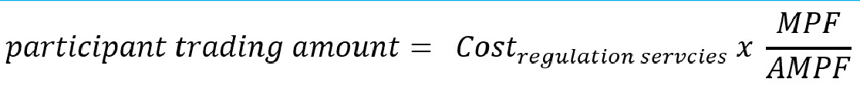

For scheduled and semi-scheduled generators, AEMO determines the participant contribution factor based on a measurement of its deviation from its dispatch trajectory multiplied by Frequency indicator (FI):

#### Figure B.2: Market Participant contribution factor

0



The residual is allocated to Market Customers in proportion to their energy consumption.

AEMO is required to publish the contribution factors with a notice period of at least ten business days prior to the application of those factors.173 It is also caused by AEMO’s decision to adopt a 28-day averaging period for the calculation of the contribution factors. This decision reduces volatility in the allocation of regulation FCAS costs, but it means that AEMO’s allocation of regulation FCAS costs for each 28-day period is based on performance contribution factors determined over a four-week period commencing around six weeks earlier.

Effectively, the current causer pays process allocates the costs of regulation services in one period (the application period) based on measured plant performance in a historical period (the sample period). Under the current process, the sample and application periods are each

1. This is referred to as the procedure for determining contribution factors in the NER. The current version is available at: [https://www.aemo.com.au/-/media/Files/Electricity/NEM/Security_and_Reliability/Ancillary_Services/Regulation-FCAS-](https://www.aemo.com.au/-/media/Files/Electricity/NEM/Security_and_Reliability/Ancillary_Services/Regulation-FCAS-Contribution-Factors-Procedure.pdf) [Contribution-Factors-Procedure.pdf](https://www.aemo.com.au/-/media/Files/Electricity/NEM/Security_and_Reliability/Ancillary_Services/Regulation-FCAS-Contribution-Factors-Procedure.pdf)
2. Clause 3.15.6A(i)(1) of the NER
3. A detailed description of the causer pays data AEMO makes available through its data subscription service is provided here: https://aemo.com.au/en/energy-systems/electricity/national-electricity-market-nem/data-nem/ancillary-services-data/ancillary- services-market-causer-pays-data

28 days long, but the sample period commences around seven weeks earlier than the application period.

# THE METHOD FOR THE VALUATION OF POSITIVE CONTRIBUTION FACTORS

The draft rule would introduce a framework for market participants to be paid through ‘frequency performance payments’ based on positive contribution factors.

The NER does not currently set out a framework for the valuation of positive contribution factors, nor for any related payments. However, the ‘causer pays’ process does include an implicit value for positive contribution factors through the portfolio-based netting of positive and negative contribution factors. The existing causer pays procedure measures individual plant performance and determines plant contribution factors which may be positive or negative. The plant contribution factors are then netted out across a market participant’s portfolio of generation and load facilities and any net positive contribution factor is zeroed out. The draft rule would remove this step where net positive contribution factors are zeroed out, thereby providing a means to determine the value of positive contributions as a basis for making payments to market participants.

Consistent with AEMO’s view set out in its discussion paper, the size of the frequency performance payments would be based on the costs of the relevant regulation service, scaled up or down by the requirement for the regulation service during the trading interval as a proportion of the amount of the service enabled at the start of the trading interval. For example, if AEMO enables 200MW of the regulating raise service at the start of a 5-minute trading interval and sends signals to enabled participants for 100MW of regulating raise service to be delivered during the trading interval, then the proportional requirement for the regulating raise service is 50%.

An example of this approach is set out below in relation to the application of the causer pays arrangements to a simplified hypothetical power system with three generating units and a single generic load.174 The series of tables below are based on a hypothetical simplified power system with regulation FCAS contribution factors for a fictitious 28-day sample period. In this example, the total regulation FCAS cost for the period is $1 million.

Table C.1 sets out the allocation of costs based on a simplified version of the existing causer pays procedure, where net positive contribution factors are zeroed. This shows how the current causer pays arrangements work and is useful as a basis to understand the proposed changes under the draft rule. The following points help explain this example:

* Generator A closely follows its dispatch trajectory and receives a contribution factor of zero. Under the existing arrangements it is not allocated any share of regulation costs.
* Generator B has active power deviations which contribute to the need for regulation services. It receives a negative contribution factor which is normalised as -0.4. Under the existing arrangements, it is allocated 40% of the regulation costs for the period.

1. In this example, the generic load does not have 4-second metering and therefore this participant represents the non-metered component of the simplified system (the ‘residual’). As in the real power system, the contribution factor for the residual reflects the contribution of the demand forecast error to the need for regulation services.

* Generator C has active power deviations which reduce the need for regulation services. It receives a positive contribution factor which, under the existing arrangements, is zeroed out and it is not allocated any share of regulation costs.
* The remaining 60% share of regulation costs are borne collectively by market participants within the residual load.175

#### Table C.1: Regulation FCAS cost allocation example – current arrangements

|  |  |  |  |  |  |
| --- | --- | --- | --- | --- | --- |
| **MARKET PARTICI- PANT** | **RAW MPF** | **MPF/AMPF** | **REG. COST ALLOCA- TION** | **FPP** | **TOTAL COST ALLOCA- TION** |
| Generator A | 0 | 0 | $ 0 | $ 0 | $ 0 |
| Generator B | - 20 | - 0.4 | $ 400,000 | $ 0 | $ 400,000 |
| Generator C | + 5 | 0 | $ 0 | $ 0 | $ 0 |
| Unmetered load  (residual) | - 30 | - 0.6 | $ 600,000 | $ 0 | $ 600,000 |

Source: AEMC

Note: Under the current arrangements, positive participant contribution factors are zeroed out for settlement purposes. Note: This example assumes that regulation costs for the period are $1,000,000

Note: MPF — Market participant contribution factor, FPP — Frequency performance payment

The following tables set out two scenarios to describe how positive contribution factors would be valued under the draft rule:176

Table C.2 shows a scenario where the proportional requirement for the regulation service is 1, indicating that 100% of the enabled volume of the regulation service was required and used by AEMO during the trading interval. In this example, there is no material impact due to the scaling by regulation requirement.

Table C.3 shows a scenario where the proportional requirement for the regulation service is

1.2 indicating that 100% of the enabled volume of the regulation service was required by AEMO during the trading interval. In this example, the value of the frequency performance payments is scaled up by 120%.

1. The residual component includes market customers that do not have appropriate metering for their individual impact on power system frequency to be assessed. Under the draft rule, non-scheduled generation without appropriate metering would also be included in the residual component.
2. These scenarios would apply similarly for the regulating raise service and the regulating lower service.

#### Table C.2: Regulation FCAS cost allocation — proposed arrangements — Example 1: FPP scaling factor = 1

|  |  |  |  |  |  |
| --- | --- | --- | --- | --- | --- |
| **MARKET PARTICI- PANT** | **RAW MPF** | **MPF/AMPF** | **REG. COST ALLOCA- TION** | **FPP** | **TOTAL COST ALLOCA- TION** |
| Generator A | 0 | 0 | $ 0 | $ 0 | $ 0 |
| Generator B | - 20 | - 0.4 | $ 400,000 | $ 0 | $ 440,000 |
| Generator C | + 5 | + 0.1 | $ 0 | $ 100,000 | $ 0 |
| Unmetered  load (residual) | - 30 | - 0.6 | $ 600,000 | $ 0 | $ 660,000 |

Source: AEMC

Note: In this scenario the proportional requirement for the regulation service (raise or lower) is 1. i.e. 100% of the enabled volume of the relevant regulating service is used during the trading interval.

Note: This example assumes that regulation costs for the period are $1,000,000

Note: MPF — Market participant contribution factor, FPP — Frequency performance payment

#### Table C.3: Regulation FCAS cost allocation — proposed arrangements — Example 2: FPP scaling factor = 1.2

|  |  |  |  |  |  |
| --- | --- | --- | --- | --- | --- |
| **MARKET PARTICI- PANT** | **RAW MPF** | **MPF/AMPF** | **REG. COST ALLOCA- TION** | **FPP** | **TOTAL COST ALLOCA- TION** |
| Generator A | 0 | 0 | $ 0 | $ 0 | $ 0 |
| Generator B | - 20 | - 0.4 | $ 400,000 | $ 0 | $ 448,000 |
| Generator C | + 5 | + 0.1 | $ 0 | $ 120,000 | $ 0 |
| Unmetered load  (residual) | - 30 | - 0.6 | $ 600,000 | $ 0 | $ 672,000 |

Source: AEMC

Note: In this scenario the proportional requirement for the regulation service (raise or lower) is 1.2. i.e. AEMO required 120% of the enabled volume of the relevant regulating service during the trading interval.

Note: This example assumes that regulation costs for the period are $1,000,000

Note: MPF — Market participant contribution factor, FPP — Frequency performance payment

In Table C.2, where the scaling component is equal to 1, the valuation of positive contributions leads to an increase in the total costs of frequency regulation of 10 per cent.

In Table C.3, where the scaling component is equal to 1.2, the valuation payments made to participants with positive contribution factors are scaled up resulting in an increase in the total costs of frequency regulation of 12 per cent. In this case, the increased valuation of positive contribution factors reflects the increased value provided, with respect to the quantity and price paid for enabled regulation services. As the requirement for regulation services exceeded the enabled amount, the price paid for regulation services is somewhat

discounted from the price that would reflect the actual requirement for regulation services. The scaling of the performance payment in this instance is intended to more accurately reflect the true value of plant behaviour that acts to reduce the need for regulation services.

The regulation requirement may be, and often is, less than the enabled amount of the relevant regulation service. For these circumstances, the draft rule also includes provisions for the value of frequency performance payments to be scaled down. The scaling down of the frequency performance payments under such conditions reduces the value of frequency performance payments, reflecting the reduced need for regulation services.

An example showing the impact of a scaling factor of 0.5 is shown below in Table C.4. In this instance the scaling factor reflects an outcome where 50% of the enabled amount of the relevant regulating service was required by AEMO during the trading interval.

#### Table C.4: Regulation FCAS cost allocation — proposed arrangements — Example 3: FPP scaling factor = 0.5

|  |  |  |  |  |  |  |
| --- | --- | --- | --- | --- | --- | --- |
| **MARKET PARTICI- PANT** | **RAW MPF** | **MPF/AMP F** | **REG. COST AL- LOCA- TION (USED)** | **FPP** | **COST AL- LOCA- TION (REG. USED PLUS FPP COSTS)** | **REG. COST ALLOCA- TION (NOT USED)** |
| Generator A | 0 | 0 | $ 0 | $ 0 | $ 0 | $100,000 |
| Generator B | - 20 | - 0.4 | $ 200,000 | $ 0 | $ 220,000 | $100,000 |
| Generator C | + 5 | + 0.1 | $ 0 | $ 50,000 | $ 0 | $50,000 |
| Unmetered load  (residual) | - 30 | - 0.6 | $ 300,000 | $ 0 | $ 330,000 | $250,000 |

Source: AEMC

Note: In this scenario the proportional requirement for the regulation service (raise or lower) is 0.5. i.e. AEMO required 50% of the enabled volume of the relevant regulating service during the trading interval.

Note: The costs for regulating services not used are allocated in column 7 based on assumed total customer demand for the interval of 50MWh. Ignoring network losses, the customer demand is met by 20MWh from Generator A, 20MWh from Generator B and 10MWh from Generator C.

Note: This example assumes that regulation costs for the period are $1,000,000

Note: MPF — Market participant contribution factor, FPP — Frequency performance payment.

# IMPLEMENTATION OF MANDATORY PFR

While the majority of scheduled and semi-scheduled capacity has now been activated to provide PFR, the roll-out is still continuing. This section outlines the progress to date, as well as the observed impact on the performance of power system frequency.

#### Activation of narrow band frequency responsiveness on affected plant

AEMO was initially required to consult on and establish the process for coordinating activation of changes to generating systems in an interim primary frequency response requirements (interim PFRR). This document outlined how affected generators (scheduled and semi- scheduled) could assess their ability to meet the PFR parameters , propose PFR settings for their units, advise their preferred approach to alter their deadband settings, approach to demonstrating plant stability, and apply for exemptions or variations to the PFRP.177 AEMO also established deadlines for affected generators with plants >200 MW to self-assess by 28 August 2020, 80-200 MW by 19 November 2020, and <80 MW by 17 February 2021.

However, there can be a delay between self-assessment and implementation of the PFR parameters for a number of reasons. To support transparency for this process, AEMO has voluntarily developed monthly status updates on the implementation.178 These reports outline the reasons for delays in implementation, as well as lessons learned with technologies and specific original equipment manufacturers (OEMs) to date. The reports also track the roll out with MWs of responsive plant representing PFR capacity in the NEM.

1. This document is available at: [https://www.aemo.com.au/-/media/files/initiatives/primary-frequency-response/2020/interim-](https://www.aemo.com.au/-/media/files/initiatives/primary-frequency-response/2020/interim-pfrr.pdf?la=en) [pfrr.pdf?la=en](https://www.aemo.com.au/-/media/files/initiatives/primary-frequency-response/2020/interim-pfrr.pdf?la=en)
2. Available on AEMO’s dedicated webpage: <https://aemo.com.au/en/initiatives/major-programs/primary-frequency-response>

#### Figure D.1: Implementation of Mandatory PFR - Cumulative MWs of responsive plant

0

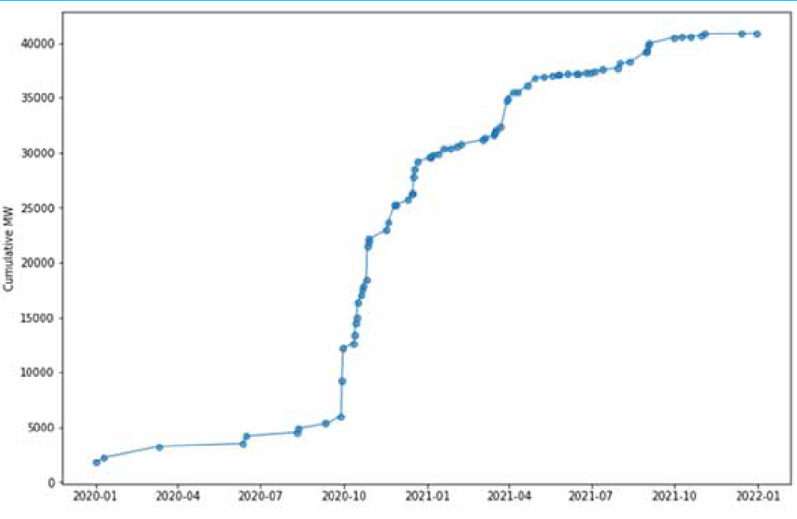

Source: AEMC analysis of AEMO data; Ref: AEMO, Implementation of the National Electricity Amendment (Mandatory Primary Frequency Response) Rule 2020 – Status as at 23 July 2021, 26 July 2021

#### Impact on power system frequency performance

As noted in GHD’s advice and Greenview’s analysis, even with the roll out of PFR still in progress, a steady improvement in power system frequency performance has already been observed in both Mainland NEM and Tasmania. The figure below outlines Greenview’s analysis of month-on-month changes in power system frequency performance with a clear change from the wider distribution before the first plants were activated at the end of September 2020. Within a few months, power system frequency is already concentrated much closer to 50 Hz.

#### Figure D.2: Month on month change in frequency

0

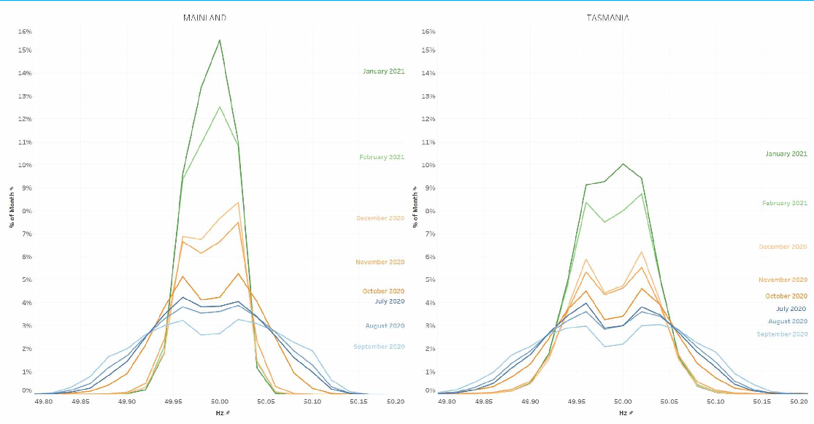

Source: Greenview analysis of publicly available data from AEMO (CPF data) presented at the 23 July 2021 Frequency Control Technical Working Group

Greenview’s analysis shows these improvements in power system frequency performance across all hours of the day, suggesting the frequency changes observed were not just a ‘solar issue’. Greenview also noted the adjustments made to deadband (and in some cases droop) on affected generators, particularly in October 2020, made the most significant difference.

The following graph from its presentation shows the correlation between power system frequency performance (top half) and changes made to PFR settings. As more plants changed their settings, frequency moved from ranging between 49.95 to 50.05 Hz to 49.98 to 50.24 Hz for 50% of the time.

#### Figure D.3: System frequency and PFR settings (PFRP) implementation

0

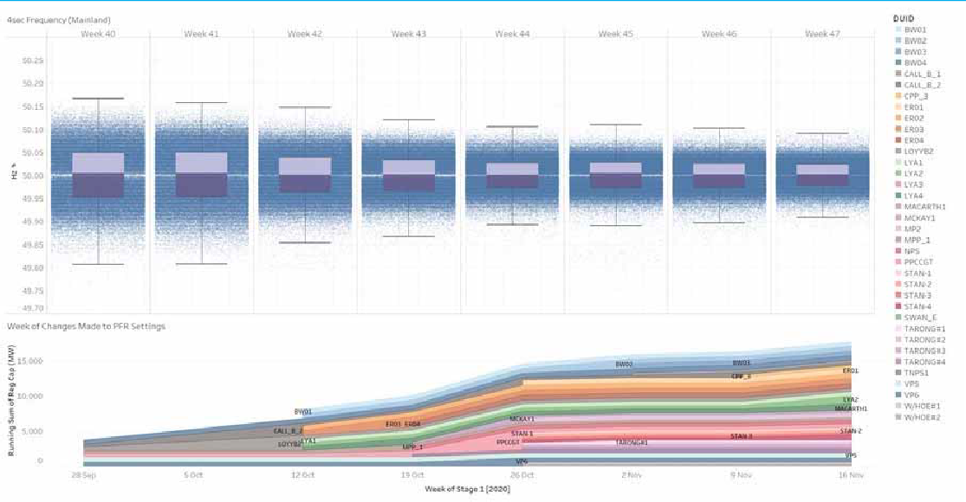

Source: Greenview analysis of publicly available data from AEMO (CPF data & PFR Implementation reports) presented at the 23 July 2021 Frequency Control Technical Working Group

AEMO also notes a number of changes were made to AEMO’s AGC area level tuning from 9 December 2020 to ensure better utilisation of available Regulation FCAS following the commencement of changes in generator primary frequency control settings.179 The changes to AGC parameters covered AGC deadbands, area control error (ACE), minor adjustments to gains, and enablement of basepoint adjustment. Although the basepoint adjustment was seen to interfere with data transfer processes used by the causer pays process, so the AGC basepoint adjustment was reversed on 18 January 2021.

GHD’s advice notes that this data suggests that AEMO has achieved a significant improvement in frequency performance with only 67% of the affected generator capacity responsive.180 GHD reports the effectiveness of the implementation of PFR to maintain frequency within the normal operating band is highlighted by the rapid reduction in the number of excursions outside this band. This reduction was driven by implementing locally measured frequency responsiveness via narrow-band PFR rather than relying on AGC driven set point changes.

#### Impact on affected generators

Greenview’s quantitative and qualitative survey of affected generators provides insights into the impacts of providing PFR for different technologies. Greenview surveyed affected

1. AEMO’s PFR Implementation Reports provide more details on this. See for example the August 2021 report available at: [https://aemo.com.au/-/media/files/initiatives/primary-frequency-response/2021/pfr-implementation-report-v18-27-aug-](https://aemo.com.au/-/media/files/initiatives/primary-frequency-response/2021/pfr-implementation-report-v18-27-aug-21.pdf?la=en) [21.pdf?la=en](https://aemo.com.au/-/media/files/initiatives/primary-frequency-response/2021/pfr-implementation-report-v18-27-aug-21.pdf?la=en)
2. GHD, *Enduring Primary Frequency Response - CT2 - Power system operation and strategic regulatory advice*, 16 September 2021, p.24

generators on observed changes in unit stability and control, key areas of concerns, and requested qualitative data on these variables.181 Responses to the survey indicated that the operational impact of providing PFR was varied but many found the stable frequency to be a positive, despite the perceived slightly increased wear and tear. The main concern identified was the lost revenue from energy markets when spare capacity was used for PFR when online and that this is not compensated under the current arrangements. Although improvements in the contribution factors allocating regulation FCAS costs were noted as a benefit of PFR provision.

The individual plant level data provided is confidential. However, there were some key themes that are worth noting:

* plants from Tranche 1 (>200 MW) are more responsive to frequency than before so are reporting an increase in movement, albeit within a tighter band
* the data provided suggested wear and tear costs are negligible at this stage, although it is too early to estimate the longer term impacts
* as more units support frequency management, the overall impact on all plant reduces
* there can be tensions between PPAs and provision of headroom for frequency support
* respondents requested further clarity on the difference between frequency response and FCAS, including the difference between enablement and usage
* respondents felt there could be value in a ‘unit settings handbook’ to cover detailed technical settings to work in conjunction with the generator performance standards and/or connection agreements.

1. Coal, Gas, Hydro, BESS, Wind and Solar were represented in surveyed generators

# ESTIMATED SHORT TERM FINANCIAL IMPACT OF CHANGES TO CAUSER PAYS

This appendix provides a summary of analysis undertaken by the AEMC to estimate the financial impacts of the proposed changes to causer pays arrangements, including the introduction of frequency performance payments, the scaling of regulation costs recovered through the performance-based arrangements, and the recovery of costs for frequency performance payments.

A detailed description of the changes that the draft rule would make to the Causer pays process is set out in section 4.2.

### Estimated scale of frequency performance payments

The Commission’s draft rule is expected to reduce the costs of frequency regulation over the long term, by aligning the financial impacts of market participant behaviour with the impacts of that behaviour on system frequency. This is expected to increase the pool of responsive plant in the power system and progressively reduce the need for regulation services, relative to the continuation of the current arrangements.

However, in the short term, the changes to the causer pays process are expected to increase the overall costs for frequency regulation, in advance of behavioural changes by market participants and the potential for future refinement by AEMO of the assumptions underpinning the approach to the procurement and utilisation of regulation FCAS. The AEMC has undertaken analysis to estimate the potential scale of frequency performance payments based on historical costs for regulation services and historical contribution factors determined by AEMO through the existing Causer pays process. This analysis, set out below, builds on similar analysis prepared by the AEMC for the 2018 *Frequency control frameworks review*.182

The analysis, based on historical contribution factors and set out below, estimates that the valuation of positive contribution factors may lead to an increase in total costs for frequency regulation in the order of 10% or $4 million to $9 million per year. This cost increase is expected to drive more efficient outcomes over the long term, noting that AEMC analysis of recent AEMO ISP projections indicates that the required level of regulation services is expected to double by 2026 under the ISP step change scenario or 2030 under the ISP central scenario. Further detail provided below.

* + 1. **Inputs, assumptions and limitations**

This analysis is intended to provide an indication of the potential impact of the proposed changes to the causer pays frameworks, based on historical data. It is not intended as an accurate prediction of future causer pays outcomes.

1. This analysis was published on page 126-127 of the 2018 *Frequency control frameworks review* final report, Appendix B, available at: <https://www.aemc.gov.au/markets-reviews-advice/frequency-control-frameworks-review>

The analysis is based on participant contribution factors, published by AEMO for historical 28- day periods. This historical data includes positive contribution factors which are currently zeroed out for the purposes of allocation of regulation costs.183 Instead of zeroing the positive contributions from market participants, the analysis shows the potential value of frequency performance payments made to market participants based on those positive contribution factors relative to the costs of regulation services. A value of 10%, indicates that the cost of frequency performance payments would be 10% of the total cost of regulation services. This would lead to a short term increase in total costs (for regulation services and frequency performance payments) of 10%. The analysis uses a sample of AEMO aggregate participant contribution factors for sample periods between 2 February 2020 and 6 June 2021. In addition to weighting positive contributions by the magnitude of their contribution to the total system need, the updated analysis also scales the frequency performance payments and cost allocations based on the requirement for regulation services, relative to the enabled amount.

The following assumptions and limitations apply to this analysis:

* + - * The analysis is based on historical contribution factor data for 28-day sample periods. Under the draft rule, separate contribution factors would be determined by AEMO for every 5-minute trading interval.
      * The analysis is based on the current practice of aggregating participant performance with respect to the raise regulating service and the lower regulating service. Under the draft rule, participant performance, along with the related payments and cost allocations, would be treated separately for the raise regulating service and the lower regulating service.
      * The analysis does not account for any behavioural changes by market participants, in response to the revised incentive arrangements. Over the long term, such behavioural changes would be expected to reduce the overall need for regulation services and lead to overall reductions in the cost of regulation service, relative to a continuation of the current arrangements.
    1. **Results**

Figure E.1 shows the results of the AEMC’s analysis which estimates the value of positive contributions based on application of the principles in the draft rule to historical participant contribution factors, scaled by historical regulation usage. The shaded blue area indicates the period where power system changes associated with the implementation of mandatory PFR arrangements had a material impact on the relative size of positive contribution factors and regulation usage. This analysis indicates that the implementation of mandatory PFR during the period October 2020 through January 2021, as well as associated changes to the tuning of AEMO AGC systems, contributed to the noticeable increase in relative size of positive contributions and a decrease in the average usage of regulation services.

1. Under the current arrangements, positive contribution factors do have a value, where they exist within a portfolio of power system plant. As part of a portfolio, the positive contribution factors can offset negative contributions from other plant in the individual participants portfolio.

The proportional size of positive contributions, relative to aggregate negative contributions, gives an indication of the potential overall increase in costs for regulation services. However, the actual financial impacts would be moderated by scaling the frequency performance payments by the requirement for regulation services as a proportion of the enabled amount.

i.e. where the regulation requirement is less than the enabled amount, the financial impact would be scaled down accordingly.

The analysis shows that the relative size of positive contribution factors jumped up from around 10% in the period to the end of December 2020 to an average of around 20% from January 2021 onward. At the same time, the average rate of usage for regulation services dropped from over 100% up to October 2020 to around 50% from November 2020 onwards. These changes are understood to be a direct result of the power system changes associated with the implementation of Mandatory PFR, noting that implementation of narrow band response was rolled out on approximately 20GW (34% of applicable generation) over the period October 2020 through December 2020.

The analysis also shows the estimated total increase in costs due to frequency performance payments, taking into account the approach proposed under the draft rule, that the value of frequency performance payments be scaled by the requirement for regulation services. The results show that where the usage of regulation service is less than 100%, the aggregate size for frequency performance payments is scaled accordingly. As a result, while the size of positive contributions is shown to have jumped from 10% to 20% after January 2021, the estimated total change in costs over the period, based on the process set out under the draft rule, would have stayed relatively steady, at close to 10%.

#### Figure E.1: Historical analysis - valuation and scaling of positive contributions

0

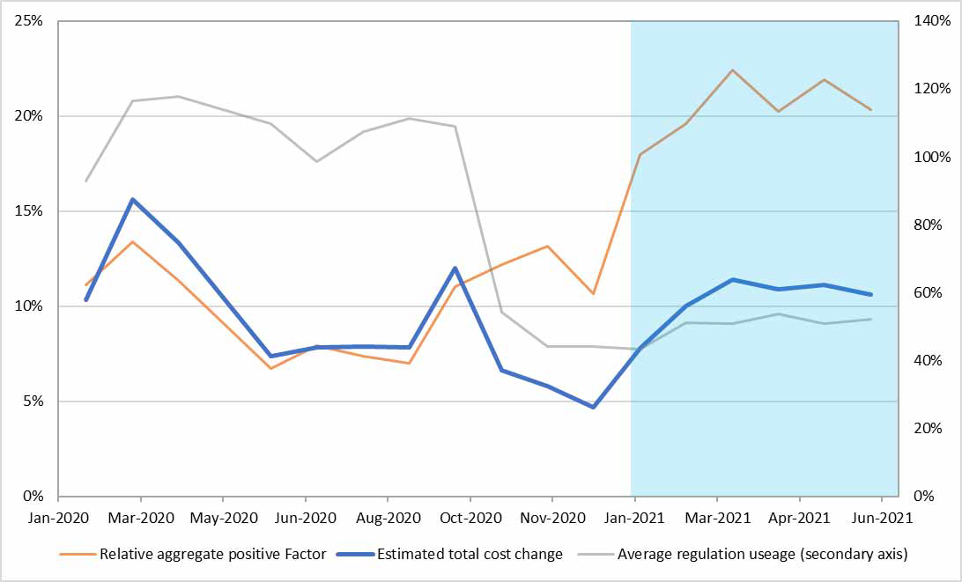

Source: AEMC analysis of AEMO contribution factors and regulation usage data.

Source: Aggregate contribution factors from AEMO — Ancillary service market Causer pays factors for sampling periods commencing 2 February 2020 through to 6 June 2021. Available at: [https://www.aemo.com.au/energy-systems/electricity/national-electricity-](https://www.aemo.com.au/energy-systems/electricity/national-electricity-market-nem/system-operations/ancillary-services/ancillary-services-causer-pays-contribution-factors) [market-nem/system-operations/ancillary-services/ancillary-services-causer-pays-contribution-factors](https://www.aemo.com.au/energy-systems/electricity/national-electricity-market-nem/system-operations/ancillary-services/ancillary-services-causer-pays-contribution-factors)

Source: Regulation usage data from AEMO weekly frequency monitoring reports, available at: [https://aemo.com.au/en/energy-](https://aemo.com.au/en/energy-systems/electricity/national-electricity-market-nem/system-operations/ancillary-services/frequency-and-time-deviation-monitoring) [systems/electricity/national-electricity-market-nem/system-operations/ancillary-services/frequency-and-time-deviation-monitorin](https://aemo.com.au/en/energy-systems/electricity/national-electricity-market-nem/system-operations/ancillary-services/frequency-and-time-deviation-monitoring) [g](https://aemo.com.au/en/energy-systems/electricity/national-electricity-market-nem/system-operations/ancillary-services/frequency-and-time-deviation-monitoring)

This analysis shows that the roll-out of Mandatory PFR has had a significant impact on the relative size of positive contribution factors and has led to a significant reduction in the average usage of regulation FCAS. It estimates a short term increase in the costs for regulation services, in the order of 10%, while at the same time showing the moderating effect of scaling by regulation usage. It can be seen that the changes to the average usage of regulation services, as a result of the implementation of mandatory PFR, present an opportunity for AEMO to adjust its approach to the procurement and utilisation of regulation services. Similarly, it is likely that, opportunities would exist for AEMO to adjust its approach to the procurement and utilisation of regulation services to reflect the changed system conditions expected following implementation of the double-sided frequency payments arrangements set out under the draft rule.

### Historical regulation costs

To provide an indication of the estimated financial impact of the proposed frequency performance payments, it is helpful to look at historical regulation costs. The following graphs show the cost of regulation raise services and the cost of regulation lower services since 2013. The thin blue line indicates the three-year moving average of these costs.

These costs can be summed to determine the total regulation costs. These range from $4.6 million in 2013 to $126.8 million in 2019, with an average over recent years (2018 to 2020) of $91.9 million.

#### Figure E.2: Historical costs for regulating raise services

0

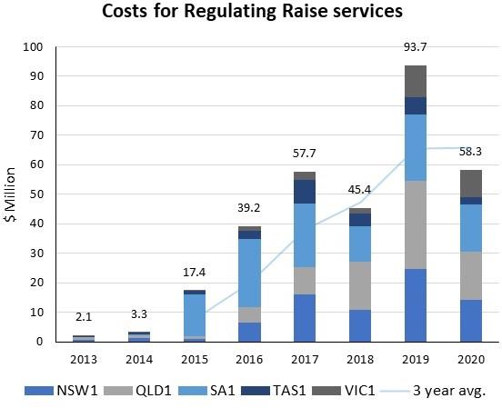

Source: AEMC analysis of historical NEM market data - available at [https://aemo.com.au/energy-systems/electricity/national-electricity-](https://aemo.com.au/energy-systems/electricity/national-electricity-market-nem/data-nem/market-management-system-mms-data/dispatch) [market-nem/data-nem/market-management-system-mms-data/dispatch](https://aemo.com.au/energy-systems/electricity/national-electricity-market-nem/data-nem/market-management-system-mms-data/dispatch)

#### Figure E.3: Historical costs for regulating lower services

0

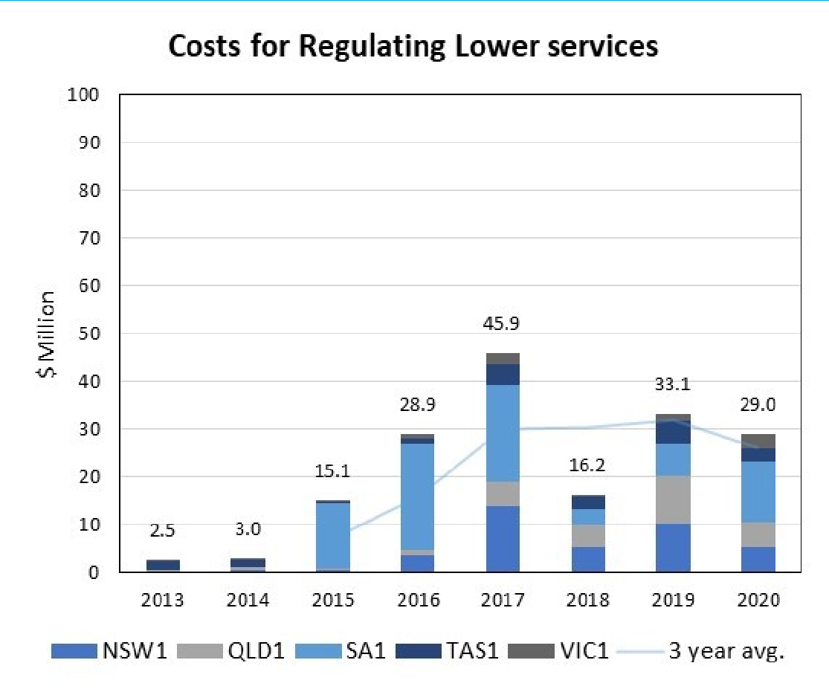

Source: AEMC analysis of historical NEM market data - available at [https://aemo.com.au/energy-systems/electricity/national-electricity-](https://aemo.com.au/energy-systems/electricity/national-electricity-market-nem/data-nem/market-management-system-mms-data/dispatch) [market-nem/data-nem/market-management-system-mms-data/dispatch](https://aemo.com.au/energy-systems/electricity/national-electricity-market-nem/data-nem/market-management-system-mms-data/dispatch)

It is worth noting that AEMO’s approach to the procurement for regulation services has been relatively steady since June 2019. AEMO currently procures a base amount of 220MW of raise regulating service and 210 MW of lower regulating service for NEM mainland (global) requirements.184 AEMO may also procure additional volumes of regulation services for local requirements and as part of a dynamic component in response to accumulated time error.185

1. AEMO, Regulation FCAS changes - June update, available at [https://aemo.com.au/-](https://aemo.com.au/-/media/files/electricity/nem/security_and_reliability/ancillary_services/frequency-and-time-error-reports/regulation-fcas-changes_june-update.pdf?la=en)

[/media/files/electricity/nem/security_and_reliability/ancillary_services/frequency-and-time-error-reports/regulation-fcas-changes_j](https://aemo.com.au/-/media/files/electricity/nem/security_and_reliability/ancillary_services/frequency-and-time-error-reports/regulation-fcas-changes_june-update.pdf?la=en) [une-update.pdf?la=en](https://aemo.com.au/-/media/files/electricity/nem/security_and_reliability/ancillary_services/frequency-and-time-error-reports/regulation-fcas-changes_june-update.pdf?la=en)

1. AEMO, Constraint implementation guidelines, June 2015, p.27.

### Projected need for regulation services

The Commission has undertaken analysis to estimate the potential requirement for regulation services due to the projected increase in installed capacity of variable renewable generation under the 2020 Integrated System Plan (ISP).

This analysis indicates that under the current market and regulatory arrangements AEMO expects that the installation of 10,000MW of large scale solar PV could potentially double the need for regulation services, from the current base requirement of 220MW/210MW raise/lower, to just over 400MW each for raise and lower regulating services in periods with significant amounts of large-scale PV generating with intermittent behaviour. This level of installed capacity is projected to be reached by 2030 under the central scenario for the 2020 ISP by 2026 under the step change scenario.

The relevant figures from the 2018 and 2018 ISP’s are included below for reference.

#### Figure E.4: New NEM VRE build, solar (left), wind (middle), and Central scenario split (right)

0

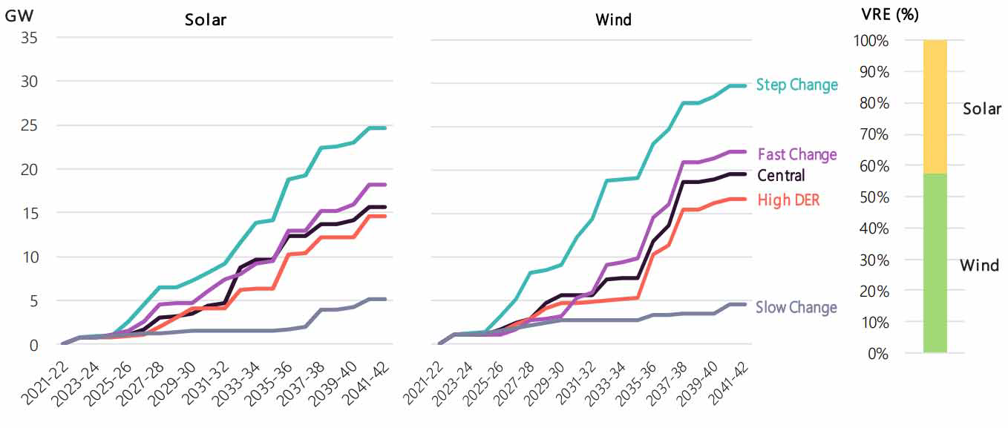

Source: AEMO, *2020 Integrated System Plan*, 30 July 2020, figure 12., p.45.

Note: Chart shows projected new build large scale wind and solar capacity over the outlook period. Installed large scale solar PV as at July 2021 is 5,730MW. Installed large scale wind generation capacity is 7,992MW. AEMO, NEM Generation information — July 2021, 13 July 2021. Available at [AEMO Generation information webpage](https://aemo.com.au/en/energy-systems/electricity/national-electricity-market-nem/nem-forecasting-and-planning/forecasting-and-planning-data/generation-information)

#### Figure E.5: Projected FCAS requirements for increasing penetration of solar and wind generation

0

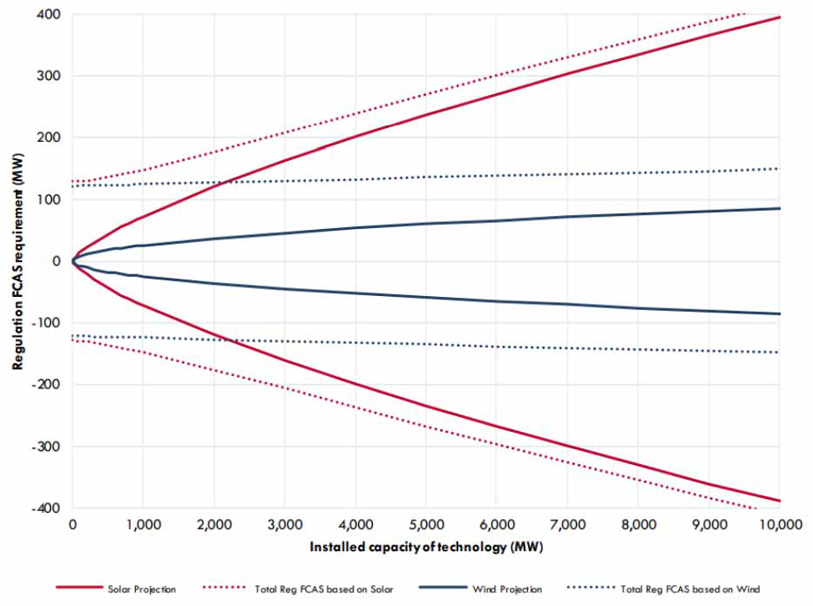

Source: AEMO, *Enduring primary frequency response requirements for the NEM*, August 2021, p.57.

Note: These projections do not assume any material changes to the collective behaviour of solar generators, and likely underestimate diversity in their output.

This analysis provides a simplified view of potential future requirements under a continuation of the existing regulatory and market arrangements and assuming no change in the operating behaviour of large scale solar generation. There are a number of factors that would tend to moderate the level of regulation projected under this analysis, including the economic incentives provided through the existing arrangements for the allocation of regulation services. The double-sided frequency performance payment and cost allocation arrangements set out in the draft rule would be expected to incentivise market participants to operate in a way that tends to reduce the need for regulation services. For example, under the draft rule, operators of large scale solar farms would be incentivised to track their dispatch trajectory more closely and take measures to manage the variability of their generation over each trading interval. These actions, along with other similar actions by other market participants, would be expected to combine to reduce the projected need for regulation services shown in this analysis.

# EXPLANATION OF AGGREGATE FREQUENCY RESPONSIVENESS

AEMO’s technical advice makes the case that the objective for broad based universal narrow band PFR is for a high level of aggregate frequency responsiveness to be provided, to deliver stable frequency that is controlled close to 50Hz. 186 The Commission considers that the concept of aggregate frequency responsiveness requires further explanation and examples.

The Commission understands that the concept of aggregate frequency responsiveness, also referred to as system frequency bias or aggregate droop, is based on:

* the amount (in MW) of plant that are operating in a frequency responsive mode and
* the aggregate plant responsiveness to changes in system frequency, as expressed by frequency droop [the change in plant output as a proportion of its rated capacity, relative to a change in system frequency];

#### Figure F.1: Droop equation - proportional active power response to change in frequency

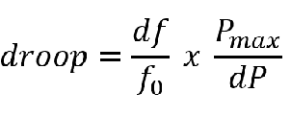

Source: AEMC

Where:

* df is the change in system frequency
* f0 is the nominal system frequency – 50Hz
* Pmax is the maximum rated power output for a generator
* dP is the change in active power for a generator

This relationship can be rearranged to describe the active power response to a change in frequency:

#### Figure F.2: Droop equation - rearranged for change in active power

0

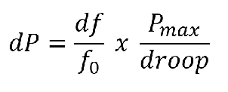

Source: AEMC

Where:

* df is the change in system frequency
* f0 is the nominal system frequency – 50Hz

1. AEMO, Enduring primary frequency response requirements for the NEM, August 2021, pp. 16-17, 55.

* Pmax is the maximum rated power output for a generator
* dP is the change in active power for a generator

Aggregated across the entire fleet of generation plant gives:

#### Figure F.3: Aggregate system droop equation

0

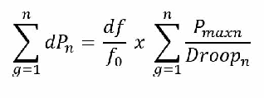

Source: AEMC

Where:

* df is the change in system frequency
* f0 is the nominal system frequency – 50Hz
* Pmax is the maximum rated power output for a generator
* dP is the change in active power for a generator
* droop is the % change in system frequency to drive power output to 100%
* g is a generator
* n is the number of generators providing frequency response.

Note that any active power response will be limited by available headroom and footroom capacity. **Headroom** refers to the ability for a generator to increase its delivered generation in response to a change in system frequency. It is supported by available stored energy within the generation system that can be rapidly converted into electricity in a short time period, typically within a matter of seconds. Similarly, **footroom** refers to the ability for a generator to reduce its delivered generation.

The following table provides a comparison of different droop settings as they relate to generation capacity and the expected active power response to frequency variations within the Normal operating frequency band, 49.85 – 50.15Hz. For simplicity of calculation, this table assumes no control deadband, active power response commences for any deviation of frequency away from 50Hz.

Australian Energy Market Commission

**Draft rule determination** PFR Incentive Arrangements 16 September 2021

#### Table F.1: Equivalent arrangements to deliver similar levels of aggregate frequency response (PFR)

|  |  |  |  |  |  |  |  |
| --- | --- | --- | --- | --- | --- | --- | --- |
|  | **ACTIVE POWER ‘DROOP’ RESPONSE** | | | | | | |
| System frequency: *f* | 49.85 Hz | 49.90 Hz | 49.95 Hz | 50.00 Hz | 50.05 Hz | 50.10 Hz | 50.15 Hz |
| Frequency error: *df* Hz = f - 50 | -0.15 Hz | -0.10 Hz | -0.05 Hz | 0 Hz | 0.05 Hz | 0.10 Hz | 0.15 Hz |
| Frequency error: *df%* = df/50 x 100% | -0.3% | -0.2% | -0.1% | 0 | 0.1% | 0.2% | 0.3% |
| 5% droop active power response: dP% = ef / -5% | 6% | 4% | 2% | 0 | -2% | -4% | -6% |
| Active power response from 1 x 250MW unit at 5% droop: dPMW =Pmax x dP% | 15 MW | 10 MW | 5 MW | 0 | -5 MW | -10 MW | -15 MW |
| a) Aggregate active power response from 35GW of plant at  5% droop | 2100 MW | 1400 MW | 700 MW | 0 | -700 MW | -1400  MW | -2100MW |
| b) Aggregate active power response from 35GW of plant at  5% droop | 2100 MW | 1400 MW | 700 MW | 0 | -700 MW | -1400  MW | -2100MW |
| c) Aggregate active power response from 35GW of plant at  5% droop | 2100 MW | 1400 MW | 700 MW | 0 | -700 MW | -1400  MW | -2100MW |

Source: AEMC

Note: As at 27 August 2021, AEMO had activated 39.3 GW of generation plant to provide narrow band PFR in accordance with its Primary frequency requirements document. This represents a responsive fraction of 68% of the registered capacity of plant affected by the Mandatory PFR rule. The *Interim primary frequency response requirements* includes a specification for affected plant to provide a minimum of 5% droop response outside of a frequency response deadband of ± 0.015Hz either side of 50Hz. Ref. AEMO, Implementation of the National Electricity Amendment (Mandatory Primary Frequency Response) Rule 2020 – Status as at 27 August 2021, 30 August 2021.

100

Australian Energy Market Commission

**Draft rule determination** PFR Incentive Arrangements 16 September 2021

In each of the examples a), b) and c) above, the overall frequency bias MW/Hz is the same, but it is being delivered in different ways i.e. with less plant providing more aggressive response.

For example, a unit operating at 1% droop will deliver its maximum active power response for a 0.5 Hz change in frequency compared to at 2.5 Hz when operating at 5%. Therefore, each of the units in the 7GW of responsive plant in example c) will have to carry five times the reserve, per unit, to achieve the same outcome.187

The Commission makes the following observations based on this analysis:

* The expected maximum delivery of active power response for frequency variations within the normal operating frequency band is approximately three times greater than typical maximum contingency FCAS volumes in the order of 700MW for fast raise services.
* 7GW of plant operating at 1% droop can theoretically provide the same aggregate active power response as 35 GW of plant operating at 5% droop.
* The above analysis shows that a small quantity of plant operating with more aggressive droop settings can theoretically provide the same aggregate active power response as a large quantity of plant operating with a more relaxed droop.

However, AEMO’s expert advice notes that:188

there is little experience in the NEM with operating synchronous generation, or any large part of the overall supply, at droop settings outside the 3-5% range.

Further discussion of the potential development of procurement arrangements for narrow band PFR is included in section 5.2.

1. Note that if thermal plant were to provide such aggressive droop response, they may need to operate at levels near minimum dispatch to provide the required level of raise response. When operating near minimum load, thermal plant may have limited ability to provide frequency lower services by reducing active power output.
2. AEMO, Enduring primary frequency response requirements for the NEM, August 2021, p.23.

101