

# Deputy Secretary

Mr Jason Lange Executive Director

Office of Best Practice Regulation Department of Prime Minister and Cabinet

Email – [Jason.lange@pmc.gov.au](mailto:Jason.lange@pmc.gov.au)

Dear Mr Lange

# Sunsetting of the Restricted Medicine Specification

I am writing to the Office of Best Practice Regulation (OBPR) regarding the *Restricted Medicine Specification 2011* (the Specification) that, in accordance with the *Legislation Act 2003*, is due to sunset on 1 October 2021.

The Specification was made on 21 January 2011 and commenced on 13 May 2011. It is made under subsections 3(2A) & 3(2B) of the Therapeutic Goods Act 1989 (the Act) and specifies medicines or classes of medicine for the purposes of the definition of ‘restricted medicine’ in subsection 3(1) of the Act. Restricted medicines are medicines for which a Product Information document is required to be submitted to the TGA as part of an application for registration. A Product Information document provides health professionals with a summary of the scientific information relevant to the safe and effective use of a medicine. The Specification requires that a Product Information document be provided for all prescription medicines, some non-prescription medicines and some biologicals.

The Australian Government Department of Health certifies that the review of the Specification found that it is fit for purpose and has operated effectively and efficiently since it came into force. Therefore, a Regulation Impact Statement is not required for the instrument to be remade.

The self-assessment was informed by a targeted consultation process. The proposal to remake the Specification without substantially altering the current arrangements was provided to the Generic and Biosimilar Medicines Association, Medicines Australia, Complementary Medicines Australia and Consumer Health Products Australia for consultation from 16 July 2021 to 16 August 2021.

**Phone:** (02) 6289 4200 **Email:** [John.Skerritt@health.gov.au](mailto:John.Skerritt@health.gov.au) PO Box 100 Woden ACT 2606 **-** [**www.health.gov.au**](http://www.health.gov.au/)

- 2 -

Those consulted were advised that a new instrument is needed to provide continuing clarity on the requirements for Product Information for certain medicines following the automatic repeal (i.e., sunsetting) of the Specification. The new instrument will reflect the current requirements without technical amendment; it is not intended to alter existing arrangements.

Medicines Australia and Consumer Health Products Australia provided responses to the consultation. Both organisations are supportive of the proposal to make an instrument to replace the Specification which will maintain existing arrangements.

I acknowledge that OBPR will publish this letter for transparency purposes. If you have any queries about this advice, please contact Michael Shum on 02 6289 2278 or via email, [michael.shum@health.gov.au](mailto:michael.shum@health.gov.au) .

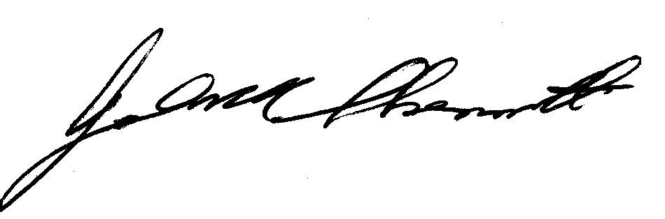Yours sincerely

Adj. Professor John Skerritt

Health Products Regulation Group 30 August 2021