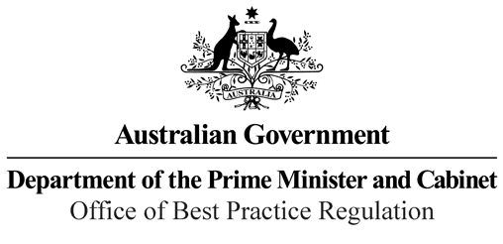

Reference: 42703

Telephone: 6271 6270

e-mail: [helpdesk-obpr@pmc.gov.au](mailto:helpdesk-obpr@pmc.gov.au)

Ms Jo Evans Deputy Secretary

Department of Industry, Science, Energy and Resources Dear Ms Evans

**Regulation Impact Statement – Second Pass Final Assessment – Offshore Electricity Infrastructure Regulatory Framework**

Thank you for your letter received on 21 April 2021 submitting a Regulation Impact Statement (RIS) on developing an offshore electricity infrastructure regulatory framework for formal Second Pass Final Assessment. I note you have formally certified the RIS consistent with the *Australian Government Guide to Regulatory Impact Analysis*.

I appreciate the Department’s constructive engagement on the RIS and the opportunities provided for our teams to work together as it was developed.

The Office of Best Practice Regulation’s assessment is that the quality of the regulatory impact analysis in the RIS is good practice.

The analysis in the RIS is good quality overall. The RIS addresses the seven RIS questions and follows an appropriate policy development process commensurate with the significance of the problem and magnitude of the proposed intervention. The RIS may now be provided to the decision-maker to inform a final decision.

We would appreciate you advising us when a final decision has been announced and forwarding a copy of the RIS in a form meeting the Government’s accessibility requirements. The OBPR will publish the RIS, along with your certification and this assessment, on the OBPR’s website https://ris.pmc.gov.au/.

If you have any further queries, please do not hesitate to contact me. Yours sincerely

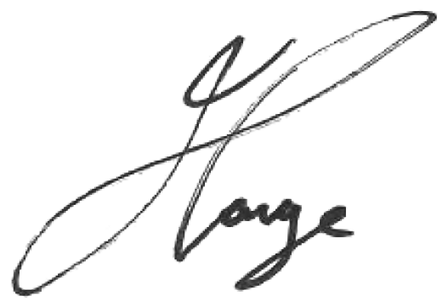

Jason Lange Executive Director 28 April 2021

1 National Circuit, Barton ACT 2600 • Telephone 02 6271 6270 • Internet [www.pmc.gov.au/regulation](http://www.pmc.gov.au/regulation)