DISCUSSION PAPER

DISCUSSION PAPER

Strengthening prudential requirements for remuneration

23 July 2019

Disclaimer and Copyright

While APRA endeavours to ensure the quality of this publication, it does not accept any responsibility for the accuracy, completeness or currency of the material included in this publication and will not be liable for any loss or damage arising out of any use of, or reliance on, this publication.

**© Australian Prudential Regulation Authority (APRA)**

This work is licensed under the Creative Commons Attribution 3.0 Australia Licence

(CCBY 3.0). This licence allows you to copy, distribute and adapt this work, provided you attribute the work and do not suggest that APRA endorses you or your work. To view a full copy of the terms of this licence, visit https://creativecommons.org/licenses/by/3.0/au/

Contents

Executive summary 5

Glossary 10

Chapter 1 - Introduction 12

1.1 Background 12

1.2 Current industry practice 13

1.3 The Banking Executive Accountability Regime 15

1.4 APRA’s proposed approach 16

1.5 Addressing the Royal Commission recommendations 19

1.6 Balancing APRA’s objectives 20

1.7 Timetable and next steps 22

Chapter 2 - Scope of application 23

2.1 Significant financial institutions 23

2.2 Special role categories 24

2.3 Group application 25

Chapter 3 - Governance and accountability 26

3.1 Remuneration framework 26

3.2 The role of the Board and Board Remuneration Committee 26

3.3 Regular reviews of the remuneration framework 27

3.4 Transparency 27

Chapter 4 - Remuneration design 29

4.1 Key considerations in remuneration design 29

4.2 Measurement of outcomes – financial and non-financial measures 30

4.3 Deferral and vesting 34

4.4 Interaction with the BEAR 36

Chapter 5 - Variable remuneration outcomes 38

5.1 Oversight and adjustments 38

5.2 Clawback 39

Chapter 6 - Consultation 42

6.1 Request for submissions 42

6.2 Important disclosure requirements – publication of submissions 42

6.3 Request for cost-benefit information 42

6.4 Consultation questions 43

Attachment A: Policy options and estimated comparative net benefits 44

# Executive summary

A resilient financial system is based on alignment between the interests of financial institutions and those of stakeholders including shareholders, customers and beneficiaries, regulators and the broader community. The design and implementation of remuneration arrangements play an important role in better aligning these interests. As highlighted by the Royal Commission into Misconduct in the Banking, Superannuation and Financial Services Industry (Royal Commission), there have been numerous examples where this alignment has been missing. In particular, financial institution executives have received substantial incentive based pay following years with strong financial performance, while instances of significant customer harm or reputational damage to the institution have emerged.

Remuneration practices, that is, how executives and other employees are rewarded financially for the outcomes they achieve, can play an important role in promoting effective management of all risks (both financial and non-financial), sustainable performance and long-term soundness. Remuneration design and implementation that does not properly consider the incentives it creates, including an over-emphasis on short-term financial performance, can drive poor customer and beneficiary outcomes and jeopardise financial soundness.

APRA is proposing to strengthen prudential requirements for remuneration across all APRA-regulated entities in the banking, insurance and superannuation industries by issuing a new prudential standard on remuneration (CPS 511). APRA’s proposals aim to ensure that an entity’s remuneration arrangements produce appropriate incentives and outcomes.

The new standard is a key milestone in APRA's broader agenda to lift industry practices in governance, culture and remuneration. The new standard will support APRA's supervision program in these areas by providing clear expectations against which supervisors will assess regulated entities.

While certain components of the package may present challenges for different stakeholders, the impact of the reform should be considered as a whole. The core elements are to:

* strengthen governance of remuneration frameworks and outcomes, in particular through an expanded Board role, where the Board needs to be active and have direct oversight;
* set overarching remuneration objectives that inform design of all remuneration arrangements and influence remuneration outcomes;
* limit the use of financial performance metrics (share price and profit-based); and
* set minimum deferral periods (up to seven years) for senior executives to provide more 'skin-in-the-game' through better alignment to the time horizon of risk and performance outcomes.

These core elements are materially more prescriptive than APRA's existing remuneration requirements. Recent evidence, as highlighted by the Royal Commission, is that the current approach to regulation in this area is not delivering satisfactory outcomes. Considering these deficiencies, APRA has looked to regulation in overseas jurisdictions and as such better international practice has strongly formed the basis of APRA’s approach to developing the new standard.

APRA has relied on its principles-based philosophy where possible and has not sought to undermine accountability within regulated entities by constraining the overall amount of remuneration. In particular, APRA is not proposing to cap the amount of variable remuneration either in absolute terms or in relation to fixed salary (as has been the case in some other countries), or prescribing specific types or forms of variable remuneration. APRA has not seen evidence that these more prescriptive approaches are effective in promoting better outcomes; indeed there is some suggestion that a strict rules-based approach is open to circumvention given the fluid nature of labour market dynamics.

A key feature of APRA's new standard is to promote the use of non-financial performance criteria in designing variable remuneration incentives. Many investors have traditionally supported a heavier weight for financial targets, whereas consumer advocates prefer customer-centric measures such as customer service and loyalty. Executives favour a remuneration arrangement reflecting their skill and expertise. No approach will satisfy all stakeholders, but in APRA's view financial targets have had too prominent a place in executive remuneration in some sectors of the financial industry.

The key proposals in the new standard are summarised below:

|  |  |  |  |
| --- | --- | --- | --- |
| Key Area | Current standard | Key proposed change | Impact on entities |
| Remuneration framework | Remuneration policy for senior executives and limited additional staff only. | Remuneration policy for all arrangements, supported by remuneration objectives and a broad framework. | Broader scope of the standard will require more comprehensive assessment of end-to-end remuneration design and outcomes. |
| Board oversight | The Board must approve the remuneration policy.  The Board has responsibility for reviewing and approving remuneration recommendations for senior executives and limited other staff. | The Board must approve the remuneration policy, actively oversee the remuneration framework, approve the remuneration of senior executives and other roles and ensure risk outcomes are reflected in remuneration outcomes. | More direct oversight role for Boards.  Direct role in setting clear accountability for poor outcomes.  Greater use of authority and discretion to achieve objectives. |
| Variable remuneration design | Variable remuneration for special categories of employees must be designed to allow adjustments to reflect business outcomes, risks inherent in business activities and incorporate appropriate time for performance to be realised. | Minimum design requirements for all employees, which promote prudent risk management and support remuneration objectives.  Financial measures limited to 50 per cent and individually capped at 25 per cent.  Constraints on deferral and vesting set for significant financial institutions (SFIs). | Determination of meaningful non-financial measures.  Lengthening deferral periods may require changes to existing structures. |
| Outcomes management | Remuneration policy must allow the Board to adjust variable remuneration downwards to zero if appropriate for employees in special categories. | Require adjustments to remuneration outcomes so as to align with risk outcomes; stronger review and oversight.  Clawback to apply to senior roles in SFIs. | Alignment of remuneration and risk outcomes may require significant investment in capability and cultural change. Review of employment contracts to ensure clawback provisions can be enacted. |
| Review | Remuneration policy must be reviewed on a regular basis. | Annual compliance reviews and triennial effectiveness reviews of the remuneration framework. | Conducting insightful reviews and acting on the insights gained will require additional resources. |
| Transparency | No requirements other than for authorised deposit-taking institutions (Pillar 3). | APRA to consult on measures in 2020. | More comprehensive analysis and accountability of how an entity's remuneration framework is applied. |

APRA is proposing a proportional implementation of the new requirements, with certain heightened expectations applied only to large, complex entities and to certain senior executives and other special roles. APRA proposes to define the group of large, complex entities for these purposes based on asset size: more than $15 billion in total assets for authorised deposit-taking institutions (ADIs); more than $10 billion in total assets for general and life insurers; and more than $30 billion in funds under management for registrable superannuation entities (RSE) licensees.

APRA will also be intensifying its supervision of remuneration practices under the new standard, with a focus on design, implementation and outcomes. This will be further strengthened through new reporting and disclosure requirements, which will be consulted on following finalisation of the new standard.

APRA's proposals address recommendations 5.1 to 5.3 of the Royal Commission and insights gained from the *Prudential Inquiry into the Commonwealth Bank of Australia (CBA)*, APRA’s *Review of Remuneration Practices at Large Financial Institutions* and its summary of industry self-assessments of governance, accountability and culture.[1] Standards and guidance produced by the Financial Stability Board (FSB) have also been incorporated to align APRA's requirements with evolving international practice.

Strengthening prudential requirements for remuneration involves a number of trade-offs and risks. Reducing the significance of objective financial performance measures in the assessment of variable remuneration outcomes could reduce alignment of the interests of shareholders and management. This view stems primarily from a perception that non-financial measures are not objective and are subject to 'gaming' by management. In APRA's view, this is not a reason to avoid using non-financial performance measures, but it creates a challenge for the financial industry to develop measures that are suitably objective, reflect underlying performance and are subject to independent verification. Some areas of the financial industry as well as international practice are moving in this direction.

Some of the measures APRA is proposing will require changes to existing remuneration practices at some cost. This may affect how entities compete for and retain skilled executives and staff. For example, proposals for longer deferral and vesting periods for senior executives at the largest institutions are designed to promote greater accountability, which is of particular interest to certain stakeholders given the time taken for misconduct issues to surface, but could also affect the use of variable remuneration as a performance management tool.

These trade-offs should be viewed in light of the need for a substantially stronger remuneration framework that provides appropriate incentives, improves accountability and that supports effective management of financial and non-financial risks and long-term soundness. Consideration of what is best practice in remuneration design is continuing to evolve, in Australia as well as internationally. APRA's proposals will place Australia in line with better international practice.

Following the consultation, APRA intends to publish a Response to Submissions and final prudential standard in late 2019 or early 2020. APRA expects that the new CPS 511 will come into effect on 1 July 2021 but will determine the effective date based on feedback regarding aspects of the implementation. APRA also intends to consult on an updated prudential practice guide in 2020, to support implementation of the new prudential standard, as well as reporting standards and disclosure requirements.

Given the significance of the proposals and potential industry impact, APRA intends to conduct a review of the effectiveness of the prudential standard three years from its initial effective date.

# Glossary

|  |  |
| --- | --- |
| **ADI** | Authorised deposit-taking institution |
| **BEAR** | Banking Executive Accountability Regime set out in Part IIAA of the *Banking Act 1959*. |
| **Board** | The board of directors, or a group of individual trustees in the case of a RSE licensee. |
| **Clawback** | The recovery of remuneration that has been paid or vested to a person. |
| **Deferral period** | In relation to the variable remuneration component, the period between inception and when it becomes fully vested. |
| **Highly paid material risk takers** | Material risk takers whose total fixed remuneration (which includes salary, superannuation, allowances and benefits) plus maximum potential variable remuneration is equal to or greater than 1 million AUD in a financial year. |
| **In-period adjustment** | An adjustment made to variable remuneration during or at the end of the period set for measuring the performance of a variable remuneration arrangement. |
| **Long-term incentive** | The amount of a person’s variable remuneration that is subjected to a performance period which spans a specified number of years following the inception of the variable remuneration component. |
| **Malus** | An adjustment to reduce the value of all or part of deferred variable remuneration before it has vested. |
| **Material risk taker** | A person whose activities have a material potential impact on the entity’s risk profile, performance, long-term soundness or for a RSE licensee, impact on promoting the financial interest, and reasonable expectations, of beneficiaries. |
| **Misconduct risk** | The risk associated with action or inaction by a person covered by an entity’s remuneration policy that falls short of expected standards, including legal, professional, internal conduct and ethical standards. |
| **RSE** | Registrable superannuation entity. |
| **Remuneration arrangement** | An arrangement that includes measures of performance, the mix of forms of remuneration (such as fixed and variable components, and cash and equity-related benefits) and the timing of eligibility to receive payments. All forms of remuneration are captured by this Prudential Standard, regardless of where, or from whom, the remuneration is sourced. |
| **Risk and financial control personnel** | Persons whose primary role is risk management, compliance, internal audit, financial control or actuarial control. |
| **Senior manager** | A person who has or exercises any of the senior management responsibilities (within the meaning of *Prudential Standard CPS 520 Fit and Proper* and for a RSE licensee, *Prudential Standard SPS 520 Fit and Proper*) for the entity (and, in the case of a foreign ADI, Category C insurer and EFLIC, for the Australian operations of the foreign entity) in their capacity other than as a director; and who is a director within the meaning of the Corporations Act 2001. |
| **Short-term incentive** | The amount of a person’s variable remuneration that is subjected to a performance period which is the financial year immediately preceding the inception of the variable remuneration component. |
| **Significant financial institution** | A large and complex entity as determined by APRA. |
| **Special role category** | A person in the category of senior manager, material risk taker (including highly paid material risk takers) and risk and financial control personnel. |
| **TSR** | Total shareholder return. |
| **Variable remuneration** | The amount of a person’s total remuneration that is conditional on the achievement of objectives. |
| **Vesting** | The process by which the person becomes the legal owner of the variable remuneration. |

1. Introduction
   1. Background

A key finding from the global financial crisis was that inappropriate risk taking incentivised by remuneration practices was a significant contributor to the large scale losses incurred by the financial sector. Although Australia did not experience the same level of losses as other countries, concerns were expressed about the growing use of complex incentive structures that could lead to unintended consequences.[2] Through the Financial Stability Board (FSB), a number of countries including Australia, collaborated on a new set of regulatory principles designed to align compensation with prudent risk taking.[3] To address these issues, and in line with actions identified by the FSB, APRA in 2010 developed prudential standards and guidance on sound remuneration practices.

The fundamental principle underlying the current prudential framework is that performance-based components of remuneration must be designed to encourage behaviour that supports the regulated entity’s long-term financial soundness and risk management. This is reflected in the prudential requirements for remuneration that are currently included in *Prudential Standard CPS 510 Governance* (CPS 510)for authorised deposit-taking institutions (ADIs), general insurers and life insurers (and apply to private health insurers from 1 July 2019) and for registrable superannuation entity (RSE) licensees in *Prudential Standard SPS 510 Governance* (SPS 510). These prudential standards, together with *Prudential Practice Guide PPG 511 Remuneration* (PPG 511) and *Prudential Practice Guide SPG 511 Remuneration* (SPG 511), form the current prudential framework for remuneration. The Banking Executive Accountability Regime (BEAR) has also prescribed specific remuneration requirements for ADIs, as discussed later in this chapter.

With the exception of the BEAR requirements, it has been nearly 10 years since the regulatory framework for remuneration was developed. As described in APRA’s *Review of Remuneration Practices at Large Financial Institutions* (APRA’s 2018 Information Paper), the framework has not always been implemented effectively in practice or ensured appropriate outcomes.[4] In addition to deficiencies highlighted in the Royal Commission into Misconduct in the Banking, Superannuation and Financial Services Industry (Royal Commission) and the Sedgwick Retail Banking Review, APRA’s own reviews identified gaps and issues in the prudential framework governing remuneration and remuneration practices.[5]

Internationally, the FSB has continued to monitor and assess the implementation of its principles and standards, and Australia has participated in these reviews. This resulted in the publication, in March 2018, of the *Supplementary Guidance to the FSB Principles and Standards on Sound Compensation Practices*. APRA’s proposals in draft CPS 511 align with the FSB guidance.

* 1. Current industry practice

APRA's 2018 Information Paper on remuneration practices provides an overview of current remuneration structures and practices.

Industry practice in remuneration design and structure, while varied, includes some features that are common across major financial entities in Australia. **Figure 1** presents a remuneration structure typical of what is currently observed in the banking and insurance industries.

1. Typical remuneration structure in banking and insurance - CEO

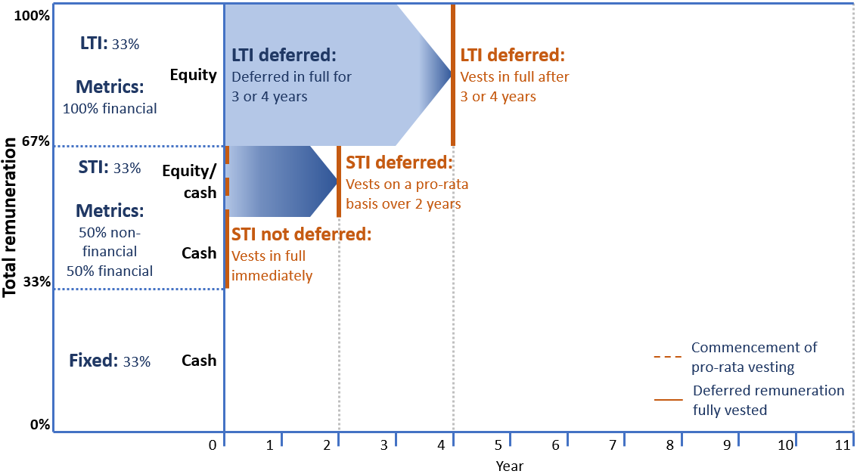

Remuneration for senior executives in the banking and insurance industries usually contains both a fixed and a variable component. The balance of fixed versus variable remuneration depends on the role of the particular executive – for example, employees in risk and compliance functions may have a higher weighting towards fixed remuneration, relative to revenue-generating functions.

Variable remuneration is typically delivered as a combination of short-term incentives (STI) and long-term incentives (LTI).

STIs and LTIs are typically assessed utilising a ‘scorecard’ approach, consisting of financial and non-financial performance measures. Financial measures tend to focus on enterprise-wide outcomes such as profit; however they tend not to account for how those outcomes were obtained. Non-financial measures may also be outcomes-focussed, for example customer loyalty, but these can also address 'inputs' that affect those outcomes, such as behaviours.

STIs are typically assessed on performance in a single year and the award is usually delivered in a combination of cash and equity.

LTIs are typically assessed over multiple years based on predetermined performance objectives. LTI measures are often entirely financial in nature, generally related to profitability and share performance, and are typically delivered in the form of performance rights which vest over a set period of time or when specified outcomes have been achieved. The practice of deferral of variable remuneration is designed in large part to mitigate the risk that performance outcomes, especially negative outcomes, may take several years to crystallise.

The use of non-financial metrics to assess performance is typically limited to STI scorecard design only, rather than incorporated in LTI. This is not unique to financial services, but is also the practice across the market generally. Among the top 30 listed companies in Australia, APRA has observed that generally non-financial metrics are well embedded in STI design but not in LTI design.

In addition to the scorecard approach, other remuneration design tools used in plan design include the application of gateways which set minimum levels of acceptable performance, modifiers which moderate and qualify scorecard outcomes, and overriding Board discretion on all measures.

Typical industry practice for senior executives is to put mechanisms in place for adjustment of variable remuneration amounts. Adjustments to remuneration amounts can be made via various tools such as in-year adjustments or by Board discretion, malus and clawback. Adjustments can be made initially when variable remuneration is determined, or when the amount awarded is subsequently deemed to be inappropriate due to negative performance or conduct. A deferral period allows this determination to take place and be reflected in actual remuneration outcomes. APRA has found that in-year adjustments are the most common form of adjustment to variable remuneration, followed by malus. These two approaches tended to be favoured over the application of clawback, in part because they are applied before the award vests.

Significant variable remuneration and LTIs are less common in the superannuation industry and remuneration structures tend to comprise of STIs in the form of cash rather than shares.

An example of a typical STI plan design of a senior executive is set out in **Figure 2**. Each of the four elements in the example represent a stage in the process to assess and determine adjustments to variable remuneration. Within each element, there are opportunities and mechanisms to evaluate risk and performance and adjust remuneration outcomes.

1. Example of a Scorecard Framework

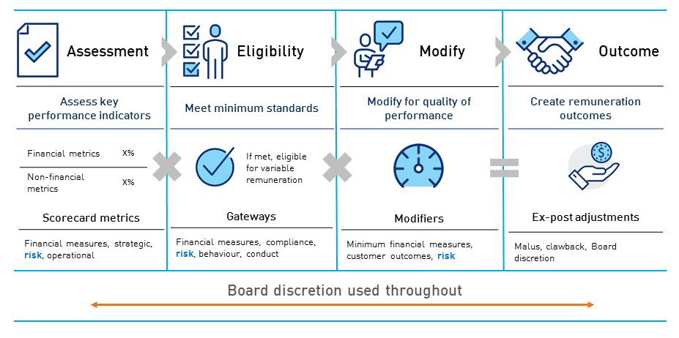

* 1. The Banking Executive Accountability Regime

In February 2018, the Banking Executive Accountability Regime (BEAR) was enacted.[6] This regime introduced heightened expectations of accountability for directors and senior executives of ADIs. The BEAR gives APRA authority to pursue clear consequences in the event of a material failure to meet those expectations and also imposes deferred remuneration obligations on certain executives to ensure any such failure results in adjustment of that deferred remuneration. Refer to **Figure 3** for a depiction of the structure of remuneration under the BEAR. Figure 3 can be compared against Figure 1 presented earlier in this chapter 1, to understand how typical industry practice is impacted under the BEAR requirements.

1. Minimum remuneration obligations under the BEAR – CEO of a large ADI[7]

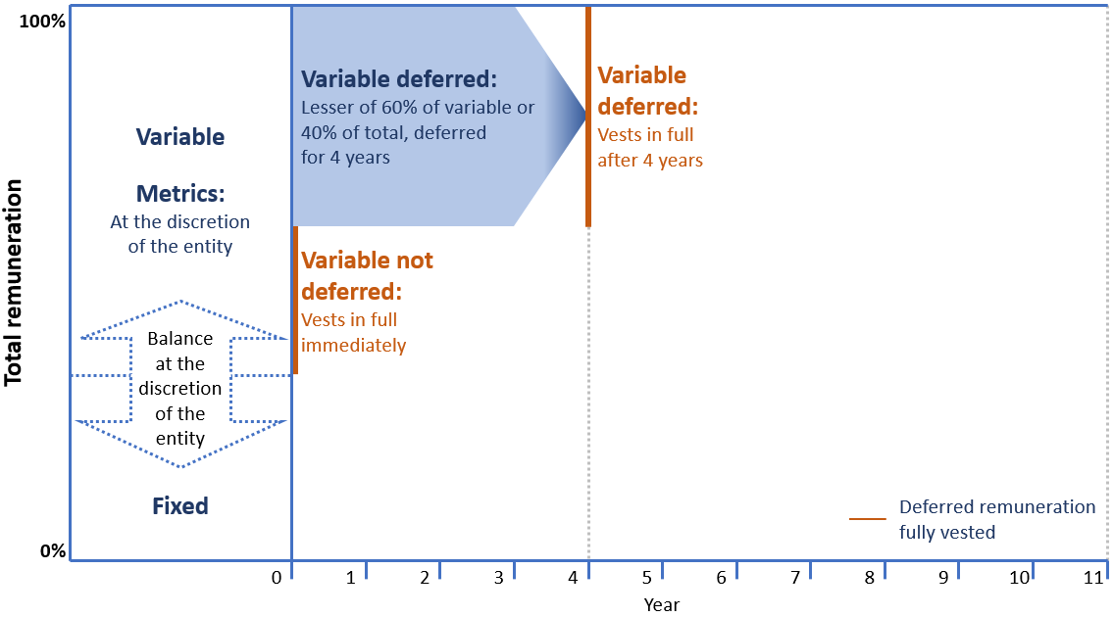

APRA considered the BEAR provisions in developing the proposals in this paper regarding deferral of variable remuneration. While the BEAR is currently limited to ADIs, the Royal Commission recommended that the accountability regime requirements be extended across the financial sector. In response, the Government has stated its intention to review the BEAR, including to extend it to insurance and superannuation entities.

APRA recognises that requirements proposed in draft *Prudential Standard* *CPS 511 Remuneration* (draft CPS 511) could apply to ADIs only to the extent they are not inconsistent with the BEAR. This issue is discussed in chapter 4 of this paper.

APRA welcomes any feedback on the application of the proposed draft CPS 511 in the context of the existing BEAR requirements and potential future extension and refinement of the BEAR.

* 1. APRA’s proposed approach

APRA proposes to shift the remuneration requirements from the governance standards in CPS 510 and SPS 510 (CPS/SPS 510) into a stand-alone prudential standard covering ADIs, general insurers, life insurers, private health insurers and RSE licensees. By elevating remuneration requirements into a separate prudential standard, APRA seeks to reinforce the need for industry to improve current remuneration practices.

APRA recognises that remuneration practices differ across segments of the financial industry; nevertheless, the basic elements of APRA's framework are applicable and appropriate to all types of entities. With the proposed removal of remuneration requirements from SPS 510, superannuation-specific issues of scope and terminology will be addressed through appropriate definitions and refinements within the new standard. However, there may be a need to adjust aspects of the proposed requirements for particular structures, such as fiduciary structures, primarily outsourced business models or entities with mutual ownership structures in order to avoid unintended consequences. APRA invites comments on any such issues and whether a separate remuneration standard for superannuation may be more appropriate.

APRA has also continued to take a predominantly principles-based approach, with more detailed prescription limited to the largest and most complex entities, where the potential industry impact of poor or inadequate remuneration practices can have the greatest impact.

The proposed approach in draft CPS 511 is based on consideration of better practice both domestically and internationally, and is reflective of what APRA considers to be reasonable in the current industry environment. However, if APRA’s requirements were to be in conflict with foreign legislation, those foreign requirements would prevail.

The key proposals in the draft standard are outlined in **Table 1** and in further detail in the subsequent chapters.

1. Key proposals in draft CPS 511

| Key Area | Current standard | Key proposed change | Discussion paper reference |
| --- | --- | --- | --- |
| Remuneration framework | Remuneration policy for senior executives and limited additional staff only. | Remuneration policy for all arrangements, supported by remuneration objectives and a broad framework. | Section 3.1 |
| Board oversight | The Board must approve the remuneration policy.  The Board has responsibility for reviewing and approving remuneration recommendations for senior executives and limited other staff. | The Board must approve the remuneration policy, actively oversee the remuneration framework, approve the remuneration of senior executives and other roles and ensure risk outcomes are reflected in remuneration outcomes. | Section 3.2 |
| Variable remuneration design | Variable remuneration for special categories of employees must be designed to allow adjustments to reflect business outcomes, risks inherent in business activities and incorporate appropriate time for performance to be realised. | Minimum design requirements for all employees, which promote prudent risk management and support remuneration objectives.  Financial measures limited to 50 per cent and individually capped at 25 per cent.  Constraints on deferral and vesting set for significant financial institutions (SFIs). | Chapter 4 |
| Outcomes management | Remuneration policy must allow the Board to adjust variable remuneration downwards to zero if appropriate for employees in special categories. | Require adjustments to remuneration outcomes so as to align with risk outcomes; stronger review and oversight.  Clawback to apply to senior roles in SFIs. | Chapter 5 |
| Review | Remuneration policy must be reviewed on a regular basis. | Annual compliance reviews and triennial effectiveness reviews of the remuneration framework. | Section 3.3 |
| Transparency | No requirements other than for ADIs (Pillar 3). | APRA to consult on measures in 2020. | Section 3.4 |

* 1. Addressing the Royal Commission recommendations

These proposals aim to address the remuneration-related recommendations made by the Royal Commission. The approach APRA has taken to addressing each recommendation is set out in **Table 2**.

1. Addressing the Royal Commission recommendations on remuneration

|  |  |
| --- | --- |
| Royal Commission recommendation | How APRA's proposals address the recommendation |
| **Recommendation 5.1**  APRA should give effect to the principles, standards and guidance set out in the Financial Stability Board’s publications concerning sound compensation principles and practices. | FSB Principles and Standards including the Supplementary Guidance have been reflected in draft CPS 511. |
| **Recommendation 5.2**  APRA should have, as one of its aims, the sound management by APRA‑regulated institutions of not only financial risk but also misconduct, compliance and other non‑financial risks. | Management of misconduct risk and other non-financial risks are reflected in draft CPS 511.  See Chapter 4 – Section 4.2. |
| **Recommendation 5.3**  APRA should:   * require APRA-regulated institutions to design their remuneration systems to encourage sound management of non-financial risks, and to reduce the risk of misconduct. | Management of misconduct risk and other non-financial risks are reflected in draft CPS 511.  See Chapter 4 – Section 4.2. |
| * require the Board of an APRA-regulated institution (whether through its remuneration committee or otherwise) to make regular assessments of the effectiveness of the remuneration system in encouraging sound management of non-financial risks and reducing the risk of misconduct. | APRA proposes criteria for effectiveness reviews which must occur every three years.  See Chapter 3 - Section 3.3. |
| * set limits on the use of financial metrics in connection with long-term variable remuneration. | The draft CPS 511 proposes to limit the use of financial metrics to 50 per cent.  Further detail in See Chapter 4 – Section 4.2. |
| * require APRA-regulated institutions to provide for the entity, in appropriate circumstances, to clawback remuneration that has vested. | Under draft CPS 511, SFIs are required to have clawback; other entities are required to implement appropriate adjustment mechanisms.  See Chapter 5. |
| * encourage APRA-regulated entities to improve the quality of information being provided to Boards and their committees about risk management performance and remuneration decisions. | Draft CPS 511 includes new requirements for the Board Remuneration Committee to obtain comprehensive reporting and sufficient information to better inform decisions around remuneration  See Chapter 2. |

* 1. Balancing APRA’s objectives

The APRA Act requires APRA to balance the objectives of financial safety and efficiency, competition, contestability and competitive neutrality, and, in balancing these objectives, promote financial system stability in Australia. APRA considers that, on balance, the proposals in this discussion paper will enhance prudential outcomes, improve financial safety and promote financial system stability while not unduly impacting the other objectives.

1. Primary objectives and other considerations

|  |  |  |
| --- | --- | --- |
| PRIMARY OBJECTIVES | | |
| Financial safety | | Financial system stability |
| **Improved:** The proposals strengthen the prudential requirements for remuneration. This is expected to encourage behaviour that supports effective management of risk and the long-term soundness of entities, taking into account financial and non-financial risks. | | **Improved:** The increased attention to non-financial risks as a material vulnerability is likely to improve incentives and accountability for the way entities manage these risks. |
| OTHER CONSIDERATIONS | | |
| Efficiency | **Increased:** The proposals may reduce efficiency in the short-term as they intervene in some existing remuneration arrangements put in place to attract and retain executives and staff. However, the proposals are expected to improve long-term efficiency by better aligning stakeholder incentives and providing greater transparency and accountability. | |
| Competition | **No change:** The proposals are not expected to disadvantage smaller entities relative to their larger competitors, as APRA is proposing a proportionate approach to implementation of the new requirements. The proposals are expected to better align the incentive arrangements of employees with the interests of consumers or beneficiaries, and be neutral for competition. The proposals may impact the ability of regulated entities to compete with unregulated entities for skilled executives and staff. | |
| Contestability | **Reduced:** The proposed standard may have a negative impact on the ability of new entrants to enter regulated industries. The proposals may make it more difficult for these new entrants to hire executives and staff with relevant skills. | |
| Competitive Neutrality | **No change**:The proposed standard does not create advantage for public sector entities relative to other market participants.[8] | |

* 1. Timetable and next steps

APRA intends to finalise the new standard in late 2019 or early 2020. APRA expects that the requirements will come into force from 1 July 2021, although APRA will consider the feedback from consultation on implementation challenges in determining the appropriate start date. For the private health insurance industry, APRA expects that the new requirements will not apply until 2022. Upon commencement of new standard, APRA will repeal the remuneration related requirements in CPS/SPS 510.

For the period between the finalisation of the new standard and its effective date, APRA expects that entities will review their existing remuneration frameworks so that any new remuneration arrangements and practices are consistent with the spirit and intent of the new standard. APRA will also consider whether appropriate transitional arrangements are needed for any aspects of the new requirements.

A prudential practice guide and reporting and disclosure standards will be developed for consultation in early 2020.

Given the significance of the proposals and potential industry impact, APRA intends to conduct a review of the effectiveness of the prudential standard three years from its initial effective date.

1. Scope of application
   1. Significant financial institutions

Consistent with the current remuneration requirements in CPS/SPS 510, draft CPS 511 applies to all APRA-regulated entities. However, APRA believes it is appropriate to be more prescriptive in certain areas for larger and more complex entities, where the payment of significant variable remuneration is more prevalent and where complex operations may lead to more opaque accountability.

In draft CPS 511, APRA is proposing to define a new category of APRA-regulated entities termed significant financial institutions (SFIs). Criteria for inclusion could be based on measurable indicators such as asset size, presence in certain markets, membership of a conglomerate group or the provision of critical services. The threshold associated with each of these indicators may also vary by industry to recognise structural differences within each industry.

APRA’s proposed starting point is to identify entities according to asset size, as set out in **Table 4**. Asset size is a simple measure used in many other contexts as a proxy for sophistication, complexity and impact on industry and the community.

The proposed thresholds for ADIs and insurers to be considered a SFI are designed generally to capture the publicly listed entities, material foreign owned banks and others of similar size and sophistication. For RSE licensees, APRA has intended to include the larger funds with more complex in-house operations which are more likely to incorporate variable remuneration into their frameworks.

1. Proposed approach to identifying significant financial institutions

|  |  |  |  |
| --- | --- | --- | --- |
| Industry | Asset size | Number of entities | Percentage of industry assets |
| ADIs | >$15 billion | 21 | 94 |
| General and life insurers | >$10 billion | 8 | 68 |
| RSE licensees | >$30 billion | 17 | 66 |
| Private health insurers | Not applicable | Not applicable | Not applicable |

APRA seeks feedback on the proposed approach to identifying SFIs, including alternative criteria.

APRA is proposing not to include private health insurers (PHI) in the SFI categorisation at this time. APRA is in the process of modernising the PHI prudential framework more broadly, and will reassess the need to include PHIs as SFIs at a later date.

Section 4.3 of Chapter 4 and Section 5.2 of Chapter 5 set out the additional requirements applied to SFIs. The additional requirements include:

* specific deferral periods and portions of variable remuneration to be held to validate outcomes; and
* recoverability of remuneration through clawback to apply to senior roles and highly paid material risk takers.
  1. Special role categories

Under CPS/SPS 510, remuneration requirements apply only to three categories of persons, namely senior executives, other persons who may have a material impact on the entity's soundness and risk and control functions. Consistent with international practice, senior executives, 'material risk takers' and risk and control functions require heightened scrutiny. The variable remuneration of these individuals is generally subject to deferral.

The proposed CPS 511 maintains these categories, with some refinement, and they are collectively termed special role categories. **Table 5** provides a comparison of the current and proposed categories of persons.

There are two main refinements that have been made to the categories. The persons captured under ’senior executives’ has been clarified by adopting 'senior manager' as defined in CPS/SPS 520. This seeks to provide better alignment with ‘senior executive responsibility’ and Accountable Persons under the BEAR.

Material risk takers are no longer limited to those individuals with a high share of performance-based pay, and the scope of impact is directed at an entity's overall soundness, rather than being limited to financial soundness, recognising the importance of non-financial risks in assessing risk and performance. APRA is proposing to remove the consideration of collective impact of groups of individuals, given that the proposed CPS 511 would apply to the remuneration arrangements of all employees.

Requirements in draft CPS 511 pertaining to persons in special role categories are discussed in subsequent chapters of this paper. These requirements are largely imposed on the Board Remuneration Committee and the Board itself. APRA has taken this approach to provide the necessary level of attention that these important roles warrant.

1. Comparison of current and proposed special role categories

|  |  |
| --- | --- |
| Current: persons covered by the Remuneration Policy – CPS/SPS 510 | Proposed: special role categories – draft CPS 511 |
| CPS 510 – CEO, direct reports to the CEO and other persons whose activities affect the financial soundness of the entity.  SPS 510 – responsible persons excluding actuaries and auditors. | Senior managers as defined in CPS 520 and SPS 520. |
| Material risk takers – all other persons for whom a significant portion of total remuneration is based on performance and whose activities individually or collectively, may affect the financial soundness of the entity. | Material risk takers – all other persons whose activities have a material potential impact on the entity’s performance, risk profile, long-term soundness. |
| Risk and financial control personnel. | Risk and financial control personnel. |

Under the proposed CPS 511, the Board Remuneration Committee would need to assess and make recommendations to the Board on the variable remuneration arrangements and outcomes of individual senior managers and highly paid material risk takers, as well as for other material risk takers and risk and control personnel on a collective basis. The new proposals require the Board Remuneration Committee to obtain sufficient information to evaluate arrangements and their alignment with the entity’s remuneration objectives. For individuals in risk and control functions, the entity is required to collectively evaluate whether the variable remuneration arrangement aligns with the objectives of the individual’s role and function.

Entities would be required to ensure that individuals in special role categories, as a condition of employment, would be prohibited from hedging any equity-linked deferred variable remuneration. This requirement is intended to reinforce the 'skin-in-the-game' for these individuals.

* 1. Group application

Under CPS/SPS 510, an entity operating in a group structure may apply a group remuneration policy and use a group Board Remuneration Committee. This approach has been carried forward into the proposed CPS 511. APRA invites industry to comment on any practical challenges in applying the new proposals on a group basis.

1. Governance and accountability
   1. Remuneration framework

CPS/SPS 510 focus primarily on policy and process for a limited set of employees. While good policy and process is important, ultimately the test for an effective framework is whether it produces appropriate outcomes.

The Royal Commission and APRA reviews found that remuneration frameworks and practices did not consistently encourage behaviour that supports effective risk management and that reduces the risk of misconduct. For example, most entities did not incorporate non-financial or risk-adjusted metrics in LTI frameworks and the risk function had a limited role in the remuneration design and risk assessment process.

A significant gap in current industry practice is that many entities lack a complete view of remuneration structures and processes across the entity, ranging from senior management through to front-line customer or member facing staff. This gap can undermine an entity’s remuneration and conduct objectives due to the absence of a complete view of remuneration, the incentives created and linkages with other important structures and processes within the entity.

As a result, in draft CPS 511, APRA is proposing to expand the scope to cover the entire remuneration framework. A framework is not simply a policy but is the entire set of policies, systems, processes and practices which support remuneration outcomes. Under the proposals, an entity is required to set out appropriate remuneration objectives that act as the foundation for the framework. These objectives must underpin effective management of all risks and the pursuit of sustainable performance and long-term soundness of an entity.

* 1. The role of the Board and Board Remuneration Committee

Under the existing requirements, the Board approves the remuneration policy and is only required to adjust performance based remuneration to protect the entity financially or respond to unforeseen circumstances. The requirement for stronger Board oversight and engagement is a key development noted internationally, with greater attention being given to risk related incentives for variable remuneration.[9]

APRA is proposing to strengthen Board requirements with respect to accountability and oversight of remuneration, by mandating:

* Board responsibility for the overall remuneration framework;
* Board involvement in remuneration arrangements for persons in special role categories. While largely reflecting current industry practice, the new standard will require Boards to approve the remuneration outcomes of all persons in special role categories on an individual and collective basis; and
* that the Board establish a clear link between remuneration arrangements and prudent risk management of the entity to ensure risk outcomes are reflected in remuneration outcomes for persons in special role categories. The practice of consulting the Board Risk Committee and Chief Risk Officer or similar role is already standard in a number of entities, although effectiveness in practice is more variable.

APRA’s intention is to address key conclusions of the APRA Reviews and the Royal Commission that there is a need to strengthen Board oversight and governance of remuneration, access to information, coordination in making remuneration decisions and senior management accountability. In particular, by requiring the Board to approve key remuneration decisions, they will need to be more actively involved in dealing with misconduct or compliance issues when variable remuneration outcomes are being determined.

* 1. Regular reviews of the remuneration framework

APRA has previously identified gaps in the scope, adequacy and thoroughness of entities' reviews of their remuneration frameworks. As a result, the proposals strengthen the current review requirements under CPS/SPS 510 to ensure continuous improvement of frameworks and their ongoing effectiveness.

Similar to requirements for risk management framework reviews under CPS 220, entities would be required to conduct a triennial effectiveness review, with a prescribed scope. The reviews would be undertaken by operationally independent, appropriately experienced and competent persons, and cover a number of specified components in their scope. The Board Remuneration Committee must then take action to ensure review findings are adequately addressed and implemented in a timely manner.

* 1. Transparency

Public disclosure of information on remuneration is designed to provide transparency and accountability for remuneration practices, particularly where senior executives receive what is considered very large amounts of remuneration. Executive and director remuneration is required to be disclosed in public company financial reports. ADIs are also subject to remuneration disclosure requirements as part of APRA's implementation of 'Pillar 3' of the Basel capital framework.[10]

A commonly expressed view is that existing remuneration disclosures are extensive, yet do not contain meaningful information for investors or the community. Existing disclosures provide information on outcomes, but do not typically detail the incentives provided or risk adjustments made to executives or other staff. The Royal Commission highlighted the importance of data to understand the remuneration practices of entities, importantly distinguishing between quantity and quality of data. For APRA, disclosure requirements directly support prudential regulation, therefore improved transparency in remuneration will directly intensify APRA’s supervision of it.

APRA intends to propose additional requirements for reporting and public disclosure of executive remuneration. Consultation on such requirements, as well as prudential guidance that would support implementation of the proposed CPS 511, will occur following consultation on draft CPS 511.

APRA invites feedback on whether it should impose additional disclosure requirements on all regulated entities. This could include requirements for:

* publication of each entity's remuneration policy; and
* publication of the specific performance metrics used to set variable remuneration for senior executives and their current and historical values.

While existing disclosures include a summary of material that would be in an entity's remuneration policy, publication of the actual policy would provide greater accountability and insight into how the Board viewed the incentives and accountabilities within its remuneration framework. Publication of actual performance metrics would allow investors and other analysts to determine whether executives had met their performance hurdles in a given period, to the extent these were set based on objective, quantitative measures, and the extent of discretion applied to the quantitative outcomes.

1. Remuneration design
   1. Key considerations in remuneration design

Internationally, regulatory measures for remuneration at financial institutions have generally focused on variable remuneration. The reasons for this include:

* variable remuneration arrangements often emphasise short-term profitability at the expense of prudent risk management and long-term soundness;
* variable remuneration, particularly at a senior management level, may form a material part of total remuneration; and
* the nature of the risks in many financial institutions can extend over long durations, and as a result may not be adequately captured in the design of existing variable remuneration structures.

Unlike some other jurisdictions, APRA is not proposing to impose a cap on variable remuneration, or to prescribe the proportion of variable and fixed remuneration. There is not sufficient evidence that these approaches materially improve remuneration practices, and they risk creating significant distortions in private employment arrangements and markets. There is also evidence that these types of measures can be circumvented.[11] Moreover, there is no evidence that the level or extent of variable remuneration in the financial sector is out of line with the broader commercial sector or international peers.

APRA is, however, proposing minimum standards relating to measures used to assess performance, as well as the time period over which variable remuneration must be deferred. These proposals are illustrated in section 4.3.

In developing its approach, APRA has considered a number of recommendations and observations of the Royal Commission, the APRA Reviews and the FSB. The Royal Commission recommended that APRA require entities to design their remuneration arrangements to encourage sound management of non-financial risks, reduce the risk of misconduct and limit the use of financial metrics in connection with long-term variable remuneration. Further, remuneration should be adjusted for all types of risk, including misconduct risk and there should be symmetry between risk and remuneration outcomes.[12]

**Table 6** compares current Australian banking practice, better international banking practice and APRA’s proposals under draft CPS 511, with respect to key elements in variable remuneration design. [13]

1. Variable remuneration design practices of Australian banks, international banks and under APRA’s proposals

|  |  |  |  |
| --- | --- | --- | --- |
| Element | Current industry practice in Australia | Better international practice | APRA’s proposal |
| Deferral of a portion | 3-4 years.  (4 years under the BEAR). | 7 years deferral for senior managers with pro-rata vesting after 3 years. | 7 years deferral for the CEO with pro-rata vesting after 4 years. |
| Performance assessment | STI – 50% weighting for financial metrics.  LTI – 100% weighting for financial metrics. | 50% - 75% weighting for financial metrics. | Maximum 50% weighting for financial metrics. |
| Adjustment tools | Moderate use of malus and clawback not widely used. | Malus used and clawback can be applied up to 10 years after the award. | Require entities to have malus and clawback in place and use these when appropriate. |

The above table, in conjunction with the observations made in the Royal Commission and APRA Reviews, indicates that current Australian industry practice is some way from international better practice. The proposals in draft CPS 511 seek to strengthen remuneration practices and elevate the standard in the APRA-regulated financial industry overall.

In particular, APRA’s proposals aim to strengthen the performance assessment measures for LTIs and in turn bring a more balanced approach to how risks are assessed for remuneration purposes and reflected in remuneration outcomes.

* 1. Measurement of outcomes – financial and non-financial measures

A key principle of remuneration design is achieving a balance of outcomes relating to effective risk management, sustainable performance and long-term soundness.

However, current industry practice shows that the balance in managing financial and non-financial risks has not translated to measures in remuneration design. As outlined in chapter 1, existing variable remuneration arrangements, particularly LTIs, are often largely or wholly based on financial metrics measured over a defined time period and have not allowed for non-financial outcomes (such as poor customer outcomes) or risks to be given sufficient weight in assessing performance.

APRA is proposing to limit the use of financial performance measures, and promote a broader suite of measures of performance, including non-financial and risk-based measures.

For this purpose, financial measures that are not risk-adjusted and relate to financial performance, such as share price, total shareholder return, profit, revenue, sales and other volume measures are included in the limit. It is not APRA’s intent to limit financial measures that are risk-adjusted and relate to financial soundness such as risk-adjusted capital adequacy, risk-adjusted cost of funding and RSE licensee investment return measures, as examples.

There is no clear consensus on the most appropriate balance of financial and non-financial measures, and so APRA has taken the view that an equal weighting is a reasonable starting point. Specifically, under APRA's proposals entities must ensure that financial performance measures make up no more than 50 per cent of the weighting of total performance criteria used to determine variable remuneration, and any individual financial performance measure comprises no more than 25 per cent of the total measures used. This requirement would apply across the entire organisation and across the total amount of variable remuneration (not individual components).

APRA believes this shift in approach is necessary and achievable in light of international experience. For example, the FSB has reported recently that in 16 of 20 jurisdictions, banks link compensation to non-financial risks through greater use of scorecards containing a mixture of financial and non-financial metrics and increased use of gateways.[14] The FSB Progress Report notes that examples of non-financial metrics have been observed across international jurisdictions in the following categories:

* effectiveness and operation of control and compliance;
* customer outcomes;
* market integrity objectives;
* reputation; and
* alignment with firms’ strategies or values.

APRA has reviewed the use of financial and non-financial metrics in variable remuneration design from a sample of 17 large banks from Canada, Europe, United Kingdom (UK) and United States (US). The key finding is that non-financial metrics are prevalent in STI design. Across the UK banks in the sample, the weighting of non-financial metrics in variable remuneration design (the combination of STI and LTI) ranged from 25 per cent to 50 per cent, with an average weighting of around 40 per cent. This result also reflects the UK's focussed regulatory supervision over appropriately balanced scorecard metrics.

**Table 7** provides typical non-financial measures observed from this international sample, and presents a mix of both outcome and input focused measures. While the table illustrates the range of measures that could be considered by Australian entities, APRA expects practice in this area to be further refined over time.

1. Examples of non-financial metrics used in variable remuneration in large international banks in the last financial year**[15]**

Blue highlight indicates non-financial metrics found in LTI design.

|  |  |  |  |  |
| --- | --- | --- | --- | --- |
| Non-financial measure | Canada | Europe | UK | US |
| **Effectiveness and operation of control and compliance** | | | | |
| Conduct |  | ***✓*** | ***✓*** | **✓** |
| Risk | **✓** | **✓** | **✓** | **✓** |
| **Customer outcomes** | | | | |
| Customer/client/stakeholder satisfaction | **✓** | **✓** |  | **✓** |
| Customer loyalty | **✓** |  |  |  |
| Service quality/customer complaints |  | **✓** | **✓** |  |
| **Market integrity objectives** | | | | |
| Innovation |  | **✓** | **✓** |  |
| Sustainability |  | **✓** | **✓** | **✓** |
| **Reputation** | | | | |
| Brand and reputation |  | **✓** |  | **✓** |
| Net trust score |  |  | **✓** |  |
| **Alignment with strategy and values** | | | | |
| Cross-bank collaboration |  | **✓** | **✓** |  |
| Culture metrics |  | **✓** | **✓** |  |
| Diversity |  | **✓** |  |  |
| Employee engagement |  |  | **✓** |  |
| Entity specific strategic priorities | **✓** |  | **✓** | **✓** |
| Leadership/effective management/teamwork |  | **✓** |  | **✓** |

An entity will be expected to select non-financial metrics appropriate for its business objectives and that support sound incentives. Moreover, some metrics will be better suited to one APRA-regulated industry over another. In this light, APRA does not intend to identify which types of non-financial metrics are more appropriate or favourable. However, an entity must be able to demonstrate how its selection of non-financial metrics, along with its financial metrics, drive long-term soundness, including, where relevant, the interests of its beneficiaries.

Concerns about the use of non-financial metrics tend to revolve around whether the activities being measured are sufficiently closely linked to the entity's performance and the objectivity and independence of the measurement, such that they are not open to manipulation. APRA has found that some regulated entities have dealt with these challenges and put in place reliable, independently verified non-financial measures.

Some investor organisations are concerned about the use of non-financial metrics to drive higher remuneration in the absence of sound financial returns. APRA's view is that these issues can be managed through sound remuneration design, such as by limiting the weighting of non-financial measures in scenarios with adverse financial outcomes. Moreover it is up to Boards to exercise their discretion to ensure this occurs.

These proposals focus on the balanced scorecard as the mechanism to improve inclusion of non-financial risks in remuneration performance measures. There may be other ways to achieve the same result. APRA is aware of emerging industry practices and that one preferred approach of some entities is to rely on Board discretion, using modifiers to determine and make adjustments. APRA seeks industry feedback on other options to ensuring that non-financial risks, including misconduct risk, are explicitly included in remuneration measures. In particular, APRA seeks comments on the merits of approaches that rely on Board discretion through the application of modifiers, rather than limits on the inclusion of financial metrics in scorecards.

Finally, when designing the objectives for remuneration arrangements, and in particular when setting financial measures, draft CPS 511 requires regulated entities to take appropriate steps to assess and mitigate conflicts of interest that may appear or be created in remuneration design. This requirement is intended among other things to avoid remuneration structures which focus primarily on volume and sales, and their effect in creating conflicts of interest among staff receiving variable remuneration. The Royal Commission observed the duty to act in the customer’s best interest to be inadequate in its case studies that revealed conflicts between an entity and customer.

* 1. Deferral and vesting

To provide appropriate incentives for managing risks prudently while meeting performance objectives, variable remuneration should be sensitive to the time horizon of risk. In financial services, the outcomes of business activities and risks are often realised over a number of years. In addition, given the potentially longer-term nature of misconduct risk, sufficient time needs to be available to make necessary adjustments to variable remuneration if misconduct is uncovered.

For entities designated as SFIs, APRA is proposing more extensive provisions. For senior managers and highly paid material risk takers in these entities, a substantial portion of variable remuneration is to be deferred. Specifically, where the variable remuneration is $50,000 or more, APRA proposes to prescribe the minimum number of years it is to be held, vesting conditions and the minimum deferral periods.

1. Additional holding requirements for variable remuneration in SFIs

|  |  |  |  |
| --- | --- | --- | --- |
| Special role category | Substantial portion to be held | Deferral period without vesting | Deferral period with pro-rata vesting |
| CEO | 60% of total variable remuneration. | Four years from the inception of the variable remuneration arrangement. | Three years thereafter. |
| Senior manager other than the CEO and highly paid material risk taker | 40% of total variable remuneration. | Four years from the inception of the variable remuneration arrangement. | Two years thereafter. |

There are two categories for this purpose; the first being the CEO and the second covering any senior manager other than the CEO and a highly paid material risk taker. The second category includes a broad range of executives and may capture some employees that while highly paid, have a narrow set of responsibilities, such as traders. All such employees will now be subject to the six year deferral period. APRA seeks feedback on the challenges that this approach may present.

The substantial portions are based on the requirements for large ADIs under the BEAR, which were aimed at incentivising a person to make decisions taking account of longer term effects. APRA's assessment of the appropriate length of deferral is based on a number of factors.

First, a deferral period of seven years for a CEO provides an appropriate time horizon for negative performance and risk outcomes to emerge. The FSB Progress Report notes that there is often a discovery time lag for significant incidents such as mis-selling or inappropriate credit risk decisions to be several years. For example, in relation to misconduct involving the manipulation of LIBOR, there was evidence of misconduct as early as 2005; however, issues were not raised with regulators until late 2007 and enforcement action was completed in 2012.[16]

Similarly in many case studies considered by the Royal Commission, the relevant misconduct was revealed only after some or all of the accountable executives had left the organisation, and their deferred remuneration had vested. In the ‘fees for no service' conduct matter, the severity of the misconduct only became apparent several years after the introduction of ongoing fee arrangements.[17]

While clawback provisions are one mitigant to risks and poor outcomes that emerge after remuneration amounts have been paid out, in APRA's view there are sufficient uncertainties about the practical use of clawback, such that it is yet to be proven as a reliable means to adjust remuneration outcomes on a routine basis. A longer deferral period, in conjunction with clawback mechanisms, provides greater assurance that adverse performance outcomes will be reflected in remuneration.

Second, a longer deferral period is consistent with international best practice. In the recently published FSB Progress Report, 16 out of 20 FSB jurisdictions set requirements or expectations for the number of years compensation needs to be deferred for senior executives of banks. FSB member jurisdictions have reported holding periods of between three and ten years.[18] Nine out of 20 jurisdictions reported the upper-range for deferral to be between five and seven years. The UK has implemented a minimum deferral period of seven years for certain senior executives.

In the United Kingdom and other European countries, post-vesting retention periods are prescribed. The STI and LTI plans must include performance and deferral periods of up to seven years for CEOs, and up to five years for other senior managers and material risk takers. The variable remuneration is then retained for a further 12 months following the end of the deferral period, resulting in overall holding period of up to eight years for CEOs and up to six years for senior managers.[19]

Having said this, APRA recognises that there can be trade-offs to longer deferral periods, including reduced mobility of senior executives.

APRA is interested in feedback on the potential impact of longer deferral periods. For example, if an outcome of the proposals was a move to a greater level of fixed remuneration, this could blunt overall performance incentives.

Illustration of APRA’s proposals

**Figure 4** depicts the proposed constraints on the remuneration structure for the CEO of a SFI under APRA’s proposals. The figure reflects the measures used to assess performance and the deferral and vesting of variable remuneration. Figure 4 can be compared against Figure 1 and Figure 3 in Chapter 1, to understand how APRA’s proposals impact current industry practice.

1. Minimum remuneration structure under APRA’s proposals – CEO of a SFI

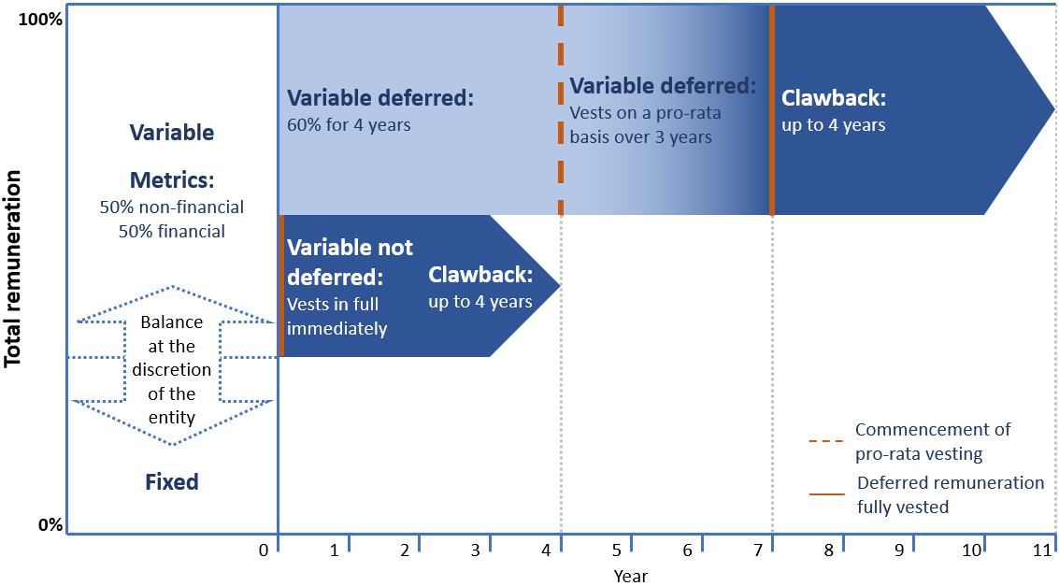

* 1. Interaction with the BEAR

Some of APRA's proposals with respect to the design and operation of variable remuneration relate to the requirements set out for ADIs under the BEAR. In particular, where applicable, the BEAR imposes a minimum deferral period of four years for a portion of variable remuneration for Accountable Persons. APRA’s proposals prescribe a longer period for SFIs. The mechanics of the calculation of amounts to be deferred under draft CPS 511 also differs slightly from the BEAR. The criteria for malus under draft CPS 511 and the BEAR also differ.

The minimum deferral requirements in the BEAR are not intended to preclude ADIs from voluntarily adopting longer deferral periods. Indeed, APRA has previously expressed concern that many entities seem to have adopted the BEAR provision as a default setting, rather than considering the appropriate set of arrangements for their own circumstances. As noted above and as evidenced by the Royal Commission, many risks have taken considerably longer to crystallise than the minimum deferral periods under the BEAR.

Nevertheless, as stated in section 1.3, APRA recognises that the interaction of draft CPS 511 with the BEAR requirements could cause some difficulty. As a result, APRA is proceeding to consult on its preferred approach to deferral and other matters, and seeks feedback on the interaction with the BEAR. APRA believes the longer deferral periods are an important component of what is needed to strengthen remuneration practices in SFIs. APRA intends to work with the Government to seek legislative amendments to the BEAR in implementing the proposed deferral requirements under CPS 511 and will review any other areas where the BEAR and CPS 511 are not fully aligned.

The Royal Commission recommended that provisions modelled on the BEAR should be extended to all APRA-regulated entities, and the Government has stated its intention to implement this recommendation.[20] APRA will work closely with the Government, including seeking potential legislative adjustments, to ensure that the extension of the accountability regime will take into account how remuneration aspects work with APRA’s prudential standard on remuneration.

1. Variable remuneration outcomes
   1. Oversight and adjustments

A key finding of the industry-wide review conducted as input to APRA's 2018 Information Paper was that there was an absence of significant downward adjustments to remuneration at executive level.[21] Downward adjustments made to lower-level staff were often not reflected in the pay of more senior executives. APRA's Reviews also found that:

* in part, the reluctance to apply Board discretion and judgement has been due to a lack of comprehensive information to support robust decisions;
* where entities have made adjustments, this typically does not extend beyond in-year adjustments to short-term variable remuneration outcomes;
* remuneration deferral periods are insufficient compared to the time taken for long-term risks to crystallise, rendering malus provisions ineffective (e.g. cases of misconduct highlighted in the Royal Commission); and
* across the majority of entities, the absence of clawback provisions limited the ability to apply remuneration consequences for longstanding matters.

An analysis of market data supports this view. **Figure 5** shows the average per cent of target STI paid out to the CEOs, CFOs and CROs of large and complex Australian financial institutions, after assessing outcomes and applying risk-based adjustments. In this respect, target STI is the total remuneration an executive would expect to receive if they meet their objectives. In the years prior to the CBA AUSTRAC matter and the Royal Commission, which resulted in increased scrutiny of executive pay, executives received on average 96 per cent of their target STI. This fell to 74 per cent in the last two years, but only after public attention had significantly focused on the relationship between executive pay and misconduct. Prior to the period of increased scrutiny, risk-based adjustments to these outcomes were rarely occurring, an outcome inconsistent with the expectations of customers, investors and regulators.

APRA intends to ensure that remuneration pay-outs remain sensitive to risk outcomes into the future, once the impact of the current events dissipates.

1. Payout trends of bank and insurance executives

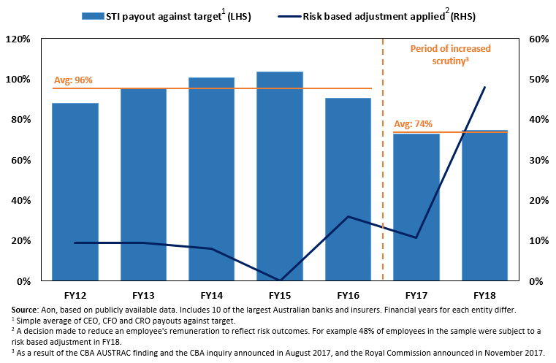

APRA is proposing to introduce specific requirements for the application and oversight of adjustments to variable remuneration outcomes.

Under draft CPS 511, entities will be required to:

* ensure that adjustments to variable remuneration to reflect performance and risk outcomes are being made; and
* set minimum criteria for adjusting any deferred variable remuneration through application of malus, including in response to risk management failures, misconduct or significant adverse outcomes for beneficiaries, among other things.
  1. Clawback

APRA is proposing that SFIs implement clawback mechanisms to adjust variable remuneration outcomes for persons in special role categories. The aim is to strengthen the entity's ability to adjust remuneration outcomes to reflect performance outcomes, both pre- and post-vesting. APRA is proposing that clawback provisions be determined in advance for variable remuneration (STIs and LTIs). The clawback time periods and application criteria proposed are based on international better practice and reflect what APRA considers as reasonable for variable remuneration to be recovered following release or payment.

**Table 9** compares clawback practices across jurisdictions.

1. International regulation and market practice on clawback design

|  |  |  |
| --- | --- | --- |
|  | Regulation | Application (market practice) |
| **Canada** | Office of the Superintendent of Financial Institutions requirements consistent with the FSB Principles for Sound Compensation. | Typical market practice includes clawback provisions. Time periods for clawback vary in practice, ranging from twelve months to three years. |
| **Europe** | European Banking Authority guidelines on sound remuneration policies require entities to be able to apply clawback to 100 per cent of total variable remuneration. The period should at a minimum cover deferral and retention periods – five years deferral and one year retention period for senior managers in significant institutions. | Typical market practice includes clawback provisions. |
| **UK** | Material risk takers who perform a Prudential Regulation Authority senior management function are subject to clawback provisions for a period of up to seven years from the date of grant, extended to ten years if under investigation. | Clawback applied to vested or paid awards for a period of seven years from the grant date. This may be extended to ten years in the event of ongoing internal/regulatory investigation at the end of the seven year period. |
| **US** | The US Securities and Exchange Commission and Federal Reserve Guidelines do not provide any prescriptive clawback requirements. | FSB Principles for Sound Compensation is referenced with varying market practice. There are examples of clawback periods of up to seven years after the award has been made. |

1. Clawback requirements for CEOs in international jurisdictions and under APRA’s proposals

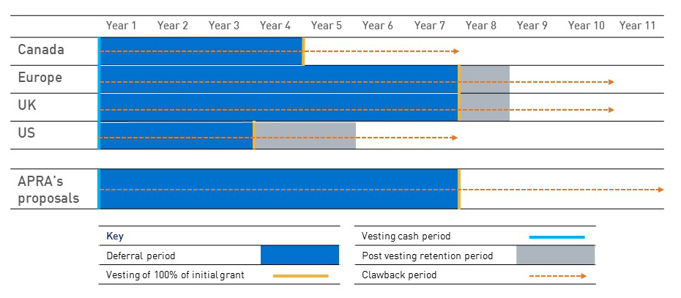

In **Figure 6**, the most conservative and lengthy periods have been compared for consistency. Under APRA’s proposals, deferral and clawback requirements are shown for a CEO of a SFI. Vesting period is shown as the time when 100% of the initial grant has vested.

APRA has taken a conservative approach whereby SFIs must allow for variable remuneration to be recoverable for at least two years after the end of the deferral period, and a further two years where an individual’s circumstances are under investigation. This is a simpler approach, balancing both deferral and clawback periods to lift market practice closer to better practice observed internationally and allow sufficient time for adverse outcomes to be realised.

APRA recognises that there are practical difficulties with the use of clawback. The FSB Progress Report outlines that in-year adjustments tend to be the most commonly used tool and there may be legal difficulties in implementing clawback in practice in certain jurisdictions and circumstances.

However, the fact that clawback may be an imperfect tool to effect *ex post* remuneration adjustments in all circumstances is not a sufficient argument to omit this tool from senior executive remuneration arrangements. That being said, longer deferral periods could potentially be used as a substitute where clawback is seen as impractical. APRA seeks feedback on the possibility of including prudential requirements that support entities extending deferral periods as a substitute for the use of clawback.

1. Consultation
   1. Request for submissions

APRA invites written submissions on the proposals set out in this Discussion Paper.

Written submissions should be sent to [PolicyDevelopment@apra.gov.au](mailto:PolicyDevelopment@apra.gov.au) by 23 October 2019 and addressed to:

General Manager

Policy Development

Policy and Advice Division

Australian Prudential Regulation Authority

* 1. Important disclosure requirements – publication of submissions

All information in submissions will be made available to the public on the APRA website unless a respondent expressly requests that all or part of the submission is to remain in confidence.

Automatically generated confidentiality statements in emails do not suffice for this purpose.

Respondents who would like part of their submission to remain in confidence should provide this information marked as confidential in a separate attachment.

Submissions may be the subject of a request for access made under the Freedom of Information Act 1982 (FOIA).

APRA will determine such requests, if any, in accordance with the provisions of the FOIA. Information in the submission about any APRA-regulated entity that is not in the public domain and that is identified as confidential will be protected by section 56 of the Australian Prudential Regulation Authority Act 1998 and will therefore be exempt from production under the FOIA.

* 1. Request for cost-benefit information

APRA requests that all interested stakeholders use this consultation opportunity to provide information on the compliance impact of the proposed changes and any other substantive costs associated with the changes. Compliance costs are defined as direct costs to businesses of performing activities associated with complying with government regulation. Specifically, information is sought on any increases or decreases to the compliance costs incurred by businesses as a result of APRA’s proposal.

Consistent with the Government’s approach, APRA will use the methodology behind the Regulatory Burden Measurement Tool to assess compliance costs. This tool is designed to capture the relevant costs in a structured way, including a separate assessment of upfront costs and ongoing costs. It is available at: <https://rbm.obpr.gov.au/home.aspx>.

Respondents are requested to use this methodology to estimate costs to ensure that the data supplied to APRA can be aggregated and used in an industry-wide assessment. When submitting their cost assessment to APRA, respondents are asked to include any assumptions made and, where relevant, any limitations inherent in their assessment. Feedback should address the additional costs incurred as a result of complying with APRA’s requirements, not activities that entities would undertake regardless of regulatory requirements in their ordinary course of business.

* 1. Consultation questions

Submissions are welcome on all aspects of the proposals in this discussion paper.

In addition, specific areas where feedback on the proposed direction would be of assistance to APRA in finalising its proposals are outlined in the **Table 10**.

1. Consultation questions

|  |  |
| --- | --- |
| **Remuneration framework** | * Is triennially an appropriate frequency for conducting independent reviews of the remuneration framework? * What areas of the proposed requirements most require further guidance? |
| **Board oversight** | * Are the proposed duties of the Board appropriate? * Are the proposed duties of the Board Remuneration Committee appropriate? |
| **Remuneration design** | * APRA is proposing that financial performance measures make up at least 50 per cent of variable remuneration measurement and individual financial performance measures are limited to 25 per cent. Is this an appropriate limit, if not what other options should APRA consider to ensure non-financial outcomes are reflected in remuneration? * What would be the impacts of the proposed deferral and vesting requirements for SFIs? For ADIs, what would be the impact of implementing these requirements in addition to the BEAR requirements? * Would the proposals impact the industry’s capacity to attract skilled executives and staff? |
| **Remuneration outcomes** | * What practical hurdles are there to the effective use of clawback provisions and how could these be overcome? Would requirements for longer vesting where clawback is not preferred address these hurdles? * What transitional provisions may be necessary for particular components of the new standard or for particular types of regulated entities? |
| **Transparency** | * What disclosures would encourage a market discipline in relation to remuneration practices? |

1. Policy options and estimated comparative net benefits

APRA is considering three policy options as set out in **Table 11**. Also set out below is APRA's preliminary analysis of the costs and benefits of each option.

1. Policy options

|  |  |
| --- | --- |
| Option 1 | No change to the prudential framework for remuneration. |
| Option 2 | Proposed changes to the prudential framework remuneration without proportionality applied. |
| Option 3 | Proposed changes to the prudential framework for remuneration with proportionality applied. |

Option 1 - No change to the prudential framework for remuneration

Under Option 1, APRA’s existing prudential framework in relation to remuneration would not change.

Entities would not incur any additional compliance costs. However, the potential costs of this option may be high.

The prudential framework on remuneration would continue to be too narrowly focused on financial risks only.

Entities are less likely to base their remuneration arrangements on a genuine and appropriate balance of financial and non-financial risks. This may result in poor customer or beneficiary outcomes and risks to the long-term soundness of those entities.

There is likely to be a further erosion of confidence and trust in the financial system. Entities would not have sufficient incentive to improve their remuneration arrangements in the absence of increased regulatory requirements and so inappropriate behaviour is likely to continue, contrary to expectations and the recommendations of the Royal Commission.

Option 2 - Proposed changes to the prudential framework for remuneration without proportionality applied

Under Option 2, entities would be required to base their remuneration arrangements on a genuine and appropriate balance of financial and non-financial risks.

Option 2 would provide both ex-ante and ex-post adjustment mechanisms for appropriate accountability. This would be consistent with expectations and the recommendations of the Royal Commission.

The advantages of enhancing the existing the prudential standards under Option 2 are clearer requirements for entities. Directors and relevant personnel would have greater understanding of their responsibilities and expectations of behaviour. Option 2 would likely drive behavioural changes that would reduce the incidence of poor risk and performance outcomes, promoting trust and stability in the financial system.

Entities would incur additional compliance costs. These compliance costs include an update to entities’ remuneration frameworks, including policies, procedures and practices. This update is likely to include additional training and education costs.

Legal costs are also likely to rise due to the need to amend remuneration arrangements. It is also expected the use of external remuneration consultants by entities is likely to increase which would also add to costs.

Compliance costs also involve new regulatory reporting forms which will require some system changes. The new regulatory reporting forms for remuneration will assist APRA to better assess how remuneration frameworks work in practice. APRA considers that each entity would have the existing data to complete the new regulatory reporting forms and that costs associated with any system changes would be limited in regard to existing infrastructure.

Option 2 would have higher proportionate cost effects on smaller entities as smaller entities would not be carved out of the additional requirements applicable to SFIs.

Option 3 - Proposed changes to the prudential framework for remuneration with proportionality applied

Under Option 3, entities would incur additional compliance costs similar to those under Option 2, however the provisions would have lower cost effects on smaller entities as smaller entities would be carved out of the additional requirements applicable to SFIs

1. Royal Commission into Misconduct in the Banking, Superannuation and Financial Services Industry (2019) *Royal* Commission *into Misconduct in the Banking, Superannuation and Financial Services Industry Final Report*; APRA (2018) *Prudential Inquiry into the Commonwealth Bank of Australia (CBA);* APRA (2018) *Information Paper* *Remuneration practices at large financial institutions*; APRA (2019) *Information Paper* s*elf assessments of governance, accountability and culture*.
2. Productivity Commission (April 2010) *Executive Remuneration in Australia*.
3. Financial Stability Board (formerly Financial Stability Forum) (April 2009) *Principles for Sound Compensation Practices*.
4. APRA (2018) *Information Paper* *Remuneration practices at large financial institutions.*
5. 5 See APRA's 2018 and 2019 Information Papers.
6. *Treasury Laws Amendment (Banking Executive Accountability and Related Measures) Act 2018*: <https://www.legislation.gov.au/Details/C2018A00005>
7. Figure 3 only applies to ADIs given that the BEAR requirements are made under the Banking Act.
8. To ensure alignment with Parliament’s original intention, APRA adopts the common usage of this term (for example, as found in the Commonwealth Competitive Neutrality Policy Statement).
9. FSB (2019) *Implementing the FSB Principles for Sound Compensation Practices and their Implementation Standards: Sixth Progress Report* (FSB Progress Report). This report addresses progress in implementing the FSB Principles and Standards on remuneration across 25 member jurisdictions. It covers regulation and supervision practice as well as current practices in selected large and significant Banks in each jurisdiction.
10. See *Prudential Standard APS 330 Public Disclosure* (APS 330) and Basel Committee on Banking Supervision Pillar 3 disclosure requirements - updated framework, December 2018.
11. EBA (November 2015) *Follow-up report* on remuneration and the use of allowances.
12. FSB principles 5 and 6 and Supplementary Guidance 7.
13. Better international practice has been sourced from FSB Progress Report and a sample of FY18 public disclosures of large banks in the UK, USA, Canada and Europe.
14. FSB Report (June 2019), page 40
15. Sourced from FY18 public disclosures for each entity in the sample.
16. FSB Progress Report, page 37.
17. Royal Commission Report page 358.
18. FSB (2019) *Implementing the FSB Principles for Sound Compensation Practices and their Implementation Standards: Sixth Progress Report* (FSB Progress Report).
19. UK practice outlined is based on the requirements under the UK Prudential Regulation Authority rulebook provisions 15:17 and the European Parliament capital regulation directive article 94 (l)(ii).
20. Australian Government (February 2019), *Restoring Trust in Australia's financial system: The Government response to the Royal Commission into Misconduct in the Banking, Superannuation and Financial Services Industry.*.
21. APRA Information Paper, page 21