Implementation of the Spectrum Pricing Review

Proposed guidelines and focus areas for change

March 2020

Canberra

Red Building   
Benjamin Offices  
Chan Street   
Belconnen ACT

PO Box 78  
Belconnen ACT 2616

T +61 2 6219 5555  
F +61 2 6219 5353

Melbourne

Level 32   
Melbourne Central Tower  
360 Elizabeth Street   
Melbourne VIC

PO Box 13112  
Law Courts   
Melbourne VIC 8010

T +61 3 9963 6800  
F +61 3 9963 6899

Sydney

Level 5   
The Bay Centre  
65 Pirrama Road   
Pyrmont NSW

PO Box Q500  
Queen Victoria Building   
NSW 1230

T +61 2 9334 7700 or 1800 226 667  
F +61 2 9334 7799

Copyright notice

[Creative Commons logo](http://i.creativecommons.org/l/by/3.0/88x31.png)

<https://creativecommons.org/licenses/by/4.0/>

With the exception of coats of arms, logos, emblems, images, other third-party material or devices protected by a trademark, this content is made available under the terms of the Creative Commons Attribution 4.0 International (CC BY 4.0) licence.

We request attribution as © Commonwealth of Australia (Australian Communications and Media Authority) 2020.

All other rights are reserved.

The Australian Communications and Media Authority has undertaken reasonable enquiries to identify material owned by third parties and secure permission for its reproduction. Permission may need to be obtained from third parties to re-use their material.

Written enquiries may be sent to:

Manager, Editorial Services  
PO Box 13112  
Law Courts  
Melbourne VIC 8010  
Email: [info@acma.gov.au](mailto:info@acma.gov.au)

Executive summary 1

Apparatus licence tax collection and formula 1

Draft spectrum pricing decision guidelines and focus areas 2

Consultation process and next steps 2

Issues for comment 3

Introduction 5

Recommendations of the Spectrum Pricing Review 7

Summary of Spectrum Pricing Review recommendations 7

Legislative and policy environment 10

Guiding legislation 10

Principles for spectrum management 10

Taxation regime 11

Observation: the role of spectrum pricing 11

Licence taxes 13

Apparatus licences and tax revenue 13

Spectrum licences and tax revenue 13

Draft spectrum pricing guidelines 14

Spectrum pricing decisions 14

Guiding principles 15

When will the ACMA consider changing prices? 16

Practical considerations 16

Focus areas 17

Prioritising the focus areas 17

Focus area 1: Large bandwidth and multiple (networked devices) requirements 18

Focus area 2: Sharing and low interference potential devices 20

Focus area 3: Defined approach to considering changes in taxes and opportunity cost pricing 22

Focus area 4: Consistency of pricing approach across geographic areas and bands 24

Focus area 5: New technologies and trials 28

Focus area 6: Transparency and ease of calculating taxes 29

Next steps 30

Invitation to comment 31

Making a submission 31

Appendix A: Assigned licence tax formula 32

Normalisation factor 32

Bandwidth 32

Power 32

Location weighting 33

Adjustment factor 34

Appendix B: Geographic area maps 36

Appendix C: Calculating commercial broadcasting taxes 46

Appendix D: ACMA implementation of opportunity cost pricing of spectrum 48

Opportunity cost pricing in the 400 MHz band 48

Opportunity cost pricing in high frequency satellite bands (Ka and above) 49

Executive summary

In February 2018, the Australian Government endorsed the recommendations of the [Spectrum Pricing Review](https://www.communications.gov.au/file/34821/download?token=7jbYg1eg).[1] This paper focuses on the implementation of three of the 11 recommendations relevant to the Australian Communications and Media Authority’s (ACMA) spectrum management responsibilities:

* **Recommendation 1**: The ACMA should publish guidelines on how it approaches its spectrum pricing decisions.
* **Recommendation 7**: The ACMA should undertake a detailed review of the administrative pricing formula’s parameters including density areas, the number of pricing bands and the number of power categories. The ACMA should implement regular updates to the location and band weightings to reflect changes in density, demography and demand.

**Recommendation 8**: The ACMA should apply opportunity cost pricing to a greater number of spectrum bands, especially where it is impractical to competitively allocate spectrum. This work should be identified in the ACMA’s annual work program. The ACMA should consider more time effective approaches to implement these, and review fees as market conditions change over time.

These three recommendations are most relevant to the ACMA’s approach to administrative pricing for apparatus licence taxes. The draft guidelines mentioned under Recommendation 1 also apply to administrative pricing aspects of the ACMA’s fees for services for its spectrum management activities and other aspects of the spectrum licensing regime. The ACMA’s role in implementing the other recommendations is outlined in this consultation paper.

## Apparatus licence tax collection and formula

At the end of June 2019, there were approximately 170,000 apparatus licences. In 2018–19, the ACMA collected $231 million in apparatus licence tax revenue. Many of those apparatus licence taxes were based on the ‘assigned licence tax formula’. The tax formula has generally provided a solid base for the ACMA to encourage incentive pricing of spectrum. That is, the formula promotes the efficient use of spectrum, with charges increasing as more spectrum is used in more densely used bands.

The tax formula was first developed in the mid-1990s. The only major review since was in 2004 when the then Australian Communications Authority introduced the remote density area. Most other changes to apparatus licence taxes can be characterised as incremental, largely accounting for new licence types and some opportunity cost initiatives.

Industry stakeholders have noted that developments in spectral efficiency techniques and network and device deployment models may result in some taxes not promoting the efficient use of spectrum. For example, the large bandwidths required for some technologies (such as satellite, fixed and mobile services providing the equivalent of 4G and now 5G services) and the low interference potential of some present-day services was not factored into the original tax formula. With the use of larger amounts of spectrum, this typically implies that taxes are similarly increasing. These increasing taxes may not always be providing appropriate incentives for the efficient use of spectrum.

## Draft spectrum pricing decision guidelines and focus areas

To help identify issues and developments relevant to the review of apparatus licence taxes and the tax formula, the ACMA is proposing the following focus areas:

* Focus area 1: Large bandwidth and multiple (networked devices) requirements.
* Focus area 2: Sharing and low interference potential devices.
* Focus area 3: Defined approach to considering changes in taxes and opportunity cost pricing.
* Focus area 4: Consistency of pricing approach across geographic areas and bands.
* Focus area 5: New technologies and trials.

Focus area 6: Transparency and ease of calculating taxes.

## Consultation process and next steps

In a more general sense, this paper is provided to engage with stakeholders about the ACMA’s approach to spectrum pricing, rather than consult on specific prices. Feedback on the paper will be an important input into any pricing considerations and offers the opportunity to comment on the proposed spectrum pricing guidelines and focus areas for the ACMA’s work program to implement the recommendations of the Spectrum Pricing Review. The ACMA is encouraging stakeholders to provide relevant pricing information to support any claims made.

To respond to the submissions to this consultation process, the ACMA will release an outcomes paper. In addition to responding to issues identified through consultation feedback, the paper will outline:

* the spectrum pricing guidelines
* confirmation of the focus areas to be considered as part of the implementation of the Spectrum Pricing Review
* a work program to consider the changes to the prices relating to the focus areas. This work program will outline:
* the further analysis required to propose new taxes
* any future consultation processes for the proposed new taxes, including the timing of those consultation processes.

This work program will also be included in the future editions of the [five-year spectrum outlook](https://www.acma.gov.au/five-year-spectrum-outlook) (the FYSO) to allow stakeholders to monitor the progress of its implementation and provide further comment.[2]

# Issues for comment

The ACMA invites comments on the issues set out in this consultation paper:

**Question 1**

Do stakeholders have any views about the status of the ACMA’s role in implementing the recommendations of the Spectrum Pricing Review?

**Question 2**

Do stakeholders have any views on the legislative and policy environment that may be relevant to the pricing issues outlined in this paper?

**Question 3**

Do stakeholders have comments on the ACMA’s draft spectrum pricing guidelines including the relevant spectrum pricing decisions, guiding principles and process for changing prices?

**Question 4**

Does the tax formula generally provide a solid base for incentivising the efficient use of spectrum?

**Question 5**

Do stakeholders have views on:

* prioritising the features of the tax formula and other taxes by considering different focus areas
* the criteria for prioritising the focus areas

other matters or focus areas that should be considered as part of the ACMA’s work program.

**Question 6**

What are the relevant price points to undertake an opportunity cost analysis of taxes for services above 5 GHz? Examples of relevant information may include:

* how prices for products and services have changed over time
* how prices of radiocommunications equipment have changed over time relative to spectrum prices

comparisons with international auctions results or administrative spectrum prices.

**Question 7**

How can taxes be designed to account for multiple devices? Under what circumstances do stakeholders believe that one tax should relate to many devices and/or there should be ‘discounts’ for multiple devices authorised under one licence?

**Question 8**

While the current low power discount provides for a significant reduction in taxes of 90 per cent, the ACMA is interested in considering further incentives to promote the greater sharing of spectrum.

Do the lower potential denial areas of different services provide a case for considering different or additional low power discounts? In responding, please provide:

* examples of these services and the denial characteristics of these services
* the information that may be required for the ACMA to be able to apply a discount

views on whether such approaches can be applied across different licence types and bands.

**Question 9**

Do stakeholders have comments on:

the proposal to monitor bands for potential changes in taxes and the balance and precision required in monitoring and pricing spectrum?

the use of inflation to keep apparatus licence taxes contemporary and whether there are alternative approaches?

**Question 10**

Do current spectrum locations or frequency ranges remain appropriate? If not, what changes should be made and why?

**Question 11**

What factors should the ACMA consider in determining new spectrum locations or frequency ranges?

**Question 12**

Do the different tax rates associated with different spectrum locations or frequency ranges influence decisions about deploying radiocommunications equipment?

**Question 13**

How does the value of spectrum change across geographic locations?

**Question 14**

The ACMA also seeks views from stakeholders about:

* should density areas be refined for different services/bands?
* rather than having density areas, do models of congestion (like that used in the 400 MHz work) potentially better reflect demand for services and the value of spectrum? If so, what features would such a model have?
* whether different pricing constructs, such as $/MHz/Pop for different licence types should be considered?
* whether there should be parity in pricing arrangements between services like commercial broadcasting taxes and open narrowcasting taxes?

whether there are other services where the ACMA should be considering providing greater parity in pricing?

**Question 15**

Do stakeholders have views on:

the current pricing arrangements for scientific-assigned licences for new technologies?

the proposal for new short-term scientific-assigned licence trials and alternative pricing proposals?

**Question 16**

Do these proposals promote transparency and ease in calculating taxes?

# Introduction

In February 2018, the Australian Government endorsed the recommendations of the Spectrum Pricing Review. This paper focuses on the implementation of three of the 11 recommendations:

* **Recommendation 1**: The ACMA should publish guidelines on how it approaches its spectrum pricing decisions.
* **Recommendation 7**: The ACMA should undertake a detailed review of the administrative pricing formula’s parameters, including density areas, the number of pricing bands, and the number of power categories. The ACMA should implement regular updates to the location and band weightings to reflect changes in density, demography and demand.

**Recommendation 8**: The ACMA should apply opportunity cost pricing to a greater number of spectrum bands, especially where it is impractical to competitively allocate spectrum. This work should be identified in the ACMA’s annual work program. The ACMA should consider more time-effective approaches to implement these, and review fees as market conditions change over time.

These three recommendations are most relevant to administrative pricing for apparatus licence taxes as most pricing aspects are administratively determined by the ACMA. However, the draft guidelines also apply to administrative pricing aspects of the ACMA’s fees for services relating to its spectrum management activities and some aspects of the spectrum licensing regime. In practice, given these latter matters largely relate to recovery of the costs of spectrum management, the ACMA’s approach is guided by Australian Government Charging Framework.

More details about the radiocommunications licensing regime and how the pricing guidelines apply can be found in the *Draft spectrum pricing guidelines* section of this consultation paper. The ACMA’s role in implementing the other recommendations is outlined in the *Recommendations of the Spectrum Pricing Review* section of this consultation paper.

The tax formula was developed in the 1990s and has generally provided a solid base for incentivising the efficient use of spectrum. However, industry stakeholders have noted developments in spectral efficiency techniques and network and device deployment models have resulted in some current taxes not promoting the efficient use of spectrum. For example, the large bandwidths required for some technologies (for example, satellite, fixed and mobile services providing the equivalent of 4G and now 5G services) and the low interference potential of some current services had not been factored into the original tax formula and imply higher taxes than might otherwise be supported by contemporary technology uses. At the same time, some of these services have the potential to significantly deny spectrum to other users and the associated opportunity costs can be significant.

To promote the efficient allocation and use of spectrum, the ACMA must balance the value of spectrum with incentives for efficient use by a wide range of users and spectrum uses. In some cases, there are competing uses of spectrum and competition among users of the spectrum. Pricing, along with allocating spectrum, licensing and planning, is one of the ACMA’s tools to manage spectrum to balance those requirements.

Feedback on the draft guidelines for the pricing of spectrum and the proposed list of focus areas will enable the ACMA to develop a work program to undertake further analysis and then consult on amendments to the apparatus licence tax arrangements.

The *Next steps* section of this paper outlines the approach to finalising the implementation of the Spectrum Pricing Review.

# Recommendations of the Spectrum Pricing Review

In February 2018 the Government endorsed the recommendations of the [Spectrum Pricing Review](https://www.communications.gov.au/file/34821/download?token=7jbYg1eg). Some of the recommendations of the [Spectrum Pricing Review](https://www.communications.gov.au/file/34821/download?token=7jbYg1eg) require change of primary legislation and/or relate to the actions of government and, as such, are matters for government. However, as stated in the FYSO, the ACMA considers that it can implement or has implemented the intent of many of these recommendations under the current legislation.

In its outcomes paper, the ACMA will include statements about how it has or expects to implement the recommendations of the Spectrum Pricing Review. The status of the ACMA’s role in implementing the recommendations is below.

## Summary of Spectrum Pricing Review recommendations

### Allocation decisions

1. **The ACMA should publish guidelines on how it approaches its spectrum pricing decisions.**

*Status:* The guidelines will provide an opportunity to state the legislative context and the ACMA’s approach to considering future pricing matters. The guidelines will complement the ACMA’s explanatory material supporting its reasoning for pricing decisions in its consultation papers and explanatory statements to amending legislative instruments. The draft guidelines are outlined in this paper. Feedback from stakeholders about increasing the transparency of the ACMA’s pricing information (focus area 6) will also inform development of the guidelines.

After considering the feedback received as part of this consultation, the ACMA expects to publish a final version of the guidelines in its outcomes paper.

1. **To ensure efficient use of spectrum, the Government and the ACMA should endeavour to charge users of similar spectrum at the same rate.**

*Status*: The calculation of apparatus licence taxes typically does not take into account the uses of spectrum. However, the ACMA acknowledges that there are different pricing constructs for different licence types. In some circumstances, similar services can be provided under different licence types. The proposed review will provide an opportunity to consider such anomalies. Feedback from stakeholders on focus area 4 will inform the further consideration of stakeholders’ perceptions of the different rates that may apply to different users.

1. **Bespoke pricing arrangements will sometimes be necessary. Where spectrum fees are determined other than by auction or by the administered pricing formula, the ACMA, or the Government where it directs the ACMA on pricing, should publish the reasons for this decision.**

*Status*: In implementing this recommendation, the ACMA sees an opportunity to improve the transparency of its pricing decisions. The ACMA provides extensive explanatory material supporting its reasoning for pricing decisions in its consultation papers and explanatory statements. In addition, the ACMA is proposing to provide more material detailing its previous pricing decisions to complement the existing information in the Apparatus Licence Fee Schedule.[3] More details about providing greater transparency of the taxation arrangements can be found in focus area 6.

### Market-based allocations

1. **The ACMA should further identify bands to transition from administratively set fees to competitive market-based allocations in its annual work program.**

*Status*: This recommendation has been implemented with the extensive forward work program of allocations published in the [*Five-year spectrum outlook 2019–23*](https://www.acma.gov.au/five-year-spectrum-outlook). There are ongoing opportunities for stakeholders to comment on work program of allocations as part of the consultation undertaken each year for the FYSO.

1. **In setting reserve prices, the ACMA and the Government should consider the influence of the reserve price on competitive behaviour, and the scope for price discovery through upward movement toward the market value of the spectrum.**
2. **For spectrum access charges determined by auction, the ACMA should generally require upfront lump-sum payments. There may be circumstances where instalment payments are warranted shortly after the beginning of a licence term. In considering use of instalments, the ACMA should assess the risks to the state of default and the potential impact on competition.**

*Status—recommendations 5 and 6:* The ACMA accepts this recommendation. The ACMA is mindful that each auction should consider the circumstances of the market.

### Administered allocations

1. **The ACMA should undertake a detailed review of the administrative pricing formula’s parameters, including density areas, the number of pricing bands, and the number of power categories. The ACMA should implement regular updates to the location and band weightings to reflect changes in density, demography and demand.**
2. **The ACMA should apply opportunity cost pricing to a greater number of spectrum bands, especially where it is impractical to competitively allocate spectrum. This work should be identified in the ACMA’s annual work program. The ACMA should consider more time effective approaches to implement these, and review fees as market conditions change over time.**

*Status—recommendations 7 and 8:* These recommendations are at the centre of the proposed review and this consultation paper. This consultation paper and the focus areas are designed to solicit feedback about stakeholder priorities and the design of the tax arrangements. From this feedback, the ACMA will develop a work program that provides a new approach to taxes consistent with the recommendations.

### Legislative and cost recovery framework

1. **The Government should consolidate the three existing spectrum tax Acts into one tax Act. The ACMA should continue to have the power to make determinations on the amount of tax under this Act. There should be no changes to the direct charges framework. In addition to the consolidation of the tax Acts, provisions of the separate *Radiocommunications Taxes Collection Act 1983* and the Radiocommunications Taxes Collection Regulations 1985 should be consolidated with the remaining legislation.**
2. **The apparatus licence taxes and spectrum access charges for spectrum licences should be combined into a single spectrum access charge. This existing apparatus licence tax formula should become the administered incentive pricing formula and should dictate the price paid for administered prices under the spectrum access charge. This formula would be adjusted to remove the minimum tax constraint.**
3. **The spectrum licence tax and the minimum tax constraint of the apparatus licence taxes should be subsumed into one radiocommunications licence tax. The ACMA should continue to recover direct costs through charges. The ACMA should explore if there are any additional costs that should be recovered through the direct cost mechanisms. The use of charges should be consistent with the Australian Government Charging Framework.**

*Status—recommendations 9, 10 and 11:* The legislative changes mentioned in these recommendations are matters for government. However, as stated in the FYSO, the ACMA considers that it can implement the intent of many of these recommendations under the current legislation.

### Question 1

Do stakeholders have any views about the status of the ACMA’s role in implementing the recommendations of the Spectrum Pricing Review?

# Legislative and policy environment

Managing spectrum efficiently and effectively for the benefit of all Australians is a key priority for the ACMA, as outlined in our corporate plan[4]. The ACMA draws on a range of legislative and administrative tools in executing these functions.

## Guiding legislation

Section 9 of the *Australian Communications and Media Authority Act 2005* (ACMA Act) sets out the spectrum management functions of the ACMA, including to:

* manage the radiofrequency spectrum in accordance with the *Radiocommunications Act 1992* (the Act)

advise and assist the radiocommunications community.

Consistent with the spectrum management functions set out in the ACMA Act, the object of the Act is to provide for management of the radiofrequency spectrum in order to (among other goals):

* maximise, by ensuring the efficient allocation and use of the spectrum, the overall public benefit derived from using the radiofrequency spectrum
* provide a responsive and flexible approach to meeting the needs of users of the spectrum

encourage the use of efficient radiocommunication technologies so that a wide range of services of an adequate quality can be provided

* provide an efficient, equitable and transparent system of charging for the use of spectrum, taking account of the value of both commercial and non‑commercial use of spectrum

support the communications policy objectives of the Commonwealth Government.

## Principles for spectrum management

The ACMA is also guided by the [Principles for Spectrum Management](https://www.acma.gov.au/rules-and-principles-manage-spectrum) (the Principles), which are:

Allocate spectrum to the highest value use (HVU) or uses.

Enable and encourage spectrum to move to its HVU.

Use the least cost and least restrictive approach to achieving policy objectives.

To the extent possible, promote both certainty and flexibility.

Balance the cost of interference and the benefits of greater spectrum utilisation.

## Taxation regime

Under the *Radiocommunications (Transmitter Licence Tax) Act 1983* and the *Radiocommunications (Receiver Licence Tax) Act 1983*, the ACMA is responsible for determining the amount of tax imposed for transmitter and receiver licences issued under the Act (apparatus licence taxes). The ACMA does this via legislative instruments, which set out methods for determining amounts of tax for different classes of transmitter and receiver licences. Many of these methods are based on a single ‘tax formula’.

Amounts of apparatus licence taxes are determined by the ACMA in the:

* Radiocommunications (Receiver Licence Tax) Determination 2015

Radiocommunications (Transmitter Licence Tax) Determination 2015.

Under the *Radiocommunications (Spectrum Licence Tax) Act 1997*, the ACMA is responsible for the determining the amount of tax imposed for spectrum licences issued under the Act(spectrum licence tax).

Amounts of spectrum licence taxes are determined by the ACMA in the Radiocommunications (Spectrum Licence Tax) Determination 2014.

Figure 1 describes the ACMA’s general approach to spectrum management decision-making.

## Observation: the role of spectrum pricing

Spectrum pricing, along with licensing, planning and technical regulation, provides a tool to manage spectrum efficiently and effectively for the benefit of all Australians.

There is no single method to determine the appropriate tool or combination of tools that provide the most benefits when managing spectrum. Like all spectrum allocation decisions, the ACMA assesses the relevant pricing method that best meets the objects of the Act and the principles of spectrum management to determine the best outcome.

### Question 2

Do stakeholders have any views on the legislative and policy environment that may be relevant to the pricing issues outlined in this paper?

1. Spectrum management decision frameworkSpectrum management decision framework

Source: ACMA

# Licence taxes

## Apparatus licences and tax revenue

At 30 June 2019, there were approximately 170,000 apparatus licences. In 2018–19, the ACMA collected $231 million in apparatus licence tax revenue. Approximately 56 per cent of all revenue collected from taxes are based on the tax formula, which applies to most ‘assigned licences’ (those with unique frequencies or frequency ranges).

The tax formula uses the following factors to determine an amount of apparatus licence tax for a licence:

* the geographic location of the service via the use of density areas (Australia-wide and high, medium, low and remote density areas)
* spectral locations of the service (that is, the frequency ranges, for example, 403–520 MHz, etc)
* the amount of bandwidth (that is, the amount of spectrum authorised by the apparatus licence)
* the power of the transmitter (for example, applying a discount of 10 per cent for ‘low power’ services)

other factors relating to the licence type (that is, the adjustment factors to account for the different characteristics of the service being provided.)

These key variables are still relevant to determining the value and providing incentives for the efficient use of spectrum.

Appendix A provides a detailed description of the tax formula and how taxes associated with the tax formula are calculated. In addition, the Apparatus Licence Fee Schedule outlines all apparatus licence taxes and administrative charges. For taxes not determined by the tax formula, various pricing constructs are used, including:

* fixed amounts
* $ per kHz or MHz

$ per MHz per population.

## Spectrum licences and tax revenue

At 30 June 2019, there were 63 spectrum licences. In 2018–19, the ACMA collected $419,000 in spectrum licence tax revenue.

# Draft spectrum pricing guidelines

Recommendation 1 of the Spectrum Pricing Review states that:

The ACMA should publish guidelines on how it approaches its spectrum pricing decisions.

## Spectrum pricing decisions

The ACMA intends to apply the pricing guidelines to its spectrum pricing decisions where it administratively determines or sets the price for the various radiocommunications licences administered under the Act.

The Act provides three types of licences for authorising the operation of radiocommunications transmitters and receivers:

* **Class licences**: A class licence authorises the operation of common radio equipment on shared frequencies. There is no need to apply for individual licences or pay any fees. As such, the draft pricing guidelines do not apply to the making of a class licence.
* **Apparatus licences**: An apparatus licence provides authorisation to operate individual transmitters and receivers. The applicant will need to pay for service charges and apparatus licence taxes. Both the charges and the taxes are administratively determined by the ACMA.

**Spectrum licences**: A spectrum licence authorises the use of frequency ranges within a defined geographic location. Most spectrum licences are allocated via competitive allocation processes (for example, an auction) with prices determined by the market and not the ACMA. These prices referred to as spectrum access charges under section 294 of the Act. The draft pricing guidelines do not apply to prices set by the market. However, where the ACMA administratively allocates spectrum licence at a pre-determined price or converts an apparatus licence into a spectrum licence, the pricing guidelines will apply. All spectrum licences may incur fee-for-service charges and spectrum licences taxes that are set by the ACMA and the draft pricing guidelines will apply.

## Guiding principles

The ACMA has drawn upon the objects of the Act, the Spectrum Management Principles and the Government’s Spectrum Pricing Review to form the following draft guiding principles that will apply when considering various administrative pricing options.

### Efficient allocation and use of the radiofrequency spectrum (efficiency)

The primary economic objective for managing public resources is to maximise the benefit that resource provides to society. This occurs when spectrum is allocated and used efficiently. This is achieved where spectrum is allocated to the highest value use or uses; that is, the use or uses that maximise the value derived from the spectrum by licensees, consumers and the wider community. This is most likely to occur when prices are set in a way that reflect the opportunity cost associated with spectrum denial.

### Consistency and simplicity

A simplified framework should enable licensees to understand and navigate their regulatory requirements, thereby minimising regulatory burden. It should use the least restrictive approach to reduce regulatory burdens, allowing licensees to focus on optimising their use of spectrum.

### Flexibility and adaptability to technology change

The highest value use of spectrum will change over time as technology develops, consumer and social preferences evolve, and as the circumstances of licensees change. These changes will also result in a change in the value of spectrum. The spectrum pricing regime should be flexible enough to reflect these changes to enable licensees to adapt spectrum usage to both market requirements and technological advances.

### Transparency in process

A principle of good governance is transparency. Stakeholders should be able to understand the basis for the pricing arrangements associated with their use of spectrum. This in turn ensures that the ACMA is accountable for the decisions being made about spectrum pricing.

### Recovery of the costs of spectrum management

The ACMA incurs costs for spectrum regulatory activities such as planning, interference management and coordination, and these costs should be recovered from those using spectrum. The Radiocommunications (Charges) Determination 2017 sets out the fee for services that can be directly attributed to a licensee, such as the consideration and issue of an apparatus licence. Indirect costs are those that cannot be attributed to a licensee. A notional component of the $231 million apparatus licence taxes contributes to the collection of the indirect costs of spectrum management. Spectrum licence taxes also enable the recovery of the indirect costs of spectrum management from spectrum licensees. The recovery of costs should be consistent with the Australian Government Charging Framework.

## When will the ACMA consider changing prices?

The ACMA expects to update existing apparatus licence taxes or introduce new taxes when:

* a new apparatus licence type is introduced
* there is a change in the value of spectrum. Changes in value could be signalled through:
* changes in use of spectrum bands. For example, in focus area 3, the ACMA is proposing to develop simple monitoring frameworks to measure congestion in the bands and undertake pricing reviews concurrently with band planning reviews
* changes in market circumstances, which may become evident in auction results for equivalent spectrum and other market analysis undertaken by the ACMA, and representations to the ACMA from industry
* ACMA initiatives to keep spectrum pricing contemporary including by regular reviews of the parameters of the tax formula and updates for inflation. It is noted that under focus area 3, the ACMA is seeking views on approaches to keep pricing contemporary

there has been a change in fee for services charges or changes in the indirect costs of spectrum management.[5]

## Practical considerations

In implementing the recommendations of the Spectrum Pricing Review and the ongoing pricing work of the ACMA, there are a set of practical factors that need to be considered, such as:

* **Data availability**: The apparatus licence taxes are determined by legislative instruments; any measures included in these instruments need to be objective and certain. This assists both the ACMA and licensees to accurately assess the amount of tax imposed and consider any compliance matters.
* **Limitations on implementation**: If changes to taxes require additional information from licensees, then this information will need to be provided as part of the licence application process. This will require changes in the ACMA and industry’s systems and processes and may incur additional costs.

**Coordinating the implementation of the Spectrum Pricing Review with other reviews:** The ACMA and government are undertaking a number of reviews and reforms. The ACMA sees great benefit in coordinating the implementation of the Spectrum Pricing Review with other reviews. This will ensure that the ACMA can coordinate discussions with stakeholders and ensure consistency of pricing.

**Question 3**

Do stakeholders have comments on the ACMA’s draft spectrum pricing guidelines including the relevant spectrum pricing decisions, guiding principles and process for changing prices?

# Focus areas

As noted, the ACMA believes that the tax formula has generally provided a solid base for incentivising the efficient use of spectrum. However, industry stakeholders have noted developments in spectral efficiency techniques and network and device deployment models, which mean that some current taxes may not promote the efficient use of spectrum.

The ACMA is proposing to prioritise its review of the features of the tax formula and other taxes (these are referred to in the following as ‘focus areas’). All focus areas will be considered over time to enable the ACMA to review all apparatus licence taxes consistent with recommendation 7 of the Spectrum Pricing Review. Having different focus areas will allow the ACMA to develop a work program that prioritises the matters that need the most immediate attention.

**Question 4**

Does the tax formula generally provide a solid base for incentivising the efficient use of spectrum?

## Prioritising the focus areas

The ACMA is proposing to consider all the focus areas over time. However, in developing a work program, the ACMA will need prioritise the order in which the focus areas are considered. Factors to consider will include:

* how well the focus areas help the ACMA meet the legislative and policy environment and the proposed draft pricing guidelines
* how a review of a focus area coordinates with other projects and reviews

how the potential changes in tax arrangements can be incorporated into the ACMA’s and industry’s systems in the most cost-effective way.

**Question 5**

Do stakeholders have views on:

* prioritising the features of the tax formula and other taxes by considering different focus areas.
* the criteria for prioritising the focus areas

other matters or focus areas that should be considered as part of the ACMA’s work program.

## Focus area 1: Large bandwidth and multiple (networked devices) requirements

When the tax formula was developed in the 1990s, the large bandwidths used by some services today were not a consideration in setting the tax rates. As discussed in the FYSO, devices that operate in frequencies above 5 GHz often require larger bandwidth allocations than those services below 5 GHz to provide a similar service. Feedback to the draft FYSO 2019–23 included discussion of potential changes to apparatus licence taxes. Several submissions suggested that the ACMA should review spectrum pricing for services—such as satellite services in Ka and Ku bands, scientific licensing for 5G services and scientific purposes, and for services above 6 GHz that require large bandwidths and multiple sites.

Further, many of the ACMA’s taxes are determined on a per spectrum access basis. Therefore, multiple networked devices imply that the amount of taxes may not be consistent with denial characteristics of the service.

The following are some examples where there are multiple networked devices with taxes based on each device, but the denial characteristics suggest a review of pricing may be appropriate.

***Examples: Antenna farm being used for multiple satellite systems all operating on the same frequency range***

Earth station operators can provide support to a number of geostationary orbiting satellites (GSO) operating in different orbital locations but on the same frequency range. While it remains important that each different orbital location/antenna needs to be licensed (recorded), there are only minor differences in spectrum denial. Arguably, the co-siting discount is not proportionate to the denial, particularly when owned by the same licensee.

For non-geostationary satellite orbit (NGSO) systems, tracking all satellites in the constellation can require the use of a number of antennas at any one location. While typically each antenna will be tracking a different satellite at any one time, the overall range of antenna pointing angles (azimuth and elevation angles) and operating the frequency range of each stations will be within the same envelope required for the overall system. That is, individual antennas do not significantly add to the spectrum denial.

Earth station operators can provide support services for a variety of NGSO satellite networks and launch support services for satellite networks using the same frequency or overlapping frequency ranges. While technical compatibility of earth station communications with each different NGO satellite network or launch vehicle requires consideration to ensure appropriate interference management measures are in place, the spectrum denial does not vary greatly. The ACMA also requires visibility of all earth station communications and requires each satellite network to be identified.[6] However, each additional antenna does not add to the denial of the original service. An example is earth stations operating in S-band (2025–2110 MHz and 2200–2290 MHz), which is commonly used for launch vehicles and CubeSat support.[7]

The ACMA is proposing to review how tax is calculated for licences that authorise the operation of radiocommunications devices in frequencies above 5GHz. Consistent with recommendation 8 of the Spectrum Pricing Review the ACMA is proposing to undertake this review using an opportunity cost approach. This focus area is a significant review project by itself, particularly when considering the other focus areas. Rather than undertaking detailed opportunity cost studies, the ACMA is interested in fostering a greater understanding of the market information that may expedite the review.

**Question 6**

What are the relevant price points to undertake an opportunity cost analysis of taxes for services above 5 GHz? Examples of relevant information may include:

* how prices for products and services have changed over time
* how prices of radiocommunications equipment have changed over time relative to spectrum prices

comparisons with international auctions results or administrative spectrum prices.

### Question 7

How can taxes be designed to account for multiple devices? Under what circumstances do stakeholders believe that one tax should relate to many devices and/or there should be ‘discounts’ for multiple devices authorised under the one licence?

## Focus area 2: Sharing and low interference potential devices

The ACMA acknowledges that technology developments are providing greater opportunities for sharing of spectrum and low interference potential devices. For example, the 400 MHz opportunity cost initiatives highlighted industry’s greater use of low power transmitters.

The recent move from apparatus licensing to class licensing of body scanners at airports highlights that very low interference potential devices may at times be apparatus licensed. The ACMA is also aware of other initiatives, such as the use of GPS repeaters in tunnels and some IoT initiatives, where the spectrum denial of the proposed deployment is likely to be minimal.

The ACMA promotes greater sharing through a mix of planning, licensing and pricing arrangements. The ACMA provides an explicit incentive within the tax formula to reduce the power transmitted; colloquially called the ‘low power discount’. As noted in the Apparatus Licence Fee Schedule:

The power factor allows a reduced tax for low-power spectrum accesses, which deny spectrum to other users over a small area. Spectrum accesses that are not low power have a power factor of one.

Low-power spectrum accesses permit the operation of one or more devices, each with a radiated power level of 8.3 watts Equivalent Isotropically Radiated Power (EIRP) or less, and designed for operation within a radius of two kilometres.[8] These types of services pay one-tenth of the annual tax that would otherwise apply (subject to the minimum tax of $41.17).

The low-power factor does not apply to point-to-point, point-to-multipoint above 960 MHz, point-to-multipoint system, television outside broadcast, or licences that attract a fixed fee. For these licensing options, there is weak correlation between the power level and the area over which spectrum is denied to other users.

In submissions to the consultation process concerning land mobile services and new small service area models, the ACMA received feedback from several stakeholders that it should consider introducing pricing for these models that reflects the small spectrum denial areas.[9] It was suggested that these price reductions would create an incentive for existing users in certain situations to move and operate within the constraints of these small area models, making available more spectrum in the congested CBD areas.

Commercial broadcasting taxes are an example where there are a variety of factors applied to provide a more granular approach to low power discounts. The level of maximum power will determine whether the transmitter is considered high, medium or low power. The maximum power factor varies depending on the spectrum band in which the transmitter is operating, with different factors for AM, FM, UHF and VHF services. More information about the commercial broadcasting tax approach can be found in Appendix C.

### Question 8

While the current low power discount provides for a significant reduction in taxes of 90 per cent, the ACMA is interested in considering further incentives to promote the greater sharing of spectrum.

Do the lower potential denial areas of different services provide a case for considering different or additional low power discounts? In responding, please provide:

* examples of these services and the denial characteristics of these services
* the information that may be required for the ACMA to be able to apply a discount

views on whether such approaches can be applied across different licence types and bands.

## Focus area 3: Defined approach to considering changes in taxes and opportunity cost pricing

The ACMA has typically changed existing tax rates to keep taxes contemporary by adjusting the taxes for inflation or to reflect changes in the value of spectrum by undertaking an opportunity cost analysis.

In simple terms, opportunity cost pricing is about attempting to mimic the market price licensees would be prepared to pay for spectrum. There are several ways that the opportunity cost price can be calculated. A short summary of the ACMA’s previous opportunity cost pricing initiatives and a description of some of the methods of calculating opportunity cost can be found at Appendix D.

There are two facets to undertaking opportunity cost initiatives, namely identifying the need to consider a change in a price and undertaking the analysis itself. Recommendation 8 of the Spectrum Pricing Review states:

The ACMA should apply opportunity cost pricing to a greater number of spectrum bands, especially where it is impractical to competitively allocate spectrum. This work should be identified in the ACMA’s annual work program. The ACMA should consider more time effective approaches to implement these, and review fees as market conditions change over time.

Focus area 1 is seeking information from industry about the market information that may expedite a review of apparatus licence taxes for services above 5 GHz.

In reviewing pricing arrangements, particularly where it is expected that prices may change, the ACMA sees benefit in developing an approach to engaging with industry. The ACMA proposes to:

* introduce a simple monitoring framework for bands that may potentially see a change in price. These bands will be identified in the FYSO with an outline of a process to develop the monitoring framework and consideration of different pricing approaches. Frameworks may differ depending on the band and why a price increase may be required

review the pricing arrangements when the ACMA undertakes a band plan review. These pricing review would also be outlined in the FYSO.

As an example of an approach to monitoring, the ACMA developed a framework for the 400 MHz in high-density areas. In the March 2018 *Response to submissions to the ACMA’s opportunity cost initiatives in the 400 MHz band*, the ACMA noted:[10]

Under this modified monitoring approach, the bandwidth used under each licence is weighted by an averaged indicator of how much of the high-density area is ‘used’, that is, denied to other users.[11] Reflecting the larger denial area of high-power services, their denial weight is significantly higher than for low-power services.

The amount of spectrum (bandwidth) used by each licensee is then multiplied by a factor representing the geographic area over which spectrum is denied[12], to provide an indicative estimate of how much spectrum is geographically denied by each licence. Aggregating across all relevant licensees effectively creates a measure of demand adjusted to allow for differential geo-spatial denial.

The approach is not a precise measure of actual denial based on actual base station/transmitter locations within the high-density area, but an averaged approach sufficiently differentiated (in terms of treatment of high- and low-power devices) to facilitate identification of broad trends in demand across time.

The ACMA is mindful of the potential trade-offs that may be required in developing new monitoring frameworks and approaches to adjusting taxes. The greater the precision in the monitoring and pricing approaches required, the greater the resources and time required to undertake this work. This can delay the ACMA’s consideration of pricing approaches.

The ACMA would like to explore alternative approaches to considering opportunity cost initiatives that finds a balance to promote the timely consideration of changes in apparatus licence taxes.

### The role of CPI to update taxes

Updating the normalisation factor (discussed in Appendix A) provides a method to keep apparatus licence tax amounts contemporary by adjusting them to account for inflation. Adjustments for inflation are a simple and generally well understood measure and reflect a general increase in prices across society. At the same time, the diversity of the apparatus licence regime implies that other measures or indexes may be more appropriate in some instances.

**Question 9**

Do stakeholders have comments on:

the proposal to monitor bands for potential changes in taxes and the balance and precision required in monitoring and pricing spectrum?

the use of inflation to keep apparatus licence taxes contemporary and whether there are alternative approaches?

## Focus area 4: Consistency of pricing approach across geographic areas and bands

The tax formula provides different tax rates for different licence types, density areas and frequency ranges. Recommendation 7 of the Spectrum Pricing Review requires among other things that the ACMA undertake **‘**a detailed review of the administrative pricing formula’s parameters, including density areas, the number of pricing bands …’

The density areas and the pricing bands/spectrum locations were set in the 1990s and updated in 2004, taking into account the different values of spectrum and the relative spectrum congestion levels across different geographic locations and frequency ranges at those times.

There are five different classifications of density areas—Australia-wide, high (Brisbane/Gold Coast, Melbourne/Geelong, and Sydney/Wollongong), medium (Adelaide, Newcastle and Perth), low (parts of east Australia, Tasmania and West Australia) and remote density areas. Detailed information about the density areas and maps are included in Appendix B.

Table 1 outlines the current location weights that are the basis of the tax formula. Any consideration of the weights and whether they should change may involve consideration of both geographic and spectrum locations. However, in considering how those rates will change, the opportunity arises to consider both the geographic and spectrum locations.

Table 1: Location weighting

|  |  |  |  |  |  |
| --- | --- | --- | --- | --- | --- |
|  | Geographic location | | | | |
| Spectrum location | Australia-wide | High density | Medium density | Low density | Remote density |
| 30 MHz and below | 4.3150 | 4.3150 | 4.3150 | 4.3150 | 4.3150 |
| >30 to 70 MHz | 9.7470 | 3.8070 | 2.0250 | 0.4370 | 0.2180 |
| >70 to 399.9 MHz | 10.0000 | 4.1040 | 1.8780 | 0.4210 | 0.2100 |
| >399.9 to 403 MHz | 10.0000 | 5.6000 | 2.5620 | 0.4370 | 0.2180 |
| >403 to 520 MHz | 10.0000 | 7.4114 | 2.5620 | 0.4370 | 0.2180 |
| >520 to 960 MHz | 10.0000 | 5.6000 | 2.5620 | 0.4370 | 0.2180 |
| >960 to 2,690 MHz | 9.9850 | 2.2410 | 1.0360 | 0.5210 | 0.2600 |
| >2,690 to 5,000 MHz | 9.9740 | 1.8530 | 0.7510 | 0.6220 | 0.3110 |
| >5.0 to 8.5 GHz | 8.4210 | 1.5570 | 0.7250 | 0.3300 | 0.1600 |
| >8.5 to 14.5 GHz | 3.7110 | 1.3360 | 0.3160 | 0.0230 | 0.0110 |
| >14.5 to 31.3 GHz | 3.7110 | 0.9880 | 0.2170 | 0.0230 | 0.0110 |
| >31.3 to 51.4 GHz | 1.0120 | 0.5390 | 0.1170 | 0.0040 | 0.0020 |
| Above 51.4 GHz | 0.1000 | 0.0100 | 0.0100 | 0.0010 | 0.0010 |

### Spectrum locations

The number of spectrum locations are a function of the different use profiles or service characteristics across different bands. However, since the 1990s, some of the use profiles/service characteristics have changed; for example, greater use of fixed wireless and mobile services in higher bands and greater use of satellite to provide consumer-related services. In addition, the ACMA’s opportunity cost pricing initiatives have also added to the spectrum locations and/or significantly changed the location weights related to some taxes. For example, the opportunity cost initiatives in the 400 MHz band lead to higher taxes in the high-density area and a reduction in taxes to minimum annual tax in remote density areas. The opportunity cost work in the Ka-band lead to significant reduction in taxes and the introduction of a new ‘break point’ where the taxes apply.

The advantage of different spectrum locations is that it allows for different price signals across all frequency ranges and can aid in the efficient use of spectrum. Conversely, more spectrum locations with different tax rates adds to the complexity of the pricing regime. This highlights the balance that must be achieved in the guiding principles outlined in the draft spectrum pricing guidelines section of this paper:

having different spectrum locations can promote efficiency by better reflecting the use and value of the spectrum

limiting the number of spectrum locations can promote greater consistency and simplicity.

The ACMA is aiming to provide a taxation regime that is simple enough to promote the efficient use of spectrum. Given the change in use profiles across much of the spectrum, the ACMA will be reviewing all spectrum locations. The work associated with focus area 1 suggests that different spectrum locations may be required to reflect the changing use profile of these various bands. However, in considering this focus area, the ACMA will also be considering whether the spectrum locations below 5 GHz remain appropriate too.

**Question 10**

Do current spectrum locations or frequency ranges remain appropriate? If not, what changes should be made and why?

**Question 11**

What factors should the ACMA consider in determining new spectrum locations or frequency ranges?

**Question 12**

Do the different tax rates associated with different spectrum locations or frequency ranges influence decisions about deploying radiocommunications equipment?

### Density areas and new pricing constructs

While the ACMA considers that the economics of the tax formula is structurally sound, this review process provides an opportunity to consider whether the tax formula is appropriate for all licences and services, particularly with regard to applying density areas. A major feature of the tax formula is that it accounts for differing values of spectrum across different geographic locations.

The ACMA has one set of density areas, namely: Australia-wide, high, medium, low and remote. The maps identifying these different density areas can be found in Appendix B. The density areas are defined by a range of fixed coordinates and were originally determined in the 1990s, with the remote density area being defined in 2004.

The general principle of applying density areas is that areas with higher population usually have more radiocommunications services, implying greater value and risk of congestion. This suggests that higher prices may be appropriate to promote the efficient use of spectrum.

However, one set of density areas may not reflect the demand for all radiocommunications services or business activities. For example, the demand for some radiocommunications services more directly related to providing consumer products is likely to imply that the transmitters are also relatively close to the population centres being served. Other services that are providing communications for industry are more likely to be located near those industries. Mining activities are a typical example of where there can be higher levels of radiocommunications activities away from population centres.

Another example relates to the wide area coverage that can be required for some broadcasting related services. Over time, the broadcasting industry has highlighted examples where transmitters may be in different density areas to the population centres the broadcaster is serving to provide adequate coverage. Such examples highlight that different density areas could apply for different services. In some instances, a different pricing construct such as $/MHz/Pop may be a more accurate measure of the value and demand for the spectrum.

The review also provides an opportunity to consider how to best develop new density areas or other approaches that have similar attributes to the density areas but may more readily be able to be developed and updated to account for changes in demand. Other approaches could include the development of measures of congestion that can be applied across Australia so that taxes increase as congestion in an area increases. While the approach would need to be adapted to fulfil this purpose, an example of a measure of congestion that the ACMA is considering relates to the monitoring framework developed for the high-density areas of the 400 MHz band. The monitoring framework is described in more detail under focus area 3.

### Consistency in pricing approaches

As noted, the ACMA uses various pricing constructs and methods for setting apparatus licence taxes, including the tax formula, fixed taxes and $/MHz/Pop.

The ACMA considers that it may be appropriate to consider different pricing constructs for similar services provided under different licence types. For example, point-to-multipoint services and some deployments of mobile services can be licensed under the point-to-multipoint licence type. However, under both spectrum licensing and the apparatus licensing of Public Mobile Telecommunications Service (PMTS) Class B services, area-based mobile services are typically priced using the $/MHz/Pop approach. Therefore, should apparatus licences that are like area-based licences be taxed using the same pricing construct (that is, $/MHz/Pop)?

Representations from some open narrowcasters have highlighted the similarities in the services they provide and those of commercial broadcasters, and that apparatus licence taxes should provide for parity pricing between the services. Spectrum pricing arrangements for commercial broadcasters are determined by the Minister for Communications, Cyber Safety and the Arts under the Commercial Broadcasting (Tax) (Individual Transmitter Amounts) Determination 2017. These commercial broadcasting taxes are not part of the scope of this review. Apparatus licence taxes for open narrowcasters are determined using a mix of pricing constructs, including the tax formula and fixed taxes for different geographic areas.

**Question 13**

How does the value of spectrum changes across geographic locations?

**Question 14**

The ACMA also seeks views from stakeholders about:

should density areas be refined for different services/bands?

rather than having density areas, do models of congestion (like that used in the 400 MHz work) potentially better reflect demand for services and the value of spectrum? If so, what features would such a model have?

whether different pricing constructs such as $/MHz/Pop for different licence types should be considered?

whether there should be parity in pricing arrangements between services like commercial broadcasting taxes and open narrowcasting taxes?

whether there are other services where the ACMA should be considering providing greater parity in pricing?

## Focus area 5: New technologies and trials

Technology developments are increasingly occurring and the ACMA wishes to encourage those developments. As noted in the FYSO:

As technology develops, it is able to use available spectrum more efficiently. Examples include more efficient radiocommunications transmission and encoding technologies, and improved antenna technology that provides greater options in the use of high frequency bands.[13]

Currently, our scientific trial licensing arrangements for assigned licences is based on the tax formula and, therefore, taxes vary based on the amount of bandwidth, the frequency range and the length of time of the trials. Despite some changes to the trial pricing arrangements in recent years, the ACMA has observed that the cost of trial licences may still be prohibitive for some potential licensees—this appears to be particularly so, given many new technologies use large amounts of bandwidths.

The ACMA remains of the view that there should be some price signal attributed to trial licensing. While the ACMA acknowledges that trial licensing is provided on a ‘no protection basis’, in that the trial must not interfere with existing radiocommunications services and may need to accept some interference, ACMA staff attempt to coordinate other services so as not to interfere with existing trials. Therefore, the longer the trial and the greater the bandwidth utilised, the greater the likelihood that some coordination will be needed, which in turn implies that some price signal remains appropriate.

There are currently 37 scientific assigned licence trials being conducted, ranging from a few days to one year. One alternative set of pricing arrangements for scientific assigned licences is providing some reduction in taxes associated with short-term trials. The ACMA is proposing to introduce new pricing arrangements for short-term trials to better reflect the potential denial characteristics for product demonstrations. As an example, for trials of less than 60 days, the ACMA is proposing that the tax be set at the minimum annual tax. To avoid licensees trying to effectively extend trials at the lower price, ACMA proposes that it would generally not renew such licences. Should there be general support for such a change in taxes in response to this paper, the ACMA would formally consult on the amendments required to the tax determinations.

**Question 15**

Do stakeholders have views on:

the current pricing arrangements for scientific assigned licences for new technologies?

the proposal for new short-term scientific assigned licence trials and alternative pricing proposals?

## Focus area 6: Transparency and ease of calculating taxes

In addition to publishing guidelines about its approach to pricing, the ACMA will continue to provide detailed calculations about its pricing decisions in consultation papers and explanatory statements.

The ACMA already publishes the Apparatus Licence Fee Schedule. The schedule provides details about the taxes and charges associated with apparatus licences. The ACMA will continue to publish the Apparatus Licence Fee Schedule and proposes to provide details of how taxes have been previously determined to support understanding of the apparatus licence taxes regime.

The Apparatus Licence Fee Schedule provides information so that a licensee can manually estimate the apparatus licence taxes that may apply. Previously, the ACMA has provided an Apparatus Licence Fee Calculator, which provided estimates of the potential taxes for the licensee rather than the licensee undertaking manual calculations. The ACMA is proposing to develop a new calculator, given the advantages of being able to readily calculate the possible taxes for a new licence. Any calculator that might be provided should only be used as guide.

**Question 16**

Do these proposals promote transparency and ease in calculating taxes?

# Next steps

Submissions to this consultation process are requested by **30 June 2020**.

In response to the submissions to this consultation process, the ACMA will release an outcomes paper. The outcomes paper will:

* respond to issues raised by submitters
* outline the spectrum pricing guidelines
* confirm the focus areas to be considered as part of the implementation of the Spectrum Pricing Review
* outline the work program to consider the changes to the prices relating to the focus areas, including:
* the further analysis that will be required to propose new taxes
* the consultation processes required to consider any proposed new taxes, and the timing of those consultation processes.

This work program will also be included in the future editions of the [FYSO](https://www.acma.gov.au/five-year-spectrum-outlook) to enable stakeholders to monitor the progress of its implementation and provide further comment.

# Invitation to comment

## Making a submission

The ACMA invites comments on the issues set out in this consultation paper.

[Online submissions](http://www.acma.gov.au/theACMA/Consultations/Consultations) can be made via the comment function or by uploading a document. Submissions in Microsoft Word or Rich Text Format are preferred.

Submissions by post can be sent to:

The Manager

Economics and Market Analysis

Australian Communications and Media Authority

PO Box 13112 Law Courts,

Melbourne Vic 8010

The closing date for submissions is COB, **Tuesday, 30 June 2020.**

The original closing date of Wednesday 15 April 2020 has been extended to allow industry sectors to prioritise their business-critical functions during the COVID-19 pandemic.

Consultation enquiries can be emailed to [spectrumpricing@acma.gov.au](mailto:spectrumpricing@acma.gov.au).

#### Publication of submissions

The ACMA publishes submissions on our website, including personal information (such as names and contact details), except for information that you have claimed (and we have accepted) is confidential.

Confidential information will not be published or otherwise released unless required or authorised by law.

#### Privacy

[*Privacy and consultation*](https://www.acma.gov.au/theACMA/About/Corporate/Accountability/privacy-and-consultations) provides information about the ACMA’s collection of personal information during consultation and how we handle that information.

Information on the *Privacy Act 1988* and the ACMA’s privacy policy (including how to access or correct personal information, how to make a privacy complaint and how we will deal with the complaint) is available at [acma.gov.au/privacypolicy](http://www.acma.gov.au/privacypolicy).

# Appendix A: Assigned licence tax formula

The annual tax is calculated by multiplying the factors listed below:

|  |  |  |
| --- | --- | --- |
| **X** | **Normalisation factor** | |
| **Bandwidth factor** | |
| **Power factor** | |
| **Location weighting** | |
| **Adjustment factor** | |
| **Annual tax** | |

In practice, it is not necessary for licensees to use the tax formula to calculate their annual tax, as the ‘annual licence tax ($ per kHz)’ tables in the divisions display the results of the formula for each licence type at every spectrum/geographic location, and include the normalisation factor. This means that licensees only need to refer to the tables in the applicable division, multiply the relevant figure by the bandwidth of their spectrum access (per kHz) and apply the low-power discount if necessary.

## Normalisation factor

The constant 0.280735637044364 converts the relative spectrum values provided by the rest of the formula to an actual dollar figure. It is updated by CPI adjustments every year to keep licence taxes constant in real terms.

## Bandwidth

Taxes also vary depending on the bandwidth within which a service is licensed to operate.

## Power

The power factor allows a reduced tax for low-power spectrum accesses, which deny spectrum to other users over a small area. Spectrum accesses that are not low power have a power factor of one.

Low-power spectrum accesses permit the operation of one or more devices, each with a radiated power level of 8.3 watts EIRP or less, and designed for operation within a radius of two kilometres.[14] These types of services pay one-tenth of the annual tax that would otherwise apply (subject to the minimum tax of $41.17).

The low-power factor does not apply to point-to-point, point-to-multipoint above 960 MHz, point-to-multipoint system, television outside broadcast, or licences that attract a fixed fee. For these licensing options, there is weak correlation between the power level and the area over which spectrum is denied to other users.

## Location weighting

There are 65 spectrum and geographic location combinations, each of which has been assigned a location weighting. The location combinations reflect the density of services and demand for spectrum at different frequencies and geographic areas. Higher taxes in locations of higher density and demand encourage efficient spectrum use. See maps in Appendix B for precise area boundaries.

1. Location weighting

|  |  |  |  |  |  |
| --- | --- | --- | --- | --- | --- |
|  | Geographic location | | | | |
| Spectrum location | Australia-wide | High density | Medium density | Low density | Remote density |
| 30 MHz and below | 4.3150 | 4.3150 | 4.3150 | 4.3150 | 4.3150 |
| >30 to 70 MHz | 9.7470 | 3.8070 | 2.0250 | 0.4370 | 0.2180 |
| >70 to 399.9 MHz | 10.0000 | 4.1040 | 1.8780 | 0.4210 | 0.2100 |
| >399.9 to 403 MHz | 10.0000 | 5.6000 | 2.5620 | 0.4370 | 0.2180 |
| >403 to 520 MHz | 10.0000 | 7.4114 | 2.5620 | 0.4370 | 0.2180 |
| >520 to 960 MHz | 10.0000 | 5.6000 | 2.5620 | 0.4370 | 0.2180 |
| >960 to 2,690 MHz | 9.9850 | 2.2410 | 1.0360 | 0.5210 | 0.2600 |
| >2,690 to 5,000 MHz | 9.9740 | 1.8530 | 0.7510 | 0.6220 | 0.3110 |
| >5.0 to 8.5 GHz | 8.4210 | 1.5570 | 0.7250 | 0.3300 | 0.1600 |
| >8.5 to 14.5 GHz | 3.7110 | 1.3360 | 0.3160 | 0.0230 | 0.0110 |
| >14.5 to 31.3 GHz | 3.7110 | 0.9880 | 0.2170 | 0.0230 | 0.0110 |
| >31.3 to 51.4 GHz | 1.0120 | 0.5390 | 0.1170 | 0.0040 | 0.0020 |
| Above 51.4 GHz | 0.1000 | 0.0100 | 0.0100 | 0.0010 | 0.0010 |

## Adjustment factor

There are five adjustment factors that modify the tax levels of some licensing options. This introduces the flexibility to vary taxes according to parameters that are not included in the tax formula.

1. Adjustment factor

|  |  |  |  |
| --- | --- | --- | --- |
| Division | Licensing option | Frequency/Notes | Adjustment factor |
| Division 1 | Most licensing options |  | 1 |
| Division 2 | Fixed point-to-point | Below 960 MHz (Note 1) | 18.484115 |
| Above 960 MHz (Note 2) | 0.436933 |
| Division 3 | Fixed point-to-multipoint | Below 960 MHz (Note 1) | 73.93646 |
| Above 960 MHz (Note 2) | 0.436933 |
| Division 4 | Licences in high demand frequency bands | (Note 3) | 73.93646 |
| All services in the 403 to 520 MHz band except fixed television outside broadcast station (remote density areas) | If remote density area  (Note 4) | 0 |
| Division 5 | Television outside broadcast station (all geographic locations except high density areas) |  | 0.513008 |
| Division 5 | Television outside broadcast station (high density areas) | (Note 5) | 0.387624906495399 |

***Note 1:***

Previously, fixed services in bands below 960 MHz were charged a lower tax than land mobile services in Division 4 of the Apparatus Licence Fee Schedule, even if they occupied the same bands, albeit in different segments. This was because the original adjustment factors were set in 1995 when demand for fixed segments was lower. However, segments allocated for fixed services had become so congested that some licensees had been prepared to pay the much higher land mobile rate for access to adjacent land mobile spectrum. This meant that the opportunity cost of fixed channels was at least as high as the land mobile tax. Accordingly, the ACMA increased taxes for fixed point-to-point and point-to-multipoint licences below 960 MHz towards equivalence with land mobile taxes.

The licence type factor for point-to-point licences in bands below 960 MHz was set at a lower level than for point-to-multipoint licences as they involved relatively efficient use of spectrum because of the directionality of their transmissions.

***Note 2:***

The factor for both fixed point-to-point and point-to-multipoint licences above 960 MHz was similar and was set below one as these services involved relatively efficient use of spectrum.

***Note 3:***

Taxes for services operating in high demand bands below 960 MHz (such as narrowband area service, point-to-multipoint system, point-to-multipoint land mobile spectrum and most land mobile licensing options) were given a high adjustment factor.

***Note 4:***

This adjustment factor reflects the introduction of opportunity cost principles in the remote density areas of the 400 MHz band. These licences in remote density areas remain subject to the minimum annual tax ($41.17).

***Note 5:***

This adjustment factor ensures that the second increment towards opportunity cost in the high-density areas of the 400 MHz band implemented in this update does not apply to television outside broadcast station services.

# Appendix B: Geographic area maps

The following pages show maps for each of the density areas.

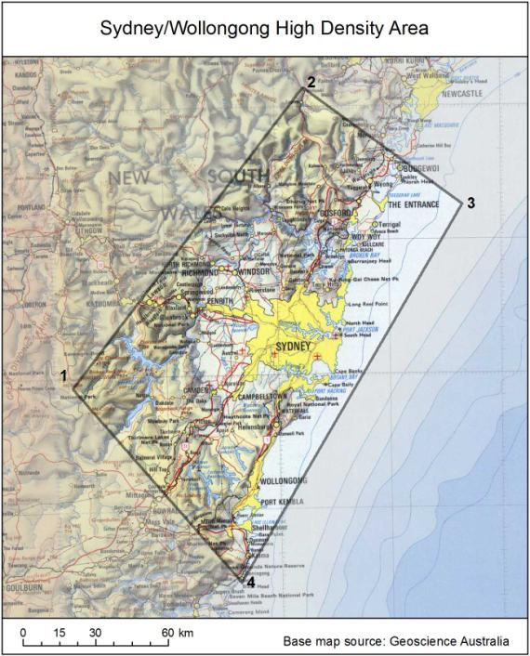

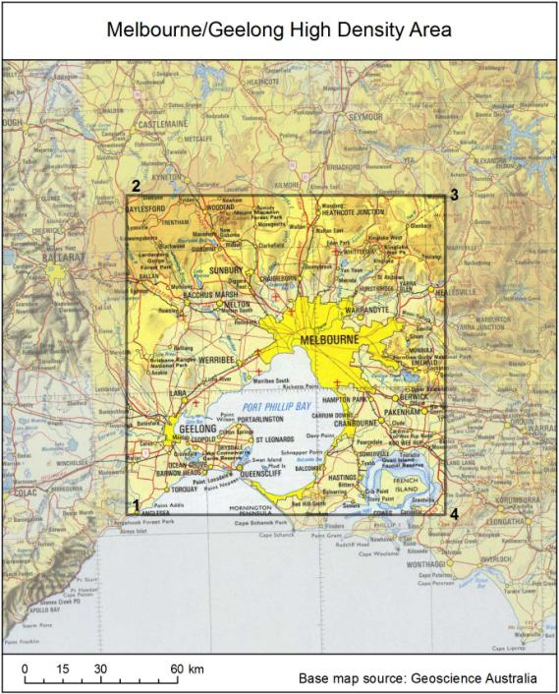

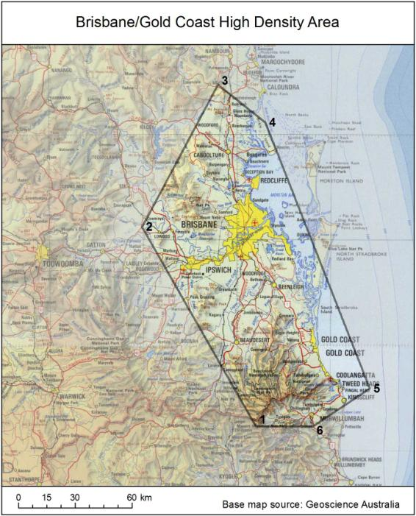

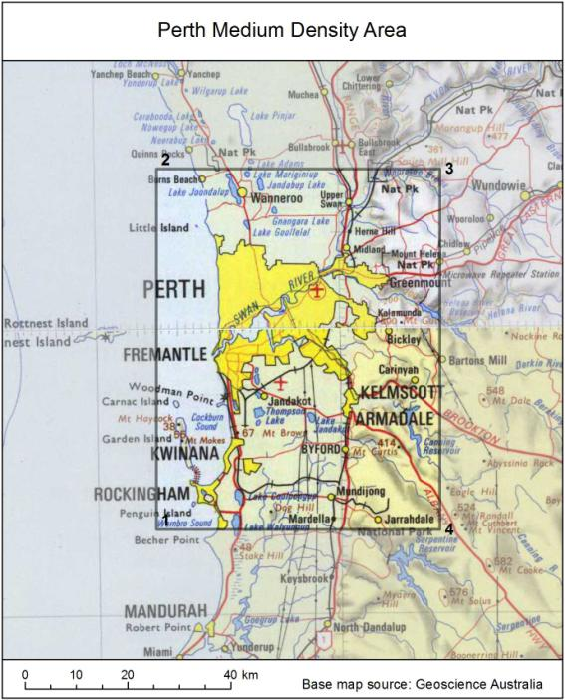

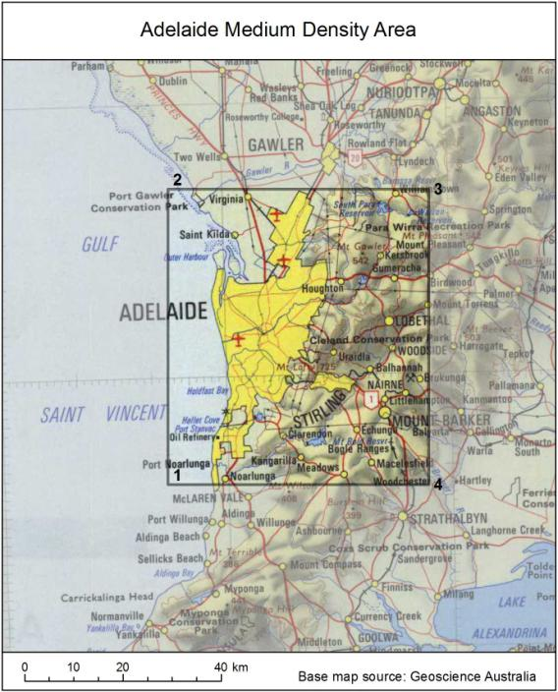

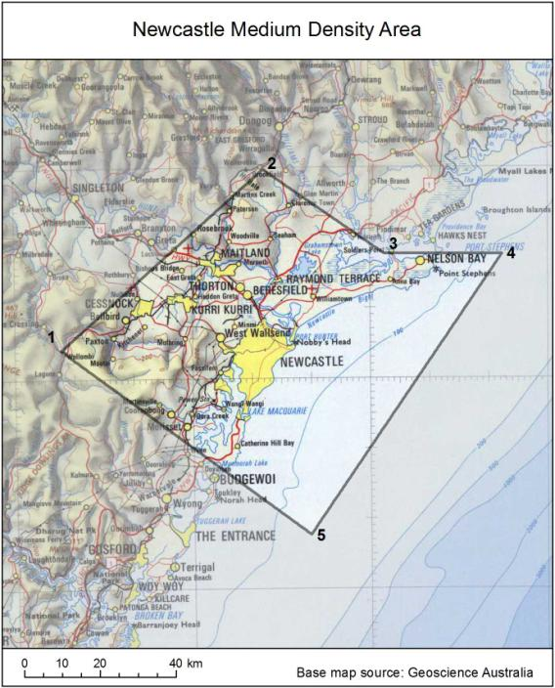

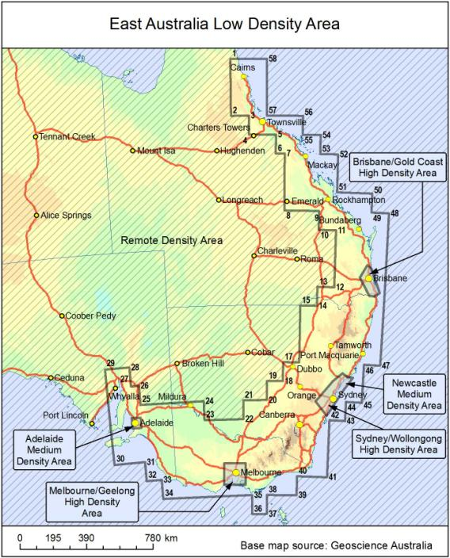

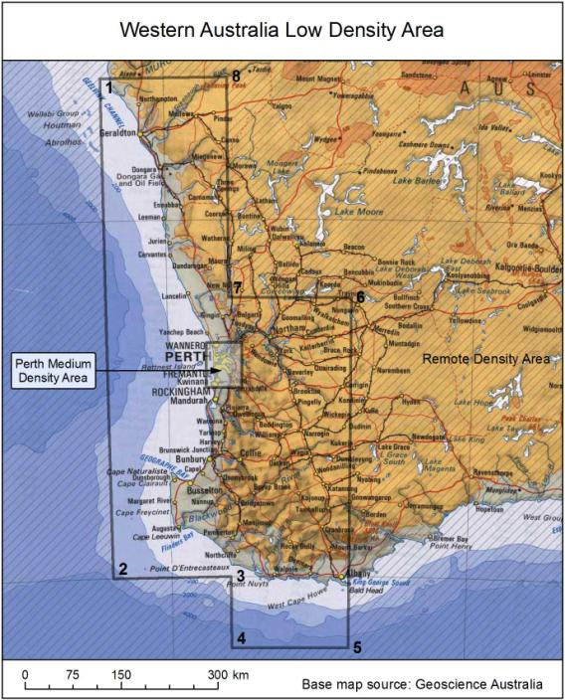

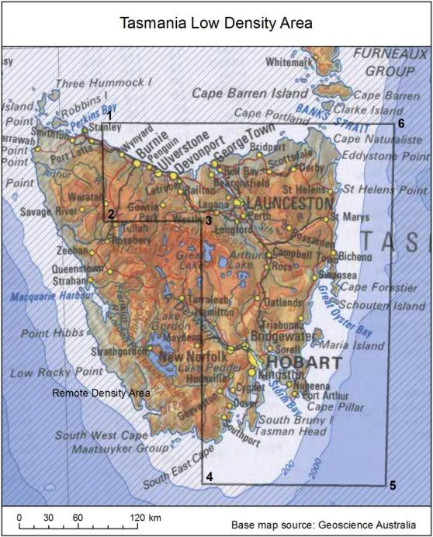

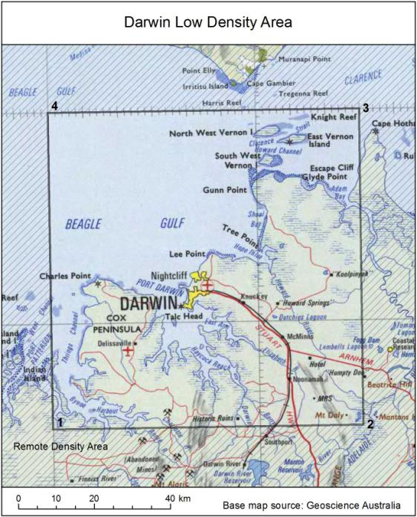

# Appendix C: Calculating commercial broadcasting taxes

The following provides are brief explanation of how commercial broadcasting taxes are calculated. Of note is the maximum power factor, which acts in a similar way to the low power discount provided in apparatus licence taxes. One of the differences between the approaches is that maximum power factor provides a more granular approach to reflecting the differences in spectrum denial.

### Transmitter information required

### 1. Spectrum band

The transmitter will be operating in either the AM or FM band (for radio broadcasting), and the VHF or UHF band (for television broadcasting). The spectrum band that the transmitter is using will have the following characteristics:

* AM band (radio): Frequency from 526.6 to 1606.5 kHz; bandwidth of 18 kHz
* FM band (radio): Frequency from 87.5 to 108 MHz; bandwidth of 200 kHz
* VHF band (television): Frequency from 174 to 230 MHz; bandwidth of 7 MHz

UHF band (television): Frequency from 520 to 694 MHz; bandwidth of 7 MHz.

### 2. Area density

The area density of the transmitter’s location refers to whether the transmitter is located in a high, medium, low or remote density area for apparatus licence fees. The geographic area maps outlining the different density areas are in Appendix B.

### 3. Maximum power factor

The maximum power of a transmitter is measured using:

* volts CMF—for the AM band

watts ERP—for the FM, VHF and UHF bands.

The level of maximum power will determine whether the transmitter is considered high, medium or low power. It should be noted that these categories differ depending on the spectrum band. The different power categorisation for each band is outlined in Table 4. The maximum power factor will then be used in the formula to calculate individual transmitter amounts.

1. Maximum power of a transmitter

| Maximum power category | Spectrum band | | | |
| --- | --- | --- | --- | --- |
| AM band | FM band | VHF band | UHF band |
| Low | n/a | Not more than 150 watts ERP | Not more than 150 watts ERP | Not more than 600 watts ERP |
| Medium | Not more than 220 volts CMF | Greater than 150 watts ERP but not more than 15,000 watts ERP | Greater than 150 watts ERP but not more than 15,000 watts ERP | Greater than 600 watts ERP but not more than 60,000 watts ERP |
| High | Greater than 220 volts CMF | Greater than 15,000 watts ERP | Greater than 15,000 watts ERP | Greater than 60,000 watts ERP |

### Calculation method

### 1. Determine the uncapped individual transmitter amount

To determine the tax amount for an individual transmitter, according to the Tax Determination:

* Find the $/kHz rate for the band (AM, FM, VHF or UHF) and area density (high, medium, low or remote) in which the transmitter operates and that has been increased for inflation.[15]
* Multiply this rate by the amount of bandwidth (in kHz) used by the transmitter, which will depend on the spectrum band:
* AM band: 18 kHz
* FM band: 200 kHz
* VHF/UHF band: 7,000 kHz.[16]
* Multiply the new amount by the maximum power factor. For each level of power, the maximum power factor is:
* low power: 0.1
* medium power: 1
* high power: 10.

This method will result in the individual transmitter amount being calculated:

$/kHz rate x bandwidth x maximum power factor = individual transmitter amount.

This amount should then be rounded to the nearest dollar (with 50 cents rounded up).

**For example:**

* In 2019–20, the $/kHz rate for a high-power FM band transmitter in a medium density location is 9.5732, as per the relevant table in Appendix B.
* A transmitter operating in the FM band uses 200 kHz. The 200 kHz of bandwidth is multiplied by the $/kHz rate of 9.5732 to equal 1914.63.
* The maximum power factor for a high-power transmitter is 10. Therefore, the amount of $1,914.63 needs to be multiplied by 10, which equals $19,146.32.

This amount is rounded to the nearest dollar, leading to an uncapped individual transmitter amount of $19,146.

# Appendix D: ACMA implementation of opportunity cost pricing of spectrum

In 2009, the ACMA introduced opportunity cost pricing as a methodology to better promote efficient use of spectrum. The idea is to set administrative prices for radio spectrum based on the opportunity cost of that spectrum, which creates better incentives for spectrum to move to high-value users/uses, and for end services to be provided at least cost.

The opportunity cost of a part of the radiofrequency spectrum is the value of the spectrum in the highest value alternative use that is denied by granting access to one party rather than to the alternative. There are various methods for calculating opportunity cost, including:

* market valuation methods:
* spectrum value can be deduced from spectrum market transactions, such as past auction results from the same or similar bands, nationally or internationally, and spectrum trades in the secondary market
* deducing value from the value of companies that own spectrum by subtracting the value of non-spectrum assets. This can also be done at the product level for products that use spectrum and by subtracting the value of non-spectrum inputs.
* direct calculation methods:
* net present value (NPV): this approach models the value of spectrum to buyers/users, by forecasting cost and revenues expected to be derived over time from buying the spectrum
* least cost alternative (LCA), or sometimes known as optimal deprival valuation (ODV): this method calculates the cost impact of a hypothetical marginal change in spectrum on the costs of an ‘average firm’ in the sector, assuming the level of output and service quality were kept constant. If a marginal unit of spectrum is denied (that is, unavailable due to congestion) to a cellular operator, how many base stations (and other inputs) would need to be erected and what are the associated costs that would need to be incurred to maintain output quantity and quality if spectrum was available? These extra costs inform the value of that marginal unit of spectrum.

## Opportunity cost pricing in the 400 MHz band

Shortly after the ACMA adopted opportunity cost pricing, the ACMA reviewed the 400 MHz band, which it considered a high priority band that was experiencing significant congestion. As part of that review, in August 2012 the ACMA proposed opportunity cost pricing in that band, with a potential annual tax rate of $199/kHz in high-density areas of Sydney/Wollongong, Melbourne/Geelong and Brisbane/Gold Coast.[17] The potential target tax rate was based on the least cost alternative (LSA) methodology.

The ACMA proposed staged price increases via a series of 15 per cent increments in the licence tax rate. This staged implementation reflected uncertainty about the ‘true’ market clearing price and provided flexibility to the ACMA to discontinue tax increases if congestion is eventually removed—and considered unlikely to return in the foreseeable future—prior to all the intended tax increases being implemented.

The ACMA implemented the first of five intended increments towards a new opportunity cost-based annual licence tax rate of $199/kHz (plus annual CPI escalation) for these high-density areas of the 400 MHz band on 15 August 2012.

In 2016, following congestion monitoring and comprehensive consultation, the ACMA implemented the second price increase in the high-density areas of the 400 MHz band. The ACMA also decreased the annual apparatus licence tax rates in remote density areas in the band so that licensees would pay the minimum annual tax for each spectrum access. The proposal to reduce taxes in the remote density areas assumed that there were generally low levels of use of spectrum across the remote density areas in the 400 MHz band, which suggested that the opportunity cost was low.

## Opportunity cost pricing in high frequency satellite bands (Ka and above)

In 2016, the ACMA reviewed pricing arrangements for high-frequency spectrum bands (17.3–51.4 GHz) because it was receiving stakeholder feedback that prices in high-frequency spectrum bands were high by international standards, suggesting that prices were particularly prohibitive for newer high-bandwidth technologies.

The ACMA reviewed congestion levels and anticipated future demand and used opportunity cost pricing principles and estimation methods to implement price reductions to promote better utilisation of higher frequency spectrum.

The main tax reform involved the following tax reductions for satellite services in the 17.3–51.4 GHz band:

* 30 per cent for Australia-wide and high-density area licences
* 50 per cent for medium-density area and low-density area licences

$0 tax for remote density area licences (subject to cost recovery fees and the minimum tax).

1. The paper outlining the recommendations can be found at: www.communications.gov.au/file/34821/download?token=7jbYg1eg
2. The current version of the FYSO 2019–23 can be found at: <https://www.acma.gov.au/five-year-spectrum-outlook>.
3. Information about the ACMA fees and the Apparatus Licence Fee Schedule can be found at [www.acma.gov.au/fees-apparatus-licences](http://www.acma.gov.au/fees-apparatus-licences).
4. ACMA [*Corporate plan 2019–20*](https://www.acma.gov.au/publications/2019-08/report/corporate-plan-2019-20)
5. This is also relevant for cost recovery initiatives relating to spectrum licensing.
6. Due to possible security issues associated with foreign ownership of aspects of space communications, some applications may be subject to wider government consultation.
7. CubeSats are a standardised type of small satellite comprising up to six modular units (or cubes) each measuring 10 x 10 x 10 cm with a combined weight under 10 kilograms. CubeSats have a limited operational lifetime of between one to three years. CubeSats usually orbit the Earth in what is known as a non-geostationary orbit (NGSO) in low circular or elliptical orbits, with altitudes between 400 and 800 km. Each orbit of the Earth takes around 90 minutes, with the satellite being visible at any specific point on Earth for only two or three passes a day, of no more than ten minutes visibility.
8. Local terrain clutter may reduce practicably achievable ranges to substantially less than a two-kilometre radius.Frequency re-use distances applicable to low power spectrum accesses are such that ranges will ultimately be interference-limited to a maximum of approximately two kilometres.
9. The consultation process was IFC 35/2018 – Land Mobile Services – New small service area models.
10. [www.acma.gov.au/publications/2018-03/report/managing-spectrum-400-mhz-band](http://www.acma.gov.au/publications/2018-03/report/managing-spectrum-400-mhz-band)
11. The averaged denial indicator depends on the re-use distances for the relevant service type, the size of the relevant high-density area and modelled representative base station locations.
12. Relative to the size of each high-density area.
13. Page 12 of the FYSO.
14. Local terrain clutter may reduce practicably achievable ranges to substantially less than a two-kilometre radius.Frequency re-use distances applicable to low power spectrum accesses are such that ranges will ultimately be interference limited to a maximum of approximately two kilometres.
15. The $/kHz table for 2017–18 can be found at section 6(5) of the [Tax Determination](https://www.legislation.gov.au/Details/F2017L01375).
16. The bandwidth amounts can be found at section 6(7) of the [Tax Determination](https://www.legislation.gov.au/Series/F2017L01375).
17. These high density areas are depicted as maps along with their geo-spatial coordinates in the [Apparatus Licence Fee Schedule](http://www.acma.gov.au/theACMA/About/Making-payments/Apparatus-licence-fees/apparatus-licence-fees-acma).