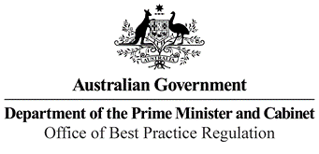

Reference: 25959

Telephone: (02) 6271 6270

Email: [helpdesk-obpr@pmc.gov.au](mailto:helpdesk-obpr@pmc.gov.au)

Ms Penny Shakespeare Deputy Secretary

Health Resourcing Group Department of Health

Dear Ms Shakespeare

**Regulation Impact Statement – Second-Pass Final Assessment – Applying greater rigour to certification for hospital admission**

Thank you for your letter of 8 May 2021, submitting a Regulation Impact Statement (RIS) on Applying greater rigour to certification for hospital admission to the Office of Best Practice Regulation (OBPR) for formal Second-Pass Final Assessment. I note the RIS has been formally certified at the Deputy Secretary level consistent with the *Australian Government Guide to Regulatory Impact Analysis*.

The OBPR’s assessment is that the quality of the regulatory impact analysis in the RIS is adequate to meet the Australian Government’s RIS requirements. However, the RIS would have benefitted from further depth of analysis of the potential impacts of the options presented. It could also have provided a stronger evidence base to support a number of the assertions made.

The RIS may now be provided to the decision-maker to inform their decision.

We would appreciate you advising us when a final decision has been announced and forwarding a copy of the RIS in a form meeting the Government’s accessibility requirements. The OBPR will publish the RIS, along with your certification and this assessment, on the OBPR’s website https://ris.pmc.gov.au.

If you have any further queries, please do not hesitate to contact me. Yours sincerely

Jason Lange Executive Director 10 May 2021

1 National Circuit, Barton ACT 2600 • Telephone 02 6271 6270 • Internet [www.pmc.gov.au/regulation](http://www.pmc.gov.au/regulation)